Project: Java Card Battle Game

1. Game Description and Rules

Overview
Desktop application titled "Card Battle." This is a turn-based strategy card game built using the Java Swing library for the Graphical User Interface (GUI).

Rules of the Game
The game logic is based on a simplified "War" or "High Card" mechanics with specific adjustments:
- Setup: The game uses a standard 52-card deck. The deck is shuffled, and the cards are dealt evenly between the Human Player and the Computer (26 cards each).
- Turn Structure: In each round, both players reveal the top card from their hand.
- Winning a Round: The player with the higher card value wins the round.
  - 2 is the lowest value; King is the highest regular card (value 13).
  - Special Ability: Aces are the most powerful cards (value 14) and grant a bonus of 5 points instead of the standard 1 point.
- Win Condition: The game ends when both players run out of cards. The player with the highest total score is declared the winner.

2. Class Design and Architecture
The application is structured around a central Game Manager that handles logic, while the GUI listens for user input. Below is the explanation of the key classes used in the system.

Class Structure
- Card: A fundamental object representing a playing card. It encapsulates the suit, value, and the visual Image associated with the card.
- Deck: A collection class that manages an ArrayList of Card objects. It includes methods for shuffling (Collections.shuffle) and dealing cards.
- Player (Abstract Class): Defines the common attributes for any participant in the game. It holds the score, the name, and the hand (list of cards).
  - HumanPlayer: Extends Player.
  - ComputerPlayer: Extends Player.
- GameManager: The "brain" of the application. It manages the flow of the game, compares cards, calculates scores, and handles file Input/Output for high scores.
- CardGameApp (Main Class): Inherits from JFrame. This class builds the Swing GUI, handles events (mouse clicks, keyboard spacebar), and manages the CardLayout to switch between screens.

3. Object-Oriented Programming (OOP) Usage
This project strictly adheres to OOP principles to ensure the code is modular and maintainable.
1. Encapsulation All data fields in classes like Card, Player, and Deck are marked as private. External classes cannot modify a player's score or a card's value directly. Instead, they must use public methods like getScore() or incrementScore().
- Example: The value integer in the Card class cannot be changed after the card is created, ensuring data integrity.
2. Inheritance I created a base class called Player that contains shared logic (keeping score, holding cards). Two specific classes, HumanPlayer and ComputerPlayer, inherit from this parent class. This reduces code duplication since both human and computer players share 90% of the same functionality.
3. Polymorphism The Player class defines an abstract method playTurn(). Both HumanPlayer and ComputerPlayer must implement this method, but they could potentially do so differently.
- Usage: The GameManager does not need to know if it is playing against a human or a computer; it simply calls p.playTurn() on any Player object.
4. Abstraction The Player class is abstract, meaning we cannot create a generic "Player"—we must create a specific type. This enforces a clear design structure where specific behaviors are defined in subclasses.

4. Graphical User Interface (GUI)
The GUI was built using standard Java Swing components (JPanel, JButton, JLabel, Graphics).
Main Menu The entry point of the application. It provides access to the game, rules, and persistent high scores.
Game Screen This is the main interactive area. It features:
- Dynamic Drawing: A custom DrawPanel inner class uses Graphics.drawImage to render card icons. It calculates positions dynamically, ensuring the UI looks good at any window size.
- Feedback: Labels display the current score, round number, and whose turn it is.
- Controls: A "Play Card" button (mapped to the Spacebar) allows the user to progress the game.
Game Over Screen Displays the final result. The title text changes color dynamically (Green for Win, Red for Loss) to provide immediate visual feedback.

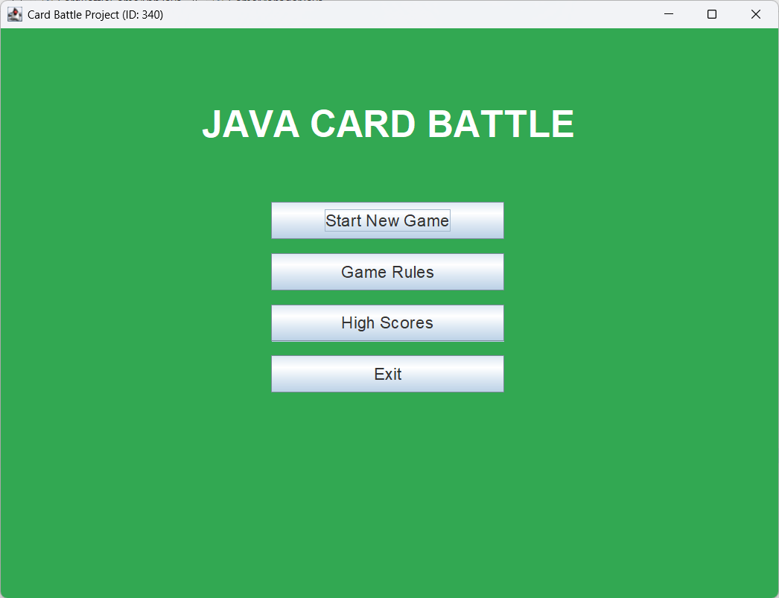

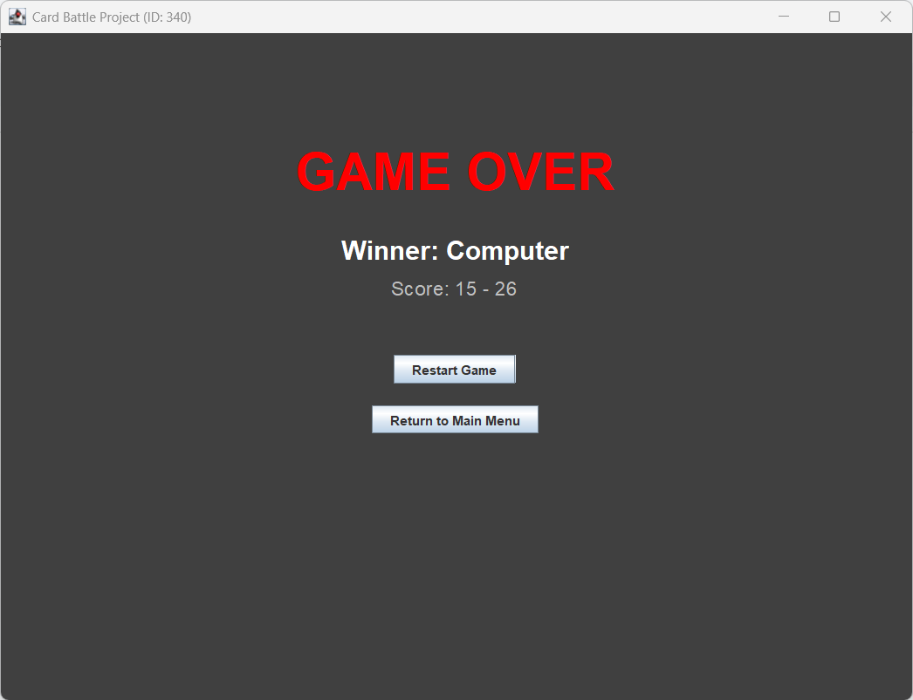
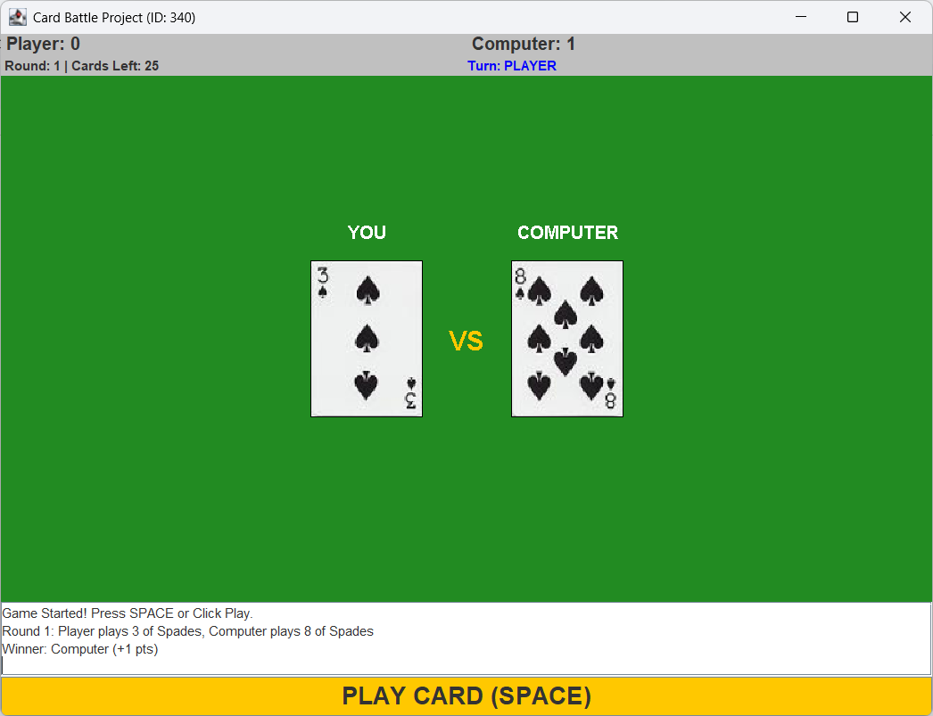5. AI Behavior and Difficulty
The opponent is implemented via the ComputerPlayer class.
- Logic: For this specific game variant ("Card Battle"), the strategy is deterministic: the computer must play the top card of its deck.
- Simulation of Thought: To make the game feel more realistic, I implemented a javax.swing.Timer. When the player moves, the game does not resolve instantly. Instead, the UI pauses for 1 second, showing a "Thinking..." status, before the computer reveals its card. This adds a layer of polish and pacing to the gameplay.

6. Persistence and Error Handling
High Score System The game uses Java File I/O (FileWriter, Scanner) to maintain a permanent record of top scores in highscores.txt.
- Data Stored: Player Name, Score, and the Date of the game.
- Sorting: When the High Score button is clicked, the application reads the file, parses the data into custom ScoreRecord objects, and sorts them using Collections.sort to display the highest scores first.
Error Handling
- Image Loading: The Card class wraps image loading in a try-catch block. If an image file is missing, the game draws a placeholder box instead of crashing.
- Input Validation: Buttons are disabled during animations to prevent users from accidentally skipping turns or crashing the logic by double-clicking.

