**Car-pooling: Real Time Ride Sharing**

SUDHANSHU SHUKLA (TUS3F151639)

BANSI KUMAR TRIVED (TUS3F151632)

PRIYANK TIWARI(TUS3F151643)

BHAVESH AMRUTKAR (TUS3F151634)

**ABSTRACT**

Increasing traffic congestion and the associated externalities require the study of alternative measures to reduce the number of automotive travelling every day, specifically single-occupant vehicles. Carpooling is a system by which a person offers his or her private vehicle to one or more people who have similar destinations. The increasing number of vehicles is an important issue for big cities administrations and many problems are related to this event, such as air pollution, traffic jams, drivers stress and so on. A spirit solution for this problem is the usage of car-pooling systems, which support the task of vehicle (especially cars) sharing among users. Present systems only work as a passage where providers and consumers can arrange shared cars for public transit. Hence, we are aiming to provide a web based secure Model which can have adaptability to any kind of vehicle system like public or private transportations. System will try to keep security on a high priority. Beside system will also implement a secured encrypted messaging facility. This system focuses on the construction process of a Logic Flow Diagram that translates the proposed methodology, allowing organization of different activities, input parameters and discrete events in a formation that can be used to study any given area and hence implement the ride sharing in a very effective manner. Main motive is to provide a system which will enable easier sharing of vehicles, so that the number of vehicles in the roads can be decreased together with all the problems that such vehicles lift on, also providing a basic structure on top of which other systems can be developed.

**METHODOLOGY**

In our system we will use a genetic algorithm to make itconvenient for the users to find the optimized journey.

By the use of genetic algorithm, our web application will display the optimized journeys relevant for the consumer.

There are 3 modules in our System :

* Service provider
* Cloud server
* Consumer

Working of Algorithm is as follows:

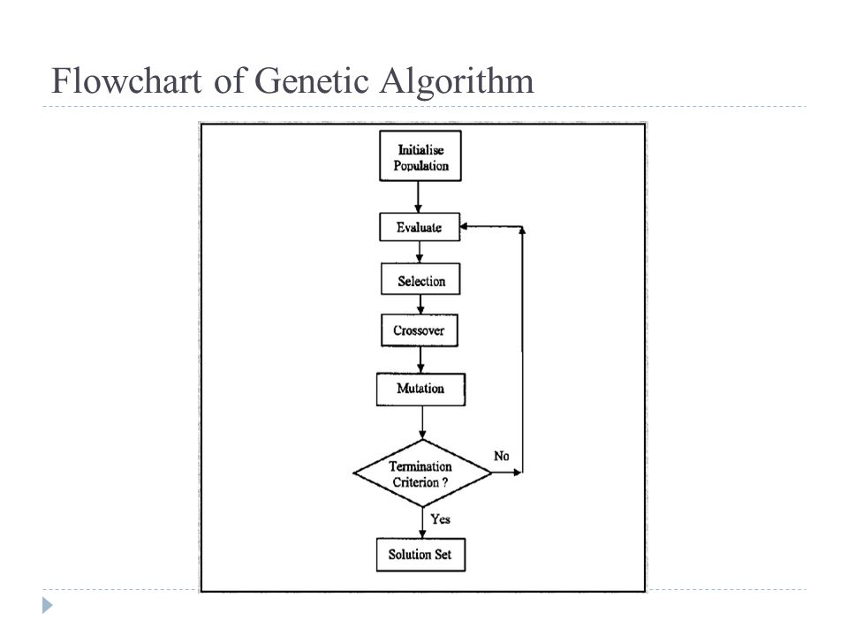

It has 5 steps:

* **Initial Population:** In the initialization procedure, each passenger is randomly chosen and assigned to a driver in the assignment layer of a chromosome. The chosen passenger is marked to prevent the passenger from being assigned twice.
* **Fitness:** To find the quality of the chromosomes in the population the fitness function is used to determine the travel cost for each driver. To calculate the fitness value we need to find the most efficient route for picking-up and dropping off passengers for each corresponding driver.
* **Selection:** The first phase involves sorting the chromosomes into a descending order according to their fitness values, and selecting those with the highest values in the population. This gives with the highest fitness values from one generation to the next
* **Crossover:** After the optimal chromosomes have been selected, the chromosome crossover procedure is utilized to recombine the chromosomes of selected parents to simulate the natural process of evolution.
* **Mutation:** It is used to change the allocation of the passengers mutually.

We will use aModified Waterfall model, which is employed for the design, planning, implementation and achievement of project objectives.

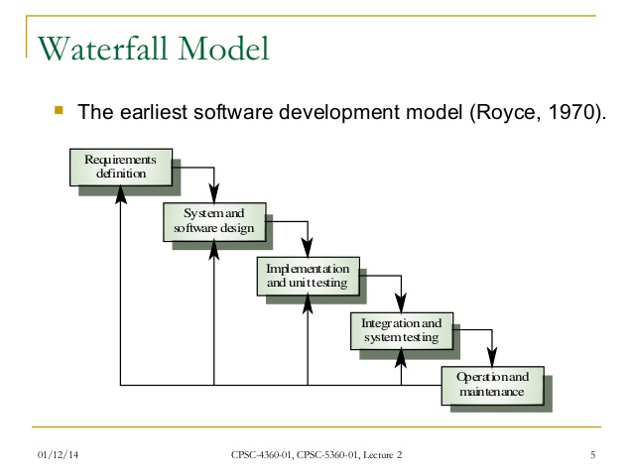

The schema above illustrates the commonly known Extended Waterfall model. We use this model because all the specifications and predictions should be done at the beginning of the iteration and they are stable to the end. We decided to use waterfall model but allows user to change/update/delete requirements at any stage.

Phases in this advanced model are permitted to overlap and number of tasks can function concurrently.

**Architecture**

This application is for two types of users: Car owner and Passenger. The passenger or the owner has to register themselves if they are using the application for first time. If they are already registered they have to login using their login id and password. During login, they have to select whether they are owner or passenger.

Car Owner: A person who can register its own car for car pooling by entering its details such as type of car, seat availability ,ID proof, address and so on.

Passenger: A person wanting to pool a car will enter its details and can select the type of car and the area from where he/she can share the car.

If user is a owner then the details of carpool will be filled and it will be stored in database. A car owner visits the system and uploads his/her car with its starting area and destination specified. He provides the list of checkpoints from where the car will navigate through, so that passengers can get to know from where they can pool the car. When passengers login into their account they provide the account and travelling details and their location from where they have to pool the car. Passengers gets a list of cars with the unique id where passenger can select a car to pool according to their comfort .A map is displayed with the respective car id showing the path of travel where passenger can select its checkpoint to pool. After selection and submission car owner gets the details about the passengers who pooled its car and passengers confirm their location to pool. The main idea of providing interface through Android mobile phones is that GPS can be used to keep track of the vehicle which would enhance security. This application can also make use of an algorithm to find the shortest path so that one spends minimum amount of fare and can also make use of messaging services to inform the passengers about the late arrival of car owner due to traffic or when car owner is not willing to go.

Figure I : Proposed model of carpool system

Figure II : Interface of the system

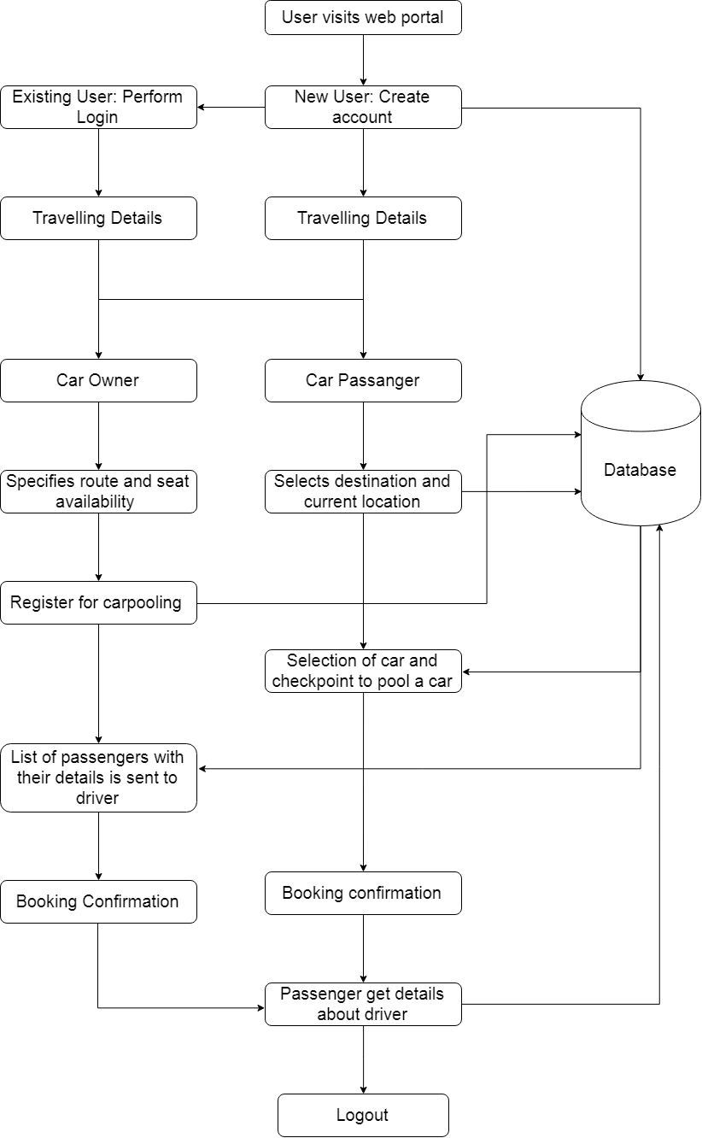

Fig.I

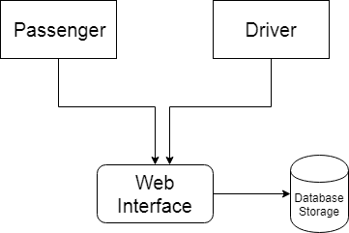

Fig.II