

|  |
| --- |
| GENDER SPEECH RECOGNITION  REPORT |
|  |
| 9 luglio  S300733: Atanasio Giuseppe  S296138: Carachino Alessio |



Sommario

Premises 3

Task 3

Dataset 3

Features 4

Histograms 4

Dimensionality Reduction Techniques 6

PCA 6

LDA 6

Considerations regarding DRT for Gender Speech Recognition 8

Classification 9

What we use… 9

Validation 9

Generative models 9

Logistic Regression 10

Support Vector Machine 12

Gaussian Mixture Models 14

Best models 15

Recap 15

Final picks 15

Experimental Results 16

Title 16

Premises

# Task

The goal of the application is to build a model that best fits for the gender classification. We will discuss how they perform for the problem we have chosen, explaining pros and cons.

# Dataset

The dataset consists of synthetic speaker embeddings that represent the acoustic characteristics of a spoken utterance. Each row corresponds to a different speaker and contains 12 features followed by the gender label (1 for female, 0 for male). The features do not have any particular interpretation. Speakers belong to four different age groups. The age information, however, is not available.

The training set consists of 3000 samples per class, whereas the test set contains 2000 samples per class.

Features

# Histograms

Here are histograms for each of the 12 features. We can see that features are already well gaussianized, but we’re going to apply a gaussianization as well.

|  |  |  |
| --- | --- | --- |
|  |  |  |
|  |  |  |
|  |  |  |
|  |  |  |

Feature 3 is highly correlated to the 0, 2, 7 and 9 ones.

This suggests we may benefit from using PCA to map data to less correlated features.

Here are the gaussianized features. As we expected, the gaussianization hasn’t brought so much improvement at all. Instead, gaussians in feature 3 and 9 were better in the previous unmodified dataset.

|  |  |  |
| --- | --- | --- |
|  |  |  |
|  |  |  |
|  |  |  |
|  |  |  |

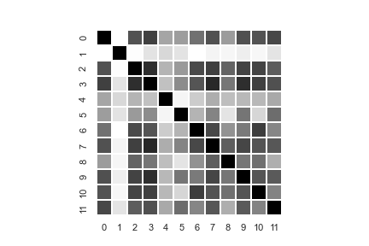

Note that, with respect to the non-gaussianized features, the correlation between 7-9 and 3 ones has decreased.

Dimensionality Reduction Techniques

We have performed feature extraction within dimensionality reduction using PCA.

# PCA

In this part we’ve tested PCA for reducing the features, and we’ve empirically concluded that the best number of those to save is m=8. In fact, we can check that the error rate in the classification methods is quite similar for increasing values of m.

When we generate a plot scatter with this value, we can check that there are four different areas, one for each group age:

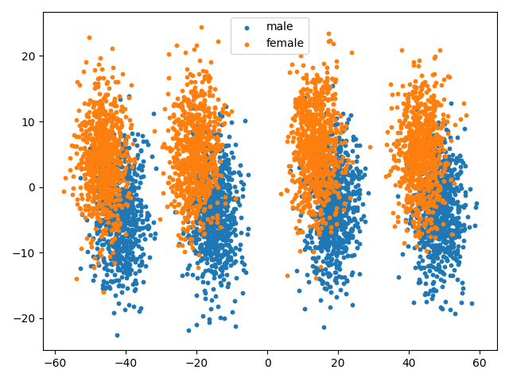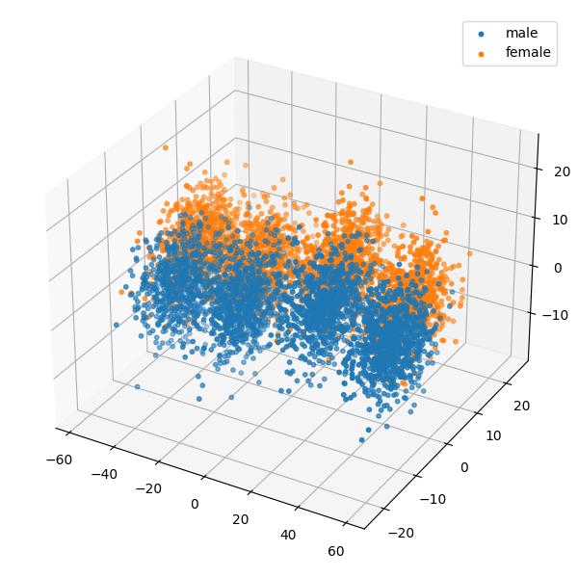

Figure 1 - PCA (12 -> 2) Figure 2 - PCA (12 -> 3)

# LDA

Text text …

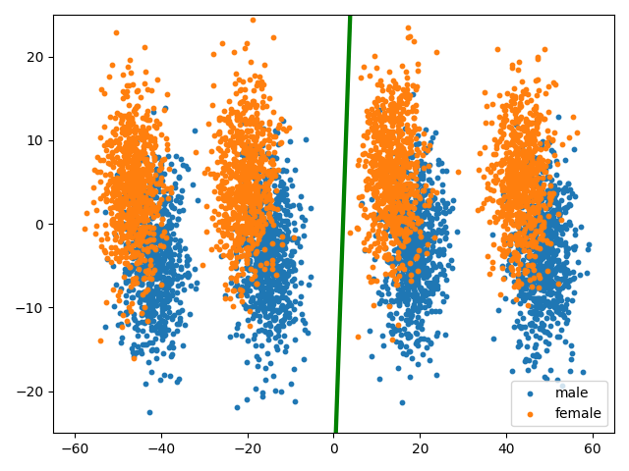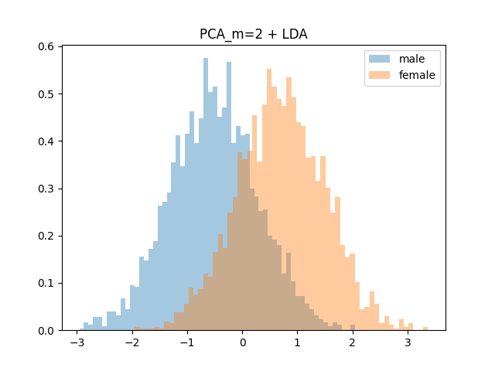

Figure 3 – PCA (12 -> 2) + LDA (green line is the best direction) Figure 4 - PCA (12 -> 2) + LDA

(histograms show how points are projected along the direction)

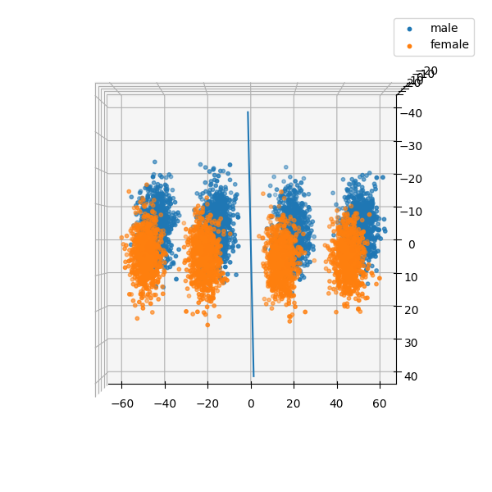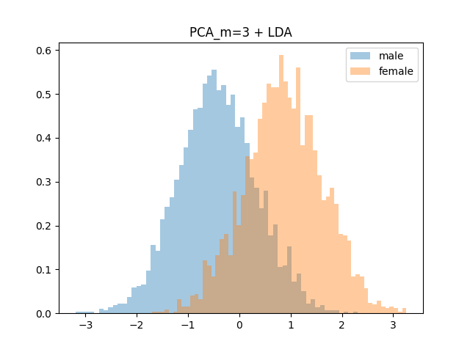

Figure 5 - PCA (12 ->3) + LDA (blue line is the best direction) Figure 6 - PCA (12 -> 3) + LDA (histograms show how points are projected along the direction)

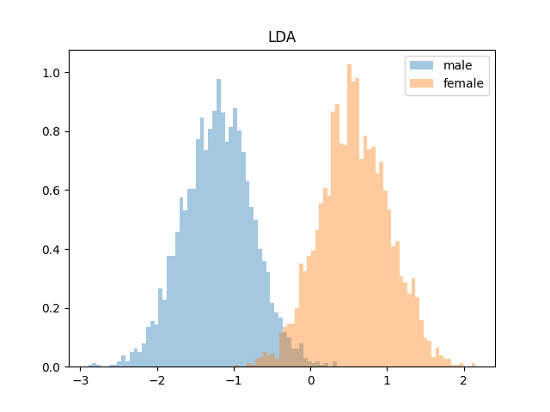

Figure 7 - LDA (12 -> 1)

# Considerations regarding DRT for Gender Speech Recognition

As we can see with m=2 and m=3 -> bad separation -> bad accuracy -> we keep results in the tables just to describe…

Classification

# What we use…

* Generative models – Linear and Quadratic Classifiers
  + Multivariate Gaussian Classifier (**MGC**)
  + MGC + Naïve Bayes Classifier
  + MGC + Tied Covariance
  + MGC + Naïve Bayes Classifier with Tied Covariance
* Logistic regression
  + Quad ???
  + Weighted Logistic Regression
* Support Vector Machines (SVM)
* Gaussian Mixture Models (GMM)
* Fusion ?

# Validation

* K FOLD con K = 5

# Generative models

***EXPECTATIONS***

Text Text

***RESULTS***

Here are the results of Multivariate Gaussian Classifiers in three different applications (ours has π=0.5). We can notice that the ones with diagonal covariance matrix perform worse than full covariance matrix, and this is due to the highly correlation between features, as we can see above in the heatmap.

|  |  |  |  |  |  |  |  |
| --- | --- | --- | --- | --- | --- | --- | --- |
|  | π = 0.5 | π = 0.9 | π = 0.1 |  | π = 0.5 | π = 0.9 | π = 0.1 |
|  | **RAW features** | | |  | **Gaussianization** | | |
|  | **no PCA** | | | | | | |
| Full-cov | 0.048 | 0.125 | 0.128 |  | 0.061 | 0.178 | 0.189 |
| DIAG-COV | 0.563 | 0.856 | 0.825 |  | 0.538 | 0.825 | 0.819 |
| Tied full-cov | 0.047 | 0.128 | 0.118 |  | 0.06 | 0.166 | 0.184 |
| tied diag-cov | 0.564 | 0.85 | 0.829 |  | 0.535 | 0.822 | 0.808 |
|  | **PCA (m=10)** | | | | | | |
| Full-cov | 0.047 | 0.124 | 0.14 |  | 0.073 | 0.213 | 0.21 |
| DIAG-COV | 0.067 | 0.156 | 0.162 |  | 0.083 | 0.225 | 0.239 |
| Tied full-cov | 0.047 | 0.125 | 0.13 |  | 0.071 | 0.199 | 0.207 |
| tied diag-cov | 0.063 | 0.149 | 0.153 |  | 0.082 | 0.218 | 0.224 |
|  | **PCA (m=9)** | | | | | | |
| Full-cov | 0.047 | 0.125 | 0.139 |  | 0.092 | 0.239 | 0.24 |
| DIAG-COV | 0.065 | 0.153 | 0.164 |  | 0.096 | 0.254 | 0.266 |
| Tied full-cov | 0.047 | 0.123 | 0.131 |  | 0.091 | 0.233 | 0.249 |
| tied diag-cov | 0.062 | 0.146 | 0.153 |  | 0.096 | 0.248 | 0.261 |

|  |  |  |  |  |  |  |  |
| --- | --- | --- | --- | --- | --- | --- | --- |
|  | π = 0.5 | π = 0.9 | π = 0.1 |  | π = 0.5 | π = 0.9 | π = 0.1 |
|  | **Z NORM** | | |  |  | | |
|  | **no PCA** | | | | | | |
| Full-cov | 0.048 | 0.125 | 0.128 |  |  |  |  |
| DIAG-COV | 0.563 | 0.856 | 0.825 |  |  |  |  |
| Tied full-cov | 0.047 | 0.128 | 0.118 |  |  |  |  |
| tied diag-cov | 0.564 | 0.85 | 0.829 |  |  |  |  |
|  | **PCA (m=10)** | | | | | | |
| Full-cov | 0.113 | 0.262 | 0.308 |  |  |  |  |
| DIAG-COV | 0.12 | 0.272 | 0.304 |  |  |  |  |
| Tied full-cov | 0.11 | 0.255 | 0.303 |  |  |  |  |
| tied diag-cov | 0.117 | 0.267 | 0.301 |  |  |  |  |
|  | **PCA (m=9)** | | | | | | |
| Full-cov | 0.162 | 0.382 | 0.415 |  |  |  |  |
| DIAG-COV | 0.164 | 0.386 | 0.425 |  |  |  |  |
| Tied full-cov | 0.159 | 0.376 | 0.414 |  |  |  |  |
| tied diag-cov | 0.162 | 0.385 | 0.413 |  |  |  |  |

***CONSIDERATIONS***

Text Text

# Logistic Regression

***EXPECTATIONS***

Since ‘TIED FULL-COV’ introduces linear separation rules, it is expected that Logistic Regression will perform well.

***RESULTS***

**LR RAW FEATURES – Results**

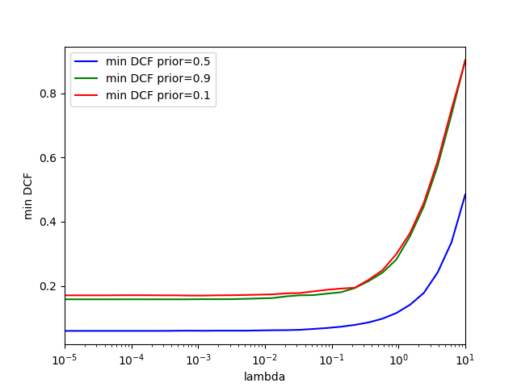

|  |  |  |  |
| --- | --- | --- | --- |
|  | π = 0.5 | π = 0.9 | π = 0.1 |
|  | NO PCA |  |  |
| LR, lambda=1e-6 | 0.06 | 0.158 | 0.171 |
| lr, lambda=1e-4 | 0.06 | 0.158 | 0.171 |
| lr, lambda=1e-2 | 0.061 | 0.161 | 0.173 |
| lr, lambda=1.0 | 0.119 | 0.291 | 0.309 |
|  | PCA m=10 |  |  |
| LR, lambda=1e-6 | 0.061 | 0.152 | 0.178 |
| lr, lambda=1e-4 | 0.061 | 0.152 | 0.178 |
| lr, lambda=1e-2 | 0.062 | 0.158 | 0.182 |
| lr, lambda=1.0 | 0.12 | 0.296 | 0.314 |
|  | PCA m=9 |  |  |
| LR, lambda=1e-6 | 0.061 | 0.153 | 0.178 |
| lr, lambda=1e-4 | 0.061 | 0.153 | 0.178 |
| lr, lambda=1e-2 | 0.062 | 0.16 | 0.181 |
| lr, lambda=1.0 | 0.12 | 0.295 | 0.317 |

**LR GAUSSIANIZED FEATURES – Results**

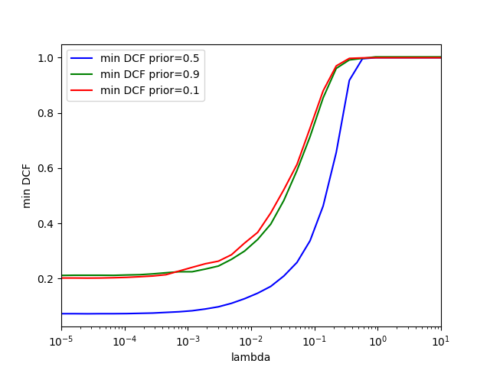

|  |  |  |  |
| --- | --- | --- | --- |
|  | π = 0.5 | π = 0.9 | π = 0.1 |
|  | NO PCA |  |  |
| LR, lambda=1e-6 | 0.072 | 0.211 | 0.201 |
| lr, lambda=1e-4 | 0.072 | 0.212 | 0.204 |
| lr, lambda=1e-2 | 0.136 | 0.318 | 0.35 |
|  | PCA m=10 |  |  |
| LR, lambda=1e-6 | 0.087 | 0. 267 | 0. 246 |
| lr, lambda=1e-4 | 0.088 | 0.268 | 0.248 |
| lr, lambda=1e-2 | 0.145 | 0.342 | 0.365 |
|  | PCA m=9 |  |  |
| LR, lambda=1e-6 | 0. 114 | 0.295 | 0.301 |
| lr, lambda=1e-4 | 0.116 | 0.299 | 0.306 |
| lr, lambda=1e-2 | 0.166 | 0.369 | 0.418 |

**LR Z-NORMALIZED FEATURES – Results**

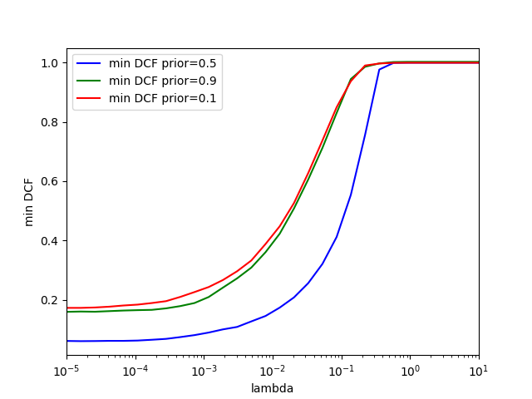

|  |  |  |  |
| --- | --- | --- | --- |
|  | π = 0.5 | π = 0.9 | π = 0.1 |
|  | NO PCA |  |  |
| LR, lambda=1e-6 | 0.06 | 0.158 | 0.171 |
| lr, lambda=1e-4 | 0.061 | 0.166 | 0.184 |
| lr, lambda=1e-2 | 0.159 | 0.392 | 0.418 |
|  | PCA m=10 |  |  |
| LR, lambda=1e-6 | 0.146 | 0.335 | 0.385 |
| lr, lambda=1e-4 | 0.148 | 0.34 | 0.386 |
| lr, lambda=1e-2 | 0.201 | 0.484 | 0.487 |
|  | PCA m=9 |  |  |
| LR, lambda=1e-6 | 0.203 | 0.48 | 0.528 |
| lr, lambda=1e-4 | 0.205 | 0.486 | 0.528 |
| lr, lambda=1e-2 | 0.249 | 0.576 | 0.615 |

**WEIGHTED LR RAW FEATURES – Results**

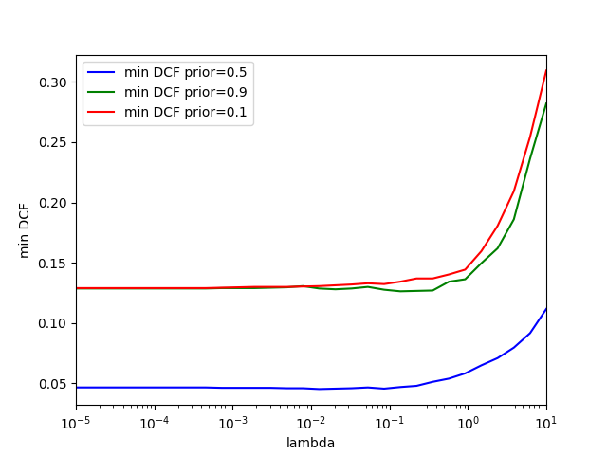

|  |  |  |  |
| --- | --- | --- | --- |
|  | π = 0.5 | π = 0.9 | π = 0.1 |
|  | NO PCA |  |  |
| lr, lambda=1e-4 | 0.047 | 0.129 | 0.129 |
| lr, lambda=1e-2 | 0.046 | 0.13 | 0.131 |
| lr, lambda=1E-1 | 0.046 | 126 | 134 |
| LR, LAMBDA=1.0 | 0.06 | 149 | 137 |
|  | PCA m=10 |  |  |
| lr, lambda=1e-4 | 0.061 | 0.152 | 0.178 |
| lr, lambda=1e-2 | 0.062 | 0.158 | 0.182 |
| lr, lambda=1E-1 | 073 | 178 | 197 |
| LR, LAMBDA=1.0 | 12 | 314 | 296 |
|  | PCA m=9 |  |  |
| lr, lambda=1e-4 | 0.061 | 0.153 | 0.178 |
| lr, lambda=1e-2 | 0.062 | 0.16 | 0.181 |
| lr, lambda=1E-1 | 072 | 177 | 199 |
| LR, LAMBDA=1.0 | 12 | 295 | 317 |

***CONSIDERATIONS***

Text Text

# Support Vector Machine

***EXPECTATIONS***

Text Text

***RESULTS***

**Primal, RAW FEATURES Implementation – Results**

|  |  |  |  |
| --- | --- | --- | --- |
| π = 0.5 | K = 0.1 | K = 1.0 | K = 10.0 |
| SVM, C=0.01 | 0.071 | 0.063 | 0.062 |
| SVM, C=0.1 | 0.071 | 0.061 | 0.06 |
| SVM, C=1.0 | 0.062 | 0.059 | 0.061 |
| SVM, C=10.0 | 0.159 | 0.077 | 0.076 |

|  |  |  |  |
| --- | --- | --- | --- |
| π = 0.1 | K = 0.1 | K = 1.0 | K = 10.0 |
| SVM, C=0.01 | 0.188 | 0.168 | 0.166 |
| SVM, C=0.1 | 0.18 | 0.169 | 0.171 |
| SVM, C=1.0 | 0.16 | 0.17 | 0.171 |
| SVM, C=10.0 | 0.37 | 0.182 | 0.211 |

|  |  |  |  |
| --- | --- | --- | --- |
| π = 0.9 | K = 0.1 | K = 1.0 | K = 10.0 |
| SVM, C=0.01 | 0.17 | 0.167 | 0.159 |
| SVM, C=0.1 | 0.178 | 0.158 | 0.152 |
| SVM, C=1.0 | 0.172 | 0.151 | 0.158 |
| SVM, C=10.0 | 0.454 | 0.256 | 0.207 |

**Dual + Polynomial, RAW FEATURES Implementation – Results**

|  |  |  |  |
| --- | --- | --- | --- |
| π = 0.5, D=4, con=1000 | K = 0.1 | K = 1.0 | K = 10.0 |
| SVM, C=0.01 | 0 | 0. | 0. |
| SVM, C=0.1 | 0.0 | 0. | 0 |
| SVM, C=1.0 | 0. | 0.13 | 0.176 |
| SVM, C=10.0 | 0. | 0. | 0. |

**Dual + RBF, RAW FEATURES Implementation – Results**

|  |  |  |  |
| --- | --- | --- | --- |
| π = 0.5, gamma=0.001 | K = 0.1 | K = 1.0 | K = 10.0 |
| SVM, C=0.01 | 0. | 0. | 0. |
| SVM, C=0.1 | 0. | 0 | 0. |
| SVM, C=1.0 | 0.057 | 0.057 | 0.055 |
| SVM, C=10.0 | 0.053 | 0.053 | 0.138 |

***CONSIDERATIONS***

Text Text

# Gaussian Mixture Models

***EXPECTATIONS***

Text Text

***RESULTS***

***CONSIDERATIONS***

Text Text

Best models

# Recap

Text Text

# Final picks

Text Text

Experimental Results

# Title