SDR quick start

1) install anaconda3

2) <https://github.com/ryanvolz/radioconda> - core resource

3) install driver for ADLM-Pluto libiio from 2) link

4) install radioconda for windows from 2) link

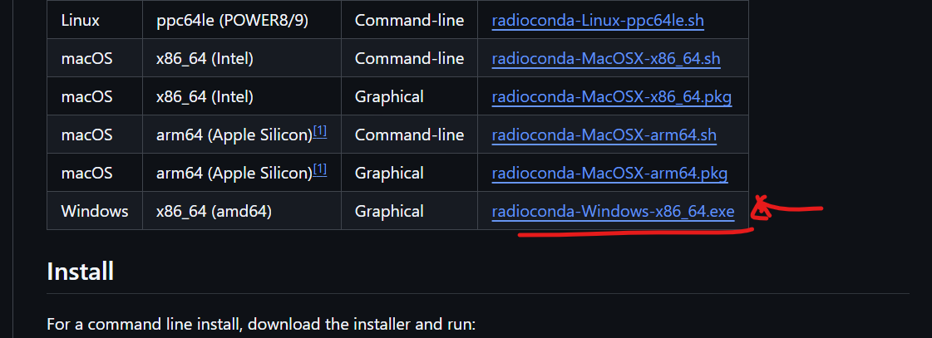

Location of conda from anaconda prompt:

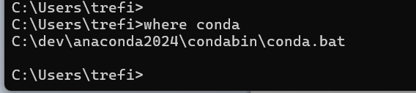

List of env:

conda evn list

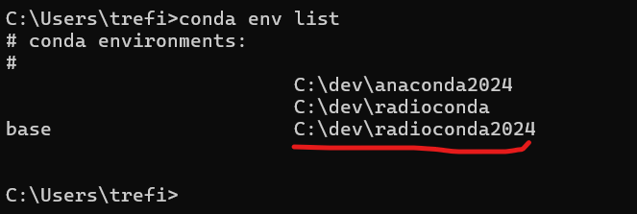

conda actiave C:\dev\radioconda2024

(in my case it become base env)

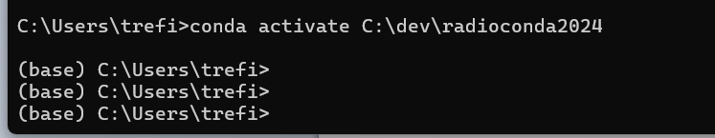

Install (critical step since 2.18 does not work properely with sionna):

pip install tensorflow==2.14

pip install sionna==0.13.0 (that version without Ray tracing work stable)

Now env is ok to use

GitHub rep: clone it

<https://github.com/Caracurt/python_sdr>

configure conda and env inside Pycharm

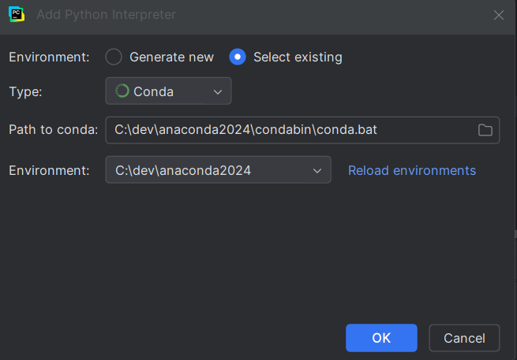

Run file rx_unit_test.py

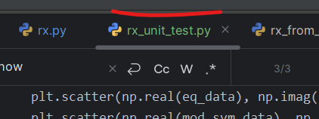

Make sure to switch on you target radioconda env

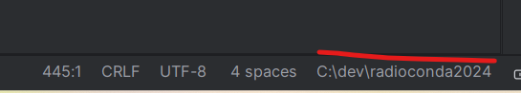

Ouput for unit test should look like this:

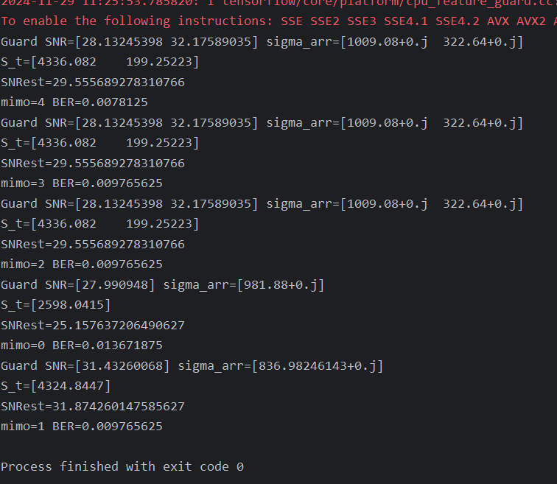

Now you are set:

to be continued

# GNU radio Linux WSL

gnuradio-companion -> cmd command

gr_modtool -> create block