SC-FDM

OFDM

# Antenna analysis:

1. Rep=1,2,4 pilot with wifi tiny antenna

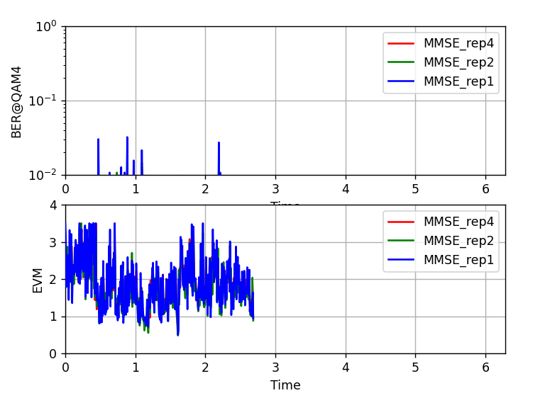

1. Long FM like anteanna

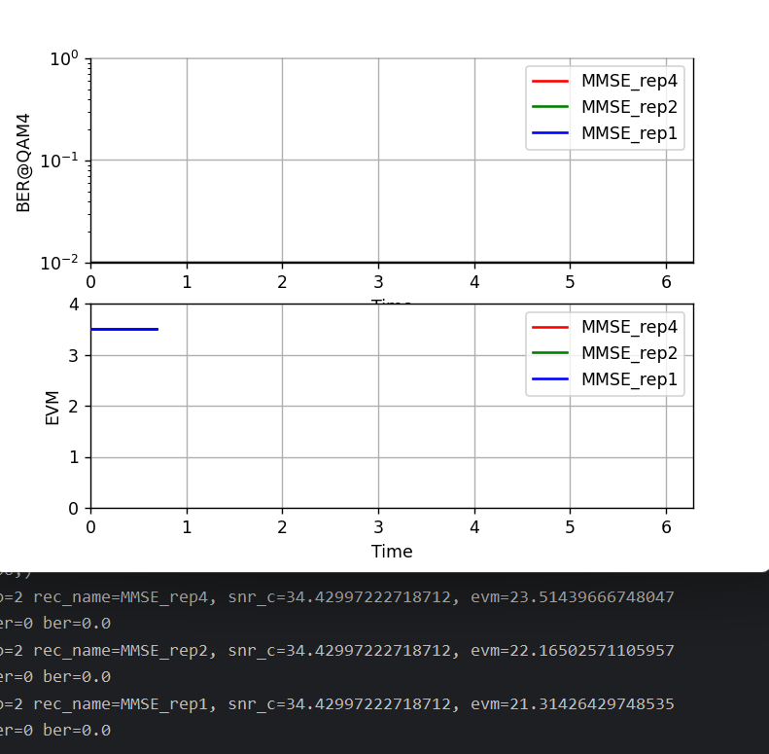

EVM about 17dB better !

My progamming experience consists of C, C++, Matlab, Python, R languages. Recently I have been used Python the most. I used write code for CUDA, Matlab mex functions etc

I am devoted to learn Python in application of usage of GNU radio, build own FM radio, OFDM/SC-FDM transmitter

Cfo_set =0, cfo_est=0, SNR=-3dB

Cfo_set=0, cfo_est=1, SNR=-3dB

If there is no CFO, CFO_est leads to 3dB EVM degradation

4time preambule (FER @ SNR=-3 CFO_set=0.001)

