/\*

-- Boss Cuts Query script

-- Alistair Clark, Jack Dean 09302152, Campbell Reid 1354940, Ashton Church 11356788

-- Created on 29th April 2016 @ 9am

\*/

/\* Group members documentation, ho ho!

INSERT INTO group (fName, lName, stuID)

VALUES ('Alistair', 'Clark', '14403362');

NSERT INTO group (fName, lName, stuID)

VALUES ('Ashton', 'Church', '11356788')

NSERT INTO group (fName, lName, stuID)

VALUES ('Jack', 'Deane', '09302152')

NSERT INTO group (fName, lName, stuID)

VALUES ('Campbell', 'Reid', '1354940')

\*/

/\* Example query \*/

SELECT userTypeCode, clientNo, staffNo

FROM userLogon

WHERE username = 'suebeale'

AND password = 'testuser'

AND statusCode = 'E';

/\* Query 1: Get all clients living in Hamilton \*/

SELECT clientNo, firstName, lastName, suburb, postCode

FROM clients

WHERE city = 'Hamilton';

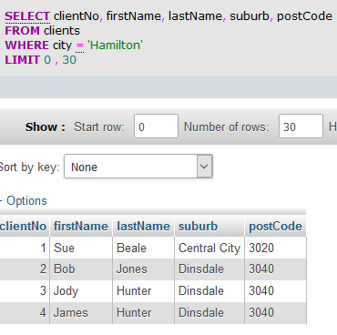

/\* Query 2: Get all clients living in Hamilton whose birthday it is \*/

SELECT firstName, lastName, email, phone

FROM clients

WHERE dayofmonth(birthDate) = dayofmonth(now())

AND month(birthDate) = month(now())

AND city = 'Hamilton';

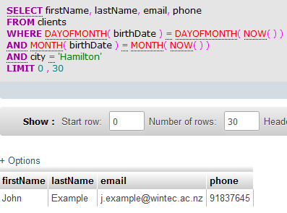

/\* Query 3: Get enabled services \*/

SELECT serviceDesc, timeRequired, statusCode

FROM services

WHERE statusCode = 'EN';

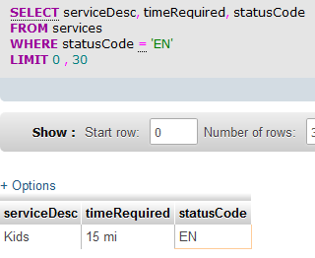

/\* Query 4: Get staff details who have equals 4 years experience\*/

SELECT staffNo, firstName, lastName, yearsExperience

FROM stylists

WHERE yearsExperience = 4;

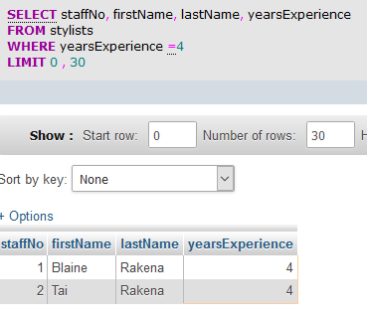

/\* Query 5: Get products that occur more than three times in the product details table and sort them by popularity \*/

SELECT p.productCode, p.productName, p.productDesc, COUNT(b.productCode)

FROM bookingDetails b, products p

WHERE p.productCode = b.productCode

GROUP BY p.productCode, p.productName, p.productDesc

HAVING COUNT(b.productCode) > 3;

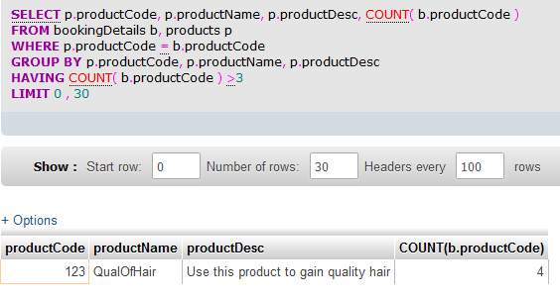

/\* Query 6: Get staff and qualifications \*/

SELECT firstName, lastName, dateObtained, qualificationName

FROM stylists s, staffQualifications sq, qualifications q

WHERE s.staffNo = sq.staffNo

AND sq.qualificationCode = q.qualificationCode;

