|  |  |
| --- | --- |
| Recipes | Users |
| id  name  cooking_time  ingredients  difficulty | id  name |

I have decided to add 2 attributes to the Recipes model.

1. Description: this is a fairly standard piece of data on other recipe sites
2. Picture: this is a fairly standard piece of data on other recipe sites

Frontend Inspirations

The Food Network

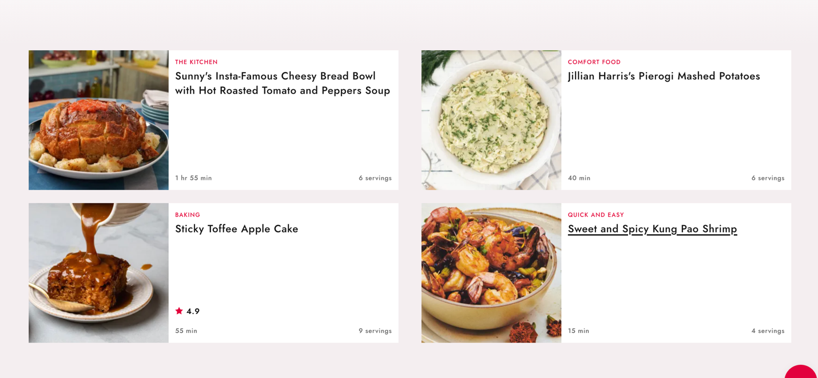

I like this page layout because it feels less cluttered. When looking at other sites like Allrecipes or Simplyrecipes the page feels too full.