All.Space Word Template


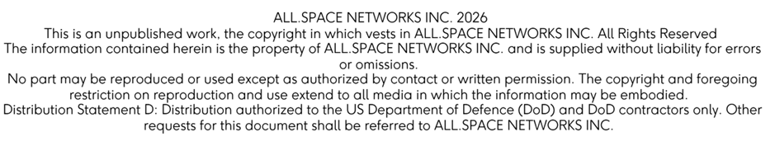

Document Information
Attributes | Data
Unique Reference Number (URN) | ASICD-000001
Information Type | Template
Keywords/Metadata | Word, Template, Engineering

Review History
Rev | Date | Comments | Author
1.0 |  | First Release

Review & Approval

 | Details | Signature | Date
Author | Name:  Role:
Reviewer | Name:  Role:  Name:  Role:
Approver | Name:  Role:

Table of Contents:
1. Document Information 1
1.1. Review History 1
1.2. Review & Approval 1
2. About This Document 4
2.1. Purpose 4
2.2. Intended Audience 4
2.3. Document Conventions 4
2.4. Document References 4
2.5. Acronyms 5
3. Introduction 6
4. Hydra Max 2 External Interfaces 6
4.1. Table of Modules 7

Index of Figures:
Figure 1: Example Terminal Setup – Top Down 6

Index of Tables:
Table 1: Typographic Conventions 3
Table 2: Document References 3
Table 3: Acronyms 4
Table 4: Module Table 6

About This Document

Purpose
This document contains an outline of the external interfaces of the Hydra 2 terminal and its associated modules. This ICD outlines the connector types, pin outs and characteristics of the connections.

Intended Audience
This document is intended for users who require information regarding the external interfaces and integrating the terminal with external systems.

Document Conventions
This document uses the following typographic conventions:

Table 1: Typographic Conventions
Convention | Element
Blue underlined text | Website, e-mail addresses and Cross-reference links.
Bold text | User controls and GUI elements
Command | Command names or phrases
 Danger | Failure to follow the instructions correctly may result in a high risk of death or serious injury
 Warning | Failure to follow the instructions correctly may cause injury to you or others
 Caution | Failure to follow the instructions correctly may result in damage to the product and can void its warranty
 Important | Provides necessary information to explain a task
 Note | Provides additional information and helpful hints

Document References

Table 2: Document References
Ref | Title | Document Reference / Link
 | Hydra Max 2 Installation Manual | ASMAN-000004
 | Hydra Max 2 Operations User Guide | ASUSG-000020
 | Customer REST API User Guide | ASUSG-000005
 | OpenAMIP – Standard – Version – 1.17 – Revision F | T0000682
 | OpenBMIP – Standard – Version – 11 – Revision F | T0000683

Acronyms

Table 3: Acronyms
Acronym | Definition
AC | Alternating Current
DC | Direct Current
GEO | Geostationary Satellite Orbit
NGEO | Non-Geostationary Satellite Orbit
MPB | Multi-Purpose Bay
MPM | Multi-Purpose Module
PPS | Pulse Per Second
TPM | Terminal Power Module

Introduction
The Hydra Max 2 terminal is a multi-beam terminal that can establish communication with satellites using multiple beams simultaneously. The Hydra Max 2 terminal supports two independent beam configurations with the ability to connect to Geostationary Satellite Orbit (GEO) and Non-Geostationary Satellite Orbit (NGEO) satellites simultaneously.

Below is a list of modules and interfaces available for integration into the terminal.

Note
Further interface information such as terminal dimensions, weights, installation and mounting information can be found in the Hydra Max 2 Installation Manual as shown in Table 2.

Note
Further information on the API specification and the terminal GUI can be found in the Customer REST API User Guide and the Hydra Max 2 Operations User Guide as shown in Table 2.

Note
Further information on the OpenAMIP & OpenBMIP standard used with the Hydra Max 2 Terminal can be found in Table 2.

Hydra Max 2 External Interfaces

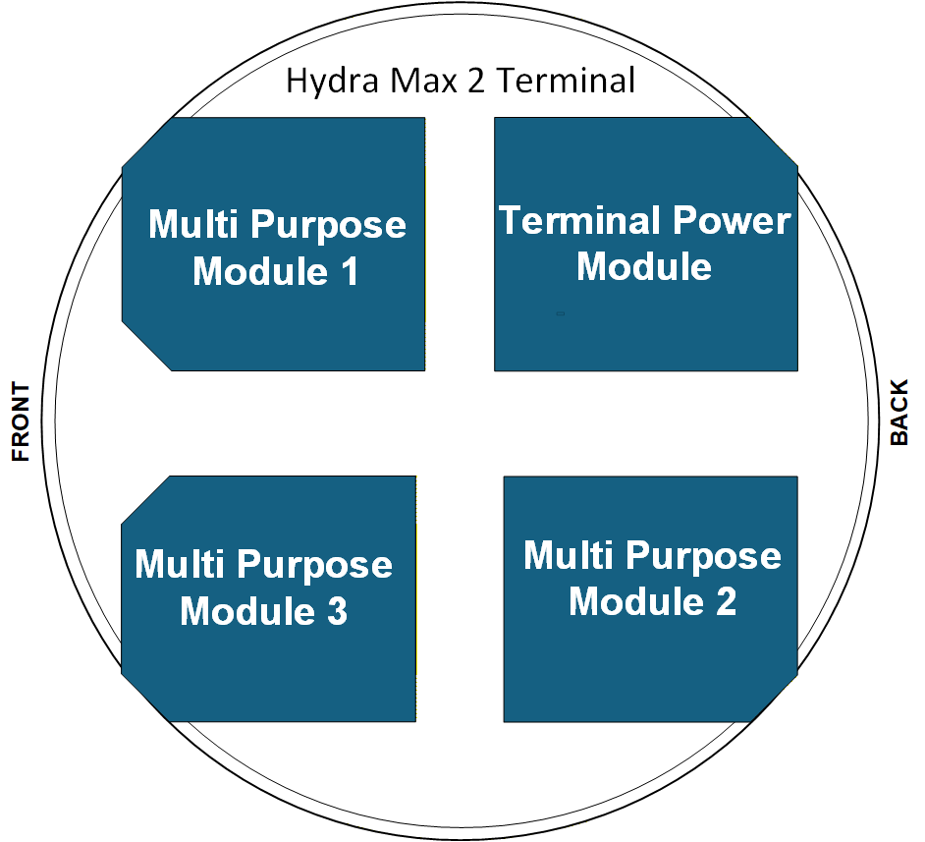
Figure 1: Example Terminal Setup – Top Down

Table of Modules

Table 4: Module Table
Module Name: | Manufacturing Part No.: | Module: |  |  |  | Section:
 |  | MPM1: | MPM2: | MPM3: | TPM:
Amazon LEO Modem (KMM) and L-Band PCBA | MPM-ALMM-20 | ü |  |  |  | 4.2.1
Dual L-band passthrough Modem | MPM-DLBAND-20 | ü |  |  |  | 4.2.2
Gilat Aquarius-e Modem | MPM-GILAT-21 | ü |  |  |  | 4.2.3
iDirect 450mp Modem | MPM-450MP-24 | ü | ü |  |  | 4.2.4
Single L-band passthrough | MPM-LBAND-20 | ü | ü |  |  | 4.2.5
Viasat LSDR Modem | MPM-LSDR-20 | ü | ü |  |  | 4.2.6
ADDC Integrated Compute Module & Iridium | MPM-HIRLS-20 |  |  | ü |  | 4.2.7
Ethernet pass through Module ​ | MPM-ETH-20 |  |  | ü |  | 4.2.8
DiFi interface, with optional x86 ICM, Iridium Modem | MPM-CAP-20 |  |  | ü |  | 4.2.9
AC/DC TPM | TPM-ACPSU-01 |  |  |  | ü | 4.3.1
DC/DC TPM | TPM-DCPSU-00 |  |  |  | ü | 4.3.2
Blank Module | MPM-BLANK-20 (MPB1/MPB2)  MPM-BLANK-21 (MPB 3) | ü | ü | ü |  | 4.4.1

-End of Document-

