Московский Авиационный Институт

(Национальный Исследовательский Университет)

Факультет информационных технологий и прикладной математики

Кафедра вычислительной математики и программирования

________________________________________________________________

**Дисциплина**

«Теоретическая механика и основы математического моделирования»

**Лабораторная работа №3**

Выполнил: студент группы М8О-206Б-20

Почечура Артемий Андреевич

Вариант: 18

Москва

2021

**Вывод формул**

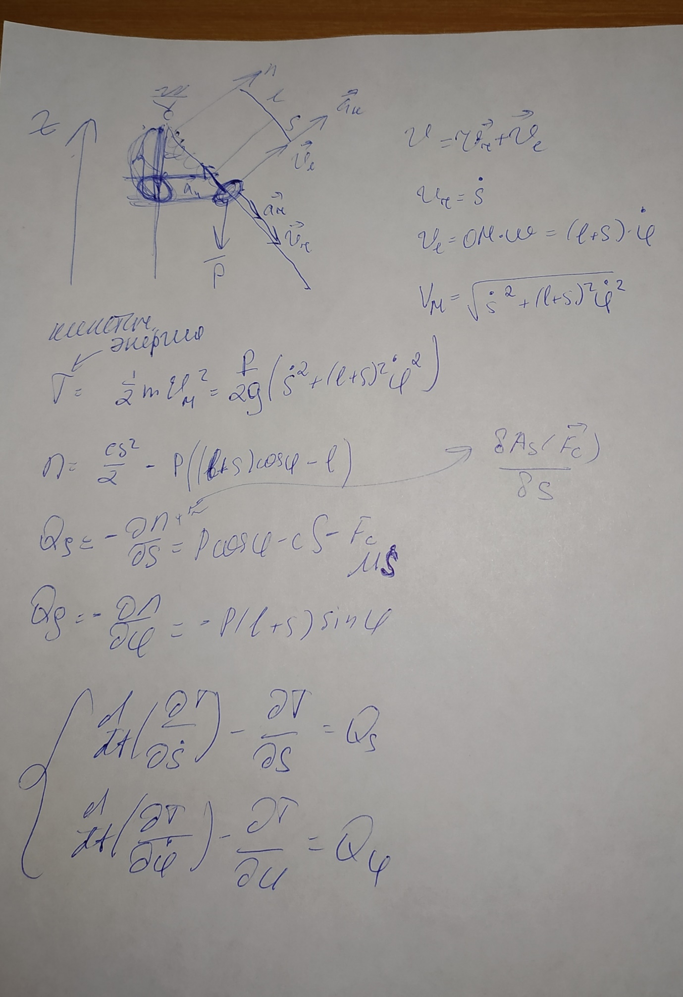

$$\frac{∂T}{∂\dot{s}}=\frac{P}{g}\dot{s}$$

$$\frac{∂}{∂t}*\frac{∂T}{∂\dot{s}}=\frac{P}{g}\ddot{s}$$

$$\frac{∂T}{∂s}=\frac{P}{g}*(l+s)\dot{φ^{2}}$$

$$\frac{∂T}{∂\dot{φ}}=\frac{P}{g}*{(l+s)}^{2}\dot{φ}$$

$$\frac{∂}{∂t}*\frac{∂T}{∂\dot{φ}}=\frac{P}{g}\left[2\left(l+s\right)\dot{s}\dot{φ}+{(l+s)}^{2}\ddot{φ}\right]$$

$$\frac{∂T}{∂φ}=0$$

$$\frac{P}{g}\ddot{s}-\frac{P}{g}*\left(l+s\right)\dot{φ^{2}}=P\cos{φ}-cs-μ\dot{s}$$

$$\ddot{s}+\frac{μg}{P}\dot{s}+\frac{cg}{P}s-{\left(l+s\right)}^{2}{\dot{φ}}^{2}-g\cos{φ}=0$$

$$\frac{P}{g}\left[2\left(l+s\right)\dot{s}\dot{φ}+{(l+s)}^{2}\ddot{φ}\right]=-P(l+s)\sin{φ}$$

$${(l+s)}^{2}\ddot{φ}+2\dot{s}\dot{φ}+g\sin{φ=0}$$

**Код программы**

import numpy as np

import sympy as sp

import math

import matplotlib.pyplot as plt

from matplotlib.animation import FuncAnimation

from scipy.integrate import odeint

#y[2] = ds

#y[3] = dphi

#y[1] = phi

#y[0] = s

def odesys(y, t, m, g, P, c, lens):

dy = np.zeros(4)

dy[0] = y[2]

dy[1] = y[3]

a11 = 1

a12 = 0

a21 = 0

a22 = lens+y[0]

b1 = g*np.cos(y[1])+(lens+y[0])*y[3]**2-c*g/P*y[0]-m*g/P*y[2]

b2 = -y[2]*y[3]-g*(lens+y[0])*np.sin(y[1])

dy[2] = (b1*a22 - b2*a12)/(a11*a22 - a12*a21)

dy[3] = (b2*a11 - b1*a21)/(a11*a22 - a12*a21)

return dy

m = 1

g = 9.81

P = 20

c = 10

lens = 4

t_fin = 20

t=np.linspace(0,t_fin,1001)

s0 = 0

phi0 = 0.5

ds0 = 0

dphi0 = 0

y0 = [s0, phi0, ds0, dphi0]

Y = odeint(odesys, y0, t, (m, g, P, c, lens))

s = Y[:, 0]

phi = Y[:, 1]

ds = Y[:, 2]

dphi = Y[:, 3]

fig_for_graphs = plt.figure(figsize=[13,7])

ax_for_graphs = fig_for_graphs.add_subplot(2,2,1)

ax_for_graphs.plot(t,s,color='blue')

ax_for_graphs.set_title("s(t)")

ax_for_graphs.set(xlim=[0,t_fin])

ax_for_graphs.grid(True)

ax_for_graphs = fig_for_graphs.add_subplot(2,2,2)

ax_for_graphs.plot(t,phi,color='red')

ax_for_graphs.set_title('phi(t)')

ax_for_graphs.set(xlim=[0,t_fin])

ax_for_graphs.grid(True)

ax_for_graphs = fig_for_graphs.add_subplot(2,2,3)

ax_for_graphs.plot(t,ds,color='green')

ax_for_graphs.set_title("s'(t)")

ax_for_graphs.set(xlim=[0,t_fin])

ax_for_graphs.grid(True)

ax_for_graphs = fig_for_graphs.add_subplot(2,2,4)

ax_for_graphs.plot(t,dphi,color='black')

ax_for_graphs.set_title('phi\'(t)')

ax_for_graphs.set(xlim=[0,t_fin])

ax_for_graphs.grid(True)

l = 9#lens+s

m = 0.2

a = phi

p1xn = l*np.sin(a)-m/2*np.cos(a)

p2xn = l*np.sin(a)+m/2*np.cos(a)

p3xn = m/2*np.cos(a)

p4xn = -m/2*np.cos(a)

p1yn = l-l*np.cos(a)-m/2*np.sin(a)

p2yn = l-l*np.cos(a)+m/2*np.sin(a)

p3yn = l+m/2*np.sin(a)

p4yn = l-m/2*np.sin(a)

h=0.2

d=1

xn=s*np.sin(a)

yn=l-s*np.cos(a)

vs = ds

vxsn=vs*np.sin(a)

vysn=-vs*np.cos(a)

w = dphi

vxn = w * np.cos(a) *s

vyn = w * np.sin(a) *s

vr = np.sqrt((vxsn+vxn)*(vxsn+vxn)+(vysn+vyn)*(vysn+vyn))

vs = np.sqrt(vxsn*vxsn+vysn*vysn)

v = np.sqrt(vxn*vxn+vyn*vyn)

an=a

def cir(xl, yl, r):

angle = np.linspace( 0 , 2 * np.pi , 150 )

px = xl + r * np.cos( angle )

py = yl + r * np.sin( angle )

return px, py

def pr(x1, y1, l, h, a):

angle = np.linspace( 0 , 10 * np.pi , 150 )

x1p = np.linspace( 0 , x1-h/2*np.sin(a) , 150 )

y1p = np.linspace( l , y1+h/2*np.cos(a) , 150 )

x = x1p+np.sin(angle)*0.5*np.cos(a)

y = y1p+np.sin(angle)*0.5*np.sin(a)

return x, y

def ring(xl, yl, l, h, a):

Mx = xl + l/2*np.cos(a)

My = yl + l/2*np.sin(a)

Nx = xl - l/2*np.cos(a)

Ny = yl - l/2*np.sin(a)

PX=[Mx - h/2*np.sin(a), Mx + h/2*np.sin(a), Nx + h/2*np.sin(a), Nx - h/2*np.sin(a),Mx - h/2*np.sin(a)]

PY=[My + h/2*np.cos(a), My - h/2*np.cos(a), Ny - h/2*np.cos(a), Ny + h/2*np.cos(a),My + h/2*np.cos(a)]

return PX, PY

def rotate(x, y, a):

x_rotated = x * np.cos(a) - y * np.sin(a)

y_rotated = x * np.sin(a) + y * np.cos(a)

return x_rotated, y_rotated

fig = plt.figure(figsize=[13,7])

ax = fig.add_subplot(1,1,1)

ax.axis('equal')

ax.set(xlim=[-l-5, l+5], ylim=[-3, m+l+2])

cx, cy = cir(0, l, m/2)

ax.plot(cx, cy, 'black')

p1s = ax.plot([p1xn[0],p2xn[0]],[p1yn[0],p2yn[0]],'black')[0]

p2s = ax.plot([p2xn[0],p3xn[0]],[p2yn[0],p3yn[0]],'black')[0]

p4s = ax.plot([p4xn[0],p1xn[0]],[p4yn[0],p1yn[0]],'black')[0]

RX, RY = ring(xn[0],yn[0],d,h,an[0])

rs = ax.plot(RX, RY, 'red')[0]

htr=0.5

tr = ax.plot([0,-htr,htr,0], [l,l+htr,l+htr,l], 'black')

cx,cy = pr(xn[0],yn[0],l,h,an[0])

cc, = ax.plot(cx,cy,'blue')

vvs=ax.plot([xn[0],xn[0]+vxsn[0]],[yn[0],yn[0]+vysn[0]],'green')[0]

vv=ax.plot([xn[0],xn[0]+vxn[0]],[yn[0],yn[0]+vyn[0]],'y')[0]

vres=ax.plot([xn[0],xn[0]+vxn[0]+vxsn[0]],[yn[0],yn[0]+vyn[0]+vysn[0]],'m')[0]

Phis = math.atan2(vysn[0], vxsn[0])

V_arrow_x = np.array([-vs[0]*0.1, 0.0, -vs[0]*0.1], dtype=float)

V_arrow_y = np.array([vs[0]*0.05, 0.0, -vs[0]*0.05], dtype=float)

V_arrow_rotx, V_arrow_roty = rotate(V_arrow_x, V_arrow_y, Phis)

V_arrow, = ax.plot(xn[0] + vxsn[0] + V_arrow_rotx, yn[0] + vysn[0] + V_arrow_roty, color="green")

Phi = math.atan2(vyn[0], vxn[0])

Vk_arrow_x = np.array([-v[0]*0.1, 0.0, -v[0]*0.1], dtype=float)

Vk_arrow_y = np.array([v[0]*0.05, 0.0, -v[0]*0.05], dtype=float)

Vk_arrow_rotx, Vk_arrow_roty = rotate(Vk_arrow_x, Vk_arrow_y, Phi)

Vk_arrow, = ax.plot(xn[0] + vxn[0] + Vk_arrow_rotx, yn[0] + vyn[0] + Vk_arrow_roty, color="y")

Phir = math.atan2(vysn[0]+vyn[0], vxsn[0]+vxn[0])

Vr_arrow_x = np.array([-vr[0]*0.1, 0.0, -vr[0]*0.1], dtype=float)

Vr_arrow_y = np.array([vr[0]*0.05, 0.0, -vr[0]*0.05], dtype=float)

Vr_arrow_rotx, Vr_arrow_roty = rotate(Vr_arrow_x, Vr_arrow_y, Phir)

Vr_arrow, = ax.plot(xn[0] + vxsn[0] + vxn[0] + Vr_arrow_rotx, yn[0] + vysn[0]+ vyn[0] + Vr_arrow_roty, color="m")

def cha(i):

p1s.set_data([p1xn[i],p2xn[i]],[p1yn[i],p2yn[i]])

p2s.set_data([p2xn[i],p3xn[i]],[p2yn[i],p3yn[i]])

p4s.set_data([p4xn[i],p1xn[i]],[p4yn[i],p1yn[i]])

RX, RY = ring(xn[i],yn[i],d,h,an[i])

rs.set_data(RX, RY)

cx, cy = pr(xn[i],yn[i],l,h,an[i])

cc.set_data(cx, cy)

vvs.set_data([xn[i],xn[i]+vxsn[i]],[yn[i],yn[i]+vysn[i]])

vv.set_data([xn[i],xn[i]+vxn[i]],[yn[i],yn[i]+vyn[i]])

vres.set_data([xn[i],xn[i]+vxn[i]+vxsn[i]],[yn[i],yn[i]+vyn[i]+vysn[i]])

Phis = math.atan2(vysn[i], vxsn[i])

V_arrow_x = np.array([-vs[i]*0.1, 0.0, -vs[i]*0.1], dtype=float)

V_arrow_y = np.array([vs[i]*0.05, 0.0, -vs[i]*0.05], dtype=float)

V_arrow_rotx, V_arrow_roty = rotate(V_arrow_x, V_arrow_y, Phis)

V_arrow.set_data(xn[i] + vxsn[i] + V_arrow_rotx, yn[i] + vysn[i] + V_arrow_roty)

Phi = math.atan2(vyn[i], vxn[i])

Vk_arrow_x = np.array([-v[i]*0.1, 0.0, -v[i]*0.1], dtype=float)

Vk_arrow_y = np.array([v[i]*0.05, 0.0, -v[i]*0.05], dtype=float)

Vk_arrow_rotx, Vk_arrow_roty = rotate(Vk_arrow_x, Vk_arrow_y, Phi)

Vk_arrow.set_data(xn[i] + vxn[i] + Vk_arrow_rotx, yn[i] + vyn[i] + Vk_arrow_roty)

Phir = math.atan2(vysn[i]+vyn[i], vxsn[i]+vxn[i])

Vr_arrow_x = np.array([-vr[i]*0.1, 0.0, -vr[i]*0.1], dtype=float)

Vr_arrow_y = np.array([vr[i]*0.05, 0.0, -vr[i]*0.05], dtype=float)

Vr_arrow_rotx, Vr_arrow_roty = rotate(Vr_arrow_x, Vr_arrow_y, Phir)

Vr_arrow.set_data(xn[i] + vxsn[i] + vxn[i] + Vr_arrow_rotx, yn[i] + vysn[i]+ vyn[i] + Vr_arrow_roty)

return [p1s], [p2s], [p4s], [rs], [cc], [vvs]

anima = FuncAnimation(fig,cha,frames=len(t),interval=10)

plt.show()

**Графики функций**

