Q2.1

Microcontroller specifications. It must be able to:

* Receive 3v3 of voltage into pins 1, 9, 24, 28.
* Connect to ground on pins 8, 23, 47.
* Not exceed an input voltage of 4V
* Not exceed an input or output current of 25mA.
* Receive an input into pin 7 (NSRT) to reset and run the loaded program.
* Receive inputs into pins 7, 34, 37 (NSRT, PA13, PA14) for programming the chip using the debugger.
* Receive a grounded input into pin 44 (BOOT0) to configure the boot mode of the chip.
* Output 3V3 to a GPIO pin
* Receive a read using an ADC a variable voltage.
* Receive data through an IC1/2 enabled pin.

Q2.2

BOM

https://github.com/Carciax/EEE3088F-Project-CKR/blob/main/KiCad/EEE3088F_CKR.xml

Components for the microcontroller are indexed 6, 7, 8, 12 and 13 which are an LED, 01x03 male connector, 10k resistor, a button, and the microcontroller (STM32).

|  |  |  |  |
| --- | --- | --- | --- |
| **Part** | **Index** | **Cost** | **Extended part** |
| LED | 6 | $0.0054 | False |
| 01x03 pin header | 7 | $0.0317 | True |
| 10k resistor | 8 | $0.0015 | False |
| Push button | 12 | $0.0425 | True |
| Microcontroller | 13 | $2.2270 | True |

Total cost estimated as $20.54.

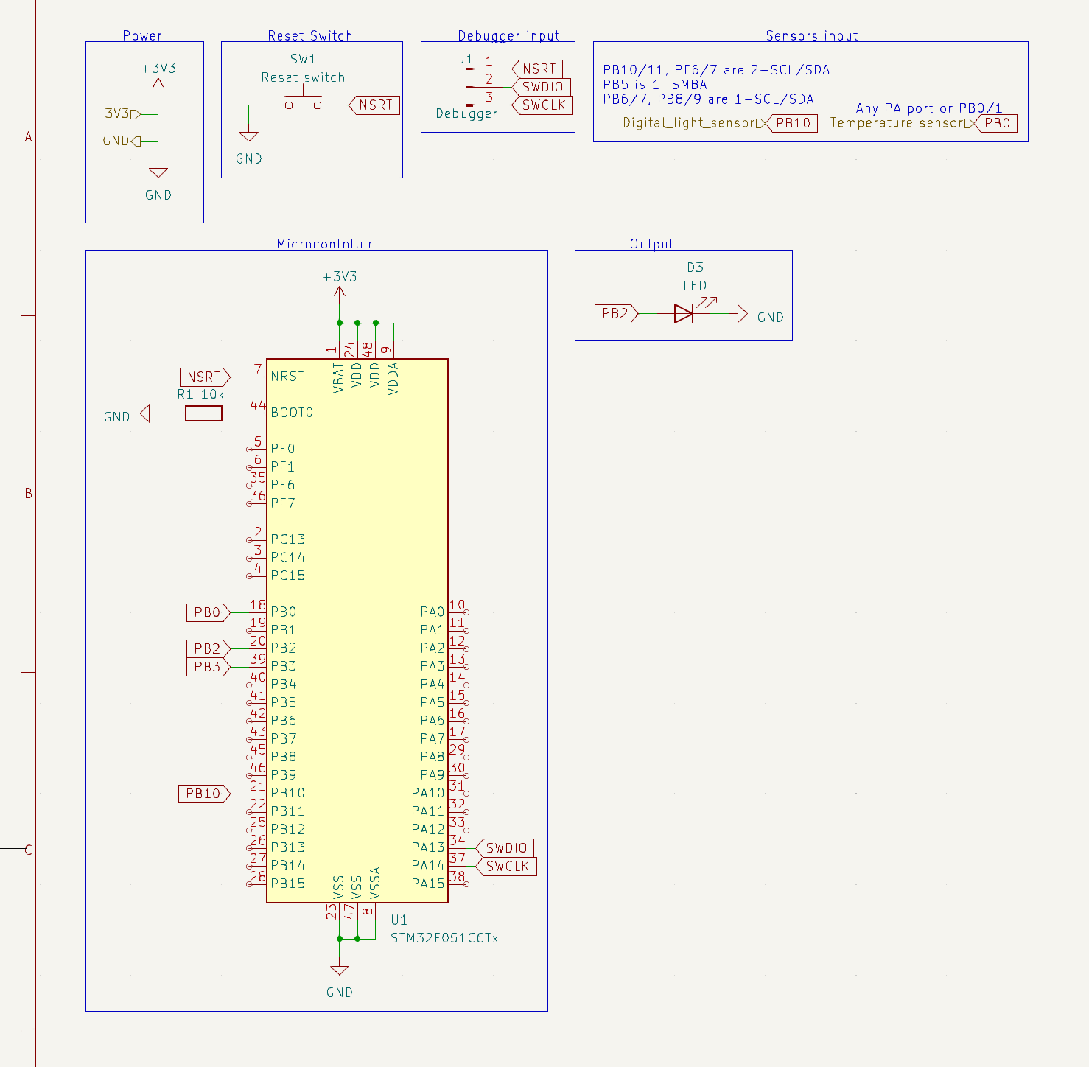

Q2.3