1. The HAT will be used as a low power temperature sensor which can be used to log temperatures and give alerts when the temperature exceeds or goes below configurable threshold temperatures.

The attachments will be a digital temperature sensor, a potentiometer and basic I/O (LEDs and pushbuttons). The HAT will also include additional breakout pins which users can connect additional output devices to (for temperature alerts), and which will allow connection to a device that logs temperatures.

The device could be used in a variety of situations, including personal weather logging, home agriculture, machinery/manufacturing temperature monitoring, student research, and office monitoring.

The potentiometer will be used for configuration of the device, such as to set threshold temperatures and change sensor frequency.

|  |  |
| --- | --- |
| **User/Use case** | **User Description** |
| Personal weather monitoring | Someone who wants to keep track of the temperature in their own home over time, or who want to be alerted when certain temperatures are reached |
| **Requirements** | **More detail** |
| Configurable "alert" temperature | Ability to change the temperature level/s at which the board will send an "alert" signal |
| Basic output for configuration | LEDs on the board that allow visual feedback for the u |
| Breakout pins for additional "alert" output | User might want to connect an aditional/different output for temperature alerts, e.g. a buzzer or a switch for an alarm |

|  |  |
| --- | --- |
| **User/Use case** | **User Description** |
| Agriculture | Monitoring of a home greenhouse or houseplants |
| **Requirements** | **More detail** |
| Ability to mount a case | Requires mounting holes so that user can add a protective case, e.g. to protect from moisture in a greenhouse |
| Temperature logging | Requires an output that users can connect to a storage device to log temperature over time |

|  |  |
| --- | --- |
| **User/Use case** | **User Description** |
| Machinery/Manufacturing | Monitoring of a workspace containing temperature sensitive machinery |
| **Requirements** | **More detail** |
| Breakout pins for additional "alert" output | Users may want to configure the board to automatically take some action upon temperature "alert", e.g., turn on additional room cooling |
| Temperature logging | Same as above |
| Highly configurable "alert" levels | Machinery may need to take actions at many different temperature levels, e.g., turn fans up or down |

|  |  |
| --- | --- |
| **User/Use case** | **User Description** |
| Research | E.g., a student doing a project tracking temperatures in a remote location |
| **Requirements** | **More detail** |
| Temperature logging | Same as above |
| Power efficient | Researchers may need to leave the device running for a long time without charging/manual intervention |
| Breakout pins for additional "alert" output | Same as above |

|  |  |
| --- | --- |
| **User/Use case** | **User Description** |
| Office monitoring | E.g., to track temperature alongside separate tracking of energy usage from fans/airconditioning |
| **Requirements** | **More detail** |
| Temperature logging | Same as above |

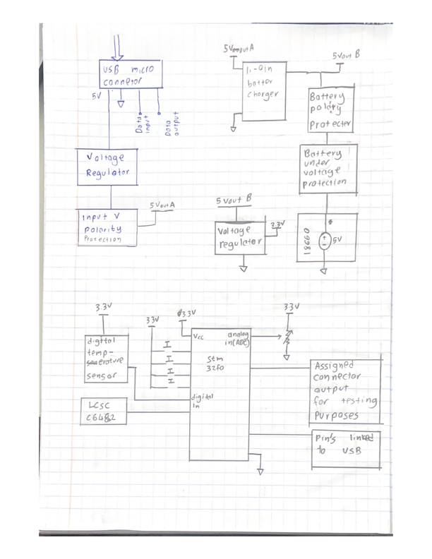

1. https://github.com/Carciax/EEE3088F-Project-CKR