Northeastern University School of Law
Student Bar Association Council
Spring Election Information

Spring 2010

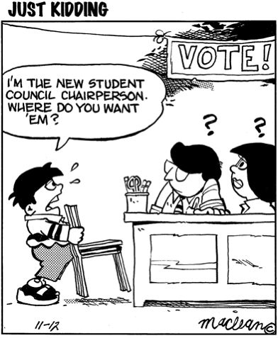
Table of Contents

- Available Positions
- Election Schedule
- Election Rules and Regulations
- Sample Platform
- Sample Campaign Poster
- SBA Attendance Policy
Available Positions

EXECUTIVE BOARD POSITIONS
Co-Chair: The SBA Co-Chair is essentially the chief executive officer of the SBA. This officer, in cooperation with his or her counterpart on the other rotation, leads the SBA membership, officially represents the SBA in public matters, and runs SBA meetings and sets agendas.
Vice-Chair of Finance: The SBA Vice-Chair of Finance is in charge of the student orgs and SBA budget. This position requires heavy responsibility that includes timely review of all budget requests, earmarks, and refunds.
Vice-Chair of Recreation: The SBA Vice-Chair of Recreation is in charge of planning recreational activities such as field day, the golf tournament and student intramural sports teams.
Vice-Chair of Social Activities: The SBA Vice-Chair of Social Activities is responsible for planning bi-weekly bar reviews and the Barristers’ Ball.
Vice-Chair of Student Organizations: The SBA Vice-Chair of Student Organizations is a liaison between the SBA and all other student organizations.
Vice-Chair of Communications: The SBA Vice-Chair of Communications conducts SBA elections, takes meeting minutes, maintains SBA records and updates the SBA’s space on MyLaw.

COMMITTEE POSITIONS
Academic and Student Affairs Committee (1 Representative + 1 Alternate): This committee deals with issues relating to the Academic Success Program and academic and student support generally. For example, the Committee might diagnose then correct a problem affecting the academic achievement of students, such as the unavailability of TA’s or tutors.
Admissions Committee (1 Representative + 1 Alternate): This committee addresses all aspects of the admissions process such as review of pending applications or development of admissions procedures and orientation programs. Student representatives will have a chance to participate in the acceptance of prospective students.
Co-op Committee (1 Representative + 1 Alternate): This committee assists the Co-op Office in areas such as developing new co-op opportunities or implementing application procedures. Recent work has involved transitioning the co-op application process to an electronic-based system.
Curriculum Committee (1 Representative + 1 Alternate): This committee addresses the current course offering and potential course offerings for all students, including the 1L schedule and the LSSC program.
Planning Committee (1 Representative + 1 Alternate): This committee identifies school-wide problems and places such matters before the Governing Council.
Graduate and Professional Student Association (1 Senator): This committee represents the School of Law before the student governing body of all of Northeastern University’s graduate students.
Governing Council (3 Representatives + 1 Alternate): The Governing Council is the general governing body of the School of Law and consists of the Dean, members of the Administration, faculty, staff, and student representatives.
At-Large Council Members (1 Representative): The At-Large representatives are assigned to various committees or positions where the workload requires additional assistance at the discretion of the representatives and the Executive Board.
Committee Against Institutional Racism (CAIR) (1 Representative + 1 Alternate): CAIR takes steps to identify, address, and remedy racism and discrimination within the law school community.
Commencement Committee (5 seats, 3L’s ONLY): The Commencement Committee is a standing ad hoc committee that plans and implements commencement related activities.
Public Interest Committee (1 Representative)
"The Public Interest Committee (PIC) was established by Dean Spieler in 2009 as a joint faculty and student committee designed to raise the profile of existing public interest resources at Northeastern and brainstorm public-interest related ideas for the law school, while ensuring that public interest-focused initiatives contribute to the greater good of all Northeastern students and not just the NUSL public interest community in a “silo.” As such, the elected student representative for each class on the PIC will attend all PIC committee meetings, report to SBA on the committee’s activities, promote existing public interest resources, and facilitate collaborations between different student group stakeholders around public interest ideas."

Election Schedule

Monday, April 12 @ 9:00AM
Campaigning for office may begin.
Sunday, April 18 @ 11:59PM
Self-nomination papers and platforms are due to Brandon McDaniel, the Vice-Chair for Communications. For further details, please see the SBAC Election Regulations below.
Monday, April 18 @ ASAP
Voting begins on the Weboard.
Friday, April 23 @ 5PM
Voting ends, all posted campaign materials must be removed.

Note: results will be posted to the Weboard the evening of Monday, April 26 and candidates will also be notified individually. Elected representatives are expected to be present at the SBA meeting on Tuesday, April 27 at noon in the Moot Court Room.

Voting
All law students are entitled to vote in this election. However, only members of the graduation class corresponding to the graduation class of the candidate can vote for their class specific positions.
SBAC Election Regulations

Petitions (Intent to Run Forms)
Petitions will be made available on the SBAC website on the WeBoard. Downloaded and completed petitions and platforms must be sent to Brandon McDaniel at mcdaniel.b@husky.neu.edu by 11:59 PM, Sunday, April 18. Emails should have the subject heading as: SBAC Candidate Petition. Completed petition files should be saved as “LastnameFirstname” (i.e. DoeJane.doc). Emails without proper subject heading and file names or late submissions will not be accepted. You may run for up to three (3) positions and accept (2) total positions.

Platforms/Candidacy
Candidates may attach and send a platform with the petition if they so desire to Brandon McDaniel. Platforms must be no more than 250 words. Platforms will be made available to the student body before and during the election on MyLaw.

Permitted Campaign Solicitations
Candidates are allowed to solicit votes in person, by phone, through hosted events, tabling in the commons and by posting flyers no larger than 11" by 14" in the locker rooms located in Cargill. Candidates may begin soliciting immediately. Flyers may not cover other materials that are already posted. Materials can only discuss a candidate’s platform; negative campaigning is prohibited. All candidates must remove all posted flyers no later than 24 hours after the close of elections.

Limitation on Email Solicitations
Emailing students that candidates personally know to ask or remind them to vote is permitted. However, mass emails (including but not limited to the use of email lists associated with LSSC, student organizations, or other listserves.) will not be permitted.

Solicitations by Others
Any solicitation that favors a candidate but is made by a person other than the candidate will be considered to have been made by the candidate it favors. Therefore, be cautious of using friends to help you campaign and make sure they understand the rules.

Questions about Campaign Rules
If you have a question about campaign rules please consult the full Election Bylaws on MyLaw. Any questions that remain should be addressed to the Vice-Chair of Communications, Brandon McDaniel, at mcdaniel.b@husky.neu.edu.

Election
Elections will be held electronically on the WeBoard beginning at as soon as possible Monday, April 19 and will end at 5:00PM Friday, April 23.

Student Code of Conduct
In addition to election regulations, all candidates must adhere to the Northeastern University School of Law Student Code of Conduct.

Violations
Any candidate allegedly found in violation of the above regulations will be investigated by the SBAC Vice-Chair of Communication with a final adjudication to be made by the SBA E-Board. Violation of any rule may be grounds for disqualification, public notice of the violation, or a revocation of that candidate’s privilege to campaign.
EXAMPLE PLATFORM

Joe Smith

My name is Joe and I am a 1L in Law Office #4. I am running for a seat on the Curriculum Committee and respectfully request your vote. My experience in student government as an undergrad as a student senator and executive committee member in charge of communications has taught me the importance of the students’ voice in discussions with the faculty and administration. The dialogue between the faculty/staff, administration, and student body is an invaluable aspect of the governance of any institituion of higher learning. However, without strong student advocates, the voice of the students will be lost in the shuffle. My student government experience, dedication to the student body, and commitment to higher education makes me an excellent candidate to be a 1L representative on the Curriculum Committee. That’s a true story.

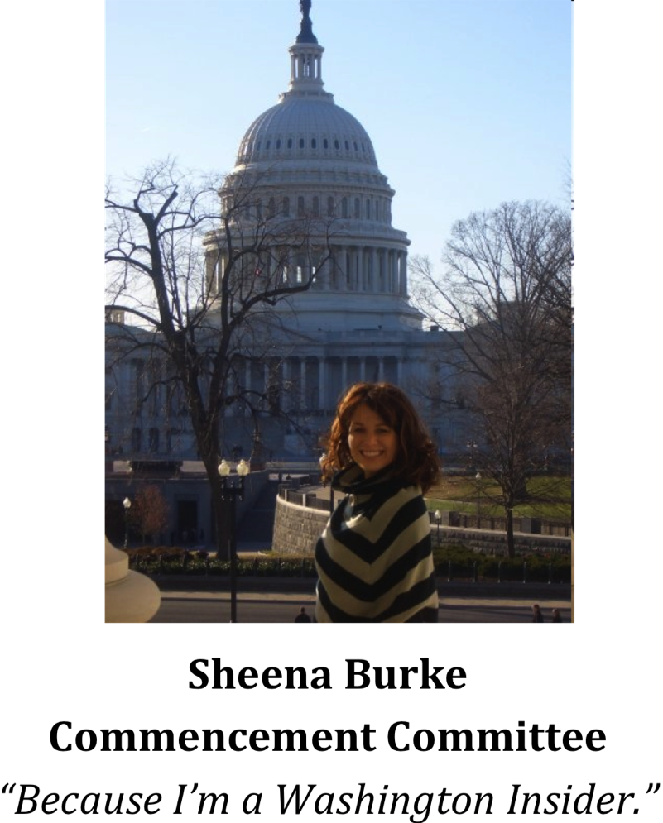

Attendance Policy

The SBAC meets biweekly, allowing for few meetings each quarter. Given the relative infrequency with which the body meets, regular attendance is absolutely imperative to the efficient functioning of the SBAC as a deliberative governing body. In addition, regular attendance on the part of each member is necessary to fulfill the mandate imposed upon each member by her election by the student body. Therefore, an attendance policy shall be imposed which requires a minimum level of attendance for the maintenance of a member’s seat in the SBAC.

- Each member shall attend every scheduled meeting of the SBAC. Where a conflict arises which prevents the member from attending, written or electronic notice of the absence should be provided to the Chairperson at least 24 hours in advance of the meeting.
- Any member who is absent without notification under section 1 from two meetings within a single academic quarter shall be placed on probationary status for the quarter. Written notice of her probationary status and the consequences of further absence shall be given to the member no later than seven days after the second absence by a member of the Executive Board.
- Any member on probationary status who is absent from a third meeting within a single academic quarter shall be eligible for the institution of removal procedures by the Chairperson. Any resulting removal procedures shall follow the process provided in Article 5, Section 3 of the Constitution.

Note: The SBA operates in accordance with the Constitution of the Student Bar Association of the Northeastern University School of Law, as approved on October 21, 2008. For more information, please see:

https://weboard.slaw.neu.edu/nusl/tiki-index.php?page=SBA+Constitution

