
SmartCard-HSM Crypto Middleware
Installation and Troubleshooting Guide
Author | Andreas Schwier
Version | X0.2
Date | 2020-09-11

Table of Contents
1 Introduction 4
2 Middleware 4
2.1 PKCS#11 4
2.2 CSP-Minidriver 4
2.3 OpenCard Framework 4
2.4 JAVA JCE-Provider 4
3 Installation 4
3.1 Windows 7 to Windows 10 4
3.2 Firefox 5
3.3 Chrome / Chromium 7
3.4 Network Security Services (NSS) 7
4 Troubleshooting 9

Introduction
A cryptographic middleware is a software that enables an application to interface with a SmartCard-HSM using a standardized Application Programming Interface (API).
The most commonly used API in this context is PKCS#11, whose development started in 1994 as part of the PKCS Standards developed by RSA Security. In 2013 responsibility for the standard was passed to the Organization for the Advancement of Structured Information Standards (OASIS). The most commonly used version of the API is 2.20, which was released 2004. PKCS#11 can be considered a mature standard. It provides for a C API and is supported by large variety of programs and multiple operating systems. The PKCS#11 API comes as a DLL on Windows or as shared object on Unix like operating systems.
For the SmartCard-HSM two implementations of a PKCS#11 middleware exists, OpenSC and the module from the sc-hsm-embedded project (subsequently referred to as sc-hsm-pkcs11). Both are open-source implementations, with the source code available at Github (https://github.com/CardContact/sc-hsm-embedded and https://github.com/OpenSC/OpenSC). The PKCS#11 implementation from sc-hsm-embedded is more targeted at the SmartCard-HSM (and a small number of Starcos based German signature cards), while OpenSC supports a broader range of smart cards.
Microsoft defined in Windows NT 4.0 a different API to interface with cryptographic devices, the Cryptographic Service Provider (CSP). A CSP allows an application to perform cryptographic operations using the Microsoft CryptoAPI (MS-CAPI). That API was later replaced by the Cryptography API: Next Generation (CNG) in Windows Vista. Because developing a CSP turned out to be too complicated, Microsoft defined the CSP Minidriver API, to allow smart card manufacturer to develop a simpler integration. A CSP Minidriver is used by the Base Smart Card Crytographic Service Provider (BASE-CSP), which is provided as part of the operating system. With CNG Microsoft introduced Key Storage Provider as third alternative to interface with a cryptographic device. For the SmartCard-HSM a CSP-Minidriver is available as part of OpenSC and the sc-hsm-embedded project.
For macOS Apple defined a further cryptographic API, TokenD based on the Common Data Security Architecture (CDSA). TokenD is deprecated since Mac OS X Lion (10.7 in 2011) and is disabled by default in macOS Catalina (10.15). The new API proposed by Apple Is CryptoTokenKit. OpenSC contains a TokenD driver for the SmartCard-HSM and a bridge exists that enables CryptoTokenKit with OpenSC.

Installation

Windows 7 to Windows 10
The middleware for Windows 7 to Windows 10 is provided as Microsoft Installer file (.msi). A version for the 32-bit and the 64-bit version of the operating system exists. The installation can be started by double-click on the downloaded MSI file. The installer is fairly simple and just installs a set of file and creates some registry entries. The installation path is automatically determined and the installer can run unattended.
The 64-bit installer (sc-hsm-middleware-x64-x.yy.msi) copies the following files
C:\Windows\System32\sc-hsm-pkcs11.dll | The 64-bit PKCS#11 DLL
C:\Windows\System32\sc-hsm-minidriver.dll | The 64-bit CSP-Minidriver DLL
C:\Program Files\CardContact\SmartCard-HSM Middleware\sc-hsm-pkcs11-test.exe | The 64-bit PKCS#11 test program
C:\Program Files\CardContact\SmartCard-HSM Middleware\sc-hsm-minidriver-test.exe | The 64-bit CSP-Minidriver test program
C:\Windows\SysWOW64\sc-hsm-pkcs11.dll | The 32-bit PKCS#11 DLL
C:\Windows\SysWOW64\sc-hsm-minidriver.dll | The 32-bit CSP-Minidriver DLL
C:\Program Files (x86)\CardContact\SmartCard-HSM Middleware\sc-hsm-pkcs11-test.exe | The 32-bit PKCS#11 test program
C:\Program Files (x86)\CardContact\SmartCard-HSM Middleware\sc-hsm-minidriver-test.exe | The 32-bit CSP-Minidriver test program

The 32-bit installer for Windows (sc-hsm-middleware-x86-x.yy.msi) installs only the 32-bit versions in the Program Files and System32 folder on the system. Please remember, that a lot of programs on Windows are available as 32-bit and as 64-bit version. Depending on which version you use, either the 32 or 64-bit middleware is selected.
For each API (PKCS#11 and CSP Minidriver) a test program is provided for diagnostic purposes.
The installer creates entries in the registry that map the ATR of a card to the DLL implementing the CSP Minidriver:

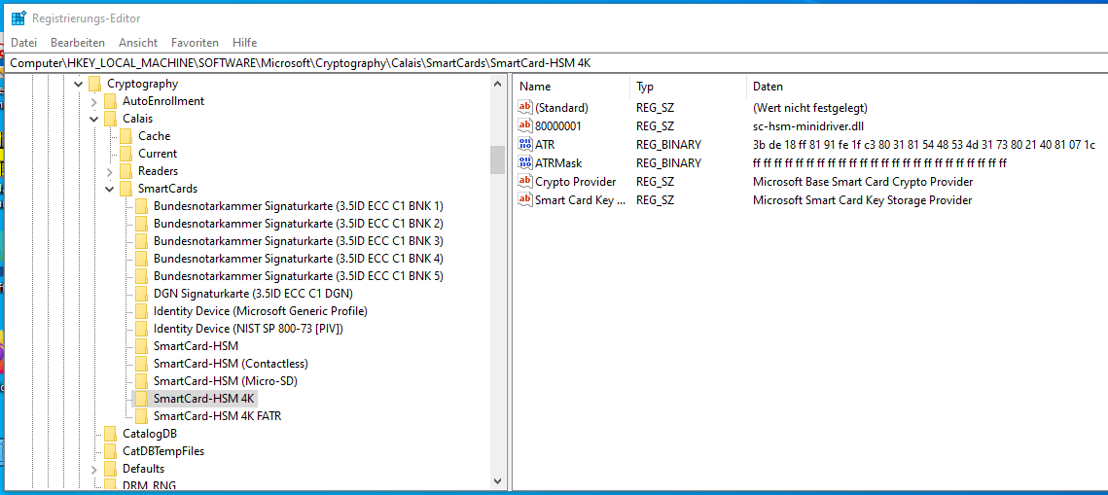
The same set of keys is duplicated under Computer\HKEY_LOCAL_MACHINE\SOFTWARE\WOW6432Node\Microsoft\Cryptography\Calais\SmartCards for the 32-bit version of the middleware.
The CSP Minidriver middleware is automatically available to programs using that API. The PKCS#11 module must be manually configured in the application.

Firefox
Firefox supports the use of a PKCS#11 module to store cryptographic keys for TLS client authentication. PKCS#11 integration is available on all OS platforms (Windows, macOS and Linux).
The PKCS#11 module is configured as security device under Preferences. Choose "Privacy & Security" and the press the "Security Devices…" button at the very end of the page. This will show the Device Manager, where all Security Modules and Devices are listed.
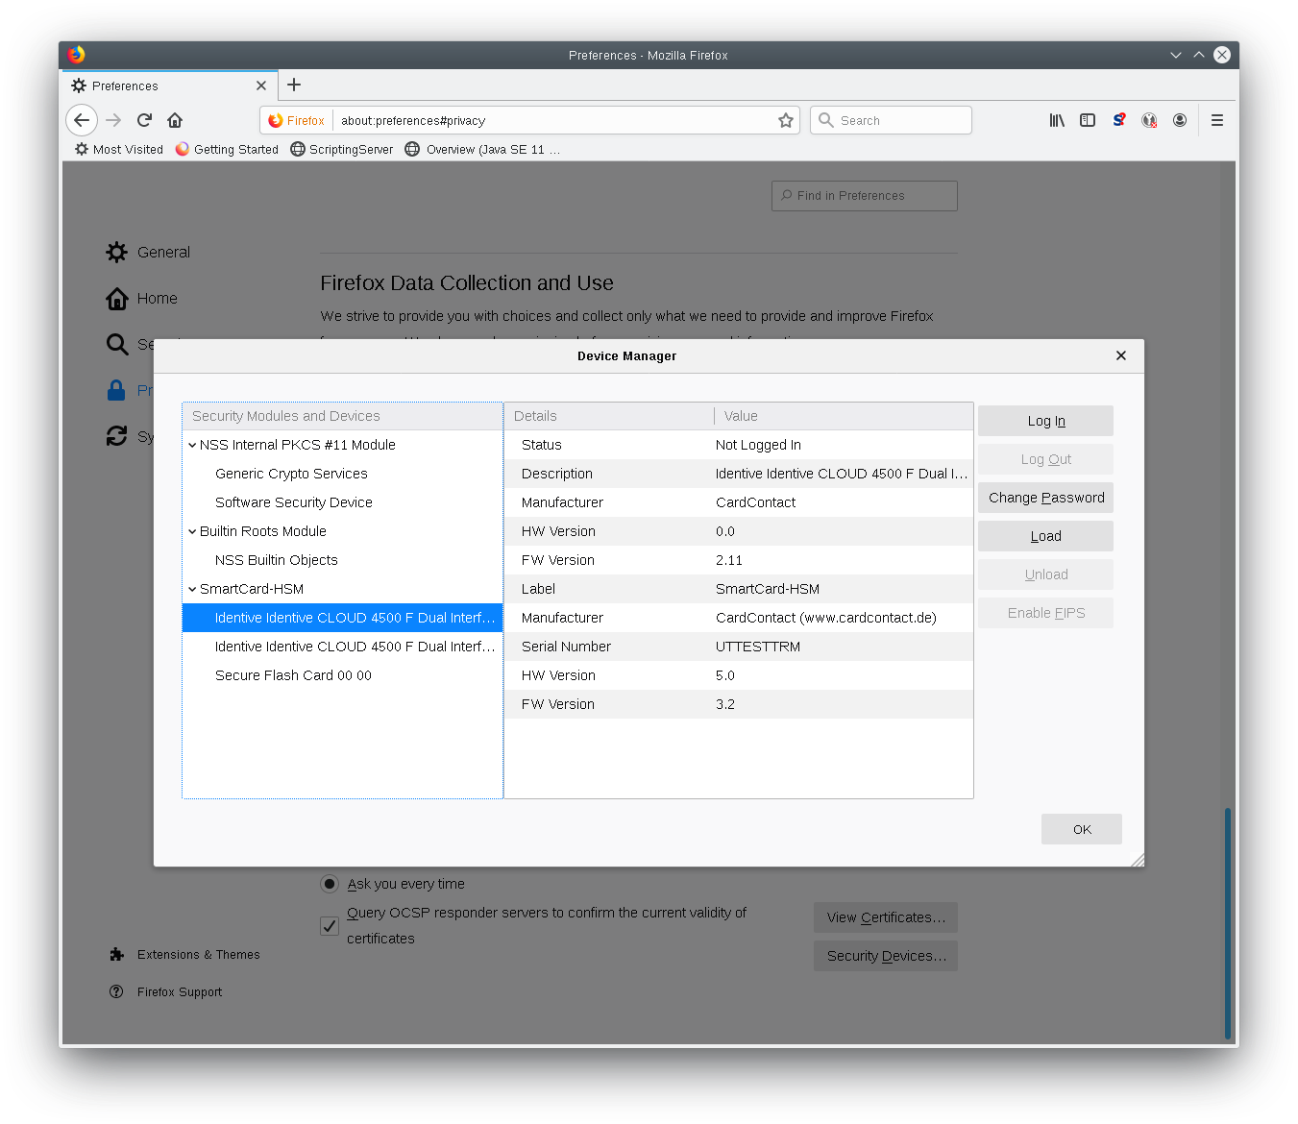
Add a new module with "Load" and enter "SmartCard-HSM" as module name and the complete path to the PKCS#11 (Usually C:\Windows\System32\sc-hsm-pkcs11.dll, /Library/sc-hsm-pkcs11/sc-hsm-pkcs11.dylib or /usr/local/lib/libsc-hsm-pkcs11.so).

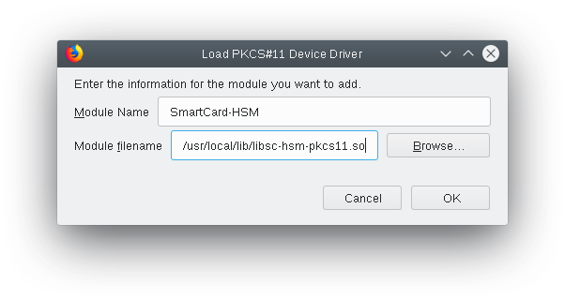
Firefox will read the user and CA certificate from the SmartCard-HSM. Firefox will try to build a certificate chain to one of the preset or imported trusted certificate. It must be ensured, that the imported trusted certificate has the proper trust settings enabled in the certificate dialog. This must also be ensured for intermediate certificates read from the card.

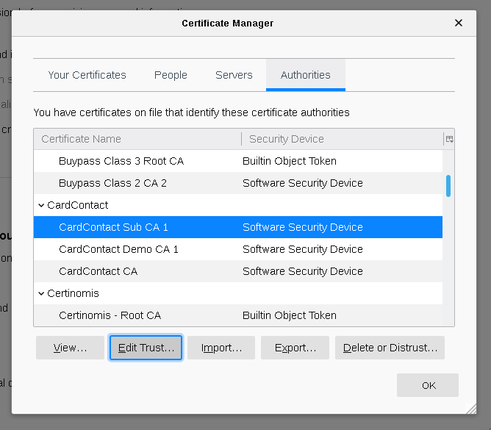
The module can also be configured on the command line using NSS tools. See chapter 2.4 for details.

Chrome / Chromium
The Chrome browser (or Chromium for the open-source variant) supports platform specific token integration. On Windows Chrome integrates with CNG, on macOS with the key chain and with NSS on Linux.
For using Chrome on Windows the middleware for Windows must be installed as described in chapter 2.1.
Using Chrome on macOS is currently not supported, as no CryptoTokenKit integration exists.
On Linux Chrome is using Mozilla NSS to access the SmartCard-HSM via PKCS#11. To enable support, the PKCS#11 module must be registered in the NSS database.

Network Security Services (NSS)
Firefox and Chrome on Linux use NSS to access PKCS#11 devices.
Chrome uses the NSS database from .pki/nssdb in the user's home directory, while Firefox locates database files in the profile directory (usually under .mozilla/firefox a directory with 8 random characters and a .default extension).
The NSS directory typically contains files cert9.db, key4.db and pkcs11.txt. The database can be configured using the Network Security Services Tools (libnss3-tools). On Debian you need to install

$ sudo apt install libnss3-tools

The database can be listed using the modutil tool. Please note, that the tilde ( ~ ) does not work with modutil – you need to provide the full or relative path with -dbdir.

$ modutil -dbdir sql:.pki/nssdb/ -list

Listing of PKCS #11 Modules
-----------------------------------------------------------
1. NSS Internal PKCS #11 Module
uri: pkcs11:library-manufacturer=Mozilla%20Foundation;library-description=NSS%20Internal%20Crypto%20Services;library-version=3.42
slots: 2 slots attached
status: loaded

slot: NSS Internal Cryptographic Services
token: NSS Generic Crypto Services
uri: pkcs11:token=NSS%20Generic%20Crypto%20Services;manufacturer=Mozilla%20Foundation;serial=0000000000000000;model=NSS%203

slot: NSS User Private Key and Certificate Services
token: NSS Certificate DB
uri: pkcs11:token=NSS%20Certificate%20DB;manufacturer=Mozilla%20Foundation;serial=0000000000000000;model=NSS%203
-----------------------------------------------------------

If the database does not exist, it can be created with

$ modutil -dbdir sql:.pki/nssdb/ -create

The PKCS#11 module can be added to the database using the -add command. The command takes the module name, which can be any string. The "-libfile" argument specifies the shared object with the PKCS#11 interface. The "-mechanisms FRIENDLY" argument is required to indicate that certificates can be read via PKCS#11 without user login.

$ modutil -dbdir sql:.pki/nssdb/ -add "SmartCard-HSM PKCS#11" -libfile /usr/local/lib/libsc-hsm-pkcs11.so -mechanisms FRIENDLY

The module should then show up in the list:

...
2. SmartCard-HSM PKCS#11
library name: /usr/local/lib/libsc-hsm-pkcs11.so
uri: pkcs11:library-manufacturer=CardContact%20(www.cardcontact.de);library-description=SmartCard-HSM%20via%20PC%2FSC;library-version=2.11
slots: 2 slots attached
status: loaded

slot: Identiv uTrust 3512 SAM slot Token [CCID Interface] (55511639600
token: SmartCard-HSM
uri: pkcs11:token=SmartCard-HSM;manufacturer=CardContact%20(www.cardcontact.de);serial=UTTESTTRM;model=SmartCard-HSM
...

It should also now be included in the .pki/nssdb/pkcs11.txt file:

$ cat .pki/nssdb/pkcs11.txt
library=
name=NSS Internal PKCS #11 Module
parameters=configdir='sql:/home/asc/.pki/nssdb' certPrefix='' keyPrefix='' secmod='secmod.db' flags=optimizeSpace updatedir='' updateCertPrefix='' updateKeyPrefix='' updateid='' updateTokenDescription=''
NSS=Flags=internal,critical trustOrder=75 cipherOrder=100 slotParams=(1={slotFlags=[RSA,DSA,DH,RC2,RC4,DES,RANDOM,SHA1,MD5,MD2,SSL,TLS,AES,Camellia,SEED,SHA256,SHA512] askpw=any timeout=30})

library=/usr/local/lib/libsc-hsm-pkcs11.so
name=SmartCard-HSM PKCS#11
NSS=slotParams={0x00000005=[slotFlags=PublicCerts ] 0x00000001=[slotFlags=PublicCerts ] }

Other tools from libnss3-tools can be used to enumerate keys and certificates:

$ certutil -d sql:.pki/nssdb -h "SmartCard-HSM PKCS#11" -K
certutil: Checking token "NSS Certificate DB" in slot "NSS User Private Key and Certificate Services"
certutil: no keys found
certutil: Checking token "NSS Generic Crypto Services" in slot "NSS Internal Cryptographic Services"
certutil: no keys found
certutil: Checking token "SmartCard-HSM" in slot "Identiv uTrust 3512 SAM slot Token [CCID Interface] (55511639600"
Enter Password or Pin for "SmartCard-HSM":
< 0> rsa 600d7ee3cf8a1161287a22e9e412eae8223ea3ae Joe Doe (RSA2048)
< 1> rsa 2362bb973b5c78d4e90d794a36877cc31661c9bd (orphan)

$ certutil -d sql:.pki/nssdb -h "SmartCard-HSM PKCS#11" -L

Certificate Nickname Trust Attributes
SSL,S/MIME,JAR/XPI

CardContact Demo CA 1 - CardContact CT,C,C
CardContact CA - CardContact CT,C,C
SmartCard-HSM:DEMOCA CT,C,C
SmartCard-HSM:Joe Doe (RSA2048) u,u,u

See man modutil for more details on using NSS.

Troubleshooting
Two programs are provided to aid solving problems with the installation, sc-hsm-pkcs11-test and sc-hsm-minidriver-test. Both can be started on the command line.
The PKCS#11 test program tries to load the PKCS#11 DLL and performs some basis operations that do not require a PIN.

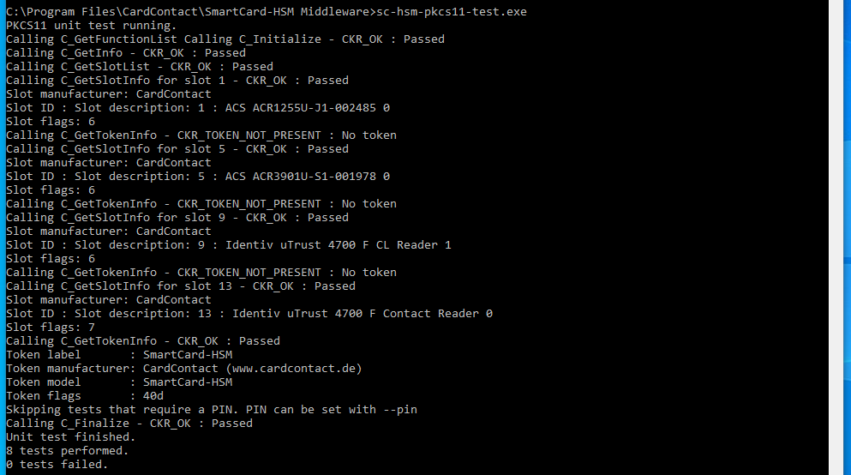
To test cryptographic operations you can pass a PIN value with –pin, following by the PIN value.
The CSP Minidriver allows listing the available card reader with the -l option
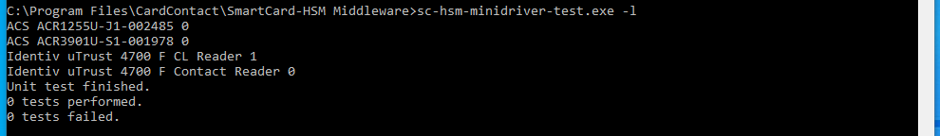
A cryptographic test can be run with -c
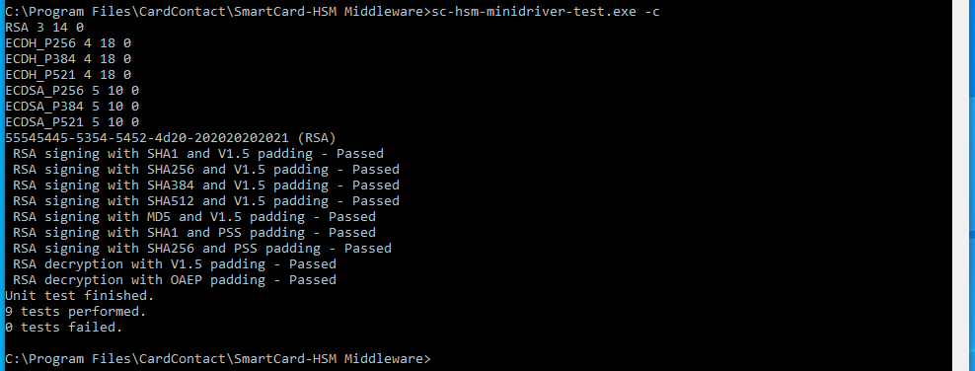
During the test the user will be prompted for the PIN.

Using certutil
The correct installation of the CSP-Minidriver can be verified using the command
certutil -scinfo
Running certutil -scinfo will report that certificate chains are incomplete, even if CA certificates have been imported. This message can be ignored, if the certificate viewer shows the full chain.

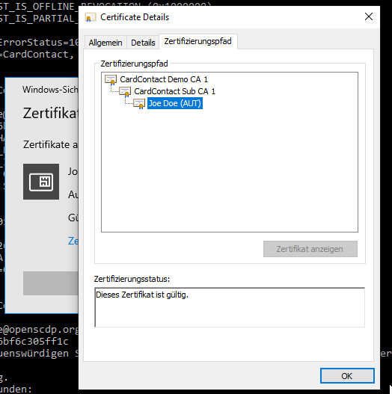

Using Minidriver Manager Tool
Mini-Driver Manager is a GUI tool for Windows to diagnose CSP-Minidriver problems. It is developed by Gemalto, but works for other cards as well. The installer can be downloaded from
https://supportportal.gemalto.com/csm/?id=kb_article_view&sysparm_rank=1&sysparm_tsqueryId=7f350cd0db672b80d298728dae9619ab&sysparm_article=KB0017162

