|  |  |
| --- | --- |
| Student name | Mosete Cardicia Masemola |
| Student number | ST10179192 |
| Module code | HCI6222 |
| Assessment type | POE (PART2 ) |

**ThriveBizHub prototype**

1.2.1.Usability goals

* Multi device compatibility: The website will be mobile-friendly as many users will be accessing it from their phones, this will help with clear navigation.
* Valid registration :The login and registration process will be user friendly, ensuring easy access for eligible users.
* Validation checks : Every user when registering they will be required to put in their ID number,the system will check if its vaid and goes hand-in-hand with the name that has been used.If they do not match or the user is underage,the system will restrict the user from using the platform.
* Seamless browsing experience : the website will be optimized for various devices to ensure seamless browsing and ordering experience.

(Sons, 2023)

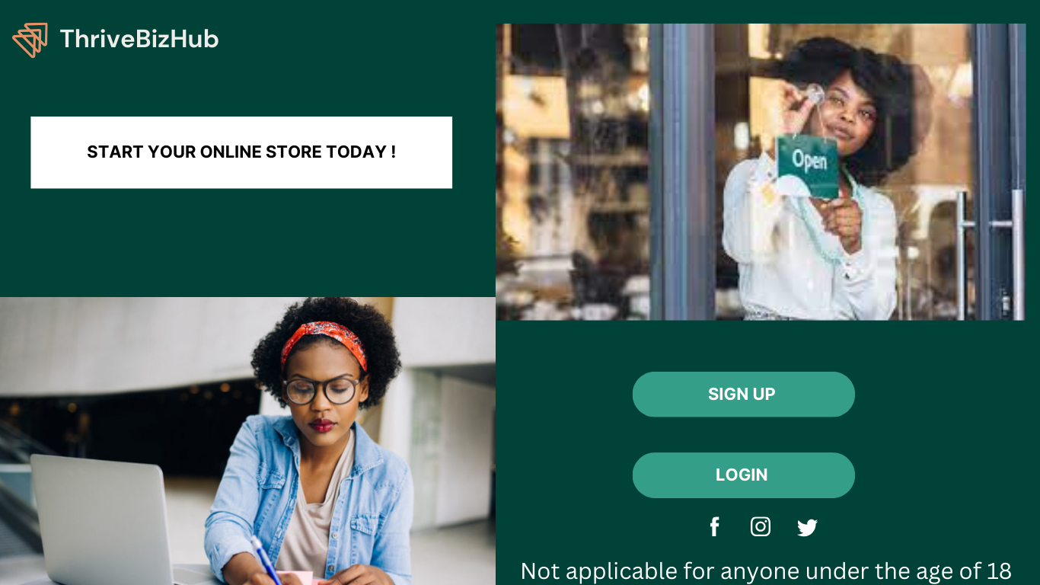

That is the first page the user will see on the website

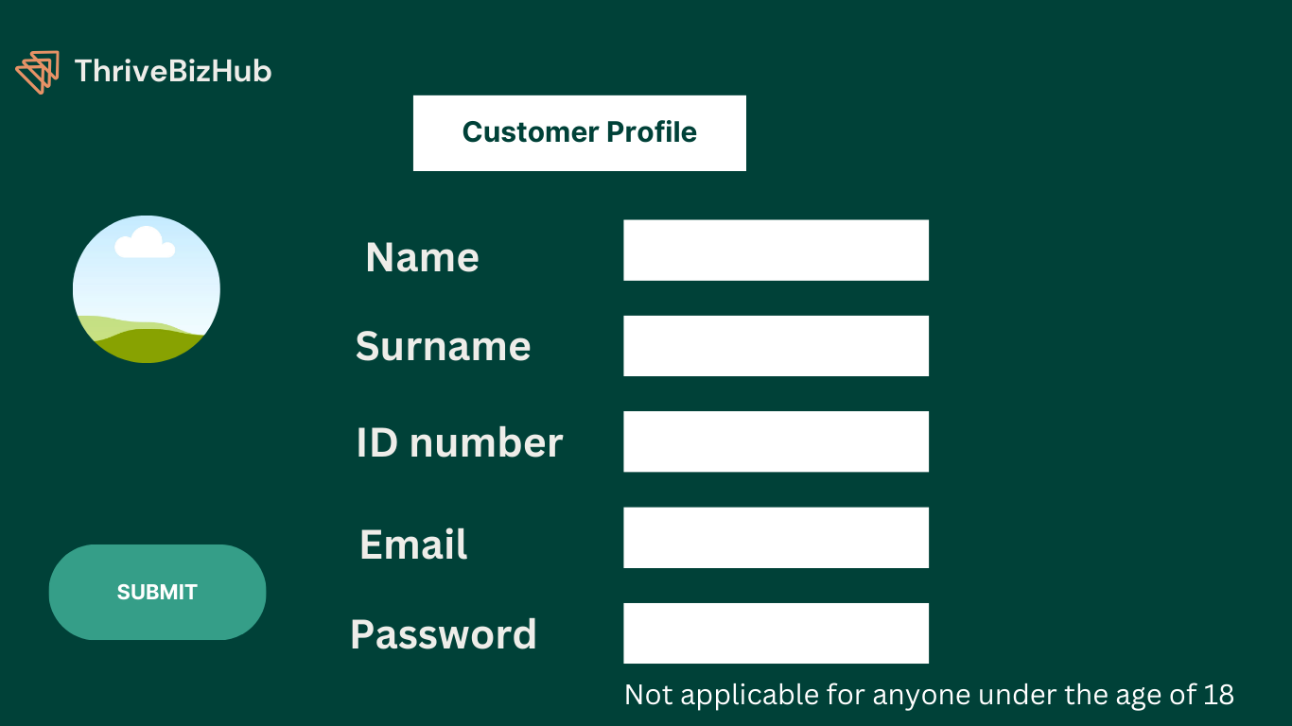

The user will be prompted for information.

1.2.2. Desirable aspects of user experience

* Custom : Users will experience a personalized journey.For example,product reccomendations based on browsing history,this will improve customer satisfaction with the website.
* Transparency & trust : Detailed and accurate information about each product, including size, condition,brand, and any imperfections will be provided to help users make informed purchasing decisions.
* Seamless checkout process: A step-by-step, stress-free checkout process to minimize a complex cart.Users are able to review and edit their order,choose payment and confirm it.

(Lu, 2023)

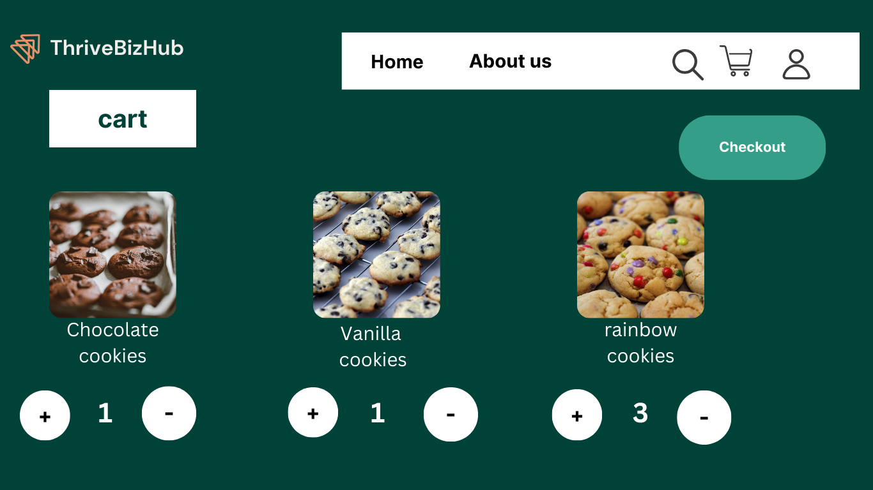

This is the cart of the customer

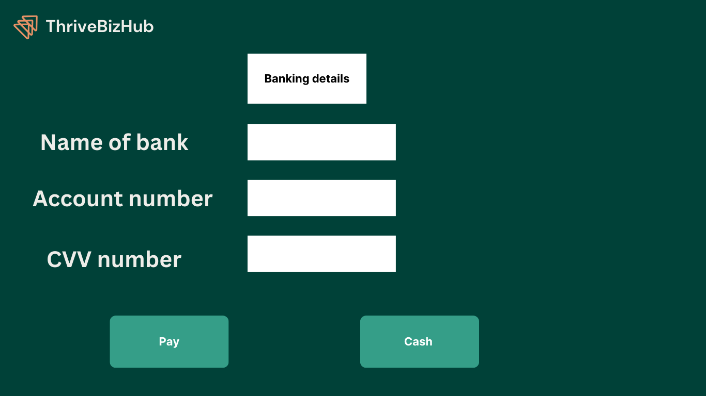

Payment page

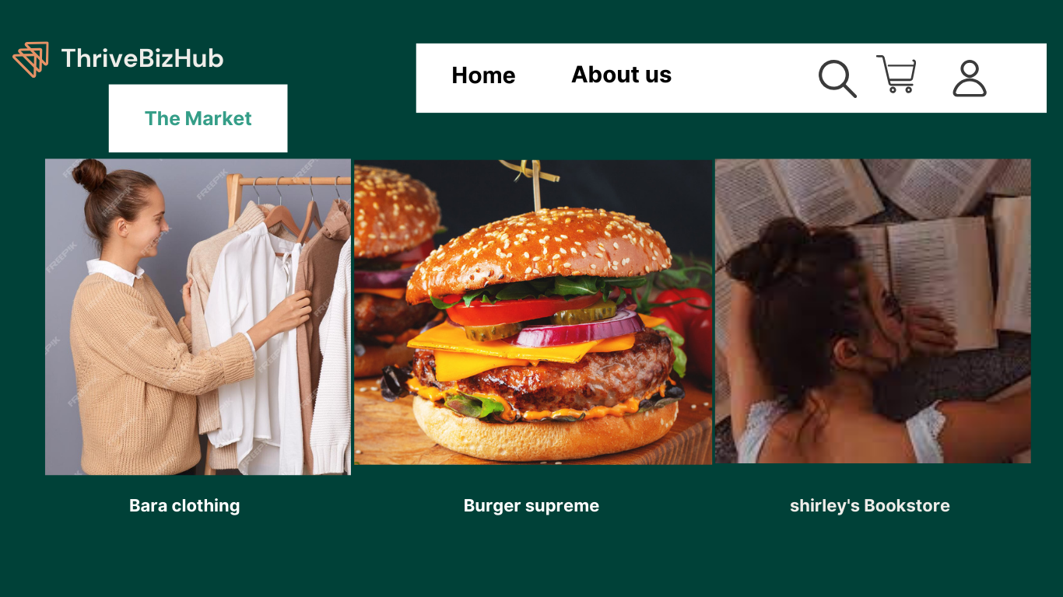

Custom page for users,according to their interest.

1.2.3 Design Principles

* Unified layout: The interface will have a simple and clean design to enhance user experience and having a minimalist layout.
* Consistency : The colour green and white has been consistently maintained throughout bthe entire webite,as well as the fonts used.This creates a sense of brand identity.
* Headings and subheadings : Clear and well-defined headings and subheadings are used to structure content,there also different typography used to make it easy for users to scan through information.

(Sons, 2023)

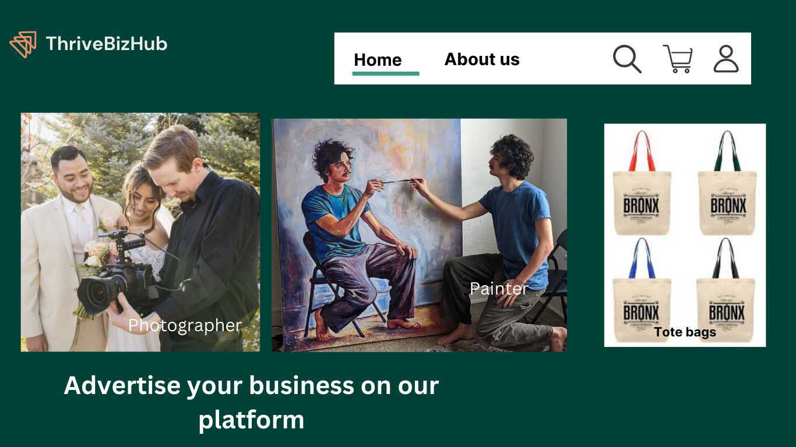

2.4 Interaction types

* Interaction between website and users : This involves business owners registering their business,listing their products and managing their profiles.Customers will interact by browsing products,adding products to their cart and placing orders.
* User-to-user interaction : Customers can leave reviews and ratings of a business.And a business can interact with the customer through messaging,to take care of any inquiries presented to them.
* User-to-System : Users will be able to upload their product images,descriptions,paying online and verifying their age during the registration process.

(Sons, 2023)

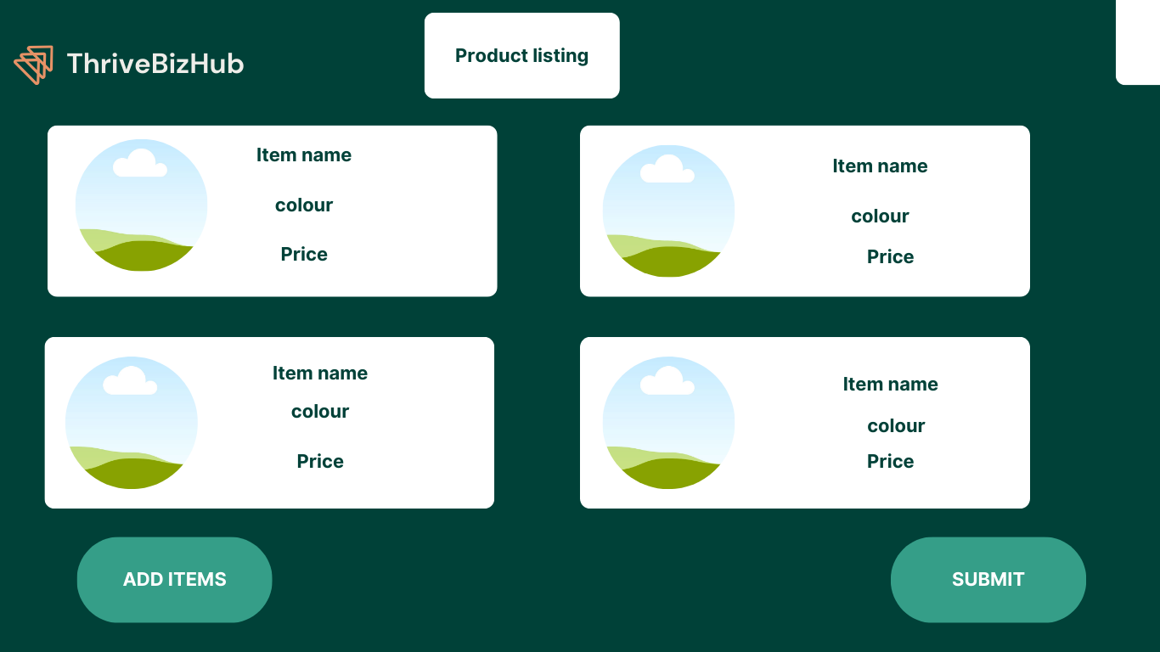

The entrepreneur does their listing on this page

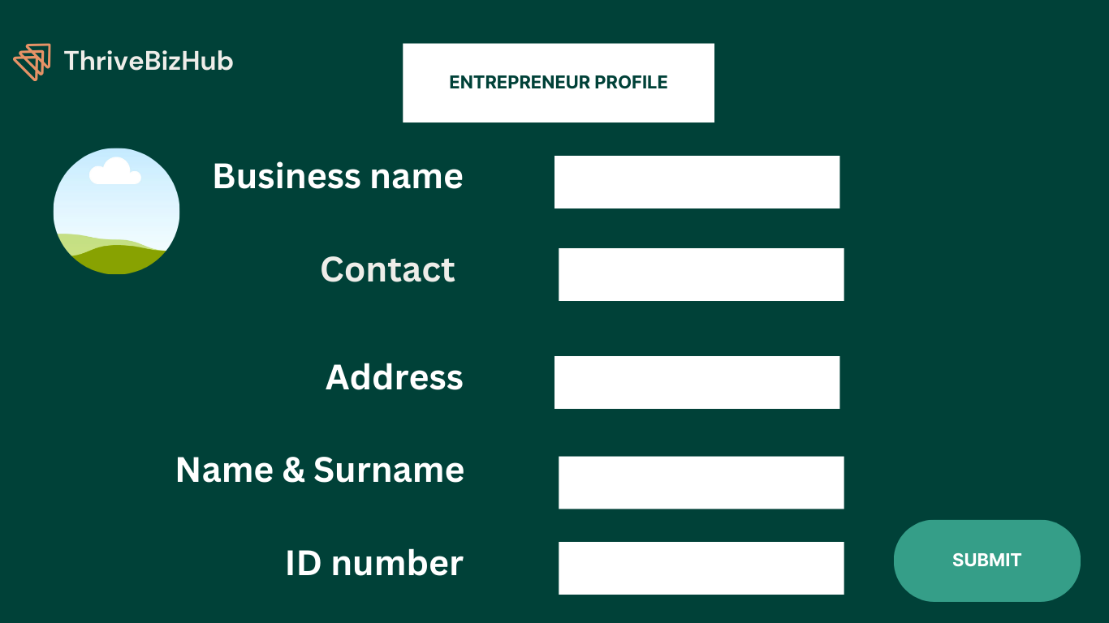

Entrepreneurs register their business on this page

1.2.5. Social interaction

* Implement social sharing buttons : This will enable users to be able share their business profile on other social media platforms to increase visibility.The website itself also has a social media accounts,hence the icons are visible on the website.
* Enabling users to rate and review : Users will be able to rate product or service and leave reviews,which will build trust within the website community.
* Use personalized reccommendations : Make product recommendations based on user behaviour patterns and preference.

(Sons, 2023)

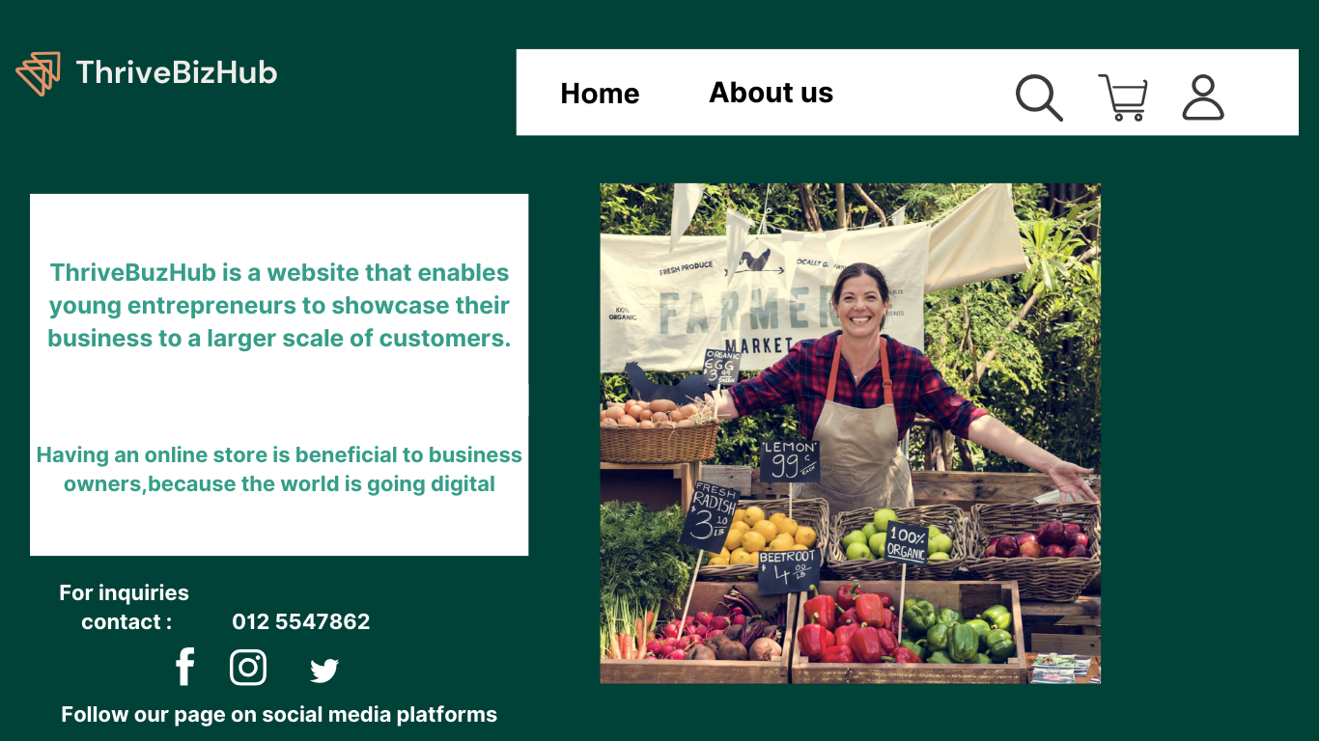

The social media icons are available above

1.2.6. Emotional interaction

* Colour scheme : I will use green and white,to give out a feeling of positivity,nature and trustworthiness.
* Use high-quality pictures : The images that will be used will be high quality and attractive.It will be unique and capture the attention of the users.For example,images of happy customers holding a specific product.
* Brand identity : I will create a logo,use the same color scheme(Green and white) on all different web pages, make good use of font choices and visual elements.And the typography will evoke positive feelings in users.

(Todorov, 2023)



High quality pictures are used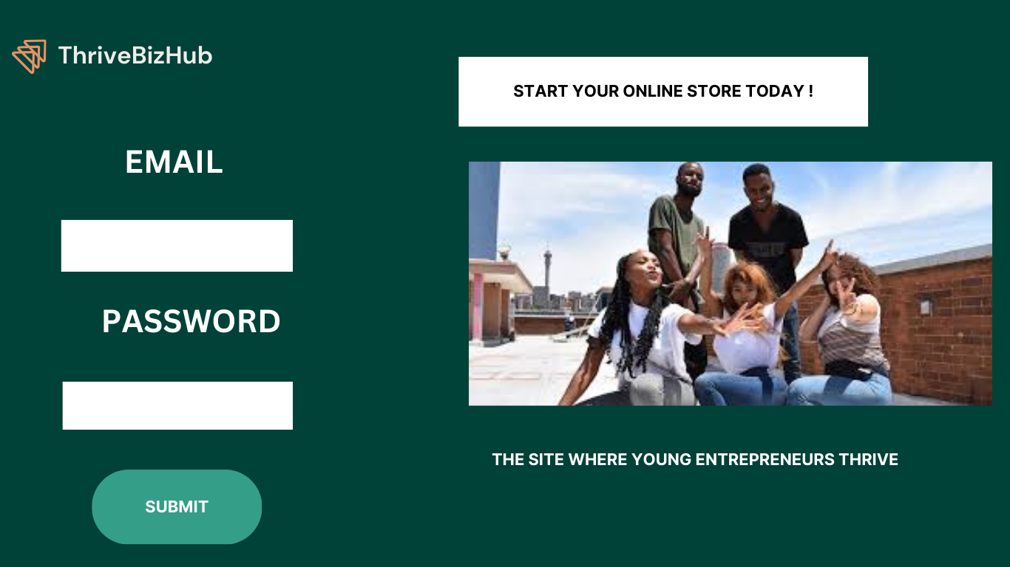

. Web Content Accessibility and Guidelines(WCAG)2.0

* Keyboard accessibility(2.1.1) : The buttons and forms can be navigated using only the keyboard.
* Title and structure (1.3.1) : Use appropriate HTML heading and structures to create a logical and streamlined layout.
* Contrast(1.4.3) : Keeps the colour contrast between text and background elements consistent.
* Focus indicator(2.4.7) : Implement a display focus indicator for keyboard navigation to assist users be aware of where they are on the page.
* Description link(2.4.4) : Use descriptive link text to give users clear information about where the link is going.
* Page title(2.4.2) : Make use of informative page titles to help users understand the content and purpose of each page.
* Error identification(3.3.1) : The website will identify error messages and will provide instructions on how to correct them to users, by filling out the form.
* Readable and understandable text(3.1.1) : The text content will be easy to read and understandable, and Concise language will be used.
* Enough time(2.2.1) : Give users enough time to read and interact with the content.
* Alt text(1.1.1) : Provide alt text for images to help visually impared users.

(W3C, 2008)

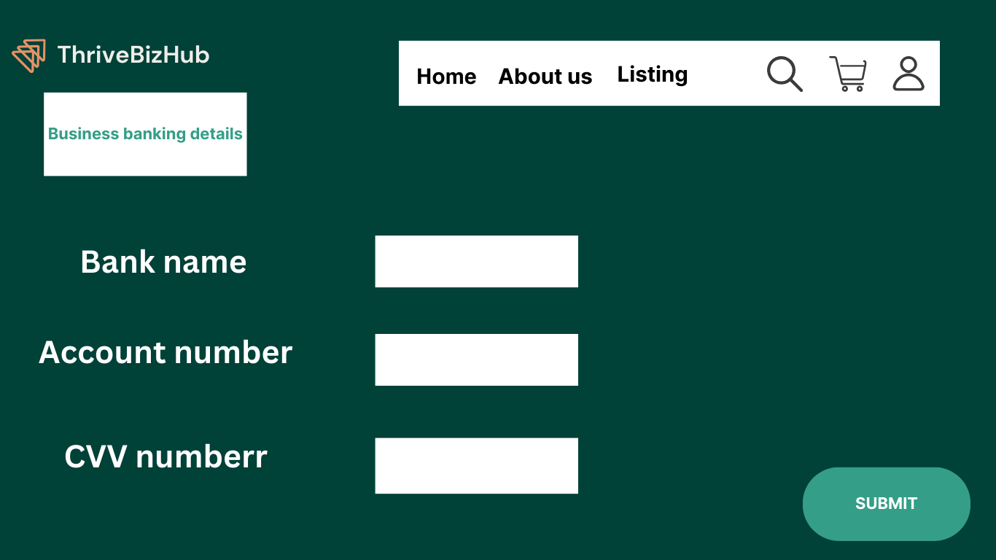



Every user will have enough time to insert information.

# Reference List

Lu, L., 2023. *Webflow.* [Online]   
Available at: https://webflow.com/blog/5-sure-fire-ways-to-improve-your-website-ux?utm_source=google&utm_medium=search&utm_campaign=SS-GoogleSearch-Nonbrand-DynamicSearchAds-Core&utm_term=dsa-45211625058___547699967189__&gclid=CjwKCAjwgsqoBhBNEiwAwe5w07yPiLZpPInwQoBitt  
[Accessed 26 September 2023].

Sons, J. W. &., 2023. *Interaction design beyond human-computer interaction.* 6th Edition ed. New Jersey: John Wilwy &Sons.

Todorov, G., 2023. *Thrive my way.* [Online]   
Available at: https://thrivemyway.com/the-power-of-emotional-web-design-6-best-examples/#:~:text=The%20use%20of%20high%2Dquality,engage%20more%20with%20the%20website.  
[Accessed 26 September 2023].

W3C, 2008. *W3C.* [Online]   
Available at: https://www.w3.org/WAI/WCAG20/versions/guidelines/wcag20-guidelines-20081211-a4.pdf  
[Accessed 26 September 2023].