**PROFESSIONAL CS ELECTIVE 2 | MATPLOTLIB ACTIVITY  
MATILLA, CARL ANDRIE D. | BSCS 3C**

**TABLE #1 (w/o Grid)**

**import matplotlib.pyplot as plt**

**import numpy as np**

**xpoints = np.array([0, 6, 10, 13])**

**ypoints = np.array([0, 6, 2, 9])**

**plt.plot(ypoints, marker = "o", linestyle = "dotted")**

**plt.title("Banana's Sales")**

**plt.xlabel("People")**

**plt.ylabel("Banana")**

**plt.show()**

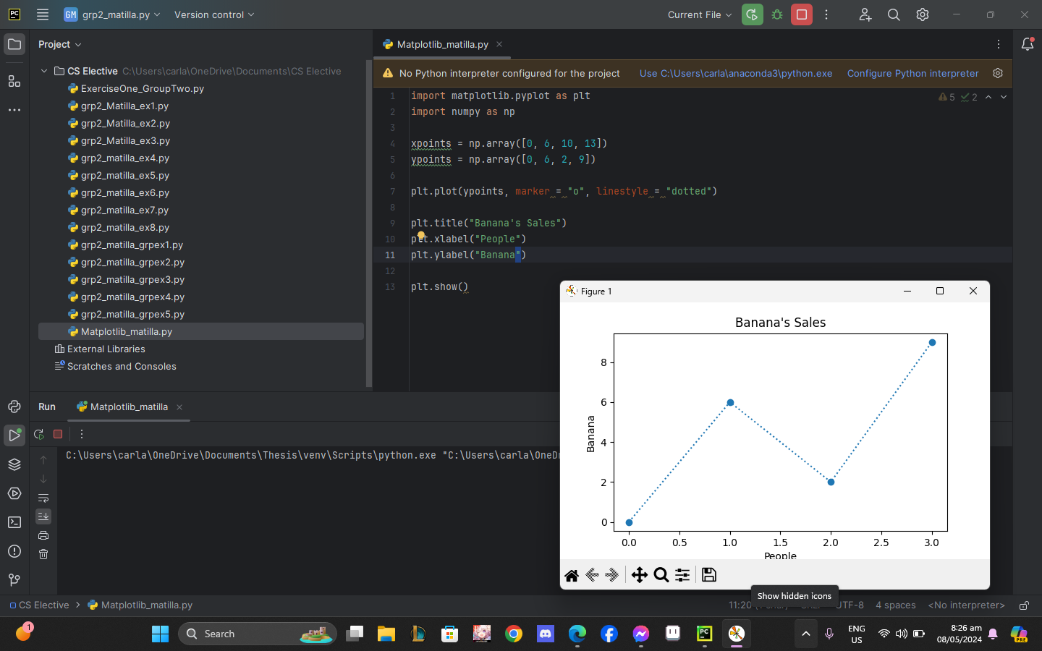

**TABLE #2: (w/ Grid)  
import matplotlib.pyplot as plt**

**import numpy as np**

**xpoints = np.array([0, 5, 3, 1])**

**ypoints = np.array([0, 2, 9, 7])**

**plt.plot(ypoints, marker = "o", linestyle = "dotted")**

**plt.title("Apple's Sales")**

**plt.xlabel("People")**

**plt.ylabel("Apple")**

**plt.grid()**

**plt.show()**

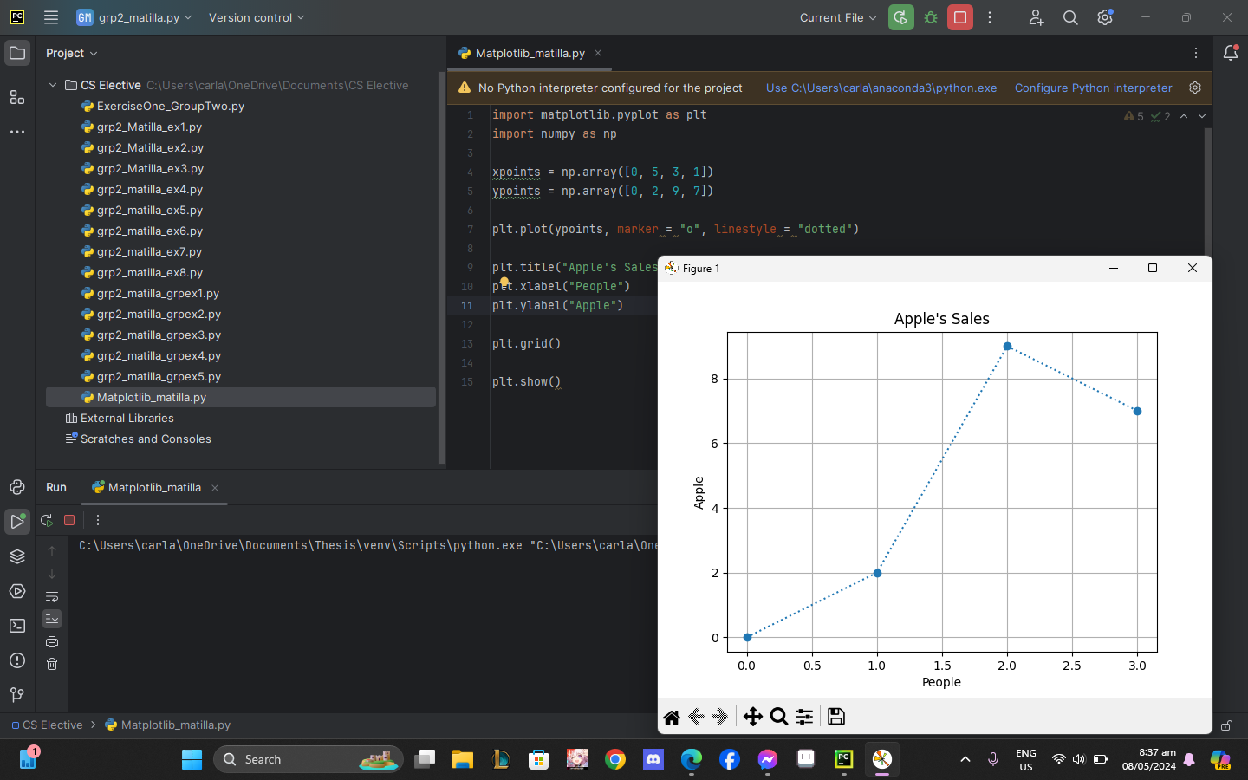

**TABLE #3: Subplot**

**import matplotlib.pyplot as plt**

**import numpy as np**

**#plot 1:**

**x = np.array([0, 6, 10, 13])**

**y = np.array([0, 6, 2, 9])**

**plt.subplot(1, 2, 1)**

**plt.plot(x,y)**

**#plot 2:**

**x = np.array([0, 5, 8, 12])**

**y = np.array([0, 2, 9, 4])**

**plt.subplot(1, 2, 2)**

**plt.plot(x,y)**

**plt.grid()**

**plt.show()**

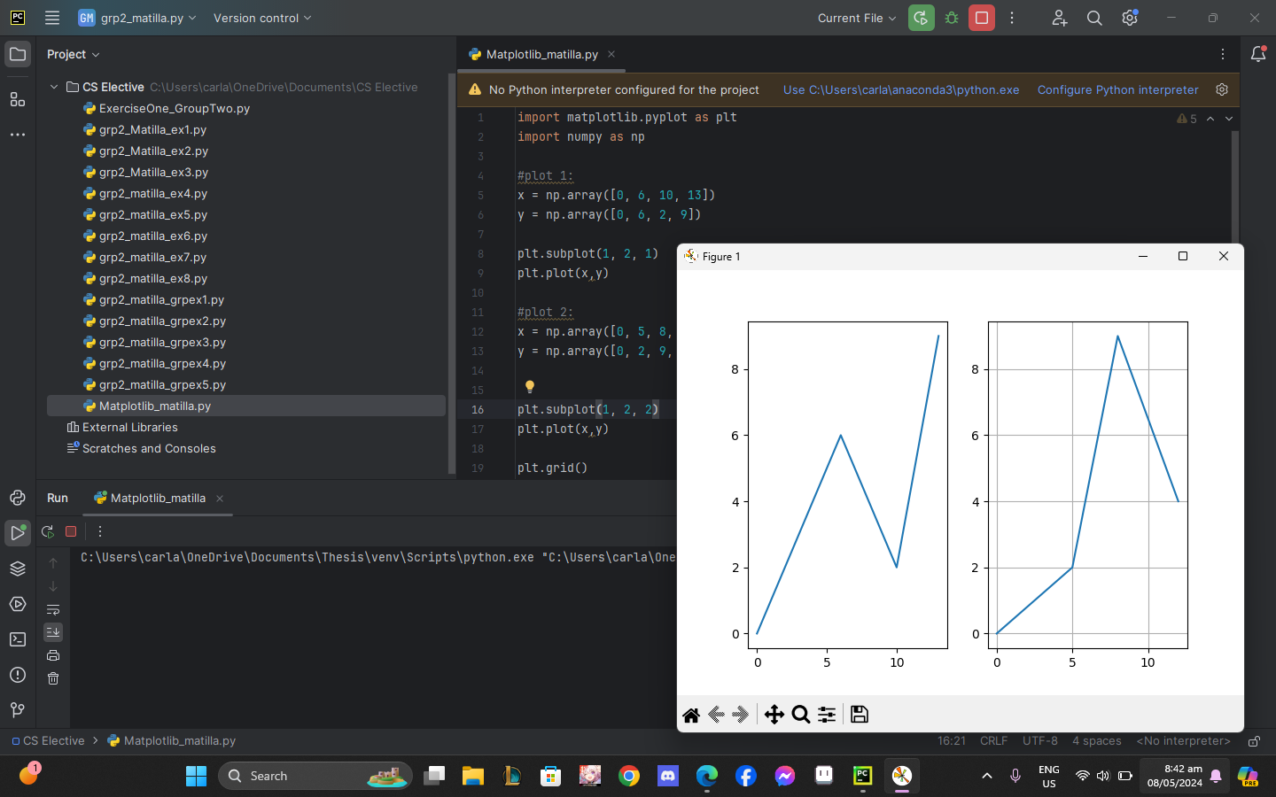

**TABLE #4: Scatter Plot**

**import matplotlib.pyplot as plt**

**import numpy as np**

**x = np.array([4, 6, 5, 7, 3, 4, 2, 1, 6, 7])**

**y = np.array([12, 45, 67, 32, 34, 65, 12, 90, 64, 32])**

**plt.scatter(x, y, color = 'hotpink')**

**x = np.array([6, 4, 5, 7, 3, 9, 0, 1, 0, 3])**

**y = np.array([36, 34, 78, 12, 34, 89, 34, 23, 45, 34])**

**plt.scatter(x, y, color = 'green')**

**plt.show()**

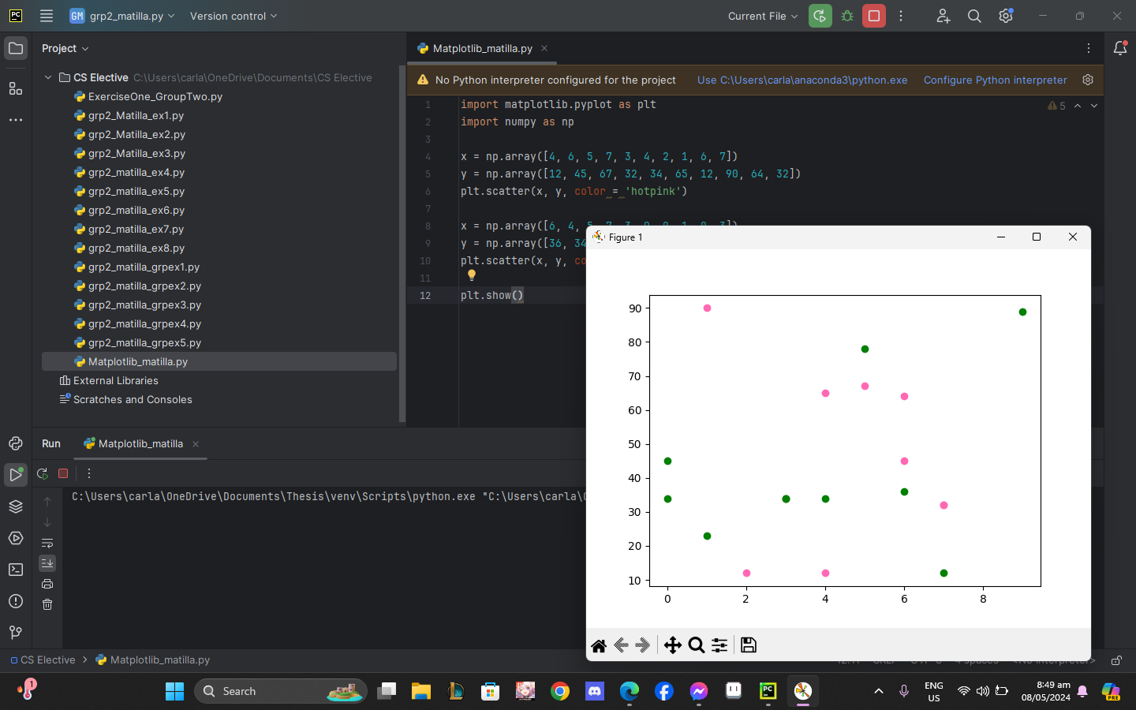

**TABLE #5: Bars  
import matplotlib.pyplot as plt**

**import numpy as np**

**x = np.array(["A", "B", "C", "D", "E"])**

**y = np.array([12, 4, 6, 15, 10])**

**plt.bar(x, y, color = "green")**

**plt.show()**

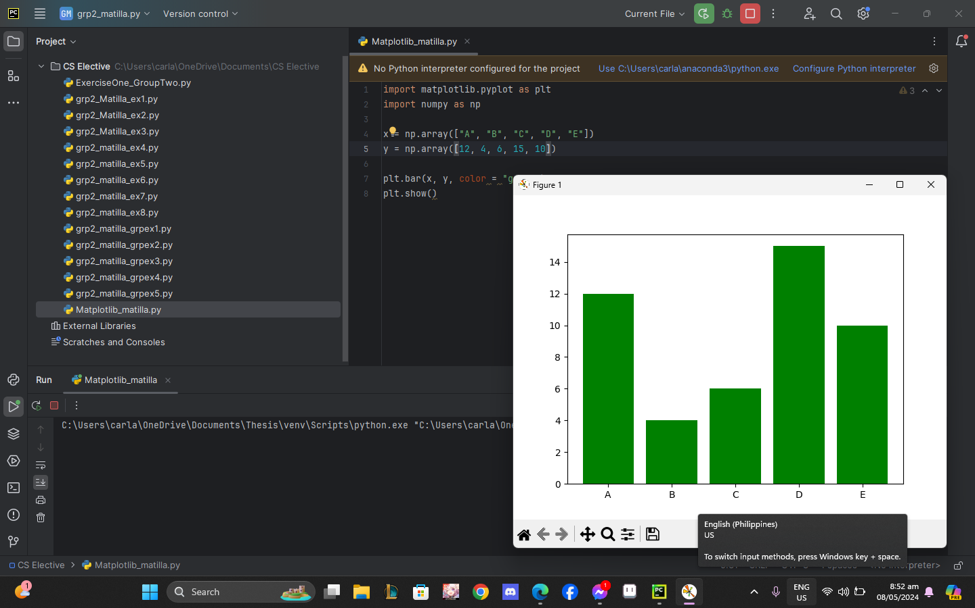

**TABLE #6: Histograms**

**import matplotlib.pyplot as plt**

**import numpy as np**

**x = np.random.normal(200, 30, 170)**

**plt.hist(x)**

**plt.show()**

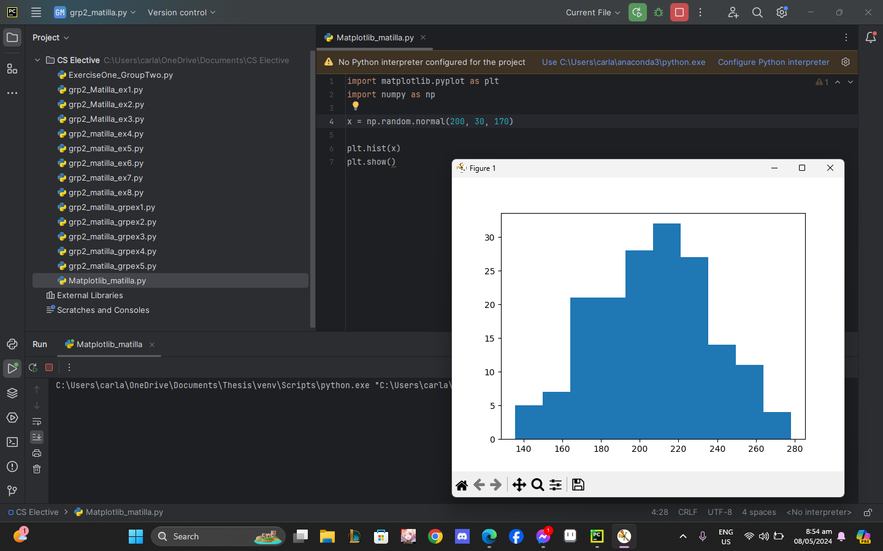

**TABLE #7: Pie Chart  
import matplotlib.pyplot as plt**

**import numpy as np**

**y = np.array([200, 30, 170])**

**plt.pie(y)**

**plt.show()**

