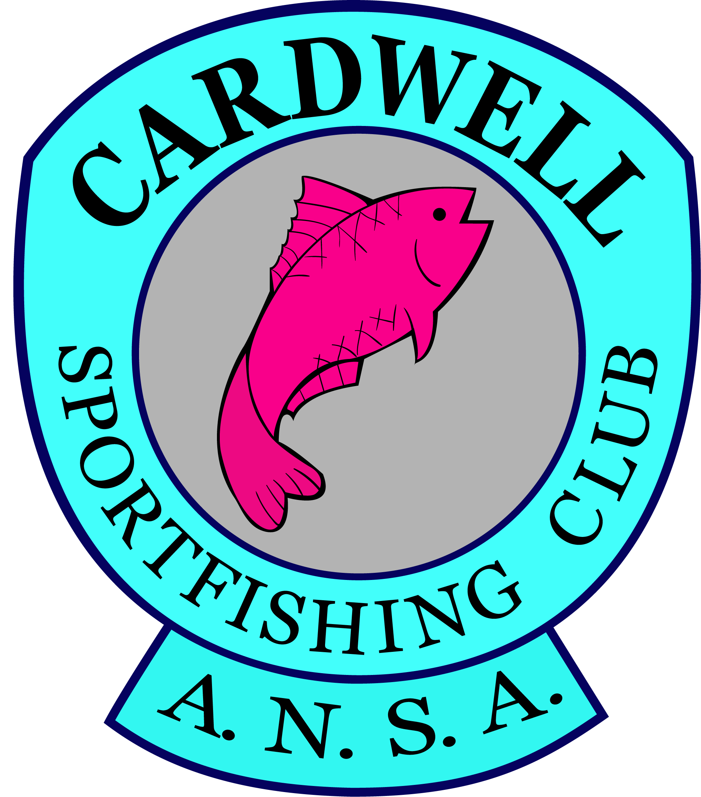CARDWELL SPORTFISHING CLUB INC

JUNE 2018 FISHING COMPETITION

**Grunter Hunter**

1. 100 points for each legal Javelin. One extra point for every centimetre over the legal length
2. Any other species will receive 50 points for legal length and then one point for every extra centimetre over the legal length.

**GENERAL RULES**

1. Competition commences at 6 pm Friday 22 June.
2. Weighin at 4 pm Sunday 24 June (no set finishing time).
3. All caught fish will be measured at Cardwell Sportfishing Club, St Albans Street, Cardwell at 4 pm on Sunday 24 June.
4. This competition is open and free to members of Cardwell Sportfishing Club Inc but members must complete a registration form.
5. This competition is open to members of the public at a cost of $10 per registrant and all participants must complete a registration form.
6. As registrants will have to abide by bag limits and size set by Australian National Sportfishing Association (ANSA) catch and release is allowed and fish must be measured on a brag mat or appropriate device and photographed with a time and date stamp.
7. Photos of released fish intended to be registered must be sent through to cardwellsportfishingclub@hotmail.com before 4 pm Sunday 24 June or registrants can attend the weigh-in with photos.
8. No photos will be accepted of released fish caught before or after the times indicated in General Rules, rule 1 and 2, above.
9. Participants must adhere to the current Queensland Recreational Fishing Rules and Regulations.
10. General rules set out by ANSA Qld are also applicable to this fishing competition. See <http://www.ansaqld.com.au/rules-forms/>

Please abide by the ANSA Qld Code of Ethics shown in the ANSA Qld Handbook available at [www.ansaqld.com.au](http://www.ansaqld.com.au)

For further information and to download a registration form and the rules. Please visit [www.cardwellsportfishingclub.com](http://www.cardwellsportfishingclub.com) or e: [cardwellsportfishingclub.com](http://cardwellsportfishingclub.com)