**Predictive performance of the KFRE according to creatinine- and cystatin C-based eGFR equations**

*Malou Magnani, Merel van Diepen, Friedo W. Dekker, Juan-Jesús Carrero, Edouard L. Fu*

Date: 31-10-2024

1. **Background and relevance**

**Aim**

The aim of this study is to assess how the predictive performance of the 4-variable KFRE for 2- and 5- year horizons is affected by (1) the use of different filtration markers (cystatin C vs. creatinine vs. both) and (2) the use of equations developed by various research groups (CKD-EPI vs. EKFC vs. RLM/CAPA). Results will be published in two manuscripts, one focussing on KFRE performance across filtration markers, and the other on KFRE performance across different research groups.

**Background**

Chronic Kidney Disease (CKD) is characterized by a decreased glomerular filtration rate (GFR) (1). GFR can be measured (mGFR) by the clearance of exogenous filtration markers (e.g. iothalamate or iohexol) or estimated (eGFR) from endogenous markers such as serum creatinine and cystatin C using equations developed by different research groups, including CKD‑EPI, EKFC, CAPA, and RLM (2–7). Although mGFR is more accurate, it is complex and costly (8), so eGFR equations are widely used in clinical practice to guide diagnosis, prognosis, and treatment decisions in CKD (9).

Until 2021, the CKD‑EPIcr2009 equation was the most widely applied (10–12). Following concerns about its race adjustment, the CKD‑EPIcr2021 equation was introduced without a race component (11,13–15) and is now recommended by the NKF/ASN Task Force and KDIGO (11,16). In contrast, the ERA and EFLM continue to recommend CKD‑EPIcr2009 (12). Performance also appears to vary across populations: the EKFC consortium reported superior performance of their equation in European cohorts, while the CKD‑EPI consortium found comparable performance in predominantly American cohorts (3,17). These findings suggest that equations developed in European populations, such as EKFC, CAPA, and RLM, may be valuable alternatives, and importantly, none of these equations include a race component (3–6).

Beyond the choice of equation, the selection of filtration marker also influences eGFR. Creatinine is the most commonly used, but cystatin C—alone or combined with creatinine—can provide more accurate estimates in certain clinical situations (2,4,5). For example, cystatin C is recommended when creatinine may be unreliable, such as in patients with eating disorders, extreme physical activity, or limb amputation (16). However, eGFR values for the same individual can differ substantially depending on the marker used. A large Swedish study of 158,601 adults with simultaneous creatinine and cystatin C measurements found that 32% had >15% difference between eGFRcr and eGFRcys, with a mean difference of 8 mL/min/1.73m².

Because eGFR is a key predictor in prognostic models, these differences may affect risk prediction. The Kidney Failure Risk Equation (KFRE) is a widely validated model that estimates the 2‑ and 5‑year risk of kidney failure in patients with CKD stage 3–5 (18,19). It is now recommended in international guidelines (16,19,20) to support timely preparation for dialysis or transplantation, guide monitoring, and inform patients about prognosis. Yet, it remains unclear how both the choice of eGFR equation and the choice of filtration marker influence the predictive performance of the KFRE.

**Type of prediction study**

In this study, the non-North American 4-variable Kidney Failure Risk Equation (KFRE) for 2- and 5-year horizons will be externally validated in a Swedish population of CKD patients.

**Study design**

**Data set description**

Data will be used from the Stockholm CREAtinine Measurement (SCREAM) project, which is a healthcare utilization cohort of individuals residing or accessing healthcare in the region of Stockholm, Sweden (21,22). The data consists of laboratory data of 2.9 million Stockholm citizens who underwent creatinine assessments between January 2006 and December 2021. Laboratory data were subsequently linked to regional and national administrative databases to obtain information on demographics, disease history, vital status, dispensed prescription medication, and healthcare utilization. No information on race is available in the cohort, since Sweden does not allow the collection of data on ethnicity to prevent discrimination. However, based on the population statistics published annually by the government, we estimate that ~2.5% of the cohort is of African ethnicity (23).

**Eligibility criteria**

1. Age ≥ 18 years old
2. eGFR < 60 ml/min/1.73m2 calculated with the CKD-EPIcr2009
3. Creatinine and cystatin C measurement from the same day
4. Albuminuria/proteinuria measurement within 12 months preceding the creatinine and cystatin C measurement
5. No KRT before index date

Only creatinine and cystatin C measurements taken in the outpatient setting will be included, while measurements taken in hospital settings will be excluded. Furthermore, measurements before 2011 will be excluded since they were performed using non-standardised methods. The observation period will be between 1 January 2011 and 31 December 2021.

We will identify all cystatin C measurements taken in the outpatient setting between 1 January 2011 and 31 December 2021. We will require the presence of a creatinine measurement on the same day, and an albuminuria/proteinuria measurement within 12 months before or after the creatinine/cystatin C measurement. Next, we will select the albuminuria measurement closest to the date of creatinine/cystatin C measurement. If a patient has more than one eligible eGFR-albuminuria measurement pair, we will select one at random. The index date will be defined as the most recent date between the selected eGFR and albuminuria measurements (to prevent immortal time). If urine albumin-creatinine ratio (UACR) is not available, the urine protein-creatinine ratio (UPCR) or dipstick proteinuria measurements will be converted to UACR using equations developed by Sumida et al. (24). When multiple measurements on the same day are available, the mean value will be used.

**Outcome definition**

The Kidney Failure Risk Equation (KFRE) predicts the 2- and 5-year risk of kidney failure (KF), which will be defined as initiation of dialysis or kidney transplantation, in line with the definition used in the original development study (18). Death will be considered a competing event (26).

The outcome of kidney failure or dialysis will be ascertained through linkage with the Swedish Renal Registry (SNR), which is a nationwide register and includes all kidney failure cases in Sweden (25). Patients will be followed up for 2- and 5-years from the index date, or until date of kidney failure, death, or the end of the observation period, whichever occurs earlier.

**Predictors**

Predictors used in the 4-variable KFRE are: sex, age, UACR measured in mg/g, and eGFR measured in ml/min/1.73m2. Since no information on ethnicity is available and we estimate that ~97.5% of the cohort is of non-African ethnicity, we will calculate the CKD-EPI2009 eGFRcr and eGFRcr-cys without the Black race coefficient.

1. **Statistical analysis**

**Methods**

For manuscript 1 (KFRE performance across filtration markers), we will compare the different CKD-EPI equations (CKD-EPIcr2009, CKD-EPIcr2021, CKD-EPIcys2012, CKD-EPIcr-cys2012, CKD-EPIcr-cys2021). For manuscript 2 (KFRE performance across research groups), we will compare performance across groups, i.e. CKD-EPI vs. EKFC vs. Revised Lund Malmo (CKD-EPIcr2009, CKD-EPIcr2021, EKFCcr, RLMcr, CKD-EPIcys2012, EKFCcys, CAPAcys, CKD-EPIcr-cys2012, CKD-EPIcr-cys2021). Predictive performance will be assessed by evaluating the discrimination and calibration (26,27). As an overall goodness of fit measure combining both discrimination and calibration the Brier score and scaled Brier score will be calculated (27).

Additionally, reclassification tables will be used to evaluate the number of patients who move to another risk category or remain in the same risk category as a result of using a different eGFR equation for the 2-year KFRE, compared to the CKD-EPIcr2009 (28). The risk threshold will be defined as 40%, based on the KDIGO guidelines (16).

The competing risk of death will be taken into account in order to validate how well the KFRE predicts absolute risk of kidney failure (26).

**Calibration**

Calibration evaluates to what degree the absolute predicted risks correspond to the observed risks. It will be assessed using three measures: (i) calibration-in-the-large (O/E and calibration intercept), (ii) a calibration plot and (iii) the calibration slope.

Calibration-in-the-large is the overall calibration. It will be assessed through the Observed-to-Expected ratio (O/E) and the calibration intercept. For the O/E, a value of 1 is perfect, values <1 suggest that the model is over-predicting the total number of events, and values >1 indicate that the model is under-predicting the number of events. The calibration intercept has an optimal value of 0, with values <0 suggesting overestimation and values >0 suggesting underestimation.

Calibration plots compare the predicted risks to observed risks within subgroups of patients, based on the predicted probabilities. Since competing risks are present, the observed probability with the Kaplan Meier will overestimate the risk of KF, therefore we will use the non-parametric Cumulative Incidence Function (CIF). The CIF quantifies the risk of both the event of interest and competing events. When a patient experiences a competing event, they are no longer at risk for the primary outcome. The probability of the outcome of interest is then scaled by the cumulative probability of experiencing any event (26). A calibration plot will display observed risks, obtained using pseudo-values, versus predicted risks with a smoothed non-linear curve generated using a GAM smoother (27).

The calibration slope evaluates how well the predicted risks correspond to the observed risks and has an optimal value of 1. A slope of <1 indicates that estimated risks are too extreme, while a slope of >1 suggests that risk estimates are too moderate.

**Discrimination**

Discrimination is a relative measure of how well a model can discern patients with the outcome from patients without the outcome. It will be assessed using an adaptation of Harrell’s C-index as proposed by Wolbers et al. (29). The C-index is defined as the proportion of all examinable pairs in which the individual with the higher predicted risk experiences the outcome sooner than the other individual. A C-index of 1 is ideal and 0.5 is equivalent to chance. Using the approach of Wolbers et al., patients who experience a competing event are retained in the risk set instead of being censored. Their follow-up time is set to infinity, indicating that they will never experience the outcome of interest. 95% confidence intervals will be calculated using the bootstrap method.

**Brier score**

The Brier score can be used to assess overall ability of a model to predict whether a patient experiences the primary events by a particular time point, combining both the calibration and the discrimination of the model (30). In the presence of competing risks, the Brier score is the average squared difference between the observed risk at the end of the prediction horizon and the absolute risk estimates by that time point (31). To account for censoring, pseudo-observations can be used (32).

The score can range from 0 for a perfect model to 0.25 for a non-informative model in a dataset with an overall event occurrence of 50%. However, when the overall outcome risk is lower, the maximum score for a non-informative model is lower, which can complicate interpretation.

Therefore, a scaled version of the Brier score has been proposed: 1 − (model Brier score ÷ null model Brier score) (30,33). In this approach, a null model (without covariates) is used that estimates the risk equally for all individuals and can be estimated by the Aalen-Johansen estimator in a setting of competing events. The scaled Brier score represents the amount of prediction error in a null model that is explained by the prediction model. A score of 100% corresponds to a perfect model, 0% to an ineffective mode, and <0% to a model in which the predictions are further away from the observed data than the null model estimating the average risk for each patient (34).

**Missing data**

Since only patients with serum creatinine, cystatin C and albuminuria/proteinuria measurements will be included, and we do not expect missing data on sex and age, a complete case analysis will be performed.

**Baseline characteristics**

Baseline characteristics will be summarised using means and standard deviations (SDs), medians and interquartile ranges (IQRs) and frequencies with percentages, depending on which is appropriate.

**Sample size considerations**

A study by Collins et al. suggests that externally validating a prognostic model requires a minimum of 100 events and ideally 200 or more events (35). Based on the large sample size of the SCREAM project, this required number of events will be achieved.

1. **Variables needed for the analysis**

Age, sex, Serum creatinine, serum cystatin C, Urine Albumin-Creatinine Ratio (UACR), comorbid conditions (Hypertension, Diabetes mellitus, Coronary heart disease, Stroke, Heart failure, Peripheral artery disease, Atrial fibrillation, Liver disease, Recent cancer, COPD), medications (Antihypertensive medication, RASi, Diuretics, Statins), all-cause mortality, kidney failure, dialysis, kidney transplantation.

1. **Tables**

**Note that the first manuscript will compare CKD-EPI equations across filtration markers, and the second manuscript will compare within each filtration marker the different groups (CKD-EPI vs. EKFC vs. RLM/CAPA).**

**Table 1**. General characteristics

|  |  |
| --- | --- |
| Characteristics |  |
| Mean age (SD), years |  |
| Female, n (%) |  |
| Median eGFR (IQR), mL/min/1.73m2 |  |
| Creatinine-based equations |  |
| CKD-EPI 2009 |  |
| CKD-EPI 2021 |  |
| EKFC 2021 |  |
| RLM 2011 |  |
| Cystatin C-based equations |  |
| CKD-EPI 2012 |  |
| EKFC 2023 |  |
| CAPA 2014 |  |
| Creatinine-cystatin C-based equations |  |
| CKD-EPI 2012 |  |
| CKD-EPI 2021 |  |
| Median UACR (IQR), mg/g |  |
| Converted from dipstick, n (%)* |  |
| Converted from PCR, n (%)* |  |
| Median serum creatinine (IQR), mg/dL |  |
| Median serum cystatin C (IQR), mg/L |  |
| Comorbidities, n (%) |  |
| Hypertension |  |
| Diabetes mellitus |  |
| Coronary heart disease |  |
| Stroke |  |
| Heart failure |  |
| Peripheral artery disease |  |
| Atrial fibrillation |  |
| Liver disease |  |
| Recent cancer |  |
| COPD |  |
| Medications, n (%) |  |
| Antihypertensive medication |  |
| RASi |  |
| Diuretics |  |
| Statins |  |
| Outcome 2 years ** |  |
| Mean observation time (SD), days |  |
| Alive without KF, n (%) |  |
| Death without KF, n (%) |  |
| KF, n (%) |  |
| Dialysis, n (%) |  |
| Transplantation, n (%) |  |
| Outcome 5 years ** |  |
| Mean observation time (SD), days |  |
| Alive without KF, n (%) |  |
| Death without KF, n (%) |  |
| KF, n (%) |  |
| Dialysis, n (%) |  |
| Transplantation, n (%) |  |

Abbreviations: eGFR, estimated glomerular filtration rate; UACR, urine Albumin-Creatinine Ratio; PCR, Protein-Creatinine Ratio; COPD, Chronic Obstructive Pulmonary Disease; RASi, Renin Angiotensin System inhibitor; KF, Kidney Failure

Kidney Failure defined as initiation of dialysis or kidney transplantation

* Converted using the equations developed by Sumida et al. (24)

** Calculated using the Cumulative Incidence Function

**Table 2**. Predictive performance of the KFRE with each GFR estimating equation and filtration marker

|  |  |  |  |  |  |  |
| --- | --- | --- | --- | --- | --- | --- |
|  | **Overall performance** | | **Calibration-in-the-large** | | **Calibration** | **Discrimination** |
| eGFR equation | Brier score | Scaled Brier score*** | O/E* | Calibration intercept* | Calibration slope* | C-statistic** |
| **Creatinine-based equations** |  |  |  |  |  |  |
| CKD-EPI 2009 |  |  |  |  |  |  |
| CKD-EPI 2021 |  |  |  |  |  |  |
| EKFC 2021 |  |  |  |  |  |  |
| RLM 2011 |  |  |  |  |  |  |
| **Cystatin C-based equations** |  |  |  |  |  |  |
| CKD-EPI 2012 |  |  |  |  |  |  |
| EKFC 2023 |  |  |  |  |  |  |
| CAPA 2014 |  |  |  |  |  |  |
| **Creatinine-cystatin C-based equations** |  |  |  |  |  |  |
| CKD-EPI 2012 |  |  |  |  |  |  |
| CKD-EPI 2021 |  |  |  |  |  |  |
| EKFC |  |  |  |  |  |  |
| RLM-CAPA |  |  |  |  |  |  |

Abbreviations: eGFR, estimated Glomerular Filtration Rate; O/E, Observed/Expected

* Estimated number calculated using the Cumulative Incidence Function

** Calculated using the method of Wolbers et al. (29)

*** Null model estimated by the Aalen-Johansen estimator (36)

**Table 3**. Reclassification table for the 2-year KFRE

|  |  |  |  |  |  |  |
| --- | --- | --- | --- | --- | --- | --- |
|  | |  | | Other equation e.g. CKD-EPIcr2021 | | |
| Patients with KF after 2 years | | | | | | |
| CKD-EPIcr2009 | |  | | KFRE >40% | KFRE <40% | |
| KFRE >40% | |  |  | |
| KFRE <40% | |  |  | |
| Patients without KF after 2 years | | | | | | |
| CKD-EPIcr2009 |  | | KFRE >40% | | | KFRE >40% |
| KFRE >40% | |  | | |  |
| KFRE >40% | |  | | |  |

40% threshold based on KDIGO guidelines (16)

**Supplemental table 1**. Comparison with the development data of the distribution of important predictors and outcomes

|  |  |  |
| --- | --- | --- |
|  | SCREAM | KFRE (4 variables) |
| N |  |  |
| Mean age (SD), years |  |  |
| Women, n (%) |  |  |
| Black race, n (%) |  |  |
| Mean eGFR (SD), mL/min/1.73m2 |  |  |
| No. (%) of patients with Albuminuria* |  |  |
| Comorbidities |  |  |
| Diabetes |  |  |
| Vascular disease** |  |  |
| Mean serum creatinine (SD), mg/dL |  |  |
| Median UACR (IQR), mg/g |  |  |
| Mean observation time (SD), days |  |  |
| No. of Kidney Failure events*** |  |  |
| Dialysis |  |  |
| Transplantation |  |  |
| Kidney Failure Incidence, per 1000 Patient-Years |  |  |

Abbreviations: eGFR, estimated Glomerular Filtration Rate; UACR, urine Albumin-Creatinine Ratio

* Urine Albumin-Creatinine Ratio ≥ 30 mg/g

** Vascular disease defined as presence of coronary artery disease or peripheral vascular disease

*** Kidney Failure defined as initiation of dialysis or kidney transplantation

**Supplemental table 2**. Definitions of study covariates and outcomes

|  |  |  |
| --- | --- | --- |
| Comorbidities | ICD-10 codes (37) | ATC codes (38) |
| Coronary heart disease | I2-I25 |  |
| Hypertension | I10-I15 |  |
| Heart failure | I50, I110, I130, I132 | C03, C07, C08, C09 |
| Stroke | I60-I69 |  |
| Atrial fibrillation | I48 |  |
| Peripheral arterial disease | I70, I72, I73 |  |
| Diabetes mellitus | E10-E14 | A10 |
| COPD | J44 |  |
| Cancer in previous year | C00-C43, C45-C97 |  |
| Liver disease | B18, I850, I859, I982, K70-K77 |  |
| Ongoing medications* | ATC codes |  |
| Antihypertensive medication | C03, C07, C08, C09 |  |
| Diuretic | C03, C07B, C09BA, C09DA |  |
| RASi | C09A, C09B, C09C, C09D |  |
| Statins | C10AA, C10BA |  |
| Study outcomes | Definition |  |
| All-cause mortality | Death in the Swedish Death Registry |  |
| Kidney transplantation | Based on the Swedish Renal Registry |  |
| Dialysis initiation | Based on the Swedish Renal Registry |  |

ICD, International Classification of Diseases; ATC, Anatomical Therapeutic Chemical

*Ongoing medications defined as dispensation of drug in the 180 days prior to index date

1. **Figures**

**Figure 1**. Ridgeline plot of GFR estimates per equation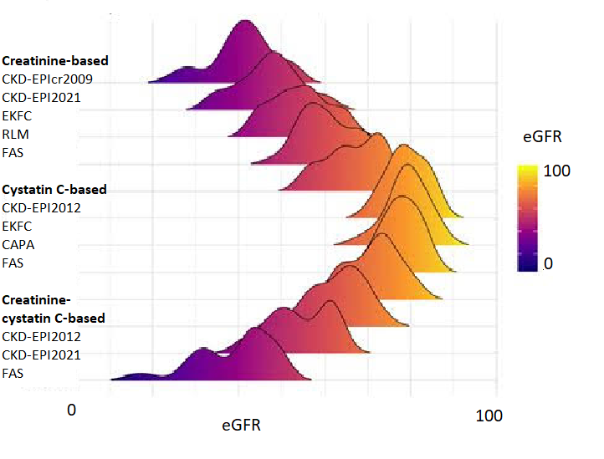

<https://r-graph-gallery.com/ridgeline-plot.html>

**Figure 2**. Ridgeline plot of changes in GFR estimates with different eGFR equations compared to CKD-EPIcr2009

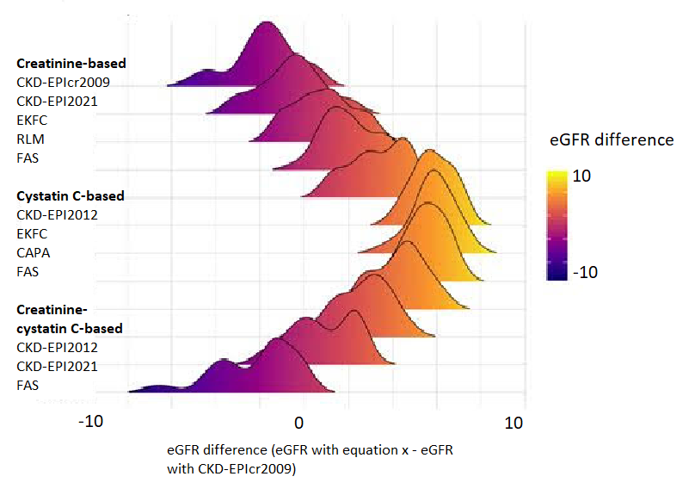

<https://r-graph-gallery.com/ridgeline-plot.html>

**Figure 3**. Ridgeline plot of KFRE risks per equation

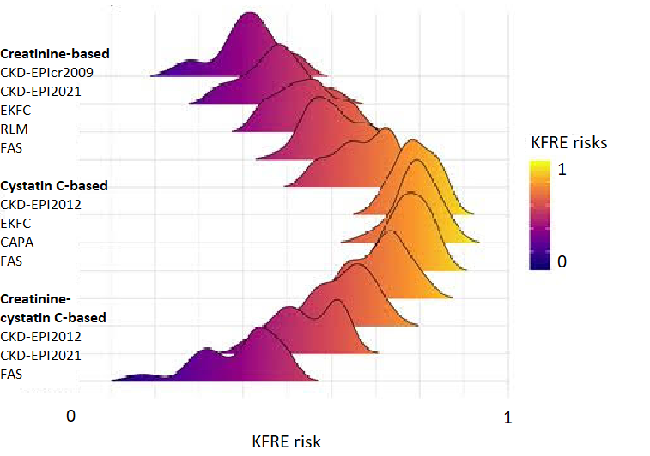

<https://r-graph-gallery.com/ridgeline-plot.html>

**Figure 4**. Ridgeline plot of changes in individual KFRE risk with different eGFR equations compared to CKD-EPIcr2009

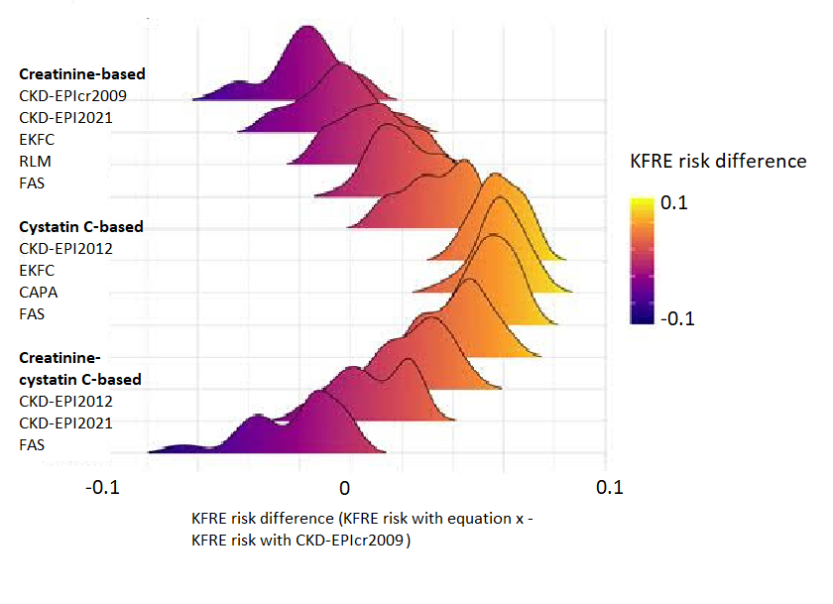

<https://r-graph-gallery.com/ridgeline-plot.html>

**Figure 5**. Calibration plots 2 year KFRE with each eGFR equation

Depending on the discernability, the plots will either be shown as a single graph for each filtration marker or individually for each equation.

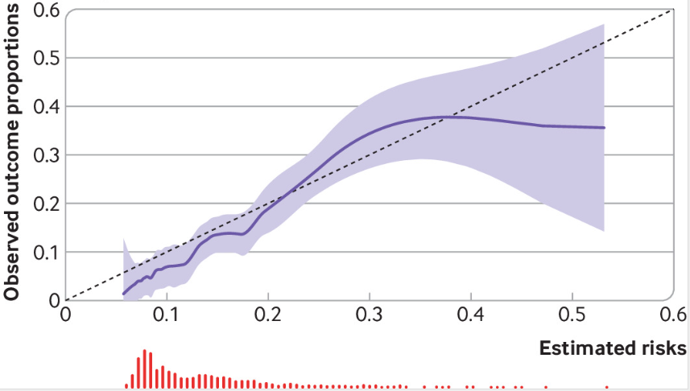

<https://pubmed.ncbi.nlm.nih.gov/34919691/>

**Figure 6**. Calibration plots 5 year KFRE with each eGFR equation

Depending on the discernability, the plots will either be shown as a single graph for each filtration marker or individually for each equation.



<https://pubmed.ncbi.nlm.nih.gov/34919691/>

**Supplemental figure 1**. Flow chart of patient inclusion into study**Reference list**

1. Levey AS, Coresh J. Chronic kidney disease. The Lancet [Internet]. 2012 Jan 14 [cited 2024 Sep 19];379(9811):165–80. Available from: http://www.thelancet.com/article/S0140673611601785/fulltext

2. Inker LA, Eneanya ND, Coresh J, Tighiouart H, Wang D, Sang Y, et al. New Creatinine- and Cystatin C–Based Equations to Estimate GFR without Race. New England Journal of Medicine [Internet]. 2021 Nov 4 [cited 2024 Sep 19];385(19):1737–49. Available from: https://www.nejm.org/doi/full/10.1056/NEJMoa2102953

3. Pottel H, Björk J, Courbebaisse M, Couzi L, Ebert N, Eriksen BO, et al. Development and validation of a modified full age spectrum creatinine-based equation to estimate glomerular filtration rate. Ann Intern Med [Internet]. 2021 Feb 1 [cited 2024 Sep 19];174(2):183–91. Available from: https://www.acpjournals.org/doi/10.7326/M20-4366

4. Grubb A, Horio M, Hansson LO, Björk J, Nyman U, Flodin M, et al. Generation of a New Cystatin C–Based Estimating Equation for Glomerular Filtration Rate by Use of 7 Assays Standardized to the International Calibrator. Clin Chem [Internet]. 2014 Jul 1 [cited 2024 Sep 19];60(7):974–86. Available from: https://dx.doi.org/10.1373/clinchem.2013.220707

5. Björk J, Grubb A, Sterner G, Nyman U. Revised equations for estimating glomerular filtration rate based on the Lund-Malmö Study cohort. Scand J Clin Lab Invest [Internet]. 2011 May [cited 2024 Sep 19];71(3):232–9. Available from: https://www.tandfonline.com/doi/abs/10.3109/00365513.2011.557086

6. Pottel H, Hoste L, Dubourg L, Ebert N, Schaeffner E, Eriksen BO, et al. An estimated glomerular filtration rate equation for the full age spectrum. Nephrol Dial Transplant [Internet]. 2016 [cited 2024 Sep 19];31:798–806. Available from: https://academic.oup.com/ndt/article/31/5/798/1751998

7. Xie D, Joffe MM, Brunelli SM, Beck G, Chertow GM, Fink JC, et al. A Comparison of Change in Measured and Estimated Glomerular Filtration Rate in Patients with Nondiabetic Kidney Disease. Clin J Am Soc Nephrol [Internet]. 2008 Sep [cited 2024 Oct 24];3(5):1332. Available from: https://pmc.ncbi.nlm.nih.gov/articles/PMC2518808/

8. Estimated Glomerular Filtration Rate (eGFR) | National Kidney Foundation [Internet]. [cited 2024 Oct 24]. Available from: https://www.kidney.org/kidney-topics/estimated-glomerular-filtration-rate-egfr

9. National Kidney Foundation. Frequently asked questions about GFR estimates. 2022;

10. Official JOurnal Of the internatiOnal SOciety Of nephrOlOgy KDIGO 2012 Clinical Practice Guideline for the Evaluation and Management of Chronic Kidney Disease. [cited 2024 Sep 19]; Available from: www.publicationethics.org

11. Delgado C, Baweja M, Crews DC, Eneanya ND, Gadegbeku CA, Inker LA, et al. A Unifying Approach for GFR Estimation: Recommendations of the NKF-ASN Task Force on Reassessing the Inclusion of Race in Diagnosing Kidney Disease. American Journal of Kidney Diseases. 2022 Feb 1;79(2):268-288.e1.

12. Delanaye P, Schaeffner E, Cozzolino M, Langlois M, Plebani M, Ozben T, et al. The new, race-free, Chronic Kidney Disease Epidemiology Consortium (CKD-EPI) equation to estimate glomerular filtration rate: Is it applicable in Europe? A position statement by the European Federation of Clinical Chemistry and Laboratory Medicine (EFLM). Clin Chem Lab Med [Internet]. 2023 Jan 1 [cited 2024 Sep 19];61(1):44–7. Available from: https://www.degruyter.com/document/doi/10.1515/cclm-2022-0928/html

13. Lucas A, Wyatt CM, Inker LA. Removing race from GFR estimates: balancing potential benefits and unintended consequences. Kidney Int. 2021 Jul 1;100(1):11–3.

14. Vyas DA, Eisenstein LG, Jones DS. Hidden in Plain Sight — Reconsidering the Use of Race Correction in Clinical Algorithms. New England Journal of Medicine [Internet]. 2020 Aug 27 [cited 2024 Sep 19];383(9):874–82. Available from: https://www.nejm.org/doi/full/10.1056/NEJMms2004740

15. Eneanya ND, Yang W, Reese PP. Reconsidering the Consequences of Using Race to Estimate Kidney Function. JAMA. 2019 Jul 9;322(2):113.

16. KDIGO 2024 Clinical Practice Guideline for the Evaluation and Management of Chronic Kidney Disease. 2024 [cited 2024 Sep 19]; Available from: www.kidney-international.org

17. Levey AS, Tighiouart H, Inker LA. Improving Glomerular Filtration Rate Estimation—Across the Age and Diversity Spectrum. Ann Intern Med. 2021 Feb;174(2):265–7.

18. Tangri N, Stevens LA, Griffith J, Tighiouart H, Djurdjev O, Naimark D, et al. A Predictive Model for Progression of Chronic Kidney Disease to Kidney Failure. JAMA [Internet]. 2011 Apr 20 [cited 2024 Sep 19];305(15):1553–9. Available from: https://jamanetwork.com/journals/jama/fullarticle/897102

19. Tangri N, Grams ME, Levey AS, Coresh J, Appel LJ, Astor BC, et al. Multinational Assessment of Accuracy of Equations for Predicting Risk of Kidney Failure: A Meta-analysis. JAMA [Internet]. 2016 Jan 12 [cited 2024 Sep 19];315(2):164–74. Available from: https://jamanetwork.com/journals/jama/fullarticle/2481005

20. Farrington K, Covic A, Nistor I, Aucella F, Clyne N, De Vos L, et al. Clinical Practice Guideline on management of older patients with chronic kidney disease stage 3b or higher (eGFR<45 mL/min/1.73 m2): a summary document from the European Renal Best Practice Group. Nephrology Dialysis Transplantation [Internet]. 2017 Jan 1 [cited 2024 Sep 19];32(1):9–16. Available from: https://dx.doi.org/10.1093/ndt/gfw411

21. Runesson B, Gasparini A, RashidQureshi A, Norin O, Evans M, Barany P, et al. The Stockholm CREAtinine Measurements (SCREAM) project: protocol overview and regional representativeness. Clin Kidney J [Internet]. 2016 Feb 1 [cited 2024 Sep 19];9(1):119–27. Available from: https://dx.doi.org/10.1093/ckj/sfv117

22. Carrero JJ, Elinder CG. The Stockholm CREAtinine Measurements (SCREAM) project: Fostering improvements in chronic kidney disease care. J Intern Med [Internet]. 2022 Mar 1 [cited 2024 Sep 19];291(3):254–68. Available from: https://onlinelibrary.wiley.com/doi/full/10.1111/joim.13418

23. http://www.statistikdatabasen.scb.se/sq/117607.

24. Sumida K, Nadkarni GN, Grams ME, Sang Y, Ballew SH, Coresh J, et al. Conversion of urine protein–creatinine ratio or urine dipstick protein to urine albumin–creatinine ratio for use in chronic kidney disease screening and prognosis: An individual participant–based meta-analysis. Ann Intern Med [Internet]. 2020 Sep 15 [cited 2024 Oct 4];173(6):426–35. Available from: https://www.acpjournals.org/doi/10.7326/M20-0529

25. SVENSKT NJURREGISTER ÅRSRAPPORT 2018 [Internet]. Available from: www.snronline.se.

26. Ramspek CL, Teece L, Snell KIE, Evans M, Riley RD, Van Smeden M, et al. Lessons learnt when accounting for competing events in the external validation of time-to-event prognostic models. Int J Epidemiol [Internet]. 2022 May 9 [cited 2024 Sep 19];51(2):615–25. Available from: https://dx.doi.org/10.1093/ije/dyab256

27. Gerds TA, Andersen PK, Kattan MW. Calibration plots for risk prediction models in the presence of competing risks. Stat Med [Internet]. 2014 Aug 15 [cited 2024 Sep 19];33(18):3191–203. Available from: https://onlinelibrary.wiley.com/doi/full/10.1002/sim.6152

28. Pencina MJ, D’Agostino RB, Steyerberg EW. Extensions of net reclassification improvement calculations to measure usefulness of new biomarkers. Stat Med. 2011 Jan 15;30(1):11–21.

29. Wolbers M, Koller MT, Witteman JCM, Steyerberg EW. Prognostic Models With Competing Risks. Epidemiology. 2009 Jul;20(4):555–61.

30. Graf E, Schmoor C, Sauerbrei W, Schumacher M. ASSESSMENT AND COMPARISON OF PROGNOSTIC CLASSIFICATION SCHEMES FOR SURVIVAL DATA. STATISTICS IN MEDICINE Statist Med [Internet]. 1999 [cited 2024 Oct 23];18:2529–45. Available from: https://onlinelibrary.wiley.com/doi/10.1002/

31. Gerds TA, Andersen PK, Kattan MW. Calibration plots for risk prediction models in the presence of competing risks. Stat Med. 2014 Aug 15;33(18):3191–203.

32. Schoop R, Beyersmann J, Schumacher M, Binder H. Quantifying the predictive accuracy of time-to-event models in the presence of competing risks. Biometrical Journal [Internet]. 2011 Feb 1 [cited 2024 Oct 24];53(1):88–112. Available from: https://onlinelibrary.wiley.com/doi/full/10.1002/bimj.201000073

33. Steyerberg EW, Vickers AJ, Cook NR, Gerds T, Gonen M, Obuchowski N, et al. Assessing the Performance of Prediction Models. Epidemiology. 2010 Jan;21(1):128–38.

34. van Geloven N, Giardiello D, Bonneville EF, Teece L, Ramspek CL, van Smeden M, et al. Validation of prediction models in the presence of competing risks: a guide through modern methods. BMJ. 2022 May 24;e069249.

35. Collins GS, Ogundimu EO, Altman DG. Sample size considerations for the external validation of a multivariable prognostic model: a resampling study. Stat Med [Internet]. 2015 Jan 30 [cited 2024 Oct 21];35(2):214. Available from: https://pmc.ncbi.nlm.nih.gov/articles/PMC4738418/

36. Aalen O. Nonparametric Estimation of Partial Transition Probabilities in Multiple Decrement Models. The Annals of Statistics. 2007 Dec 17;6(3).

37. ICD-10 : international statistical classification of diseases and related health problems : tenth revision [Internet]. [cited 2024 Oct 10]. Available from: https://iris.who.int/handle/10665/42980

38. Anatomical Therapeutic Chemical (ATC) Classification [Internet]. [cited 2024 Oct 10]. Available from: https://www.who.int/tools/atc-ddd-toolkit/atc-classification