Comparison of Python vs current. Version with notes.
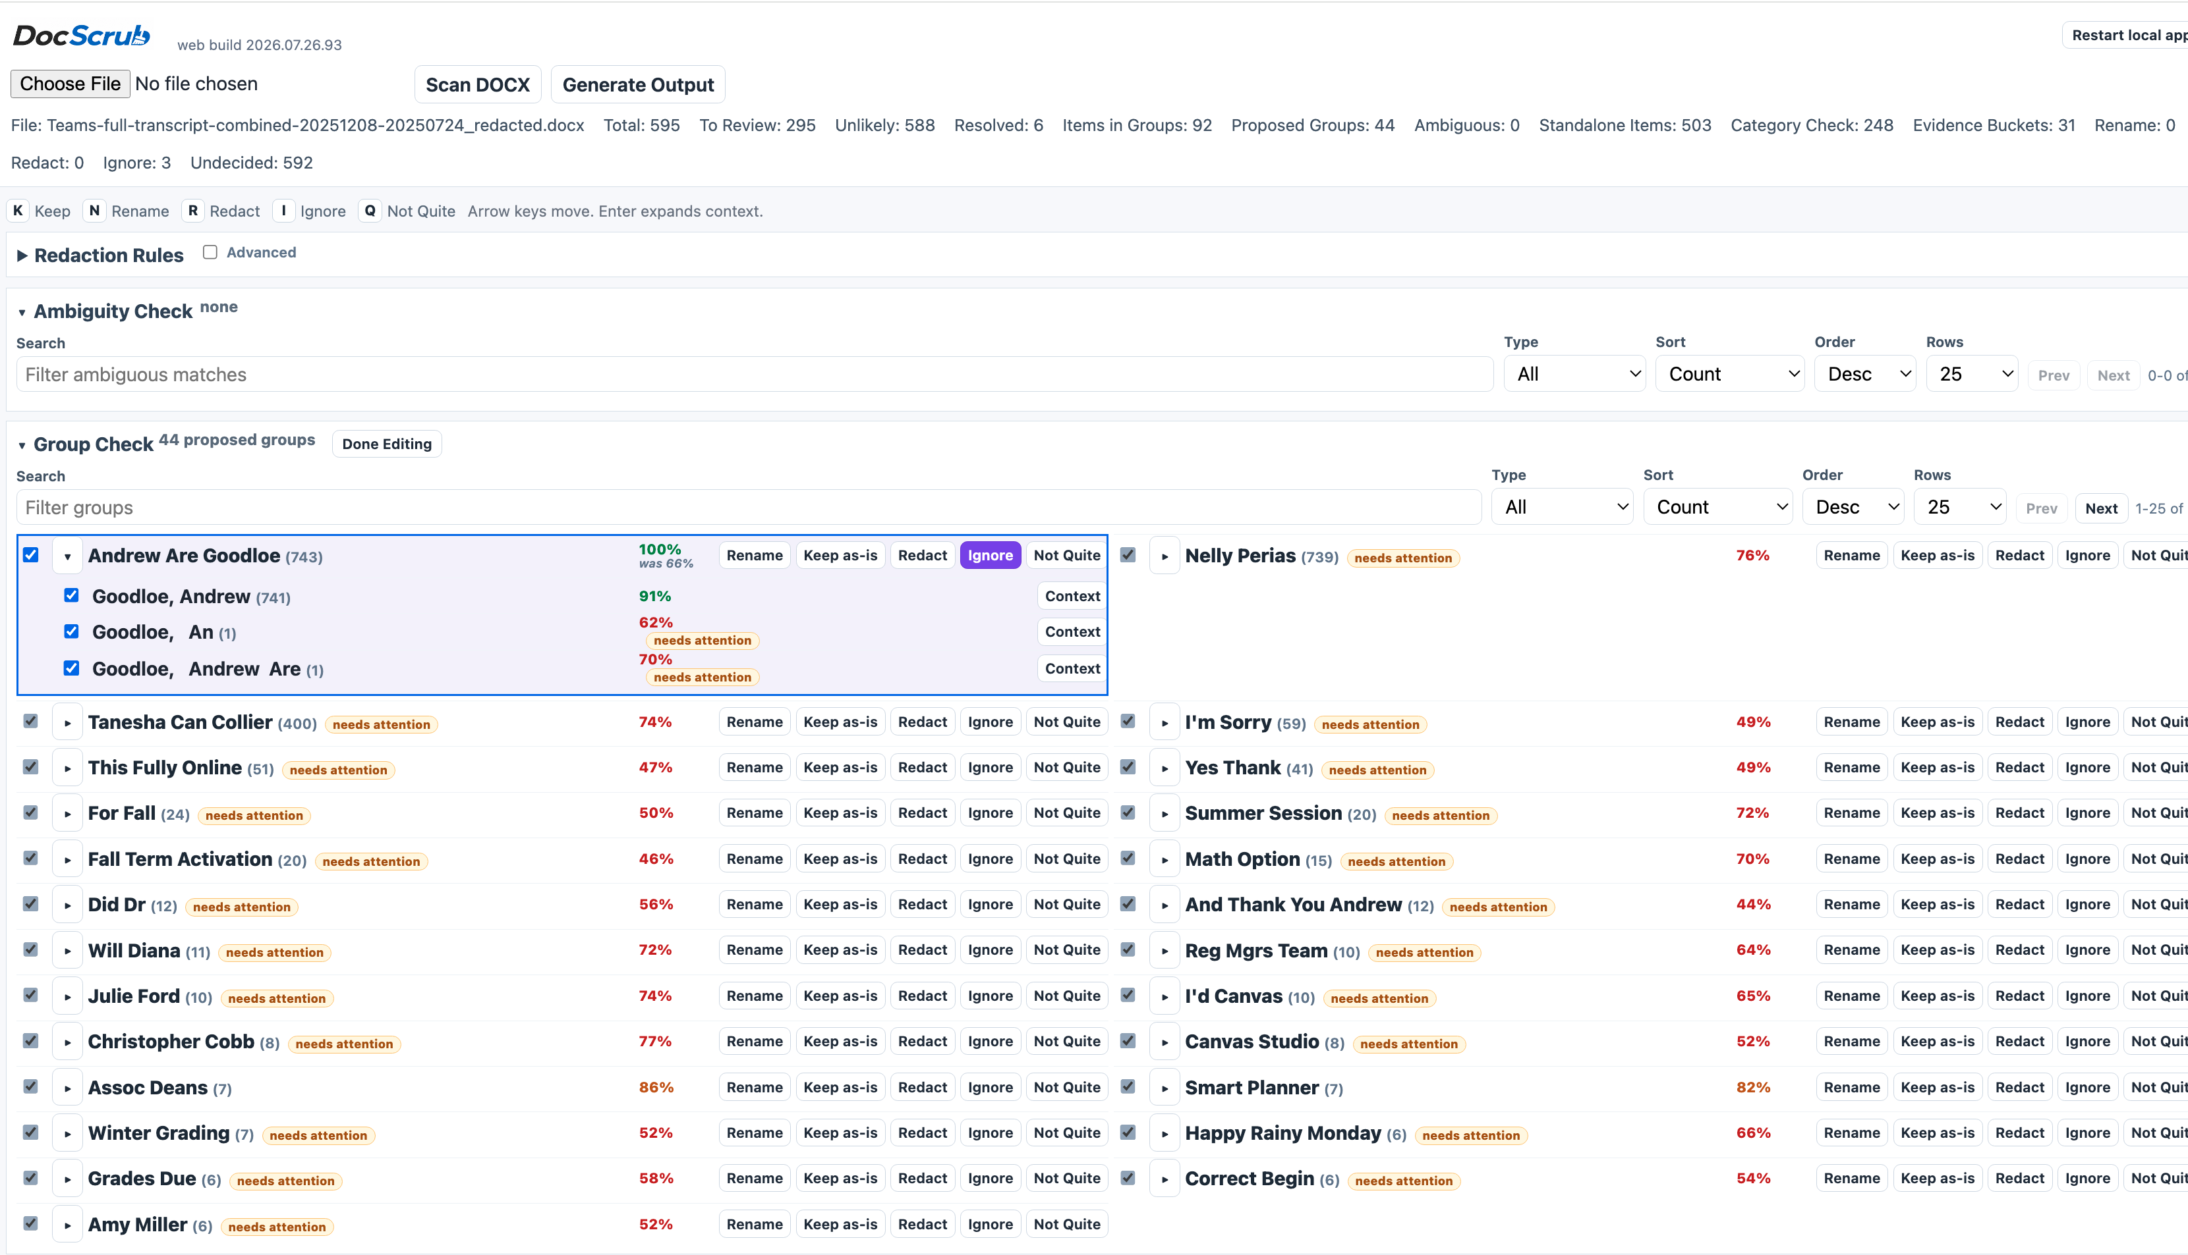
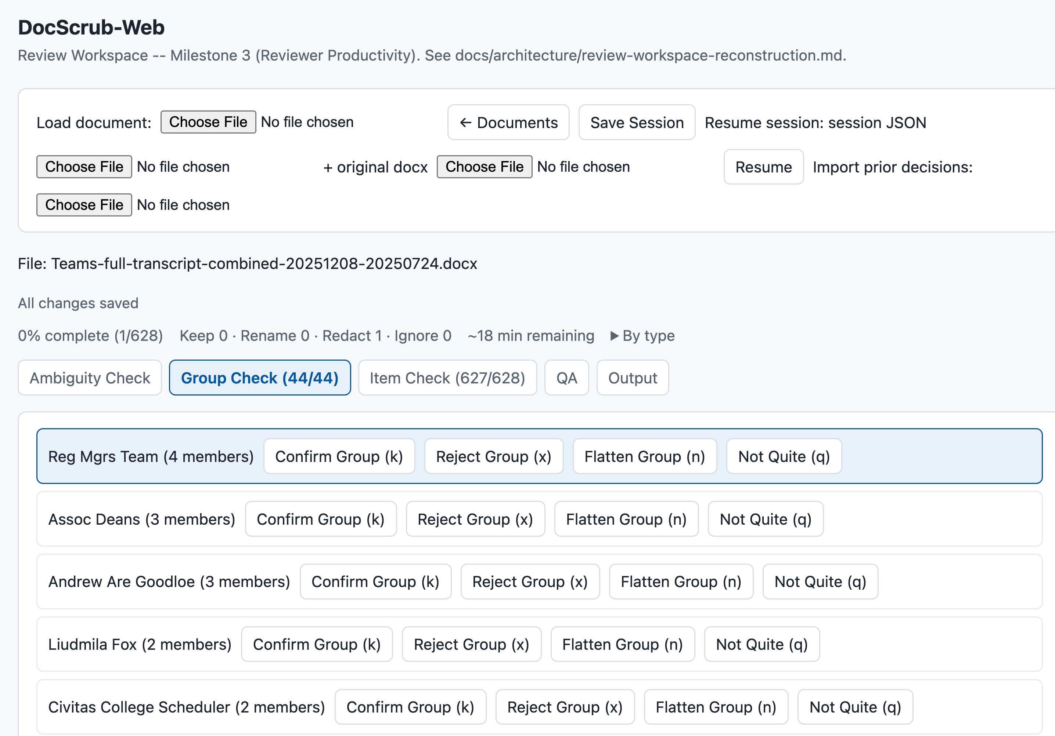
- Two column layout when large enough to justify it.
- Rows are not bounded by boxes. More compact layout allows for more to be visible, particularly when the secondary Results panel is to be seen.
- Counts are a simple number that shows the total occurrence count, not the number of matches.
- Checkboxes exist on left of each item to allow for multi-select, as well as a “select all” option.
- Space bar expands/collapse selected item. Tab, shift+tab advances and goes back through the items sequentially, preserving state – that is, if the item is open, browsing to the next item automatically opens the new one and closes the former one. The default browsing state for a selected item should be open, encouraging review of that item.
- “needs attention” is a fairly quiet pill next to the name
- The score is listed, color-coded by likelihood, at top-level. While default sort is by frequency, this is another sort option.
- The buttons are Rename, Keep as-is, Redact, Ignore, Not Quite. – flatten and reject etc are not terms we decided upon. The buttons do not contain the keystroke embedded – this is visible in the commander bar instead. This reduces visual clutter and compresses the layout.
- A lot of work to make this visually quieter was done – sizing, colors etc.
- Nav behavior is standardized in all “cells”, i.e. areas with items to review. That should be clearly documented in the Python-based docs.
- While I was interested in improving cosmetic elements of the UI, I was fairly satisfied with how it was behaving. It was getting efficient, it was compact, and it was fast. We want that.
- Category Check and the Results had specific navigation models to allow shift + arrows to nav categories but just arrows to nav the results. There are tons of bits like this that really make a difference and will be outlined in the Commander bar.
- Arrow behavior has specific contextual powers. It navigates between items, but it can also navigate within an open item. The key shortcuts also get short-circuited when navigating to a text input field.
- Thought went into these layouts. Compact, navigable with arrows, color coded with specific types of colors and saturations etc, functions for processing and Accepting items.
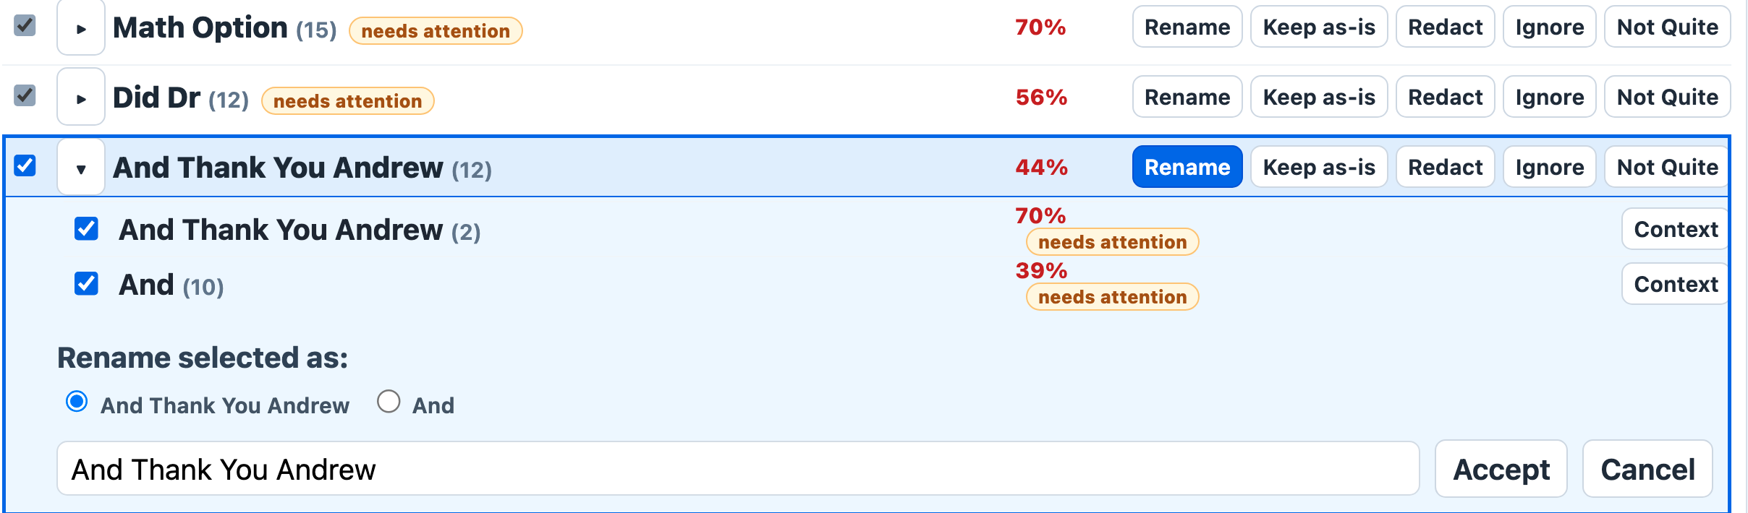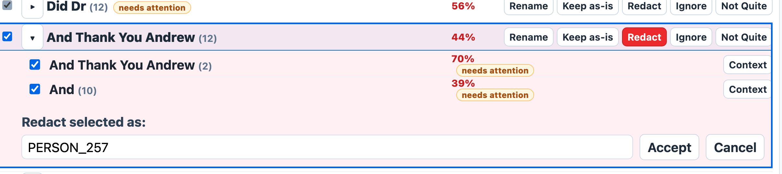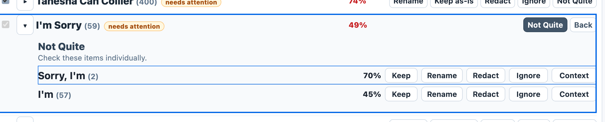
- Example of the commander bar:
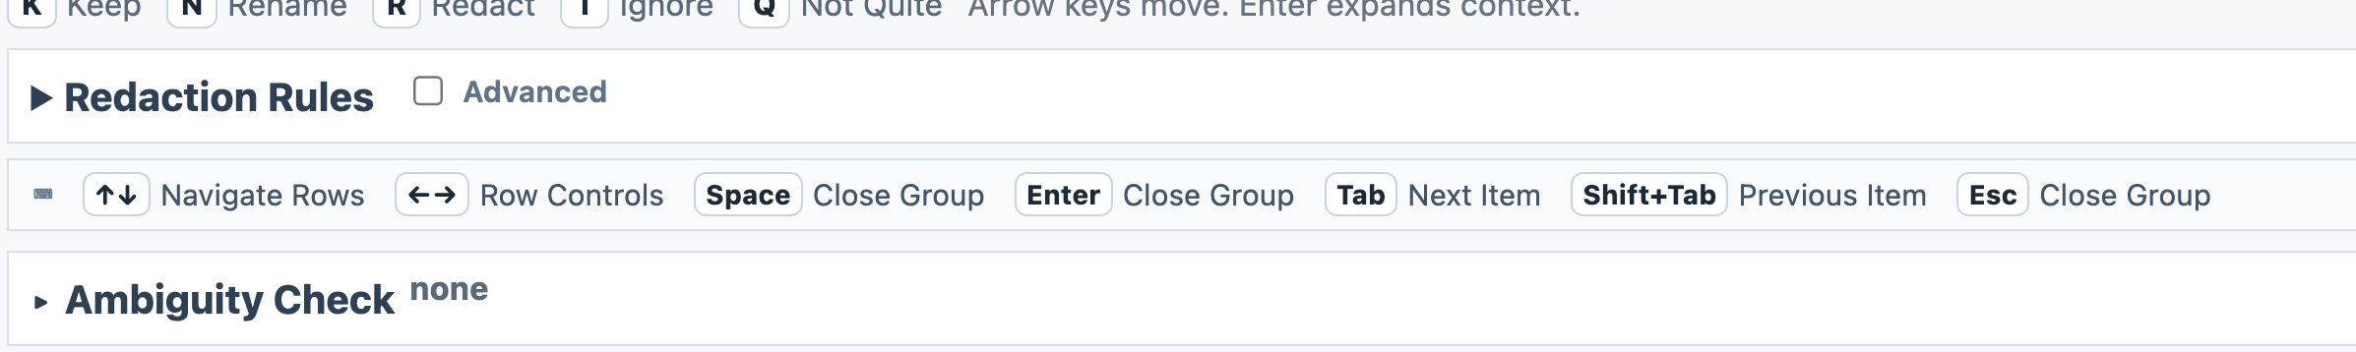
- Redaction Rules were never sussed out for placement and location. They should not be as they are in the Python version.
- The detail section of this is solid., The header area is not clean. But the part expanded for Perias, Nelly is good. 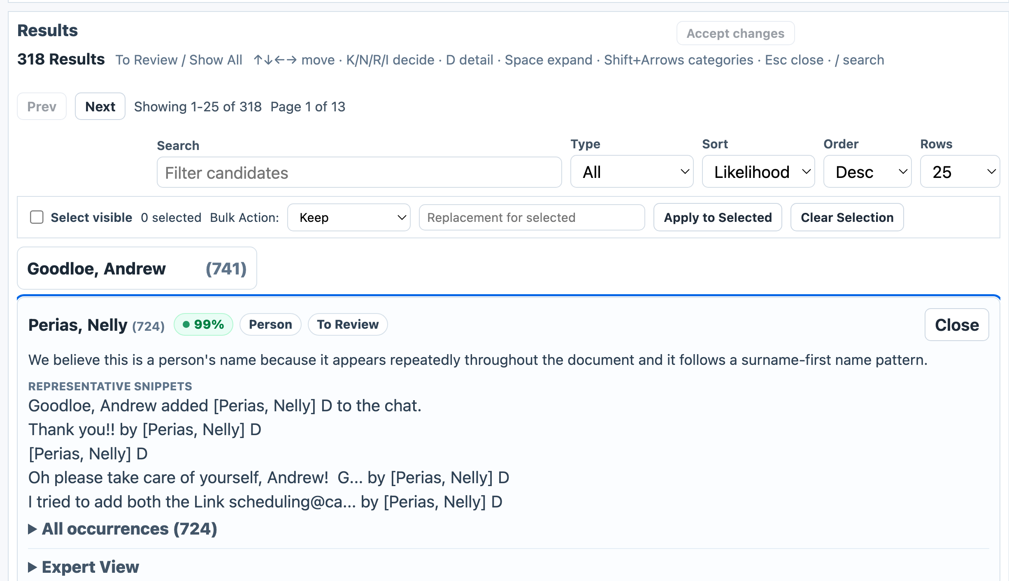
- Specific categorization rules allows for very broad and useful categories for the evidence presented. We don’t want 75 categories here. This was well defined. 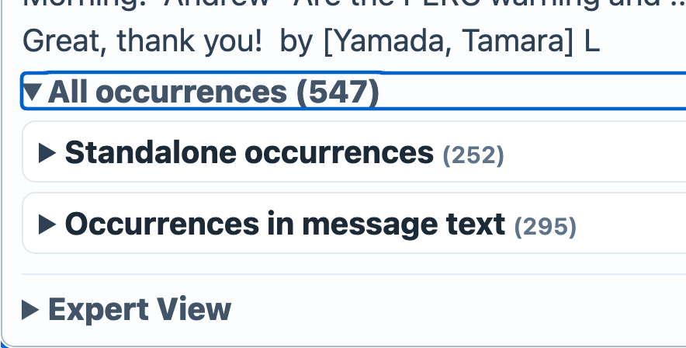
- Expert mode is actually surprisingly solid here and I want to retain it.
- 