Appendix

Nozzle Initial Designs
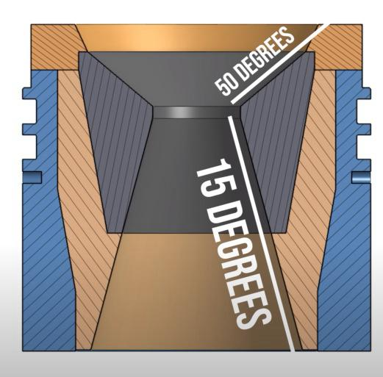
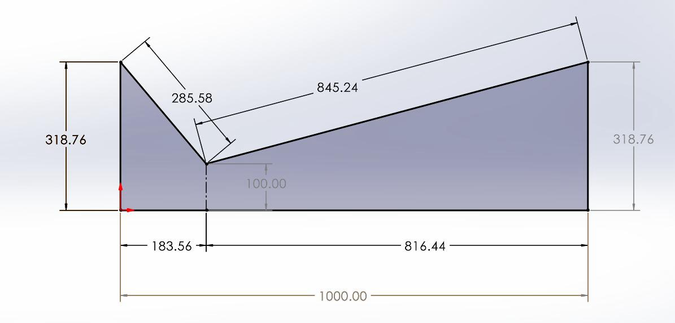
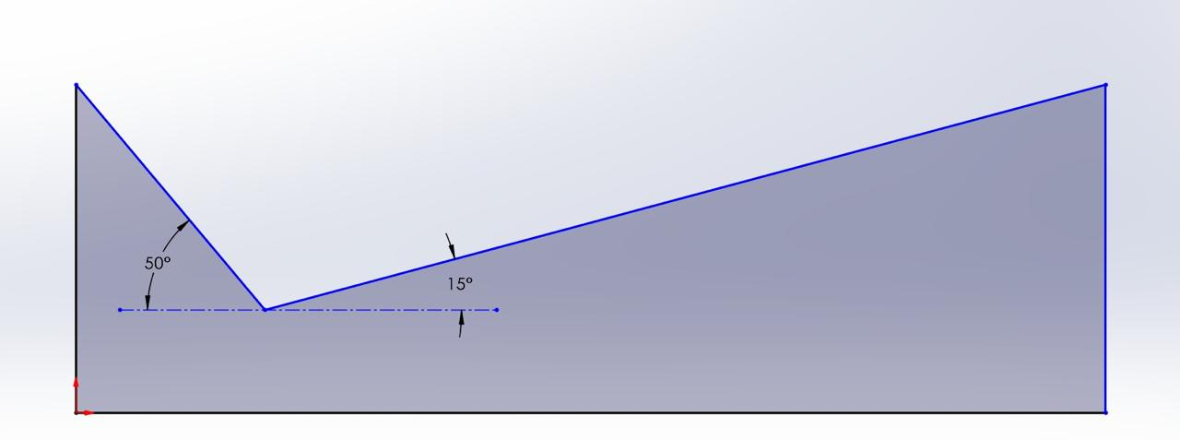

Nozzle Mesh Study

Mesh at 75,000 Nodes
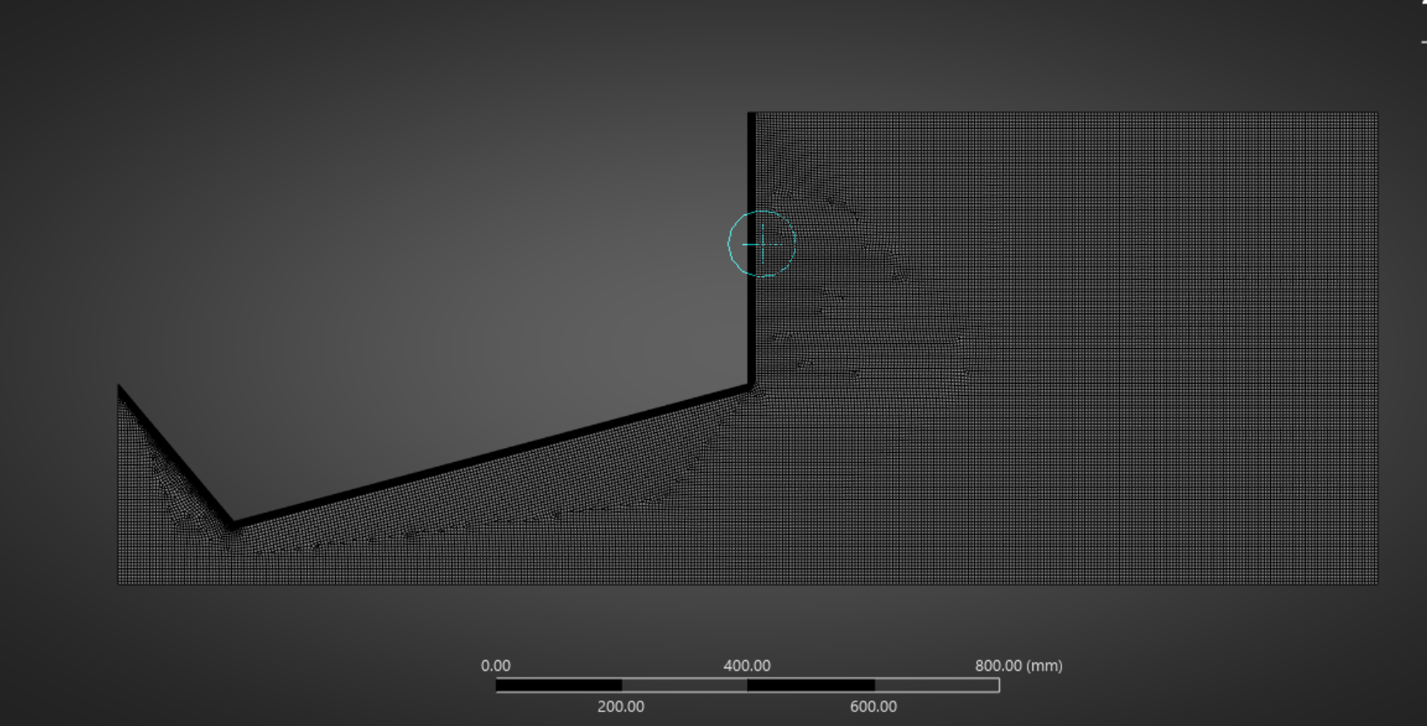
Figure 1: Mesh
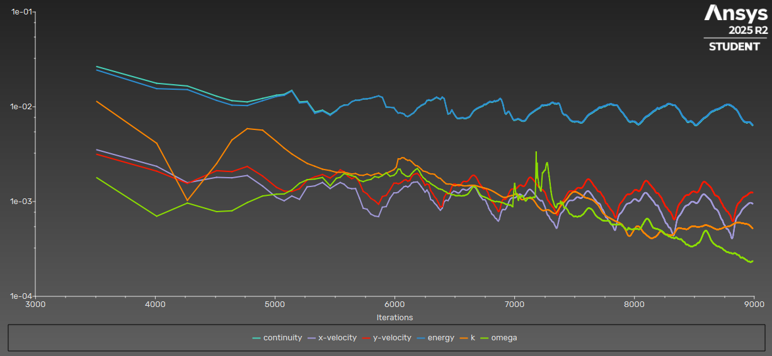
Figure 2: Scaled Residuals.
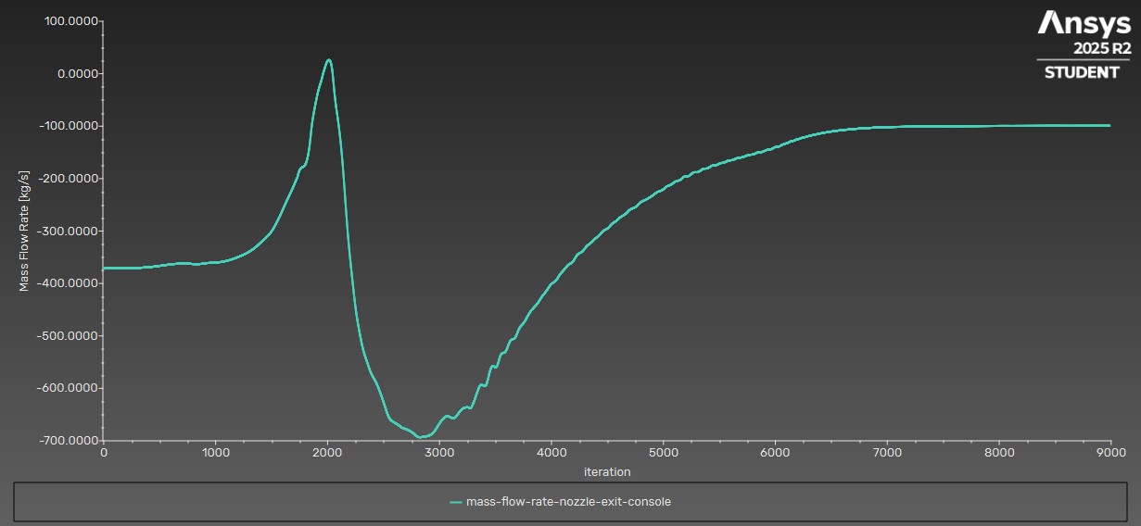
Figure 3: Mass flow rate (Kg/s).
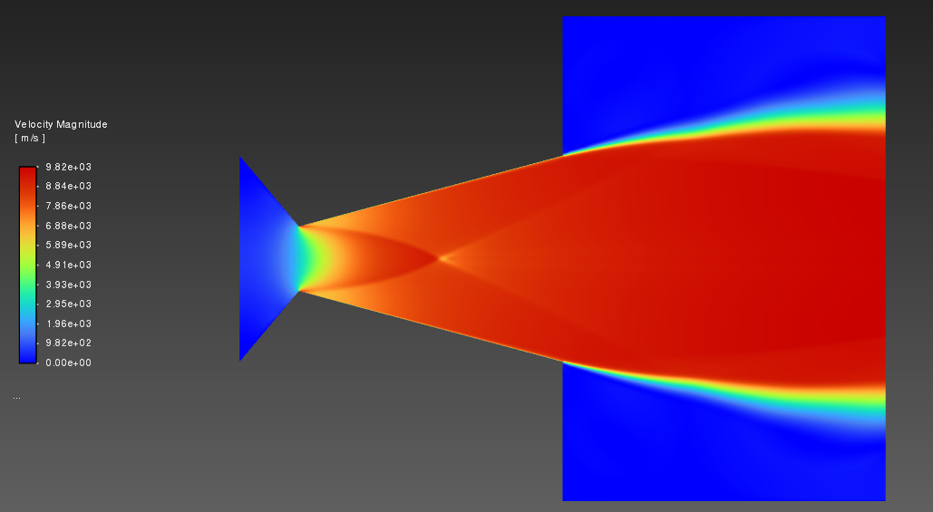
Figure 4: Velocity (m/s).
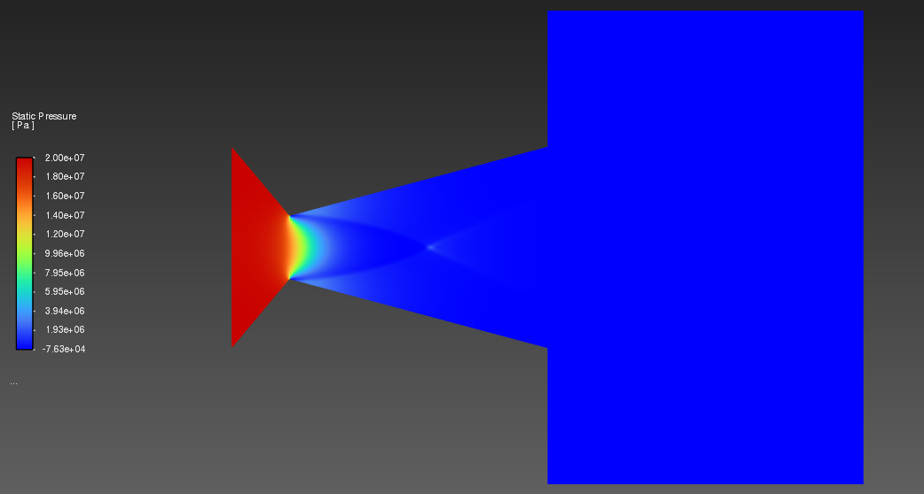
Figure 5: Pressure (Pa).
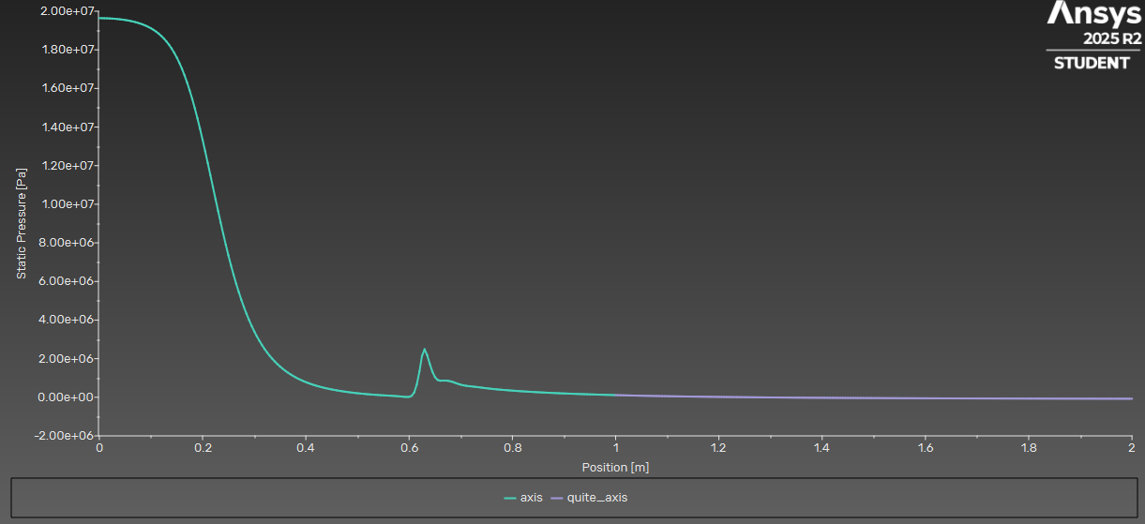
Figure 6: Pressure along the axis (Pale green is the nozzle axis, and Pale purple is the Quiet area, i.e. area outside the nozzle's axis).
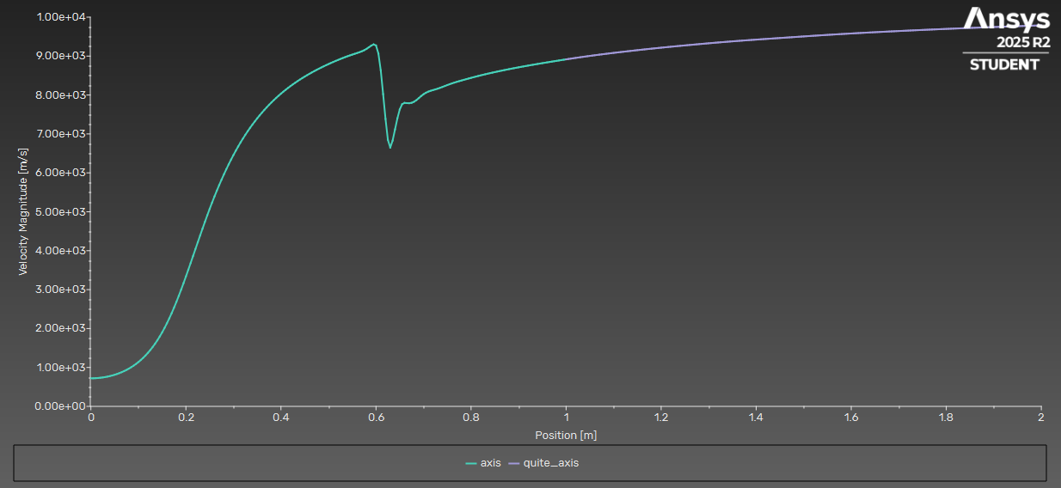
Figure 7: Velocity along the axis (Pale green is the nozzle axis, and Pale purple is the Quiet area, i.e. area outside the nozzle's axis).

Mesh at 35,000 Nodes
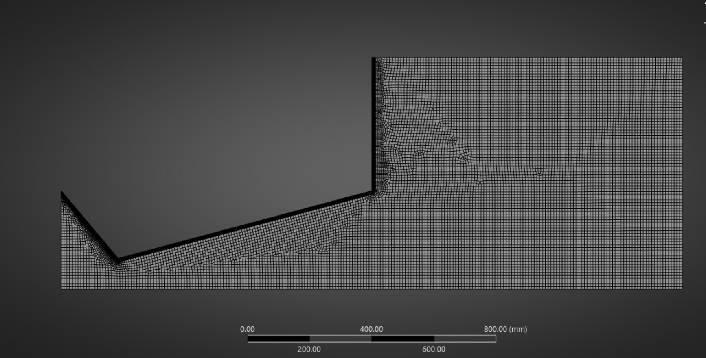
Figure 8: Mesh

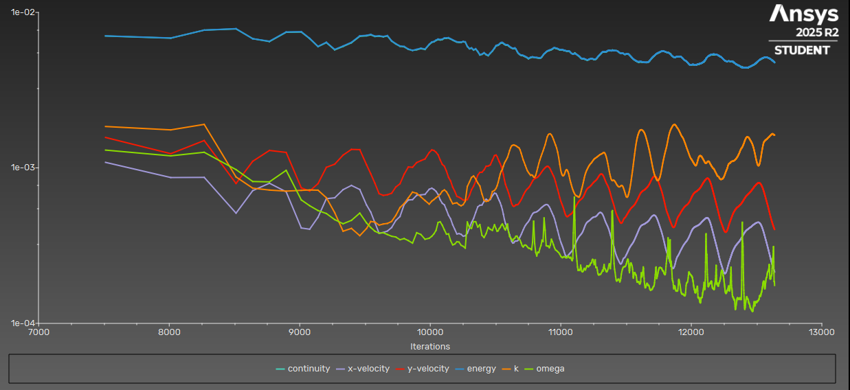
Figure 9: Scaled Residuals.
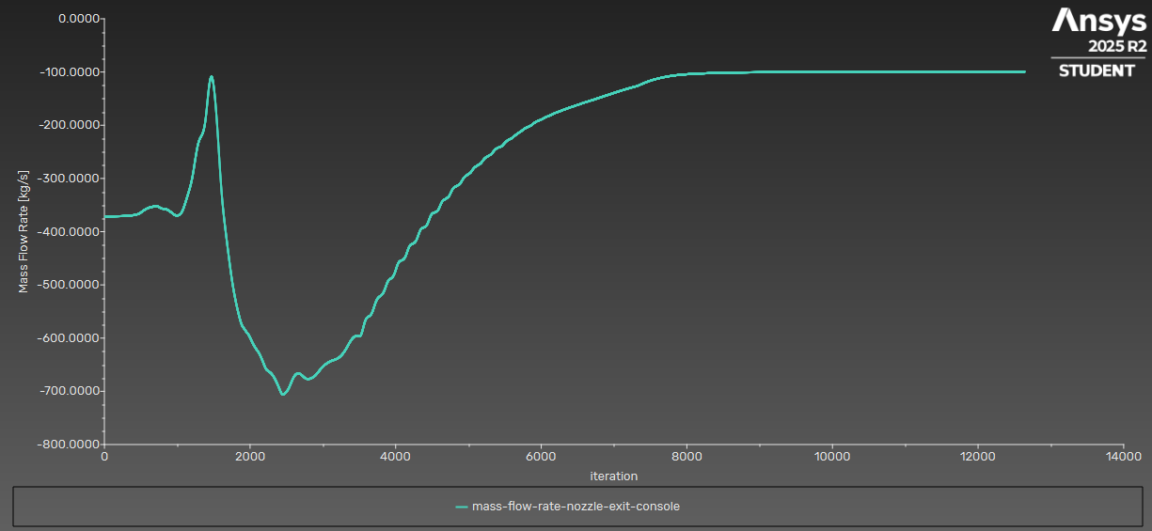
Figure 10: Mass flow rate (Kg/s).

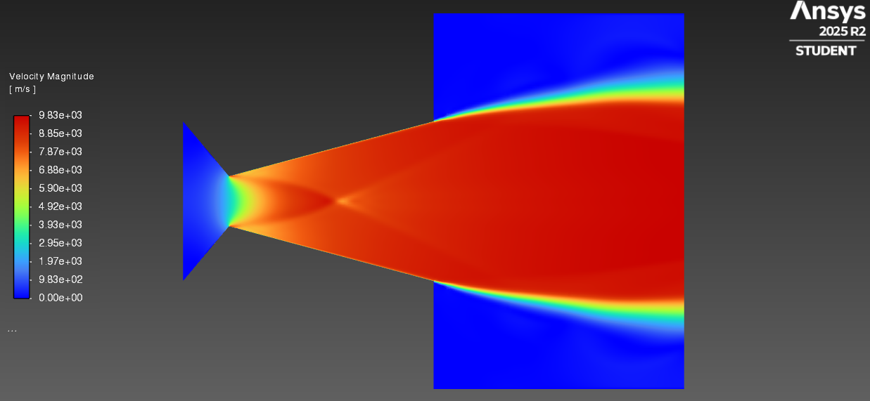
Figure 11: Velocity (m/s).

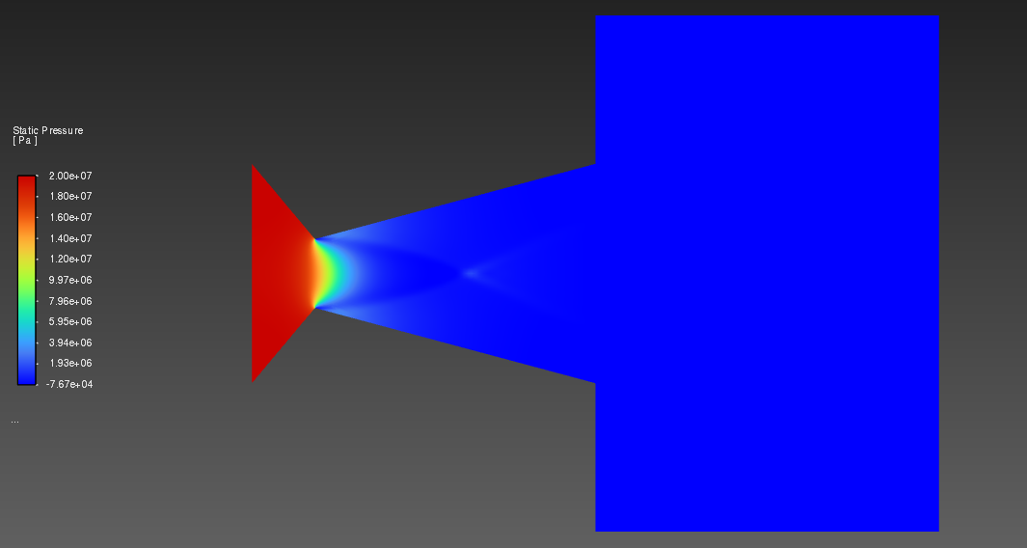
Figure 12: Pressure (Pa).
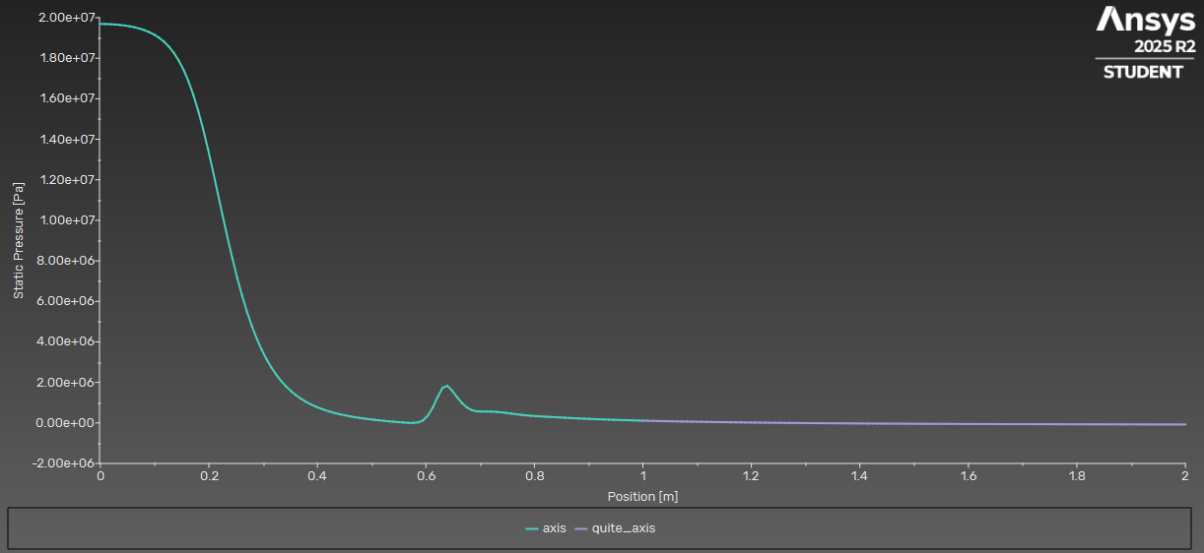
Figure 13: Pressure along the axis (Pale green is the nozzle axis, and Pale purple is the Quiet area, i.e. area outside the nozzle's axis).
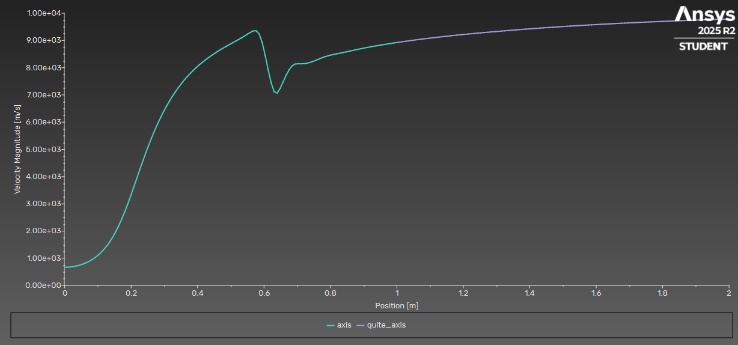
Figure 14: Velocity along the axis (Pale green is the nozzle axis, and Pale purple is the Quiet area, i.e. area outside the nozzle's axis).

Mesh at 9,500 Nodes
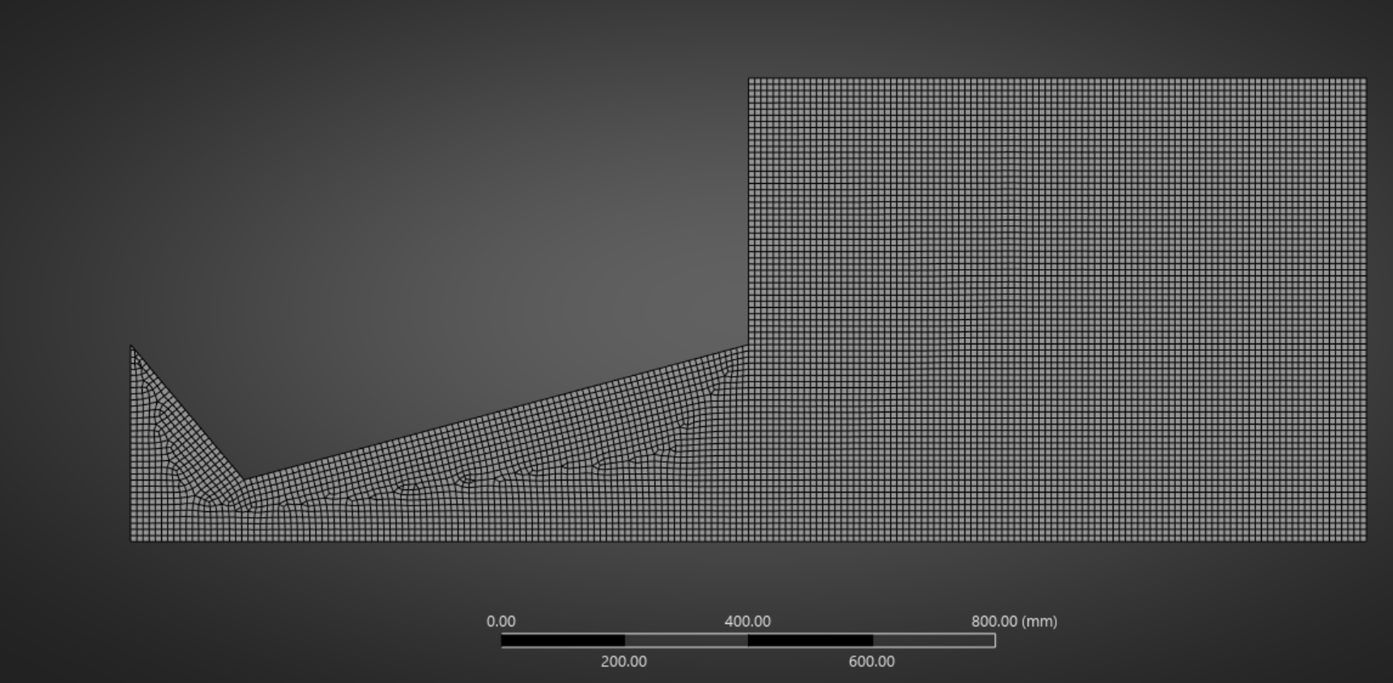
Figure 15: Mesh.
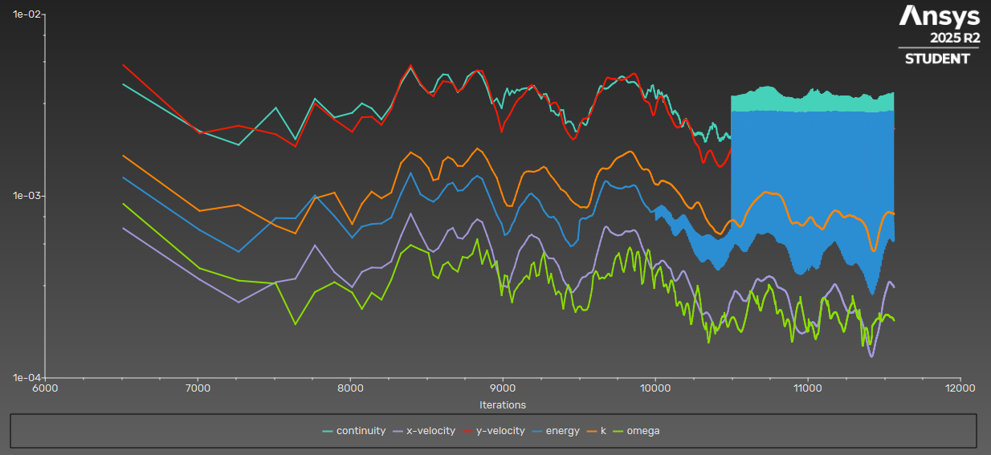
Figure 16: Scaled residuals.
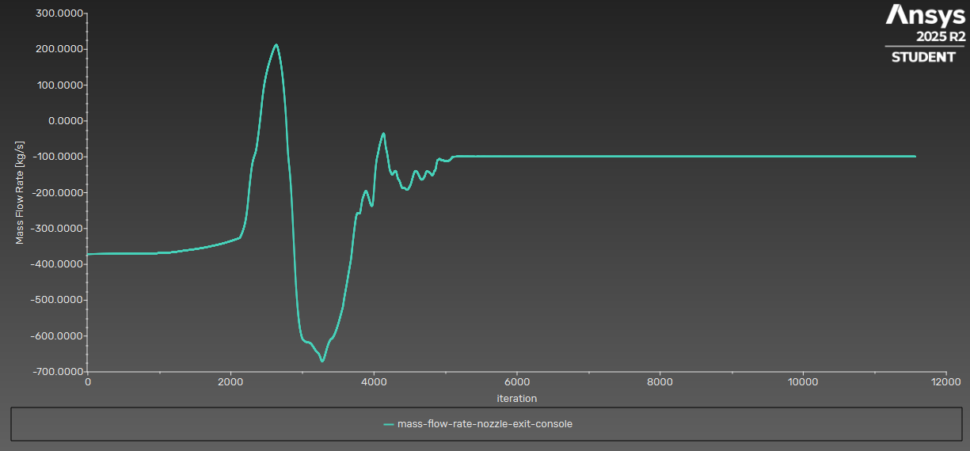
Figure 17: Mass flow rate (Kg/s).
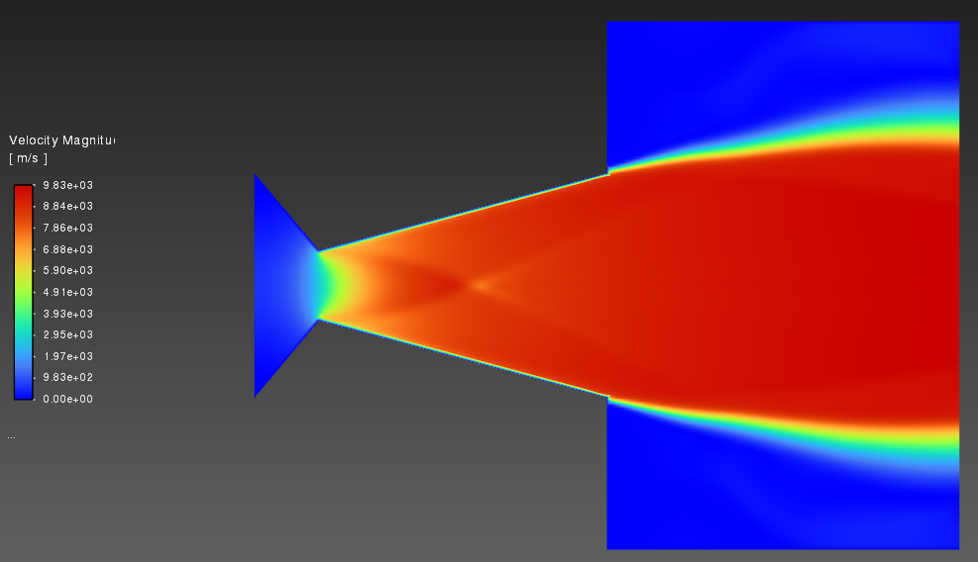
Figure 18: Velocity (m/s).
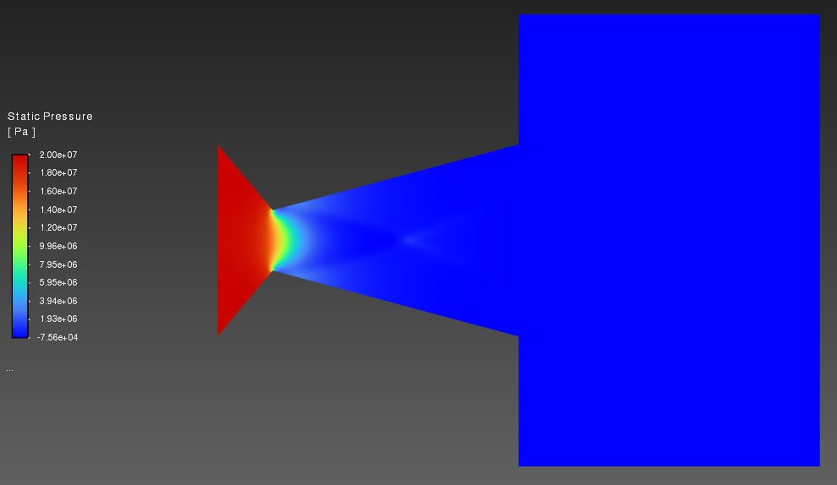
Figure 19: Pressure (Pa).
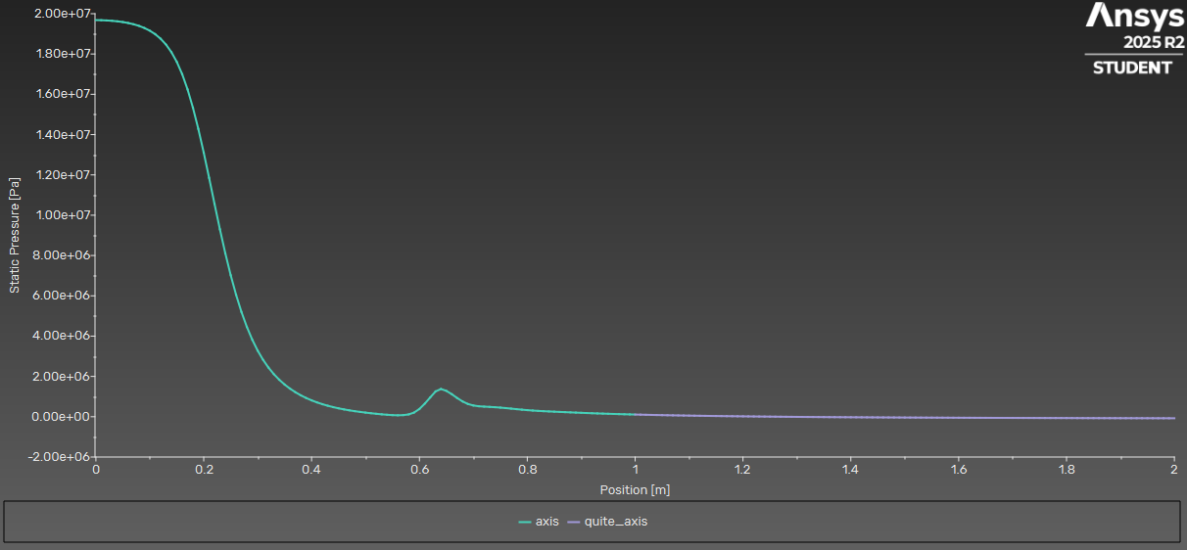
Figure 20: Pressure along the axis (Pale green is the nozzle axis, and Pale purple is the Quiet area, i.e. area outside the nozzle's axis).
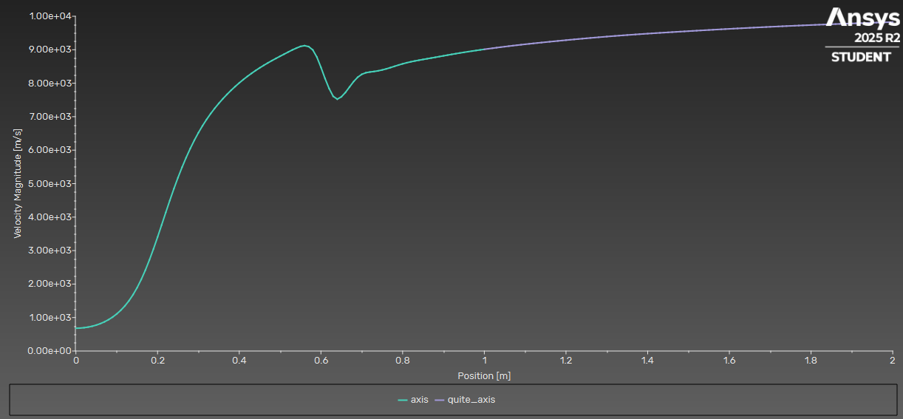
Figure 21: Velocity along the axis (Pale green is the nozzle axis, and Pale purple is the Quiet area, i.e. area outside the nozzle's axis).

Extra Contours for Nozzle from Ansys
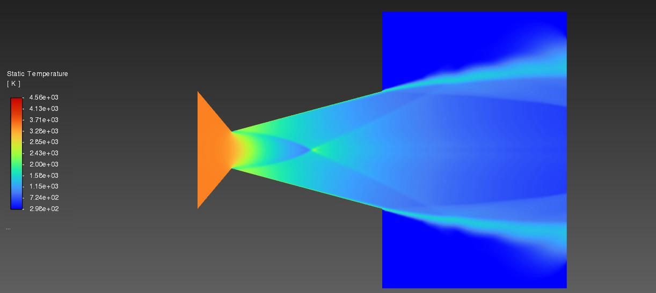
Figure 22: Temperature Contours.
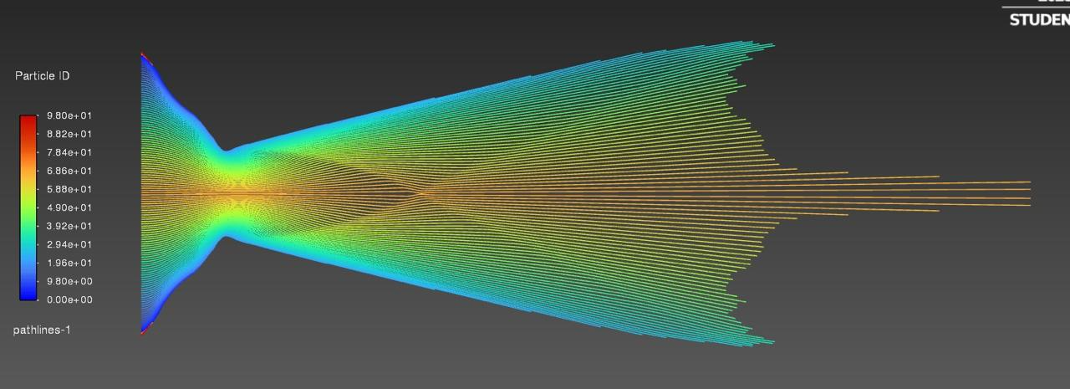
Figure 23: Velocity Particle ID.
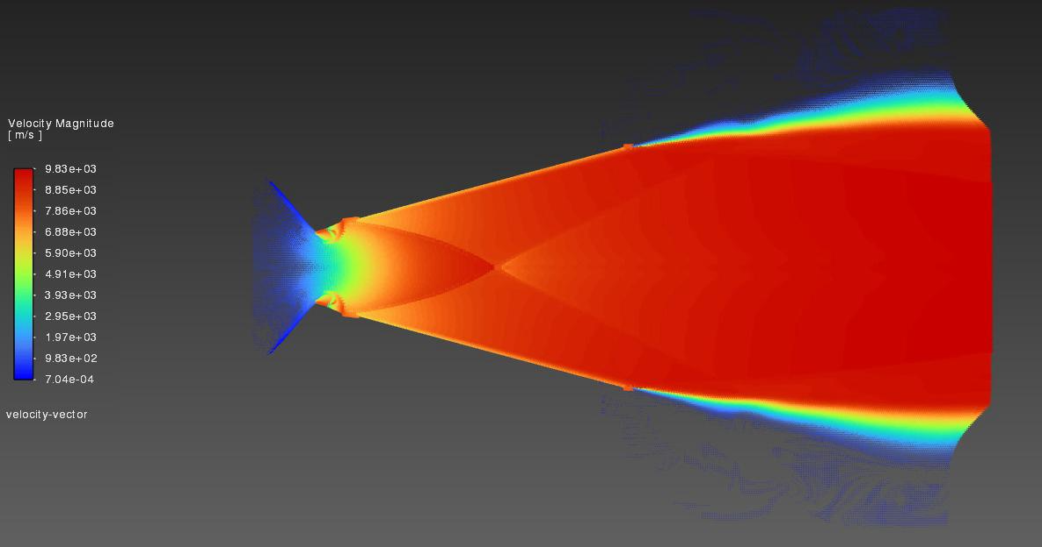
Figure 24: Velocity Magnitude (m/s).

Fatigue Tests When Convection Film Coefficient (h) is 0.03, i.e. 30,000 W/m²K.
- Mesh independence was validated for CFD results; structural and fatigue results were assumed mesh-independent due to minimal variation in stress distribution.
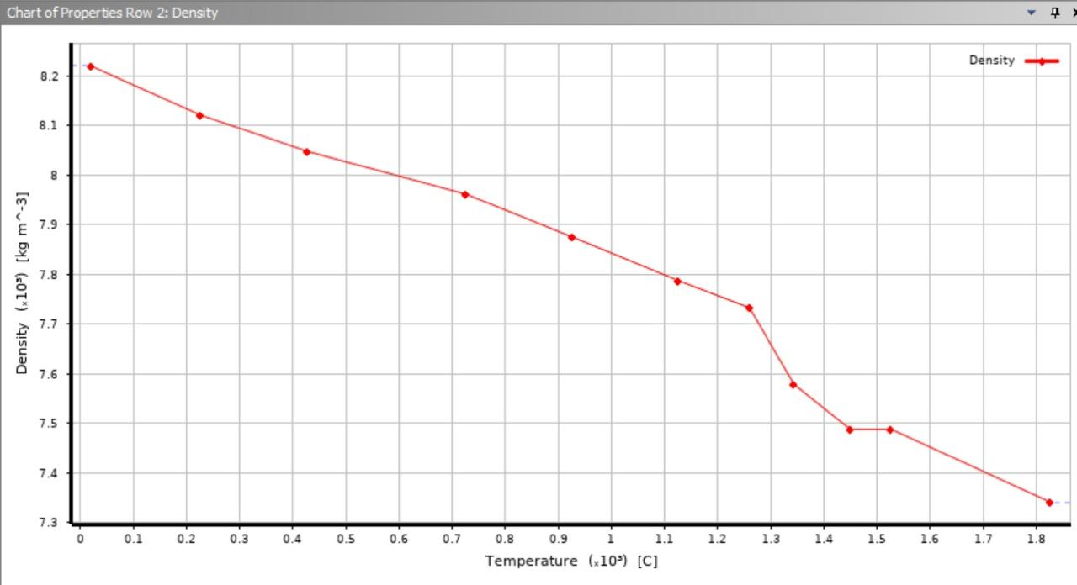
Figure 25: Insole 718 Properties.
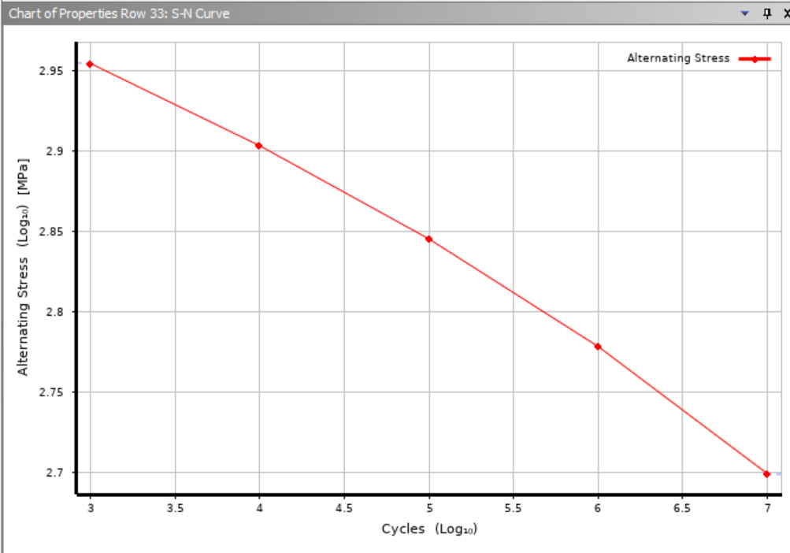
Figure 26: S-N Curve.
- The S–N curve follows a log-log linear relationship consistent with Basquin’s fatigue model.

Fatigue test at 20MPa
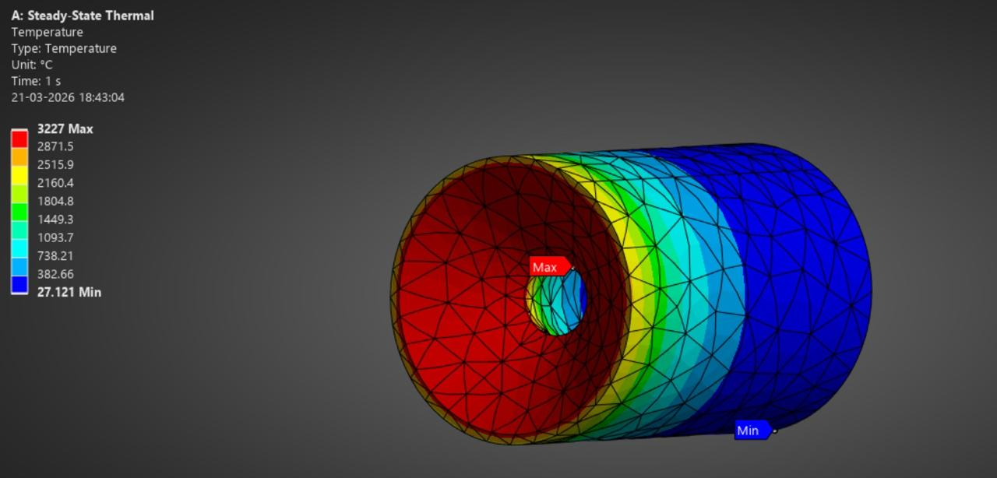
Figure 27: Nozzle Temperature.
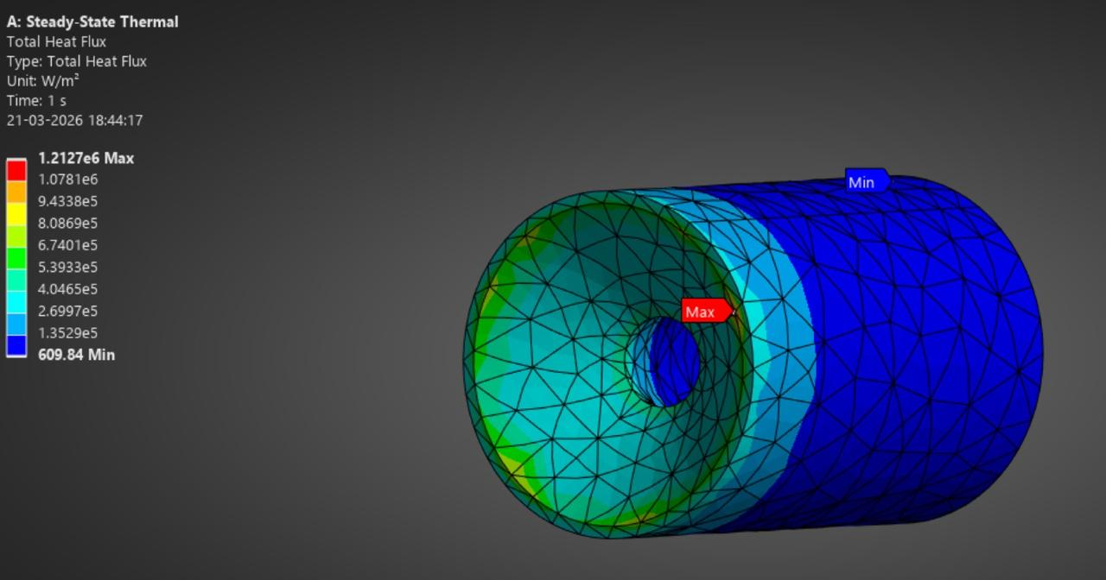
Figure 28: Total Heat Flux on Nozzle.
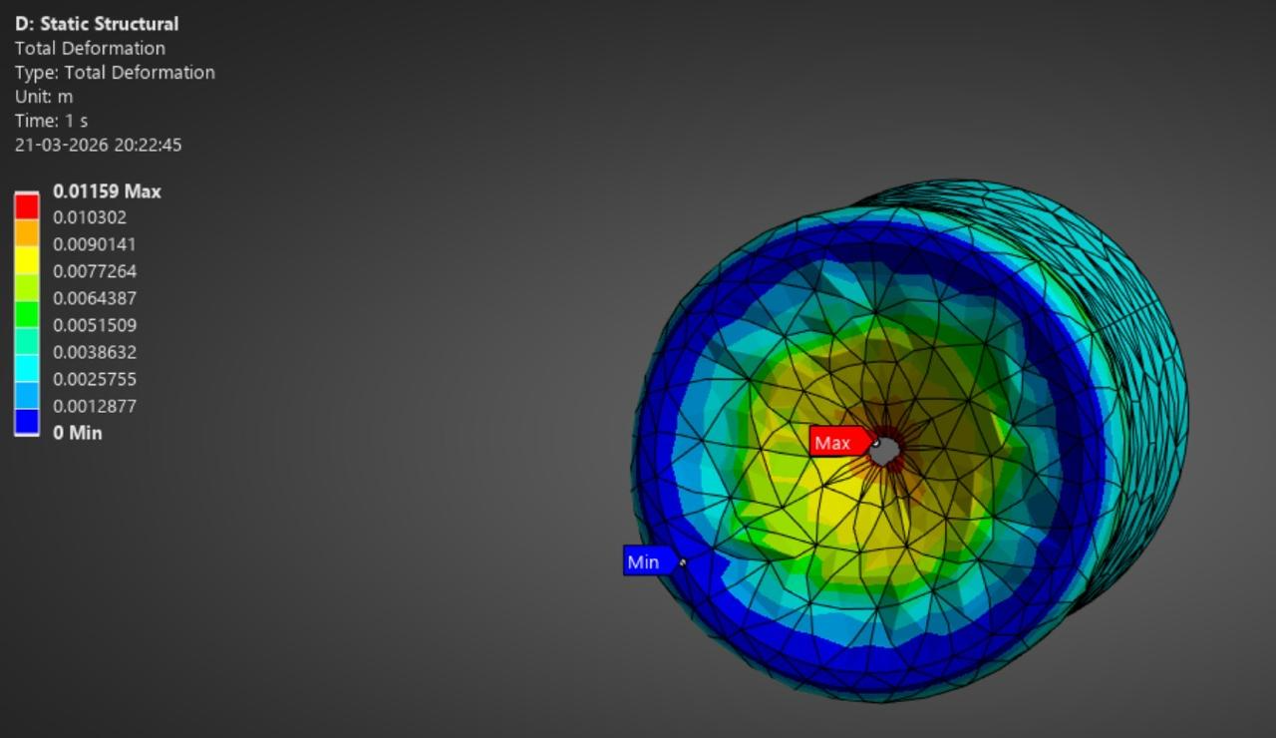
Figure 29: Total deformation on the nozzle.
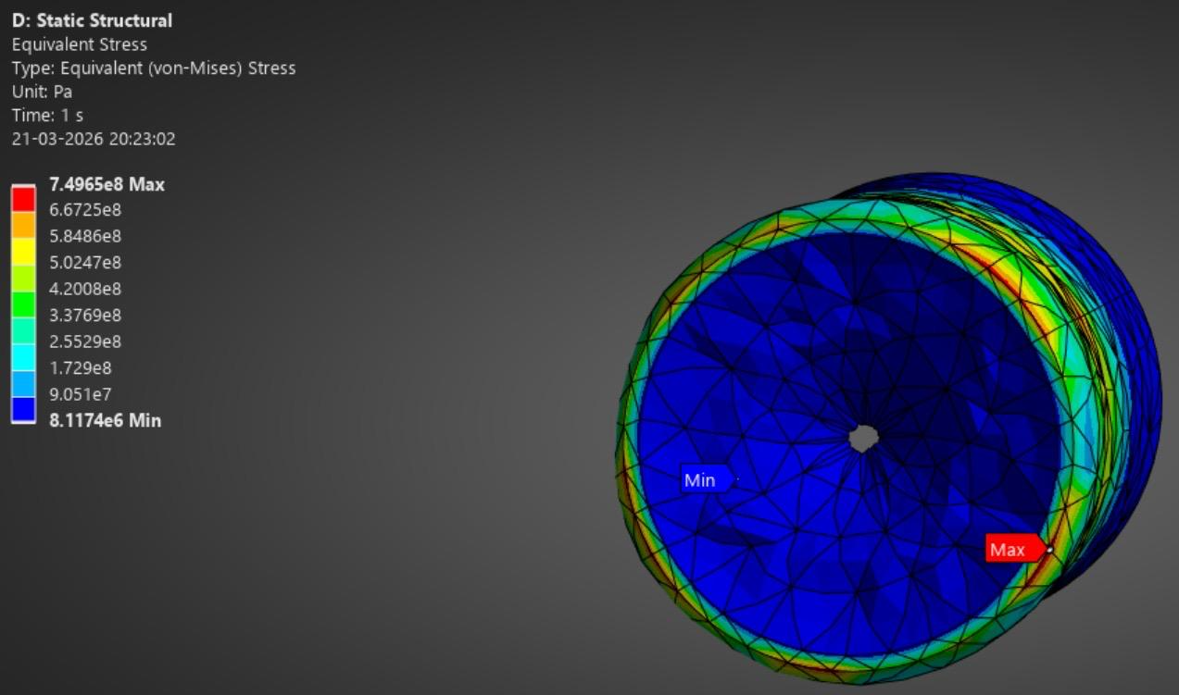
Figure 30: Nozzle Stress Results.
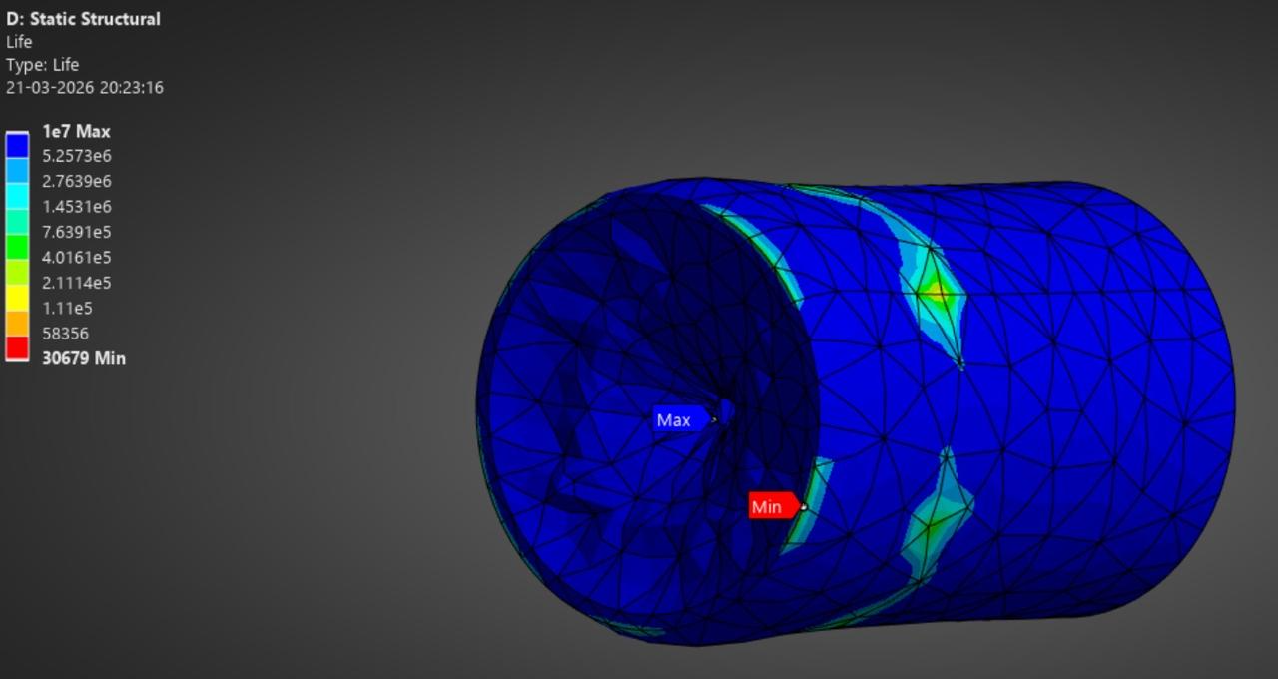
Figure 31: Nozzle Life.

Fatigue Test at 40MPa
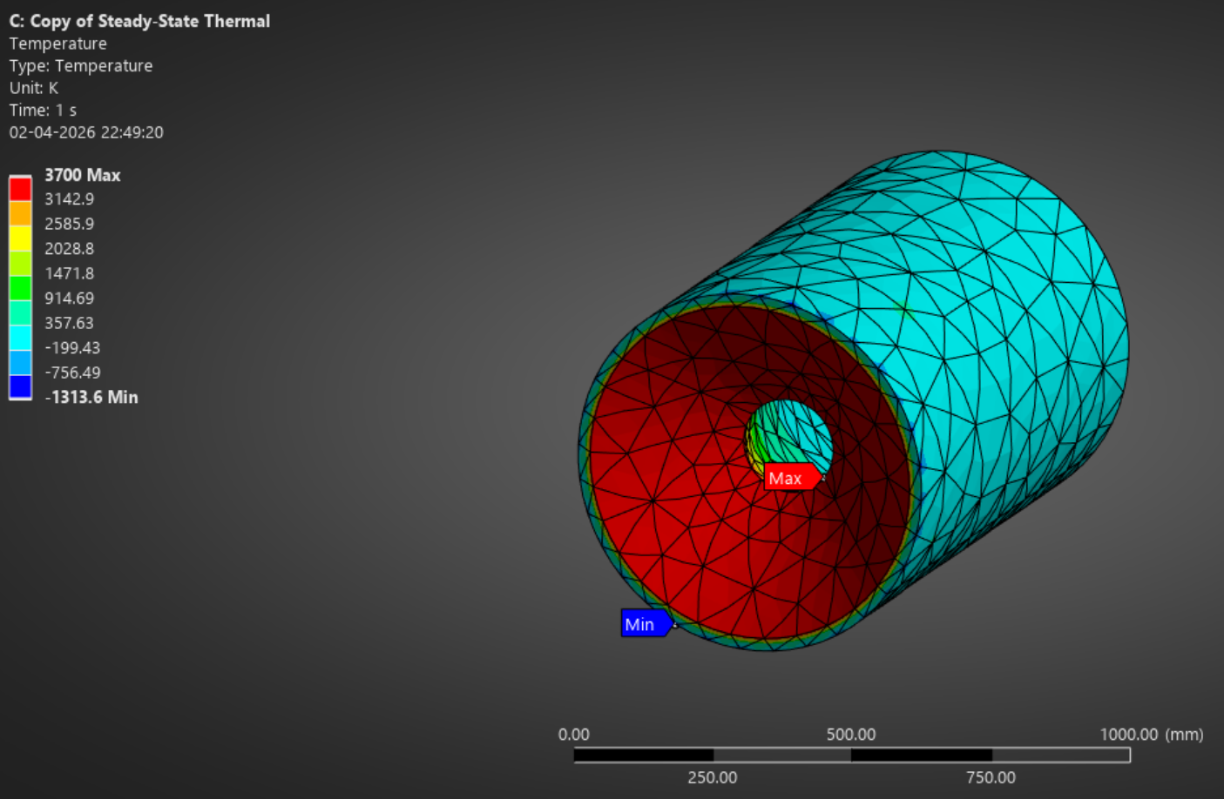
Figure 32: Temperature Results.
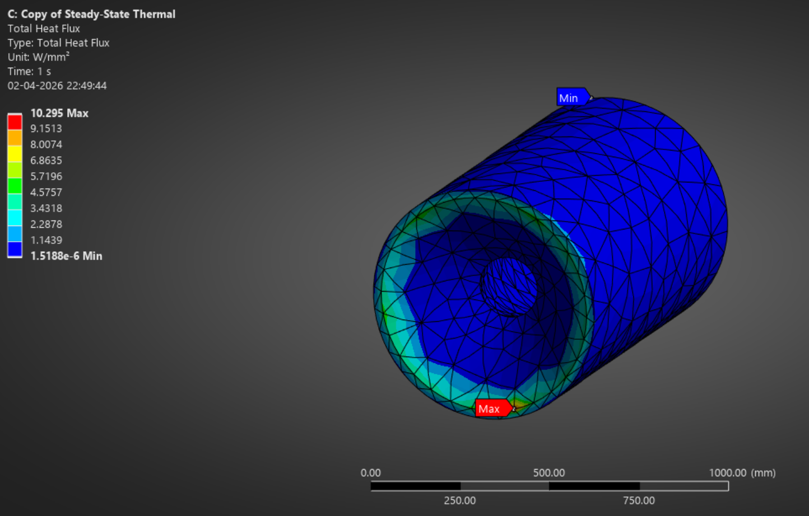
Figure 33: Total Heat Flux.
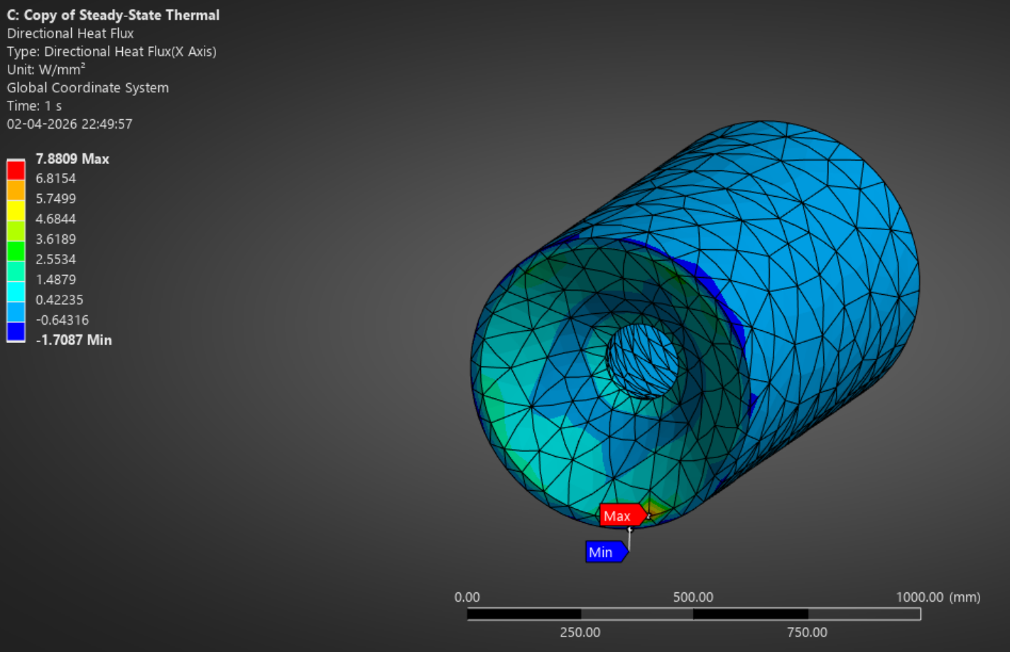
Figure 34: Directional Heat Flux.
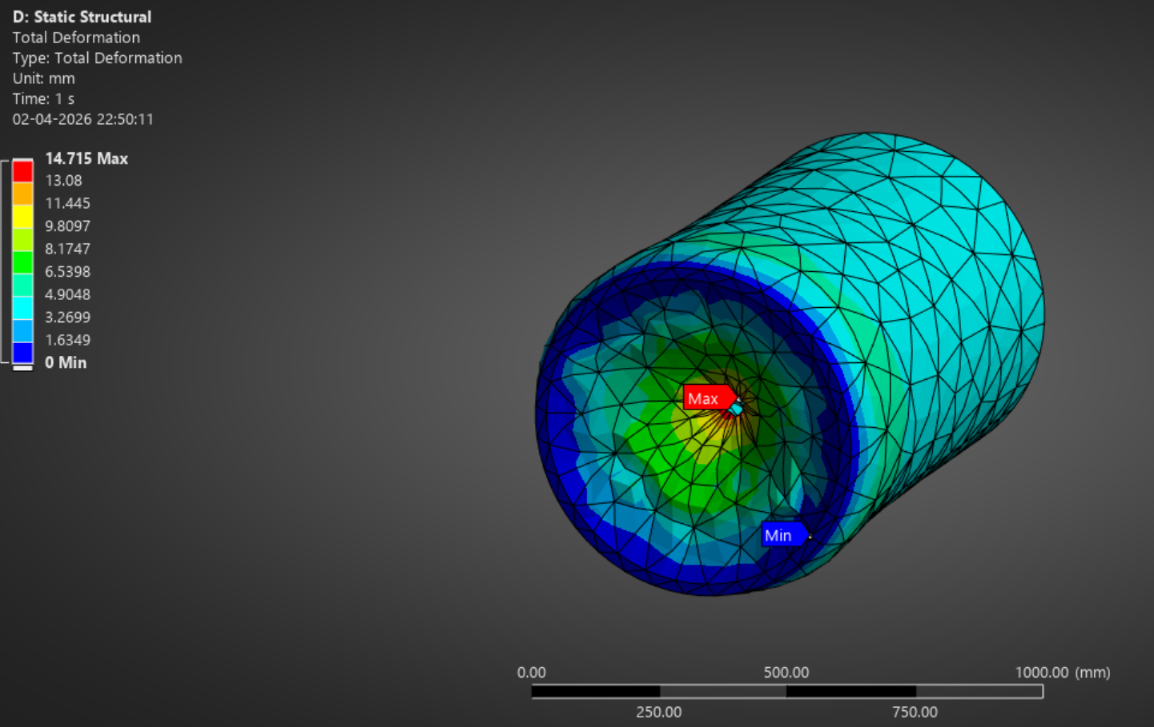
Figure 35: Total Deformation.
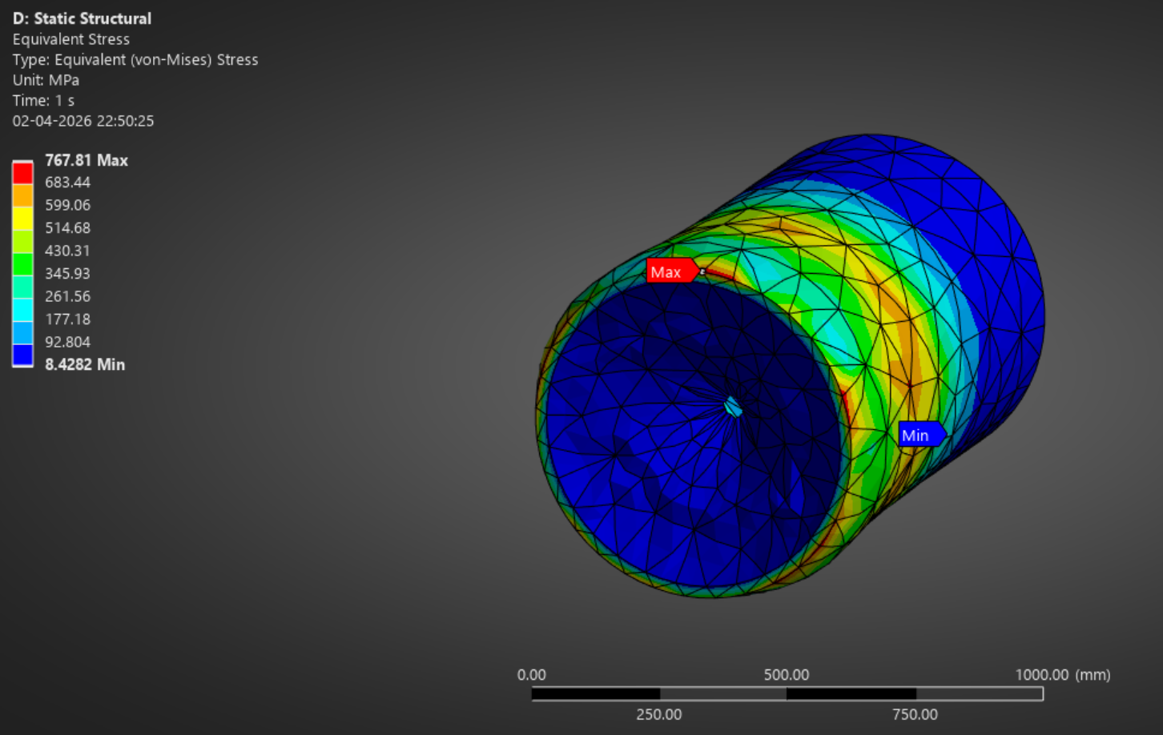
Figure 36: Equivalent Stress.
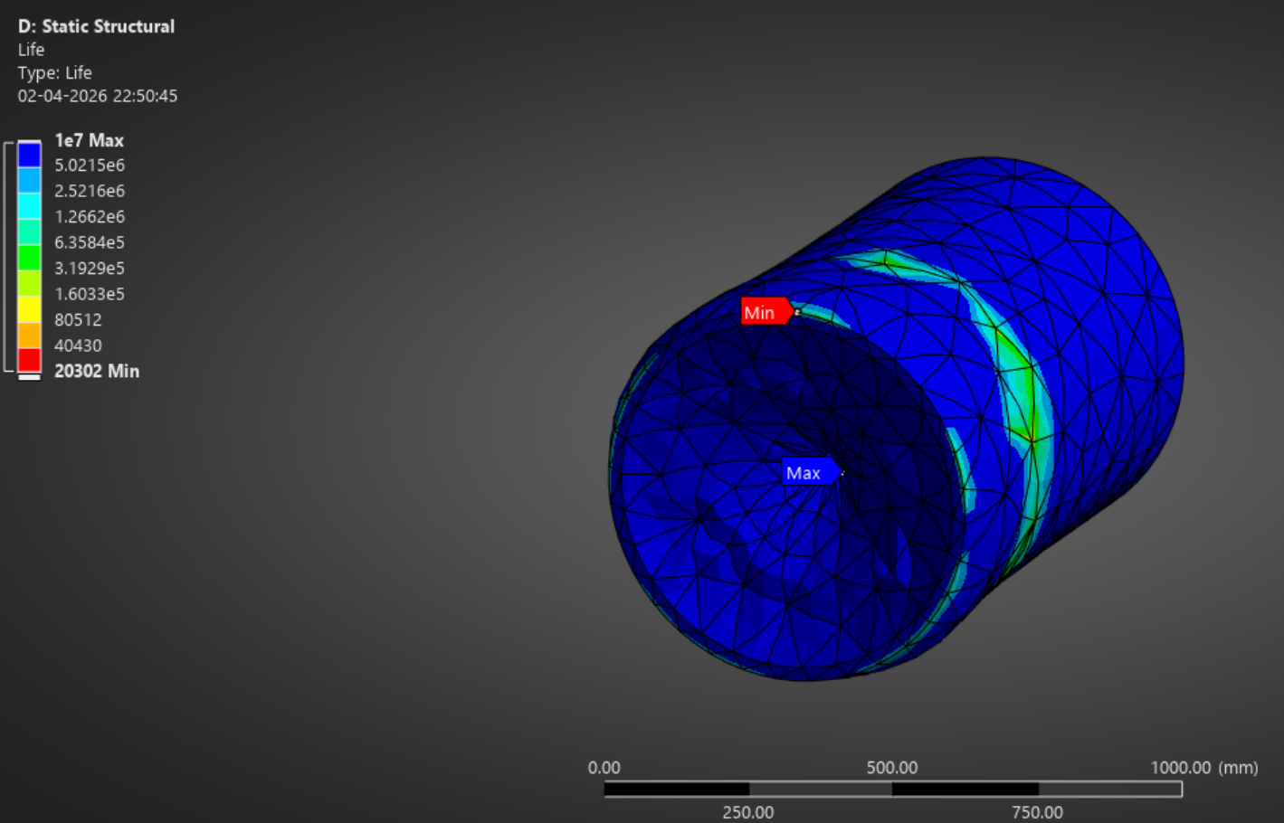
Figure 37: Nozzle Life.

MATLAB Codes
clc;
clear;

%% 1. Input Parameters
Pc = 40e6; % Chamber Pressure (Pa)
Tc = 5000; % Chamber Temperature (K)
Pa = 101325; % Ambient Pressure (Pa)
R = 4124; % Gas Constant for H2 (J/kg*K)
gamma = 1.3; % Heat Capacity Ratio
Rt = 0.1; % Throat Radius (m)
epsilon = 20.25; % Expansion Ratio (Ae/At)
total_mass = 140000; % Total Rocket Mass (kg)
g = 9.81; % Gravity (m/s^2)

%% 2. Geometric Calculations
At = pi * Rt^2; % Throat Area
Ae = epsilon * At; % Exit Area

%% 3. Throat Conditions
Tt = Tc * (2 / (gamma + 1));
Vt = sqrt(gamma * R * Tt);

%% 4. Mass Flow Rate (Choked Flow)
term1 = (At * Pc) / sqrt(Tc);
term2 = sqrt(gamma/R * (2/(gamma+1))^((gamma+1)/(gamma-1)));
mdot = term1 * term2;

%% 5. Solve for Exit Mach Number (Area-Mach Relation)
area_mach_eq = @(M) (1./M) .* ((2/(gamma+1)) .* ...
(1 + (gamma-1)/2 .* M.^2)).^((gamma+1)/(2*(gamma-1))) - epsilon;

Me = fzero(area_mach_eq, 4); % Supersonic guess

%% 6. Exit Conditions
Te = Tc / (1 + (gamma-1)/2 * Me^2);
Ve = Me * sqrt(gamma * R * Te);

% Exit Pressure (Isentropic relation)
Pe = Pc * (1 + (gamma-1)/2 * Me^2)^(-gamma/(gamma-1));

%% 7. Thrust Calculation (FULL EQUATION)
Momentum_Thrust = mdot * Ve;
Pressure_Thrust = (Pe - Pa) * Ae;

Total_Thrust = Momentum_Thrust + Pressure_Thrust;

%% 8. Thrust-to-Weight Ratio
TWR = Total_Thrust / (total_mass * g);

%% 9. Mission Status Logic (Professional Version)
if TWR < 1
status = 'Insufficient thrust for liftoff';
elseif TWR < 1.2
status = 'Marginal liftoff (assisted launch recommended)';
else
status = 'Sufficient thrust for liftoff';
end

%% 10. Display Results
fprintf('--- Cryo-Stingray Performance Report ---\n');
fprintf('Mass Flow Rate: %.2f kg/s\n', mdot);
fprintf('Exit Mach Number: %.3f\n', Me);
fprintf('Exit Velocity: %.2f m/s\n', Ve);
fprintf('Exit Pressure: %.2f Pa\n', Pe);
fprintf('Momentum Thrust: %.2f MN\n', Momentum_Thrust/1e6);
fprintf('Pressure Thrust: %.2f MN\n', Pressure_Thrust/1e6);
fprintf('Total Thrust: %.2f MN\n', Total_Thrust/1e6);
fprintf('TWR: %.2f\n', TWR);
fprintf('\nMISSION STATUS: "%s"\n', status);
fprintf('----------------------------------------\n');
