Career Crox CRM Deployment Guide
Easy steps for GitHub, Supabase, and Render. Follow the checklist one by one.
1. Create or open your GitHub account and create a new repository.
2. Upload the project files or push them with Git.
3. Create a Supabase project and note the project URL and keys.
4. Check the database tables and keep the credentials safe.
5. Create a Render web service and connect your GitHub repository.
6. Add the same environment variables in Render.
7. Deploy the service and wait for the first successful build.
8. Open the live URL and test login, candidates, approvals, reports, Aaria, and chat.

Where to find items
- GitHub: repository code tab, settings, and branches.
- Supabase: project dashboard, API section, and table editor.
- Render: service dashboard, logs, deploys, and environment variables.

Visual flow
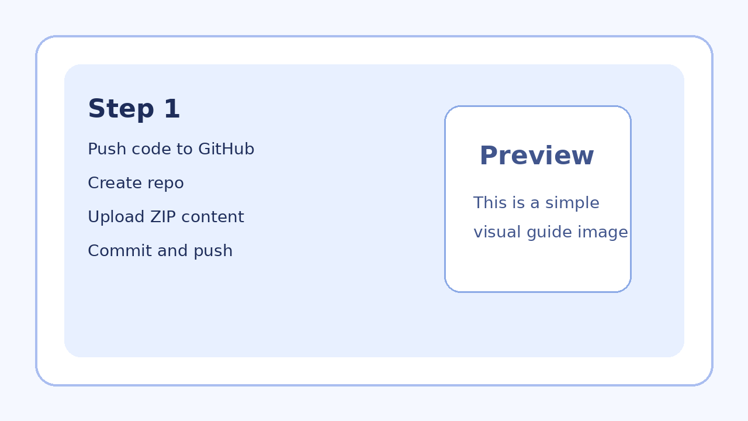
Step 1 Github
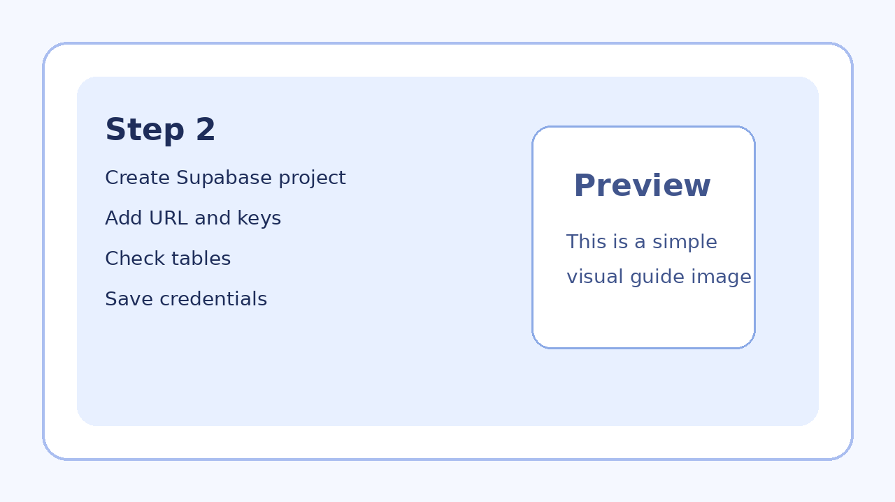
Step 2 Supabase
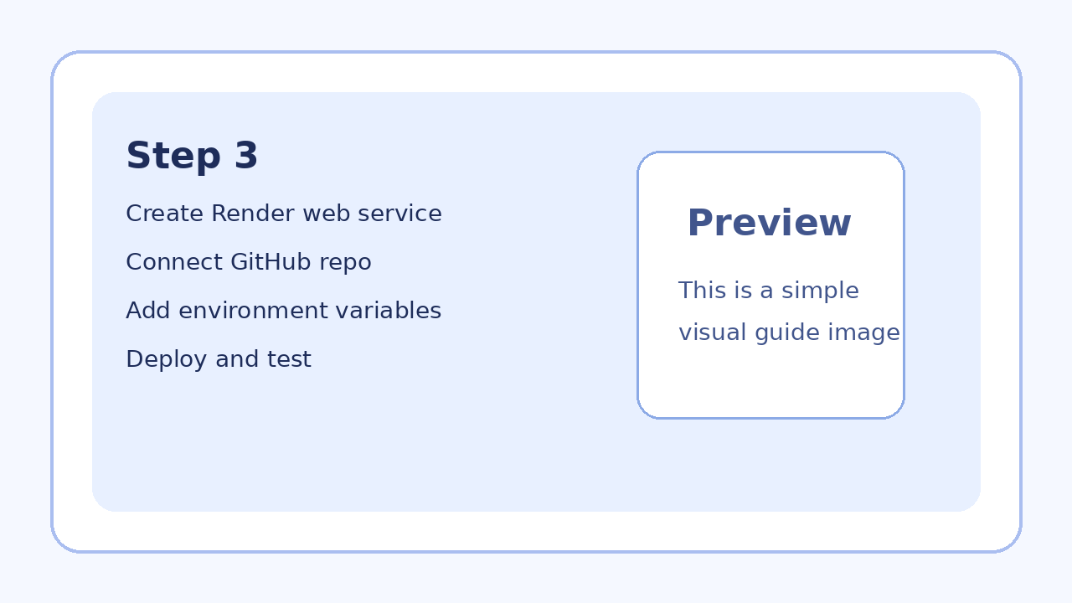
Step 3 Render

Checklist
- [ ] Project files extracted
- [ ] .env values ready
- [ ] GitHub repository created
- [ ] Project pushed to GitHub
- [ ] Supabase project created
- [ ] Supabase URL copied
- [ ] Supabase keys copied
- [ ] Required tables checked
- [ ] Render web service created
- [ ] GitHub connected to Render
- [ ] Environment variables added in Render
- [ ] First deploy finished
- [ ] Login tested
- [ ] Candidate page tested
- [ ] Aaria tested
- [ ] Approval flow tested
- [ ] Unlock flow tested
- [ ] Reports tested
- [ ] Team Chat tested
- [ ] Wallpaper option tested
- [ ] Follow-up reminder tested
- [ ] Bulk dial queue tested
- [ ] Final smoke test done

