 | 
INFORMATION TECHNOLOGY INSTITUTE
9-MONTH PROGRAM – INTAKE 46
GRADUATION PROJECT

CAREER PILOT
AI-Powered Career Preparation, Adaptive Interview Coaching, ATS Optimization, and Job Readiness Platform
PREPARED BY
TEAM MEMBERS
ANDROID  1. Hazem Abdelraouf Mohammed  2. Hossam Ahmed Elgmmal  3. Tasneem AbdElhakeem Soliman  4. Mohamed Amir Mohamed | iOS  1. Ahmed El Sayyad Mohamed  2. Moaz Osama Ahmdd  3. Mohamed Magdy Ahmed  4. Eyad Waleed Abd El Fatah
BACKEND  1. Amr Mohammed Shms  2. Noureen Ashraf Abdelmoneam  3. Mohamed Salah Mahmoud | TESTING  1. Ahmed Hazem Ahmed  2. Yousef Mohamed Fawzy  3. Alhussein Abdelgaber Ibrahim  4. Zainab Yousef Rashwan  5. Hager Ashraf AboElfadl
Supervised By
Eng. Mayar Hassan

Acknowledgment
We would like to express our deepest gratitude to the Information Technology Institute (ITI) for providing an exceptional environment of technical excellence, continuous mentorship, and state-of-the-art engineering training during the 9-Month Professional Program (Intake 46).
We extend our heartfelt appreciation to our esteemed project supervisors and technical instructors whose valuable insights, rigorous feedback, and constructive guidance were instrumental in shaping the architecture and implementation of Career Pilot.
Finally, we thank our colleagues, families, and peers for their unwavering encouragement, collaboration, and support throughout the entire development lifecycle of this graduation project.
Table of Contents
Acknowledgment i
Table of Figures ii
Core Acronyms ii
PART 1: Overview 1
1.1 Abstract 1
1.2 Introduction 1
1.2.1 Background & Industry Context 1
1.2.2 Motivation 1
1.2.3 Problem Statement 1
1.2.4 Proposed Solution 2
1.2.5 Scope and System Boundaries 2
1.3 Target Users, Value Proposition & Business Model 2
1.3.1 Target User Groups & Personas 2
1.3.2 Value Proposition 2
1.3.3 Business, Pricing & Monetization Model 3
1.4 Project Objectives 4
1.4.1 Primary Business Objectives 4
1.4.2 Technical & Operational Objectives 4
PART 2: Characteristics 4
2.1 Core Features & Functional Pillars 4
2.2 Implemented vs Planned Scope Matrix 5
2.3 Mobile Design System & UI Specification 6
PART 3: SDLC 6
3.1 Analysis 6
3.1.1 User Personas & Scenarios 6
3.1.2 Comprehensive Functional Requirements (FR) 6
3.1.3 Comprehensive Non-Functional Requirements (NFR) 8
3.1.4 Component Responsibilities & System Boundaries 9
3.2 Design 10
3.2.1 High-Level System Architecture 10
3.2.2 Android Application Architecture 10
3.2.3 iOS Application Architecture 10
3.2.4 Android vs iOS Architectural Comparison 10
3.2.5 Backend Service Architecture 11
3.2.6 AI & RAG Pipeline Architecture 11
3.2.6.1 AI Modeling & Execution Boundaries 11
3.2.6.2 Backend Retrieval-Augmented Generation (RAG) Model 11
3.2.6.3 Backend Agentic AI Model 11
3.2.6.4 Android Mobile AI Models 12
3.2.6.5 iOS Mobile AI Models 12
3.2.6.6 Challenge AI Evaluation Model 12
3.2.6.7 AI Model Responsibility Matrix 12
3.2.7 Feature Access & Entitlement Architecture 13
3.2.8 Challenge Platform Architecture 13
3.2.9 Database Schema & Persistence Design 14
3.2.10 REST API & Integration Contracts 14
3.3 Implementation 16
3.3.1 Multi-Modal Interview Simulation Engine 16
3.3.2 ATS Resume Parsing, Vector Matching & Async Optimization 16
3.3.3 Payment, Wallet & Subscription Processing 16
3.3.4 Challenge Platform Implementation 16
3.3.5 Feature Access & Gating Implementation 16
3.3.6 Key Engineering Decisions & Trade-Offs 17
3.4 Tools & Technology Stack 18
PART 4: Illustrations 18
4.1 Diagrams 18
4.1.1 System Context & Overall Architecture 18
4.1.2 Database Entity-Relationship Diagrams (ERD) 19
4.1.3 Use Case Model & Detailed Specifications 32
4.1.4 Class & Subsystem Architecture Diagrams 41
4.1.5 AI, RAG & Workflow Diagrams 43
4.2 Application Screenshots 47
4.2.1 Authentication & Career Track Onboarding 47
4.2.2 CV Ingestion, Parsing & Semantic Vectorization 47
4.2.3 Adaptive Mock Interview Practice Room 48
4.2.4 ATS Job Matching & Asynchronous CV Optimization 48
4.2.5 Session Performance Analytics & Feedback Reports 49
4.2.6 Subscriptions, Coin Wallet & Secure Checkout 49
4.2.7 Challenge Discovery, Creation & Dashboard 50
4.2.8 Feature Access & Upgrade States 50
References 51
Table of Figures
Figure 1.1: Career Pilot System Context Diagram 18
Figure 1.2: Career Pilot Overall System Architecture 19
Figure 2.1: Database ERD — Identity, Profile, and Security Domain 19
Figure 2.2: Database ERD — Interview Practice, AI Evaluation, and Vectors Domain 20
Figure 2.3: Database ERD — ATS Job Workspace, AI Jobs, and Payments Domain 20
Figure 3.1: Career Pilot Use Case Model 32
Figure 4.1: Backend High-Level Architecture & Layered Class Diagram 42
Figure 4.2: Android High-Level Architecture (MVI / Jetpack Compose) 42
Figure 4.3: iOS High-Level Architecture (MVVM / SwiftUI) 43
Figure 5.1: Retrieval-Augmented Generation (RAG) Architecture 43
Figure 5.2: Agentic Interview Coach & Dual Evaluation Pipeline 44
Figure 5.3: ATS Workspace, Vector Matcher & Asynchronous CV Optimizer 44
Figure 5.4: Adaptive Mock Interview Execution Architecture 45
Figure 5.5: Payment Settlement & Reconciliation Architecture 45
Figure 5.6: AI Processing Execution Boundaries & Data Flow 46
Figure 6.1: Authentication & Career Track Onboarding UI Flow 47
Figure 6.2: CV Ingestion, Skills Extraction & Vector Database Hub UI Flow 47
Figure 6.3: Adaptive Mock Interview Room with On-Device Multimodal Feedback 48
Figure 6.4: ATS Job Matching, Gap Analysis & CV Optimization UI Flow 48
Figure 6.5: Performance Analytics Dashboard & Session Feedback Report 49
Figure 6.6: Subscriptions, Coin Wallet & Secure Checkout UI Flow 49

Core Acronyms
Acronym | Formal Definition & Context
AI | Artificial Intelligence
API | Application Programming Interface
ATS | Applicant Tracking System
CV | Curriculum Vitae / Professional Resume
DI | Dependency Injection
DTO | Data Transfer Object
ERD | Entity-Relationship Diagram
HMAC | Hash-based Message Authentication Code
HNSW | Hierarchical Navigable Small World (Vector Graph Index)
JWT | JSON Web Token
LLM | Large Language Model
MVI | Model-View-Intent (Android Architecture)
MVVM | Model-View-ViewModel (iOS Architecture)
NFR | Non-Functional Requirement
ONNX | Open Neural Network Exchange Runtime
OTP | One-Time Password
PII | Personally Identifiable Information
RAG | Retrieval-Augmented Generation
REST | Representational State Transfer
SRS | Software Requirements Specification
STAR | Situation, Task, Action, Result (Interview Structuring Method)
TLS | Transport Layer Security (Version 1.3)
UML | Unified Modeling Language
WPM | Words Per Minute (Speech Pacing Metric)

PART 1: Overview

1.1 Abstract
Executive Summary: Career Pilot is an intelligent, evidence-driven career acceleration ecosystem connecting candidate profile context, target job requirements, adaptive multimodal mock interviews, real-time posture/voice coaching, ATS resume optimization, tailored Cover Letter generation, and comprehensive performance analytics into a unified closed-loop platform.

In today's highly competitive job market, candidates face significant barriers in securing employment due to automated Applicant Tracking System (ATS) filters and high-stress technical/behavioral screening interviews. Traditional preparation methods remain fragmented across disjointed resume builders, static flashcard lists, and expensive human coaching.
Career Pilot solves this fragmentation by delivering an end-to-end intelligent career platform. The system connects candidate qualifications, target job postings, and real-time multimodal mock interviews into a closed-loop learning experience. Built with native mobile frontends (Android in Jetpack Compose / MVI and iOS in SwiftUI / MVVM) backed by an enterprise Spring Boot 3 modular platform with PostgreSQL and pgvector semantic storage, Career Pilot delivers on-device MediaPipe/Apple Vision body language tracking, sherpa-onnx Whisper speech transcription, intelligent ATS keyword gap scoring, asynchronous CV bullet rewriting, and integrated Paymob local checkout in EGP.
By combining generative AI models with retrieval-augmented generation (RAG), strict prompt schemas, and deterministic on-device signal processing, Career Pilot eliminates AI hallucinations and ensures that every mock question, ATS recommendation, and Cover Letter is firmly grounded in real candidate achievements and target job requirements.

1.2 Introduction

1.2.1 Background & Industry Context
Modern recruitment pipelines rely extensively on automated screening systems that filter applicants before human review. Research indicates that over 70% of qualified resumes are eliminated by ATS algorithms due to missing domain-specific keywords or formatting misalignments. Furthermore, qualified candidates often underperform in live interviews due to unpracticed behavioral structuring (STAR method), poor pacing, or non-verbal mannerisms such as weak eye contact and posture collapse.
The recruitment landscape has shifted toward competency-based hiring, where candidates must demonstrate concrete evidence of problem-solving skills, architectural trade-offs, and professional composure under pressure. Disconnected preparation tools fail to support candidates through this demanding process because they isolate CV creation from interview simulation and feedback.

1.2.2 Motivation
The motivation behind Career Pilot stems from the profound disconnect between what a candidate's resume communicates and what a specific vacancy demands. A modern career preparation assistant should convert this gap into tangible, measurable practice: automatically discovering missing requirements, formulating targeted interview questions, analyzing verbal and visual responses in real time, and guiding continuous refinement until job readiness is achieved.

1.2.3 Problem Statement
Job seekers currently lack a unified, evidence-driven platform that bridges the gap between what their resume communicates and what a specific vacancy demands. Existing solutions suffer from three fundamental limitations:
1. Workflow Fragmentation: Resume building, job searching, mock interviews, and ATS scoring occur in isolated applications with no shared context.
2. Ungrounded Generative AI: Generic AI chatbots frequently hallucinate irrelevant interview questions or invent fictional candidate achievements during resume rewrites.
3. Absence of Real-Time Multimodal Feedback: Existing mock tools evaluate only text or audio after the fact, failing to capture visual composure, eye contact, and posture stability during delivery.

1.2.4 Proposed Solution
Career Pilot delivers a unified preparation lifecycle. Candidates ingest their resume (PDF), select target career tracks (e.g., Mobile Engineer, Backend Developer, Data Scientist), or import specific job posting URLs. The system performs semantic gap analysis, highlights missing technical competencies, generates customized mock interview sessions with real-time video/audio analysis, produces granular performance scorecards, and provides one-click CV optimization and custom Cover Letter generation.

1.2.5 Scope and System Boundaries
Subsystem / Boundary | Implemented Scope Description
Mobile Frontends | Native Android (Compose, MVI, Hilt, Ktor) and Native iOS (SwiftUI, MVVM, Swinject, URLSession). Core flows cover authentication, CV management, interview practice, ATS, reports and subscriptions. The latest Android implementation additionally includes Challenges and centralized Feature Access modules.
Authoritative Backend | Spring Boot 3 (Java 21), Spring Security, stateless JWT authentication, Spring Data JPA, PostgreSQL with pgvector, Flyway migrations, interview orchestration, ATS services, subscriptions and wallet APIs.
AI & On-Device ML | Backend RAG and Agentic AI provide grounded interview/ATS reasoning. Android performs MediaPipe/Whisper processing and Firebase AI-assisted evaluation; iOS uses Apple Vision and Apple Speech. The Android Challenge runtime also uses Firebase AI for question validation and structured challenge-answer scoring.
Challenge Runtime | Android implements public/private challenge discovery, challenge details, creation, creator dashboard and challenge sessions. Challenge state is stored in Firebase Firestore collections for public challenges, private challenges and challenge sessions.
Feature Access & Entitlements | Android core:access centralizes plan eligibility, quota/coin checks, stale-cache handling and gating UI. Access data is refreshed from backend subscription and wallet endpoints and cached locally in DataStore.
Monetization & Billing | Tiered Free, Plus and Max subscriptions are combined with a coin wallet and secure payment checkout. Feature access is enforced by plan, quota and coin balance.
Future Extensions | Cross-platform Challenge parity, challenge notifications, exportable challenge results, recruiter talent discovery and multiplayer interview experiences.

1.3 Target Users, Value Proposition & Business Model

1.3.1 Target User Groups & Personas
• Fresh Graduates & Entry-Level Job Seekers: Building interview confidence, learning STAR response structuring, and passing initial ATS screening.
• Career Changers & Transitioning Engineers: Identifying transferable skills and bridging gaps for newly targeted career tracks.
• Senior Specialists & Technical Leads: Polishing high-level system design explanations, leadership framing, and concise delivery.
• Recruiters & Hiring Teams: Using private interview challenges for structured first-round screening and candidate comparison.
• Community & Training Organizers: Hosting public interview competitions that encourage repeated practice, ranking, and peer engagement.
• Platform Administrators: Managing career tracks, auditing AI job queues, configuring payment tiers, and monitoring system telemetry.

1.3.2 Value Proposition
• Grounded Personalization: Questions and feedback are customized to candidate profile embeddings and vacancy requirements via RAG.
• Real-Time Multimodal Intelligence: On-device tracking of gaze deviation, posture stability, and vocal cadence without streaming video to external servers.
• Closed-Loop Employability Elevation: From initial resume ingestion to mock interview mastery, ATS optimization, and Cover Letter export.
• Challenge-Based Practice & Screening: Public and private challenges extend the interview experience into community competition and recruiter-led screening.
• Unified Feature Access: A centralized entitlement layer consistently gates premium functionality by plan, quota, and coin balance.
• Localized Market Accessibility: Support for Egyptian Pounds (EGP), subscription tiers, coin-based usage, and secure localized payment options.

1.3.3 Business, Pricing & Monetization Model
Career Pilot uses a hybrid monetization model that combines tiered monthly subscriptions with pay-as-you-go coins. Access decisions are centralized so every feature follows the same plan, quota, and wallet rules:
Feature Coin Pricing & Plan Entitlement
Feature | Coin Cost | Minimum Plan | Access & Gating Behavior
Enter Public / Private Challenge | 0 Coins | FREE | Free-plan users can browse public challenges, join private challenges by invitation/code, and submit challenge attempts.
AI Voice Mock Interview | 10 Coins | FREE | Available to Free, Plus and Max users when sufficient coins or quota are available.
Voice Practice Mode | 10 Coins | FREE | On-demand voice practice with speech feedback; uses the same centralized access check.
ATS Resume-to-Job Match | 5 Coins | PLUS | Requires Plus or Max plan and 5 coins when no plan quota covers the action.
CV AI Analysis / Optimizer | 15 Coins | PLUS | Deep CV analysis and AI optimization are available from Plus upward.
AI Cover Letter Generator | 5 Coins | PLUS | Generates a job-tailored cover letter for eligible Plus/Max users.
Job Description Parsing | 1 Coin | PLUS | Parses job text or URL input into structured job context.
AI Technical Skill Quizzes | 0 Coins | PLUS | Unlocked for Plus and Max subscribers.
Export PDF Career Report | 0 Coins | PLUS | Unlocked for Plus and Max subscribers.
Video Interview (Body Language) | 0 Coins | MAX | Max-only video interview with body-language/posture analysis.
Advanced Reports | 0 Coins | MAX | Deep insights and advanced analytics are reserved for Max.
Create & Host Challenge | 0 Coins | MAX | Creating and hosting a custom public/private interview challenge is a Max-tier capability.
Subscription Tier Plans
Plan | Price (EGP / month) | Included Coins | Key Included Features
FREE | 0 EGP | No monthly coins | Voice interviews and voice practice are available through coins; core analytics are included; participation in public/private challenges is free.
PLUS | 349 EGP | 80 Coins / month | Everything in Free plus ATS matching, CV AI analysis/optimization, cover letters, job parsing, technical quizzes and PDF report export.
MAX | 599 EGP | 160 Coins / month | Everything in Plus plus video body-language interviews, advanced reports, priority AI processing, and challenge creation/hosting.
Coin Packs & Wallet Top-Up
Coin Pack | Coins | Price (EGP) | Effective Rate | Badge
Small Pack | 50 | 149 EGP | ~2.98 EGP / coin | -
Medium Pack | 120 | 299 EGP | ~2.49 EGP / coin | Most Popular
Large Pack | 300 | 599 EGP | ~1.99 EGP / coin | Best Value

1.4 Project Objectives

1.4.1 Primary Business Objectives
1. Deliver a unified career acceleration ecosystem connecting resumes, vacancies, mock interviews, and analytics.
2. Provide candidates with verifiable ATS compatibility scores and actionable keyword bridging for target roles.
3. Deliver real-time, multi-modal feedback on verbal answers, speech pacing, posture stability, and eye contact.
4. Implement an accessible monetization and entitlement engine combining subscription tiers, centralized access rules, and on-demand coin usage.

1.4.2 Technical & Operational Objectives
1. High Performance & Low Latency: Deliver real-time on-device facial landmark tracking at >= 25 FPS and fast speech transcription.
2. Clean, Scalable Architecture: Enforce strict separation of concerns across Mobile (MVI/MVVM) and Backend (Controller-Service-Repository).
3. Semantic Vector Search: Utilize pgvector 1536-dimensional embeddings for sub-second semantic resume-to-job matching.
4. Enterprise Security: Enforce cryptographic JWT session verification, encrypted local storage (Keystore / Keychain), and HMAC webhook validation.
5. Challenge Platform Extensibility: Reuse the existing interview experience to support public competitions and private candidate screening without duplicating the core practice workflow.
6. Consistent Access Governance: Centralize feature availability so plan, quota, coin, and stale-cache rules are evaluated uniformly across Android features.

PART 2: Characteristics

2.1 Core Features & Functional Pillars
Career Pilot delivers ten tightly integrated functional pillars designed to guide a candidate from profile ingestion to job preparation, challenge participation, interview mastery, and application submission:
Feature Pillar | Capabilities & Business Value
1. Profile & CV Knowledge Hub | Accepts PDF CV uploads, extracts candidate context, and supports semantic retrieval for interview and ATS workflows.
2. Adaptive Mock Interview Simulator | Conducts track-specific interview sessions, evaluates answers, and provides adaptive coaching.
3. Real-Time Multimodal Coaching | Analyzes speech delivery and supported visual signals such as posture, face and hands using mobile AI.
4. Smart ATS Job Workspace & Matcher | Parses job descriptions, computes ATS match results, identifies gaps, and connects the job context to downstream preparation.
5. Asynchronous AI CV Optimization | Runs AI-assisted CV analysis and optimization aligned with target job requirements.
6. Tailored Cover Letter Generator | Generates personalized cover-letter drafts from candidate and job context.
7. Analytics & Session Reports | Provides scorecards, historical performance, strengths, weaknesses and actionable recommendations.
8. Subscription, Wallet & Payments | Provides Free/Plus/Max plans, monthly coin allowances, pay-as-you-go usage and secure checkout.
9. Interview Challenges | Supports public/private challenge discovery, participation, creation, creator dashboards, challenge sessions and AI-scored results.
10. Centralized Feature Access | Applies one access policy across features using plan eligibility, quotas, coin costs, cached entitlement state and shared gating UI.

2.2 Implemented vs Planned Scope Matrix
Feature Area | Android Client | iOS Client | Spring Boot Backend | Current Status
Authentication & OTP | Implemented (Compose) | Implemented (SwiftUI) | Implemented (JWT/BCrypt) | Production Ready
Career Track Onboarding | Implemented | Implemented | Implemented | Production Ready
CV PDF Parsing & Embedding | Implemented | Implemented | Implemented (pgvector) | Production Ready
Adaptive Mock Interview | Implemented (MVI) | Implemented (MVVM) | Implemented (RAG Agent) | Production Ready
On-Device Face/Pose Tracking | Implemented (MediaPipe) | Implemented (Vision) | Not Applicable (On-device) | Production Ready
Speech-to-Text Transcription | Implemented (Whisper integration) | Implemented (Speech) | Not Applicable (On-device) | Implemented
ATS Job Parsing & Scoring | Implemented | Implemented | Implemented | Production Ready
Async CV Optimization | Implemented | Implemented | Implemented (AI Job Queue) | Production Ready
Cover Letter Generator | Implemented | Implemented | Implemented (LLM Engine) | Production Ready
Subscription / Wallet / Payments | Implemented | Implemented | Implemented | Production Ready
Centralized Feature Access | Implemented (:core:access) | Not in supplied iOS snapshot | Subscription + wallet contracts | Android Implemented
Challenge Platform | Implemented (Firestore-backed) | Not in supplied iOS snapshot | Not in supplied Spring Boot snapshot | Android Implemented

2.3 Mobile Design System & UI Specification
The mobile clients adhere to a cohesive design system engineered for high legibility, accessible contrast, and focused candidate interaction:
Color Token | Hex Value | Usage & Context in User Interface
Primary Navy | #1A365D | Primary headers, navigation bars, and active state highlights.
Slate Blue | #2B6CB0 | Secondary action buttons, progress indicators, and section headers.
Teal Accent | #0D9488 | Success indicators, high score badges, and completed step icons.
Dark Background | #0F172A | Deep slate background for dark theme and mock interview room.
Surface Card | #1E293B | Elevated card containers, question panels, and metric widgets.
Warning Amber | #F59E0B | Moderate score warnings, missing keyword alerts, and coin cost badges.
Error Red | #EF4444 | Recording indicator, critical gap alerts, and stop session buttons.

PART 3: SDLC

3.1 Analysis

3.1.1 User Personas & Scenarios
User Persona | Characteristics & Primary Goals
Fresh Graduate / Junior Job Seeker | Needs structured interview practice, guidance on answering behavioral questions, and ATS resume verification to secure their first software engineering role.
Mid-Level Career Changer | Possesses transferable skills but struggles to tailor their resume to specific job postings and needs track-specific technical interview simulation.
Senior Engineer / Specialist | Focuses on high-level system design questions, communication clarity, and fast ATS optimization for executive/senior positions.
Platform Administrator | Monitors AI job processing queues, manages subscription tiers, audits Paymob transaction logs, and updates system prompt templates.

3.1.2 Comprehensive Functional Requirements (FR)
Req ID | Requirement Name | Functional Specification Description
FR-AUTH-01 | User Registration & Login | The system shall allow users to register and sign in via email with 6-digit OTP verification.
FR-AUTH-02 | Session Token Management | The system shall issue stateless JWT access tokens and store them securely in encrypted client storage.
FR-ONB-01 | Career Track Selection | The system shall allow users to select from standardized career tracks (Mobile, Backend, AI, Full-Stack).
FR-CV-01 | CV Upload & Ingestion | The system shall accept PDF CV uploads (up to 10MB) and extract structured text sections.
FR-CV-02 | Vector Ingestion & Indexing | The system shall chunk CV text and generate 1536-dimensional vector embeddings stored in PostgreSQL/pgvector.
FR-INT-01 | Interview Session Init | The system shall instantiate mock interview sessions tailored to career track, seniority, and uploaded CV.
FR-INT-02 | Multimodal Sensor Capture | The mobile client shall capture camera video and microphone audio during interview responses.
FR-INT-03 | On-Device Vision Analysis | The client shall compute eye contact and posture stability metrics in real-time using local ML.
FR-INT-04 | Speech Recognition | The client shall transcribe candidate audio answers using on-device Whisper or Apple Speech.
FR-INT-05 | Verbal Answer Evaluation | The backend AI engine shall evaluate verbal responses for technical accuracy, clarity, and completeness.
FR-ATS-01 | Job Description Import | The system shall parse job postings from submitted URLs or pasted text.
FR-ATS-02 | ATS Compatibility Scoring | The system shall compute cosine similarity between job embeddings and candidate CV embeddings.
FR-ATS-03 | Keyword Gap Analysis | The system shall identify missing hard/soft skills and keywords present in the vacancy.
FR-ATS-04 | Async CV Optimization | The system shall asynchronously generate optimized resume bullet points aligned with the vacancy.
FR-ATS-05 | Cover Letter Generation | The system shall generate professional, customized cover letters grounded in candidate experience.
FR-REP-01 | Session Performance Scorecard | The system shall display multi-dimensional scores (Technical, Structuring, Fluency, Visual presence).
FR-PAY-01 | Secure Checkout Session | The system shall initiate a secure payment checkout for subscriptions or coin packs and return the client information required to complete payment.
FR-PAY-02 | Payment Settlement | The backend shall verify payment settlement callbacks and update subscription or wallet state idempotently.
FR-ACC-01 | Feature Gating & Entitlement | The system shall verify active subscription tier or coin balance before granting access to premium AI features.
FR-ACC-02 | Plan-Based Feature Eligibility | The system shall determine the minimum eligible plan for every gated feature and block access when the user plan is below the requirement.
FR-ACC-03 | Quota / Coin Fallback | When an eligible feature has no remaining quota, the system shall allow execution only when the user has enough coins for the configured feature cost.
FR-ACC-04 | Access Cache Freshness | The mobile client shall block gated execution when cached entitlement data is stale beyond the configured freshness window and require access refresh.
FR-CHAL-01 | Challenge Discovery | The Android application shall display available public challenges and allow authenticated users to open challenge details.
FR-CHAL-02 | Private Challenge Entry | The application shall allow users to enter a private challenge using its invitation identifier or code.
FR-CHAL-03 | Challenge Participation | Challenge participation shall be available from the Free tier at 0 coins under the current access policy.
FR-CHAL-04 | Challenge Creation | Creating and hosting a public or private challenge shall require the Max tier under the current access policy.
FR-CHAL-05 | Challenge Configuration | A challenge creator shall configure track, visibility, seniority, interview type, optional video analysis settings, and a validated question set.
FR-CHAL-06 | Challenge Session Evaluation | The Challenge runtime shall persist participant sessions and produce structured per-question and aggregate AI scores for completed attempts.
FR-CHAL-07 | Creator Dashboard | Challenge creators shall be able to view created challenges, participation sessions, results and management actions available in the Android dashboard.

3.1.3 Comprehensive Non-Functional Requirements (NFR)
NFR ID | Quality Dimension | Requirement Specification
NFR-PERF-01 | Vision Processing Frame Rate | On-device face and posture tracking shall execute at >= 25 FPS without UI lag.
NFR-PERF-02 | API Response Latency | Standard backend REST endpoints shall respond within < 200 ms under normal load.
NFR-SEC-01 | Data Encryption in Transit | All client-server communications shall be strictly encrypted using TLS 1.3.
NFR-SEC-02 | Secure Local Storage | Sensitive authentication tokens and keys shall be stored in Android EncryptedSharedPreferences/Keystore and iOS Keychain.
NFR-PRIV-01 | Media Privacy Boundary | Candidate camera and microphone feeds shall be processed locally on-device; raw video shall never be transmitted to the cloud.
NFR-RELI-01 | Asynchronous Job Resilience | AI optimization jobs shall use resilient state machines with automatic timeout and retry handling.
NFR-USAB-01 | Mobile Responsiveness | The UI shall adhere to modern Material 3 (Android) and Human Interface Guidelines (iOS) with dark/light themes.

3.1.4 Component Responsibilities & System Boundaries
System Component | Architectural Responsibilities & Boundaries
Android Client | Jetpack Compose presentation, MVI/Clean Architecture, Ktor networking, CameraX/MediaPipe media intelligence, Whisper integration, DataStore, Challenges and centralized feature gating.
iOS Client | SwiftUI presentation, MVVM, URLSession networking, Keychain security, Core Data, Apple Vision and Apple Speech.
Spring Boot Backend | Authoritative user, interview, ATS, subscription, wallet and payment business services with JWT security and PostgreSQL persistence.
AI / RAG Orchestrator | Spring AI services for retrieval, prompt assembly, structured LLM responses, interview agents, ATS/CV intelligence and cover-letter workflows.
Feature Access Layer | Android core:access combines backend subscription/wallet state with PlanAccessMap, FeaturePricingMap, quota logic, 24-hour freshness checks and shared gating UI.
Challenge Runtime | Android Challenge modules use Firebase Firestore for public/private challenge data and challenge sessions, plus Firebase AI for question validation and answer scoring.
PostgreSQL Database | Authoritative relational storage for the core backend, including users, interviews, ATS workspaces, subscriptions, wallet data and pgvector indexes.
Payment Gateway | External secure payment service used for subscription and coin purchases; settlement updates backend wallet/subscription state.

3.2 Design

3.2.1 High-Level System Architecture
Career Pilot is structured as a multi-tier, client-server architecture with clear domain boundaries. The system decouples presentation, business orchestration, semantic retrieval, and data persistence:
1. Client Tier: Native Android and iOS mobile applications delivering rich user experiences, local sensor capture, and on-device ML inference.
2. API Gateway & Security Layer: Spring Security filter chain enforcing stateless JWT validation, CORS policies, and rate limiting.
3. Application & Domain Services: Modular Spring Boot 3 services managing user identity, interview lifecycles, ATS matching algorithms, and payment state machines.
4. AI & Retrieval Orchestration: LangChain / RAG services interfacing with external LLMs and internal vector search.
5. Persistence Tier: PostgreSQL 16 relational database with pgvector extension for high-performance vector indexing.

3.2.2 Android Application Architecture
The Android client is built with Kotlin and Jetpack Compose following Clean Architecture and Model-View-Intent (MVI) principles:
• Presentation Layer: Stateless Composable functions observing immutable StateFlow instances emitted by Hilt-injected ViewModels. User interactions are dispatched as explicit Intent sealed classes.
• Domain Layer: Pure Kotlin business logic encapsulating reusable Use Cases (e.g., StartInterviewUseCase, EvaluateAnswerUseCase, OptimizeCvUseCase).
• Data Layer: Implements repository interfaces, managing remote Ktor HTTP clients, local SQLite cache, and Android Keystore backed EncryptedSharedPreferences.
• On-Device ML Pipeline: CameraX streams preview frames into MediaPipe Face and Pose Landmarkers; audio buffers are fed to sherpa-onnx Whisper running on device CPU/NNAPI.
• Feature Access Layer: :core:access centralizes subscription, quota, coin and cache-freshness decisions and exposes shared gate states/components to feature modules.
• Challenge Feature Family: four dedicated Challenge feature modules share Firestore challenge data/session logic through :core:challengefirestore and reuse the existing practice-session navigation for participation.

3.2.3 iOS Application Architecture
The iOS client is engineered in Swift using SwiftUI and Model-View-ViewModel (MVVM) architecture:
• Presentation Layer: Declarative SwiftUI views bound reactively to ObservableObject ViewModels via @Published properties and Combine pipelines.
• Dependency Injection: Swinject provides container-based inversion of control across services and repositories.
• Persistence & Cache: Active Core Data stack provides offline caching for interview history and reports, while Apple Keychain securely stores JWT tokens.
• Native Media Intelligence: AVFoundation captures camera/audio feeds; Apple Vision framework (VNDetectFaceLandmarksRequest) and Apple Speech framework (SFSpeechRecognizer) execute fully on-device.

3.2.4 Android vs iOS Architectural Comparison
Architectural Concern | Android Implementation | iOS Implementation
UI Framework | Jetpack Compose (Material 3) | SwiftUI (Human Interface Guidelines)
Architectural Pattern | Clean Architecture + MVI | Clean Architecture + MVVM
Dependency Injection | Hilt / Dagger | Swinject Container
Reactive Streams | Kotlin Coroutines & StateFlow | Combine & Swift async/await
Networking Client | Ktor HTTP Client with ContentNegotiation | URLSession with Decodable / Codable
Token & Key Security | EncryptedSharedPreferences + Android Keystore | Apple Keychain Services (Hardware Enclave)
Local Database Cache | Room / SQLite & Jetpack DataStore | Core Data Object Graph
On-Device Vision | MediaPipe Face & Pose Landmarker | Apple Vision Framework (VNRequests)
On-Device Speech | sherpa-onnx Whisper ONNX Runtime | Apple Speech Framework (SFSpeechRecognizer)
Payment Presentation | Custom Tabs / In-App Browser | WKWebView with JavaScript Bridges

3.2.5 Backend Service Architecture
The Spring Boot 3 application follows a layered modular structure:
• Web Layer: REST Controllers exposing versioned /api/v1/* endpoints with OpenAPI documentation.
• Security Layer: JWT authentication filters, password hashing via BCrypt, and HMAC verification for Paymob callbacks.
• Service Layer: Transactional business services managing interview workflows, ATS similarity math, and async AI job queues.
• Repository Layer: Spring Data JPA repositories communicating with PostgreSQL over HikariCP connection pooling.

3.2.6 AI & RAG Pipeline Architecture
To eliminate AI hallucination and ensure interview questions are grounded in reality, Career Pilot employs a specialized RAG architecture:
1. Ingestion: Candidate CVs and job postings are sanitized, parsed, and split into semantically coherent text chunks.
2. Vector Embedding: Chunks are transformed into 1536-dimensional dense vectors using embedding models.
3. Semantic Querying: When initiating an interview or ATS scan, cosine distance queries in pgvector retrieve the top-k most relevant candidate experiences matching the required job competencies.
4. Prompt Assembly & Guardrails: Retrieved context is assembled into strict prompt templates with JSON schema enforcement, ensuring structured, deterministic output.

3.2.6.1 AI Modeling & Execution Boundaries
Career Pilot uses a hybrid AI model instead of forcing every intelligent task through one cloud model. Backend AI handles contextual reasoning, retrieval, interview orchestration, ATS optimization, and cover-letter generation; Android and iOS perform latency-sensitive media intelligence locally. Android additionally supports a direct mobile-to-generative-AI path for body-language interpretation. This separation reduces raw media transfer, preserves privacy, and allows deterministic fallbacks when generative services are unavailable.

3.2.6.2 Backend Retrieval-Augmented Generation (RAG) Model
The backend RAG model is centered on Spring AI, PostgreSQL, pgvector, and the EmbeddingIndexService. Active career tracks are indexed from track name and description, while question-bank entries are indexed from question text, expected keywords, and category metadata. Each indexed item carries object-type and domain metadata so retrieval can be restricted to TRACK or QUESTION knowledge rather than mixing unrelated records.
At query time, the backend creates an embedding for the user/session query and performs cosine-similarity retrieval through the pgvector HNSW index. The analyzed implementation uses a configurable similarity threshold of approximately 0.45; interview question context typically retrieves up to eight ranked question-bank candidates. If semantic retrieval is unavailable or produces insufficient results, PostgreSQL lexical matching using pg_trgm is used as a fallback. The latest user CV can also be loaded directly as profile context in some flows, so the documentation should not imply that every CV access is a vector top-k retrieval operation.

3.2.6.3 Backend Agentic AI Model
Interview orchestration is implemented as an agentic workflow rather than a sequence of isolated LLM calls. InterviewAgentService builds state from the candidate CV, selected track, previous session performance, current transcript, asked-question history, job context, and retrieved question-bank knowledge. InterviewTools exposes bounded operations such as answer evaluation, question-bank search, web/job lookup where allowed, and completion checks. The agent returns structured JSON containing evaluation scores, the next question, coaching guidance, source-question information, and session status.
Server-side validation remains authoritative around the agent: duplicate-question checks, deterministic completion conditions, score aggregation, and regeneration safeguards prevent the language model from controlling business state directly. ATS optimization follows the same principle: long-running CV optimization executes as an asynchronous AI job with explicit PENDING, PROCESSING, COMPLETED, and FAILED states, while the cover-letter flow can use a tool-enabled company-research agent for entitled tiers.

3.2.6.4 Android Mobile AI Models
Android combines local perception models with optional direct generative interpretation. CameraX supplies frames to MediaPipe Tasks Vision engines for face, pose, and hand landmarks. The local body-language pipeline derives gaze, posture, hand-visibility, and facial-delivery signals and aggregates them into interview metrics. A Firebase AI integration can send derived body-language context directly from Android to a Gemini model and expects structured JSON; network, timeout, disabled-AI, or parsing failures fall back to deterministic local scoring so the interview flow can continue.
For speech, the Android code integrates sherpa-onnx OfflineRecognizer and a Whisper tiny.en INT8 pipeline that decodes device audio, converts it to mono, resamples to 16 kHz, and performs local transcription. The analyzed source references the required Whisper encoder, decoder, and token assets, but those model files were not present in the supplied repository snapshot; therefore the documentation treats this as implemented code integration with an external model-asset dependency rather than claiming that the analyzed archive alone is fully deployable.

3.2.6.5 iOS Mobile AI Models
The iOS client uses Apple-native media intelligence. AVFoundation manages camera and audio capture; Apple Vision performs face/landmark and pose-oriented analysis used by the interview feedback pipeline; Apple Speech provides speech recognition and transcript generation. In the analyzed iOS snapshot, visual metrics are evaluated locally with deterministic application logic and no direct Firebase/Gemini mobile-to-AI path was found. This is an intentional platform difference from Android and should be reflected in the iOS class and architecture diagrams.

3.2.6.6 Challenge AI Evaluation Model
The latest Android Challenge implementation uses Firebase AI with the Google AI backend for two bounded tasks: validating creator-authored interview questions and scoring submitted challenge answers. Each answer can include transcript text and recorded audio. The model returns structured JSON scores for content relevance, clarity, confidence, pacing, filler-word control, overall performance, and a coaching tip. Challenge session aggregation remains deterministic in application code, while Firestore persists the challenge, participant session, per-question results, and final aggregate scores.

3.2.6.7 AI Model Responsibility Matrix
Execution Area | Primary Model / Framework | Input | Output | Fallback / Boundary
Backend RAG | Spring AI + embeddings + pgvector | Track/question query, metadata | Ranked grounded context | pg_trgm lexical fallback
Backend Agentic Interview | LLM + InterviewTools | CV, track, transcript, history, retrieved context | Scores, next question, coaching, session state | Server-side validation and deterministic completion
Backend ATS / CV AI | LLM + async AI jobs | CV and normalized job context | ATS score, optimized sections, cover letter | FAILED state, refund/fallback handling where implemented
Android Vision | MediaPipe Face/Pose/Hand | Camera frames | Gaze/posture/hand/facial metrics | Deterministic local scoring
Android Speech | sherpa-onnx Whisper integration | Recorded audio | Local transcript | Model assets required by deployment
Android Direct AI | Firebase AI / Gemini | Derived body-language context | Structured coaching/evaluation JSON | Local evaluator on timeout/offline/parse failure
iOS Vision & Speech | Apple Vision + Apple Speech | Camera frames and microphone audio | Local visual metrics and transcript | Deterministic local application logic
Challenge AI | Firebase AI / Gemini | Question set or transcript + optional audio | Validation result or structured challenge score | Firestore persists state; application code aggregates final scores

3.2.7 Feature Access & Entitlement Architecture
The Android :core:access module is the single decision point for feature eligibility. AccessRepository refreshes subscription status and wallet balance from backend endpoints, maps the result into AccessState, and caches the state in a dedicated DataStore. CheckFeatureAccessUseCase evaluates cache freshness, plan eligibility, feature quota, configured coin cost, and wallet balance before a feature action is allowed.
The domain exposes explicit outcomes: Granted, Locked(requiredPlan), CoinTopUpRequired, StaleCacheBlocked, and Unknown. Shared UI components such as FeatureGateBottomSheet and pricing badges consume these states so ATS, interviews, quizzes, reports, and other gated features present consistent upgrade/top-up behavior. Current product policy grants challenge participation from Free and reserves challenge creation for Max.

3.2.8 Challenge Platform Architecture
The latest Android implementation introduces four dedicated feature modules - Challenges, Challenge Details, Create Challenge, and Challenge Dashboard - plus a shared core:challengefirestore module. The Challenges module discovers public challenges and accepts private codes; Challenge Details validates media permissions and launches the challenge practice flow; Create Challenge configures track, visibility, seniority, audio/video mode and question set; Challenge Dashboard exposes created/taken challenge history and participant sessions. Free-tier users may enter public or private challenges, while creating and hosting a challenge is reserved for the Max tier under the product access policy.
Challenge data is currently stored directly in Firebase Firestore using public_challenges, private_challenges, and challenge_sessions collections. The challenge session model stores current question state, transcript/audio metadata, per-question scores, aggregate scores and coaching tips. This Android-first implementation is separate from the supplied Spring Boot backend snapshot; the previously supplied iOS snapshot does not contain equivalent Challenge modules.

3.2.9 Database Schema & Persistence Design
The database layer is implemented using PostgreSQL 16 with the pgvector extension. The authoritative schema consists of 22 normalized tables partitioned across 5 distinct business domains:
Database Domain | Included Database Tables | Domain Responsibility & Data Description
Identity & Profile | users, user_profiles, career_tracks, user_tokens, audit_logs | Manages credentials, profile attributes, track specialization, and session tracking.
CV & Vector Embeddings | cv_documents, cv_chunks, cv_skills, skill_taxonomies | Stores raw CV metadata, parsed text chunks, 1536-dim vector embeddings, and categorized skills.
Interview Practice | interview_sessions, interview_questions, interview_evaluations, vision_metrics, speech_metrics | Coordinates session states, dynamic questions, audio transcripts, posture metrics, and AI scorecards.
ATS & Asynchronous Jobs | job_postings, ats_workspaces, ai_jobs, cover_letters | Manages scraped job specs, ATS match scores, asynchronous CV optimization workers, and cover letters.
Monetization & Billing | subscriptions, subscription_plans, wallets, coin_transactions, payment_orders | Enforces access tiers, tracks coin balances, audits credit/debit transactions, and records Paymob orders.

3.2.10 REST API & Integration Contracts
The backend exposes a comprehensive RESTful API secured by stateless Bearer JWT tokens:
Method | API Endpoint Path | Contract Description & Purpose | Auth Boundary
POST | /api/v1/auth/otp/send | Dispatches a 6-digit OTP code to the requested email address. | Public
POST | /api/v1/auth/otp/verify | Validates OTP code and returns signed JWT access & refresh tokens. | Public
POST | /api/v1/cv/upload | Uploads PDF resume, extracts structured text, and triggers vector embedding. | Bearer JWT
GET | /api/v1/cv/profile | Retrieves extracted skills, experience summary, and active career track. | Bearer JWT
POST | /api/v1/interview/sessions | Initializes a new mock interview session based on candidate CV and track. | Bearer JWT
POST | /api/v1/interview/answers | Submits audio transcript, vision metrics, and triggers AI answer evaluation. | Bearer JWT
GET | /api/v1/interview/reports/{id} | Retrieves full multi-dimensional performance report for a finished session. | Bearer JWT
POST | /api/v1/ats/jobs/import | Parses job posting from submitted URL and generates vector embeddings. | Bearer JWT
POST | /api/v1/ats/match | Computes cosine match score and identifies missing vacancy keywords. | Bearer JWT
POST | /api/v1/ats/cv/optimize | Queues an asynchronous AI job to rewrite resume bullet points. | Bearer JWT
GET | /api/v1/ats/jobs/{id}/status | Polls the execution status (PENDING/PROCESSING/COMPLETED) of an AI job. | Bearer JWT
POST | /api/v1/cover-letter/generate | Generates a customized, professional cover letter for the target job. | Bearer JWT
GET | /api/v1/wallet/balance | Retrieves current coin balance and active subscription tier status. | Bearer JWT
POST | /api/v1/payment/checkout | Creates a Paymob intention and returns secure payment iframe URL. | Bearer JWT
POST | /api/v1/payment/webhook | Processes Paymob HMAC webhook callback and credits wallet / activates plan. | HMAC-SHA512

3.3 Implementation

3.3.1 Multi-Modal Interview Simulation Engine
The interview simulation engine dynamically choreographs questions based on candidate progression. Once a question is presented, the mobile client activates camera and microphone streams:
• Speech Capture & Transcription: On Android, audio buffers are streamed into sherpa-onnx running an embedded Whisper model; on iOS, Apple Speech Framework performs live transcription.
• Computer Vision Processing: MediaPipe (Android) and Apple Vision (iOS) track 468 facial landmarks to evaluate gaze deviation angles and shoulder pose landmarks to detect slouching or fidgeting.
• LLM Evaluation: Transcripts are sent to the backend where AI evaluates answer completeness, technical precision, and STAR structuring.

3.3.2 ATS Resume Parsing, Vector Matching & Async Optimization
The ATS workspace operates through a multi-stage pipeline:
1. Job Extraction: Jsoup extracts readable text and requirements from provided job URLs.
2. Similarity Scoring: Cosine similarity between candidate CV embeddings and job requirement vectors produces the quantitative match score.
3. Keyword Extraction: Natural language processing extracts domain skills and compares frequencies.
4. Asynchronous Optimization: Heavy CV optimization tasks are queued as AI_JOB records in PostgreSQL. The mobile clients poll job status (PENDING -> PROCESSING -> COMPLETED) and display side-by-side diff previews.

3.3.3 Payment, Wallet & Subscription Processing
Monetization is managed through Paymob integration:
1. Intention Creation: The client requests a checkout session; backend calls Paymob API to obtain an iframe payment token.
2. Payment Execution: The client loads the Paymob checkout URL inside a secure in-app browser.
3. Webhook Settlement: Paymob posts transaction data to backend webhook endpoint. The backend validates the HMAC-SHA512 signature, credits coins to the user's wallet, or updates subscription tier in PostgreSQL.

3.3.4 Challenge Platform Implementation
Challenge discovery and management are implemented as independent Android feature modules backed by the shared Firestore data source. Public and private challenges are persisted separately, while participant attempts are stored as ChallengeSession documents. Creators can configure audio-only or video-and-audio challenges, optional posture/hand analysis, and validated question sets. Participants launch the existing practice experience using Firestore session/challenge identifiers rather than a second interview engine.
Challenge answer evaluation is performed through Firebase AI using transcript text and optional audio. Structured scores are stored per question, and aggregate clarity, confidence, pacing, filler-word, content-relevance and overall scores are calculated when the final question is completed.

3.3.5 Feature Access & Gating Implementation
AccessRepositoryImpl synchronizes subscription tier and wallet balance, caches an AccessState locally, and updates the user profile snapshot. The use case blocks execution when cached entitlements are older than 24 hours, resolves the minimum plan through PlanAccessMap, and evaluates quota before falling back to FeaturePricingMap coin costs.
FeatureAccess outcomes are rendered through common design-system gates so a user receives one of three actionable experiences: continue immediately, upgrade the plan, or top up coins. This removes duplicated entitlement logic from individual screens and keeps monetization rules consistent.

3.3.6 Key Engineering Decisions & Trade-Offs
Engineering Challenge | Adopted Technical Decision | Architectural Rationale & Trade-Off Benefits
On-Device vs Cloud Media Processing | Execute vision & speech models on-device (MediaPipe / Whisper / Apple Vision) | Preserves candidate privacy, eliminates bandwidth costs of streaming raw video, and ensures zero latency for real-time visual feedback.
RAG vs Fine-Tuning for Interviews | Adopt Retrieval-Augmented Generation with pgvector cosine indexing | Eliminates AI hallucinations, allows real-time dynamic context ingestion of new job postings without model retraining, and keeps question generation deterministic.
Asynchronous vs Synchronous AI Jobs | Execute heavy CV optimizations asynchronously via PostgreSQL task queues | Prevents HTTP request timeouts on mobile clients, guarantees execution resilience, and enables polling state machines.
Modular Clean Architecture | Decouple presentation, domain use cases, and data repositories | Ensures high unit testability, independent module evolution, and clean separation between mobile clients and shared backend contracts.

3.4 Tools & Technology Stack
Technology Category | Tools, Frameworks & Libraries Used
Mobile (Android) | Kotlin, Jetpack Compose, Coroutines/Flow, Hilt, Ktor, CameraX, MediaPipe, sherpa-onnx/Whisper integration, DataStore, Firebase Firestore and Firebase AI.
Mobile (iOS) | Swift, SwiftUI, Combine, Swinject, URLSession, AVFoundation, Apple Vision, Apple Speech, Core Data and Keychain Services.
Backend Server | Java, Spring Boot, Spring Security, Spring Data JPA, Flyway and REST APIs.
Database & Storage | PostgreSQL + pgvector for the core backend; Firebase Firestore for the current Android Challenge runtime; local encrypted/cached mobile storage.
AI & Machine Learning | Spring AI/RAG/Agentic workflows on the backend; MediaPipe and Whisper integration on Android; Apple Vision/Speech on iOS; Firebase AI for Android challenge validation/scoring.
Access & Monetization | Centralized Android :core:access entitlement checks, subscription/wallet backend contracts, Free/Plus/Max plan mapping, quotas and feature coin pricing.
Development & Collaboration | Git, GitHub, Docker, Postman, Figma, Android Studio, Xcode and IntelliJ IDEA.

PART 4: Illustrations

4.1 Diagrams

4.1.1 System Context & Overall Architecture
The System Context diagram defines external system boundaries, showing native mobile clients interacting with the Spring Boot server, external AI providers, and the Paymob payment gateway:
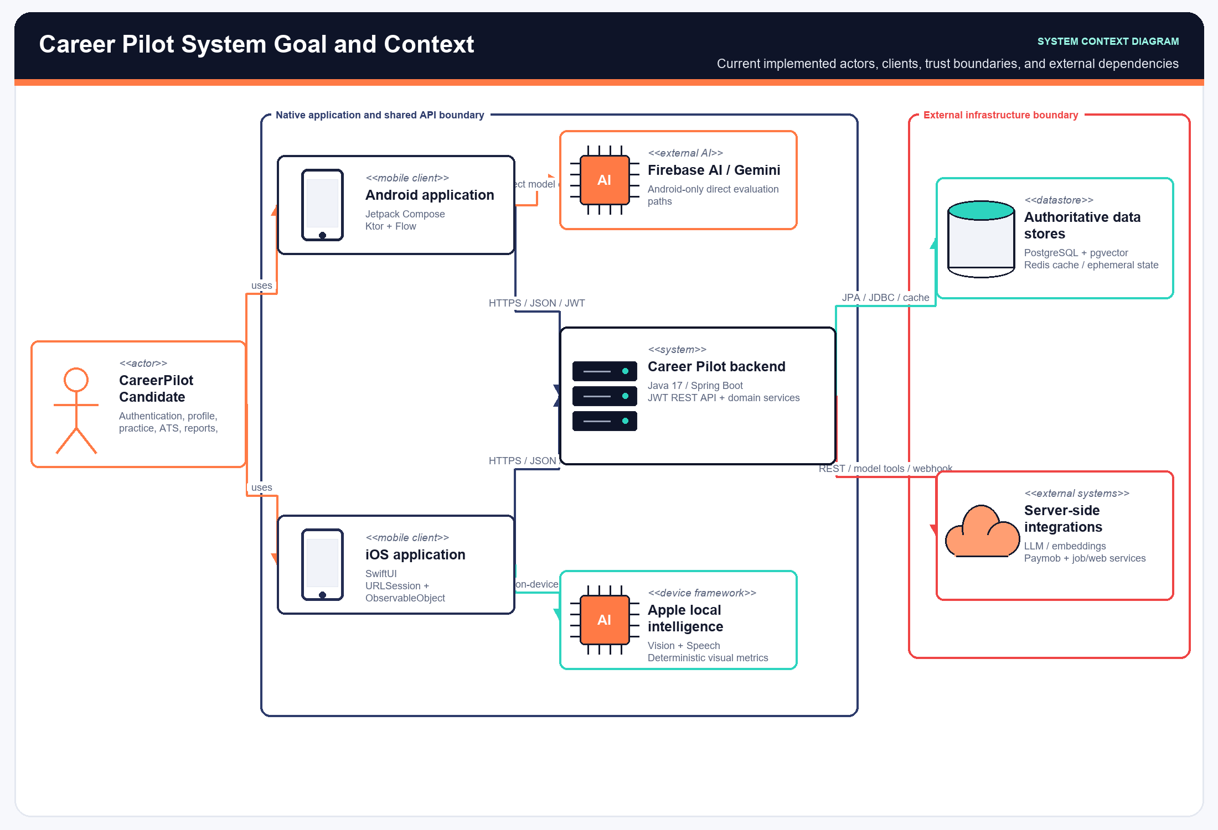
Figure 1.1: Career Pilot System Context Diagram
The Overall Architecture diagram details internal layer boundaries across presentation, application, domain, persistence, and external service layers:
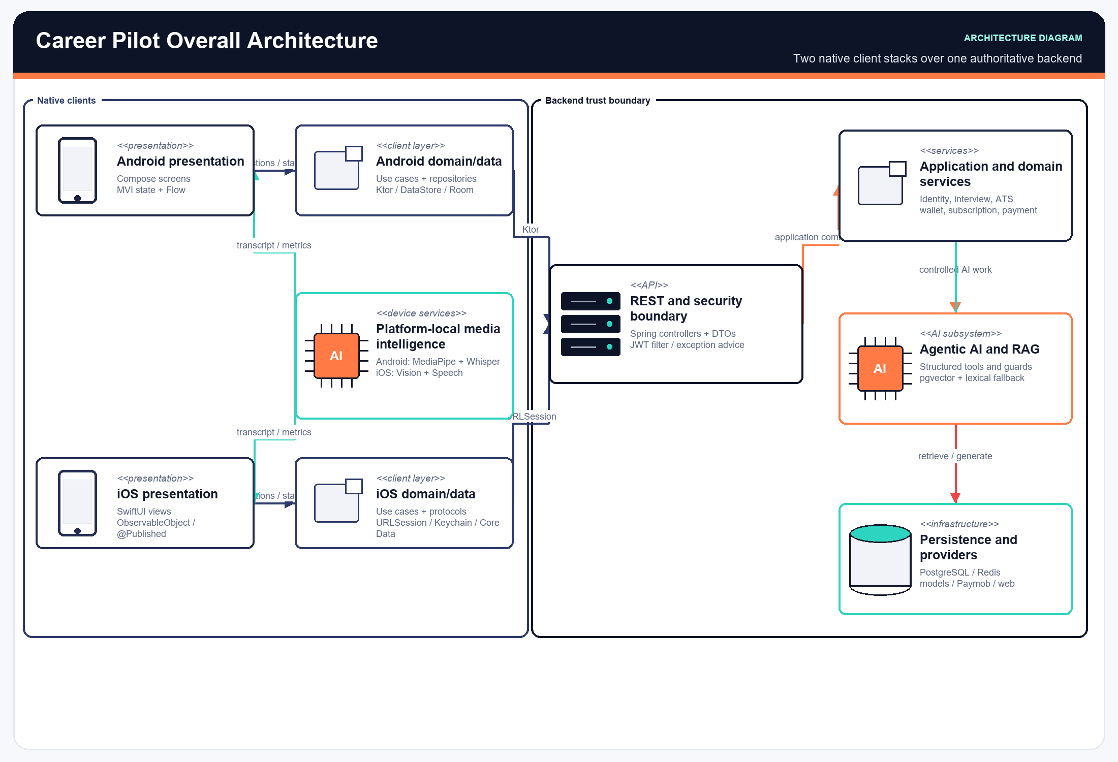
Figure 1.2: Career Pilot Overall System Architecture

4.1.2 Database Entity-Relationship Diagrams (ERD)
Career Pilot utilizes a normalized PostgreSQL database schema designed for relational integrity, vector similarity indexing, and audit logging:
• Identity & Profile Domain: users, user_profiles, career_tracks, user_tokens, audit_logs.
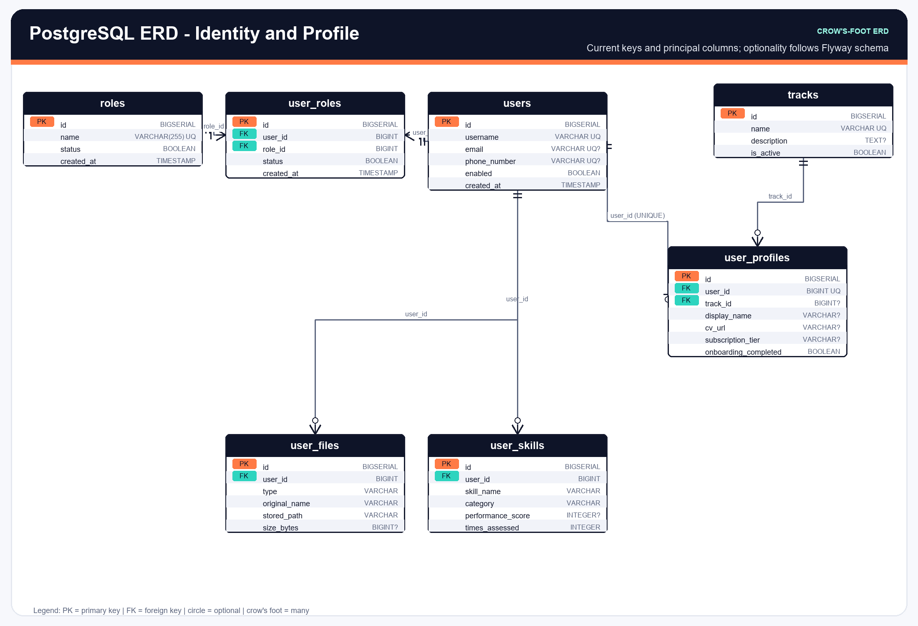
Figure 2.1: Database ERD — Identity, Profile, and Security Domain
• CV & Vector Domain and Interview Practice Domain: cv_documents, cv_chunks, cv_skills, interview_sessions, interview_questions, interview_evaluations, vision_metrics, speech_metrics.
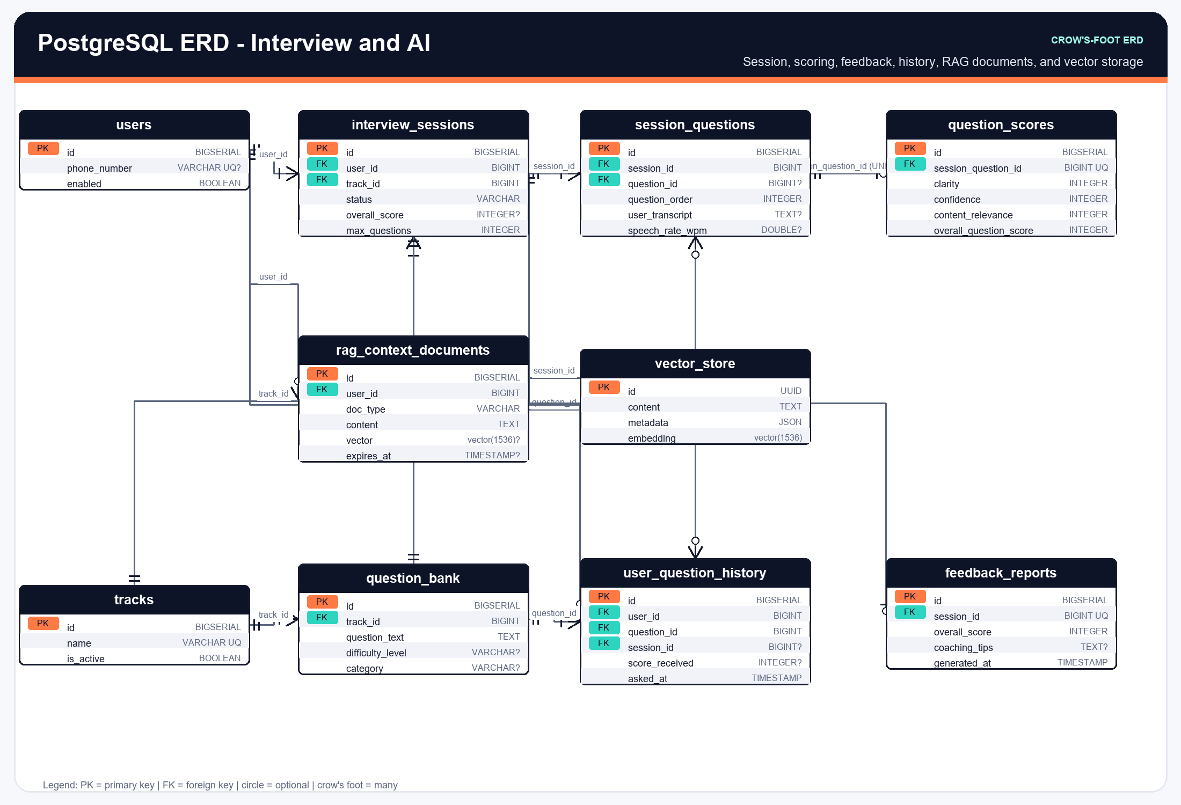
Figure 2.2: Database ERD — Interview Practice, AI Evaluation, and Vectors Domain
• ATS & Optimization Domain and Monetization Domain: job_postings, ats_workspaces, ai_jobs, cover_letters, subscriptions, subscription_plans, wallets, coin_transactions, payment_orders.
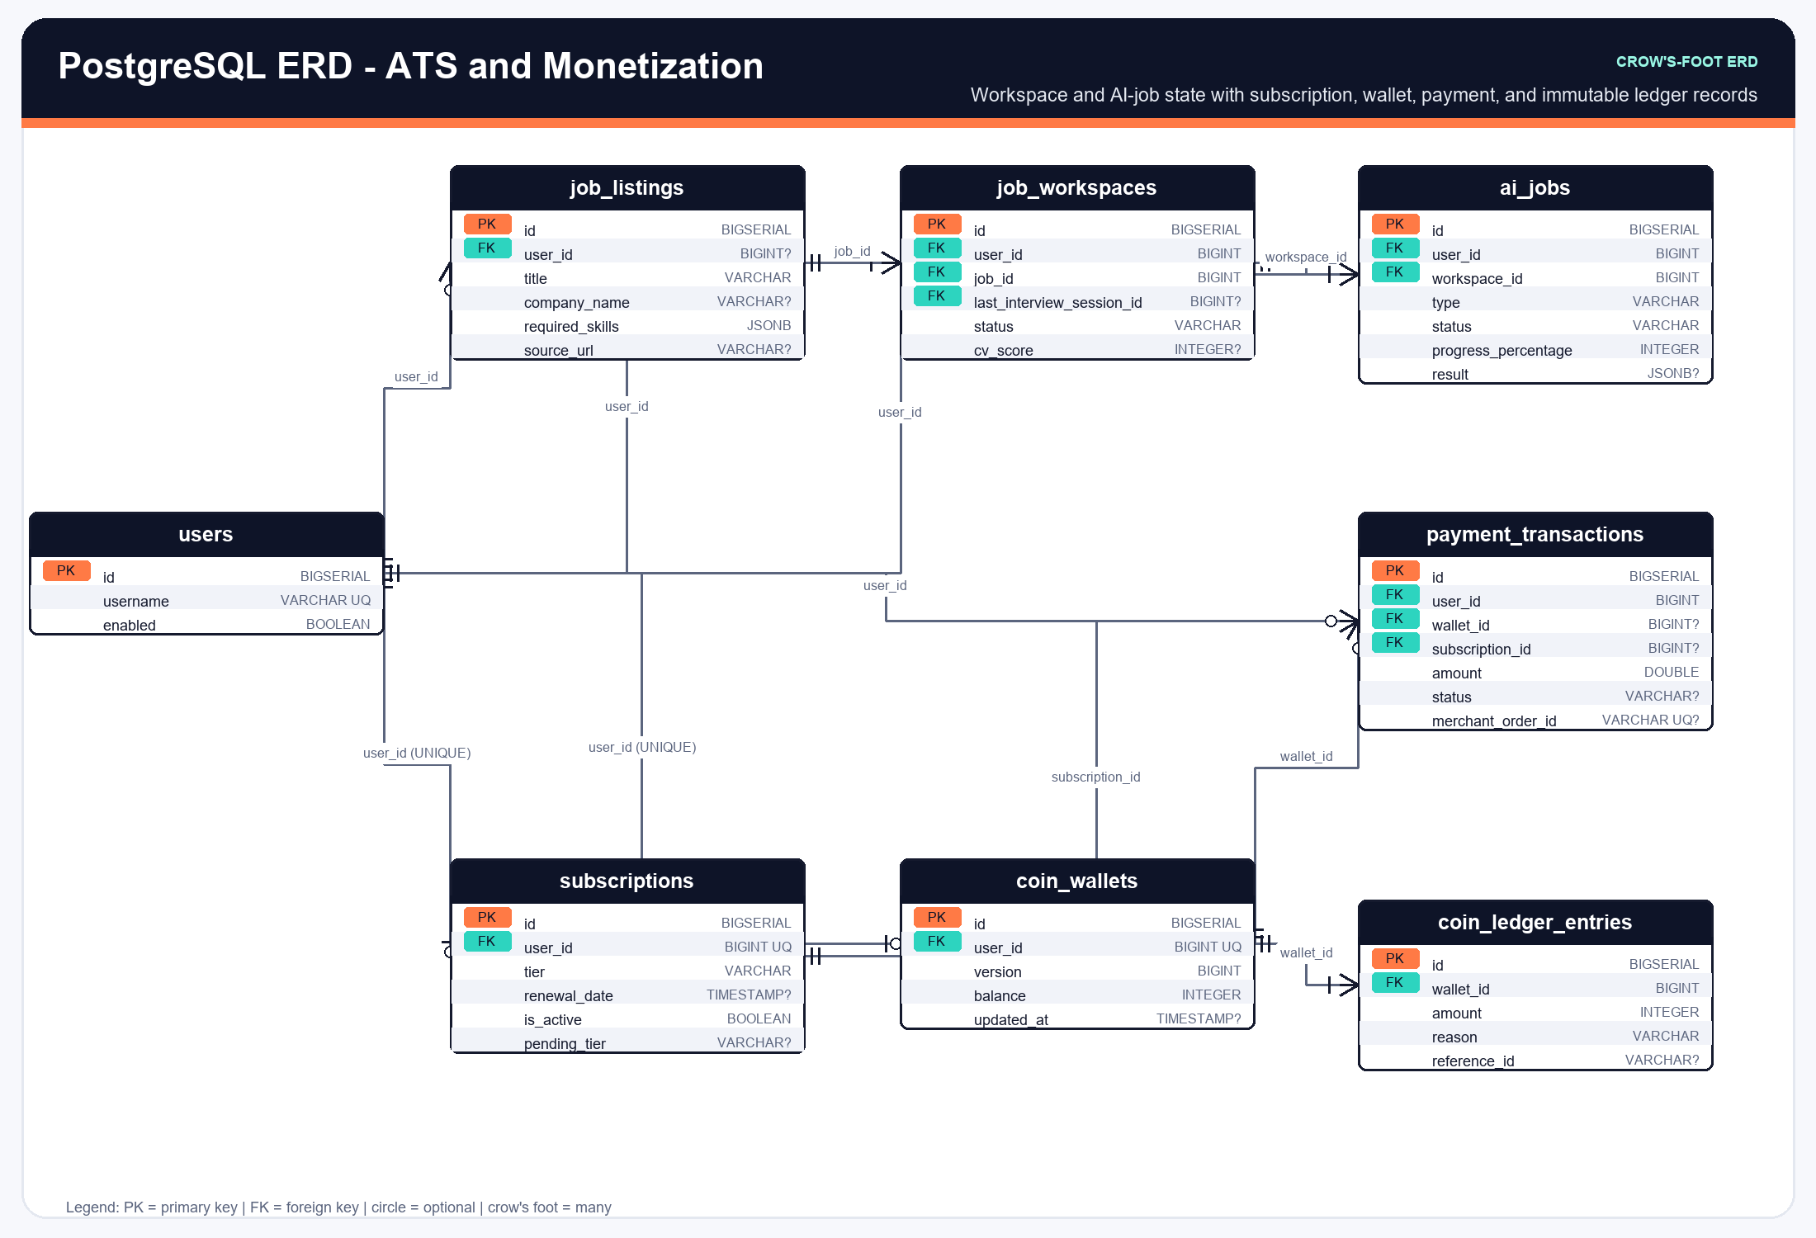
Figure 2.3: Database ERD — ATS Job Workspace, AI Jobs, and Payments Domain
Complete PostgreSQL Database Schema Catalog
The following tables document the authoritative PostgreSQL database schema (22 tables) implemented in Career Pilot:
Table: users (Identity & Security)
Description: Primary user entity storing authentication credentials, role definitions, and account status.
Column Name | Data Type | Constraints / Keys | Column Description & Business Meaning
id | UUID / BIGSERIAL | PRIMARY KEY | Unique user identifier
email | VARCHAR(255) | NOT NULL, UNIQUE | User email address for login and OTP dispatch
password_hash | VARCHAR(255) | NULLABLE | BCrypt password hash (if password auth enabled)
role | VARCHAR(50) | NOT NULL | User role: CANDIDATE, RECRUITER, ADMIN
is_active | BOOLEAN | NOT NULL, DEFAULT TRUE | Account active/suspended status
email_verified | BOOLEAN | NOT NULL, DEFAULT FALSE | Email verification status
created_at | TIMESTAMP WITH TIME ZONE | NOT NULL | Account creation timestamp
updated_at | TIMESTAMP WITH TIME ZONE | NOT NULL | Last profile modification timestamp

Table: user_profiles (Identity & Security)
Description: Extended profile information including career seniority, target job track, and bio.
Column Name | Data Type | Constraints / Keys | Column Description & Business Meaning
id | UUID / BIGSERIAL | PRIMARY KEY | Unique profile record identifier
user_id | BIGINT | NOT NULL, FK -> users(id) | Associated user reference
full_name | VARCHAR(255) | NOT NULL | Candidate full legal name
headline | VARCHAR(500) | NULLABLE | Professional headline (e.g., Senior iOS Engineer)
seniority_level | VARCHAR(50) | NOT NULL | JUNIOR, MID_LEVEL, SENIOR, LEAD
target_track_id | BIGINT | NULLABLE, FK -> career_tracks(id) | Selected primary career track
phone_number | VARCHAR(50) | NULLABLE | Contact phone number
country | VARCHAR(100) | DEFAULT 'Egypt' | Candidate country of residence
created_at | TIMESTAMP WITH TIME ZONE | NOT NULL | Profile record creation timestamp

Table: career_tracks (Identity & Security)
Description: Standardized engineering career tracks and specialization benchmarks.
Column Name | Data Type | Constraints / Keys | Column Description & Business Meaning
id | BIGSERIAL | PRIMARY KEY | Unique career track identifier
name | VARCHAR(150) | NOT NULL, UNIQUE | Track name (e.g., Mobile Engineering, Backend Java)
slug | VARCHAR(100) | NOT NULL, UNIQUE | URL-friendly track slug
description | TEXT | NOT NULL | Detailed track scope, expected competencies, and roadmap
is_active | BOOLEAN | NOT NULL, DEFAULT TRUE | Track availability status
created_at | TIMESTAMP WITH TIME ZONE | NOT NULL | Track creation timestamp

Table: user_tokens (Identity & Security)
Description: Encrypted session tokens, refresh tokens, and device identifiers.
Column Name | Data Type | Constraints / Keys | Column Description & Business Meaning
id | BIGSERIAL | PRIMARY KEY | Unique token record identifier
user_id | BIGINT | NOT NULL, FK -> users(id) | Token owner reference
token_hash | VARCHAR(255) | NOT NULL, UNIQUE | SHA-256 hash of issued JWT refresh token
device_info | VARCHAR(255) | NULLABLE | Client device model, OS, and client version
ip_address | VARCHAR(45) | NULLABLE | Client IP address for security audit
expires_at | TIMESTAMP WITH TIME ZONE | NOT NULL | Token expiration timestamp
revoked_at | TIMESTAMP WITH TIME ZONE | NULLABLE | Explicit token revocation timestamp

Table: audit_logs (Identity & Security)
Description: System security and administrative audit trail recording critical actions.
Column Name | Data Type | Constraints / Keys | Column Description & Business Meaning
id | BIGSERIAL | PRIMARY KEY | Unique audit log identifier
user_id | BIGINT | NULLABLE, FK -> users(id) | User who triggered the event
action | VARCHAR(100) | NOT NULL | Action performed (e.g., LOGIN, PASSWORD_CHANGE, PAYMENT)
resource_type | VARCHAR(100) | NOT NULL | Target entity (USER, INTERVIEW, CV, WALLET)
resource_id | VARCHAR(100) | NULLABLE | Identifier of affected resource
details | JSONB | NULLABLE | Structured JSON metadata of the event
created_at | TIMESTAMP WITH TIME ZONE | NOT NULL | Event timestamp

Table: cv_documents (CV & Vector Ingestion)
Description: Uploaded candidate resume files, text extraction metadata, and parsing status.
Column Name | Data Type | Constraints / Keys | Column Description & Business Meaning
id | BIGSERIAL | PRIMARY KEY | Unique CV document identifier
user_id | BIGINT | NOT NULL, FK -> users(id) | Candidate reference
file_name | VARCHAR(255) | NOT NULL | Original uploaded PDF filename
file_size_bytes | BIGINT | NOT NULL | File size in bytes
file_hash_sha256 | VARCHAR(64) | NOT NULL | Integrity checksum hash of raw PDF
storage_uri | VARCHAR(500) | NOT NULL | Encrypted file storage path / S3 bucket URI
parsed_text | TEXT | NOT NULL | Extracted clean plaintext of the resume
parse_status | VARCHAR(50) | NOT NULL | PENDING, PARSED, EMBEDDED, FAILED
created_at | TIMESTAMP WITH TIME ZONE | NOT NULL | Upload timestamp

Table: cv_chunks (CV & Vector Ingestion)
Description: Chunked text segments of the CV with 1536-dimensional vector embeddings for RAG.
Column Name | Data Type | Constraints / Keys | Column Description & Business Meaning
id | BIGSERIAL | PRIMARY KEY | Unique chunk identifier
cv_document_id | BIGINT | NOT NULL, FK -> cv_documents(id) | Parent CV document reference
chunk_index | INT | NOT NULL | Zero-indexed chunk sequence number
section_type | VARCHAR(50) | NOT NULL | EXPERIENCE, EDUCATION, SKILLS, PROJECTS, SUMMARY
chunk_text | TEXT | NOT NULL | Plaintext content of the chunk segment
embedding | vector(1536) | NOT NULL | pgvector 1536-dimensional dense embedding vector
created_at | TIMESTAMP WITH TIME ZONE | NOT NULL | Embedding creation timestamp

Table: cv_skills (CV & Vector Ingestion)
Description: Normalized technical and soft skills extracted from candidate CV.
Column Name | Data Type | Constraints / Keys | Column Description & Business Meaning
id | BIGSERIAL | PRIMARY KEY | Unique skill record identifier
cv_document_id | BIGINT | NOT NULL, FK -> cv_documents(id) | Associated CV reference
skill_name | VARCHAR(150) | NOT NULL | Normalized skill name (e.g., Swift, Kotlin, Spring Boot)
category | VARCHAR(100) | NOT NULL | LANGUAGE, FRAMEWORK, DATABASE, CLOUD, METHODOLOGY
proficiency_level | VARCHAR(50) | NULLABLE | BEGINNER, INTERMEDIATE, ADVANCED, EXPERT
years_of_experience | NUMERIC(4,1) | NULLABLE | Calculated years of experience with skill

Table: interview_sessions (Interview Practice)
Description: Mock interview sessions, configuration parameters, and overall session scores.
Column Name | Data Type | Constraints / Keys | Column Description & Business Meaning
id | BIGSERIAL | PRIMARY KEY | Unique interview session identifier
user_id | BIGINT | NOT NULL, FK -> users(id) | Candidate reference
career_track_id | BIGINT | NOT NULL, FK -> career_tracks(id) | Target career track for the session
job_posting_id | BIGINT | NULLABLE, FK -> job_postings(id) | Specific job vacancy reference (if targeted)
session_status | VARCHAR(50) | NOT NULL | INITIALIZED, IN_PROGRESS, COMPLETED, ABANDONED
total_questions | INT | NOT NULL, DEFAULT 5 | Number of questions in session
overall_score | NUMERIC(5,2) | NULLABLE | Overall calculated readiness score (0-100)
technical_score | NUMERIC(5,2) | NULLABLE | Technical accuracy score component
behavioral_score | NUMERIC(5,2) | NULLABLE | STAR structuring and communication score
visual_score | NUMERIC(5,2) | NULLABLE | Posture stability and eye contact score
speech_score | NUMERIC(5,2) | NULLABLE | Pacing, pauses, and fluency score
started_at | TIMESTAMP WITH TIME ZONE | NOT NULL | Session initiation timestamp
completed_at | TIMESTAMP WITH TIME ZONE | NULLABLE | Session completion timestamp

Table: interview_questions (Interview Practice)
Description: Individual questions presented during an interview session with candidate answers.
Column Name | Data Type | Constraints / Keys | Column Description & Business Meaning
id | BIGSERIAL | PRIMARY KEY | Unique question instance identifier
session_id | BIGINT | NOT NULL, FK -> interview_sessions(id) | Parent interview session reference
question_number | INT | NOT NULL | Sequential question index (1 to 5)
question_text | TEXT | NOT NULL | Generated or retrieved interview question text
question_category | VARCHAR(100) | NOT NULL | TECHNICAL_DEPTH, ARCHITECTURE, BEHAVIORAL, PROBLEM_SOLVING
difficulty_level | VARCHAR(50) | NOT NULL | EASY, MEDIUM, HARD, SENIOR
expected_topics | TEXT[] | NULLABLE | Key technical topics and concepts expected in answer
audio_transcript | TEXT | NULLABLE | Whisper on-device transcribed answer text
duration_seconds | INT | NULLABLE | Candidate answer duration in seconds
created_at | TIMESTAMP WITH TIME ZONE | NOT NULL | Question creation timestamp

Table: interview_evaluations (Interview Practice)
Description: AI evaluations, feedback rubrics, strengths, and improvement suggestions for questions.
Column Name | Data Type | Constraints / Keys | Column Description & Business Meaning
id | BIGSERIAL | PRIMARY KEY | Unique evaluation record identifier
question_id | BIGINT | NOT NULL, UNIQUE, FK -> interview_questions(id) | Evaluated question reference
technical_accuracy_score | NUMERIC(5,2) | NOT NULL | Question technical accuracy score (0-100)
clarity_score | NUMERIC(5,2) | NOT NULL | Communication clarity score (0-100)
star_compliance_score | NUMERIC(5,2) | NOT NULL | STAR structuring compliance score (0-100)
strengths | TEXT[] | NOT NULL | Identified candidate response strengths
weaknesses | TEXT[] | NOT NULL | Identified missing concepts or gaps
actionable_tips | TEXT[] | NOT NULL | Concrete suggestions for improvement
ideal_answer_outline | TEXT | NOT NULL | Model answer reference outline
evaluated_at | TIMESTAMP WITH TIME ZONE | NOT NULL | Evaluation completion timestamp

Table: vision_metrics (Interview Practice)
Description: On-device computer vision metrics recorded during interview answer delivery.
Column Name | Data Type | Constraints / Keys | Column Description & Business Meaning
id | BIGSERIAL | PRIMARY KEY | Unique vision metric record identifier
question_id | BIGINT | NOT NULL, UNIQUE, FK -> interview_questions(id) | Associated question reference
eye_contact_percentage | NUMERIC(5,2) | NOT NULL | Percentage of time candidate maintained direct eye contact
posture_stability_score | NUMERIC(5,2) | NOT NULL | Stability score based on shoulder pose keypoints
head_nod_count | INT | NOT NULL, DEFAULT 0 | Detected positive engagement head gestures
face_detected_ratio | NUMERIC(5,2) | NOT NULL | Ratio of frames with valid face detection
sampled_frames_count | INT | NOT NULL | Total video frames analyzed on-device

Table: speech_metrics (Interview Practice)
Description: Audio metrics evaluated from microphone stream during response.
Column Name | Data Type | Constraints / Keys | Column Description & Business Meaning
id | BIGSERIAL | PRIMARY KEY | Unique speech metric record identifier
question_id | BIGINT | NOT NULL, UNIQUE, FK -> interview_questions(id) | Associated question reference
words_per_minute | NUMERIC(6,2) | NOT NULL | Calculated speaking speed (WPM)
total_words_count | INT | NOT NULL | Total word count in spoken answer
filler_words_count | INT | NOT NULL, DEFAULT 0 | Detected filler words (um, uh, like, basically)
filler_word_percentage | NUMERIC(5,2) | NOT NULL | Filler words ratio to total words
long_pause_count | INT | NOT NULL, DEFAULT 0 | Number of awkward pauses exceeding 2.5 seconds
total_pause_duration_sec | NUMERIC(6,2) | NOT NULL | Cumulative silence duration in seconds

Table: job_postings (ATS & Job Workspace)
Description: Scraped and normalized job descriptions, required skills, and vector embeddings.
Column Name | Data Type | Constraints / Keys | Column Description & Business Meaning
id | BIGSERIAL | PRIMARY KEY | Unique job vacancy record identifier
user_id | BIGINT | NOT NULL, FK -> users(id) | Candidate who imported the vacancy
job_title | VARCHAR(255) | NOT NULL | Target job title (e.g., Senior iOS Developer)
company_name | VARCHAR(255) | NULLABLE | Hiring organization name
source_url | VARCHAR(1000) | NULLABLE | Original job board / LinkedIn posting URL
raw_description | TEXT | NOT NULL | Full raw job description text
extracted_requirements | JSONB | NOT NULL | Structured JSON of hard skills, years of exp, and education
job_embedding | vector(1536) | NOT NULL | pgvector 1536-dimensional job requirement vector
created_at | TIMESTAMP WITH TIME ZONE | NOT NULL | Job ingestion timestamp

Table: ats_workspaces (ATS & Job Workspace)
Description: ATS comparison workspaces linking candidate CV with target job vacancy.
Column Name | Data Type | Constraints / Keys | Column Description & Business Meaning
id | BIGSERIAL | PRIMARY KEY | Unique ATS workspace identifier
user_id | BIGINT | NOT NULL, FK -> users(id) | Candidate reference
cv_document_id | BIGINT | NOT NULL, FK -> cv_documents(id) | Candidate CV reference
job_posting_id | BIGINT | NOT NULL, FK -> job_postings(id) | Target job vacancy reference
overall_match_score | NUMERIC(5,2) | NOT NULL | Calculated ATS compatibility score (0-100)
technical_skills_match | NUMERIC(5,2) | NOT NULL | Technical skills alignment percentage
experience_alignment_score | NUMERIC(5,2) | NOT NULL | Seniority and experience match percentage
keyword_density_score | NUMERIC(5,2) | NOT NULL | Relevant ATS keyword density score
missing_keywords | TEXT[] | NOT NULL | Critical vacancy keywords missing in candidate CV
matched_keywords | TEXT[] | NOT NULL | Successfully matched vacancy keywords in CV
created_at | TIMESTAMP WITH TIME ZONE | NOT NULL | Workspace creation timestamp

Table: ai_jobs (ATS & Job Workspace)
Description: Asynchronous AI task queue for heavy CV optimizations and background workflows.
Column Name | Data Type | Constraints / Keys | Column Description & Business Meaning
id | UUID | PRIMARY KEY | Unique asynchronous AI job UUID
user_id | BIGINT | NOT NULL, FK -> users(id) | Job owner reference
job_type | VARCHAR(100) | NOT NULL | CV_OPTIMIZATION, COVER_LETTER, BATCH_EVALUATION
job_status | VARCHAR(50) | NOT NULL | PENDING, PROCESSING, COMPLETED, FAILED
input_payload | JSONB | NOT NULL | Structured JSON input parameters for the task
output_result | JSONB | NULLABLE | Generated output result payload upon completion
error_message | TEXT | NULLABLE | Error diagnostics if job execution failed
retry_count | INT | NOT NULL, DEFAULT 0 | Number of execution retry attempts
created_at | TIMESTAMP WITH TIME ZONE | NOT NULL | Task enqueue timestamp
completed_at | TIMESTAMP WITH TIME ZONE | NULLABLE | Task execution completion timestamp

Table: cover_letters (ATS & Job Workspace)
Description: Tailored, job-specific cover letters generated by LLM engine.
Column Name | Data Type | Constraints / Keys | Column Description & Business Meaning
id | BIGSERIAL | PRIMARY KEY | Unique cover letter identifier
workspace_id | BIGINT | NOT NULL, FK -> ats_workspaces(id) | Associated ATS workspace reference
tone | VARCHAR(50) | NOT NULL | PROFESSIONAL, ENTHUSIASTIC, TECHNICAL, EXECUTIVE
letter_body | TEXT | NOT NULL | Full generated cover letter text content
custom_notes | TEXT | NULLABLE | Candidate custom edits or personal notes
created_at | TIMESTAMP WITH TIME ZONE | NOT NULL | Generation timestamp
updated_at | TIMESTAMP WITH TIME ZONE | NOT NULL | Last edit timestamp

Table: subscription_plans (Monetization & Billing)
Description: Available subscription tiers, pricing, monthly coin allocations, and feature flags.
Column Name | Data Type | Constraints / Keys | Column Description & Business Meaning
id | BIGSERIAL | PRIMARY KEY | Unique plan tier identifier
plan_code | VARCHAR(50) | NOT NULL, UNIQUE | FREE, PLUS, MAX
name | VARCHAR(100) | NOT NULL | Display name (e.g., Plus Plan)
price_egp | NUMERIC(10,2) | NOT NULL | Monthly subscription price in Egyptian Pounds
monthly_coins | INT | NOT NULL | Monthly coins allocated by plan (PLUS: 80; MAX: 160). FREE receives 20 signup coins.
unlimited_ats | BOOLEAN | NOT NULL | Unlimited ATS scan access flag
priority_ai_queue | BOOLEAN | NOT NULL | Priority processing worker queue flag
is_active | BOOLEAN | NOT NULL, DEFAULT TRUE | Plan availability flag

Table: subscriptions (Monetization & Billing)
Description: Active and historical user subscription records.
Column Name | Data Type | Constraints / Keys | Column Description & Business Meaning
id | BIGSERIAL | PRIMARY KEY | Unique user subscription identifier
user_id | BIGINT | NOT NULL, FK -> users(id) | Subscribed user reference
plan_id | BIGINT | NOT NULL, FK -> subscription_plans(id) | Subscribed plan tier reference
status | VARCHAR(50) | NOT NULL | ACTIVE, CANCELLED, EXPIRED, PAST_DUE
current_period_start | TIMESTAMP WITH TIME ZONE | NOT NULL | Current billing cycle start timestamp
current_period_end | TIMESTAMP WITH TIME ZONE | NOT NULL | Current billing cycle end timestamp
auto_renew | BOOLEAN | NOT NULL, DEFAULT TRUE | Automatic monthly renewal flag
created_at | TIMESTAMP WITH TIME ZONE | NOT NULL | Subscription initiation timestamp

Table: wallets (Monetization & Billing)
Description: User coin wallet balances consumed for AI mock interviews and CV optimizations.
Column Name | Data Type | Constraints / Keys | Column Description & Business Meaning
id | BIGSERIAL | PRIMARY KEY | Unique wallet record identifier
user_id | BIGINT | NOT NULL, UNIQUE, FK -> users(id) | Wallet owner reference
coin_balance | INT | NOT NULL, DEFAULT 0 | Current available coin balance
lifetime_coins_earned | INT | NOT NULL, DEFAULT 0 | Cumulative coins credited from plans and packs
lifetime_coins_spent | INT | NOT NULL, DEFAULT 0 | Cumulative coins consumed for AI services
updated_at | TIMESTAMP WITH TIME ZONE | NOT NULL | Last balance modification timestamp

Table: coin_transactions (Monetization & Billing)
Description: Audit ledger of all coin credit and debit operations.
Column Name | Data Type | Constraints / Keys | Column Description & Business Meaning
id | BIGSERIAL | PRIMARY KEY | Unique transaction record identifier
wallet_id | BIGINT | NOT NULL, FK -> wallets(id) | Associated wallet reference
amount | INT | NOT NULL | Positive integer for credits, negative for debits
transaction_type | VARCHAR(50) | NOT NULL | PLAN_GRANT, PACK_PURCHASE, INTERVIEW_DEBIT, ATS_DEBIT
reference_entity_type | VARCHAR(100) | NULLABLE | INTERVIEW_SESSION, AI_JOB, PAYMENT_ORDER
reference_entity_id | VARCHAR(100) | NULLABLE | Identifier of associated service or order
balance_after | INT | NOT NULL | Wallet balance immediately following transaction
created_at | TIMESTAMP WITH TIME ZONE | NOT NULL | Transaction ledger timestamp

Table: payment_orders (Monetization & Billing)
Description: Paymob payment orders, intention IDs, transaction statuses, and webhook audit trails.
Column Name | Data Type | Constraints / Keys | Column Description & Business Meaning
id | BIGSERIAL | PRIMARY KEY | Unique payment order identifier
user_id | BIGINT | NOT NULL, FK -> users(id) | Purchasing user reference
paymob_order_id | VARCHAR(100) | NOT NULL, UNIQUE | Paymob gateway assigned order ID
paymob_transaction_id | VARCHAR(100) | NULLABLE | Paymob settled transaction reference ID
order_type | VARCHAR(50) | NOT NULL | SUBSCRIPTION, COIN_PACK
plan_or_pack_code | VARCHAR(50) | NOT NULL | Purchased tier or coin package code
amount_cents | BIGINT | NOT NULL | Order amount in Egyptian Piastres (Cents)
currency | VARCHAR(10) | NOT NULL, DEFAULT 'EGP' | Transaction currency
payment_status | VARCHAR(50) | NOT NULL | PENDING, PAID, FAILED, REFUNDED
payment_method | VARCHAR(50) | NULLABLE | CARD, VODAFONE_CASH, ORANGE_MONEY, MEEZA
hmac_verified | BOOLEAN | NOT NULL, DEFAULT FALSE | HMAC-SHA512 webhook signature verification flag
created_at | TIMESTAMP WITH TIME ZONE | NOT NULL | Order initiation timestamp
paid_at | TIMESTAMP WITH TIME ZONE | NULLABLE | Payment settlement timestamp

4.1.3 Use Case Model & Detailed Specifications
The Use Case model captures candidate interactions across identity, interview practice, ATS resume alignment, monetization, centralized feature access, and the Android Challenge experience:
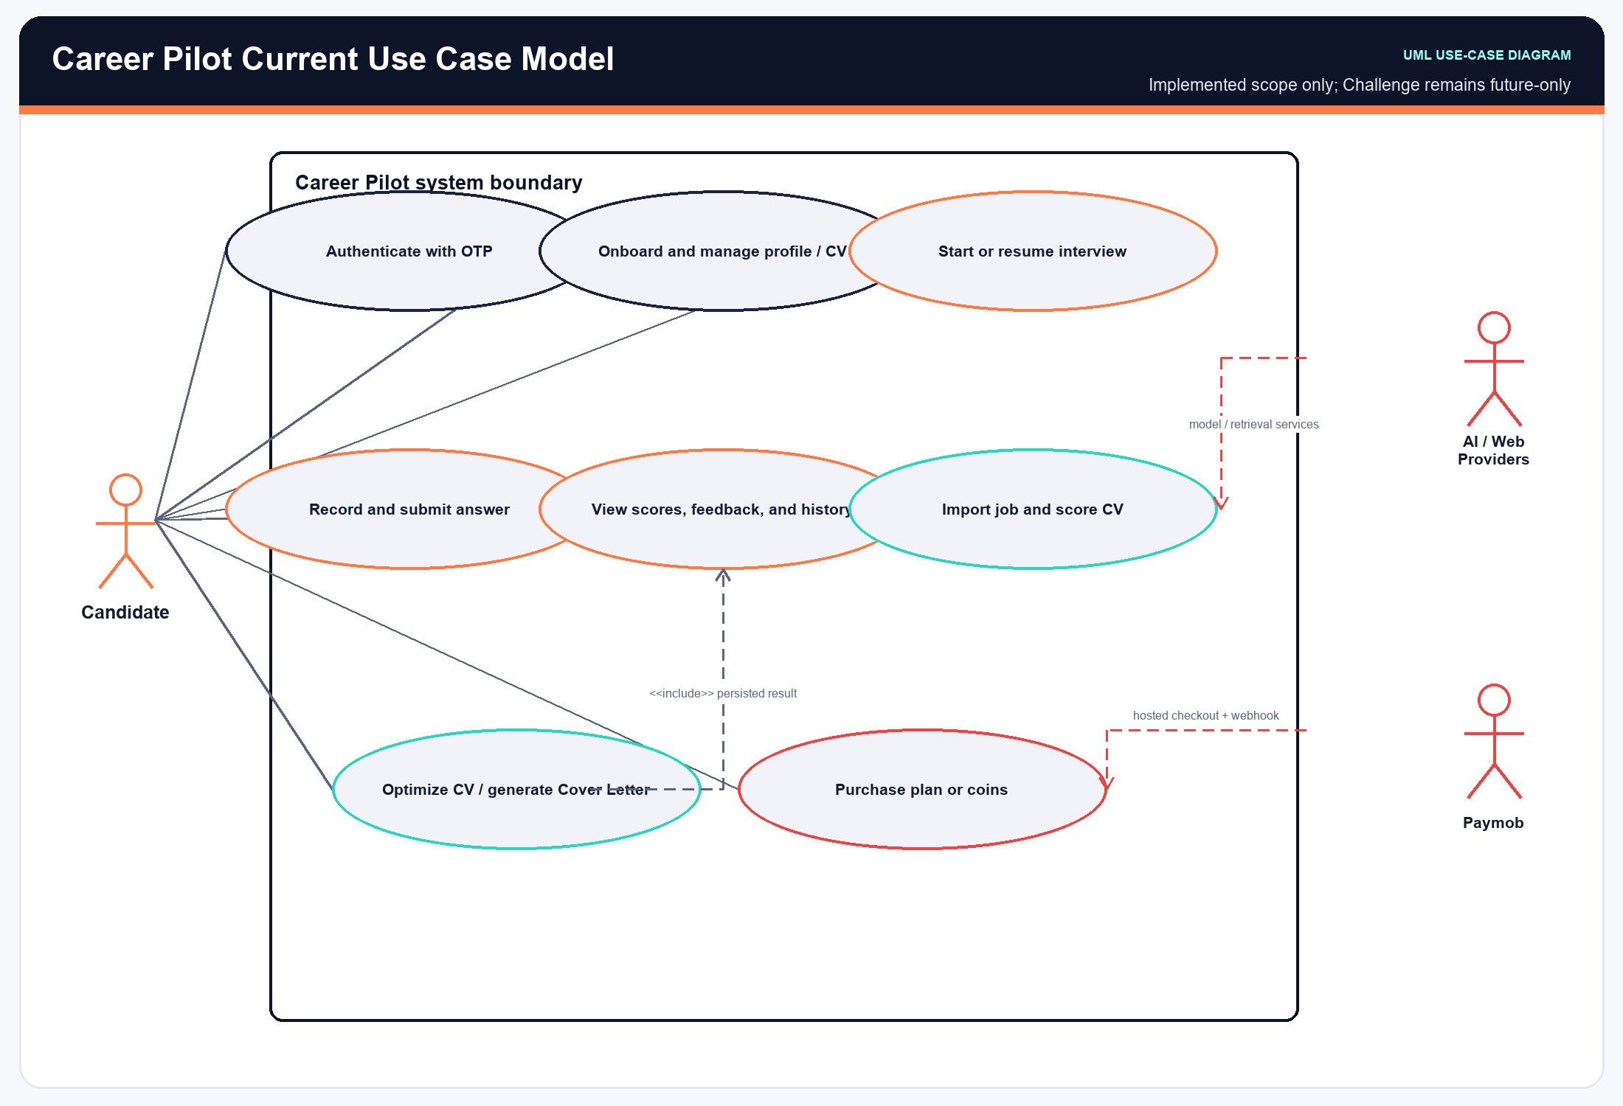
Figure 3.1: Career Pilot Use Case Model
Complete Use Case Specifications (UC-01 to UC-13)
The following structured specifications document the end-to-end user workflows, pre/post-conditions, main flows, and alternative exception scenarios:
Use Case: UC-01 - Candidate Registration & OTP Authentication
Field | Specification Details
Use Case ID & Name | UC-01: Candidate Registration & OTP Authentication
Primary Actor | Candidate (Job Seeker)
Secondary Actors | Email Dispatcher Service, Security Token Authority
Pre-conditions | Candidate has installed the mobile app and possesses a valid email address.
Trigger Event | Candidate opens the app and enters their email address on the authentication screen.
Main Success Scenario | 1. Candidate enters email address and taps 'Send OTP'.  2. Mobile client validates email syntax and sends HTTP POST to `/api/v1/auth/otp/send`.  3. Backend generates a cryptographically secure 6-digit numeric OTP and stores its SHA-256 hash with a 5-minute TTL.  4. Backend dispatches OTP via SMTP email gateway and returns a 200 OK response.  5. Mobile client transitions to the OTP input screen with a countdown timer.  6. Candidate enters the 6-digit verification code received in their email.  7. Mobile client sends HTTP POST to `/api/v1/auth/otp/verify` with email and code.  8. Backend validates OTP hash, provisions a new user record if first login, and generates a pair of signed JWT access and refresh tokens.  9. Mobile client stores access token in Android Keystore / iOS Keychain and navigates to Dashboard.
Alternative & Error Flows | 3a. Email rate limit exceeded: Backend returns 429 Too Many Requests; client displays 'Please wait 60 seconds before requesting a new code'.  8a. Invalid OTP entered: Backend increments failed attempt counter and returns 400 Bad Request; client highlights input boxes in red.  8b. Expired OTP: Backend returns 401 Unauthorized; client prompts candidate to request a new code.
Post-conditions | User session is established; authenticated JWT tokens are securely stored on the device.

Use Case: UC-02 - Career Track Onboarding & Profile Customization
Field | Specification Details
Use Case ID & Name | UC-02: Career Track Onboarding & Profile Customization
Primary Actor | Candidate (Job Seeker)
Secondary Actors | Backend Profile Service
Pre-conditions | Candidate is authenticated and has not yet completed onboarding.
Trigger Event | Application detects unconfigured profile after initial authentication.
Main Success Scenario | 1. Application presents available engineering career tracks (Mobile Engineering, Backend Java, Full-Stack Cloud, AI/ML).  2. Candidate reviews track descriptions, core competencies, and selects their target track.  3. Candidate selects their current experience level (Fresh Graduate, Junior, Mid-Level, Senior).  4. Candidate provides their full name, professional headline, and optional phone number.  5. Mobile client dispatches HTTP POST `/api/v1/profile/onboarding` with selected parameters.  6. Backend creates `user_profiles` record linked to the authenticated user and target `career_tracks` ID.  7. Backend grants the FREE-tier signup allocation of 20 coins into the candidate's wallet.  8. Mobile client persists profile state locally and transitions to Main Dashboard.
Alternative & Error Flows | 5a. Network connection lost: Mobile client caches input locally and retries upon reconnection.  6a. Career track inactive: Backend returns 400 Bad Request; client updates list of active tracks.
Post-conditions | Candidate profile is fully configured; target track is set for interview and ATS benchmarks.

Use Case: UC-03 - CV Document Upload, Ingestion & Semantic Vectorization
Field | Specification Details
Use Case ID & Name | UC-03: CV Document Upload, Ingestion & Semantic Vectorization
Primary Actor | Candidate (Job Seeker)
Secondary Actors | PDF Text Parser, AI Embedding Engine, pgvector Database
Pre-conditions | Candidate is logged in and has an active profile.
Trigger Event | Candidate taps 'Upload CV' on the profile or ATS workspace screen.
Main Success Scenario | 1. Candidate selects a PDF resume from device storage (file size <= 10 MB).  2. Mobile client verifies PDF MIME type, computes local SHA-256 checksum, and initiates multipart upload to `/api/v1/cv/upload`.  3. Backend streams PDF to secure encrypted storage and initiates Apache PDFBox / PDF extraction worker.  4. Parser extracts structured sections: Contact, Education, Work Experience, Technical Skills, and Projects.  5. Extracted text is split into semantic chunks (300-500 tokens with 50-token overlap).  6. Backend sends chunks to OpenAI text-embedding-3-small API to generate 1536-dimensional vector embeddings.  7. Embeddings and chunk metadata are inserted into `cv_chunks` table in PostgreSQL with pgvector HNSW index.  8. Backend extracts normalized skills and populates `cv_skills` table.  9. Backend returns 201 Created with parsed profile highlights; mobile client displays extracted skills overview.
Alternative & Error Flows | 2a. File exceeds 10MB limit: Mobile client displays error dialog before upload.  3a. Corrupted or encrypted PDF: Backend returns 422 Unprocessable Entity; client prompts candidate to upload an unencrypted PDF.  6a. AI Embedding service timeout: Backend enqueues vectorization task in background worker and returns 202 Accepted.
Post-conditions | Candidate CV is parsed, vectorized, indexed in pgvector, and linked to candidate profile.

Use Case: UC-04 - Initialize Adaptive Mock Interview Session
Field | Specification Details
Use Case ID & Name | UC-04: Initialize Adaptive Mock Interview Session
Primary Actor | Candidate (Job Seeker)
Secondary Actors | Interview Agent, RAG Pipeline Service, Wallet Entitlement Service
Pre-conditions | Candidate is authenticated, has selected a career track, and possesses sufficient wallet coins or an active subscription.
Trigger Event | Candidate taps 'Start Mock Interview' from the dashboard or practice tab.
Main Success Scenario | 1. Candidate selects interview parameters: Career Track, Target Seniority, Focus Area (General, System Design, Behavioral), and Question Count (5).  2. Candidate clicks 'Begin Session'.  3. Mobile client sends HTTP POST to `/api/v1/interview/sessions` with chosen configuration.  4. Backend applies mode-specific entitlement rules: an AI Voice Mock Interview costs 10 coins (or uses an available plan quota), while an AI Video Mock Interview costs 0 coins but requires an active MAX subscription.  5. Backend RAG engine queries `cv_chunks` and standard track competencies in pgvector to formulate a personalized interview agenda.  6. Interview Agent instantiates session in `interview_sessions` table with status `INITIALIZED`.  7. Backend generates first question (Technical Depth) and returns session metadata with Question 1 DTO.  8. Mobile client requests camera and microphone runtime permissions and opens the live interview room.
Alternative & Error Flows | 4a. For Voice mode, fewer than 10 available coins with no applicable quota returns 402 Payment Required and opens coin top-up. For Video mode, any non-MAX user is shown the MAX upgrade paywall.  8a. Camera or microphone permission denied: Mobile client displays explanatory permission prompt with deep link to system settings.
Post-conditions | An active `interview_sessions` record is created; the applicable mode entitlement is enforced (10 coins for Voice or MAX access for 0-coin Video); the interview room is initialized.

Use Case: UC-05 - Record, Analyze & Submit Multimodal Interview Answer
Field | Specification Details
Use Case ID & Name | UC-05: Record, Analyze & Submit Multimodal Interview Answer
Primary Actor | Candidate (Job Seeker)
Secondary Actors | On-Device MediaPipe / Apple Vision, On-Device Whisper / Speech, Backend AI Evaluator
Pre-conditions | Candidate is inside an active mock interview room with camera and microphone active.
Trigger Event | Candidate taps 'Start Answer' or begins speaking after question prompt.
Main Success Scenario | 1. Mobile client presents question card and countdown timer (maximum 3 minutes per answer).  2. CameraX (Android) or AVFoundation (iOS) captures front camera video frames at 30 FPS.  3. On-device MediaPipe / Apple Vision processes frames in real time: tracks 468 facial landmarks for gaze angle and shoulder keypoints for posture stability.  4. Audio stream is captured and fed in real time to on-device sherpa-onnx Whisper / Apple Speech, displaying live transcription text.  5. Candidate completes answer and taps 'Stop & Submit Answer'.  6. Mobile client aggregates vision metrics (eye contact %, posture score, head gestures) and speech metrics (WPM, pause counts, filler words).  7. Client dispatches HTTP POST `/api/v1/interview/answers` with question ID, full text transcript, vision metrics, and speech metrics.  8. Backend AI evaluates verbal response: scores technical accuracy, STAR structuring, completeness, and formulates strengths and weaknesses.  9. Backend persists evaluation in `interview_evaluations`, `vision_metrics`, and `speech_metrics` tables.  10. Backend determines next adaptive question difficulty and returns next question DTO (or session completion signal).
Alternative & Error Flows | 1a. Maximum time limit reached: Client automatically stops recording at 3 minutes and submits captured metrics.  4a. Speech recognition silence detected: Client displays subtle prompt: 'We cannot hear you clearly. Please check microphone'.  7a. Network timeout during submission: Client stores answer payload in local SQLite / Core Data cache and displays retry banner.
Post-conditions | Candidate answer is transcribed, vision/speech metrics are captured on-device, and backend evaluation is persisted.

Use Case: UC-06 - Review Session Performance Report & Detailed Feedback
Field | Specification Details
Use Case ID & Name | UC-06: Review Session Performance Report & Detailed Feedback
Primary Actor | Candidate (Job Seeker)
Secondary Actors | Backend Analytics Engine, PDF Report Generator
Pre-conditions | Candidate has completed all questions in a mock interview session.
Trigger Event | Candidate finishes last interview question or selects a completed session from history.
Main Success Scenario | 1. Backend calculates composite session scores: Overall Readiness, Technical Accuracy, STAR Structuring, Visual Presence, and Vocal Fluency.  2. Backend updates `interview_sessions` status to `COMPLETED` and persists aggregated scores.  3. Mobile client requests HTTP GET `/api/v1/interview/reports/{sessionId}`.  4. Client renders comprehensive session scorecard: radar competency chart, score breakdowns, and question-by-question cards.  5. Candidate expands individual question cards to review exact transcript, identified strengths, improvement tips, and ideal model answers.  6. Candidate reviews body language insights (eye contact consistency, fidgeting rate) and speech cadence analysis (WPM, filler word count).  7. Candidate taps 'Export PDF Report'. Export costs 0 coins but requires PLUS or MAX; eligible users receive the formal evaluation document for portfolio or mentor review.
Alternative & Error Flows | 3a. Report data not yet finalized: Backend returns 202 Accepted; client displays animated score calculation loader.  7a. PDF export requested by a PLUS/MAX user: Backend generates signed PDF document and returns downloadable URI.
Post-conditions | Candidate receives actionable, grounded feedback; session report is indexed in historical analytics.

Use Case: UC-07 - Import Job Vacancy & Execute ATS Gap Analysis
Field | Specification Details
Use Case ID & Name | UC-07: Import Job Vacancy & Execute ATS Gap Analysis
Primary Actor | Candidate (Job Seeker)
Secondary Actors | Jsoup Web Scraper, AI Keyword Extractor, pgvector Database
Pre-conditions | Candidate is authenticated, has an active CV uploaded, and has sufficient balance for job parsing (1 coin) and ATS match scoring (5 coins).
Trigger Event | Candidate pastes a job vacancy URL or raw text in the ATS workspace tab.
Main Success Scenario | 1. Candidate inputs job vacancy URL (or pastes raw job description text) and taps 'Analyze Match'.  2. Mobile client dispatches HTTP POST `/api/v1/ats/jobs/import`; the backend applies the 1-coin job-description parsing charge, and the ATS match operation applies its 5-coin charge.  3. If URL provided, backend Jsoup worker fetches webpage, strips boilerplate HTML, and extracts clean job description.  4. Backend LLM extracts structured requirements: Job Title, Experience Range, Hard Skills, Soft Skills, and Educational Requirements.  5. Backend generates 1536-dimensional embedding vector for job requirements and saves `job_postings` record.  6. Backend compares candidate `cv_chunks` vector embeddings against job embeddings via cosine distance in pgvector.  7. Backend computes category match scores: Technical Match, Experience Match, and Keyword Density.  8. System identifies missing critical keywords present in the vacancy but absent from candidate CV.  9. Backend creates `ats_workspaces` record and returns full gap analysis DTO.  10. Mobile client displays ATS Compatibility Score gauge (0-100%), matching category breakdown, and highlighted missing keywords.
Alternative & Error Flows | 3a. Job URL protected by anti-bot / login wall: Backend returns 422 Unprocessable Entity with error: 'Unable to scrape URL automatically. Please paste job text directly'.  6a. No active CV found: Backend returns 400 Bad Request; client redirects candidate to CV Upload screen.
Post-conditions | Job vacancy is stored and embedded; ATS workspace is initialized with match scores and keyword gap analysis.

Use Case: UC-08 - Execute Asynchronous AI CV Bullet Optimization
Field | Specification Details
Use Case ID & Name | UC-08: Execute Asynchronous AI CV Bullet Optimization
Primary Actor | Candidate (Job Seeker)
Secondary Actors | Asynchronous AI Worker, LLM Optimizer, Notification Dispatcher
Pre-conditions | Candidate has an active ATS workspace comparing their CV with a target job vacancy and at least 15 coins available for optimization.
Trigger Event | Candidate taps 'Optimize Resume for this Job' in the ATS workspace.
Main Success Scenario | 1. Candidate selects experience bullet points they wish to optimize.  2. Candidate taps 'Generate Optimized Bullets'.  3. Mobile client sends HTTP POST `/api/v1/ats/cv/optimize` with workspace ID and selected bullet IDs.  4. Backend verifies the wallet balance and deducts 15 coins for the AI Deep CV Section Optimizer; the feature is available on all plans.  5. Backend enqueues a background task in `ai_jobs` table with status `PENDING` and returns task UUID to client.  6. Background AI worker picks up task, transitions status to `PROCESSING`.  7. Worker retrieves target job missing keywords and candidate's factual bullet points.  8. LLM rewrites bullet points utilizing strong action verbs, quantifiable metrics, and missing domain keywords while strictly preserving factual truth.  9. Worker stores optimized bullet diffs in `output_result` JSONB and marks task `COMPLETED`.  10. Mobile client polls `/api/v1/ats/jobs/{taskId}/status` (every 2 seconds) and displays side-by-side Diff View upon completion.
Alternative & Error Flows | 4a. Insufficient coins: Backend returns 402 Payment Required; client shows top-up dialog.  8a. AI Worker failure: Task status marked `FAILED`; worker automatically retries up to 3 times before returning diagnostic error.  10a. App closed during processing: State is persisted in PostgreSQL; upon reopening, client loads completed optimization from workspace.
Post-conditions | AI-optimized resume bullets are generated, displayed in side-by-side diff, and available for PDF resume export.

Use Case: UC-09 - Generate Job-Specific Tailored Cover Letter
Field | Specification Details
Use Case ID & Name | UC-09: Generate Job-Specific Tailored Cover Letter
Primary Actor | Candidate (Job Seeker)
Secondary Actors | LLM Generation Engine, Document Template Formatter
Pre-conditions | Candidate has an active ATS workspace with a parsed job vacancy and at least 5 coins available for Cover Letter generation.
Trigger Event | Candidate taps 'Generate Cover Letter' in the ATS workspace.
Main Success Scenario | 1. Candidate selects desired tone: Professional, Enthusiastic, Technical, or Executive.  2. Candidate provides optional custom focal points (e.g., 'Highlight my leadership in mobile architecture').  3. Mobile client dispatches HTTP POST `/api/v1/cover-letter/generate`; the backend deducts 5 coins for the AI Cover Letter Generator before generation.  4. Backend retrieves candidate profile, CV skills, and job posting requirements.  5. Backend LLM synthesizes candidate background and vacancy requirements into a compelling 3-paragraph cover letter adhering to standard business correspondence formatting.  6. Backend persists generated text in `cover_letters` table.  7. Mobile client displays interactive Cover Letter editor allowing inline editing, clipboard copy, or PDF export.
Alternative & Error Flows | 5a. LLM generation timeout: Backend retries with fallback prompt and returns completed text.  7a. Candidate edits letter text: Client sends HTTP PUT `/api/v1/cover-letter/{id}` to update saved draft.
Post-conditions | Tailored Cover Letter is generated, persisted, and ready for job application submission.

Use Case: UC-10 - Purchase Subscription Tier or Top-Up Coins
Field | Specification Details
Use Case ID & Name | UC-10: Purchase Subscription Tier or Top-Up Coins
Primary Actor | Candidate (Job Seeker)
Secondary Actors | Payment Gateway, Payment Settlement Service, Wallet Service
Pre-conditions | Candidate is logged in and navigates to the subscription/wallet screen.
Trigger Event | Candidate selects a subscription plan (PLUS/MAX) or coin package (Small/Medium/Large) and taps 'Checkout'.
Main Success Scenario | 1. Candidate selects desired plan or coin pack and taps 'Proceed to Checkout'.  2. Mobile client dispatches HTTP POST `/api/v1/payment/checkout` with selected item code.  3. Backend initializes payment intention with Paymob API, obtaining a secure payment token and iframe URL.  4. Backend creates a `payment_orders` record with status `PENDING`.  5. Mobile client displays Paymob payment UI in an in-app browser (Android Custom Tabs / iOS WKWebView).  6. Candidate enters credit/debit card details or selects a mobile wallet (Vodafone Cash, Orange Money, Meeza).  7. Candidate completes 3D-Secure / OTP verification on the bank/wallet portal.  8. Paymob processes transaction and dispatches an asynchronous HTTP POST webhook to backend `/api/v1/payment/webhook`.  9. Backend calculates HMAC-SHA512 signature of received payload and verifies match against Paymob secret key.  10. Backend updates `payment_orders` to `PAID`, credits coins to `wallets` (or updates `subscriptions` status to `ACTIVE`), and writes to `coin_transactions` ledger.  11. Mobile client receives success redirect callback, refreshes wallet balance, and presents celebratory confirmation screen.
Alternative & Error Flows | 7a. Bank declines transaction: Paymob redirects to failure URL; client displays 'Payment Declined by Issuer' and allows retry.  9a. HMAC signature mismatch: Backend rejects webhook with 403 Forbidden, logs security incident in `audit_logs`, and marks order `FAILED`.  10a. Duplicate webhook delivery: Backend detects already processed `paymob_transaction_id` and idempotently returns 200 OK without double crediting.
Post-conditions | Payment is settled; user subscription is activated or wallet coins are credited with full cryptographic audit trail.

Use Case: UC-11 - Explore and Participate in Interview Challenge
Field | Specification Details
Use Case ID & Name | UC-11: Explore and Participate in Interview Challenge
Primary Actor | Candidate / Community Participant
Secondary Actors | Challenge Firestore Runtime, Firebase AI Evaluation, Existing Practice Session
Pre-conditions | User is authenticated. Public challenge exists or a valid private challenge code/invitation is available.
Trigger Event | 1. User opens Challenges. 2. User browses a public challenge or enters a private code. 3. User reviews challenge details and required permissions. 4. Access policy grants challenge participation from Free. 5. A challenge session is created and the existing practice flow starts. 6. Answers are scored and saved. 7. User receives permitted results.
Main Success Scenario | Invalid challenge identifier; challenge unavailable; permission denied; Firestore or AI scoring failure; session can be retried according to application state.
Alternative & Error Flows | Challenge session and per-question results are persisted; final scores are available when the challenge is completed.
Post-conditions | FR-CHAL-01, FR-CHAL-02, FR-CHAL-03, FR-CHAL-06
Use Case: UC-12 - Create and Host Custom Interview Challenge
Field | Specification Details
Use Case ID & Name | UC-12: Create and Host Custom Interview Challenge
Primary Actor | Challenge Creator / Recruiter / Community Host
Secondary Actors | Feature Access Layer, Track Service, Challenge Firestore Runtime, Firebase AI Question Validator
Pre-conditions | User is authenticated and the current access policy grants Max-tier challenge creation.
Trigger Event | 1. User selects Create Challenge. 2. Access policy verifies Max eligibility. 3. User selects track, visibility, seniority and interview type. 4. User configures optional posture/hand analysis. 5. User enters the question set. 6. Firebase AI validates questions. 7. Challenge is saved to the public or private Firestore collection. 8. Creator receives the generated challenge identifier/invitation code.
Main Success Scenario | User is below Max and is shown upgrade guidance; fewer than ten valid questions; duplicate questions; validation or save failure.
Alternative & Error Flows | A new public/private challenge is persisted and becomes available through the appropriate discovery or invitation flow.
Post-conditions | FR-ACC-02, FR-CHAL-04, FR-CHAL-05
Use Case: UC-13 - Manage Challenge Dashboard and Results
Field | Specification Details
Use Case ID & Name | UC-13: Manage Challenge Dashboard and Results
Primary Actor | Challenge Creator
Secondary Actors | Challenge Firestore Runtime
Pre-conditions | Creator is authenticated and owns at least one challenge.
Trigger Event | 1. Creator opens Challenge Dashboard. 2. Created challenges and taken challenges are loaded. 3. Creator selects a challenge. 4. Participant sessions/results are retrieved. 5. Creator reviews completion state and AI score data. 6. Creator may edit or delete supported challenges.
Main Success Scenario | No challenges available; network/Firestore failure; selected challenge was deleted or unavailable.
Alternative & Error Flows | Creator obtains current participation and result information; supported management actions are persisted.
Post-conditions | FR-CHAL-07

4.1.4 Class & Subsystem Architecture Diagrams
The following architectural diagrams illustrate the core class structure and subsystem separation:
The Backend High-Level Architecture class diagram illustrates Spring Boot controllers, services, repositories, and domain models:
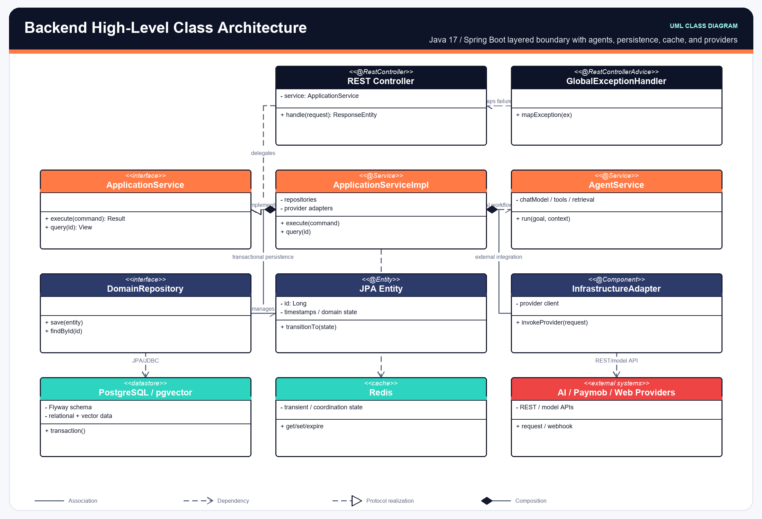
Figure 4.1: Backend High-Level Architecture & Layered Class Diagram
The Android High-Level Architecture class diagram depicts MVI ViewModels, UI StateFlows, and Hilt dependency injection bindings:
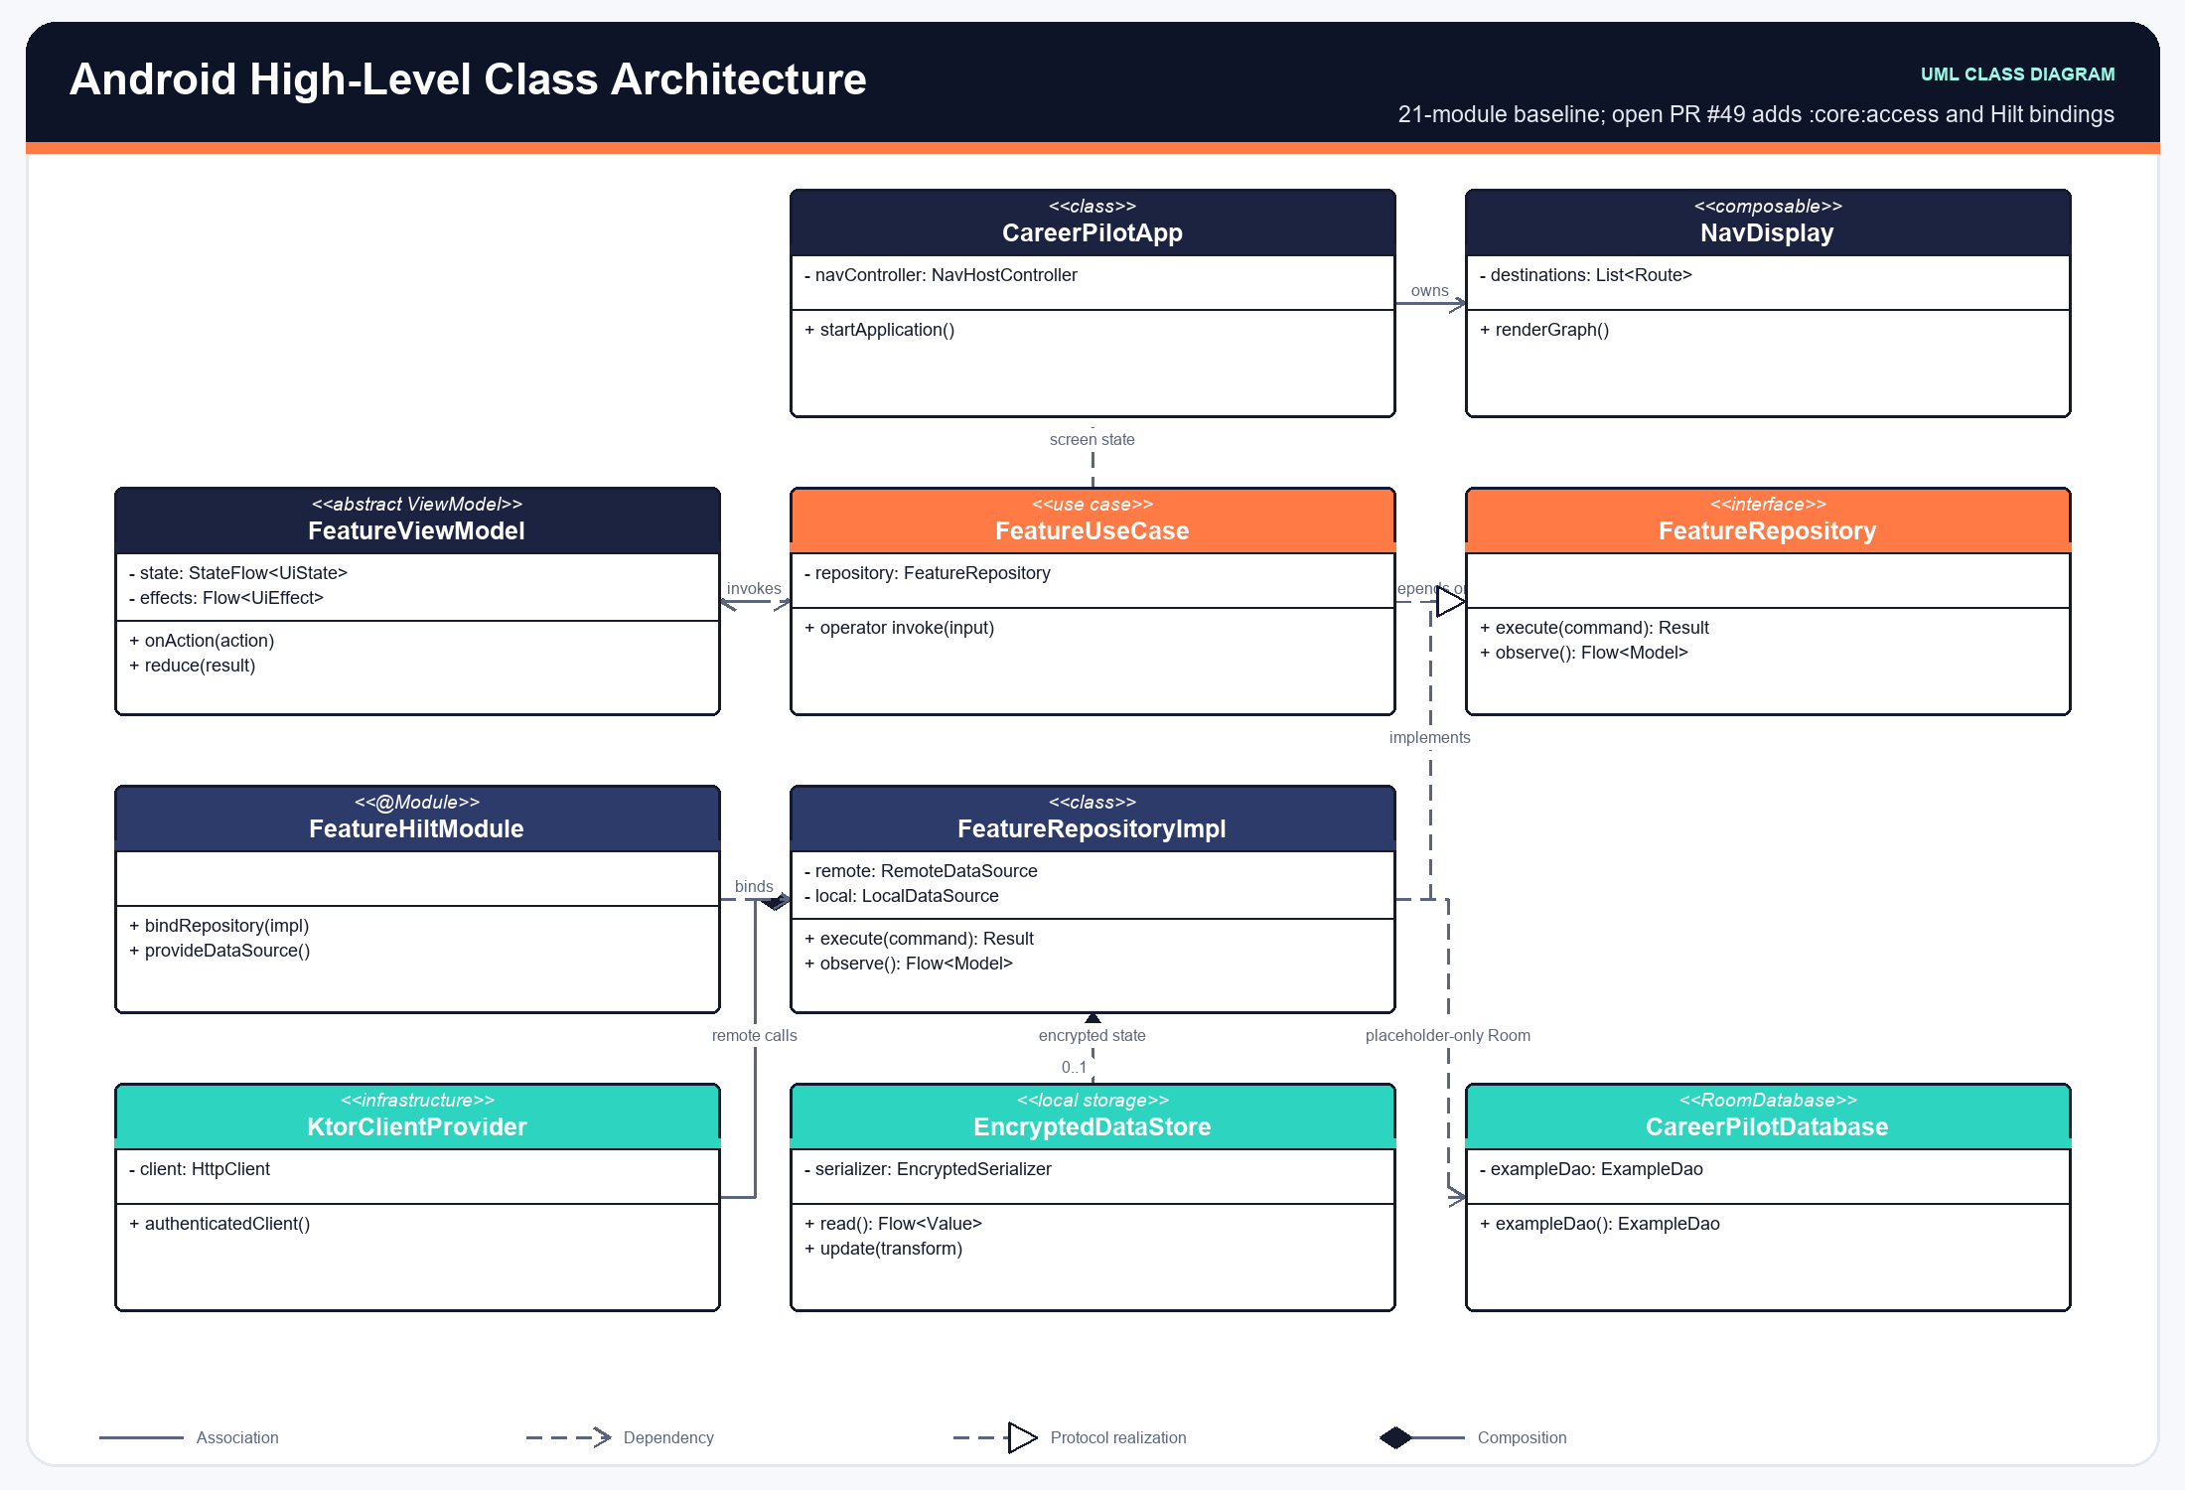
Figure 4.2: Android High-Level Architecture (MVI / Jetpack Compose)
The iOS High-Level Architecture class diagram details MVVM ObservableObjects, SwiftUI Views, and Combine reactive pipelines:
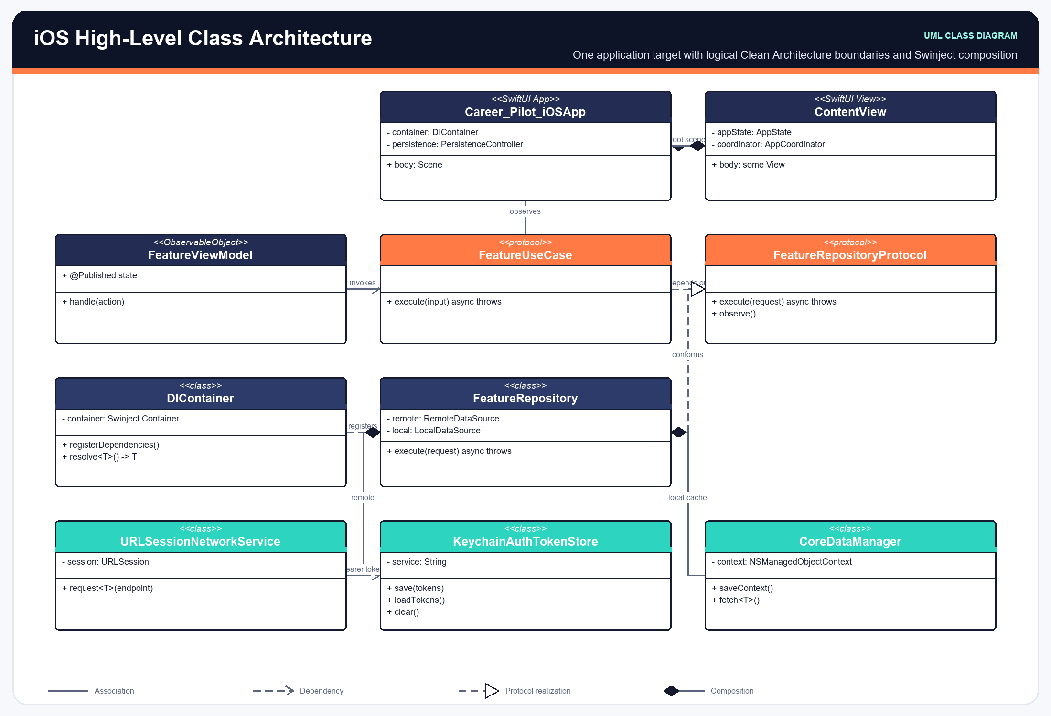
Figure 4.3: iOS High-Level Architecture (MVVM / SwiftUI)

4.1.5 AI, RAG & Workflow Diagrams
The RAG Architecture diagram shows how document chunks, vector search, and grounded prompts coordinate to eliminate hallucinations:
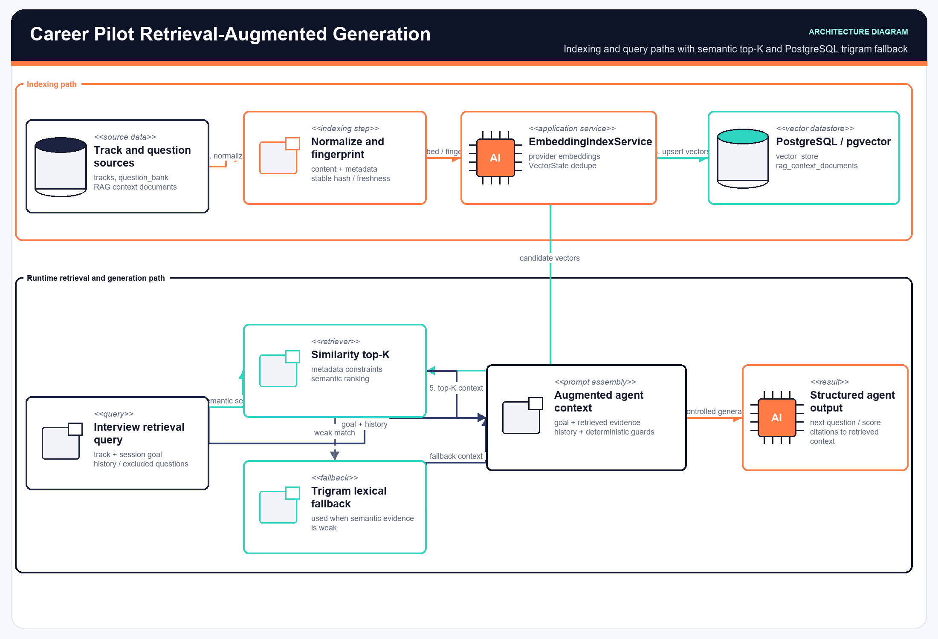
Figure 5.1: Retrieval-Augmented Generation (RAG) Architecture
The Agentic Interview Architecture diagram details the adaptive question selection and dual evaluation pipeline:
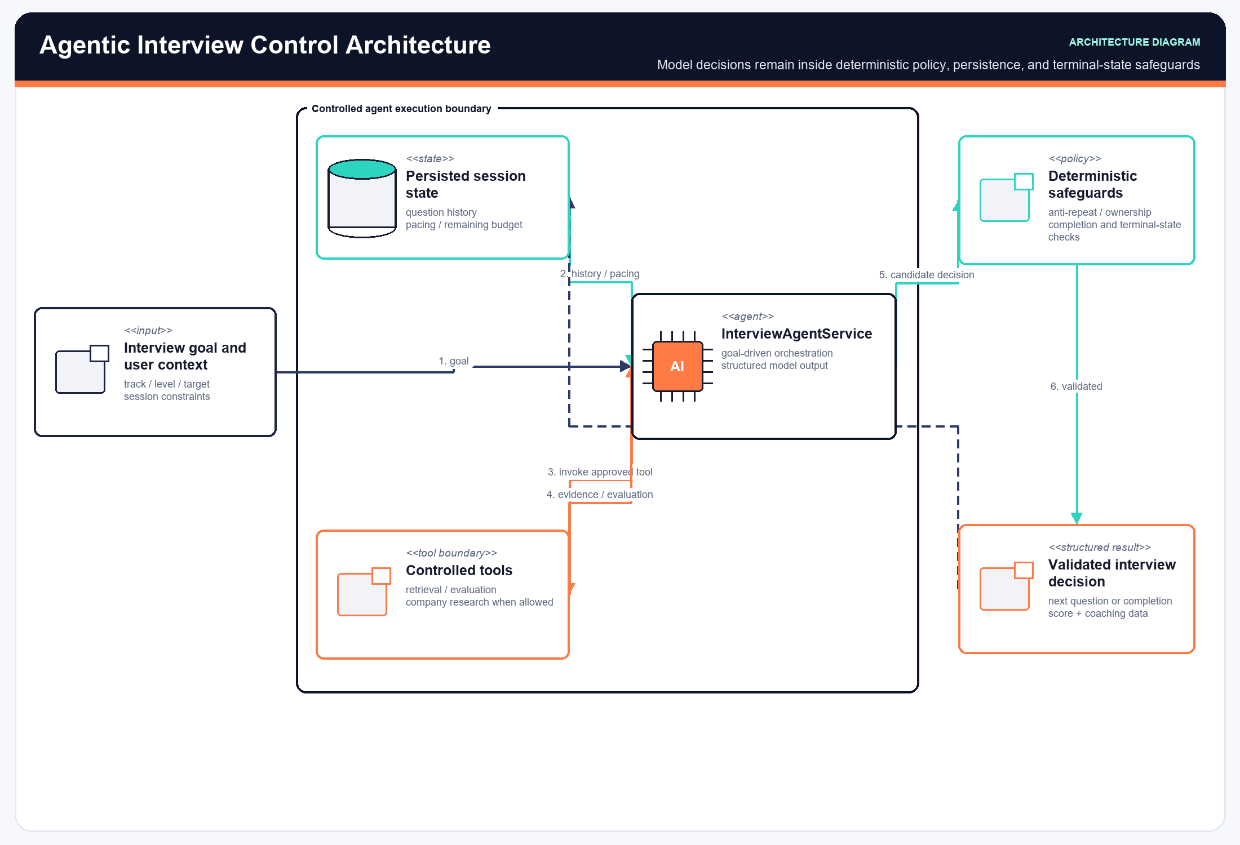
Figure 5.2: Agentic Interview Coach & Dual Evaluation Pipeline
The ATS Architecture diagram outlines job normalization, vector matching, and asynchronous CV bullet rewriting:
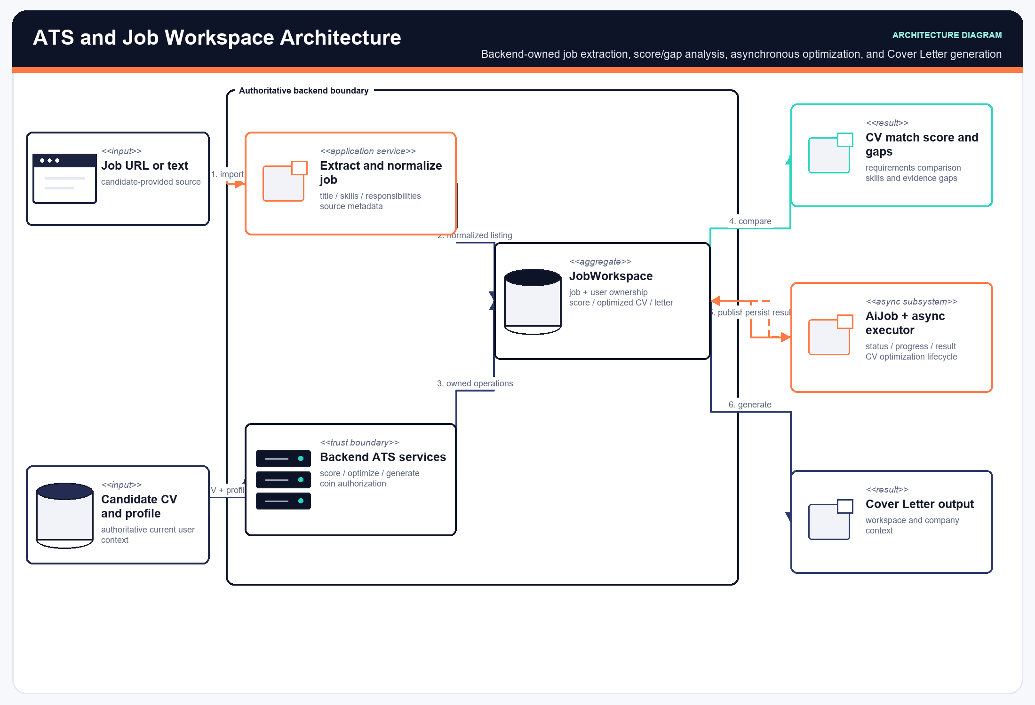
Figure 5.3: ATS Workspace, Vector Matcher & Asynchronous CV Optimizer
The Interview Execution Architecture diagram depicts the dynamic flow between mobile sensors and backend scoring:
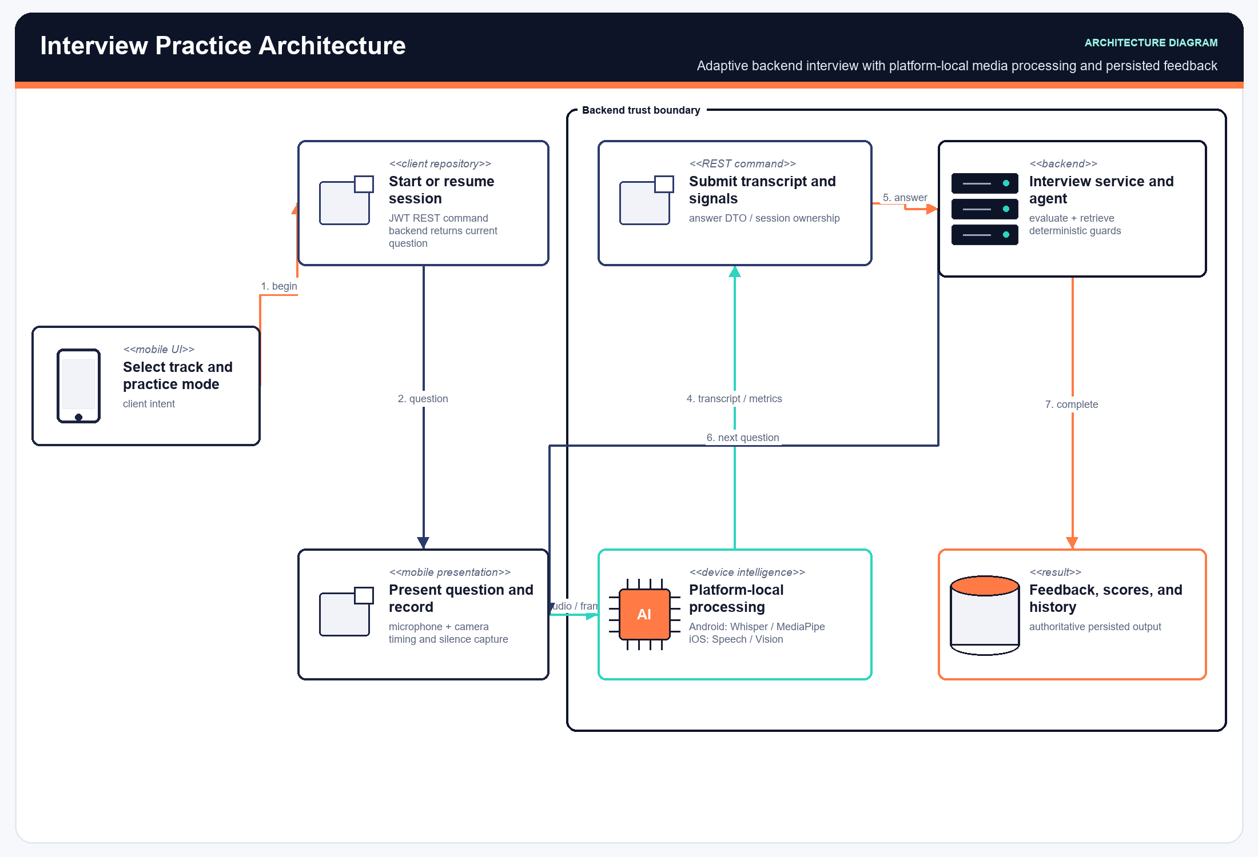
Figure 5.4: Adaptive Mock Interview Execution Architecture
The Payment Architecture diagram depicts the Paymob intention creation, checkout redirection, and HMAC webhook reconciliation flow:
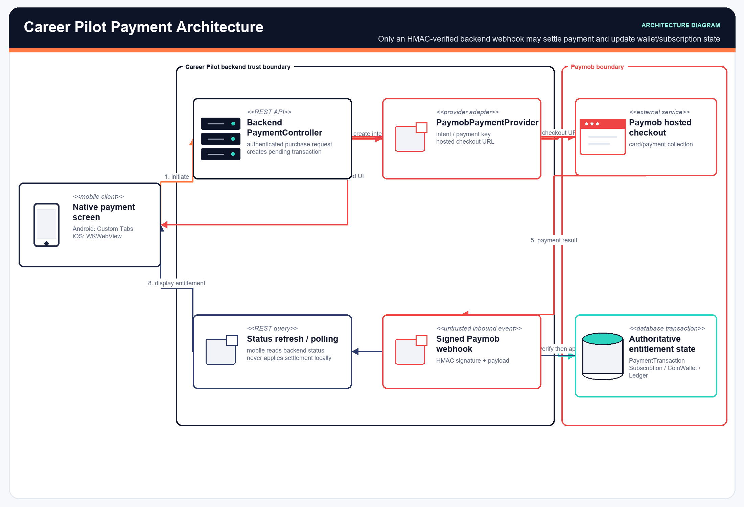
Figure 5.5: Payment Settlement & Reconciliation Architecture
The AI Execution Boundaries diagram differentiates on-device ML inference from backend LLM orchestration:
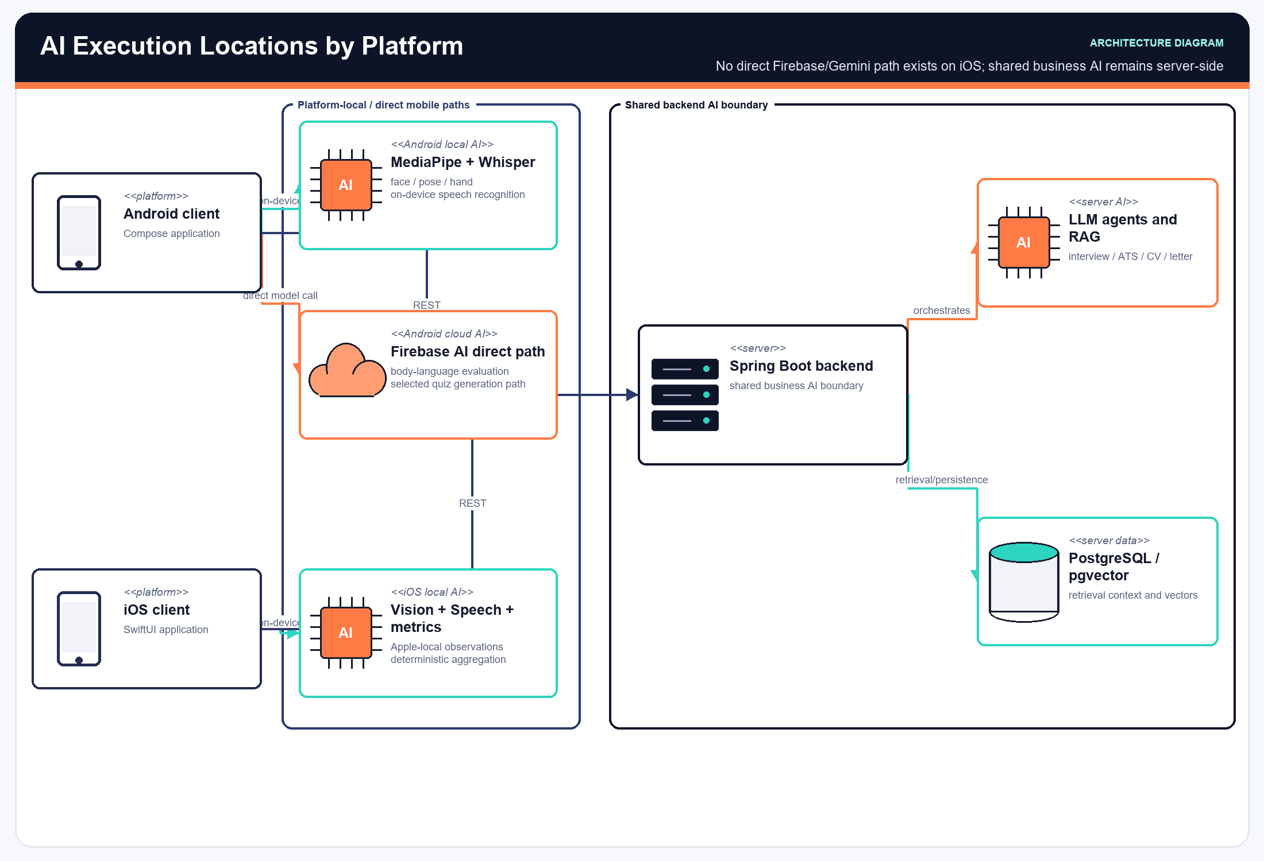
Figure 5.6: AI Processing Execution Boundaries & Data Flow

4.2 Application Screenshots
The following visual walkthrough showcases the key screens, UI flows, and interactive features of the Career Pilot mobile applications:

4.2.1 Authentication & Career Track Onboarding
Candidates authenticate seamlessly using university or professional emails with secure 6-digit OTP codes, followed by selecting their target engineering career track:
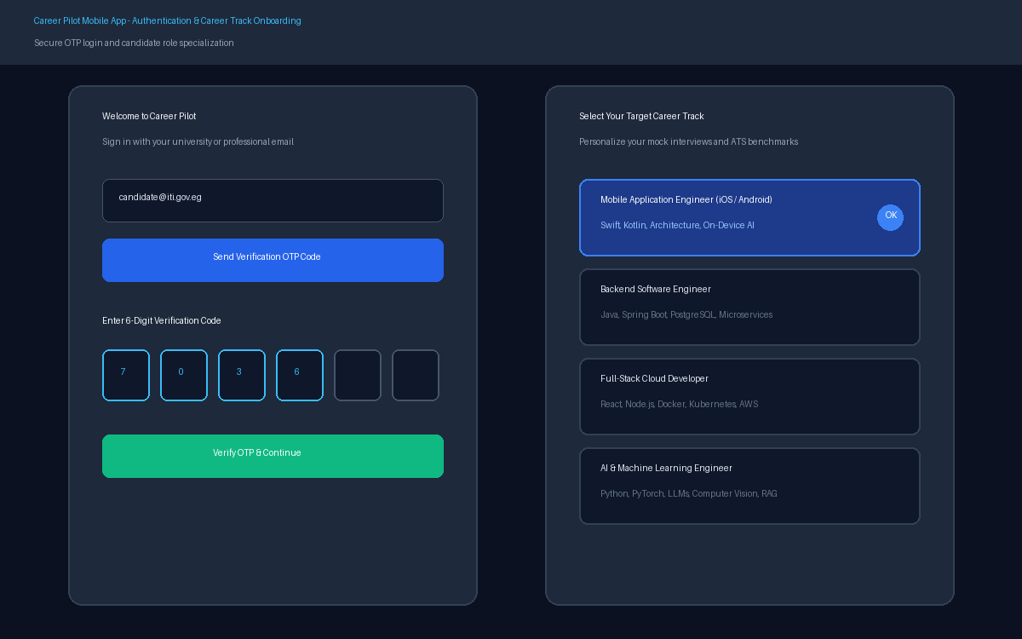
Figure 6.1: Authentication & Career Track Onboarding UI Flow

4.2.2 CV Ingestion, Parsing & Semantic Vectorization
Candidates upload their resume in PDF format. The system parses structured profile fields, categorizes technical competencies, and builds 1536-dimensional vector embeddings:
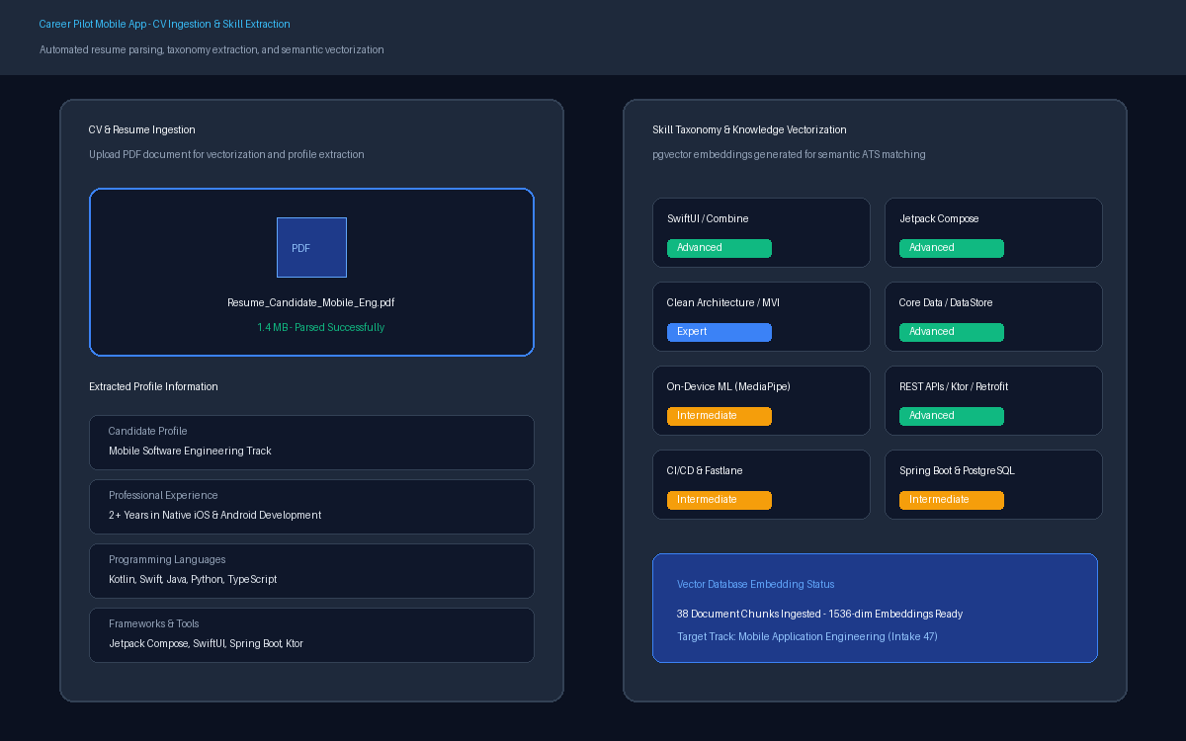
Figure 6.2: CV Ingestion, Skills Extraction & Vector Database Hub UI Flow

4.2.3 Adaptive Mock Interview Practice Room
The live interview environment features real-time face tracking (eye contact and posture stability), live audio waveform streaming, Whisper voice transcription, and adaptive questions:
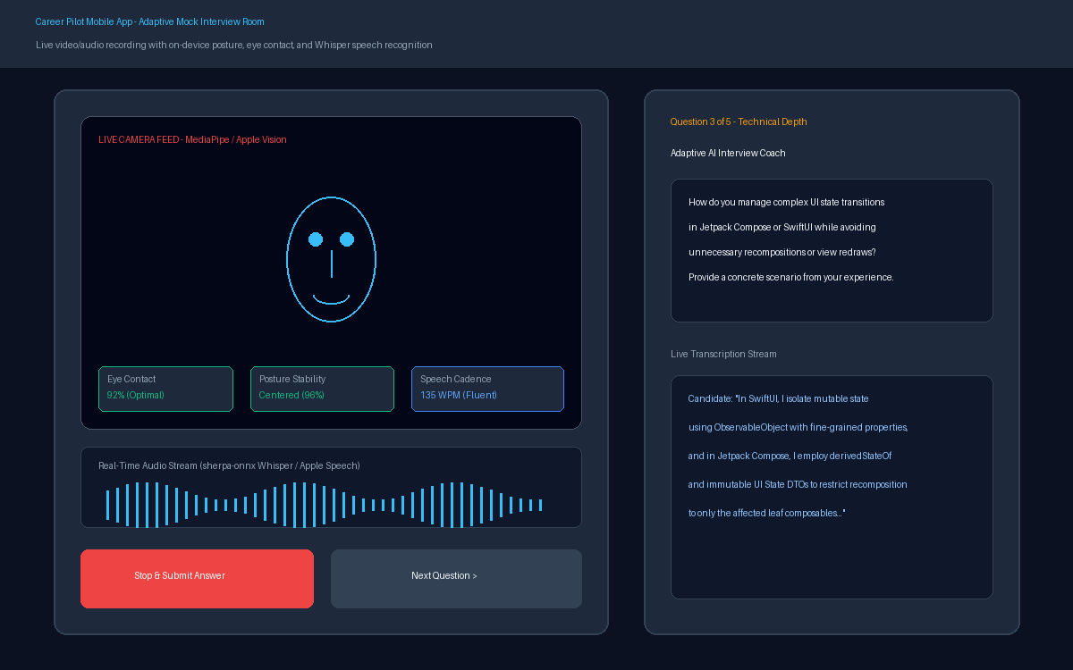
Figure 6.3: Adaptive Mock Interview Room with On-Device Multimodal Feedback

4.2.4 ATS Job Matching & Asynchronous CV Optimization
The ATS workspace analyzes job postings, computes match percentages across technical criteria, identifies missing keywords, and displays side-by-side optimized resume bullet diffs:
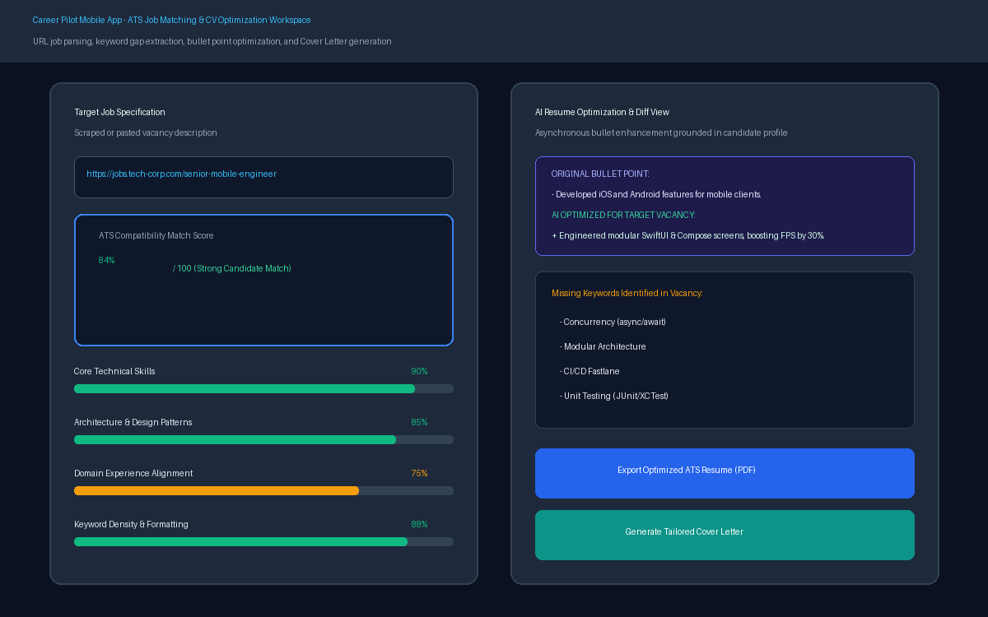
Figure 6.4: ATS Job Matching, Gap Analysis & CV Optimization UI Flow

4.2.5 Session Performance Analytics & Feedback Reports
After concluding an interview, candidates receive a multi-dimensional performance evaluation with score breakdowns (Technical, STAR Structure, Fluency, Posture), identified strengths, and actionable improvement areas:
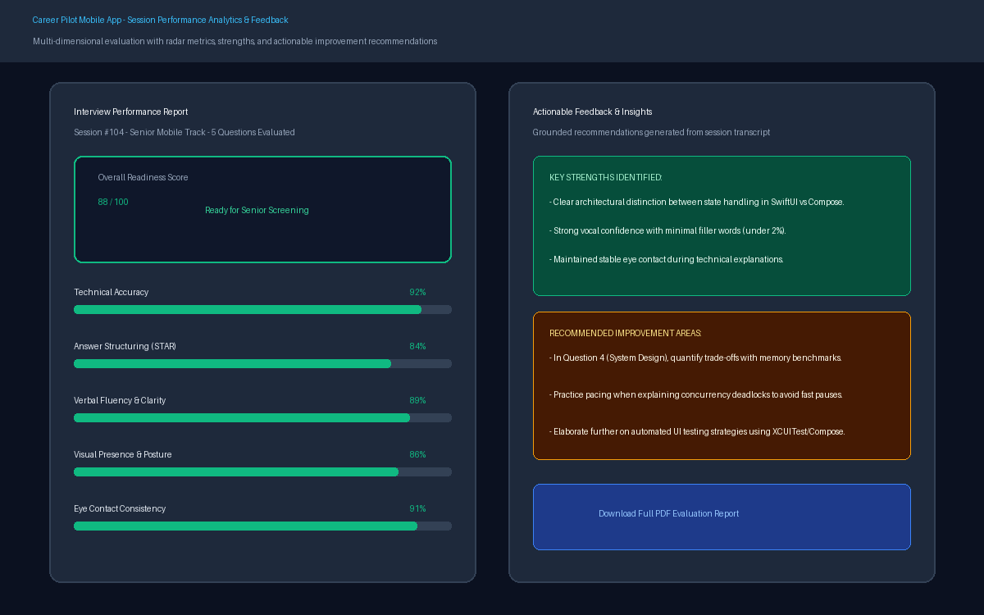
Figure 6.5: Performance Analytics Dashboard & Session Feedback Report

4.2.6 Subscriptions, Coin Wallet & Secure Checkout
The monetization hub allows users to view coin balance, top up through localized packages, subscribe to monthly tiers, and complete secure payment checkout:
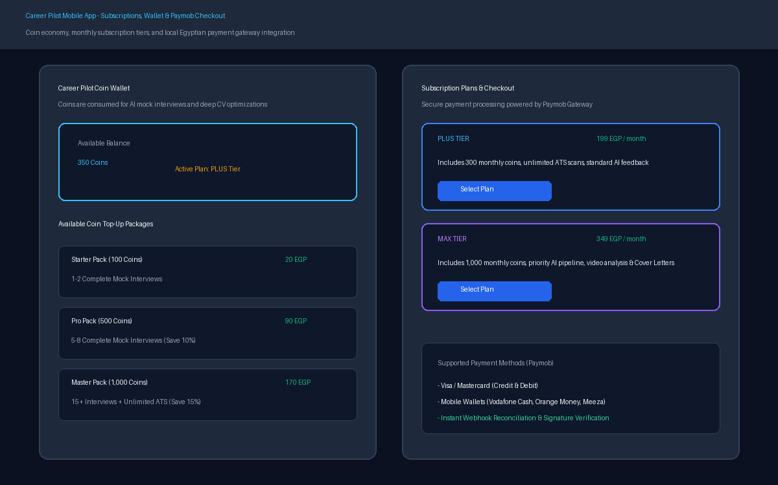
Figure 6.6: Subscriptions, Coin Wallet & Secure Checkout UI Flow

4.2.7 Challenge Discovery, Creation & Dashboard
The latest Android Challenge experience includes public/private discovery, challenge details, challenge creation and a creator dashboard. Screens can be inserted here when the final challenge UI capture set is prepared.

4.2.8 Feature Access & Upgrade States
The shared access UI presents consistent Granted, Locked, Coin Top-Up Required and stale-access states across gated features. Final screenshots of the shared gate and plan/coin states can be inserted here.

References
[1] Information Technology Institute (ITI), '9-Month Professional Program Graduation Project Guidelines and Documentation Standards', Intake 46, 2026.
Online: ITI 9-Month Professional Program
[2] IEEE Computer Society, 'IEEE Standard for System, Software, and Hardware Requirements Engineering', IEEE Std 29148-2018.
Online: ISO/IEC/IEEE 29148:2018
[3] Gamma, E., Helm, R., Johnson, R., & Vlissides, J., 'Design Patterns: Elements of Reusable Object-Oriented Software', Addison-Wesley, 1994.
Online: Design Patterns — InformIT
[4] Martin, R. C., 'Clean Architecture: A Craftsman's Guide to Software Structure and Design', Prentice Hall, 2017.
Online: Clean Architecture — Pearson
[5] Walls, C., 'Spring Boot in Action', Manning Publications, 2023.
Online: Spring Boot in Action — Manning
[6] Lewis, P. et al., 'Retrieval-Augmented Generation for Knowledge-Intensive NLP Tasks', Advances in Neural Information Processing Systems (NeurIPS), 2020.
Online: RAG Paper — arXiv
[7] Radford, A. et al., 'Robust Speech Recognition via Large-Scale Weak Supervision (Whisper)', OpenAI Research, 2022.
Online: Whisper Paper — arXiv
[8] Lugaresi, C. et al., 'MediaPipe: A Framework for Building Perception Pipelines', arXiv preprint arXiv:1906.08172, 2019.
Online: MediaPipe Paper — arXiv
[9] Apple Inc., 'Human Interface Guidelines & Apple Vision / Speech Framework Documentation', Apple Developer Documentation, 2026.
Online: Apple Human Interface Guidelines | Apple Vision | Apple Speech
[10] Google Android Developers, 'Jetpack Compose Architecture and Material 3 Design Guidelines', Android Open Source Project, 2026.
Online: Jetpack Compose Architecture | Material 3 in Compose

