1. **Defects:**

* **Defect 1:**

No Default background image is displayed when user opens home page

Expected: Default background image

Actual: None displayed

**Related story #1**

Scenarios in automated tests:

Scenario: A default background image is displayed when no background image selected

Given I am in About me page

And no background image is selected

Then a default background image is displayed

Screenshot:

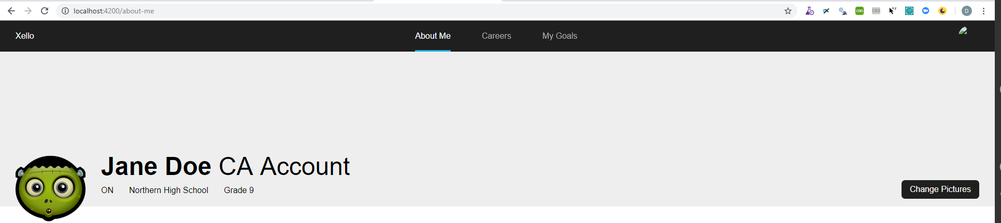

* **Defect 2:**

The title of the page is not “Change Pictures”

Expected: Title as Change Pictures

Actual: Displayed Change pictures

**Related story #2**

Scenarios in automated tests:

Scenario: The title of the page is “Change Pictures”

Given I am in edit page

Then The title of the page is "Change Pictures"

Screenshot:



* **Defect 3:**

“Change Pictures” is not a button in look and feel.

Expected: A button look and feel

Actual: Not a button

Performs actions as if clicking a button but look and feel is not a button.

**Related story #2**

Screenshot:



* **Defect 4:**

“Cancel” is not a button in look and feel.

Expected: A button look and feel

Actual: Not a button

Performs actions as if clicking a button but look and feel is not a button.

**Related story #3**

Screenshot:



* **Defect 5:**

When no changes made background image is highlighting default image

Expected: Selected background image

Actual: Default background image

Performs actions as if clicking a button but look and feel is not a button.

**Related story #3**

Scenarios in automated tests:

Scenario Outline: Selcted profile and background images are focused

Given I am in edit page

When I selected "<profilePic>" and "<backgoundPic>"

And I click Save button

Given I am in edit page

When I click Save button

Then selected "<profilePic>" and "<backgoundPic>" images are defaulted

Examples:

| profilePic | backgoundPic |

| ProfilePic2 | BackgoundPic2 |

Screenshot:

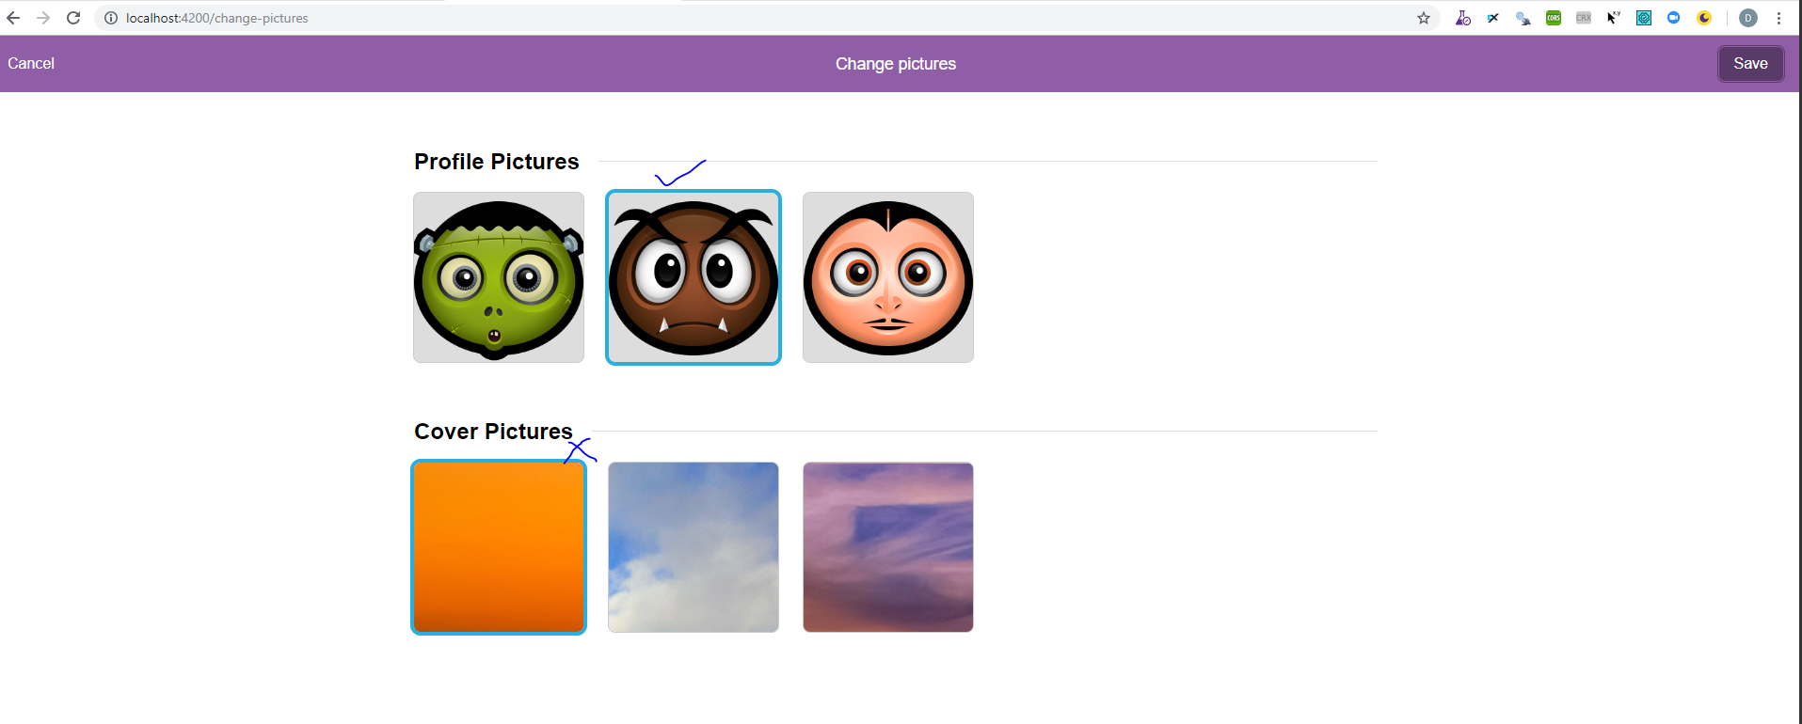

1. **WCAG issues:**

* Content on hover or focus missing.
  + Defect 3 and Defect 4 can be considered.
* Keyboard accessible missing as a user cannot navigate through webpage using any keys.

1. **Thoughts on User stories**

* Mock screens would be helpful for Dev and testers.
* WCAG requirements can be described in stories