CAREER GUIDANCE ACADEMY (C.G.A)
Website Prototype: Requirements Summary
Phase 1: Design and Frontend Only (No Backend)
Item | Details
Client | Career Guidance Academy, Chanban Youth Club Rd, behind Youth Club, Udaipur, Tripura 799114
Version / Date | 1.0 (Draft) / 30 September 2026
Prepared by | [Developer / Company Name]

1. Purpose
This is a demo version (prototype) of the C.G.A website, made for the client to review and approve. It uses sample data only. The real database and payments will be added later in Phase 2.

2. Users
User | What They Can Do
Visitor | View courses, toppers, faculty and contact details
Student | Log in, buy courses, read study material, take mock tests, check fees
Admin | Manage students, courses, faculty, fees, tests and website content

3. Public Website
- Home, About Us, Courses, Achievements (toppers), Faculty and Contact pages.
- Course details: price, faculty, batch size, seats left and status (Open / Closed).
- Login and Register buttons.

4. Courses (Sample)
- TET, STGT, STPGT, TPSC, JRBT
- Banking, SSC, Railway and other competitive exams
- Class VII to X (TBSE and CBSE)

5. Student Portal
- Login, registration and profile.
- Dashboard with courses, tests, notices and fee summary.
- Buy a course with a demo payment and get a receipt.
- Study materials (PDF books and notes) unlocked only for purchased courses.
- Timed mock tests with instant score and rank.
- Fee details: paid, due and history.

6. Admin Portal
- Dashboard with students, revenue and pending dues.
- Add, edit and delete students, courses, faculty and toppers.
- Open or close a batch for admission and set seat limits.
- Record fees and print receipts.
- Upload study materials and create mock tests.
- Post announcements and edit website content.

7. Design
White background with blue as the main colour (other colours from the C.G.A logo). Clean, formal look that works on mobile and computer.

8. Prototype Limits
Login, payment, email/SMS and PDF files are demo only. Changes stay in the same browser and are not shared between users.

9. Needed From Client
- C.G.A logo
- Course fees, batch sizes and faculty details
- Toppers' names, photos and ranks
- Phone number and email

10. Approval
Role | Name | Signature(digital) | Date
Client (C.G.A)
Developer | Angat Saha | 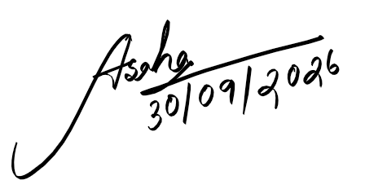 | 30/09/2026

