VisiCalc
Architecture/Design Document

Table of Contents
1 Introduction 2
1.1 Users and the Customer 3
1.2 Developers 3
1.3 Project Manager 3
2 Design Goals 4
3 System Behavior 4
4 Logical View 4
4.1 High-Level Design (Architecture) 4
4.2 Mid-Level Design 5
4.3 Detailed Class Design 5
5 Process View 5
6 Physical View 5
7 Use Case View 5

Introduction

Architecture and Design
The purpose of the architecture/design document is to explain the organization of the code. A well-written architecture document will make it easier for new programmers to become familiar with the code.

The architecture/design document should identify major system components and describe their static attributes and dynamic patterns of interaction.

Software architecture and designs are typically expressed with a mix of UML models (class and sequence diagrams being the two most common) and prose. Dataflow diagrams are also helpful for understanding the interaction between components and overall flow of data through the system.

This document describes the architecture and design for VisiCalc being developed for Mr. Mulvaney. VisiCalc was the first spreadsheet application, and many feel that it is the reason that the personal computer became a reasonable investment for businesses and families. This program is a tribute to this influential program.

The purpose of this document is to describe the architecture and design of VisiCalc in a way that addresses the interests and concerns of all major stakeholders.

Users and the Customer
This application will be interfaced through the command line, just as it was in the original program. Although the interface may be rudimentary, this applications main purpose is a tribute to the program that made the personal computer an essential part of everybody’s life.

Developers
To reduce complexity and points of communication through a development team, this application will be the work of a sole developer.

Project Manager
Because each developer will be responsible for their own program, one project manager (Mr. Mulvaney) will pass requirements and assistance to the developer on an as-needed basis. Further detail on requirements will be described in the requirements documentation.

The architecture and design for a software system is complex and individual stakeholders often have specialized interests. There is no one diagram or model that can easily express a system’s architecture and design. For this reason, software architecture and design is often presented in terms of multiple views or perspectives [IEEE Std. 1471]. Here the architecture of VisiCalc is described from a few different perspectives [1995 Krutchen]:

Design Goals
The design priorities for VisiCalc are:
- The design should minimize complexity and development effort.
- The design should make heavy use of technologies that we cover in our daily meetings
- The design should prefer readability and manageability over performance
- The design should not use strategies that are not described in our developer handbook (Building Java Programs)

System Behavior
The use case view is used to both drive the design phase and validate the output of the design phase. The architecture description presented here starts with a review of the expect system behavior in order to set the stage for the architecture description that follows. For a more detailed account of software requirements, see the requirements document.

VisiCalc will be accessed through a command line interface. The user will first enter command or load in a file to populate cells in the spreadsheet. Once the user is done entering in data, they will be able to print the spreadsheet to the console. The user will also have the ability to save the spreadsheet to load in later. The data in the cells can be one of many things, a text value, a numerical value, an equation, or any of the functions described later.

Logical View
The logical view describes the main functional components of the system. This includes modules, the static relationships between modules, and their dynamic patterns of interaction.

In this section the modules of the system are first expressed in terms of high level components (architecture) and progressively refined into more detailed components and eventually classes with specific attributes and operations.

High-Level Design (Architecture)
The high-level view or architecture consists of 2 major components:

- Application control logic
- Data Access

Example:
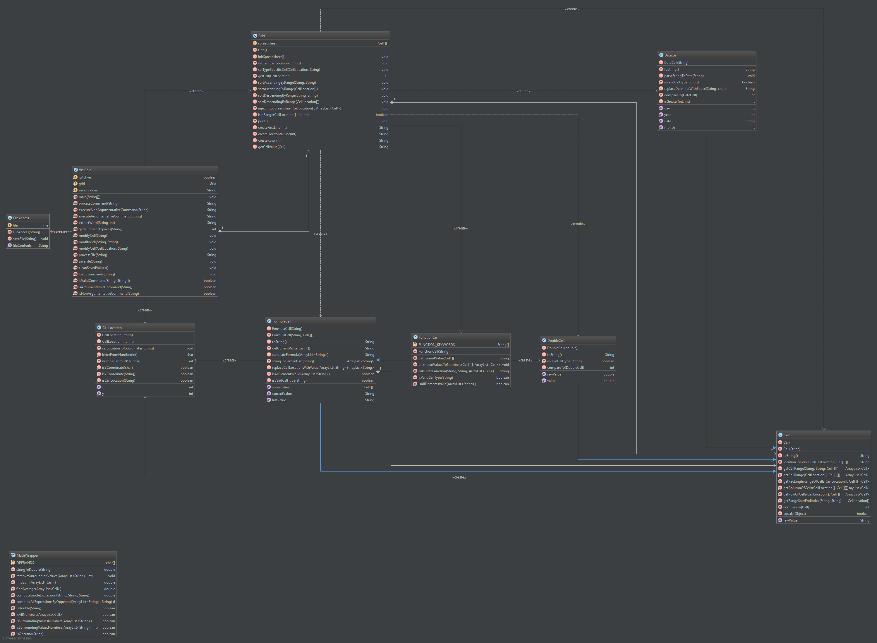System Architecture
- The Application Control Logic is the main driver of the application. It presents information to the user and reacts to user inputs
- The Data Access is a central repository for data that will be accessed through the interface. Data access is apart from the control logic to reduce complexity in both units, especially if the data access ever has to change.

Detailed Class Design

VisiCalc.java
This class is responsible for the interface with the user. It will take the users input and will execute the desired command. This contains the main method and will be the starting point for the application

Grid.java
Grid is responsible for the spreadsheets. Each grid has its own spreadsheet and can display it to the user. Grid is resalable for:
- Displaying/Printing the spreadsheet
- Modifying and retreating data from the spreadsheet
- Defining relationships between each cell (finding ranges)

FileAccess.java
FileAccess was created to encapsulate all of the data access logic in one place, allowing changes to how data could be accessed if that change is required. This reduces the coupling between the rest of the program and the data access logic.

MathWrapper.java
MathWrapper is a central place for all of the basic calculations that aren’t available in the regular Math class, like PEMDAS logic. This class is static and final and cannot be instantiated.

CellLocation.java
This is the solution to the tight coupling between the Grid class and the Cell classes. This will turn a value such as “A1” into an object with X = 0 and Y = 0.

Cell.java
This is the base class for all of the Cell’s. Cell will store a String value. Although the requirements describes the base Cell class store numbers, it makes more sense to store string values because Strings require the least amount of specialty functionality. Also, because the spec requires a literal value of the cell, that is all the String class needs.

