Business Performance Dashboard
Turning industrial sales transactions into a management view of revenue, margin and risk
Tools: Excel (pivot tables, data validation), Python (pandas, matplotlib) | Data: simulated, 12 months, all figures in ZAR

The Challenge
An industrial services business had a year of transaction data but no single view of how it was performing. Management could not easily see which categories actually made money, how dependent the business was on a few customers, or whether sales were holding up through the year.

The Approach
- Cleaned and validated the data. Built control checks on revenue, gross profit and direct cost. All 200 transactions passed.
- Added analysis fields: month, quarter, gross margin % and revenue band.
- Analysed with pivot tables across time, category, customer and region.
- Built the dashboard with KPI cards, six charts, key insights and recommendations, and cross-checked the revenue trend in Python.

Key Findings
Metric | Result | Context
Total revenue | R8,198,345 | 200 transactions, 15 customers
Gross profit | R2,935,337 | 35.8% gross margin
Jan to Dec revenue | R906k to R410k | Down 55%
Q4 vs Q1 revenue | R1.40M vs R2.37M | Down 41%
Top 5 customers | 57.2% of revenue | Top customer alone: 16.8%

- Sales are falling, and it is a volume problem. Q4 closed 37 deals against 59 in Q1, while the average deal size held steady (about R38k vs R40k). The business is winning fewer deals, not smaller ones.
- Product drove the decline. Product revenue fell 75% from its Q2 peak (R1.35M) to Q4 (R340k).
- The biggest category is not the most profitable. Product is 40.5% of revenue at only 24.8% margin. Service is 30.4% of revenue at 44.5% margin and produces the largest share of gross profit (37.8%).
- Customer concentration is high. The top 3 customers account for 41.2% of revenue and the top 5 for 57.2%.
- Regional picture. Gauteng (32.2%) and North West (25.6%) lead on revenue. Gauteng has the lowest margin (33.0%), while Limpopo is the smallest region but the most profitable (39.1%).

Recommendations
- Diagnose the Q4 drop first. Break lost volume down by customer and category, starting with Product, to establish whether it is seasonal, a lost account or a pipeline gap.
- Shift sales effort toward Service and Support. Service earns about 20 cents more gross profit per rand than Product. Illustratively, replacing R500k of Product sales with Service would add roughly R98k of gross profit.
- Manage concentration risk. Set a review trigger when any customer exceeds 15% of revenue and build a pipeline of mid-sized accounts.
- Review pricing in Gauteng and on Consumables, which have the lowest regional and category margins (33.0% and 19.7%).

Business Value
The dashboard replaces a raw transaction list with one page that shows where the business makes its money, where it is exposed, and where sales are slipping. Reviewing revenue and gross profit together, rather than revenue alone, changes which categories deserve sales attention.

The Dashboard
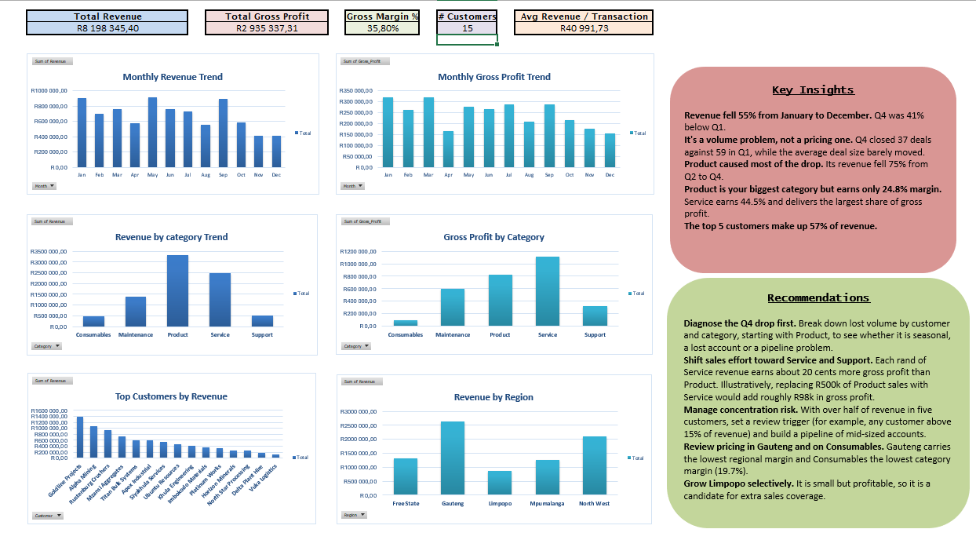

Monthly Revenue Trend (Python cross-check)
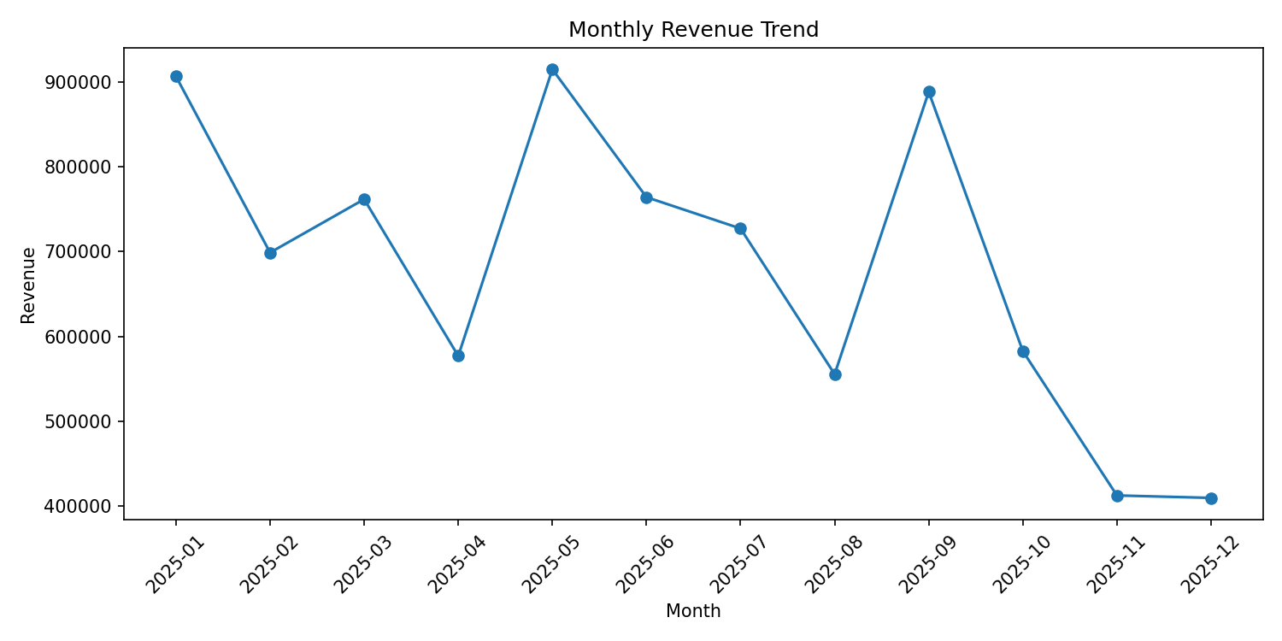

Next Steps
- Add monthly target vs actual reporting.
- Build a forecast by category and region.
- Extend to customer-level profitability and connect to a live data source.

