**The *global portfolio model*: epidemiological impact component**

Sandip Mandal, Srinath Satyanarayana, Carel Pretorius

and the global portfolio model advisory group

Contents

Background 2

Model structure 2

Equations and parameter tables 3

Age structure and aging 6

Interventions 8

Case detection 8

Treatment cascade 9

Prevention 9

TB preventive therapy for key and vulnerable populations 9

TB vaccine 9

Impact from the Target Population interface via Hazard Ratios 10

Model implementation 11

Compartments and variables 11

Outputs used in model calibration 12

Model functions 12

Natural history parameters 13

Parameters that are estimated during fitting 15

Intervention parameters 16

Country-specific calibration targets 17

Model calibration and data fitting 17

Calibration process 17

# Background

The dynamical impact model used to estimate the impact of investment scenarios laid out in the Investment Case analysis of the 8th replenishment of the Global Fund -the “global portfolio model” - was developed in a collaboration between the Global Fund, TBMAC, Avenir Health, and advisory partners including WHO and the Stop TB Partnership.

This document outlines the technical details of the model.

# Model structure

Figure 1 gives a schematic illustration of the overall model structure, with all model parameters listed in Table 1.

The model is stratified by HIV-status, Drug-susceptibility status and by Age groups. The compartment for second line treatment, in case of drug resistance TB is also considered in the model but not shown in the diagram for clarity.

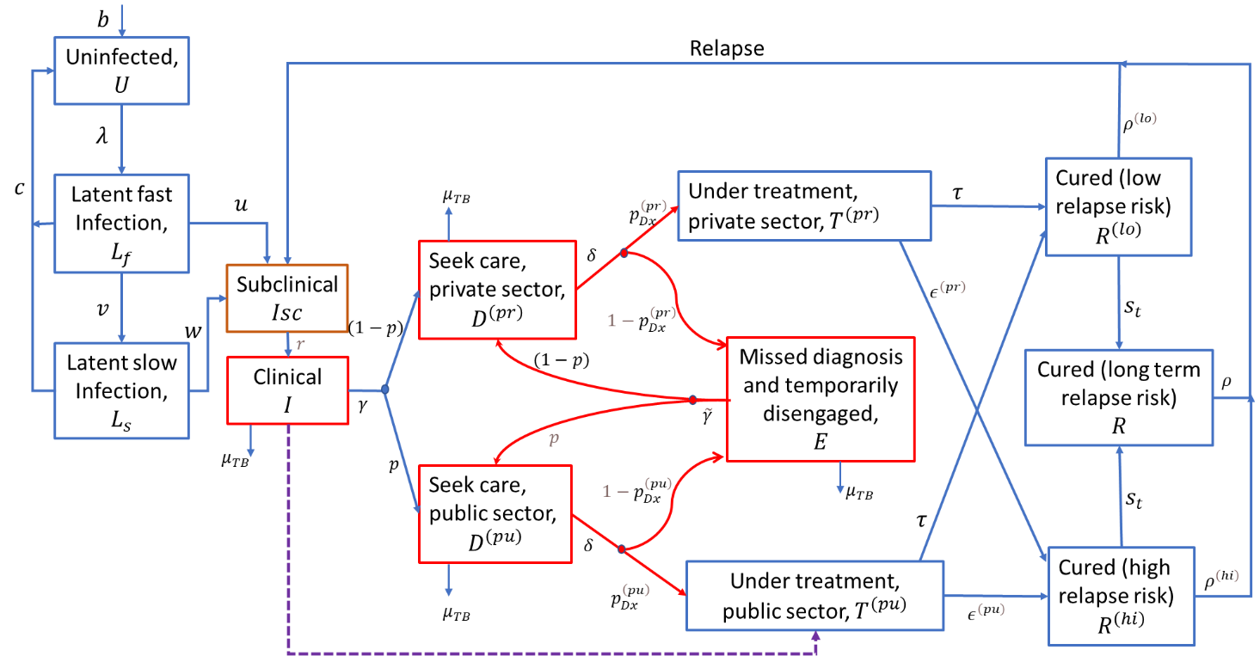

**Figure 1. Schematic illustration of the model structure.** Parametersare defined below, and in Table 1. Infectious compartments contributing the force-of-infection are shown in red. For clarity, the diagram omits certain rates incorporated in the model, including: self-cure; exogenous reinfection; and background mortality.

# Equations and parameter tables

The governing equations of the model are as follows. All state variables are written as proportions of the population (not as absolute numbers). All variables are divided into three age groups ( $a$ = 0,1,2) but for clarity we have presented the variable $X_{h, a}$ as $X_{h}$. And the aging rate from one age group to the next age group is not shown in the set of equations. For example, the rate of aging from $a$ to $a$ +1 (where $a$ = 0, 1) is $a_{g}\left(a\right)$ is not shown in the equations.

Uninfected ($U_{h}$):

$$\frac{dU_{h}}{dt}=b+c \sum_{s}{\left(L_{h,s}^{\left(fast\right)}+L_{h,s}^{\left(slow\right)}\right)}-U_{h}ϵ_{h}\sum_{s}{λ_{s}}- {μ_{h} U}_{h}+f\left(U_{h}\right)$$

for a birth-rate $b$; force-of-infection $λ_{s}$; s denotes the infecting strain (denoting drug-susceptible (s = 0) and drug-resistant (s = 1) TB); h indicates HIV status (denoting HIV negative (h = 0), HIV positive (h = 1) and HIV positive with ART (h = 2); rate of clearance of LTBI $c$; and background mortality rate $μ_{h}$.

Latent, ‘fast’ infection ($L_{h,s}^{(fast)}$):

$$\frac{dL_{h,s}^{\left(fast\right)}}{dt}=λ_{s}\left[U_{h}+\left(1-h\right) \left(R_{h,s}^{(hi)}+R_{h,s}^{(lo)}+R_{h,s}^{(st)}\right)\right]-\left(μ_{h}+u_{h}+v_{h}+c\right)L_{h,s}^{\left(fast\right)}+f\left(L_{h,s}^{\left(fast\right)}\right)$$

for a progression rate $u_{h}$; a ‘stabilisation’ rate (to latent ‘slow’ status) $v_{h}$; and protection from reinfection $h$, amongst those previously infected.

Latent, ‘slow’ infection ($L_{h,s}^{\left(slow\right)}$):

$$\frac{dL_{h,s}^{\left(slow\right)}}{dt}=v_{h}L_{h,s}^{\left(fast\right)}-\left(μ_{h}+c+w_{h}\right)L_{h,s}^{\left(slow\right)}+f\left(L_{h,s}^{\left(slow\right)}\right)$$

for a reactivation rate $w_{h}$.

Subclinical TB ($I_{h,s}^{\left(sc\right)}$):

$$\frac{dI_{h,s}^{\left(sc\right)}}{dt}=u_{h}L_{h,s}^{(fast)}+w_{h}L_{h,s}^{\left(slow\right)}+ρ^{(hi)}R_{h,s}^{(hi)}+ρ^{(lo)}R_{h,s}^{(lo)}+ρ^{(st)}R_{h,s}^{(st)}-\left(μ_{h}+σ_{h}+r+a\left(t\right)\right)I_{h,s}^{\left(sc\right)}+f\left(I_{h,s}^{\left(sc\right)}\right)$$

for relapse rates $ρ^{\left(hi\right)}, ρ^{\left(lo\right)}, ρ^{\left(st\right)}$; rate of developing clinical symptom $r$ and self-cure rate $σ_{h}$. The term $a(t)$ represents the time-dependent effect of active case-finding.

Clinical TB ($I_{h,s}$):

$$\frac{dI_{h,s}}{dt}=r I_{h,s}^{\left(sc\right)}-(γ+μ_{h}^{(TB)}+σ_{h}+a(t))I_{h,s}+f\left(I_{h,s}\right)$$

for care-seeking rate $γ$ and TB mortality rate $μ_{h}^{(TB)}$.

Presented for diagnosis with provider type $s$, ($D_{h,s}^{(s)}$):

$$\frac{dD_{h,s}^{(pu)}}{dt}= p (γ I_{h,s}+ \tilde{γ} E_{h,s})-\left(μ_{h}^{(TB)}+σ_{h}+δ\right)D_{h,s}^{(pu)}+f\left(D_{h,s}^{(pu)}\right)$$

$$\frac{dD_{h,s}^{(pr)}}{dt}=(1-p) (γ I_{h,s}+ \tilde{γ} E_{h,s})-\left(μ_{h}^{(TB)}+σ_{h}+δ\right)D_{h,s}^{(pr)}+f\left(D_{h,s}^{(pr)}\right)$$

Here, $p$ and $(1-p)$ are, respectively, the proportion-of-presentation to healthcare providers in the public and private sectors. Rate-of-offering diagnosis $δ$. Here, $\tilde{γ}$ is analogous to $γ$ but attached to individuals who remain undiagnosed despite having previously sought care (i.e. compartment $E_{h},$ below).

On TB treatment with provider type $po,$ with DS TB ($T_{h,0}^{(po)}$) initiating first line treatment

$$\frac{dT_{h,0}^{(pu)}}{dt}=δ p_{Dx}^{\left(pu\right)}\left(D_{h,0}^{(pu)}+(1-{DST}_{(+ve)})D_{h,1}^{(pu)}\right)+a\left(t\right)(I_{h,0}+I_{h,0}^{\left(sc\right)})-\left(μ_{h}+τ+ϵ^{\left(pu\right)}\right)T_{h,0}^{(pu)}+f\left(T_{h,0}^{(pu)}\right)$$

$$\frac{dT_{h,0}^{(pr)}}{dt}=δ p_{Dx}^{\left(pr\right)}D_{h,0}^{(pr)}-\left(μ_{h}+τ+ϵ^{\left(pr\right)}\right)T_{h,0}^{(pr)}+f\left(T_{h,0}^{(pr)}\right)$$

for a treatment completion rate $τ$; and a treatment interruption rate $ϵ^{\left(po\right)}$.

Drug resistance TB initiating second line treatment ($S_{h,1}^{(pu)}$)

$$\frac{dS_{h,1}^{(pu)}}{dt}=δ p_{Dx}^{\left(pu\right)} {DST}_{(+ve)} D_{h,1}^{(pu)}+SLtrans*T_{h,0}^{(pu)}-\left(μ_{h}+T+{ϵ2}^{\left(pu\right)}\right)T_{h,0}^{(pu)}+f\left(S_{h,1}^{(pu)}\right)$$

For treatment completion rate $T$; and a treatment interruption rate ${ϵ2}^{\left(po\right)}$. SLtrans represents transfer to SL treatment during FL treatment.

Missed diagnosis and temporarily disengaged from care-seeking ($E_{h,s}$):

$$\frac{dE_{h,s}}{dt}=δ\left(1-p_{Dx}^{\left(pu\right)}\right)D_{h,s}^{(pu)}+δ\left(1-p_{Dx}^{\left(pr\right)}\right)D_{h,s}^{(pr)}-\left(μ_{h}^{(TB)}+σ_{h}+\tilde{γ} \right)E_{h,s}+f\left(E_{h,s}\right)$$

Recovered with low relapse risk, following treatment completion ($R_{h}^{(lo)}$):

$$\frac{dR_{h,s}^{(lo)}}{dt}=τ\left(T_{h,s}^{(pu)}+T_{h,s}^{(pr)}\right)-[(1-h)λ_{s}+ρ^{\left(lo\right)}+μ_{h}+s_{t}]R_{h,s}^{(lo)}+f\left(R_{h,s}^{(lo)}\right)$$

for a rate of ‘stabilisation’ of relapse risk $s_{t}$.

Recovered with high relapse risk, following treatment completion ($R_{h,s}^{(hi)}$):

$$\frac{dR_{h,s}^{(hi)}}{dt}=\left(ϵ^{\left(pu\right)} T_{h,s}^{(pu)}+ϵ^{\left(pr\right)}{ T}_{h,s}^{(pr)}\right)-[(1-h)\sum_{s}{λ_{s}}+ρ^{\left(hi\right)}+μ_{h}+s_{t}]R_{h,s}^{(hi)}+f\left(R_{h,s}^{(hi)}\right)$$

Long-term, ‘stabilised’ relapse risk ($R_{h,s}^{(st)}$):

$$\frac{dR_{h,s}^{(st)}}{dt}=s_{t}\left(R_{h,s}^{(lo)}+R_{h,s}^{(hi)}\right)-\left[\left(1-h\right)λ_{s}+ρ^{\left(st\right)}+μ_{h}\right]R_{h,s}^{\left(st\right)}+f\left(R_{h,s}^{(st)}\right)$$

Force-of-infection $(λ_{s})$:

$$λ_{0}=\sum_{h}{β_{h,ds} ({k I}_{h,0}^{\left(sc\right)}+{I_{h,0}+E}_{h,0}+D_{h,0}^{(pu)}+D_{h,0}^{(pr)})}$$

$$λ_{1}=\sum_{h}{β_{h,dr} ({k I}_{h,1}^{\left(sc\right)}+{I_{h,1}+E}_{h,1}+D_{h,1}^{(pu)}+D_{h,1}^{(pr)})}$$

Where $β_{h, ds}$ is the rate-of-transmission associated with drug-susceptible and $β_{h,dr}$ is associated with drug-resistance TB disease. Both are accompanying with HIV status. HIV-positive TB can be less infectious than HIV-negative TB, $β_{1,s}$ is expected to be lower in value than $β_{0,s}$ and $β_{2,s}$. Accordingly, it was assumed that $β_{0,s}$ = $β_{2,s}$ = 𝑚 $β_{1,s}$, for a parameter 𝑚 to be calibrated, and constrained to be between 0 and 1. $k$ is the infectiousness of subclinical TB relative to clinical TB.

In all the above equations, $f\left(.\right)$ denotes transitions between HIV states. For any given state variable $X_{h}$, it is defined as follows:

$$f\left(X_{h}\right)=\left\{\begin{aligned}-r_{HIV}X_{0}, if h=0 \\ r_{HIV}X_{0}-r_{ART}X_{1}, if h=1 \\ r_{ART}X_{1}, if h=2\end{aligned}\right.$$

where $r_{HIV}$ denotes the per-capita rate of acquiring HIV, and $r_{ART}$ denotes the per-capita rate of initiating ART.

## Age structure and aging

The age structure of the model is depicted below. The age categories 0-4, 5-9, 10-14 ,15-64 and 65+ are chosen to inform WHO recommended screening and diagnostic algorithms for specific age groups, with the 65+ category added to capture the high mortality of this age group.

The aging rates are based on input from the Spectrum IHT demographical model (DemProj) which uses WPP data set up its demographical structure.

The rate at which individuals age out of age category with age bounds [a1,b1] (e.g. 0-4 years), and into the next age category [a2,b2] (5-9 years) is given by pop[b1]/(pop[a1]+…pop[b1]).

These rates are prepared for each country, by year, with calls to the Spectrum DemProj model allowing the global TB model to maintain an approximate age structure for a given population.

Table 1: Table of parameters: list of model parameters and their symbol as depicted in figure 1 and model equation.

|  |  |  |  |  |
| --- | --- | --- | --- | --- |
| Parameter | | | Symbol (diagram and equation) | Symbol used in the code |
| Natural history | | | | |
| Infection rate (number of annual infections per case) | | | $β$, $β_{mdr}$ , $β_{hiv}$ | $$r.beta$$ $$r.beta*p.rfbeta_mdr$$ $$r.beta*p.rfbeta_hiv$$ |
| Per-capita annual rate of progression from ‘fast’ latent infection | | | $$u$$ | $$r.progression$$ |
| Per-capita annual rate of stabilisation from ‘fast’ to ‘slow’ latent status | | | $$v$$ | $$r.LTBI_stabil$$ |
| Per-capita annual rate of reactivation from ‘slow’ latent infection | | | $$w$$ | $$r.reactivation$$ |
| Per-capita annual rate of self-clearance of latent TB | | | $$c$$ | $$r.LTBI_cure$$ |
| Per-capita annual rate of developing symptoms, amongst subclinical TB | | | $$r$$ | $$r.sym$$ |
| Per-capita annual rate of TB mortality while untreated | | | $μ_{TB}$ (general population) $μ_{TB}$ (among HIV) | $$r.mort_TB(1)$$ $$r.mort_TB(2)$$ |
| Per-capita annual rate of TB self-cure | | | $$σ$$ | $$r.self_cure$$ |
| Protection from reinfection amongst those with prior infection | | | $$h$$ | $$p.imm$$ |
| Per-capita annual rate of relapse in first two years after treatment completion | | | $$ρ^{\left(lo\right)}$$ | $$r.relapse(1)$$ |
| Per-capita annual rate of relapse in first two years after self-cure or incomplete treatment | | | $$ρ^{\left(hi\right)}$$ | $$r.relapse(2)$$ |
| Per-capita annual rate of relapse>two years after last TB episode | | | $$ρ$$ | $$r.relapse(3)$$ |
| Per-capita annual rate of ‘stabilising’ from high to low relapse risk | | | $$s$$ | $$r.s$$ |
|  | | | | |
| Rate-of-presentation to care, first care-seeking visit | In 1997  In 2022 | | $$γ(1997)$$ $$γ(2022)$$ | $$r.cs_1997$$ $$r.cs_1997*rf_cs2022$$ |
| Rate-of-presentation to care, second and subsequent care-seeking visits | In 1997  In 2022 | | $$\tilde{γ } (1997)$$ $$\tilde{γ } (2022)$$ | $$r.cs_1997*rf_cs2$$ $$r.cs_1997*rf_cs2$$ |
| Probability that a TB patient visits public provider, per care-seeking attempt | In 2022 | | $$p$$ | $$p.pu_2022$$ |
| Per-capita rate of offering diagnosis | | | $$δ$$ | $$r.Dx$$ |
| Probability of successful TB diagnosis and treatment initiation per care-seeking visit | | Public sector | $$p_{Dx}^{\left(pu\right)}$$ | $$p.Dx(1)$$ |
| Private sector | $$p_{Dx}^{\left(pr\right)}$$ | $$p.Dx(2)$$ |
| Per-capita annual rate of treatment completion | | | $$τ$$ | $$r.Tx$$ |
| Per-capita annual rate of treatment interruption | | Public sector | $$ϵ^{\left(pu\right)}$$ Calculated using $ϵ^{\left(pu\right)}=\frac{1-P}{P}τ$, for treatment completion rate $P$, and assuming U[0.75, 0.95] for $P$ | $$r.default(1)$$ |
| Private sector | $$ϵ^{\left(pr\right)}$$ | $$r.default(2)$$ |
| Demographics | | | | |
| Per-capita annual rate of background mortality | | | $μ$ (general population) $μ$ (among HIV) | $$r.mort(age)$$ $$r.HIV_mort$$ |

# Interventions

The model focusses on three major areas of interventions: case detection, treatment and prevention, as shown in Figure 2. The numeric values mentioned here are based on the current TB Global Plan analysis and may need adjustment when numerical targets for total notification, for example, are set in a National Strategic Plan (NSP). The specific values mentioned below are illustrative and show the impact mechanisms of the model.

Note that the flows resulting from a vaccine program are not shown in Figure 2. Vaccination will be handled by an additional dimension to the model and will work similarly to the TPT flows shown.

## Case detection

* Strengthen existing systems:
  + Expand laboratory facilities to increase uptake of public-sector TB care provision by say 35%, over 5 years.
  + Private sector engagement
    - Recruit additional 80% of private-sector providers, to attain the same quality of care as in the public sector, over 5 years.
    - This structure is meant to be active only for the ~15 countries with high private sector involvement.
* Accelerated Case Detection:
  + Contact-tracing and intensified case finding
    - Extensive contact investigation amongst community, household and social contacts. These are modelled by estimating prevalent TB cases based on relative population and TB risk sizes, to move the treatment categories.
* Upstream case finding (symptomatic TB):
  + These represent activities that are designed to diagnose symptomatic TB more rapidly than an individual’s first attempt at care seeking. These activities could include active case finding in the community, and measures such as demand generation, i.e., encouraging those with symptoms to come forward for care more rapidly than they do at present. An assumption is made about delays-to-diagnosis, e.g. that these measures would reduce the delay-to-diagnosis by 30% for symptomatic individuals
* Detecting subclinical TB:
  + Measures are put in place to find and treat say 20% of individuals with subclinical TB before they develop symptoms.

## Treatment cascade

* In the public sector, increase treatment initiations amongst diagnosed TB cases to at least 95% and treatment completion rates to at least 95%, over 5 years.
* All current second-line treatments are replaced with new regimens, such that the proportion of treatment success increases to 90%.

## Prevention

### TB preventive therapy for key and vulnerable populations

* Full uptake of TPT among key and vulnerable populations identified in WHO recommendations is modelled, i.e., PLHIV and all-age, close contacts of persons diagnosed with TB.

### TB vaccine

* Although not part of IHT currently, the model can be used to study the impact of a post-exposure vaccine with a stated efficacy in reducing TB incidence among those with latent TB infection and conferring immunity for 10 years is rolled out to reach a given coverage of the population (with coverage dependent on the country setting, to meet the End TB goals by 2030).

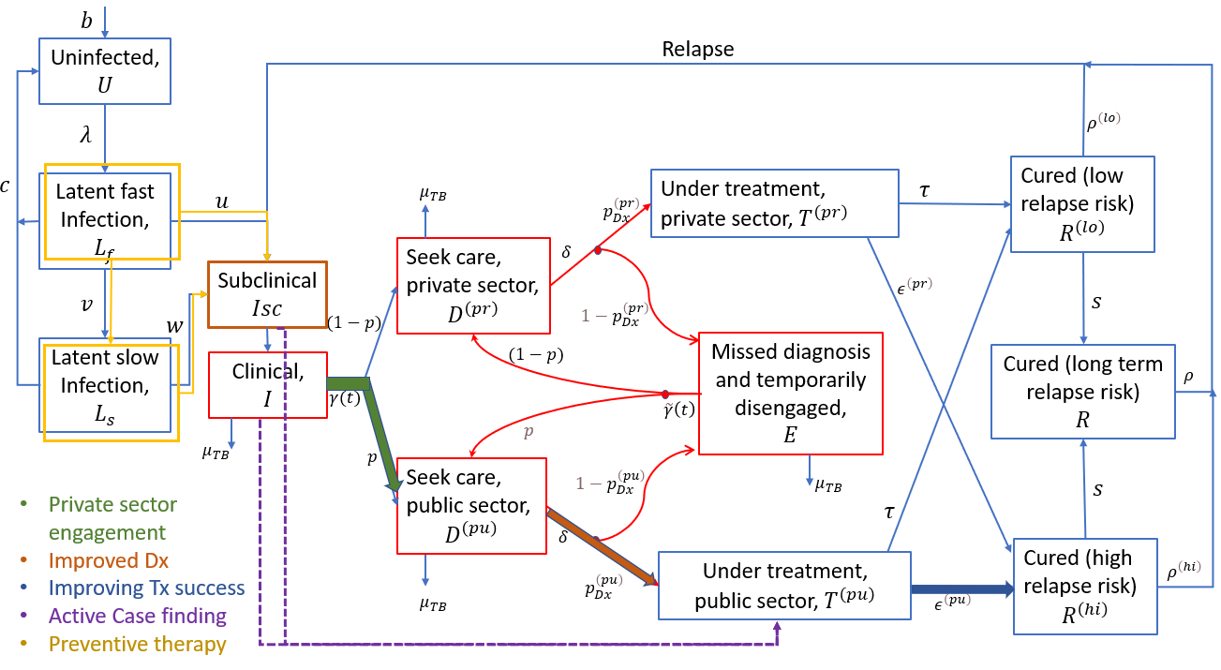

**Figure 2. Schematic illustration of intervention structure.** Key intervention shown as slows between model compartments.

## Impact from the Target Population interface via Hazard Ratios

To obtain impact using a dynamical model the user configures the impact section of a projection. This section draws information from the Target Population interface which represents a TB strategy when fully configured by the user.

So called Hazard-ratios between a scale-up and baseline scenario are used to map the relative difference in key impact-related parameters to a baseline dynamical model.

Namely:

* The Hazard Ratio of Detection maps to:​

Model parameters that the determine the probability of being screened, and detected including early detection​

Model parameters that determine the probability of being diagnosed (i.e. sensitivity)​

* The Hazard Ratio of Prevention maps to:​

TB regression and progression parameters in the dynamical model, and​

* The Hazard Ratio of Treatment outcomes maps to:​

Treatment success for first- and second-line patients.​

The hazard ratios are ratios between hazard rates of a counterfactual projection (usually representing a baseline scenario) and a scale-up projection (usually representing an NSP).

These hazard rates are managed in two sections of the Impact table of IHT’s Target Population component, and the user can seek further guidance on how to use the impact table to generate impact, from presentations and other materials.

# Model implementation

The model is implemented in both Matlab and Python and the code is hosted in a GitHub repository. The sections below define and describe the syntax and functions used:

* Table 2 defines states names and symbols used of compartments and variables in the model.
* Table 3 defines auxiliary measures (outputs) that are needed for fitting and display purposes.
* Table 4 defines the functions that structure the model setup, model calibration and projection steps.
* Table 5 states the natural history parameters and their data values and ranges, with references.
* Table 6 state parameters that are estimated within assigned ranges as part of the fitting process.
* Table 7 state time-dependent variables that are linked to interventions.
* Table 8 states the WHO data used for calibration purpose.

## Compartments and variables

Table 2: Defining compartments and variables.

|  |  |
| --- | --- |
| gps.vacc | Grouping by vaccination status |
| v0 | Unvaccinated |
| v1 | Vaccinated, immune |
| v2 | Vaccinated, waned immunity |
| gps.hiv | Grouping by HIV status |
| h0 | hiv-negative |
| h1 | hiv-positive |
| hart | hiv-positive, with ART |
| gps.strains | Grouping by drug resistance status |
| ds | Drug susceptible TB |
| mdr | Drug-resistant (rifampicin-resistant) TB |
| gps.provs | Grouping by provider type |
| pu | NTP provider (public, or notifying) |
| pr | non-NTP provider (private, or non-notifying) |
|  |  |
|  |  |
| U | Uninfected |
| Lf | Latent fast |
| Ls | Latent slow |
| Isc | Subclinical infection |
| I | Infection with clinical symptoms |
| E | Missed diagnosis and temporarily disengaged from care-seeking |
| Rlo | Recovered with low relapse risk, following treatment completion |
| Rhi | Recovered with high relapse risk, following treatment non-completion or self-cure |
|  |  |
| R | Long-term, ‘stabilized’ relapse risk |
| Dx | Presented for diagnosis |
| Tx | Initiated first line treatment |
| Tx2 | Initiated second line treatment |
|  |  |
|  |  |
| s.infectious | All the compartments contributing to spreading infection |
| s.infectious_wosc | Compartments subject to TB mortality |
| s.prevalent | All compartments constituting prevalent TB |

## Outputs used in model calibration

Table 3: Auxiliary measures

|  |  |
| --- | --- |
| inc | Incidence rate (all TB, hiv +ve TB and RR-TB) |
| noti | Public sector notification (TB that is HIV-negative, HIV-positive, and on ART) |
| noti2 | RR-TB notification (initiating second line treatment) |
| mort | TB mortality (HIV negative and HIV coinfected mortality) |

## Model functions

Table 4: Model functions

|  |  |
| --- | --- |
| Model_setup | To define all variables, parameters and assign their default values, as well as specifying posterior densities corresponding to input data |
| get_address | To construct lookup tables for compartment numbers relating to each state variable |
| get_distribution_fns | Function to find log-density functions matching given data (e.g. incidence) and uncertainty intervals |
| make_model2 | Specify the full model in matrix form, given all model parameters |
| goveqs_basis2 | Calculate local gradient for given values of state variables (used in ODE solver) |
| goveqs_scaleup | To capture linear scaleup of parameters between two time points (e.g. used for linear scale-up of interventions) |
| alloc_parameters | Given a parameter vector x, to allocate parameter values (p: proportion, r: rate) |
| get_objective | Given a parameter vector x, to simulate the model and calculate the log-posterior density |
| Get_calibrations2 | To calibrate the model using MCMC |
| MCMC_adaptive | Adaptive MCMC, using Haario et al |
| goveqs_basis_disruption | As for goveqs_basis, but used during periods of disruption, allowing rates of diagnosis to vary |
| goveqs_scaleup_disruption | As for goveqs_scaleup, but used during periods of disruption, allowing rates of diagnosis to vary |
| Show_model_fits1 | To show calibration results |
| Simulate_forward | Forward projection with different intervention scenarios |
| Figure_final | To plot incidence and mortality projection |
| jbfill | Function to show shaded areas for uncertainty intervals |
| linspecer | To specify color series for plotting |

## Natural history parameters

Table 5: Natural history parameters, assigned values and references.

|  |  |  |  |
| --- | --- | --- | --- |
| **Symbol** | **Definition** | **Assigned values** | **References/Note** |
| r.progression | Per-capita annual rate of progression from ‘fast’ latent infection (differentiated by HIV-status, h0, h1, hart) | [0.0826 0.8260 0.1652] | Calibration: Menzies (2018) [1] for hiv-ve and 10 times higher for hiv+ve and with ART its rate reduces by 80% |
| r.LTBI_stabil | Per-capita annual rate of stabilization from ‘fast’ to ‘slow’ latent status (differentiated by HIV-status, h0, h1, hart) | [0.8720 0 0.8720] | Menzies (2018) [1] for HIV-ve and for HIV+ve with ART |
| r.reactivation | Per-capita annual rate of reactivation from ‘slow’ latent infection (differentiated by HIV-status, h0, h1, hart) | [0.0006 0.0600 0.0120] | Calibration: Menzies (2018) [1] for hiv-ve and 100 times higher for hiv+ve and with ART its rate reduces by 80% |
| r.relapse(1)  (ro_lo) | Per-capita annual rate of relapse in first two years after treatment completion | 0.032 | Thomas A et al (2005) [2], Romanowski (2019)[3], Menzies (2009) [4] and Weis (1994) [5], with uniform prior using intervals of ± 5% |
| r.relapse(2)  (ro_hi) | Per-capita annual rate of relapse in first two years after self-cure or incomplete treatment | 0.14 |
| r.relapse(3) | Per-capita annual rate of relapse >two years after last TB episode | 0.0015 | Most relapse occurs in first two years after recovery: Guerra-Assuncao (2015) [6] |
| r.mort | Per-capita annual rate of background mortality |  | Corresponds to average lifespan of 70 years (World Bank 2021) [7] |
| p.imm | Immune protection from reinfection | [0.8 0 0.8] | Assumption, with uniform prior using intervals of ± 25% |
| r.Dx | Per-capita rate of offering diagnosis | 52 | Assumption: corresponds to an average of 1 week to arrive at a diagnosis |
| p_MDRrec2015 | Of diagnosed TB with rifampcin resistance, proportion that is recognized as such in 2015 (through DST) | [0.001 0] | It is assumed to be a very low value if data is not available for a country |
| p. Tx_init2 | Proportion of second-line treatment initiation after diagnosis as RR | [0.88 0] | Assumption in absence of country specific data |
| p.SL_trans | Amongst RR-TB incorrectly initiated on FL treatment, proportion that is subsequently transferred to second-line treatment | [0.88 0] | Assumption in absence of country specific data |
| p.Tx_init | Of diagnosed patients, proportion initiating first-line treatment | [1 1] |  |
| r.Tx | Per-capita annual rate of first-line treatment completion | 2 | Corresponds to average duration of 6 months |
| r.Tx2 | Per-capita annual rate of second-line treatment completion | 0.5 | Corresponds to average duration of 2 years |
| p.cure | Proportion cure after successful completion of FL treatment | [1 1] |  |
| p.tsrsl | Proportion treatment completion of SL treatment | [0.48 1e-6] | Country specific |
| r.default2 | Per-capita annual rate of treatment interruption during SL treatment (r.default2) in public and private sector |  | Calculated using $r.default2=r.Tx2*p.tsrsl/(1-p.tsrsl),$ for values of $r.Tx2, p.tsrsl$ given above |
| p.cure2 | Proportion cure after successful completion of SL treatment | [0.5 0] | Taken from country reports where available |
| prm.ART_start | Year of ART initiation |  | Country specific |
| HIV_incd | Data for annual HIV incidence: assume HIV burden scaled up linearly from 1980 to first data point in 1990 and then using HIV incidence data till 2019 |  | Country specific |
| prm.rHIV | Per-capita rate of HIV acquisition, adjusted in to give model agreement with HIV_incd |  | Calibration: Estimated |
| r.self_cure | Per-capita annual rate of TB self-cure | 0.17 (0.13 – 0.21) | Tiemersma et al., (2011) [8] for central value, with uniform prior using intervals of ± 15% |

## Parameters that are estimated during fitting

Table 6: Parameters that are estimated within assigned ranges as part of the fitting process

|  |  |  |
| --- | --- | --- |
| **Symbol** | **Definition** | **Assigned ranges** |
| r_beta | Infection rate (number of annual infections per case) of DS TB | [0 - 40] |
| rfbeta_mdr | Infection rate of RR-TB relative to DS TB | [0 - 1] |
| rfbeta_hiv | Relative transmission rate for HIV +ve TB patients, relative to HIV -ve TB | [0 - 1] |
| r_sym | Per-capita annual rate of developing symptoms, amongst subclinical TB | [0.1 - 100] |
| p_pu | Proportion of care-seeking visits that are to the public sector | [0 - 1] |
| r_cs (1997) | Rate-of-presentation to care, first care-seeking visit for symptomatic TB in 1997 | [0.1 - 100] |
| rf_cs 2022 | Rate-of-presentation to care in 2022 relative to 1997 | [1 - 10] |
| r_cs2 | Rate-of-presentation to care, second and subsequent care-seeking visits for symptomatic TB | [1 - 24] |
| r_mort_TB | Per-capita annual rate of TB mortality while untreated differentiated by HIV-status (hiv-ve and hiv+ve) | 1/6*[0 - 2; 0 - 100] |
| p_Dx | Probability of successful TB diagnosis and treatment initiation per care-seeking visit (in public and private sector) | [0.75- 0.9; 0.1- 0.3] |
| p_TX_complete | Proportion treatment completion (used to estimate per-capita annual rate of treatment interruption (r.default) in public and private sector) | [0.75 - 0.95; 0.4 - 0.8] |
| p_MDRrec2022 | Of diagnosed TB with rifampcin resistance, proportion that is recognized as such in 2022 (through DST) | [0 - 1] |
| r_MDR_acqu | Per capita rate of acquired RR/MDR during treatment | [0 - 0.06] |
| r_ART_init | Per-capita rate of ART initiation | [0 - 10] |
| r_HIV_mort | Per-capita annual rate of HIV mortality while untreated | [0 - 10] |
| r_self_cure | Per capita annual rate of self-cure | 1/6*[0.85 - 1.15] |
| p_HIV_relrate | Progression and activation rate among HIV positive, relative to HIV-negative people | [1 - 100] |

## Intervention parameters

Table 7: Interventions

|  |  |
| --- | --- |
| p.pu | This value increases with the private sector engagement intervention |
| r.cs/ r.cs2  (in the model $γ/ \tilde{γ}$) | Parameter related to case-finding activity |
| p.DX(1), p.DX(2) | To improve diagnosis in public sector and private sector respectively |
| r.progression and r.reactivation | These parameters reduce with preventive measures |
| p.MDR_rec | Increases to increase drug susceptibility testing |
| r.Tx2 | Intervention parameter to reduce the duration of second line treatment |
| p.cure2 | Intervention on second-line treatment success rate |
| r.default(1) | Increase of treatment completion and reduction of ILTFU can be modelled by reducing r.default(1). |
| p.PT_PLHIV | Proportion reduction of progression rate resulting from TPT among PLHIV |
| r.cs3 | Per-capita rate of case-finding amongst sub-clinical TB |
| p.VE(1) | Vaccine efficacy on reduction of susceptibility (pre-exposure protection) |
| p.VE(2) | Vaccine efficacy on reduction of progression to active disease (post-exposure protection) |
| r.vacc | Per-capita annual rate of vaccination |
| r.waning | Per-capita annual rate of waning vaccine immunity |

|  |  |
| --- | --- |
|  |  |
|  |  |
|  |  |
|  |  |
|  |  |
|  |  |

## Country-specific calibration targets

Table 8: WHO data used for calibration purposes

|  |  |
| --- | --- |
| popn | Population size in 2022 |
| data.inc_all | Total TB incidence rate in 2000 and 2022 |
| data.inc_h1 | HIV-positive TB incidence in 2022 |
| data.noti | TB notification rate in 2022 |
| data.mort_H0 | HIV-negative TB mortality in 2000 and 2022 |
| data.mort_H1 | HIV-positive TB mortality in 2022 |
| data.sym | Proportion of prevalent TB that has symptoms |
| data.mdr2015 | MDR/RR-TB incidence in 2015 |
| data.mdr2019 | MDR/RR-TB incidence in 2022 |
| data.mdriniTX | MDR/RR-TB cases started on second-line treatment in 2022 |
| data.ART_covg | ART coverage in 2022 |
| data.HIV_prev | Prevalence of HIV in 2022 |

# Model calibration and data fitting

## Calibration process

The model was calibrated to the 29 highest burden countries in TGF’s TB portfolio (in order of calibration completion):

India, Indonesia, Philippines, Pakistan, Nigeria, Bangladesh, DRC, South Africa, Myanmar, Vietnam, Ethiopia, Tanzania, Kenya, Mozambique, Angola, Thailand, Uganda, Afghanistan, Nepal Uzbekistan, Ukraine, Madagascar, Zambia, Cambodia, Peru, Papa New Guinea, Ghana, Cameroon, Zimbabwe

* A calibration of the model for the Democratic People's Republic of Korea (DPRK) could not be completed due to a lack of publicly available data for DPRK.

For all countries we used a general model fitting framework. For example, NTP programs (DOTS) started around 1997, that may vary from country to country. We didn't attempt to capture the actual reason behind the change of some parameters (for example, care seeking rate) which vary by country. For some countries, like Ukraine and Uzbekistan we dropped the 2000 WHO data point, as these are much uncertainty associated with these data points for these countries and leads to non-convergent model fits for these countries when included.

- Estimated incidence and mortality rates of HIV -ve TB in 2000 and 2022, with uncertainty intervals

- Estimated incidence and mortality rates of HIV +ve TB in 2022, with uncertainty intervals

- Notification rate (all TB) in 2022

- Cumulative notification rate (all TB) from 2000-2022

- Proportion of PLHIV on ART, in 2022

- Prevalence of HIV, in 2022

- Incidence of RR TB in 2022

- Second-line treatment initiation in 2022

- Proportion of symptomatic TB among prevalent cases 2022

For countries where HIV prevalence is low and sufficient data are unavailable, the model is calibrated without HIV indicators.

To obtain point estimates and estimate uncertainty systematically from model inputs, we performed calibration using Bayesian Markov Chain Monte Carlo (MCMC). We constructed the posterior density as follows: for each of the calibration targets described above, we constructed beta distributions to capture model proportions, and log-normal distributions to capture population rates, adjusting distribution parameters to match the central and uncertainty intervals of each calibration target. We also included wide prior uniform distributions for uncertain model parameters, such as the rates of treatment completion in the private sector. We then took the posterior density to be proportional to the product of all likelihood and prior densities. For practical purposes we calculated the log-posterior density, therefore taking a sum of the log-probability distributions of each of the individual likelihood components.

As an efficient way of sampling from the posterior distribution, we implemented adaptive MCMC, which uses the covariance structure of already-drawn samples to inform the proposal distribution. We first generated 1,000 samples for model parameters using Latin hypercube sampling, then choosing the three parameter sets with the highest posterior density as starting conditions for independent MCMC chains. We ran each chain for 50,000 MCMC iterations. After discarding the burn-in and selecting every 50th sample, we drew 250 samples from the posterior density. For all model outputs, we took central estimates as the 50th percentile. We quantified uncertainty using the 2.5th and 97.5th percentiles, denoting this range as the 95% Bayesian credible interval. We compared results from the three independent chains to ensure that they gave convergent estimates.

The results of model calibration are shown in Figure 3. This shows the resulting comparisons between model outputs and indicator data.

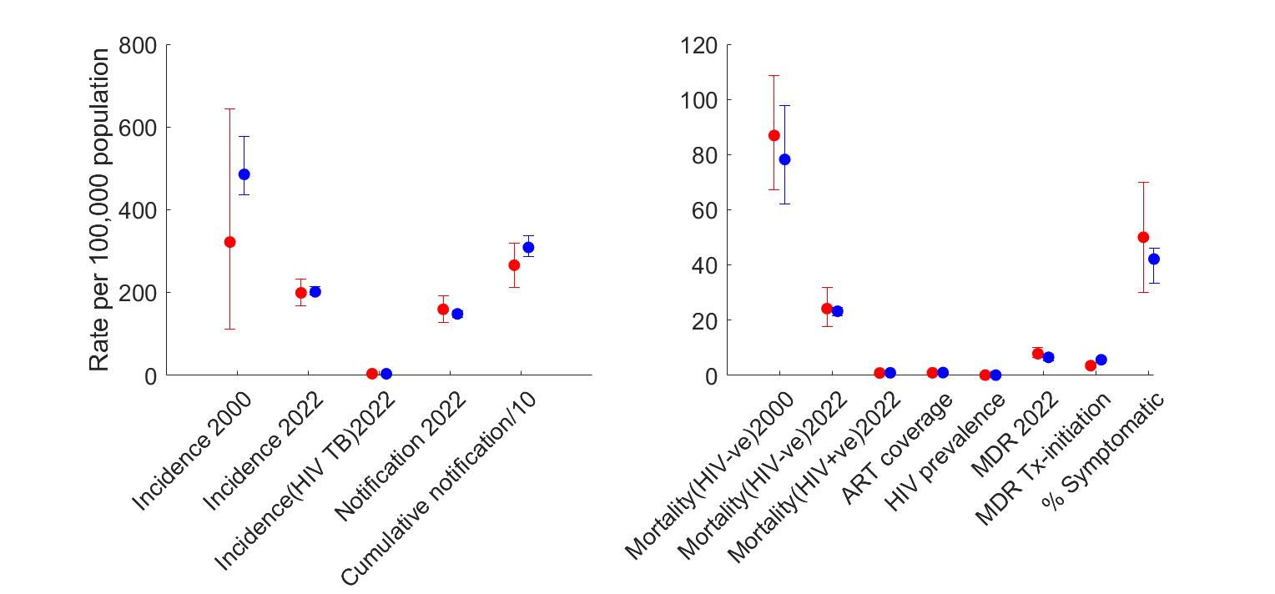

Figure 3. Basic calibration results for India**.** Dots show central estimates, while error bars show 95% uncertainty intervals. Here, the red indicates the data and blue model projected outcomes.

References

1. Menzies NA, Wolf E, Connors D, *et al.* Progression from latent infection to active disease in dynamic tuberculosis transmission models: a systematic review of the validity of modelling assumptions. Lancet Infect. Dis. 2018. doi:10.1016/S1473-3099(18)30134-8
2. Thomas A, Gopi PG, Santha T, Chandrasekaran V, et al. Predictors of relapse among pulmonary tuberculosis patients treated in a DOTS programme in South India. Int J Tuberc Lung Dis. 2005 May;9(5):556-61. PMID: 15875929.
3. Romanowski K, Balshaw RF, Benedetti A, *et al.* Predicting tuberculosis relapse in patients treated with the standard 6-month regimen: an individual patient data meta-analysis. *Thorax* 2019;**74**:291–7. doi:10.1136/thoraxjnl-2017-211120
4. Menzies D, Benedetti A, Paydar A, *et al.* Effect of duration and intermittency of rifampin on tuberculosis treatment outcomes: A systematic review and meta-analysis. PLoS Med. 2009;**6**. doi:10.1371/journal.pmed.1000146
5. Weis SE, Slocum PC, Blais FX, *et al.* The Effect of Directly Observed Therapy on the Rates of Drug Resistance and Relapse in Tuberculosis. *N Engl J Med* 1994;**330**:1179–84. doi:10.1056/NEJM199404283301702
6. Guerra-Assunção JA, Houben RMGJ, Crampin AC, *et al.* Recurrence due to relapse or reinfection with Mycobacterium tuberculosis: a whole-genome sequencing approach in a large, population-based cohort with a high HIV infection prevalence and active follow-up. *J Infect Dis* 2015;**211**:1154–63. doi:10.1093/infdis/jiu574
7. The World Bank. India demographic data. https://data.worldbank.org/country/india (accessed 14 Nov 2018).
8. Tiemersma EW, van der Werf MJ, Borgdorff MW, Williams BG, Nagelkerke NJD. Natural history of tuberculosis: Duration and fatality of untreated pulmonary tuberculosis in HIV negative patients: A systematic review. PLoS One. 2011; **6**. DOI:10.1371/journal.pone.0017601.