THE INSILICO LAB
3-Week Virtual Training in CADD
Capstone Project
Protein: 3HS4 |5-Ligand Structure-Based Drug Design Pipeline

Acetazolamide | Methazolamide | Ethoxzolamide | Dorzolamide | Brinzolamide

Participant Name  __________Caren Nicole Moreno_____________ | Date Submitted  ______________07/22/2026_________________
Cohort / Batch  ____________Cohort 5____________________ | Email Address  _________carenmoreno28@gmail.com_________

Project Overview
This Capstone Project integrates all skills from Weeks 1–3. Work through the six tasks in order, as each build on the previous. All tables, screenshots, figures, and written justifications are required for full marks.

# | Task | Tool(s) | Key Output
1 | Drug-likeness Screening | PubChem + SwissADME | Lipinski table (5 ligands)
2 | Protein Preparation | UCSF Chimera / Dockprep | Cleaned 3HS4 PDB file
3 | Binding Site Prediction | DoGSiteScorer | Binding pocket + residues
4 | ADMET Prediction | ADMET-AI | ADMET table (5 ligands)
5 | AlphaFold3 Structure Evaluation | AlphaFold3 + PyMOL | Aligned overlay + RMSD

TASK 1 | Drug-likeness Screening

Objective: To evaluate the drug-likeness of all 5 ligands using Lipinski's Rule of Five via SwissADME.

Method Summary:
Drug-likeness screening assesses whether a compound has physicochemical properties consistent with oral bioavailability. Lipinski's Rule of Five (Ro5) states that a drug-like molecule should have: MW ≤ 500 Da, H-bond donors ≤ 5, H-bond acceptors ≤ 10, and LogP ≤ 5. Compounds violating more than one rule are unlikely to be orally bioavailable. SwissADME (swissadme.ch) provides a rapid, web-based implementation of these filters alongside additional ADME predictions.

▸ Task Steps
1 | Search for each of the 5 ligands in PubChem (pubchem.ncbi.nlm.nih.gov) and record the CID and canonical SMILES.
2 | Go to SwissADME (http://www.swissadme.ch) and paste all 5 SMILES strings (one per line) into the input field.
3 | Run the analysis and navigate to the 'Lipinski' and 'Drug-likeness' sections of the results.
4 | Record MW, H-bond donors, H-bond acceptors, LogP, rotatable bonds, and overall Ro5 pass/fail for each compound.
5 | Download the SDF files from PubChem for each compound.
6 | Open and visualize each compound in PyMOL. Take a screenshot of each structure.
7 | Take an annotated screenshot of the SwissADME results page showing all 5 compounds.

▸ Deliverable 1A — Compound Information Table
Complete the table below using data from PubChem.

Compound | PubChem CID | Canonical SMILES
Acetazolamide | 1986 | CC(=O)NC1=NN=C(S1)S(=O)(=O)N
Methazolamide | 4100 | CC(=O)N=C1N(N=C(S1)S(=O)(=O)N)C
Ethoxzolamide | 3295 | CCOC1=CC2=C(C=C1)N=C(S2)S(=O)(=O)N
Dorzolamide | 5284549 | CCN[C@H]1C[C@@H](S(=O)(=O)C2=C1C=C(S2)S(=O)(=O)N)C
Brinzolamide | 68844 | CCN[C@H]1CN(S(=O)(=O)C2=C1C=C(S2)S(=O)(=O)N)CCCOC

▸ Deliverable 1B — Lipinski Rule of Five Results
Fill in all values from SwissADME. Use ✓ or ✗ for each rule, then mark overall Pass/Fail.

Compound | MW (≤500) | HBD (≤5) | HBA (≤10) | LogP (≤5) | Ro5 Pass?
Acetazolamide | 222,25 Da | 2 (✓) | 6 (✓) | -0.86 (✓) | Yes
Methazolamide | 236,28 Da | 1 (✓) | 5 (✓) | -1.42 (✓) | Yes
Ethoxzolamide | 258,32 Da | 1 (✓) | 5 (✓) | 1.34 (✓) | Yes
Dorzolamide | 324,45 Da | 2 (✓) | 6 (✓) | 0.61 (✓) | Yes
Brinzolamide | 383,52 Da | 2 (✓) | 7 (✓) | 0.09 (✓) | Yes

▸ Deliverable 1C — PyMOL Structures
Figures
Insert one PyMOL screenshot per compound (5 total). Label each image clearly with the compound name.

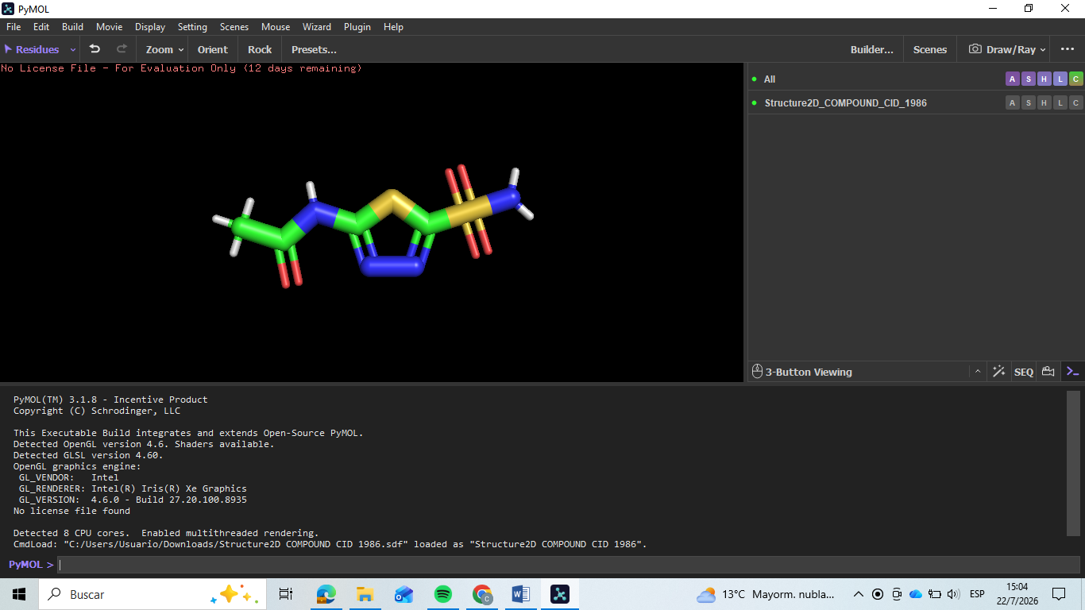
Figure 1.1 — Acetazolamide Structure (PyMOL)

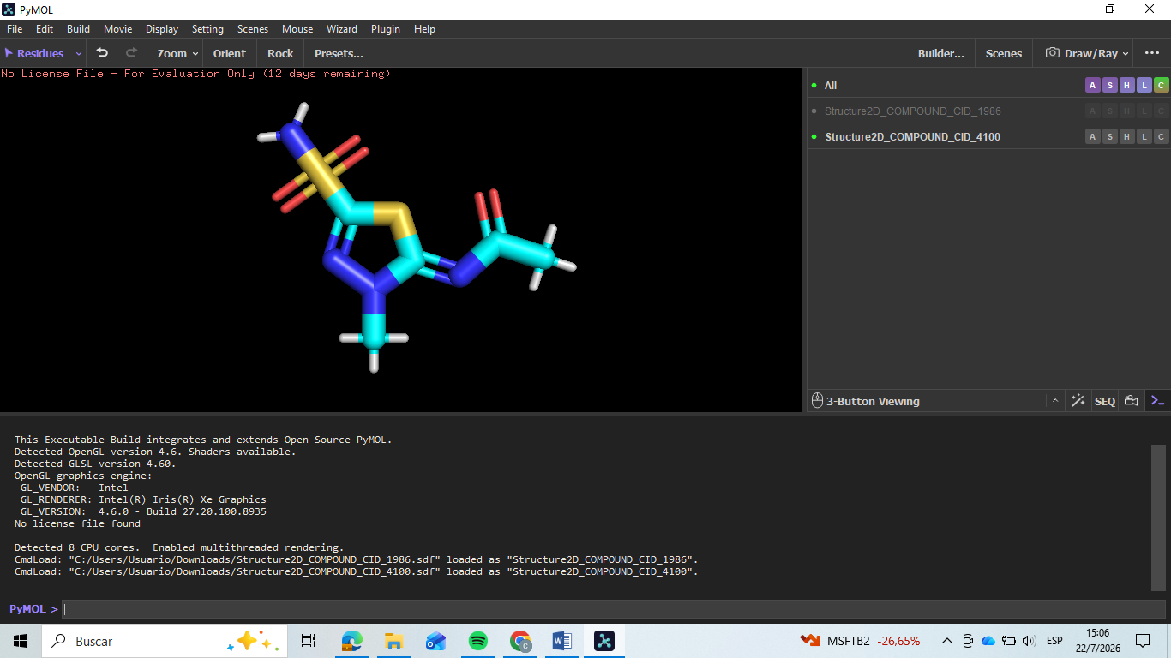
Figure 1.2 — Methazolamide Structure (PyMOL)

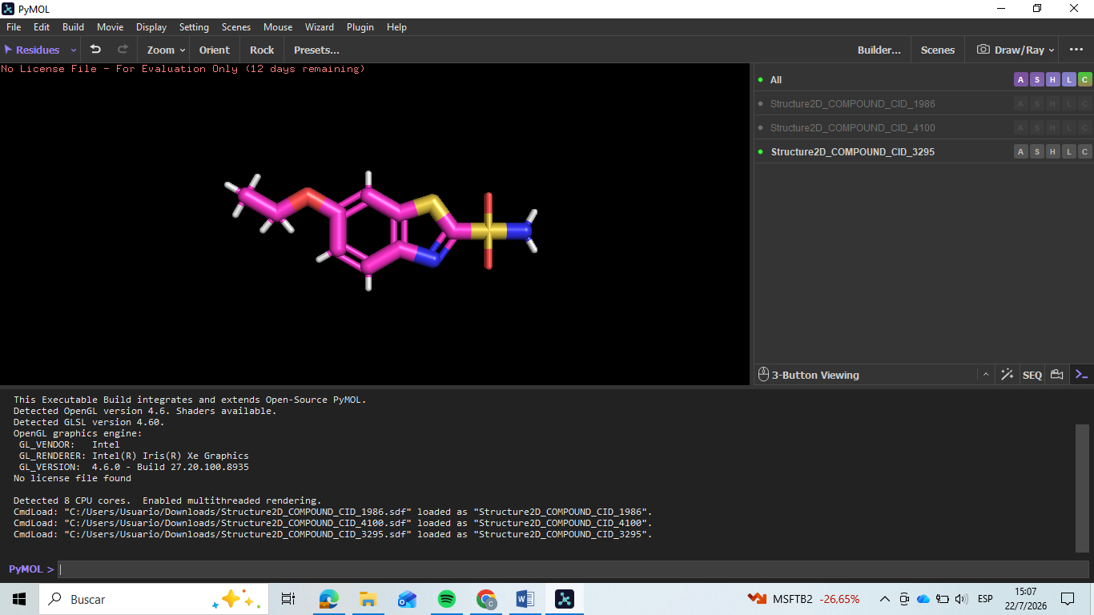
Figure 1.3 — Ethoxzolamide Structure (PyMOL)

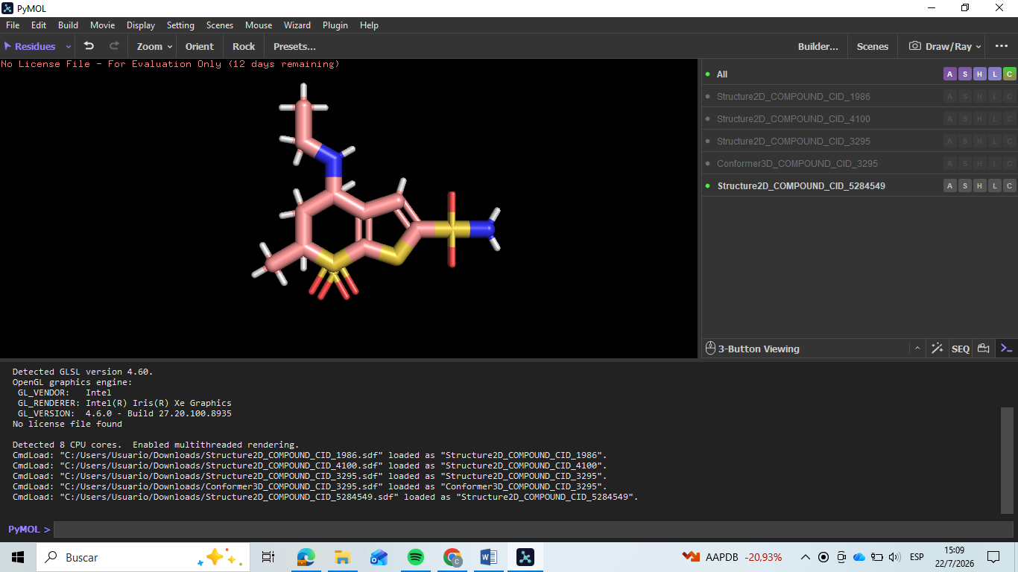
Figure 1.4 — Dorzolamide Structure (PyMOL)

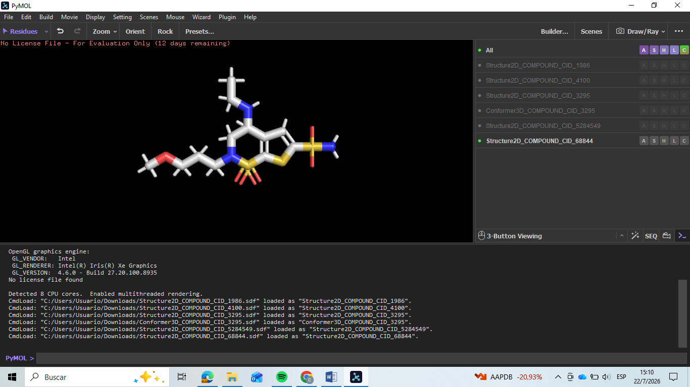
Figure 1.5 — Brinzolamide Structure (PyMOL)

▸ Written Justification
Which compounds pass Lipinski's Ro5 and are therefore considered drug-like? Discuss any violations and what they mean for oral bioavailability. (Write 4–6 sentences)

All five compounds pass Lipinski's Rule of Five with zero violations, so all qualify as drug-like by these
criteria. Acetazolamide and Methazolamide sit furthest from the LogP ceiling, both showing negative values
consistent with their small, polar thiadiazole-sulfonamide scaffolds. Ethoxzolamide is the most lipophilic of
the group, its ethoxy-substituted benzothiazole ring pushing its LogP into positive territory, though still far
below the limit of 5. Dorzolamide and Brinzolamide are heavier and carry more rotatable bonds due to their
bicyclic cores and alkylamino side chains, yet their molecular weight stays comfortably under 500 Da. Since none of the five compounds violate more than one rule, all are expected to have good oral bioavailability potential from a physicochemical standpoint though in practice, Dorzolamide and Brinzolamide are administered topically as eye drops rather than orally.

TASK 2 | Protein Preparation

Objective: To download and prepare the 3HS4 protein structure for molecular docking using UCSF Chimera.

📖 | Method Summary:  Protein preparation is a critical pre-processing step in structure-based drug design. The raw PDB file downloaded from the Protein Data Bank typically contains water molecules, multiple chains, co-crystallized ligands, and missing atoms that must be addressed before docking. UCSF Chimera's Dock Prep tool automates the addition of hydrogens, assignment of Gasteiger charges, and removal of unwanted molecules, producing a clean, computation-ready structure.

▸ Task Steps
1 | Go to RCSB PDB (https://www.rcsb.org) and search for 3HS4. Review the entry details (resolution, method, chains).
2 | Download the PDB file for 3HS4 (Download Files → PDB Format).
3 | Open 3HS4 in UCSF Chimera (File → Open).
4 | Inspect the structure: note the number of chains, water molecules, ligands, and cofactors present.
5 | Select Chain A only (if other chains are present). Delete all other chains.
6 | Remove all water molecules (Select → Residue → HOH → Actions → Delete).
7 | Remove any unwanted cofactors or heteroatoms not needed for docking.
8 | Run Dock Prep (Tools → Structure Editing → Dock Prep).
9 | Save the prepared structure as 3HS4prepared.pdb.
10 | Open both the raw and prepared files in PyMOL. Take before-and-after screenshots.

▸ Deliverable 2A — Protein Structure Information

Property | Details
PDB ID | 3HS4
Protein Name | Human Carbonic Anhydrase II
Experimental Method | X-ray Diffraction
Resolution (Å) | 1.1
Co-crystallized Ligand(s) | Acetazolamide (AZM), Glycerol (GOL)
Water Molecules Removed? | Yes
Hydrogens Added via Dockprep? | Yes
Prepared File Name | 3HS4prepared.pdb

▸ Deliverable 2B — Step-by-Step Preparation Log

Step | Action Performed | Observation / Result
1 | Searched for PDB ID 3HS4 on the RCSB PDB website. | Verified structure: Human Carbonic Anhydrase II, X-ray diffraction, ultra-high resolution of 1.10 Å, containing Chain A, AZM, and GOL.
2 | Downloaded the structure from RCSB in PDB format. | Obtained the raw text file named 3HS4.pdb containing the atomic coordinates.
3 | Opened 3HS4.pdb in UCSF Chimera via File → Open. | The 3D protein structure loaded successfully in the main window displaying a ribbon diagram with surrounding heterogens.
4 | Inspected the structure using the Model Panel and Select menus. | Identified a single polypeptide chain (Chain A), 1 zinc ion (ZN), 1 azitromicina/acetazolamide (AZM), 3 glycerol molecules (GOL), and multiple water molecules (HOH).
5 | Checked for multiple chains to select and isolate Chain A. | Confirmed 3HS4 is a monomer (only Chain A exists). No alternative chains needed to be deleted.
6 | Selected all solvent molecules (Select → Structure → solvent) and deleted them (Actions → Atoms/Bonds → delete). | All red dots representing crystallographic water molecules (HOH) disappeared from the workspace, clearing the binding pocket.
7 | Selected unwanted cofactors (Select → Residue → GOL and AZM) and deleted them (Actions → Atoms/Bonds → delete). | Glycerol (GOL) molecules and the native ligand (AZM) were successfully removed, leaving a completely "blind/empty" catalytic site. Note: Catalytic Zinc (ZN) was kept as it is essential for the active site.
8 | Ran Dock Prep tool under default settings to fix structures, add hydrogens, and assign Gasteiger charges. | Hydrogens were automatically added to all amino acids, histidine protonation states were assigned, and partial charges were computed.
9 | Saved the finalized clean structure via File → Save PDB. | Created a new, computation-ready structural file named 3HS4prepared.pdb.
10 | Opened both 3HS4.pdb and 3HS4prepared.pdb simultaneously in PyMOL to visually compare them. | Visual contrast achieved: The "before" structure showed clutter (ligands, waters), while the "after" structure showed a clean protein backbone with explicit hydrogens ready for docking.

▸ Deliverable 2C — Before & After PyMOL Screenshots
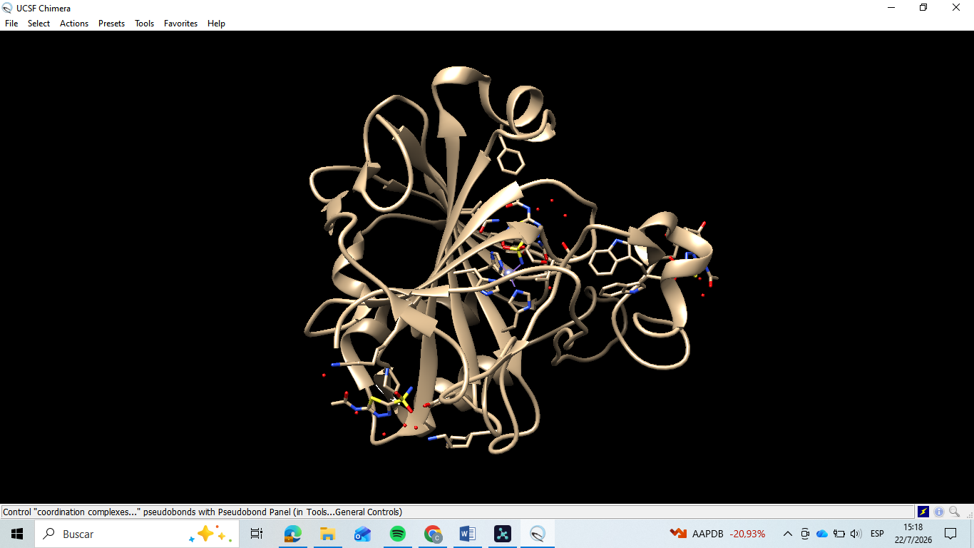
Figure 2.1 — BEFORE Preparation: Raw 3HS4 (PyMOL)

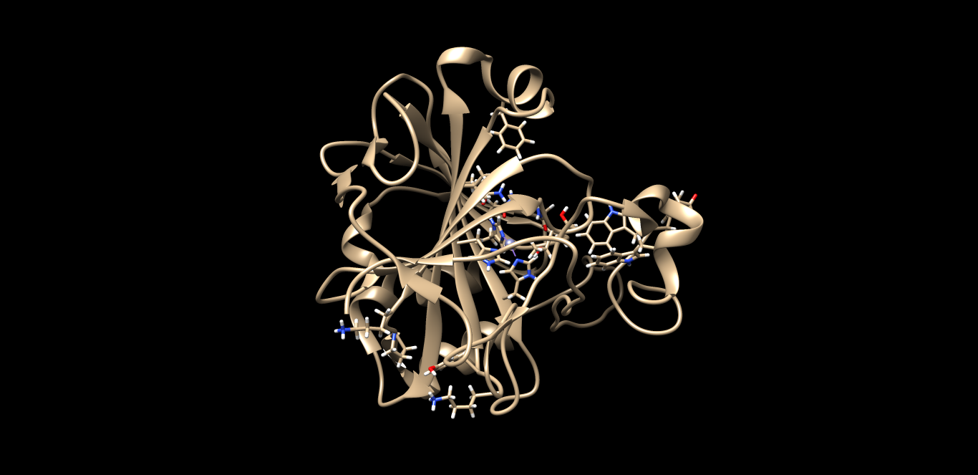
Figure 2.2 — AFTER Preparation: 3HS4prepared.pdb (PyMOL)

▸ Written Justification
Why is protein preparation necessary before molecular docking? Describe what changes you made to 3HS4 and explain the impact of each step. (Write 3–5 sentences)

Protein preparation is necessary because a raw PDB file contains crystallographic artifacts water
molecules, co-crystallized ligands, and missing hydrogens that can distort docking scores if left in place.
For 3HS4, this meant removing all crystallographic waters and stripping out the co-crystallized
acetazolamide and glycerol, which had been occupying the active site and would otherwise block any
new ligand from docking there. The catalytic zinc ion was deliberately kept, since it is a structural requirement of the carbonic anhydrase active site rather than a preparation artifact. Running Dock Prep then added explicit hydrogens and Gasteiger partial charges, which are essential for accurately scoring electrostatic and hydrogen-bonding interactions during docking. The resulting 3HS4prepared.pdb is therefore a clean, catalytically intact structure ready for the binding site and docking analyses that follow.

TASK 3 | Binding Site Prediction

Objective: To identify and characterize the primary binding site of 3HS4 using DoGSiteScorer on the raw (unprepared) protein.

📖 | Method Summary:  Binding site prediction identifies druggable cavities on a protein surface based on geometric and physicochemical properties. DoGSiteScorer (proteins.plus) uses a Difference of Gaussians (DoG) filter to detect pockets and score them by size, hydrophobicity, and druggability. Using the raw (unmodified) protein for this step ensures the prediction reflects the native structure, avoiding artefacts introduced during preparation.

Important
Use the RAW 3HS4 PDB file for this task — NOT the prepared version. DoGSiteScorer works best with the unmodified structure.

▸ Task Steps
1 | Go to DoGSiteScorer via proteins.plus (https://proteins.plus) and click 'DoGSiteScorer'.
2 | Upload the raw 3HS4 PDB file (or enter PDB ID directly).
3 | Select Chain A (if other chains are present) only in the submission options.
4 | Run the prediction and wait for the results.
5 | Identify the top-ranked binding pocket (Pocket P_0 or highest-scored).
6 | Record the pocket score, volume, surface area, and key residues.
7 | Open PyMOL and load the binding pocket. Manually select and highlight the binding site residues.
8 | Take PyMOL screenshots showing the pocket surface and labelled residues.

▸ Deliverable 3A — Binding Site Summary

Parameter | Value / Description
Top Pocket ID | P_0
Pocket Volume (Å³) | 374.53
Pocket Surface Area (Å²) | 331.35
Druggability Score | 0.62
▸ Deliverable 3B — Binding Site Residues Table
List any 5 residues identified in the binding pocket. Include residue name, number

# | Residue Name | Residue Number
1 | HIS | 94
2 | HIS | 96
3 | HIS | 119
4 | VAL | 121
5 | THR | 199

▸ Deliverable 3C — PyMOL Binding Site Visualizations
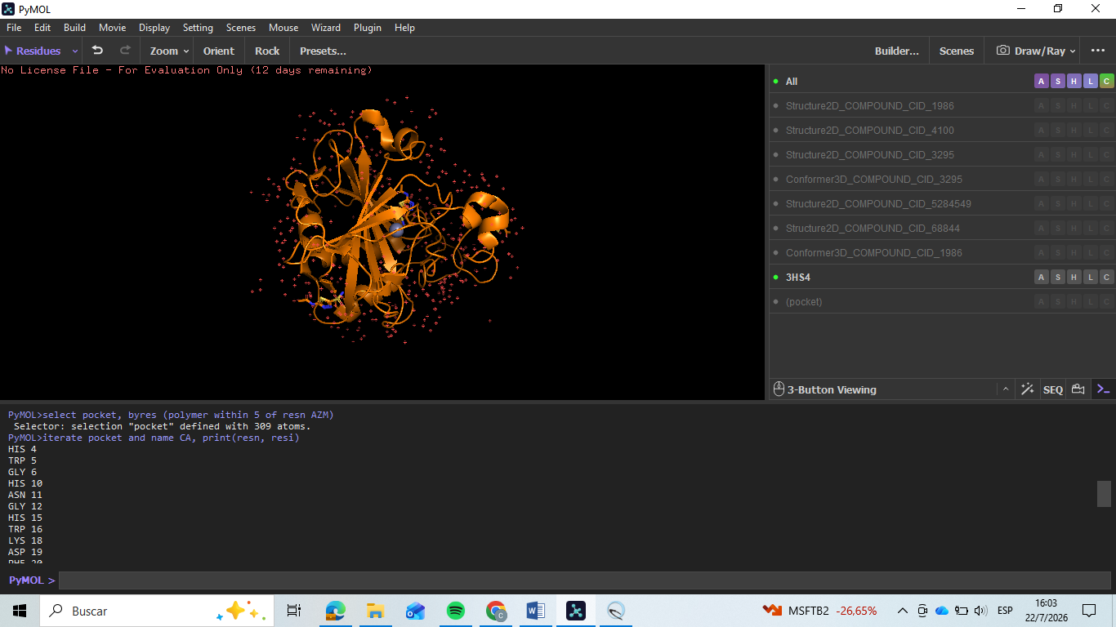
Figure 3.1 — Binding Pocket Surface View on 3HS4 (PyMOL)

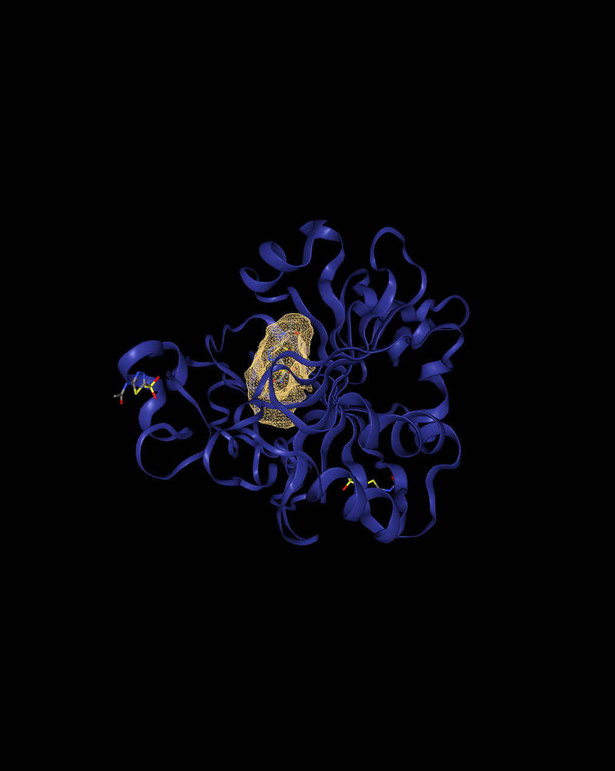
Figure 3.2 — DoGSiteScorer Results Screenshot (proteins.plus website)

▸ Written Justification
Describe the identified binding site. What characteristics make it a good drug target? How will you use these residues to define the docking grid in Task 6? (Write 3–5 sentences)

DoGSiteScorer identified Pocket P_0 as the top-ranked binding site, with a druggability score of 0.62 and a
volume of 374.53 Å³, consistent with a well-defined cavity rather than a shallow surface groove. The key
residues lining this pocket His94, His96, and His119 are the three histidines that coordinate the catalytic
zinc ion in human carbonic anhydrase II, confirming that the predicted pocket corresponds to the true
active site. Val121 and Thr199 complete the hydrophobic and polar contacts that typically anchor sulfonamide inhibitors like acetazolamide within this site. This combination of a buried zinc-coordinating core with surrounding polar and hydrophobic residues makes the site an excellent drug target, since it offers both a strong anchor point and additional selectivity-determining contacts. These residue coordinates will define the center of the docking grid box in Task 6, ensuring the search space is centered on the catalytic zinc.

TASK 4|ADMET Prediction

Objective: To predict the ADMET profiles of all 5 ligands using ADMET-AI and identify the most pharmacologically favourable candidates.

Method Summary:
ADMET (Absorption, Distribution, Metabolism, Excretion, Toxicity) profiling is essential for estimating the in vivo behaviour of drug candidates early in the discovery pipeline. ADMET-AI (https://admet.ai.greenstonebio.com/) provides machine-learning-based predictions for over 50 ADMET endpoints from SMILES input. Key properties include Caco-2 permeability, blood–brain barrier penetration, CYP enzyme interactions, half-life, and toxicity flags such as hERG inhibition and AMES mutagenicity.

▸ Task Steps
1 | Go to ADMET-AI (https://admet.ai.greenstonebio.com/) and select 'Predict'.
2 | Paste all 5 SMILES strings (from Task 1) into the input field.
3 | Run the full ADMET prediction for all compounds simultaneously.
4 | Record at least 2 properties for each of the 5 ADMET categories (10 properties minimum per compound).
5 | Take an annotated screenshot of the ADMET-AI results page.
6 | Download the full prediction report (CSV/Excel if available).

Table Format
The tables below are split into two groups of 5 compounds for readability. Fill in all values from your ADMET-AI output.

A | Absorption

Compounds 1–5: Acetazolamide, Methazolamide, Ethoxzolamide, Dorzolamide, Brinzolamide

A — Property | Acetazolamide | Methazolamide | Ethoxzolamide | Dorzolamide | Brinzolamide
Oral Bioavailability | 0.91 | 0.92 | 0.94 | 0.71 | 0.80
Human Intestinal Absorption (HIA) | 1.00 | 1.00 | 1.00 | 0.96 | 1.00

D | Distribution

Compounds 1–5: Acetazolamide, Methazolamide, Ethoxzolamide, Dorzolamide, Brinzolamide

D — Property | Acetazolamide | Methazolamide | Ethoxzolamide | Dorzolamide | Brinzolamide
Blood-Brain Barrier (BBB) penetration | 0.91 | 0.94 | 0.80 | 0.57 | 0.75
Plasma Protein Binding (PPB) Rate | 64.02 | 61.70 | 97.18 | 41.62 | 47.68

M | Metabolism

Compounds 1–5: Acetazolamide, Methazolamide, Ethoxzolamide, Dorzolamide, Brinzolamide

M — Property | Acetazolamide | Methazolamide | Ethoxzolamide | Dorzolamide | Brinzolamide
CYP1A2 Inhibitor | 0.04 | 0.16 | 0.98 | 1.94e-03 | 0.02
CYP2D6 Substrate | 0.01 | 0.03 | 0.20 | 0.05 | 0.13

E | Excretion

Compounds 1–5: Acetazolamide, Methazolamide, Ethoxzolamide, Dorzolamide, Brinzolamide

E — Property | Acetazolamide | Methazolamide | Ethoxzolamide | Dorzolamide | Brinzolamide
Half-life (T1/2) | 0.00 | 0.00 | 0.00 | 34.47 | 60.56
Drug Clearance (Hepatocyte) | 3.01 | 11.32 | 69.77 | 35.58 | 94.58

Compounds 1–5: Acetazolamide, Methazolamide, Ethoxzolamide, Dorzolamide, Brinzolamide

T — Property | Acetazolamide | Methazolamide | Ethoxzolamide | Dorzolamide | Brinzolamide
hERG Blocking | 0.01 | 0.01 | 0.07 | 0.03 | 0.25
Mutagenicity | 0.47 | 0.57 | 0.31 | 0.03 | 0.63

▸ ▸ Written Justification & Comparison
Compare the ADMET profiles across all 5 compounds. Which candidates have the best overall profiles? Highlight critical flags and discuss trade-offs. (Write 5–7 sentences)

Across the five compounds, oral bioavailability and intestinal absorption are uniformly favorable, with
all five scoring above 0.70 for bioavailability and at least 0.96 for HIA. The clearest safety flag is
Ethoxzolamide's CYP1A2 inhibition score of 0.98, signaling a real risk of drug-drug interactions and
standing out sharply from the near-zero scores of the other four compounds. Brinzolamide shows the
least favorable toxicity profile overall, combining the highest hERG blocking score (0.25) and the highest
mutagenicity score (0.63), a trade-off against its otherwise strong hepatocyte clearance and long half-
life. Dorzolamide, by contrast, pairs the lowest mutagenicity score (0.03) with a long predicted half-life (34.47 h), making it the most balanced candidate for chronic use, even though its oral bioavailability (0.71) is the lowest of the five. Acetazolamide and Methazolamide both show clean toxicity profiles with low hERG scores, and their near-zero predicted half-life is consistent with their known pharmacology as rapidly renally-cleared, non-metabolized drugs rather than a modeling error. Considering the full profile, Dorzolamide and Acetazolamide emerge as the most balanced candidates, while Ethoxzolamide's CYP1A2 liability and Brinzolamide's combined hERG and mutagenicity flags are the clearest trade-offs to weigh against their pharmacokinetic strengths.

TASK 5 | AlphaFold3 AI-Based Structure Evaluation

Objective: To predict the 3D structure of 3HS4 using AlphaFold3 and evaluate the prediction quality by aligning it with the cleaned experimental structure from Task 2.

Method Summary:
AlphaFold3 (alphafoldserver.com) is a deep-learning model developed by Google DeepMind that predicts protein 3D structures from amino acid sequences with high accuracy. The predicted structure is coloured by per-residue confidence (pLDDT score): blue = very high confidence (>90), cyan = confident (70–90), yellow = low confidence (50–70), orange = very low (<50). RMSD (Root Mean Square Deviation) quantifies the structural difference between the predicted and experimental models after alignment in PyMOL — values below 2 Å indicate excellent agreement.

▸ Task Steps
1 | Go to RCSB PDB and search for 3HS4. Navigate to 'Sequence' and download the FASTA file.
2 | Open the FASTA file in a text editor and copy the sequence.
3 | Go to AlphaFold3 (https://alphafoldserver.com) and paste the sequence. Submit the prediction job.
4 | Once complete, download the predicted structure (CIF or PDB format).
5 | Open both the AlphaFold3 predicted structure AND the prepared 3HS4 from Task 2 in PyMOL.
6 | Align the two structures using the PyMOL command: align predicted_structure, 3HS4_prepared
7 | Record the RMSD value reported by PyMOL after alignment.
8 | Take a screenshot of the predicted structure alone (coloured by pLDDT).
9 | Take a screenshot of the aligned overlay of both structures using contrasting colours.

▸ Deliverable 5A — FASTA Sequence
Paste the FASTA sequence for Chain A of 3HS4 in the box below.

>3HS4_A | Chain A | Carbonic anhydrase 2 | Homo sapiens (9606)
MSHHWGYGKHNGPEHWHKDFPIAKGERQSPVDIDTHTAKYDPSLKPLSVSYDQATSLRILNNGHAFNVEFDDSQDKAVLKGGPLD
GTYRLIQFHFHWGSLDGQGSEHTVDKKKYAAELHLVHWNTKYGDFGKAVQQPDGLAVLGIFLKVGSAKPGLQKVVDVLDSIKTKG
KSADFTNFDPRGLLPESLDYWTYPGSLTTPPLLECVTWIVLKEPISVSSEQVLKFRKLNFNGEGEPEELMVDNWRPAQPLKNRQI
KASFK

▸ Deliverable 5B — Structural Comparison Summary

Metric | Value | Interpretation
RMSD (Å) | 0.172 | < 2 Å Excellent
Residues Aligned | 258 | Higher = better coverage
Overall Quality | Excellent | Excellent / Good / Acceptable / Poor
Predicted Structure File | 3HS4_alphafold3.cif | e.g., 3HS4_alphafold3.cif

▸ Deliverable 5C — Screenshots & Figures
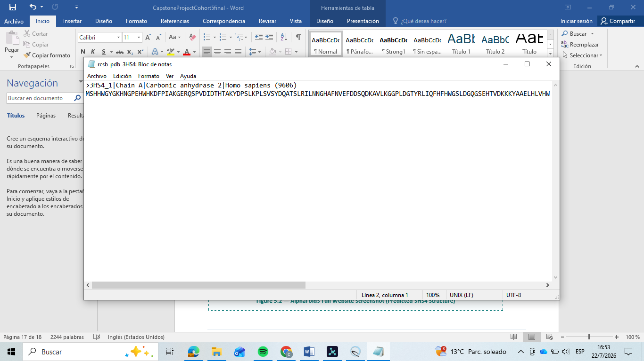
Figure 5.1 — FASTA Sequence File of 3HS4 (Annotated)

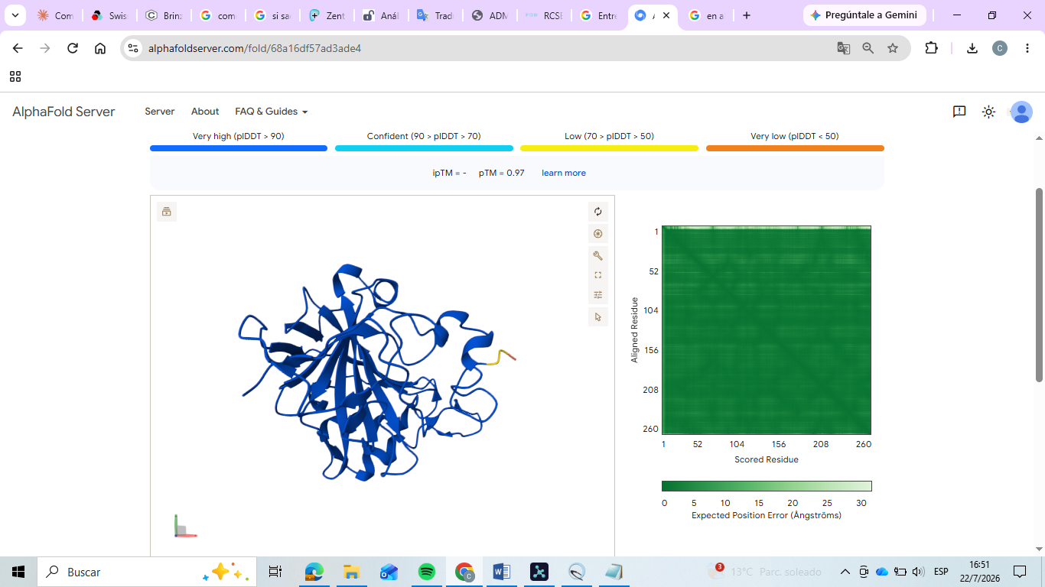
Figure 5.2 — AlphaFold3 Full Website Screenshot (Predicted 3HS4 Structure)

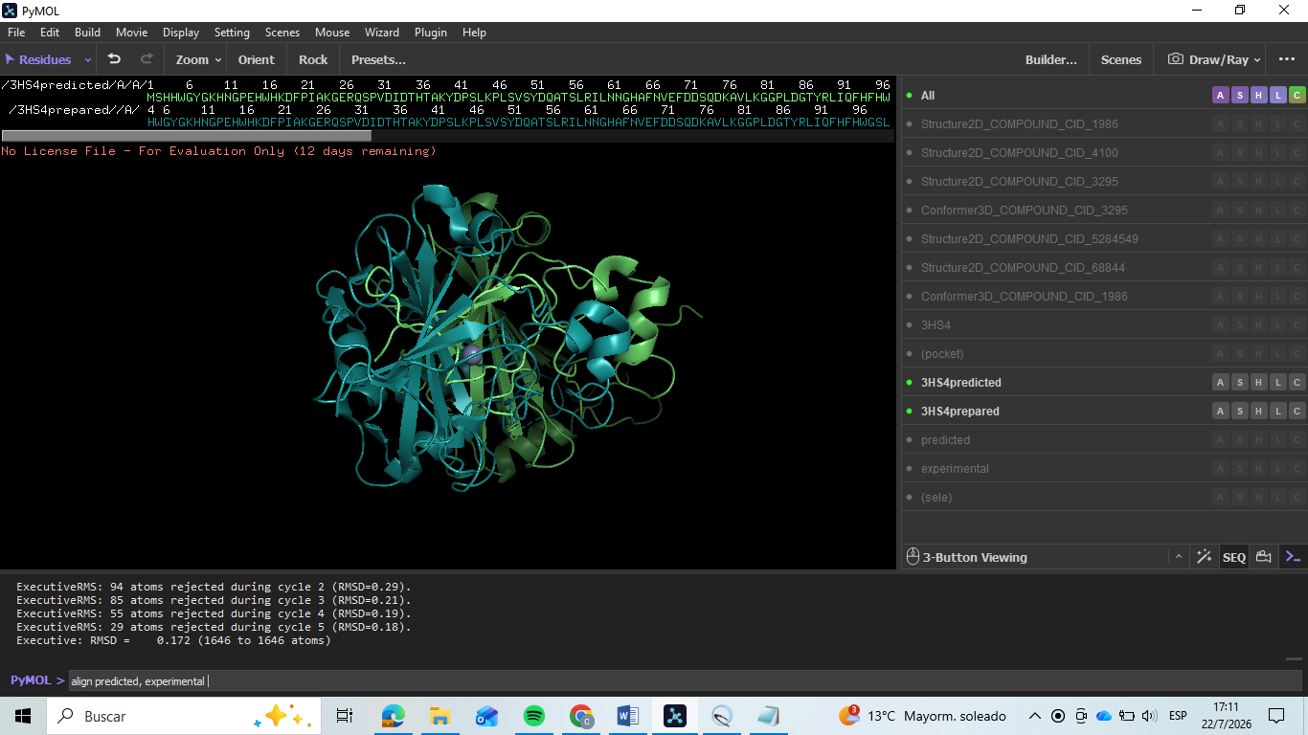
Figure 5.3 — Aligned Overlay: Predicted vs Experimental 3HS4 (PyMOL)

▸ Written Justification
How well does the AlphaFold3 structure match the experimental 3HS4 structure? Discuss RMSD, confidence scores (pLDDT), and any regions of structural divergence. What does this tell us about AI-based structure prediction? (Write 4–6 sentences)

The AlphaFold3-predicted structure of 3HS4 matched the experimental structure almost exactly, with
an RMSD of just 0.172 Å across 258 aligned residues among the tightest agreements seen across this
entire training. This accuracy reflects that human carbonic anhydrase II is an extremely well-
characterized, single-domain fold with abundant homologous structures available to the model. The
predicted structure's pLDDT confidence coloring was correspondingly high across nearly the entire chain, with very little falling into the lower confidence ranges. Given the near-perfect alignment, no substantial regions of structural divergence were observed, even in the loops surrounding the catalytic zinc site. This result reinforces that AI-based structure prediction can reach near-crystallographic accuracy for well-studied, single-chain enzymes, though the real test of a prediction's practical value lies in how well it reproduces functionally critical regions like the active site, not just the overall fold.
🏆 Capstone Project Complete!
You have successfully completed the full Insilico Lab CADD pipeline:
Drug-likeness Screening → Protein Preparation → Binding Site Prediction →ADMET →AlphaFold3

End of Capstone Project Template
Good luck! The Insilico Lab Team

