CMP104 – Assessment Cover Document

Joseph Lee 1903399

## Game Overview

For this assessment rather then making a standard fruit machine, I decided to take the fruit machine concept and make a hacking themed fruit machine. So, the reel values are Linux commands and the prizes are data dumps. One feature I added was the randomly generated vulnerability winning condition that is randomly generated at the start of each spin. This vulnerability victory yields the highest prize, but is also the hardest to achieve. In keeping with the theme this fruit machine game has been named ‘HACK MACHINE’, see screen shots of game below:

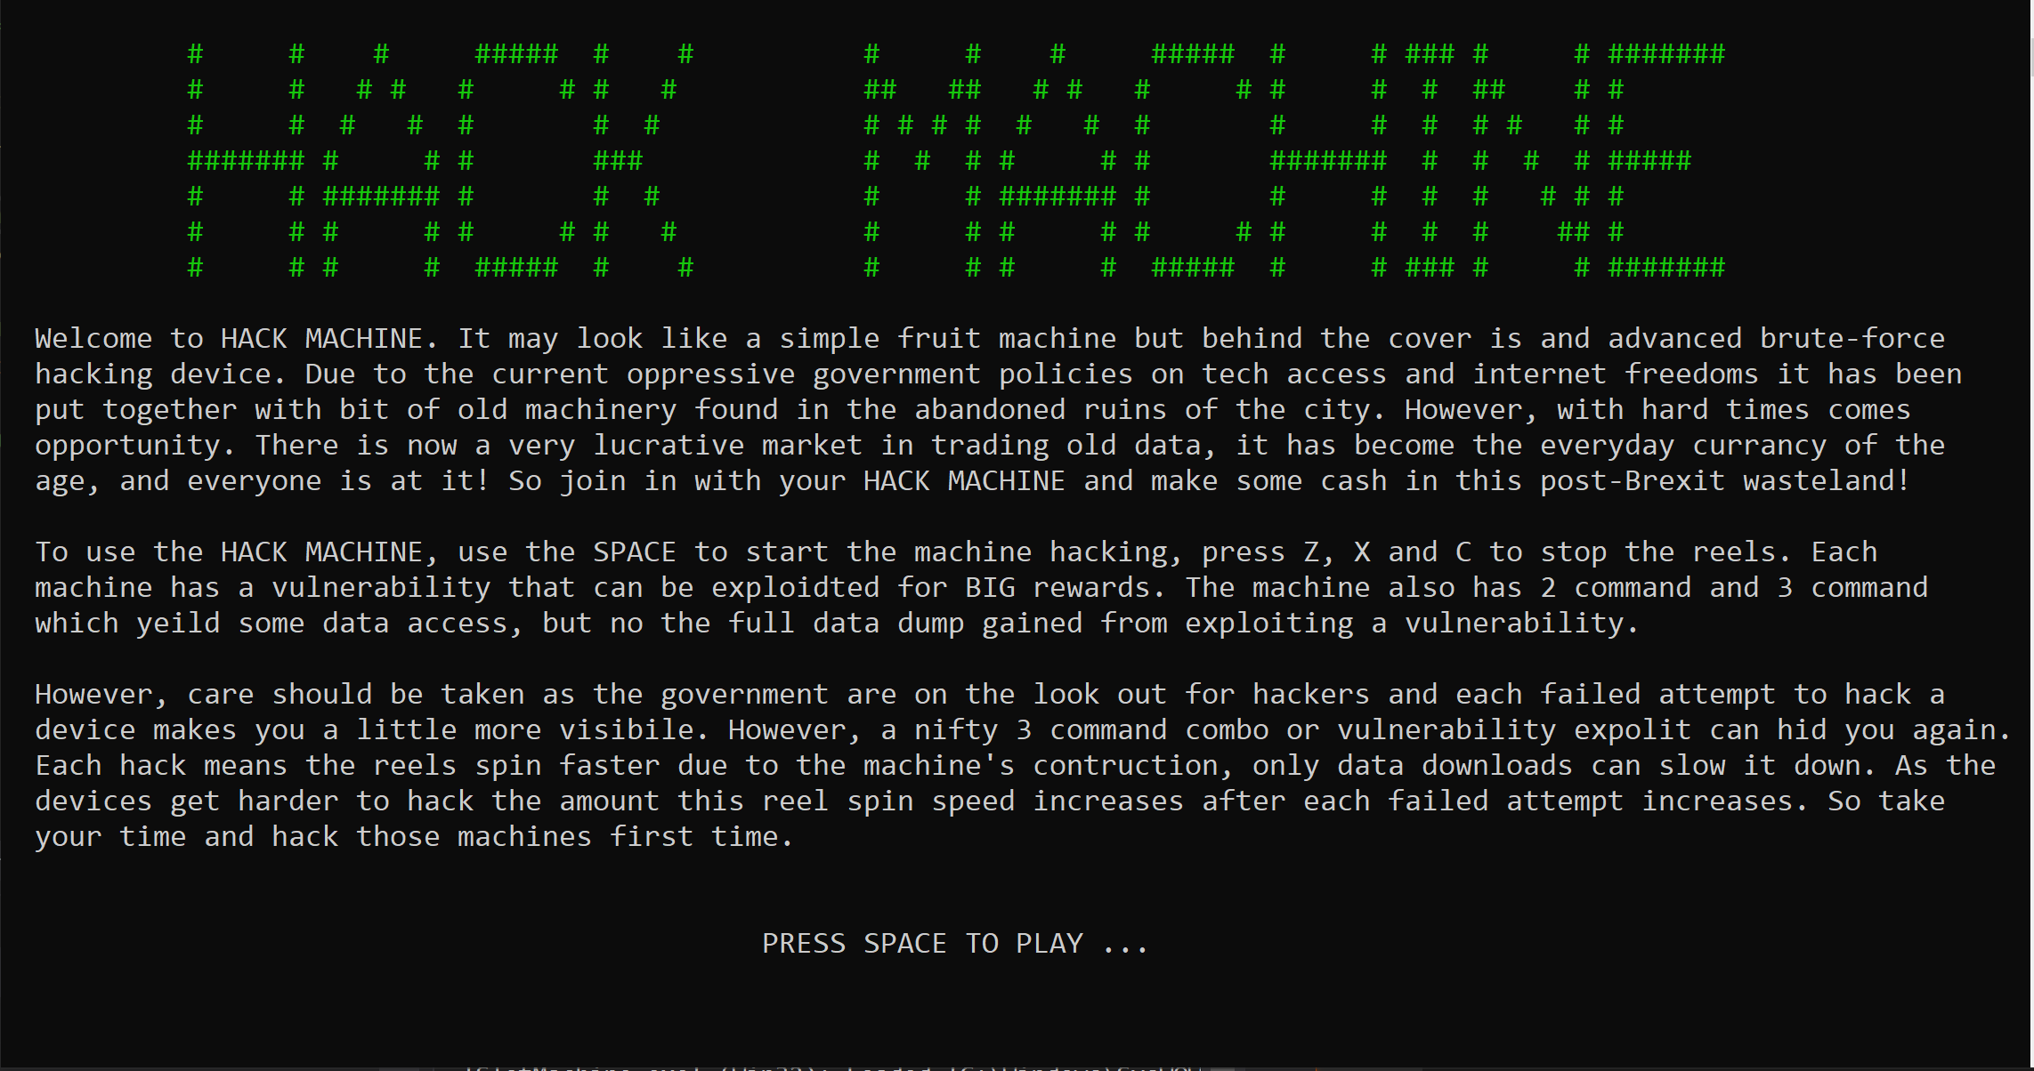

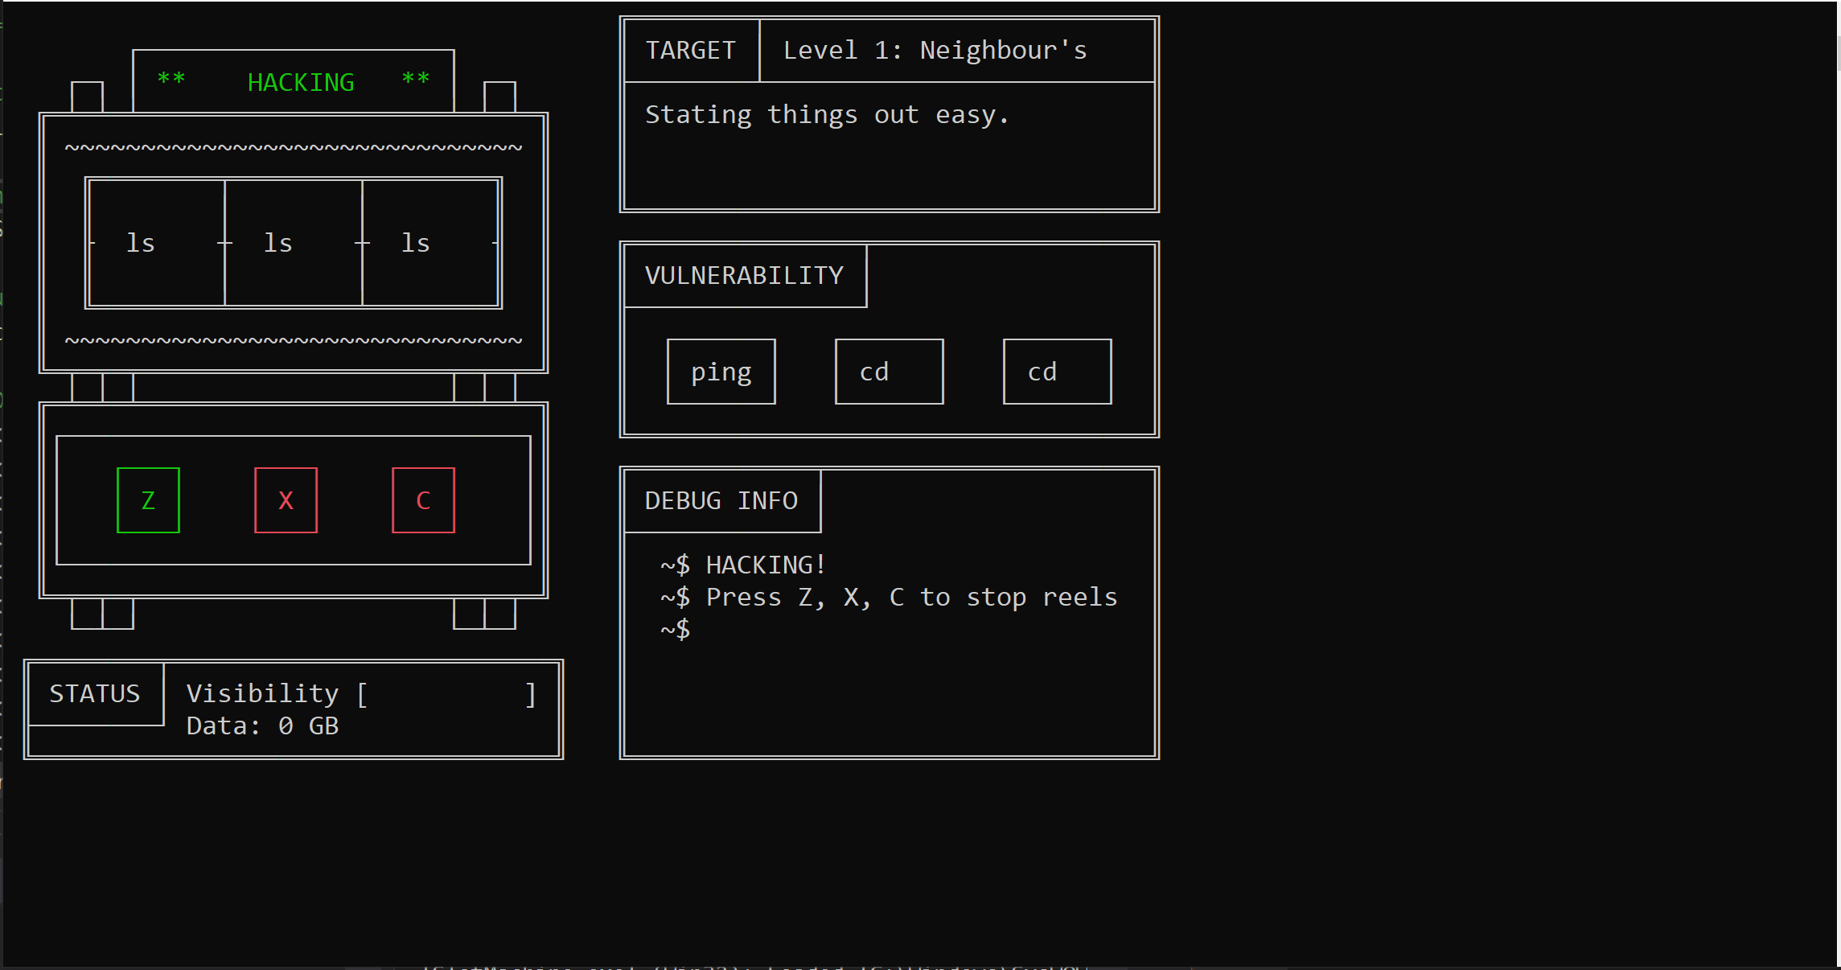

## Mechanics

A normal game would flow like below:

* Game intro and main screen displays with all the instruction games.

* `Space` to start game.

* Pints slot machine with animations.

* `Esc` to quit from this state back to main screen, `Space` starts reels spinning.

* All 3 reels keep spinning and vulnerability generated.

* Press `Z` key to stop Reel 1 spinning, other 2 reels keep spinning.

* Press `X` key to stop Reel 2 spinning, reel 3 keeps spinning.

* Press `C` key to stop Reel 3 Spinning.

* Once all reels stopped values are checked against victory conditions.

* Data value increased if a winning score, visibility increases.

* Each spin attempt reel spinning speed increases, this is more drematic the higher the level.

* Winning will also reduce the spin speed increase.

* If Max visibility reached, game is over.

* If game is over `R` can be pressed to restart the game.

## Design Choices

* State Machine
* Hacking Theme
* Vulnerability
* Target
* Debug Info
* Animations

## Flow

<< Insert State Machine Flow Chart >>

## README

For more information on this game’s code please consult the README file submitted with the game, this contains lots of detail on the concept and the implementation of each of the game’s features. The markdown (.md) and PDF versions have been included.