Verilator: The Open-Source Simulator
Reshaping Chip Design

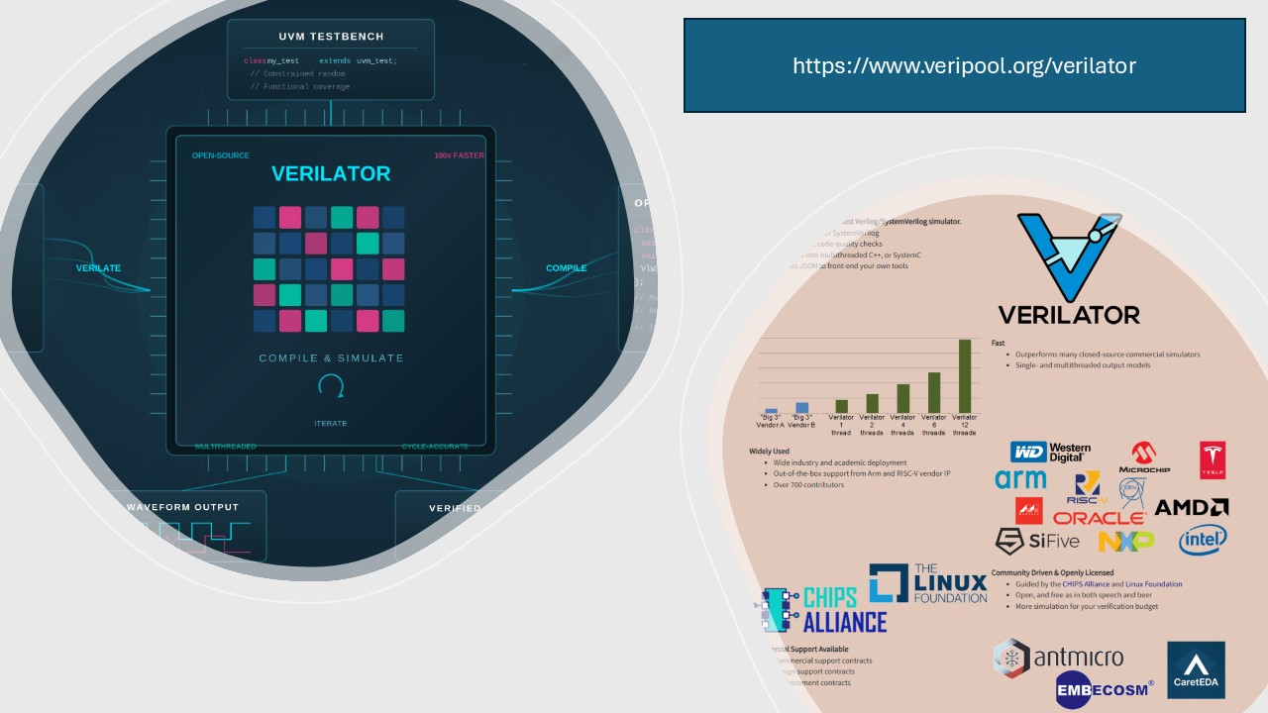

When Tesla set out to validate the neural processing unit (NPU) inside their Full Self-Driving chip, they hit a scaling wall with commercial simulators. Their solution? An open-source tool called Verilator.Their senior director of Autopilot Hardware stated publicly at HotChips 2019 that Verilator was central to proving the quality of their design.
Tesla isn’t alone. Google, AMD, Microsoft, and NVIDIA all rely on Verilator for the Caliptra Root of Trust project — an open-source silicon root of trust for datacenter-class SoCs. Western Digital has championed it for years, using it to verify their VeeR RISC-V cores and funding much of the tool’s recent UVM work through the CHIPS Alliance. lowRISC’s OpenTitan, CERN’s radiation-tolerant SoC ecosystem, and NXP have all adopted it. The RISC-V community has largely standardized on it.
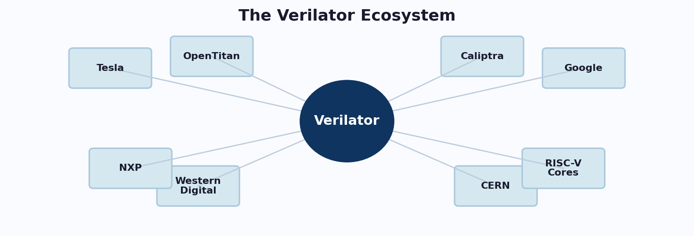
How did a project born at Digital Equipment Corporation in 1994 end up at the center of chip verification for some of the world’s most demanding silicon?

Why Simulation Matters in Chip Design
A modern SoC can contain billions of transistors and take years to design. Once a chip goes to fabrication, a bug isn’t something you fix with a patch — it means a respin, months of delay, and enormous financial damage. Simulation is the primary mechanism engineers use to catch those bugs before they become permanent.
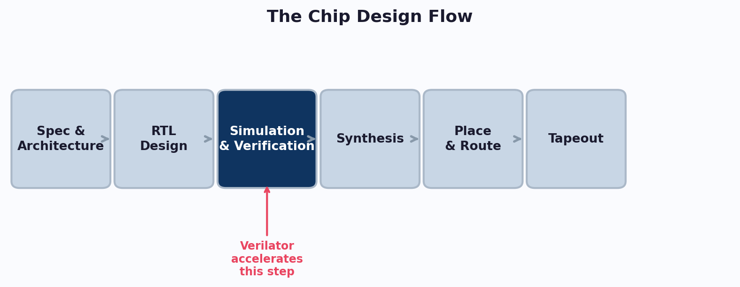
RTL simulation lets designers describe hardware in Verilog or SystemVerilog, then exercise it against testbenches modeling real-world input. The quality and speed of this simulation directly determines how much of the design space a team can explore before committing to silicon. Traditional commercial simulators are powerful but expensive — license costs scale with engineers, cores, and parallel regressions. Verilator, being fully open sourced, lets teams scale with compute instead of licenses.

A Brief History of Verilator
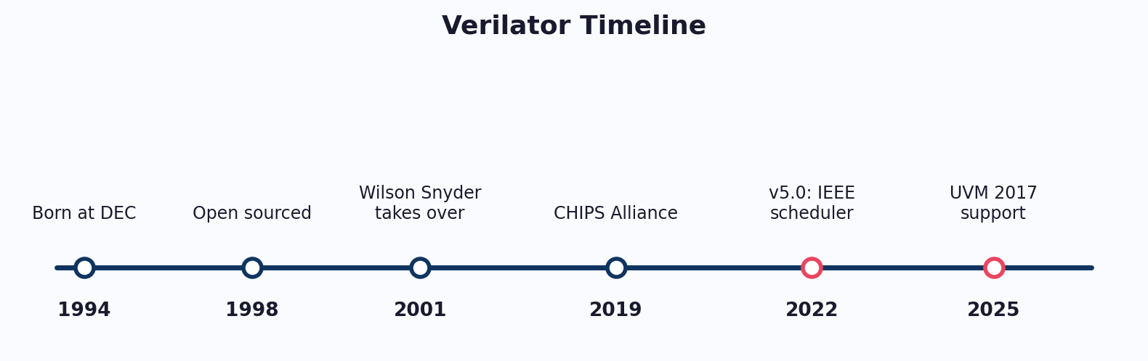
Verilator was born in 1994 at Digital Equipment Corporation as a Verilog-to-C conversion tool, and was released into the public domain in 1998.
Verilator’s modern era began in 2001 when Wilson Snyder absorbed it into the Veripool open-source project. Under Snyder’s ongoing stewardship, the community tore down the legacy codebase, rewrote it entirely in C++, integrated a SystemC mode, and supercharged its execution speeds. In 2022, Verilator 5.0 introduced an IEEE-compliant scheduler and delay semantics, a fundamental architectural change that opened the door to event-driven simulation and UVM support. Today it’s a community project guided by the CHIPS Alliance under the Linux Foundation.

Cycle-Based vs. Event-Driven Simulation
Event-driven simulation is the traditional approach. The simulator maintains an event queue ordered by simulation time. When a signal changes, it schedules downstream events based on propagation delays and IEEE 1800 scheduling semantics. Every delta cycle and intra-assignment delay is faithfully modeled. This gives high fidelity but at significant performance cost.
Cycle-based simulation, Verilator’s historical approach, evaluates the entire design once per clock edge. Intra-cycle timing is ignored. The result is a model that’s functionally equivalent at clock boundaries but doesn’t reproduce what happens between them. Without an event queue or delta cycles to process, it runs dramatically faster.
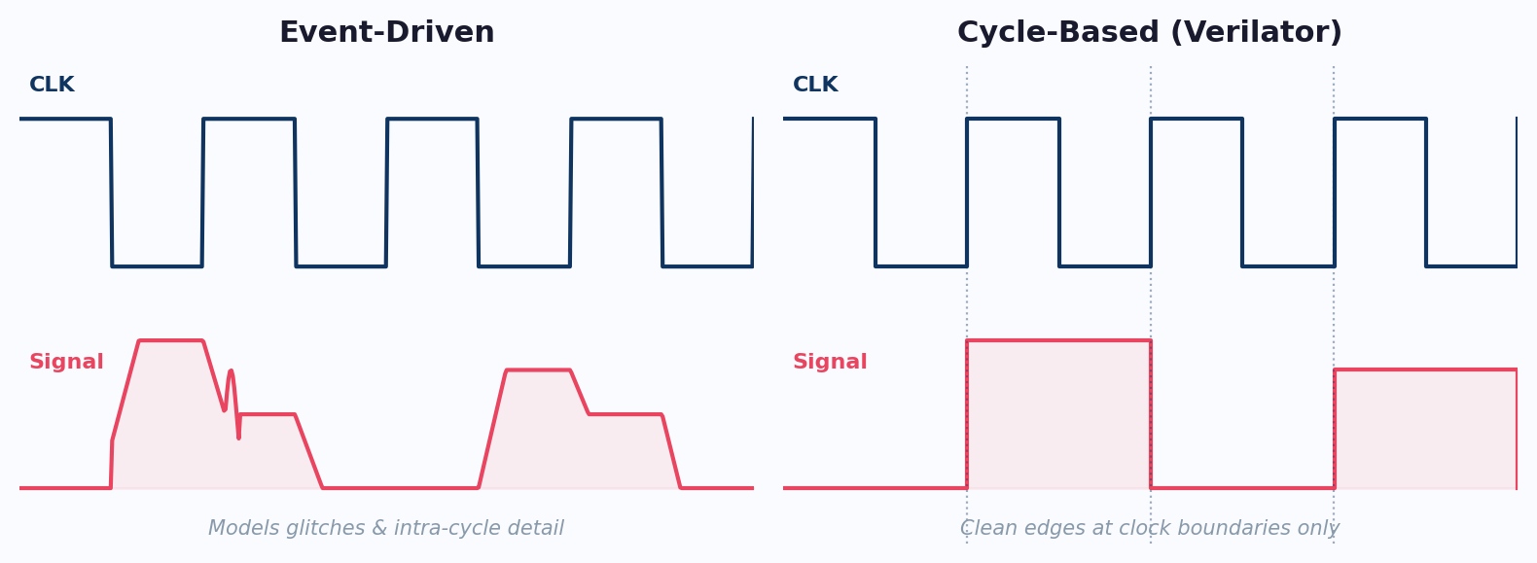
For most design verification — checking pipeline correctness, bus protocol behavior, state machine transitions — cycle-accurate behavior is exactly what you need. Verilator exploits this by compiling to highly optimized C++ that can be multithreaded. The result is performance roughly 100x faster than interpreted simulators, with an additional 2–10x from multithreading. The historical limitation was that cycle-based simulation couldn’t run UVM testbenches. That has now been largely addressed.
Think of event-driven simulation as a movie director micro-managing every single frame, tracking every actor's minor flinch. Cycle-based simulation, by contrast, is like a time-lapse camera taking a single snapshot exactly when the clock strikes the hour. It skips the messy intermediate drama (glitches and delta cycles), allowing Verilator to cross the finish line dramatically faster.

Recent Changes: Why Verilator Is More Relevant Than Ever
The past few years have seen remarkable acceleration in Verilator’s capabilities, driven primarily by Antmicro with Western Digital, Google, and the CHIPS Alliance community.

Event-Driven Scheduling & UVM Support
Starting with coroutine-based dynamic scheduling and culminating in the IEEE-compliant scheduler in v5.0, Verilator now handles the constructs UVM requires. As of late 2025, it can elaborate upstream UVM 2017-1.0 without patches. Virtual interfaces, parameterized classes, constrained randomization with SMT solvers, concurrent assertions, and clocking blocks have all been implemented. Antmicro has demonstrated Verilator running axi-vip, a UVM-based verification IP for AXI bus systems.

Constrained Randomization & DUT Integration
Verilator now supports constrained random verification through external SMT solvers, covering if-else constraints, inline constraints, rand_mode, solve..before, and randomization of arrays and structs. For DUT integration, the --binary flag generates standalone executables, improved VPI support enables richer verification environments, and Cocotb integration lets teams write Python testbenches with Verilator’s speed.

Performance & SystemVerilog Coverage
Hierarchical verilation, multithreaded model generation, DPI profiling, NUMA-aware threads, and expression coverage have all landed recently. Gaps in generic interfaces, unpacked structs, signal strengths, and covergroups continue to close.

Looking Ahead
The technical gap is evaporating. With patchless UVM 2017 support fully live and UVM 2020 firmly on the horizon, the calculus has fundamentally shifted. For modern engineering teams, the combination of raw simulation throughput and zero-cost scaling makes Verilator an indispensable asset. The question is no longer whether you can afford to use open-source verification—it's whether you can afford to ignore it.

About CaretEDA
CaretEDA builds AI-native design systems for modern semiconductor teams, with its SpecToNetlist™ platform serving as a powerful force multiplier across the entire engineering workflow. To learn more or request a demo, contact info@careteda.com

