From 160 Gates a Day to Verified Gates
The KPIs for chip design look like they are changing. Are they?
Sashi Obilisetty
Co-founder & CEO, CaretEDA, Inc.

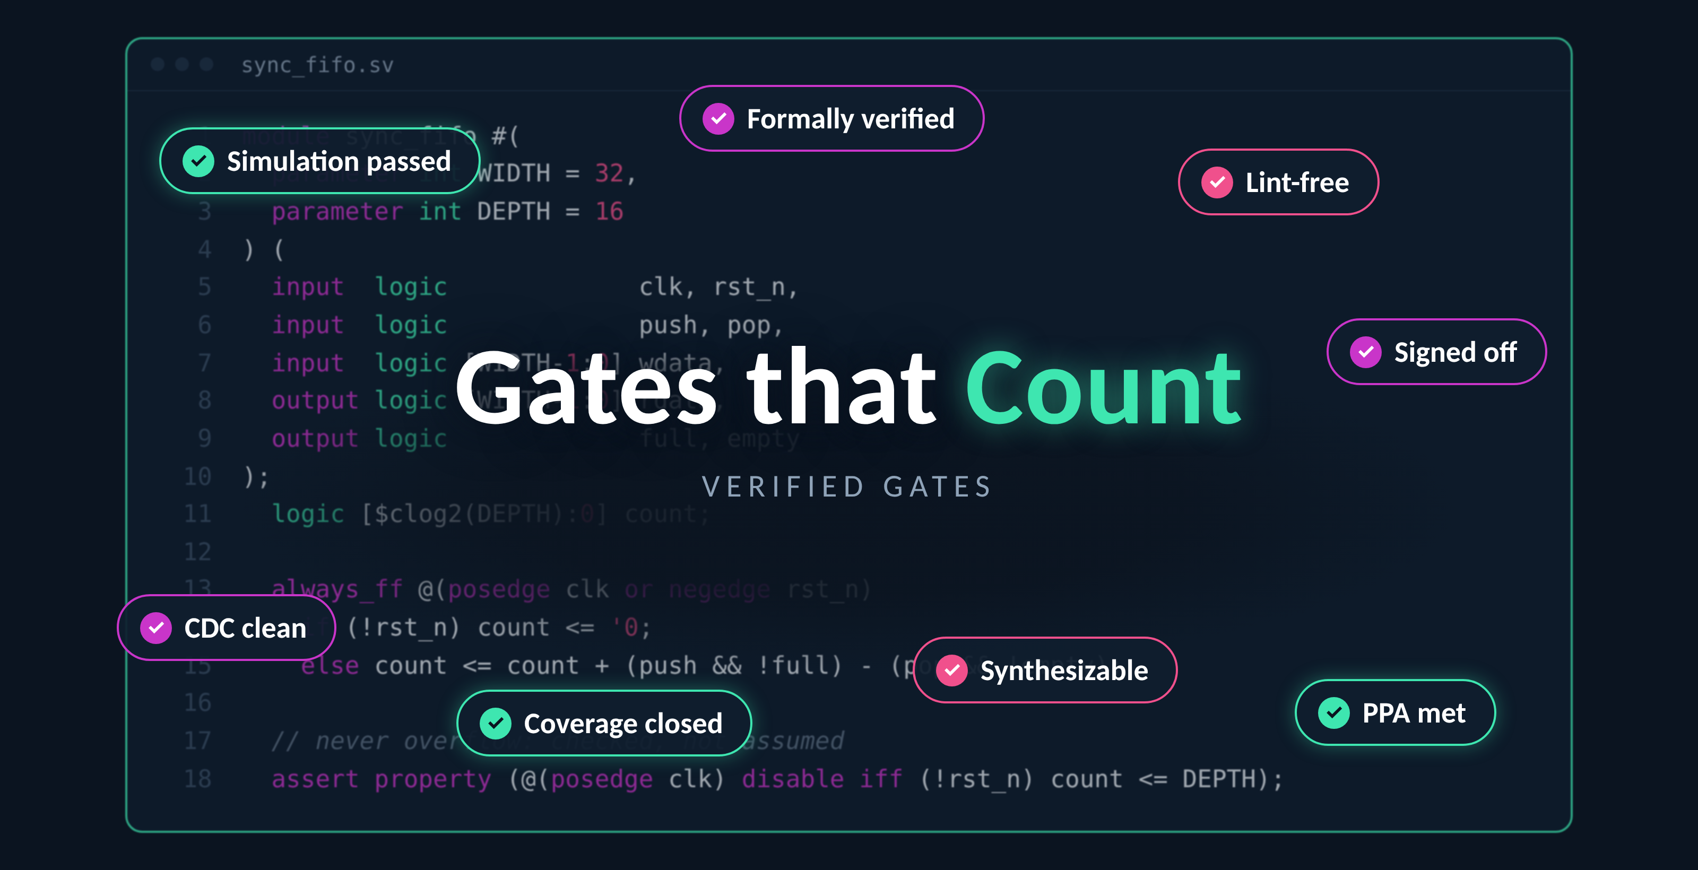
Software learned long ago that lines of code is a poor measure of an engineer. Chip design had its own version, and for a while we took it just as seriously: gates per engineer-day.
In 1997, the average chip designer produced about 160 gates a day. The industry roadmap put productivity at 40,000 gates per engineer-year, which works out to roughly 160 gates per working day, and projected 600,000 by 2007.
Today an agent can write a few thousand lines of SystemVerilog in minutes. By the old yardstick, that is a productivity miracle. By any yardstick an experienced design lead would accept, it is a pile of unverified text.
If your team is already using AI to write RTL, and most teams are, the question is worth asking: what should we actually measure?
My answer: the unit was never really gates. It was verified gates, and agents are forcing us to say so plainly.

A Metric That Faded Away
Nobody formally retired gates per engineer-day. People just stopped quoting it, because it had stopped meaning much.
Transistor counts were growing 58% a year while designer productivity grew about 21%. The industry closed part of that gap the cheap way: by not designing most of the gates. The 2003 roadmap credited IP reuse with 75% of the projected productivity improvement. Once much of your chip arrives as a licensed block, "gates per engineer" stops describing engineering.
AI brought the measurement question back. In 2023, researchers used GPT-4 to help design an 8-bit processor, and the first benchmarks scored AI-written Verilog on a simple test: did it pass a simulation? By 2026, agents were building complete processor cores from specs a few hundred words long, and the newest benchmarks have started grading the whole result against timing, power, area and physical checks.
Run the old arithmetic on any of these results and you get an absurd productivity number. Nobody serious quotes it. Generation is becoming a commodity. What stays scarce is confidence that the output is right.

DARPA IDEA Already Wrote the Better Metric
In 2018, DARPA's IDEA program set an ambitious target: no-human-in-loop design, 24-hour turnaround, and zero loss of PPA quality. OpenROAD was its flagship. UC San Diego and partners received a multi-year, multi-million-dollar grant to build it.
Look at how that goal is phrased. It never mentions gates. It has three terms:
- Human attention (no humans in the loop), the scarce input.
- Time (24 hours), the schedule.
- Quality held constant (no PPA loss), the bar the output must clear.
That is a productivity metric. It measures output that meets a quality bar per unit of expert attention, which is exactly what gates per day failed to do. The team's own poster framed the baseline bluntly: a layout that took 10+ weeks at a university lab, versus a goal of one day with no humans.
The program was also realistic about people. The same poster states a principle that still holds: humans are in the loop for good reasons. But the program moved the field. OpenROAD has since been used in over 180 tapeouts in SkyWater 130nm, and its autotuning now finds tool configurations better than expert users do.
The agentic era inherits IDEA's ambition and extends it upstream, from RTL-to-GDS to spec-to-RTL. It should inherit IDEA's measurement discipline too.

Generated Gates and Verified Gates
A generated gate is logic an agent has written. A verified gate is logic your team will sign its name to. The difference between them is where nearly all the engineering lives.
 | Generated gate | Verified gate
Exists when | The RTL compiles | It meets the spec under your signoff bar
Evidence | A file | Coverage closed, formal or equivalence clean, synthesizable, PPA met
Marginal cost with agents | Close to zero | Still dominated by expert review and debug
Who answers for it | Nobody in particular | A named engineer

What stands out to me is that it was always this way. Even before agents, design engineers spent 49% of their time on verification (sometimes even more!), and verification engineers spent more time debugging than on anything else. Nobody counted a gate that failed regression. The old metric simply assumed the verification had happened, because humans who wrote the RTL also carried the responsibility for it.
Agents break that assumption. Generation and accountability are now separable, and generation is cheap. A metric that counts generated gates rewards the cheap part and hides the expensive part. Worse, it rewards volume at the exact moment when only 14% of IC/ASIC projects achieved first-silicon success in the 2024 Wilson study, the lowest in 20 years.

What Recent Research Says About Measuring Agent Output
Two papers from this year point the same way. A synthesis-in-the-loop study of 32 models found that simulation pass rates overstate hardware quality, and that single attempts trail best-of-five results by up to double digits. A benchmark of agents running a full RTL-to-GDS flow found that the execution harness mattered more than the model, with costs varying by up to 141x for similar progress. Neither paper asks how much an agent produces. Both ask how much of it survives a gate, and at what cost. Industry metrics should follow.

Policies That Make Verified Gates Mean Something
When agents write RTL, accountability has to be designed in, not assumed. Here are seven policies any team can adopt this quarter.
- Every verified block has a named human owner. An agent can author a module; only a person can sign it off. The owner's name goes in the signoff record, not just the commit log.
- Define the signoff bar before generation starts. Coverage targets, required formal properties, lint and CDC rules, and PPA budgets are written down per block. A gate counts as verified only against that pre-agreed bar, so nobody moves the goalposts after the fact.
- No agent grades its own homework. The agent that wrote the RTL should not also write the only testbench or the only assertions that judge it. Use independent stimulus, formal properties derived from the spec, or a separate agent with no access to the implementation.
- Log provenance for every artifact. Record which model, prompt, spec version and tool versions produced each file. When a bug escapes, you need to know whether it came from a person, an agent, or a spec gap.
- Count interventions, honestly. Track every time an engineer edits agent output, overrides a decision, or restarts a run. A falling intervention rate is the real evidence of autonomy.
- Report single-attempt results alongside best-of-n. The research above shows best-of-five can flatter a system by double-digit points. If your flow samples many candidates, say so, and count that compute as part of the cost.
- Re-verify reused and regenerated code in context. Agent-regenerated RTL is new RTL, even if the prompt was unchanged. Treat it like a fresh block until it clears the bar again.
None of these is exotic. Most are what good verification leads already demand of human engineers. The change is making them explicit, because an agent will not volunteer the context a human would have carried in their head.
About CaretEDA
CaretEDA builds AI-native design systems for modern semiconductor teams, with its Spec-to-Netlist™ platform putting agents to work across the entire engineering workflow. CaretEDA’s agents are integrated with commercial EDA stacks as well as an SLA-backed RTL-to-GDS open source stack. Qualifying chip startups can access the stack and agentic tools at no charge for a limited time through the CaretEDA Startup Program at www.CaretEDA.com/startups.
CaretEDA and Spec-to-Netlist are trademarks of CaretEDA, Inc. Verilator, Yosys, SymbiYosys and OpenROAD are open source projects of their respective maintainers.

Sources
- Modeling Total Cost of Ownership for Semiconductor IP, Design & Reuse (ITRS productivity and IP reuse figures)
- NISTEP report on the LSI design crisis (58% vs 21% growth)
- OpenROAD documentation and UCSD news release, July 2018
- OpenROAD / IDEA poster, DARPA ERI Summit
- The OpenROAD Project: status and outlook, UCSD
- GPT-4-assisted 8-bit processor design, arXiv 2305.13243
- Summary of the 2024 Wilson Research Group reports, Sigasi
- Synthesis-in-the-Loop Evaluation of LLMs for RTL Generation, arXiv 2603.11287
- Can AI Agents Really Complete RTL-to-GDS?, arXiv 2607.17528

