Ses Net Field Protocol

Materials:

Ses net

S hooks

1 large bottle DI

1 empty amber bottle labeled with “ses net” and the date

Meter stick

Flo-mate

Data sheet

Methods:

1. Measure flow with the flo-mate at the weir
2. BE CAREFUL to avoid touching poison ivy while walking to the net
3. Look at the net. Note any observations on the data sheet
4. Approach net from behind, so as to not kick up sediment into the net
5. Measure flow with the flo-mate at the mouth of the net. Flo-mate should be slightly inside the net, so as to represent flow that is actually going into the net. Write down the exact time
6. Measure the depth of the water at the center of the net, as well as the depth from the top of the water to the bottom of the net
7. Write down the exact time
8. Unclip the net and hold it up. Use DI to rinse down the inside of the net. Let it drain until you are sure the water in the net could all fit into the amber bottle
9. Place the end of the net into the top of the amber sample collection bottle. Turn the valve on the end of the net to release the sample
10. Rinse the net into the bottle until it looks clean
11. Make sure the amber bottle is totally full. If there is any airspace, add stream water to fill it to the top

Notes:

1. Be sure to write down the time of each step. This is critical for future calculations!

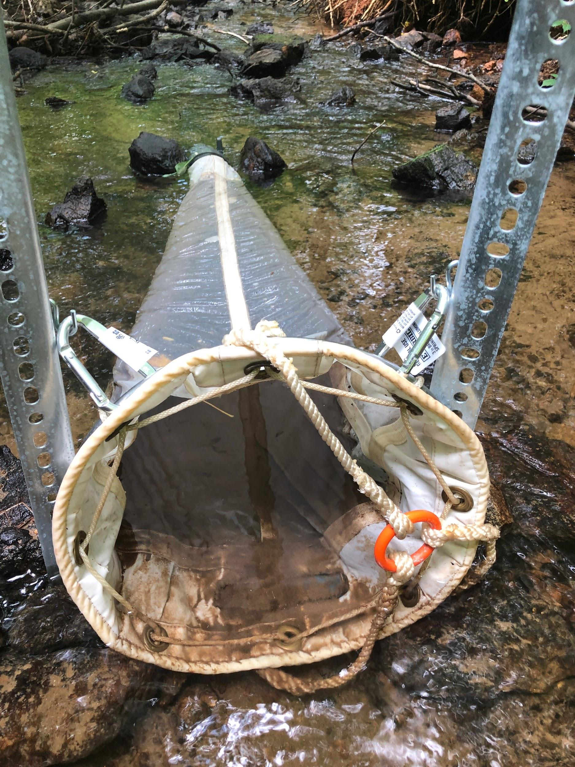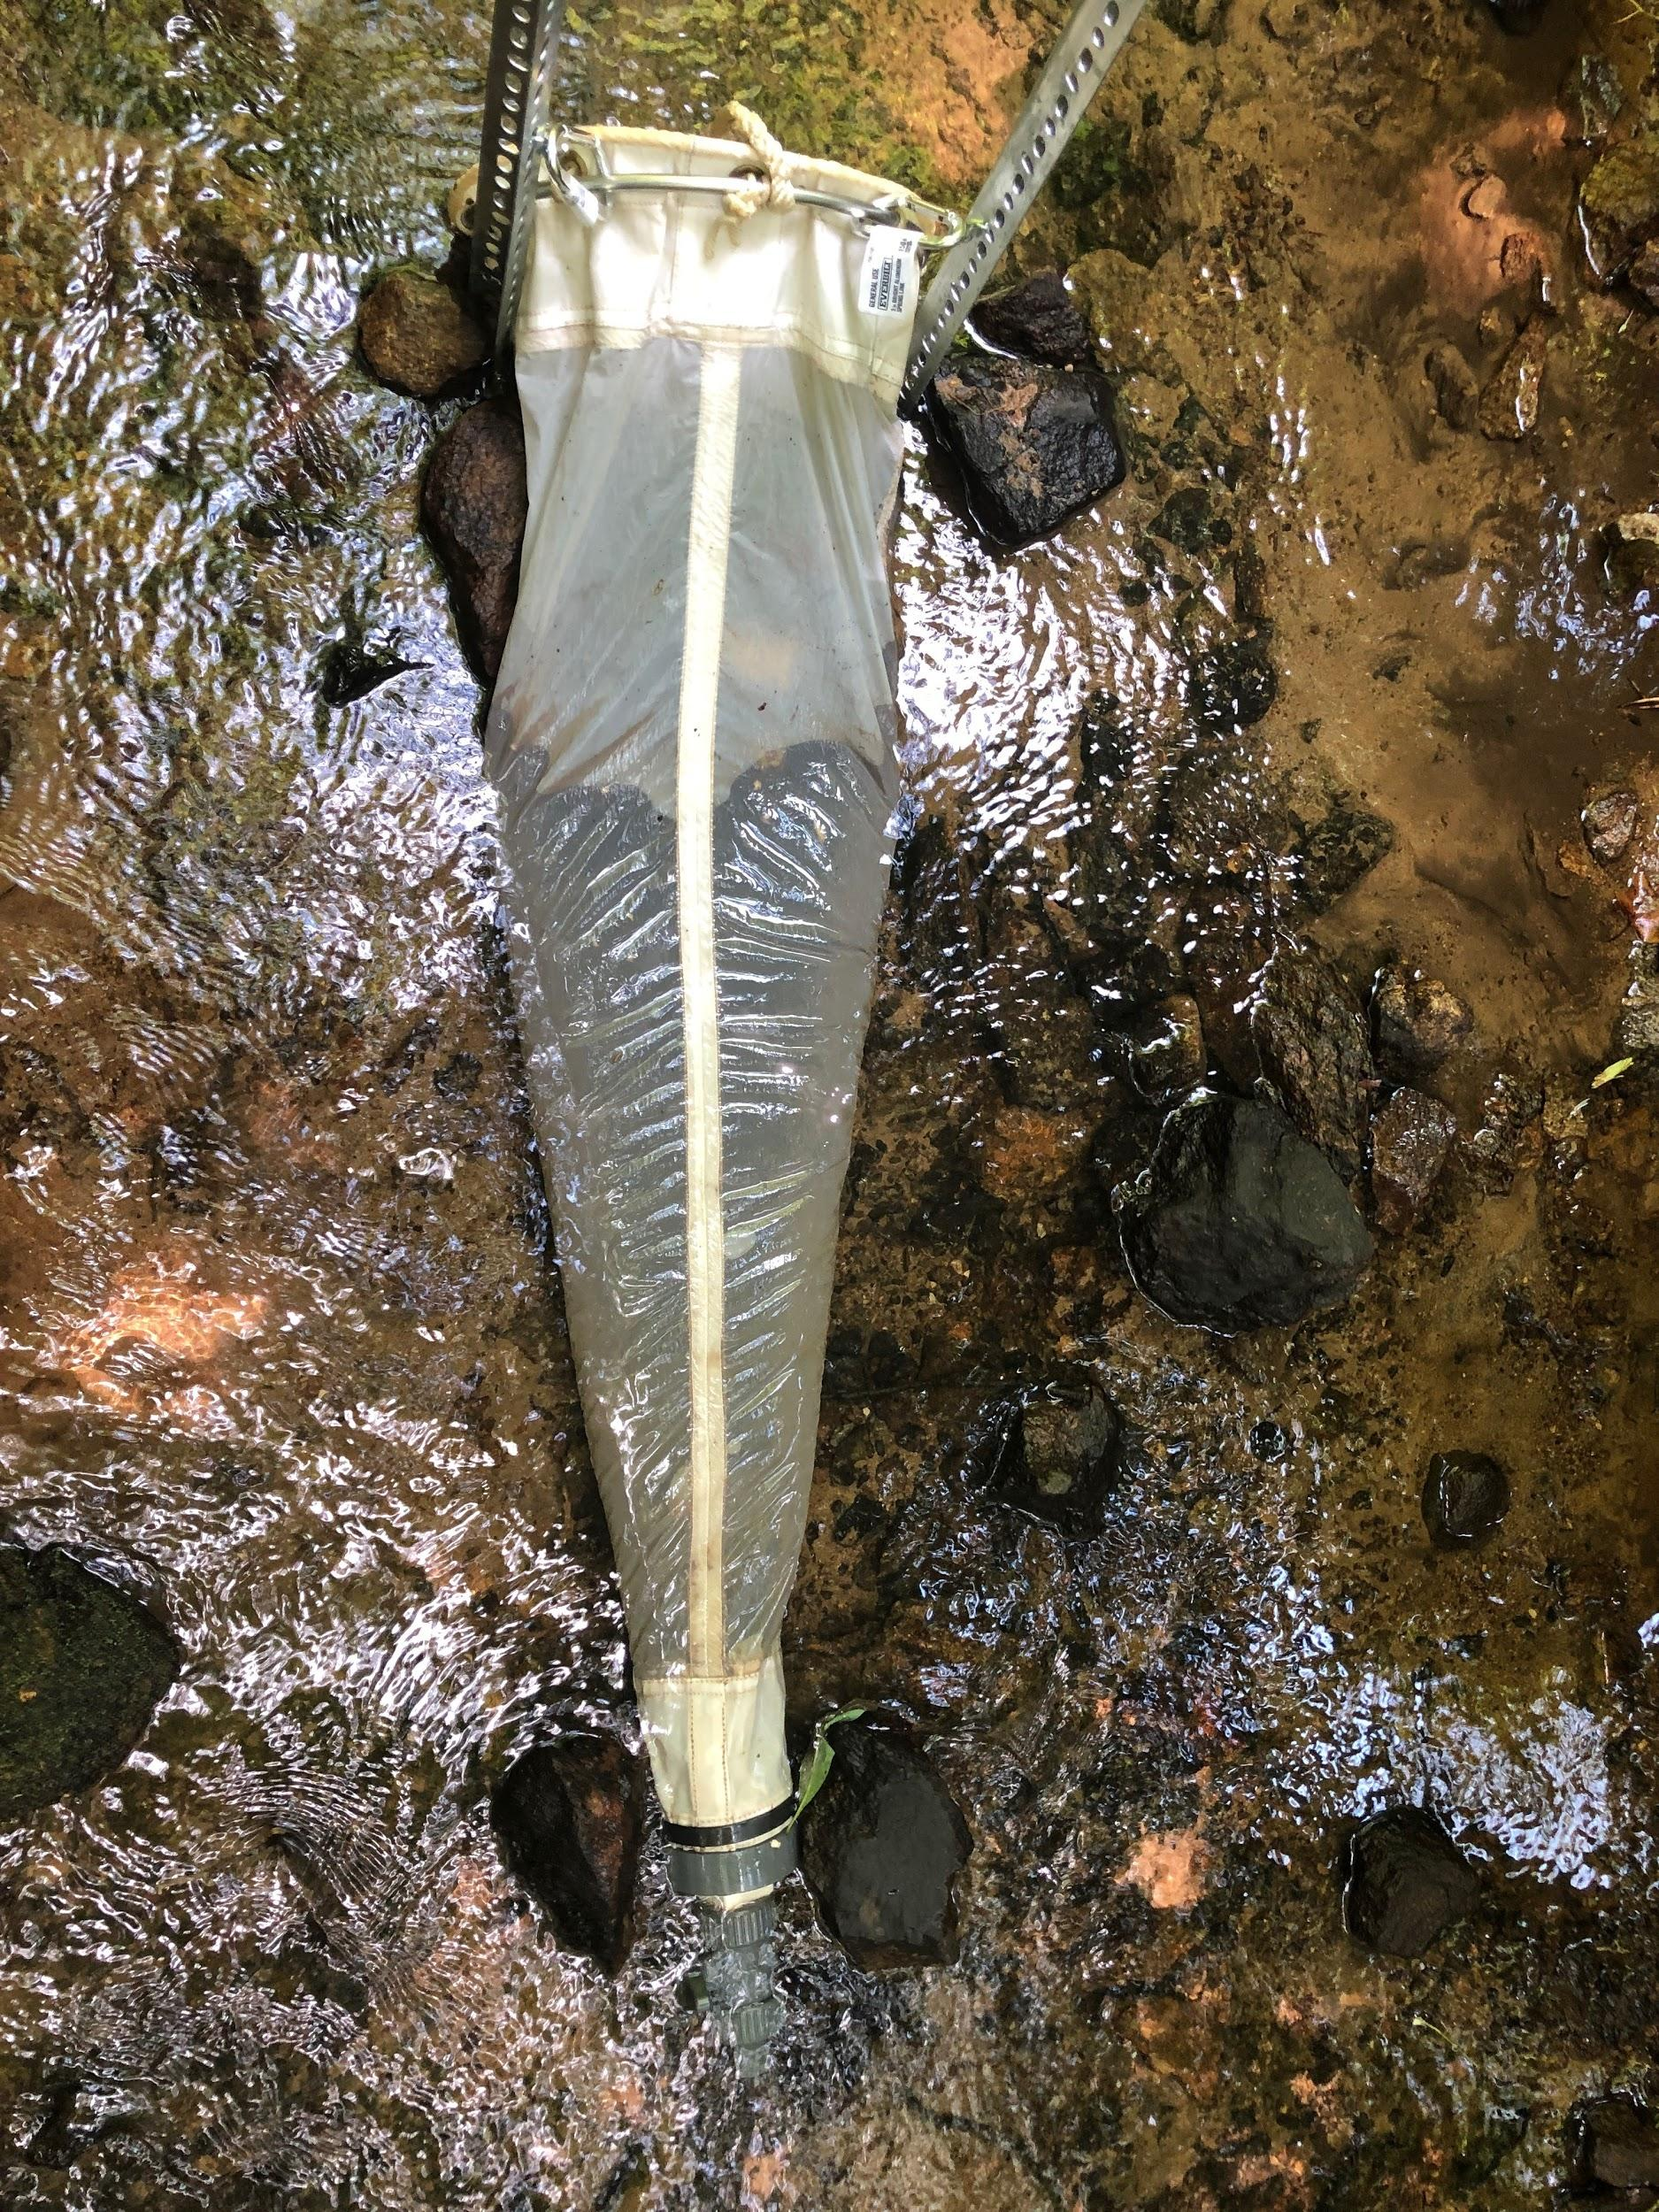

Ses net processing SOP

Materials

* 3 Sed trap filters
* Ses net sample
* 25 mL graduated cylinder
* Large graduated cylinder
* DI

Methods

1. Homogenize the ses net sample
2. Pour 25 mL into a graduated cylinder
3. Filter onto a sed trap filter (record filter weight, date, etc as usual)
4. Rinse graduated cylinder with DI and pour onto the filter
5. Repeat steps 1-4 three times
6. Place filters into the usual trays
7. Label the trays “Ses net <DATE>” and F1-F3 for the filter number
8. Place the trays in the drying oven
9. Record the total volume of the rest of the sample using the graduated cylinder and email/text this number to Abby

That’s it. Thank you so much!!!