Eddy Flux Weekly Download Protocol

Cayelan Carey & Quinn Thomas

Needed: Lab notebook, kimwipes, squirt bottle with either tap or distilled water, Mark Johnson's Panasonic Toughbook

1. Arrive at FCR. Go to end of catwalk. First note your time of arrival in your notebook, and if you can hear the "whirrrrrrr" of the methane sensor and eddy flux system pump.
2. Grab a few kimwipes and tap or distilled water squirt bottle, and squirt the bottom and top blue discs on the methane sensor (Figure 1). I prefer to do the top disc first because it will squirt water inevitably on the bottom second. Once thoroughly wet, use the Kimwipes to dry them both off and record the time. Both discs need to be removed from dust and other debris that have collected throughout the week.
   * 1. Record the time that the discs were cleaned: this later will need to be entered in the eddy flux google doc as maintenance notes.
3. Open up the white Campbell top-most box that's in the right corner of the catwalk near the eddy flux system. Check to make sure that both the "Power" and "Ready" red lights are on (red) in the bottom-left corner of white setup (Figure 2). If not, this is likely an electrical power issue that will need to be troubleshooted after downloads.
4. Within the same box, press Eject in the top right of the box, under "USB Logging." This will remove the USB stick- be careful with it! (It is super expensive and built just for the eddy flux system). It is important to not grab the USB until you hit the Eject.
5. Walk the USB off the catwalk to Mark Johnson's Panasonic Toughbook. Open the Toughbook. It will prompt for a "User" Password which just leave blank and hit enter. Click through again to the desktop. Insert the USB stick into the Toughbook.
6. On computer desktop, create a blank new folder with the data download date in this format: YYYY-MM-DD (e.g., "2020-05-02").
7. There should be on the USB four folders: Archive, Raw, Results, and Summaries. Copy all of them and paste into the new computer desktop. This will take a few minutes because these are big files.
8. Once all of the files are transferred safely to the Desktop new folder, open up each of the folders on the USB stick and delete their contents, leaving the "Archive", "Raw", "Results", and "Summaries" folders empty on the USB stick.
9. On your desktop new folder, open up the Summaries folder within your download folder. There should be a file that has a date that corresponds to each day since the previous download. CHECK that this is correct! If there are any missing days, this will require troubleshooting (see below.)
10. Safely eject USB stick from Toughbook, and walk back to the end of the catwalk. Place the USB stick back into the Campbell box in the proper position (it should firmly be held in place; make sure that it is aligned properly in the hole). Once it is back in position, confirm that logging has resumed, as indicated by the blinking LED light right under the Eject button (Figure 2).
11. Close up the Campbell box.
12. Last thing to do is add some of the tap/distilled water to the water reservoir in the bottom most Campbell box (Figure 3).
13. Open up the box, unscrew black cap and fill up the reservoir with either tap or distilled. From past few weeks, this was <500 mL of water.
14. Once back at home, update notes in the Eddy Flux google document for Brenda: https://docs.google.com/document/d/1_XBuQJC_eBiBGgDc2OfqU9yCHWYXsdEj_TAsXwNLwsE/edit
    * 1. This should include the download times + cleaning times, and if there were any other issues with the machine on the visit (e.g., lights or pump not on).
15. Email Brenda, Cayelan, + Mark Johnson a dropbox or google drive link to the download folder from the Toughbook (I've transferred it with USB to my laptop first- as of right now the Toughbook hasn't been on the internet). Be sure to do this within a day or two of downloads so that if there is a problem with the data or sensor Brenda can inform additional maintenance. Thank you!

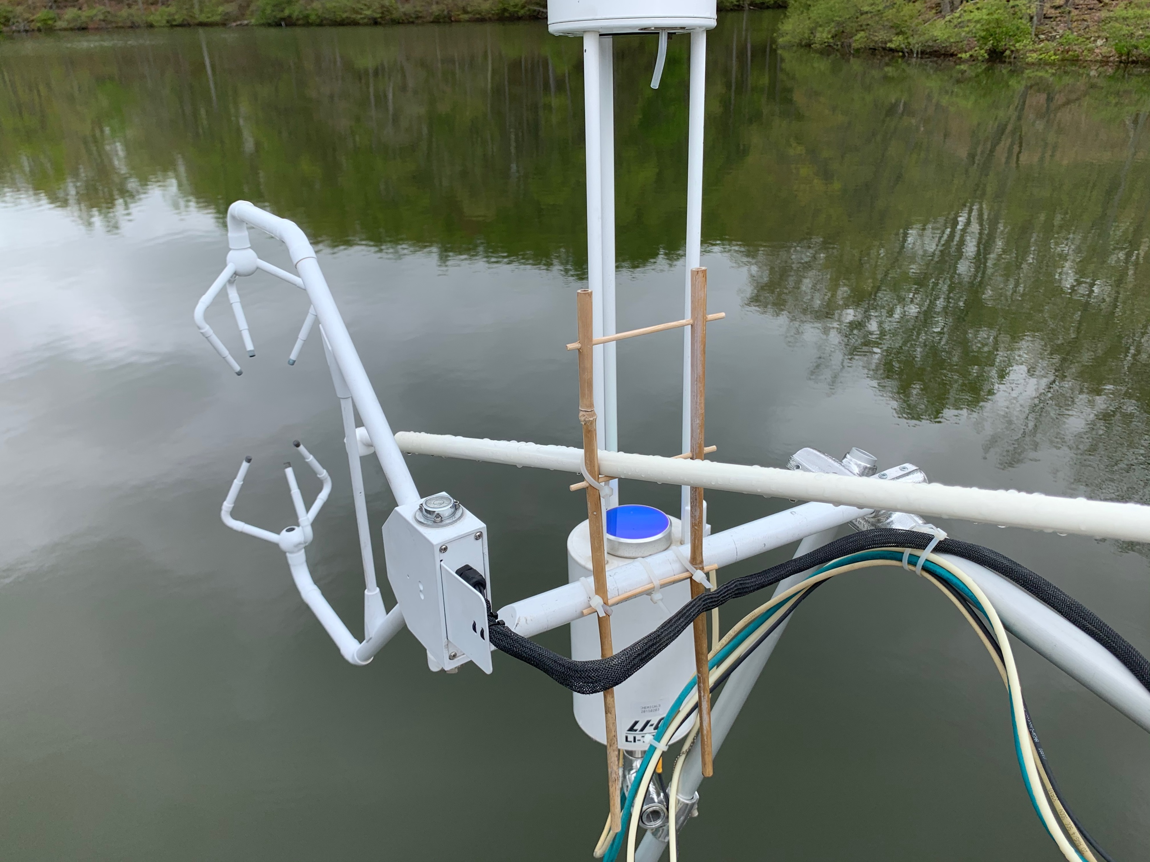

Figure 1. Methane sensor blue discs (bottom only that is shown) that need to be rinsed and wiped with kimwipes.

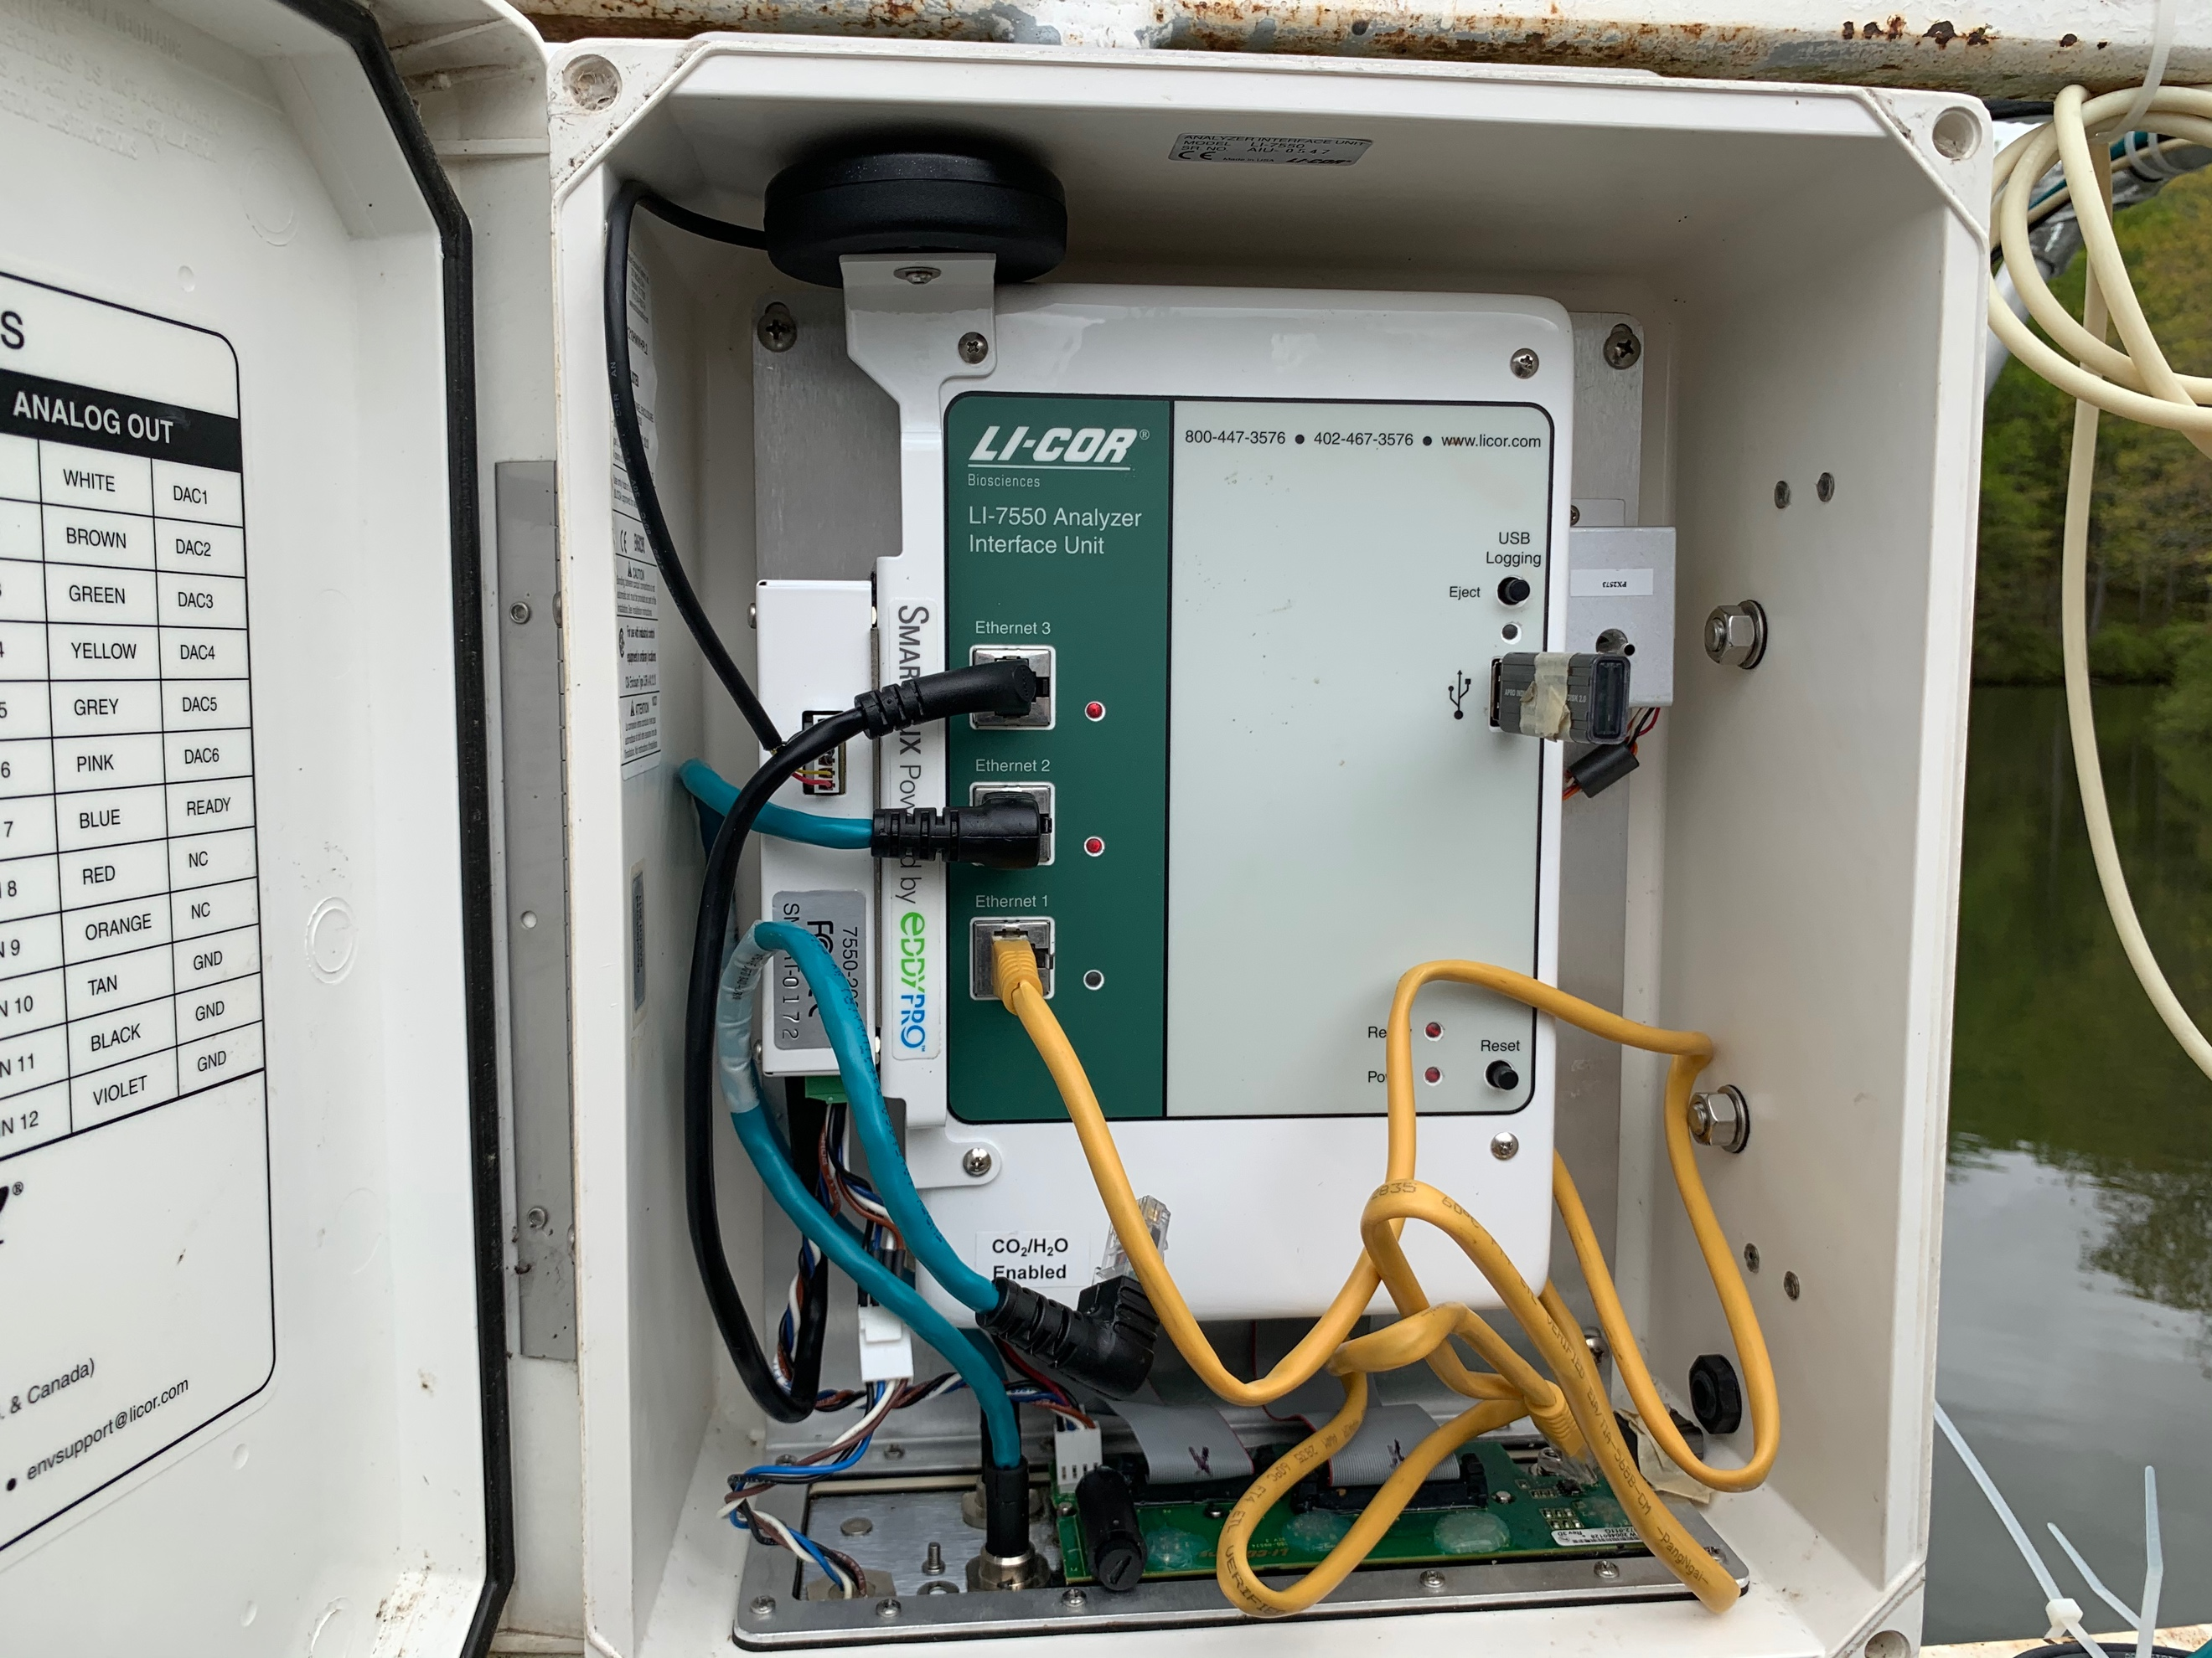

Figure 2. The Power and Ready lights are in the bottom corner and both should be on and red if everything operational. The USB can be ejected from the top red.

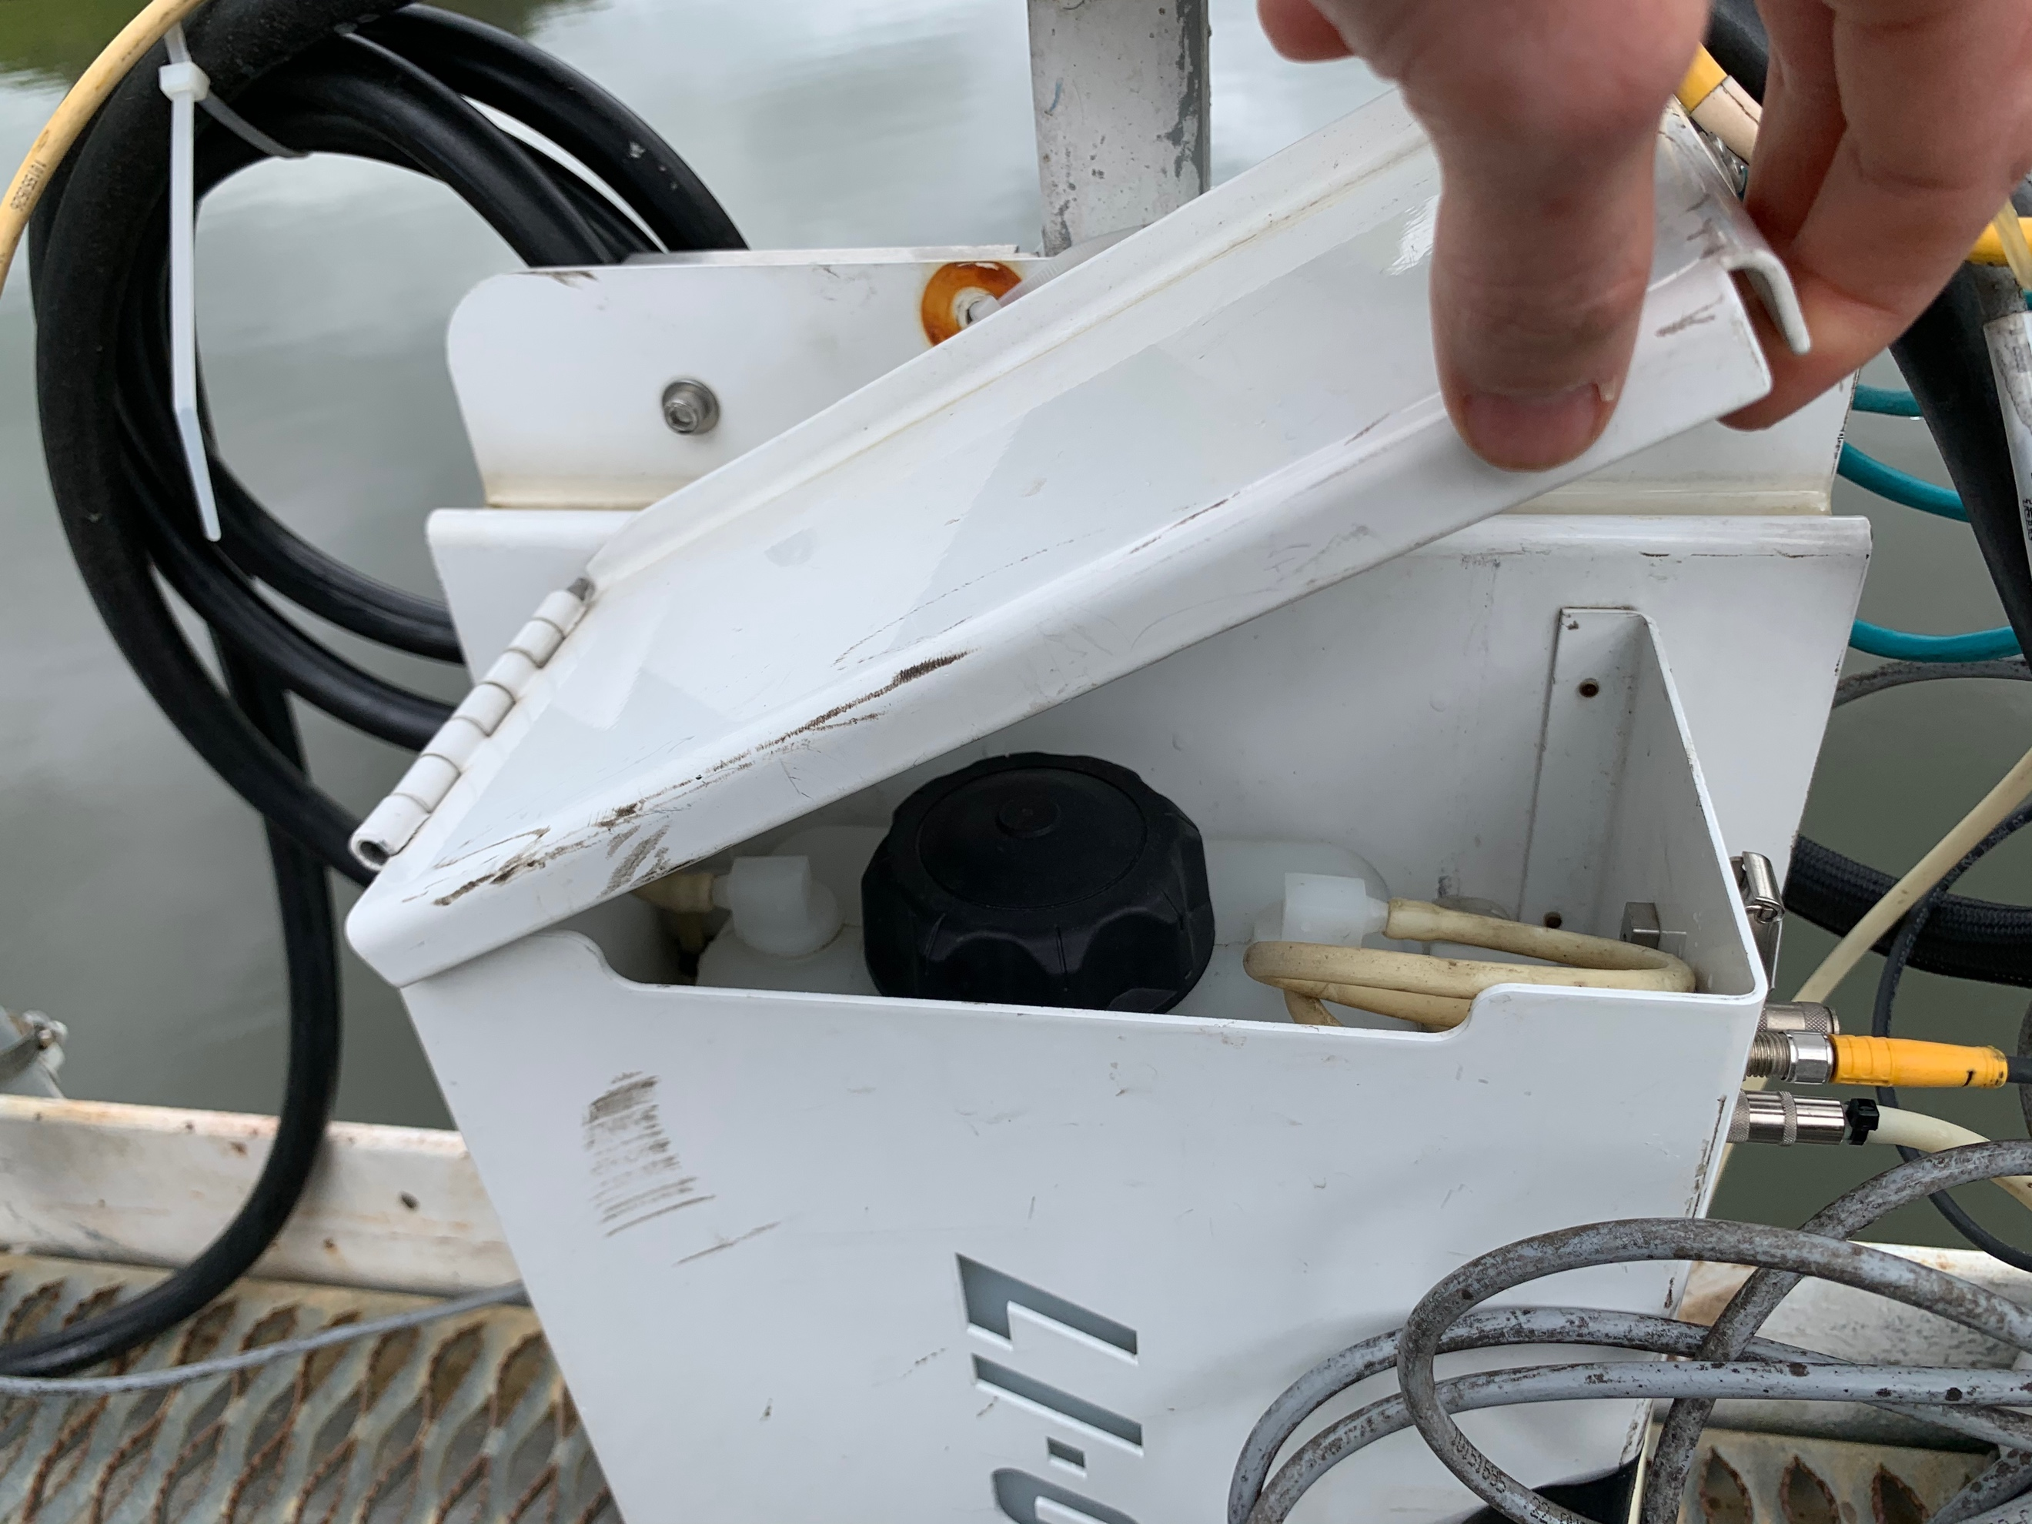

Figure 3. Black capped reservoir of water for the methane pump cleaning.

Troubleshooting:

Updated by AGH, 04 June 220

If there are missing summary files: This likely because the CH4 sensor is not communicating/connecting with the datalogger. We will use Mark Johnson’s laptop to directly connect to the datalogger, CO2, and CH4 sensors to check this.

1. Connect Mark Johnson’s computer to the datalogger (the box where the USB stick is) using the yellow ethernet cord (labeled ‘Ethernet 1’).
2. On the desktop, open the LI-7x00 software (the blue one!). From the pop-up window, select the instrument in the list and click ‘connect’.
3. This should pull up a whole window of things! Most importantly, in the top middle of the screen, there should be a list of instruments (things like LI-7700, LI-7200, and smartflux – there’s a fourth one that’s not important!). If the LI-7700, LI-7200, and smartflux are connected correctly, ‘connected’ should be listed next to all of these things. Additionally, if everything is working, you should see read-outs for data for both CH4 and CO2. If any of these are disconnected, you will need to follow the troubleshooting procedure below (a choose your own adventure based on which instruments are not connected!):

CH4 Sensor, LI-7700 (this is most likely the problem…):

1. On the desktop, open up the software called: LI-7700. There is a connect button on the top row of the software (to the right of the ‘save’ button – it looks like a USB cord and says ‘Connect’ when you hover over it). Click on this connect button.
   1. This will bring up a second window – select ‘Ethernet’ which will pull up a drop-down menu. If the CH4 sensor is being recognized correctly, there should be a selection within the drop-down menu. NOTE: If there is no selection option available, then additional troubleshooting is necessary. Skip to #3.
   2. If the LI-7700 is listed in the drop-down menu, select it and click ‘Connect’. If the instrument is working properly, then you should see data displayed! This means the CH4 sensor is connected to the data logger and the program should be generating ‘summary’ files. Close down the program, disconnect the ethernet cord, and before leaving the reservoir later in the afternoon, re-download the data from the USB to check that a summary file was generated. If a summary file was not created, then additional troubleshooting is needed! Call Cayelan.
2. If you are not able to connect to the CH4 sensor using the LI-7700 software, then try connecting with the LI-7x00 A RS software. Click on the 7700 tab to check the connection status. If the sensor is disconnected, click on connect.
3. If the sensor will not connect: Try manually un-plugging the power cable to the CH4 senor. This can be done by disconnecting the yellow cable attached to the bottom of the CH4 sensor (verify it says ‘Power’ on the bottom of the CH4 sensor). Once disconnected, check to make sure the light next to ‘Ethernet 2’ is off on the USB box. If the light is off, then you can reconnect the power cord to the bottom of the CH4 sensor.
4. After re-plugging the power cord, make sure the light next to ‘Ethernet 2’ is back on then try to re-connect to the CH4 sensor as described in step 2. If this doesn’t work, try step 3.
5. If you still cannot connect to the CH4 sensor, try rebooting the system by pressing the reset button on the box with the USB. Then try re-connecting to the CH4 sensor as in steps 2 and 3.
6. If you STILL cannot connect to the CH4 sensor, call Cayelan!
7. If you ARE able to connect to the CH4 sensor following any of the steps above, then close down the software, disconnect the ethernet cord, and allow the Eddy Flux system to run until the end of the day.
8. BEFORE YOU LEAVE THE RESERVOIR: Re-download the data off of the USB drive and check to see if a summary file was created (follow same download procedure, including the deletion of files as outlined in the SOP). If a summary file was created, then, congratulations, it’s all good to go! If a summary file was not created, then additional troubleshooting is needed, call Cayelan!

Smartflux (this has happened, but not as often! You’ll know it’s disconnected if it’s listed next to ‘smartflux’)

1. Unplug the jumble of wires connecting to the bottom of the ‘smartflux’ box that is located next to the ethernet box (red circle in pictures). It looks like a bunch of wires going into a green connection piece.
2. Unplug this connection and wait until the Ethernet 3 red light turns-off (blue circle in picture).
3. Once the light has gone off, re-plug the green connection port + jumble of wires back into the smartflux box.
4. Try reconnecting using the LI-7x00 software as above. It should now say ‘connected’ next to smarflux.



CO2 Sensor, LI-7200 (this hasn’t happened yet, so hopefully won’t be an issue!):

1. Call Alex to walk through this (she doesn’t totally remember how to do it without being with the instrument…so please call!).

Other:

1. This is mostly likely electrical in nature. Call Cayelan!!