Macrosystems EDDIE:

Introduction to Ecological Forecasting

**Instructor’s Manual**

# Module Description

Ecological forecasting is an emerging approach which provides an estimate of the future state of an ecological system with uncertainty, allowing society to prepare for changes in important ecosystem services. In this module, students will apply the iterative forecasting cycle to develop an ecological forecast for a National Ecological Observation Network (NEON) site of their choice. This module will introduce students to the basic components of an ecological forecast; how a forecasting model is constructed; how changes to model inputs affect forecast uncertainty; and how productivity forecasts vary across climatic regions.

# Pedagogical Connections

|  |  |  |
| --- | --- | --- |
| **Phase** | **Functions** | **Examples from this module** |
| Engagement | Introduce topic, gauge students’ preconceptions, call up students’ schemata | Short introductory lecture; Stepping through each stage of the forecast cycle and answering discussion questions |
| Exploration | Engage students in inquiry, scientific discourse, evidence-based reasoning | Developing hypotheses of how primary productivity responds to different ecological conditions; Testing these hypotheses by generating an ecosystem forecast with different model parameters |
| Explanation | Engage students in scientific discourse, evidence-based reasoning | Comparing forecast output with observations; Updating the productivity model to generate a new forecast |
| Expansion | Broaden students’ schemata to account for more observations | Generating and comparing ecological forecasts of primary productivity at different sites in different climatic regions |
| Evaluation | Evaluate students’ understanding, using formative and summative assessments | In-class discussion of forecast output and how ecological forecasting can be used to improve ecosystem understanding and natural resource management |

# Learning Objectives

By the end of this module, students will be able to:

* Describe an ecological forecast and the iterative forecasting cycle
* Explore and visualize NEON data
* Construct an ecological model to generate forecasts of ecosystem primary productivity with uncertainty
* Adjust model parameters and inputs to study how they affect forecast performance relative to observations
* Compare productivity forecasts among NEON sites in different ecoclimatic regions

# How to Use this Module

This entire module can be completed in one 3-hour lab period or two 75-minute lecture periods for introductory undergraduate students in Ecology, Environmental Science, Ecological Modeling, and Quantitative Ecology classes. We found that teaching this module in two separate periods, in which the first period included the instructor lecture (~20 minutes) before having the students complete Activity A, and the second period was focused on completing Activity B worked well.

Lesson structure, depending on the time available for your class:

* Two classes (75-90 minutes)
  + Class 1 – Introductory lecture and completion of Activity A
  + Class 2 – Activity B followed by 15-20 minute presentation of each groups' results
  + Homework (or 3rd class)– Activity C
* One class (3 hours)
  + Introductory lecture – 20mins, Activity A – 45mins, break – 5mins, Activity B – 45mins, group presentation/discussion – 15/20mins, Activity C – 45mins

Depending on available time, you can ask the students to complete Activity C (which is a repeat of Activity B but with a different site and comparing results) in-class or as a homework. If time is limited, you can ask students to present their Activity B forecasts to a group that has selected a different site instead of the whole class.

Quick overview of the activities in this module

* Activity A: Students explore data at a NEON site of their choice and create a productivity model.
* Activity B: Students use their model to generate hypotheses regarding productivity responses at their NEON site, create an ecological forecast, update the model and forecast again.
* Activity C: Students run forecasts at a different NEON site and compare ecological forecasts.

# Module Workflow (for either in-person or virtual instruction)

1. Instructor chooses method for accessing the Shiny app:
   1. In any internet browser, go to: [**https://macrosystemseddie.shinyapps.io/module5/**](https://macrosystemseddie.shinyapps.io/module5/)
      * This option works well if there are not too many simultaneous users (<20)
      * The app generally does not take a long time to load but requires consistent internet access
      * It is important to remind students that they need to save their work as they go, because this webpage will time-out after 15 idle minutes. It is frustrating for students to lose their progress, so a good rule of thumb is to get them to save their progress after completing each objective
   2. The most stable option for large classes is downloading the app and running locally, see instructions at: [**https://github.com/MacrosystemsEDDIE/module5**](https://github.com/MacrosystemsEDDIE/module5)
      * Once the app is downloaded and installed (which requires an internet connection), the app can be run offline locally on students’ computers
      * This step requires R and RStudio to be downloaded on a student’s computer, which may be challenging if a student does not have much R experience (but this could be done prior to instruction by an instructor on a shared computer lab)
      * If you are teaching the module to a large class and/or have unstable internet, this is the best option
   3. As a last option, the app is accessible in any internet browser via Binder hosting: [**https://mybinder.org/v2/zenodo/10.5281/zenodo.6587161/?urlpath=shiny/app/**](https://mybinder.org/v2/zenodo/10.5281/zenodo.6587161/?urlpath=shiny/app/)
      * Prior to class, the instructor should go to the Binder webpage and make sure that it loads (because Binder is provided as a free platform, it occasionally needs to be loaded more than once the first time)
      * It takes ~5-10 minutes to load, so it’s helpful for students to start loading this webpage prior to instruction
      * During instruction, this webpage occasionally times out if there are many users (even if on good internet), so this is a less stable alternative than options 1 or 2

*Regardless of which option you pick, all module activities are the same!*

1. Give students their pre-module handout ahead of time to read over prior to class or distribute handouts when they arrive to class. The R Shiny app is set up for students to complete discussion questions as they navigate through the module activities. Thus, students could answer questions 1-3 prior to the start of instruction and can save their progress, which will allow them to return at a different time. The questions can be saved and downloaded as a Microsoft Word file at the end of the module, which could be submitted to their instructor for potential grading.
2. Instructor gives a brief PowerPoint presentation that introduces ecological forecasting, the iterative forecasting cycle, forecast uncertainty, and a basic ecosystem productivity model (~20mins).
3. After the presentation, the students divide into pairs. Each pair selects their own NEON site and visualizes their site's data, which is used to build and calibrate an ecosystem productivity model (Activity A). The two students within a pair each build their own model with unique inputs and parameters to compare the performance of two different models for the same ecosystem. For virtual instruction, we recommend putting two pairs together (n=4 students) into separate Zoom breakout rooms during this activity so the two pairs can compare results.
4. The instructor then introduces Activity B using a few PowerPoint slides. For virtual instruction, this would entail having the students come back to the main Zoom room for a short check-in.
5. The students work in their pairs to create hypotheses about how they expect their site's productivity to change in the future, forecast the productivity using each model, and investigate how the forecast uncertainty changes with different model inputs and parameters (Activity B). Students first compare their forecasts with their partner's and then revisit their initial hypotheses to see if they are supported or need to be updated. For virtual instruction, we recommend putting the two pairs back into the same Zoom breakout rooms.
6. Student pairs then apply their ecological model to a second NEON site (the same site that the other team in their breakout room is working on) and generate ecological forecasts for this second site using their initial productivity model (Activity C). The students work together in a group to present the results from their two sites and two different models and discuss why the forecasts are similar or different among the different sites and models.

**Important Note to Instructors:**

The R Shiny app used in this module is continually being updated, so these module instructions will periodically change to account for changes in the code. If you have any questions or have other feedback about this module, please contact the module developers (see “We’d love your feedback” below).

We highly recommend that instructors familiarize themselves with the Shiny app prior to the lesson. This will enable you to be more prepared to answer questions related to certain areas of the app’s functionalities.

# Things to do prior to starting the instructor’s presentation

* Have the students read through the student handout, especially the ‘Why macrosystems ecology and ecological forecasting?’ and ‘Today’s focal question’ sections.

# Introductory PowerPoint Presentation

*Note: the numbers below match the PowerPoint slide numbers. The text for each slide is also in the “Notes” of the PowerPoint, so can be viewed when projecting in Presenter View. There is also a video recording of the presentation on YouTube available* [*here*](https://youtu.be/0ihRoD-NJug)*.*

1. Welcome the students to class.
   1. It is important at this point to emphasize that there will be lots of new material covered during this module, and that going slowly and asking for help is very much encouraged!
   2. If the students are using the Binder option for accessing the module, asking them to start loading the module in an internet browser will save time later (see link above).
2. Quick road map of what will be covered in this lesson
3. Big picture, framing ecological forecasts in the context of changing climate and land use. Focus on aquatic ecosystems today, management of these resources could be improved my having advance knowledge of how they could potentially change. Why do we want to generate ecological forecasts? Answer: Because there is lots of variability in how climate change is occurring globally and lakes provide critical ecosystem services for humans, so ecological forecasts are critical to help management of these resources in the short-term.
4. Ask the class “What is a Forecast?” – if teaching virtually, prompt them to either type answers into the chat or raise their hand to ask the question. Key aspects of a forecasts are listed in the slide. Actionable implies that the information is given in a time frame that allows for a response. For example, you could forecast air temperature five minutes into the future with relatively low uncertainty, but this is not much use compared to a forecast for air temperature three days into the future.
5. Ask the class ‘What do we forecast?’. Encourage them to provide answers by either un-muting or typing into the chat or raising their hand. Add the examples with the animation and detail how forecasting is prevalent across many different sectors of society.
6. There are two main purposes of forecasts. Talk through the examples and stress the difference between a situation when we have no control over the outcome (passive) and when we can influence the outcome (active)
   1. Preparation – the example is Hurricane Sandy in 2012 - passive
   2. Actionable – the example is COVID-19 - active
7. Today, we are going to focus specifically on ecological forecasting. Question to ask the students on this slide: what is an ecological forecast? Highlight the inclusion of “uncertainty”
8. Uncertainty:
   1. A forecast is a well-informed guess of the future; therefore, it will always be uncertain
   2. It is at the core of how people evaluate risk and make decisions
   3. Uncertainty generally increases with time into the future
   4. Here is a plot showing 16 day forecast of air pressure with shaded regions showing 95% confidence interval and the solid line represents the median
9. Introduce each point in the forecast cycle and that you will break each of them down. Highlight that it is “iterative” which means that it is a repetitive process, hence why it is described as a cycle
10. Create Hypothesis – use the example of how phytoplankton in a lake use light to photosynthesize, so and increase in light would be expected to increase the phytoplankton biomass in a lake
11. Build Model – use data to build a mathematical model to describe the observations. Driver data are variables (such as light and water temperature) which can be used to drive the model.
12. Quantify uncertainty – key step, there are also different types of uncertainty sources include: driver, model, parameter, initial conditions. This plot shows a 10-day forecast of air temperature at a particular site. Each line represents a different forecast. Uncertainty can be calculated based on the distribution of the potential futures.
13. Generate Forecast – using the model for phytoplankton concentrations, we will drive it using weather forecast data to generate an ecological forecast. A key part of what makes a forecast is that it is driven by forecasted variables. This example shows a forecast for primary productivity (represented as concentration of chlorophyll-a) in a lake with each line showing a different potential future. It is from this distribution of the lines that we can calculate the confidence intervals and hence the uncertainty.
14. Communicate Forecast – potential stakeholders being a water resource manager for a drinking water reservoir. There are different ways to communicate a forecast, but this is a critical step as a forecast is not effective for helping management if it is not communicated effectively to end users/stakeholders. This plot shows the distribution of the forecast where the solid line is the median and the shaded regions indicate the 95% confidence interval.
15. Assess Forecast – Example is for chlorophyll-a, where the forecast median is represented by the solid line and the 95% confidence intervals are represented by the shaded area and observations are the orange points. Here it is predicting observed conditions relatively accurately.
16. Update model – used if model is not accurately predicting observations, can be done by updating model parameters, adding new driver variable. For example, initially in your model you had the uptake of nutrients in your model by phytoplankton to be relatively, so you might revisit the model and decide to increase the rate of nutrient uptake within the model. Here the example shows the original forecast (in green) and then the updated model forecast (red) which matches observations closer.
17. As time moves forwards you will repeat the cycle as you generate new forecasts and then update your model with new observations. This is why we call refer to the forecast cycle as “iterative”.
18. A simple version of a model is a linear model: “y = mx + b”, but today we will be using a model to predict chlorophyll-a concentrations in a lake, where chlorophyll is the "y" in the equation but will add in other drivers such as surface water temperature and incoming light.
19. Primary productivity is the **productivity** of the photosynthesizers at the base of the food chain in aquatic ecosystems. Phytoplankton photosynthesize in the water column by taking up nutrients and using light to convert carbon dioxide into oxygen and sugars. Water temperature can affect the energy required to photosynthesize. Zooplankton graze on phytoplankton.
20. A primary productivity model is a simple food web model with a producer, consumer and nutrients.
    1. For the terrestrial model, plants use sunlight to grow, deer consume the plants and then when the deer die, they decompose, and nutrients become available for plants.
    2. For the aquatic model, phytoplankton take up nutrients from the water column and photosynthesize using sunlight, zooplankton graze on the phytoplankton, and then when they die their nutrients become available for uptake of phytoplankton.
21. We are going to simplify the model further to just focus on phytoplankton and nutrients. So we will eliminate the consumer, zooplankton.
22. Which leaves us with the producer phytoplankton and nutrients. Phytoplankton uptake nutrients and increase in concentration and the mortality, or death of phytoplankton, increases the availability of nutrients. For driving variables of our model, we will be using incoming light and can add in the influence of surface water temperature. This simplified model is the “Nutrient-Phytoplankton model” or NP model.
23. National Ecological Observatory Network (NEON) is a continental-scale observatory designed to collect long-term open access ecological data to better understand how U.S. terrestrial and aquatic ecosystems are changing. Today we will be forecasting primary productivity at a NEON lake site.
24. Learning objectives!
    1. Talk through these with the students one by one: use the embedded animations to sequentially show each of the six bullet points.
    2. Most importantly, the goal here is to have students develop their own ecological model for their aquatic ecosystem, and then step through each stage of the forecast cycle.
    3. They will then make mini-presentations to share their forecast results at the end of Activity B.
25. Introduce Activity A, which has five objectives (have students work in pairs but will input their answers individually).
    1. Select and view a NEON site
    2. Inspect the data
    3. Explore variable relationships
    4. Understand model
    5. Build model and test scenarios
26. Activity B – continue working in pairs and answer the questions individually. Step through each step of the forecast cycle
    1. Quantify forecast uncertainty
    2. Generate a forecast of primary productivity for your site
    3. Communicate forecast
    4. Assess forecast with data
    5. Update model to improve forecast
    6. Generate the next forecast
    7. At the end of Activity B, regroup as a class and each of the groups present the results from their forecast and how their forecast got better or worse over time
27. Activity C – if there is time, students can repeat the forecasting activity (Activity B) with a different site.
28. Shiny App:
    1. The module can be accessed as described above via Shiny, GitHub or Binder (see above)
    2. This is an interactive webpage built using R code
    3. It has interactive plots and options embedded which allow you to build your own personal model, visualize and explore the data, and answer questions
29. Overview slide for the day (Will require instructor edits if adapting for different class lengths!)
    1. 2 classes (1:15 -1:30 in length), completion of Activity A in class 1 and Activity B in class 2; Activity C could happen as homework or in another class
    2. 1 class (3:00 in length), Activity A - 45mins, 5min break, Activity B – 45 mins followed by 15 min presentation/discussion of each groups results
30. Saving & resuming progress in the Shiny app.
31. Generating the student report.
    1. Stop the presentation here and navigate to the Shiny App while screen sharing.
    2. Briefly demonstrate how to navigate between Activity Tabs and objective tabs within each Activity.
    3. Demonstrate the buttons regarding saving your progress and resuming your progress and the “Generate Report” feature.
    4. Make sure to emphasize to students to read through the text carefully as there are instructions there if they get confused. Also encourage them to feel free to ask questions if they don’t understand what to do.
    5. At this point send the students into breakout rooms of ~4 (2 pairs each) and let them get started on the Shiny App.
    6. Identify if the saved report will be submitted as an assignment and which app questions need to be completed as part of the activity.

# Module Overview

This is the landing page of the Shiny app. It gives an overview of the module - there are no questions students need to complete on this tab.

# Introduction

The introduction outlines the workflow for the module and students can input their name and student ID number into the text boxes and answer Questions 1-3 (hereafter, denoted as Q1-3). This is also where they will return to resume their progress if they do not complete the module in one session and where they will generate the student report at the end when they have completed the necessary activities.

# Exploration

Exploration allows the students to explore an actual ecological forecast. They will answer Q4a-d about their chosen forecast based on the different visualizations and displays of uncertainty.

# Activity A: Visualize data from a selected NEON site

Activity A challenges the students to explore the data at a NEON site, explore variable relationships and construct a model to simulate primary productivity (chlorophyll-a concentrations).

**Important: Tell the students to read through the detailed text in each section as this will explain what is happening within each objective.**

## Common stumbling blocks for Activity A include:

* For Q6, students might get confused about how to calculate the mean, minimum, and maximum values for each of the different variables. There are two selection options at the top of the Plotly figure visualization: “Box Select” and “Lasso Select.” After selecting these tools, students will need to highlight points in the plot and then select the calculation in the “Calculate Statistics” section.
* For Q7, students might not understand clearly what is meant by “Relationship”. Explain that if there is a positive relationship, both variables increase. In a negative relationship, an increase in one variable causes a decrease in the other, and if there is no relationship, there would be no discernible pattern in the two variables. Emphasize that variable relationships can also sometimes be more nuanced, e.g. “high concentrations of chlorophyll-a only increase when surface temperatures are above some threshold.”
* For Q8, students might not know what is meant by "other relationships." Stress that this exercise should be focused on pairwise comparisons of the other variables (**NOT** chlorophyll-a) to see if any relationships exist. A good example is shortwave radiation and underwater PAR: if you plot these two variables, there will be a positive relationship between them; a similar trend can be found between air temperature and surface water temperature. These relationships will be revisited when they convert weather forecasts of air temperature and shortwave radiation in Objective 6.
* In Objective 4, students might skim past the “What is a Model?” section. Encourage students to slow down and read through the text and to scroll through the slides to gain a better understanding of how an ecological model is built.
* In Objective 5, students may get confused by the Model States and the Primary Productivity plot panels. Make sure to state that the goal of this is activity is to calibrate their model (i.e. get their model to replicate observations) for primary productivity.
  + Encourage students not to spend too long on each question, remind them that this a relatively simple model, so focus on getting the model to simulate concentrations around the average observed values, not perfectly recreate the data's patterns. After 5-10 minutes, encourage them to move on from the model calibration to the next activity.
  + To save their parameters the students will need to select a row in the data table and **THEN** then click the “Run Model” button. They will need to do this for Q12-15.
  + Sometimes students move through this exercise quickly and forget to save their parameters.

Walk around the pairs/move between breakout rooms and make sure that everyone can follow along the Shiny app successfully. When they are done with Activity A, they should have a filled parameter table Q12-15. The model settings in Q15 will be used in Objective 7.

They should also have a saved plot with observations with their “best-fit” model setting (used in Q15) before moving onto Activity B.

# Activity B: Generate a forecast and work through the forecast cycle

At this point, students will now work through the different stages of the forecast cycle using the model they have built from Objective 5. Through these steps, they will gain further understanding of how the parameters and initial conditions can affect model performance.

If you are continuing from a previous lesson it is good to show the students how to reload the data into the app through uploading the “.eddie” file and then clicking through the objective tabs 1-5 and checking if their values are updated. If students have lost their “.eddie” file, then you can share with them the solution files included in the ZIP folder for their chosen lake: e.g. “module5_answers_SUGG.eddie” for Lake Suggs via email. This will only update the parameter table in Objective 5 so it will be up to the student to re-input all the answers to the questions.

At the end of Activity B, spend some time going around the classroom (in person or virtually) so that each student pair can show their initial forecast, updated forecast, and then new forecast. This could be done by either sharing their screen and showing within the app or by generating their report and sharing that on the screen and talking through it. Ask probing questions and try to initiate a class discussion in which the other students respond to questions and ask their own. Questions could include:

* Why do you think your forecast did not predict observations well on the first forecast?
* Was it an easy or difficult task to describe the forecast? Why?
* Is the image of the plot or the description in words better for communicating the forecast?
* What are some of the challenges to assessing your forecast?
* When updating your model, did you anticipate how the model would respond?
* Can you think of benefits of updating your model with observations as they become available? Any potential drawbacks?
* How do you think your forecasts might change on a seasonal scale? (e.g. in summer compared to fall)

## Common stumbling blocks for Activity B include:

**Important: Tell the students to read through the detailed text within each objective. We have embedded lots of directions, hints, and troubleshooting help within the Shiny app text! We encourage instructors to read and work through the Shiny app before teaching the module so that you are familiar with all of the steps of this activity.**

* In Objective 6, the students might skip reading the text on uncertainty. Make sure to remind them that reading the text will help to explain further about the concept of uncertainty.
  + When exploring the weather forecast, encourage students to think about the connection between ensemble weather forecasts and uncertainty quantification.
  + Highlight the relationship between air temperature and water temperature and encourage them to revisit Objective 3. This will help solidify the connection between using this weather forecast to drive our model- if air temperatures go up, likely so will water temperatures, affecting their primary productivity output.
* In Objective 7, students might end up with a negative intercept for the relationship between underwater PAR and shortwave radiation. Highlight that they can use the “Lasso select” tool in the plot to select which points they want to include when calculating the linear regression equation
* In Objective 8, they cannot run their forecast unless all the following conditions are met. Students must have:
  1. Selected a site in Activity A objective 1
  2. Saved a “calibrated” parameter set in the Model Settings table for Q15
  3. Loaded the NOAA weather forecast in Objective 6
  4. Converted the air temperature and shortwave radiation forecasts to surface water temperature and underwater PAR
  5. Loaded the forecast data in Objective 8
  + Once all these conditions are met, THEN they can run the model. If one of these components is missing, hints will also appear as prompts within the plotting panel.
  + Here they adjust the initial conditions of the phytoplankton to match the concentrations of chlorophyll-a seen in the plot. This allows them to start their forecast from the most up-to-date observations.
  + We do not have observations of the nutrient concentrations in real time so encourage them to adjust this value to explore how a range of values affects their forecast.
* In Objective 9, they will have needed to save the forecast plot from Objective 7. Encourage them to think of how weather forecasts are communicated through words and to be descriptive, while also including uncertainty in their responses.
* In Objective 10, the students assess their forecast by calculating R2. A point to emphasize here is that this is just one way of assessing your forecasts and there are other ways in which this can be done.
  + Reminding students to save their plots as they go is also a good thing to do here!
* In Objective 11, the students get the chance to update their forecast, but they only get one opportunity to do so. Advise them to think critically about how their forecast compares to observations and think through how the parameters “Mortality Rate” and “Nutrient Uptake” are likely to influence the forecast. Encourage them to revisit Objective 5 to play around with the different parameter values and examine the effects of parameter increases and decreases may have on model output for chlorophyll-a.
* In Objective 12, they are expected to update the initial conditions of the model for phytoplankton to match the observations in the plot. Again, they should adjust the initial conditions for their nutrients. Remind them to save their plots. Once they have completed this task, they are finished with Activity B. They are encouraged to return to the Introduction and generate their report if it is an expectation of the assignment.

If a student pair has finished much earlier than the other students, ask them to generate their report (which saves all their results from Activity A & B) and they can then continue with Activity C (and answering the questions into their downloaded report). Activity C is repeating Activity A & B with a different site.

We highly recommend having the pairs regroup for a full-class discussion at the end of Activity B, in which each pair gives informal, mini-presentations to describe their NEON sites, the forecasts they produced, and the decisions they made while stepping through the forecast cycle. From our experience, spending 15-20 minutes on the presentations would be recommended for helping ensure that all students can benefit from their classmates' findings.

# Activity C: Scale your model to a new site and generate ecological forecasts

If classroom time permits, we encourage pairs to generate a forecast for a new NEON site and compare their output with their original site. Depending on timing, this could be an optional homework activity.

## Common stumbling blocks for Activity C include:

* Ensuring that the students answer the answers into their downloaded reports rather than the Shiny App.
* Otherwise, Activity C is a repeat of Activities A & B, so see stumbling blocks for those activities.

# Resources and References

## Optional pre-class readings and videos:

Articles:

* Dietze, M., & Lynch, H. (2019). Forecasting a bright future for ecology. Frontiers in Ecology and the Environment, 17(1), 3. https://doi.org/10.1002/fee.1994
* Dietze, M. C., Fox, A., Beck-Johnson, L. M., Betancourt, J. L., Hooten, M. B., Jarnevich, C. S., Keitt, T. H., Kenney, M. A., Laney, C. M., Larsen, L. G., Loescher, H. W., Lunch, C. K., Pijanowski, B. C., Randerson, J. T., Read, E. K., Tredennick, A. T., Vargas, R., Weathers, K. C., & White, E. P. (2018). Iterative near-term ecological forecasting: Needs, opportunities, and challenges. Proceedings of the National Academy of Sciences, 115(7), 1424–1432. https://doi.org/10.1073/pnas.1710231115
* Jackson, L. J., Trebitz, A. S., & Cottingham, K. L. (2000). An Introduction to the Practice of Ecological Modeling. BioScience, 50(8), 694. [https://doi.org/10.1641/0006-3568(2000)050[0694:aittpo]2.0.co;2](https://doi.org/10.1641/0006-3568(2000)050%5b0694:aittpo%5d2.0.co;2)

Videos:

* NEON's [Ecological Forecast: The Science of Predicting Ecosystems](https://youtu.be/Lgi_e7N-C8E)
* Fundamentals of Ecological Forecasting Series
  + [Why Forecast?](https://youtu.be/kq0DTcotpA0)

## Recent publications about EDDIE modules:

* Carey, C. C., R. D. Gougis, J. L. Klug, C. M. O’Reilly, and D. C. Richardson. 2015. A model for using environmental data-driven inquiry and exploration to teach limnology to undergraduates. Limnology and Oceanography Bulletin 24:32–35.
* Carey, C. C., and R. D. Gougis. 2017. Simulation modeling of lakes in undergraduate and graduate classrooms increases comprehension of climate change concepts and experience with computational tools. Journal of Science Education and Technology 26:1-11.
* Klug, J. L., C. C. Carey, D. C. Richardson, and R. Darner Gougis. 2017. Analysis of high-frequency and long-term data in undergraduate ecology classes improves quantitative literacy. Ecosphere 8:e01733.
* Farrell, K.J., and C.C. Carey. 2018. Power, pitfalls, and potential for integrating computational literacy into undergraduate ecology courses. Ecology and Evolution 8:7744-7751. DOI: [10.1002/ece3.4363](https://onlinelibrary.wiley.com/doi/pdf/10.1002/ece3.4363)
* Carey, C. C., Farrell, K. J., Hounshell, A. G., & O'Connell, K. 2020. Macrosystems EDDIE teaching modules significantly increase ecology students' proficiency and confidence working with ecosystem models and use of systems thinking. Ecology and Evolution. DOI: [10.1002/ece3.6757](https://onlinelibrary.wiley.com/doi/10.1002/ece3.6757)

# We’d love your feedback!

We frequently update this module to reflect improvements to the code, new teaching materials and relevant readings, and student activities. Your feedback is incredibly valuable to us and will guide future module development within the Macrosystems EDDIE project. Please let us know any suggestions for improvement or other comments about the module at <http://module5.macrosystemseddie.org> or by sending an email to MacrosystemsEDDIE@gmail.com

# Answer Key

The following plots are indicative of what student model output should look like (approximately) if the module is run correctly. We note that answers may vary depending on which lake and model the students run in the module. Answers are given below as bullet points beneath each question.

## Introduction

Q1. How have you used forecasts (ecological, political, sports, any kind!) before in your day-to-day life?

* Usually weather forecast is the most widely used forecast, but any reasonable answer is acceptable here.

Q2. How can ecological forecasts improve both natural resource management and ecological understanding?

* If we can predict how ecosystems will change in the future, we can be proactive about avoiding changes that we deem undesirable.
* If we can predict the future responses to management decisions, we can make more informed decisions to optimize natural resource abundance and human benefits.

Q3. How do you think forecasts of freshwater primary productivity will differ between warmer lakes and colder lakes?

* Generally, warmer lakes will likely have higher forecasted primary productivity than cold lakes, but this can vary depending on local land use conditions in the lake’s watershed.

## Exploration

Q4. Choose one of the ecological forecasts above and use the website to answer the questions below.

1. Which ecological forecast did you select?
2. What ecological variable(s) are being forecasted?
3. How can this forecast help the public and/or managers?
   * Help decision makers/stakeholders make decisions in how to preserve the target resource
4. Describe the way(s) in which the forecast is visualized
   * Is it a time series or spatial map?
   * Is uncertainty included in the visualization?
   * How is uncertainty visualized? Confidence intervals, color, etc.

## Activity A:

### Objective 1 - Objective 1 - Select a Site

Q5. Fill out information about your selected NEON site:

* Collate information from the description in the Shiny app and also latitude and longitude are available on the Site info page. For some lakes, not all the data is available so they can input NA.

### Objective 2 - Inspect the Data

Q6. Fill out the table below with the description of site variables:

* Simple summary statistics which vary by site

### Objective 3 - Explore variable relationships

Q7. Describe the effect of each of the following variables on chlorophyll-a. Chlorophyll-a is used as a proxy measurement for phytoplankton concentration and primary productivity in aquatic environments.

* Generally, we are looking for students to describe relationships between variables – e.g., positive relationship, negative relationship. For water temperature and chlorophyll-a, it may be more nuanced, e.g.: “high concentrations of chlorophyll-a occur only when there is high water temperature” but this can vary by site.

Q8. Were there any other relationships you found at your site? If so, please describe below.

* Here we are looking for students to describe the positive relationship between air temperature and surface temperature and also underwater PAR and shortwave radiation. This will set them up for Objective 7.
* There may also be a negative relationship between surface water temperature and dissolved oxygen but this varies by site.

### Objective 4 – Understand the ecological model

Q9. What is the relationship between each of these driving variables and productivity? For example, if the driving variable increases, will it cause productivity to increase (positive), decrease (negative), or have no effect (stay the same).

1. Surface water temperature – positive
2. Incoming light – positive
3. Available nutrients – positive

Q10. Classify the following as either a state variable or a parameter by dragging it into the corresponding bin.

|  |  |
| --- | --- |
| **State variable** | **Parameter** |
| Phytoplankton | Uptake |
| Nutrients | Mortality |

Q11. We are using chlorophyll-a as a proxy of aquatic primary productivity. Select how you envision each parameter to affect chlorophyll-a concentrations:

* Nutrient uptake by phytoplankton – Positive
* Phytoplankton mortality – Negative

### Objective 5 – Build model

Q12. Without using surface water temperature or underwater light (uPAR) as inputs into your model, adjust the initial conditions and parameters of your model to best replicate the observations. Make sure you select the 'Q12' row in the parameter table to save your setup. Describe how the model simulation compares to the observations.

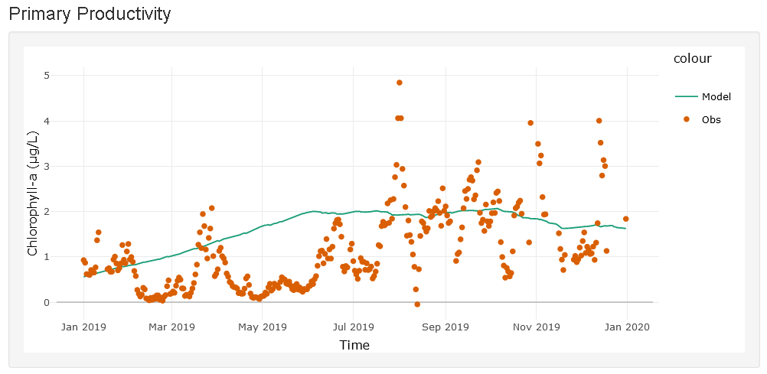

This is an example target plot that students should produce. The aim is to get the model to replicate similar ranges for chlorophyll-a. There will be differences among sites, but we aim to get within ranges.

Q13. Explore the model's sensitivity to SWT and uPAR:

1. Switch on surface water temperature by checking the box. Adjust initial conditions and parameters to replicate observations. Is the model sensitive to SWT? Did it help improve the model fit? (Select the "Q13a" row in the Parameter Table to store your model setup there).
2. Switch on uPAR and switch off surface water temperature. Adjust initial conditions and parameters to replicate observations. Is the model sensitive to uPAR? Did it help improve the model fit? (Select the "Q13b" row in the Parameter Table to store your model setup there).

Q14. Develop a scenario (e.g. uPAR is on, low initial conditions of phytoplankton, high nutrients, phytoplankton mortality is high, low uptake, etc.) and hypothesize how you think chlorophyll-a concentrations will respond prior to running the simulation.

* Students should give reasonable hypotheses that follow their expectations articulated above about relationships between parameters and state variables.

Q15. Add the observations to the plot. Calibrate your model by selecting sensitive variables and adjusting the parameters until they best fit the observed data. Save the plot and the parameters (Select the "Q15" row in the Parameter Table to store your model setup there), these are what will be used for the forecast.

* Make sure students don’t spend more than 10 minutes calibrating their model!

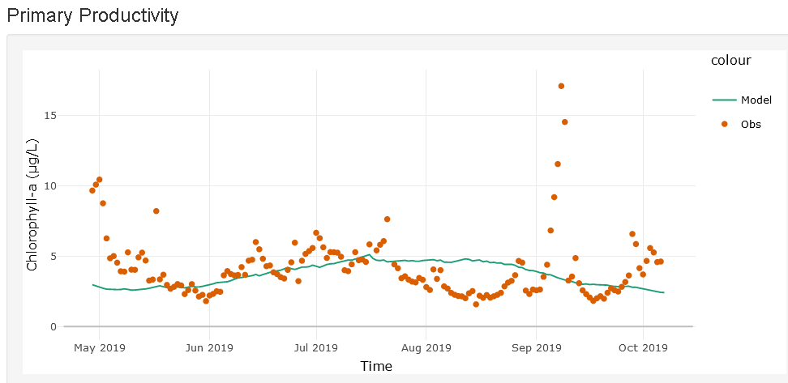

Here is an example plot of a “calibrated” model.

Below are the tables of calibrated parameters for each site which you can use a reference to guide students if they are spending too long on the calibration of their model.

Barco Lake – BARC

|  |  |  |  |  |  |  |
| --- | --- | --- | --- | --- | --- | --- |
|  | SWT | uPAR | Phytos | Nitrogen | Mortality | Uptake |
| Q12 | FALSE | FALSE | 0.31 | 0.08 | 0.93 | 0.03 |
| Q13a | TRUE | FALSE | 0.31 | 0.08 | 0.89 | 0.06 |
| Q13b | FALSE | TRUE | 0.56 | 0.08 | 0.91 | 0.05 |
| Q14 | - | - | - | - | - | - |
| Q15 | FALSE | TRUE | 0.56 | 0.08 | 0.92 | 0.07 |

Crampton Lake – CRAM

|  |  |  |  |  |  |  |
| --- | --- | --- | --- | --- | --- | --- |
|  | SWT | uPAR | Phytos | Nitrogen | Mortality | Uptake |
| Q12 | FALSE | FALSE | 0.45 | 0.11 | 0.75 | 0.11 |
| Q13a | TRUE | FALSE | 0.45 | 0.11 | 0.79 | 0.13 |
| Q13b | FALSE | TRUE | 0.75 | 0.11 | 0.57 | 0.26 |
| Q14 | - | - | - | - | - | - |
| Q15 | TRUE | TRUE | 0.93 | 0.11 | 0.59 | 0.26 |

Little Rock Lake – LIRO

|  |  |  |  |  |  |  |
| --- | --- | --- | --- | --- | --- | --- |
|  | SWT | uPAR | Phytos | Nitrogen | Mortality | Uptake |
| Q12 | FALSE | FALSE | 3.72 | 0.05 | 0.92 | 0.09 |
| Q13a | TRUE | FALSE | 3.22 | 0.05 | 0.88 | 0.12 |
| Q13b | FALSE | TRUE | 2.97 | 0.05 | 0.76 | 0.24 |
| Q14 | - | - | - | - | - | - |
| Q15 | TRUE | TRUE | 2.97 | 0.05 | 0.81 | 0.21 |

Prairie Lake – PRLA

|  |  |  |  |  |  |  |
| --- | --- | --- | --- | --- | --- | --- |
|  | SWT | uPAR | Phytos | Nitrogen | Mortality | Uptake |
| Q12 | FALSE | FALSE | 3.72 | 0.05 | 0.92 | 0.09 |
| Q13a | TRUE | FALSE | 3.22 | 0.05 | 0.88 | 0.12 |
| Q13b | FALSE | TRUE | 2.97 | 0.05 | 0.76 | 0.24 |
| Q14 | - | - | - | - | - | - |
| Q15 | TRUE | TRUE | 2.97 | 0.05 | 0.81 | 0.21 |

Prairie Pothole – PRPO

|  |  |  |  |  |  |  |
| --- | --- | --- | --- | --- | --- | --- |
|  | SWT | uPAR | Phytos | Nitrogen | Mortality | Uptake |
| Q12 | FALSE | FALSE | 3.46 | 0.04 | 0.85 | 0.15 |
| Q13a | TRUE | FALSE | 3.46 | 0.04 | 0.85 | 0.15 |
| Q13b | FALSE | TRUE | 5.29 | 0.06 | 0.72 | 0.25 |
| Q14 | - | - | - | - | - | - |
| Q15 | TRUE | TRUE | 5.00 | 0.06 | 0.72 | 0.25 |

## Activity B

### Objective 6 - Understand uncertainty and explore a weather forecast

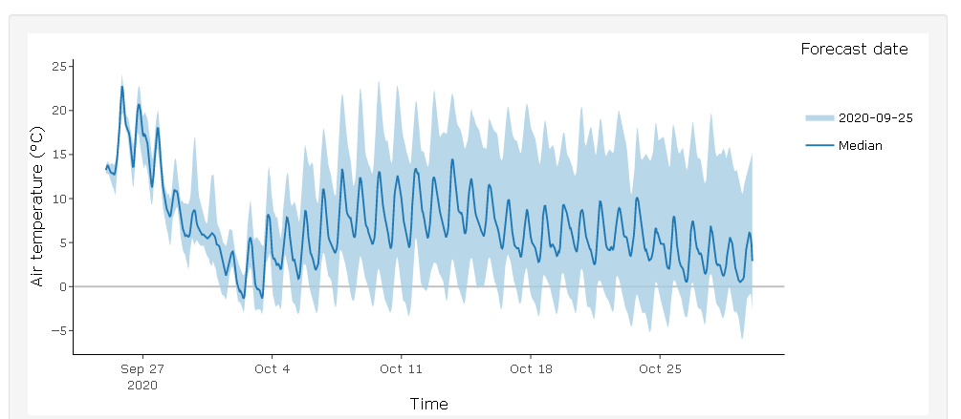

Plot of forecasted air temperature. This will vary by site and by how many members they choose to include.

Q17. Inspect the weather forecast data for the site you have chosen:

1. How does increasing the number of ensemble members in the weather forecast affect the size of the uncertainty in future weather?
   * As you increase the number of ensemble members, the uncertainty increases in the future, but there may be a threshold plateau when adding more members will not substantially affect uncertainty.
2. Which type of plot (line or distribution) do you think visualizes the forecast uncertainty best?
   * This is a subjective answer but is good at highlighting how people view and interpret uncertainty differently in a visualization.
3. Using the interactivity of the weather forecast plot, compare the air temperature forecasts for the first week (Sep 25 - Oct 1) to the second week (Oct 2 - 8). How does the forecast uncertainty change between the two periods?
   * The forecast uncertainty is relatively low for the first week, but increases during the second week.

### Objective 7 - Prepare inputs

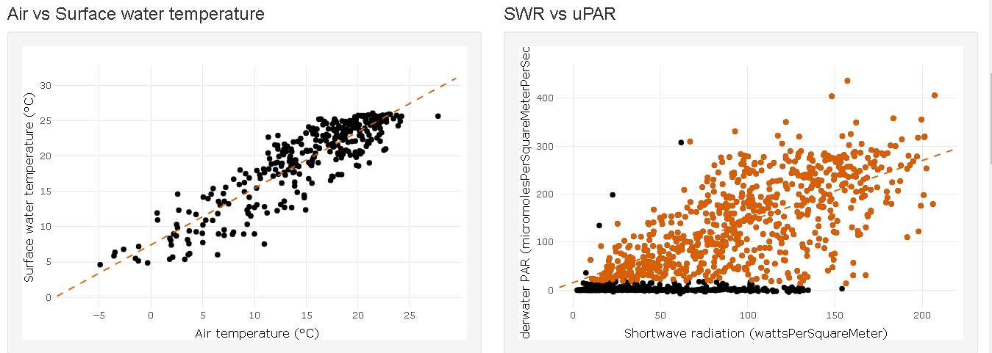

Example plot of linear regressions for air temperature and surface water temperature and underwater PAR and shortwave radiation.

|  |  |  |
| --- | --- | --- |
| Site | wtemp ~ airtemp | uPAR ~ SWR |
| BARC | wtemp=0.84∗airtemp+7.32;R2=0.79 | uPAR=0.8∗SWR+2.56; R2=0.51 |
| CRAM | wtemp=0.8∗airtemp+7.43;R2=0.79 | uPAR=1.27∗SWR+15.94; R2=0.45 |
| LIRO | wtemp=0.84∗airtemp+7.4;R2=0.8 | uPAR=2.4∗SWR+28.62; R2=0.47 |
| PRLA | wtemp=0.78∗airtemp+6.16;R2=0.73 | uPAR=2.14∗SWR+10.92; R2=0.11 |
| PRPO | wtemp=0.9∗airtemp+4.38;R2=0.87 | uPAR=0.47∗SWR+6.2; R2=0.15 |

It is important to make sure that there is not a negative intercept for uPAR ~ SWR as this could lead to negative uPAR values. Encourage students to use the lasso select to avoid the zero values. Students will get a prompt in the app if this occurs.

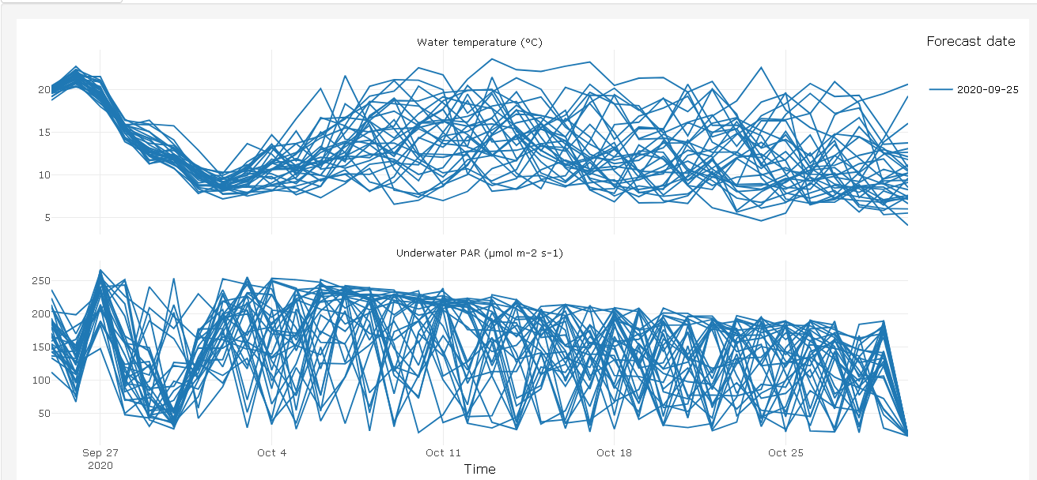

Plot showing converted weather forecast of air temperature to surface water temperature and shortwave radiation to underwater PAR.

### Objective 8 - Generate an Ecological Forecast

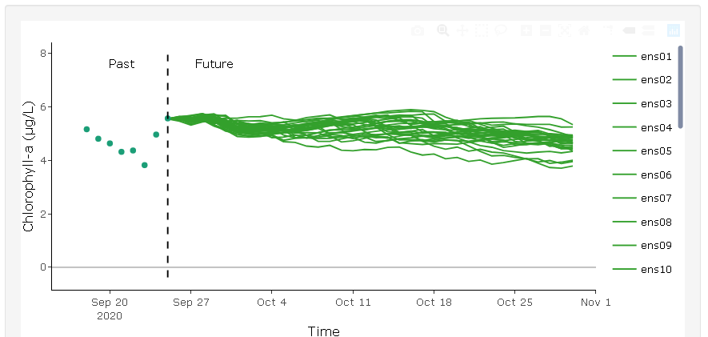

Example forecast for CRAM. Students are expected to adjust the initial conditions to the observed measurement.

Q18. How does driver uncertainty affect the forecast, specifically, does an increase in the number of members increase or decrease the range of uncertainty in the forecasts? How does that change over time?

* Increasing the number of members increases the range of uncertainty in forecasts, with the effect of greater uncertainty the further into the future a prediction is made.

Q19. What do you think are the main sources of uncertainty in your ecological forecast?

* We are quantifying meteorological (driver) uncertainty by using up to 30 different NOAA forecasts of meteorological conditions.
* The main sources of uncertainty in my ecological forecast include model uncertainty, parameter uncertainty, initial conditions uncertainty and driver uncertainty.

### Objective 9 - Communicate an Ecological Forecast

Q20. How would you describe your forecast of primary productivity at your NEON site so it could be understood by a fellow classmate?

* We are looking for descriptive answers here which include a description of the uncertainty and a summary of the general trend.
  + Primary productivity is expected to increase substantially in the next day, then plateau at a relatively high level. Chlorophyll-a concentrations will reach around 8 micrograms/L and most likely stay there for the next 7 days.
  + According to my model, the chlorophyll-a concentration spikes up to 30 ug/L and then slowly declines over time.
  + Our forecast predicts that algae will increase over the next month to levels greater than that observed over the last week.

### Objective 10 - Assess an Ecological Forecast

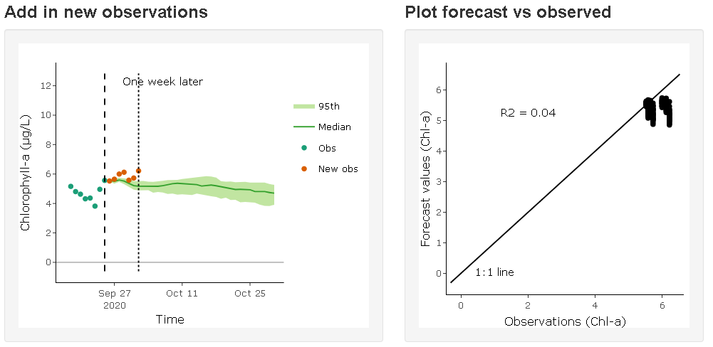

Plot of assessment of the ecological forecast.

Q21. How well did your forecast do compared to observations? (include R2 value) Why do you think it is important to assess the forecast?

* Write and include the R2 value here and describe the performance.
  + It’s important to assess forecasts so you can see how accurate the forecast was and if it is providing correct information to the forecast users (e.g., managers).

### Objective 11 - Update Model

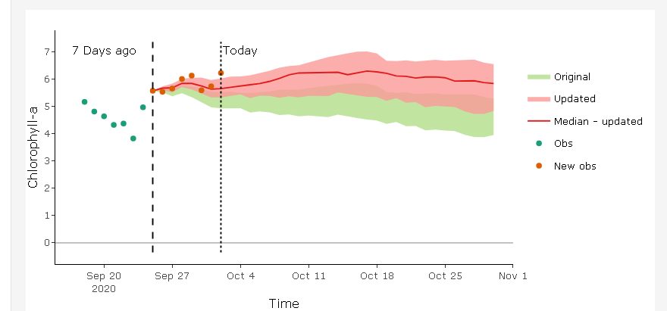

Plot showing the updated model.

Students get one opportunity to update their model. It is important that they think carefully about how the model will respond before deciding how to update their forecast.

Q22. Did your forecast improve when you updated your model parameters? Why do you think it is important to update the model?

* From the example figures shown above, a reasonable answer could include:
* Yes, I was able to make the forecast more closely match the observations, OR, The forecast did not improve much, if at all.
* Updating the model is necessary to improve forecasts, as well as provide improved estimation of how the model simulates reality.

### Objective 12 - Next Forecast

Students should update their initial conditions to match the new observations before running their next forecast.

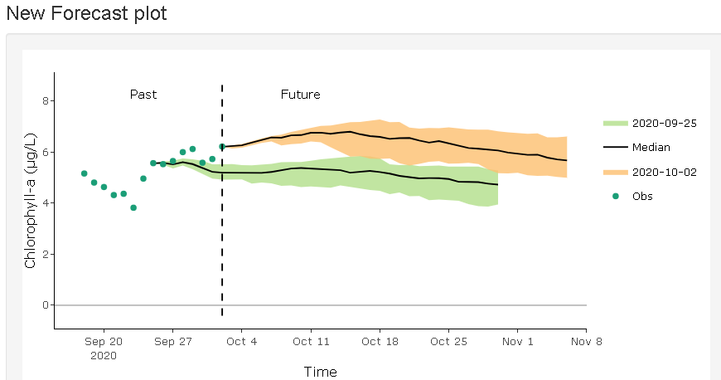

Plot showing the next forecast for CRAM.

Q23. Describe the new forecast of primary productivity.

* Examples of potential answers include:
  + The new forecast now predicts the primary productivity will increase initially, but not as high as previously forecasted. Then, the primary productivity decreases gradually over the next 7 days.
  + Chlorophyll-a concentrations are forecasted to decline over the course of the forecast period.

Q24. Why is the forecast cycle described as 'iterative' (i.e. repetition of a process)?

* The forecast cycle is iterative because the model is being updated with each new round of data collection before a new forecast is generated.
* With each iteration, the forecast is continually improving over time.

### Discussion topics:

Following completion of Activity B, bring the students back into the same room and remind them to return to the “*Introduction*” tab and generate and download their report and their answers. This is **VERY IMPORTANT** as if students leave the Shiny app idle for 15 minutes (which is likely to happen during the discussion period) they will lose all their progress.

* A good exercise to start with would be to ask students present their results to the class. This can be done by either screen-sharing and showing Shiny app and navigating through the relevant tabs or instead using the generated and downloaded Word report:
  + Introduce their site
  + Calibrated model from Obj 5
  + Their first forecast from Obj 8
  + How did they communicate their forecast from Obj 10
  + And then their updated forecast from Obj 11
* Throughout this, encourage other students to ask questions and you can also ask questions related to their results e.g.
  + What do you think are some of the shortcomings with this model?
  + In Obj 5, why do you think the parameters differ between the different scenarios (Q12-15)?
  + Why do the forecasts look the way they do?
  + How did changing/updating the model parameters affect the forecast? E.g. what is the connection between mortality rate and nutrient uptake on phytoplankton concentrations?
  + Do you think this will vary between sites?
  + Why do you think the forecast performed better/worse after updating the model?
  + What do you think would be the most important thing to change to improve the accuracies in the forecast?
  + Describe the uncertainty you saw in your forecasts. Where do you think that comes from?
* Try and ask each of the groups to present (as time permits)
* After discussion, it would be good to summarize some of the key points:
  + Simple ecological models can work well at capturing seasonal variability but not as responsive to sudden short-term events so even though your model captures the seasonal cycle in Obj 5, it might not predict short-term (35 day) events accurately
  + Ecological forecasts follow an iterative cycle
  + Meteorological forecasts use ensembles (multiple realizations of future conditions) to quantify uncertainty
  + This uncertainty transfers into our ecological model
  + Uncertainty generally increases into the future
  + Communicating a forecast is just as important as generating a forecast. If a forecast is not communicate effectively it reduces the potential usefulness of a forecast
  + As more data becomes available it allows the accuracy of the forecast to be assessed and this informs us if the model we are using is accurately predicting future conditions or if we need to make updates to our model

## Activity C

This activity can instead be completed by having pairs of students with different sites present the results from Activity A and B. They also compare their model parameter sets.

Q25. Repeat Activity A and B with a different NEON site (ideally from a different region).

1. Apply the same model scenario (with the same model structure and parameters) which you developed in Q14 to this new site. How do you expect chlorophyll-a concentrations will respond prior to running the simulation?
2. Was your hypothesis supported or refuted? Why?
3. Revisit your hypothesis from Q3, what did you find out about the different productivity forecasts in warmer vs colder sites?

Q26. Does forecast uncertainty differ at this site compared to the first selected site? Why do you think that is?

* Possible answers could include:
  + Different driver data
  + Different model inputs
  + Different parameters
  + Different climate