Macrosystems EDDIE:

Time Series Modeling and Prediction of Environmental Data
Instructor’s Manual

Module Description
Advances in environmental sensor technology in recent decades are enabling the collection of environmental data at high temporal frequencies (e.g., every 10 minutes) across many ecosystems. These time series of environmental data can be used to gain information about previous and current conditions of ecosystems, as well as make predictions about ecosystem conditions in the future. To help researchers and managers understand the complex patterns that can occur in high-frequency environmental time series data, they commonly apply a range of time series models. These models use statistical and machine learning methods to identify signals in high-frequency environmental data.
In this module, students will apply several different time series and machine learning models to explore, analyze, and interpret environmental data. They will explore data from an environmental case study of their choice, choose which environmental variables to use to fit a time series model, assess the model, and apply the model to make predictions of future ecosystem conditions. Then, students will process a new dataset into a standardized format, upload it into the module's R Shiny App, and fit several other models to compare predictive performance across models. Students will also evaluate the ecological understanding that can be drawn from each model (e.g., which driver variables are important for explaining the dynamics of the target environmental variable being predicted).
Focal question: How can we use time series models to understand and predict ecosystem conditions?

Pedagogical Connections
Phase | Functions | Examples from this module
Engagement | Introduce topic, gauge students’ preconceptions, call up students’ schemata | Short introductory lecture introducing time series modeling and environmental case studies; students answer introduction questions
Exploration | Engage students in inquiry, scientific discourse, evidence-based reasoning | Students explore environmental data of different variables from an environmental case study of their choosing
Explanation | Engage students in scientific discourse, evidence-based reasoning | Student interpret data to identify relationships among variables and use that information to fit and assess a time series model
Expansion | Broaden students’ schemata to account for more observations | Students upload a new dataset of their own choosing and fit and assess a time series model using this new dataset at a different environmental site
Evaluation | Evaluate students’ understanding, using formative and summative assessments | Students fit additional time series model and evaluate the performance of the different models on out-of-sample predictions; students interpret the model evaluation to determine which environmental variables are important as drivers for predicting the target variable in their environmental case study

Learning Objectives
By the end of this module, students will be able to:
- Explore relationships between ecological variables from environmental case studies. (Activity A, Activity B)
- Understand the structure of four time series models (including machine learning models) that are commonly applied in environmental science. (Activity A, Activity C)
- Fit time series models using environmental data and assess the importance of ecological driver variables in making model predictions. (Activity A, Activity B, Activity C)
- Process environmental datasets into standardized formats suitable for training and assessing time series models. (Activity B)
- Compare multiple time series models to assess their performance on out-of-sample predictions. (Activity C)

How to Use this Module
This entire module can be completed in one 3-hour lab period or two 75-minute lecture periods for introductory undergraduate students in Ecology, Environmental Science, Ecological Modeling, and Quantitative Ecology classes. We found that students spent the most time on Activity A (~50 minutes) and Activities B and C went much more quickly (~20 minutes each). However, if students use outside datasets provided by the instructor for Activity B that require more extensive data wrangling than the datasets provided in the module, we recommend dedicating additional time to introduce these datasets and for students to process the data.
In-person or virtual synchronous lesson structure, depending on the time available for your class:
- Three classes (50-60 minutes)
  - Class 1 – Introductory lecture (30 min.) and completion of Introduction and Activity A, Objectives 1 and 2 (20 min.)
  - Class 2 – Finish Activity A and take questions as needed (30 min); do data wrangling and data upload for Activity B, Objective 6 (20 min.)
    - Note: this assumes that students are using one of the datasets provided within the module for Activities B and C; if students are using other datasets provided by the instructor that require more extensive data wrangling, we recommend either: 1) introducing the dataset in class and assigning the data wrangling as homework or 2) dedicating an additional class period to introduce the dataset and give students time to wrangle data
  - Class 3 – Finish Activity B and take questions as needed (20 minutes); completion of Activity C (20 min.); wrap-up (10 min.)
- Two classes (75-90 minutes)
  - Class 1 – Introductory lecture and completion of Introduction and Activity A
  - Class 2 – Complete Activities B & C followed by 10-15 minute discussion and wrap-up
    - Note: this assumes that students are using one of the datasets provided within the module for Activities B and C; if students are using other datasets provided by the instructor that require more extensive data wrangling, we recommend either: 1) introducing the dataset in class and assigning the data wrangling as homework or 2) dedicating an additional class period to introduce the dataset and give students time to wrangle data
- One class (2.5-3 hours)
  - Introductory lecture – 30 mins; Activity A, Objectives 1 and 2 – 20 mins; break – 10mins, Activity A Objectives 3-5 – 30 mins; Activity B – 20 mins; break – 10 mins; Activity C – 20 mins; wrap-up – 10 mins
    - Note: this assumes that students are using one of the datasets provided within the module for Activities B and C; if students are using other datasets provided by the instructor that require more extensive data wrangling, we recommend either: 1) introducing the dataset in class and assigning the data wrangling as homework or 2) dedicating an additional class period to introduce the dataset and give students time to wrangle data

Quick overview of the activities in this module:
- Activity A: Students visualize data from a selected environmental data case study, and fit and assess a time series model.
- Activity B: Students choose a new environmental dataset or upload their own dataset and fit and assess a time series model.
- Activity C: Students fit additional time series models to their environmental dataset and compare performance across models.

Module Workflow (for either in-person or virtual instruction)
- Instructor chooses a method for accessing the Shiny app (regardless of which method you pick, all module activities are the same!):
  - In any internet browser, go to:https://macrosystemseddie.shinyapps.io/module11/
    - This option works well if there are not too many simultaneous users (<20)
    - The app generally takes several seconds to load and requires consistent internet access
    - It is important to remind students that they need to save their work as they go, because this webpage will time-out after 15 idle minutes. It is frustrating for students to lose their progress, so a good rule of thumb is to get them to save their progress after completing each Shiny App activity objective
    - Note that for this module, progress-saving is only available for Activity A, because students upload their own data to use for Activities B and C, and we are unable to store users' data within the app. Students and instructors should plan to allocate 45-60 minutes to complete Activities B and C or be prepared to re-upload their data and regenerate plots within the app.
  - The most stable option for large classes is downloading the app and running locally, see instructions at: https://github.com/MacrosystemsEDDIE/module11
    - Once the app is downloaded and installed (which requires an internet connection), the app can be run offline locally on students' computers
    - This step requires R and RStudio to be downloaded on a student's computer, which may be challenging if a student does not have much R experience (but this could be done prior to instruction by an instructor on a shared computer lab)
    - If you are teaching the module to a large class and/or have unstable internet, this is the best option
- Give students their module report (or ask them to download it from the app on the Introduction page at https://macrosystemseddie.shinyapps.io/module11/) ahead of time to read over prior to class or distribute reports when students arrive to class. The report includes optional pre-class readings and a short pre-class activity introducing some current examples of ecological forecasts. Students will also answer the questions embedded throughout the R Shiny App in the module report, which could be submitted to the instructor for grading if desired.
- Instructor gives a brief PowerPoint presentation that introduces time series modeling and the environmental case studies which students can explore during the module (~30 mins).
- After the presentation, the students divide into pairs. Each pair selects their own environmental case study and visualizes their case study's data, which is used to fit and assess a time series model (Activity A). The two students within a pair each build their own model with unique inputs and parameters to compare the performance of two different models for the same ecosystem. For virtual instruction, we recommend putting two pairs together (n=4 students) into separate Zoom breakout rooms during this activity so the two pairs can compare results.
- The instructor then introduces Activities B and C, potentially revisiting some of the slides from the introductory presentation as a reminder to students about the next steps. For virtual instruction, this would entail having the students come back to the main Zoom room for a short check-in.
- The students work in their pairs to process and upload data in a standardized format and fit a new time series model to their uploaded data (Activity B). Note: the amount of time required for data wrangling may vary widely depending on the datasets the instructor chooses to use for the module. The datasets provided within the module require minimal data wrangling that can be done in Microsoft Excel (~5-10 minutes depending on student experience). However, instructors should plan to allocate additional time if they are asking students to do more extensive data wrangling prior to uploading their own data in Activity B. For virtual instruction, we recommend putting the two pairs back into the same Zoom breakout rooms. Optionally, instructors may bring the class back together at the end of Activity B to discuss performance of students' time series models before beginning Activity C.
- Student pairs then fit additional time series models to their uploaded datasets and compare performance across models on out-of-sample predictions (Activity C). The students work together in groups to present the results from their dataset and different models to the rest of the class. The class may discuss why the models perform similarly or differently among the different sites, as well as the skill of more complex models (with environmental drivers) vs. simple models at various sites.
Important Note to Instructors:
The R Shiny app used in this module is continually being updated, so these module instructions will periodically change to account for changes in the code. If you have any questions or have other feedback about this module, please contact the module developers (see “We’d love your feedback” below).
We highly recommend that instructors familiarize themselves with the Shiny app prior to the lesson. This will enable you to be more prepared to answer questions related to certain areas of the app’s functionalities.

Guide to Introductory PowerPoint Presentation
Note: the numbers below match the PowerPoint slide numbers. The text for each slide is also in the “Notes” of the PowerPoint, so can be viewed when projecting in Presenter View.
  - Welcome to the Macrosystems EDDIE module: Time Series Modeling and Prediction of Environmental Data. This module has been developed in collaboration by scientists at the University of Western Australia and Virginia Tech, leveraging data from the Swan Canning Estuary Virtual Observatory and the U.S. National Ecological Observatory Network. The module is part of the Macrosystems EDDIE program, which stands for Environmental Data-Driven Inquiry and Exploration, and is supported by grants from the United States National Science Foundation.
  - This module includes three activities, which are all designed to introduce concepts related to time series modeling in the context of environmental science. In Activity A, students will visualize data from a selected environmental data case study and fit and assess a time series model. In Activity B, students will choose a new environmental dataset or upload their own dataset and fit and assess a time series model. In Activity C, students will fit additional time series models to their environmental dataset and compare performance across models.
  - All of the activities are designed to address the focal question for this module, which is: How can we use time series models to understand and predict ecosystem conditions?
  - As ecosystems change rapidly due to human pressures, historic conditions can no longer be used to predict future conditions. Use of time series models can help inform managers and decision-makers about the likely future state of ecosystems, helping them to make more informed decisions regarding use and conservation of environmental resources.
  - In recent decades, our increasing ability to collect high-frequency environmental data has enabled greater application of time series models in ecology. High-frequency environmental data are measurements of various attributes of an ecosystem that are taken many times during a day or during a week (for example, every 10 minutes). This is different from low-frequency data, which are only collected perhaps once a week or even once a month. High-frequency data allow managers and scientists to observe and analyze patterns and trends in ecosystems that were not previously measurable using low-frequency measurements. For example, the plot on the bottom of the slide shows water temperature data collected from many different depths in a reservoir every day over the course of a year. You can see there is a lot of variability in this data that would not be visible if the data were collected once a month, for example.
  - Due to increasing availability of large quantities of environmental data, time series models are increasingly applied in ecology to analyze and make predictions using environmental data across a wide variety of ecosystems. A few examples of how time series models are currently used in ecology and environmental science are shown here. Predictions of future salmon population sizes can be used to inform salmon harvests; predictions of future pollen concentrations can help people make decisions about when to take allergy medication or how much time to spend outside; predictions of forest pest outbreaks can help inform forest management, and predictions of harmful algal blooms can inform drinking water advisories or recreational area closures. So understanding how to develop and apply time series models is an important skill for students of ecology and environmental science.
  - Today, we are going to explore time series modeling and out-of-sample prediction of standardized environmental datasets using several different models. A time series model is a statistical representation of data that occur in a particular order over time. Time series models can be used to make predictions of future observations. The figure is showing an example of a time series model fit to chlorophyll-a data from a river. Chlorophyll-a is the variable we are trying to predict, and we refer to that variable as the “target variable”. Note that gaps in the data can result in gaps in the fitted model values.
  - First, we will fit, or train, or models using a subset of the available environmental data, known as training data. We will then generate predictions on data that we withheld from the model during training, known as testing data. Use of out-of-sample predictions is a robust way to test the skill of our model using data it has not previously seen. A typical “split” of data for training and testing is to use 80% of the data for training and 20% for testing. This is because many time series models require large volumes of data to get a good fit.
  - To be able to fit our time series models, we will need to work with data in a standardized format. This is because the models are run using computer programs that expect a particular format of the data; if the data are not in the correct format, the model will not run and will throw an error. Standardized data follow specified guidelines regarding column headers and the format of values within columns. On the left is an example of a standardized data frame; all the dates are formatted similarly and all the values in the temp_degC column are numeric. On the right is an example of a “messy” dataset – a computer won’t be able to read these data without some data cleaning on your part! Dates have inconsistent formatting and there are notes embedded along with numeric values in the temperature column.
  - We will use the standardized datasets in this module to fit several different time series models, which we will introduce next. Researchers use different types of models because they provide complementary predictions: some may be more accurate than others, and provide unique information about an ecosystem. Commonly-used ecological time series models include statistical time series models, machine learning models, and baseline models against which more complex models are compared.
  - In the module, you will learn about, fit, and assess four different time series models that are commonly applied in environmental science. The first is an AutoRegressive Integrated Moving Average, or ARIMA model. You can think of ARIMA models as having three key components: the autoregressive component, the integration or differencing component, and the moving average component. The autoregressive component means that ARIMA models use past values of a variable to help predict future values. Integration refers to the fact that the target variable, or the variable we are trying to predict, may be differenced, meaning that each number is subtracted from the one after it in the time series. The moving average component means that ARIMA models use past model errors to help make predictions of the future. While this is a very brief overview of ARIMA model structure, we will go into more detail once you begin working through the module.
  - The second model you will work with is an autoregressive neural network, or NNETAR model. A neural network is a model whose structure is designed to mimic the structure of the human brain and nervous system. They are good at capturing complex, nonlinear relationships in data. The figure on the right shows a conceptual presentation of a neural network model. The light blue circles are inputs to the model (environmental variables such as air temperature, for example). The medium blue circles are the hidden layer of the neural network, where the data undergo a non-linear transformation, and the dark blue circle is the output layer, which is the model predictions. Again, we will go into more detail about this model in Activity C, when you fit the model to environmental data.
  - The third model we will fit is a historical mean model. A historical mean model simply uses the mean of the previous observations as the prediction for the next timestep. Historical mean models can be useful as baseline, or null, models against which to compare more complex models. If the more complex model doesn’t outperform the historical mean model, the additional complexity is not adding predictive value. The figure on the right shows a historical mean model fit to net ecosystem exchange data (the net exchange of carbon dioxide between an ecosystem and the atmosphere). You can see the model fit is just a flat line representing the mean of all the previously observed data.
  - The final model we will learn about today is a day-of-year model, which uses the Julian day of year (from 1-365 or 366 in a leap year) to predict the target variable. The figure on the right shows net ecosystem exchange data plotted vs. day of year. You can see there is a clear annual pattern in NEE, which indicates that day-of-year might be a helpful predictor for these data. Day-of-year models are also good baseline models against which to compare more complex models.
  - This module has five learning objectives (read objectives).
  - In Activity A, you will pick an environmental case study. You will use data from this case study to fit and assess an ARIMA time series model. The module includes two case studies: an aquatic and a terrestrial case study. If you choose the aquatic case study, you’ll be working with data from the Canning River, located in Western Australia.
  - The Canning River is part of the Swan-Canning Estuary, an urban estuary system that runs through Perth, the capital of Western Australia. Perth has a population of about 1.5 million people. The estuary experiences both freshwater flushing from terrestrial catchments as well as salt water intrusion from the Indian Ocean, which leads to complex hydrology and biogeochemistry. Due to its urban location, the Canning River has experienced increased nutrient loading from human activity, resulting in water quality impacts.
  - Our focal target variable for this case study is chlorophyll-a, a photosynthetic pigment that is commonly used as a proxy for phytoplankton biomass. Phytoplankton are tiny aquatic organisms which are key primary producers in many aquatic ecosystems. However, over-proliferation of phytoplankton can lead to harmful blooms, which can release toxins, cause taste and odor problems, and form unsightly scums. Chlorophyll-a can be measured using high-frequency sensors deployed on buoys.
  - Periodically, the Swan-Canning Estuary and the Canning River experience harmful blooms of various phytoplankton species. This can lead to fish kills, fisheries warnings, and recreational area closures. Models that can provide predictions of high chlorophyll-a levels can be a useful tool as managers try to anticipate and mitigate the effects of these blooms.
  - The data for the Canning River case study is retrieved from the Swan-Canning Estuary Virtual Observatory, or SCEVO, which is operated by the University of Western Australia. To learn more about SCEVO, you can visit the link on the slide.
  - The terrestrial case study for the module is Bartlett Experiment Forest, which is located in Carroll County, New Hampshire, USA.
  - Bartlett Experimental Forest is an old-growth northern deciduous hardwood forest (primarily beech and maple) located within the White Mountain National Forest. It was logged historically but has been dedicated as a research station since 1931, and is currently managed by the U.S. Department of Agriculture’s Forest Service.
  - Our data source for the Bartlett Experimental Forest case study is the U.S. National Ecological Observatory Network, or NEON, which coordinates comprehensive collection of ecological data from a variety of ecosystems across the U.S. You can learn more at the link on the slide.
  - Our focal target variable for the Bartlett Experimental Forest is net ecosystem exchange, or NEE. NEE is the net exchange of carbon between the air and a terrestrial ecosystem. The magnitude of NEE depends on the rates of photosynthesis and respiration of the ecosystem’s vegetation. If NEE is positive, the ecosystem is emitting carbon to the atmosphere; if it is negative, the ecosystem is taking up carbon. The figure on the right shows NEE over the course of a year in the Bartlett Experimental Forest. You can see that in summer, high rates of photosynthesis lead to uptake of carbon from the atmosphere by the forest. In contrast, during the winter, leaves drop off trees and photosynthesis rates are low. In this case, respiration of vegetation leads to emission of carbon to the atmosphere from the ecosystem.
  - Understanding the magnitude and patterns in NEE has important climate implications. NEE measures the exchange of carbon dioxide, a greenhouse gas. As a result, NEE measures the degree to which an ecosystem contributes to or mitigates climate change. Because NEE is affected by temperature and moisture, changes in climate can affect NEE, creating a feedback loop between ecosystems and climate. NEE is measured by high-frequency sensors deployed on towers which extend above the canopy of an ecosystem.
  - I will now give a brief overview of the module activities. In Activity A, you will complete five objectives. You will select an environmental case study to work with in Objective 1 and explore the data from that case study in Objective 2. Then, you will learn more details about the structure of ARIMA models and fit an ARIMA model to your environmental case study data in Objectives 3 and 4. Finally, in Objective 5, you will assess the ARIMA model fit by generating out-of-sample predictions for data from your environmental case study.
  - In Activity B, you will either choose a new environmental dataset to work with from within the module or upload a dataset of your own in a standardized format. Instructions regarding the standardized data format are provided within the module. Once the data are uploaded, you will once again fit and assess an ARIMA model using you own dataset.
  - Finally, in Activity C, you will fit three additional models to the dataset you uploaded in Activity B. This is when you will learn more about the neural network, historical mean, and day-of-year models. You will then compare performance across models using out-of-sample predictions, and use this comparison to make conclusions about which variables are important for predicting the target variable in the dataset you uploaded.
  - The module can be accessed at the link on this slide. You will complete module activities in an R Shiny app, which is an interactive website. Be sure to complete the ”Quick-start” guide to the module and watch the video that explains the interactive module features. Questions are embedded in the app and you will answer these in a Word document that you download from the app.
  - Thank you for participating!

Guide to Shiny App

Module Overview
This is the landing page of the Shiny app. It gives an overview of the module - there are no questions students need to complete on this tab.

Presentation
The presentation tab has key slides from the introductory presentation embedded so students may review this material. There are no questions students need to complete on this tab.

Introduction
The introduction outlines the workflow for the module and provides instructions about how to save and resume progress. This is also where they will download the module report into which they should type their answers. Students should answer questions 1-2 (hereafter, denoted as Q1-2). We have observed a tendency to forget about these questions as students skip straight to Activity A!

Activity A: Fit a time series model to environmental data
Activity A challenges the students to explore the data from an environmental case study of their choosing, explore variable relationships and fit and assess an ARIMA model to predict the target variable from their case study.
Important: Tell the students to read through the detailed text in each section as this will explain what is happening within each objective.

Tips for Activity A:
- Important: Tell the students to read the embedded slides and text in each section as this will explain what is happening within each objective and help answer questions.
- In Objective 1, students must select an environmental case study to complete the rest of the module activities.
- In Objective 2, students will explore the relationships between the target variable (variable they are trying to predict) and other environmental variables. It is likely that they will find that the relationships between environmental variables and their target variable are weak or nonexistent, even if previous research and ecological theory show that there should be a connection between the two (e.g., phosphorus and chlorophyll-a). Encourage students to discuss why this might be. You could ask:
  - Why do you think we aren’t seeing very strong relationships between these variables? Are there unique features about the case study site that might explain this? What about measurement error or differences in the timescales at which these variables are measured? Do you think the lack of relationship here means that our ecological understanding is fundamentally incorrect, or can it be explained by other factors?
- In Objective 3, students will explore the degree of autocorrelation in their dataset. Encourage them to pay special attention to Q9, which asks them to compare the R² of the environmental variable relationships they explored in Objective 2 with the R² of the one-day lag they plot in Objective 3. Often, the R² of the one-day lag is higher, indicating that lags may be more useful for predicting future vales of the target variable than environmental variables. This will set students up well to choose a model structure in Objective 4.
- A note on the difference between process-based and ARIMA models: In Objectives 3 and 4, students will learn about and fit an ARIMA model. For students who are more familiar with process-based models (which use equations that explicitly represent known and hypothesized physical, chemical, and biological processes in ecosystems), emphasize that ARIMA models rely on statistical relationships between data rather than encoding our intellectual understanding of a process into a model. As a result, ARIMA models involve fewer assumptions than process-based models. For example, a process-based model may assume that phosphorus and nitrogen are important drivers of phytoplankton growth based on our understanding of aquatic ecosystems from previous research, with this assumption instantiated in the model via an equation that specifies that as phosphorus/nitrogen increases, chlorophyll-a increases. ARIMA models are devoid of such assumptions. If there is not a strong relationship between phosphorus/nitrogen and chlorophyll-a observed in the data used to fit the model, then the coefficient for phosphorus/nitrogen in the fitted ARIMA model will have a small absolute value, perhaps indistinguishable from 0, indicating a negligible effect on model predictions. Encourage students to discuss whether their fitted ARIMA model terms match or contradict their expectations about which variables are important for predicting the target variable in ecosystems. Another important point to make here is that the goal of using an ARIMA model is often for prediction, whereas process-based models are often used for understanding. A helpful resource on this subject may be:
  - Rastetter, E.B. Modeling for Understanding v. Modeling for Numbers. Ecosystems 20, 215–221 (2017). https://doi.org/10.1007/s10021-016-0067-y
- In Objective 4, encourage students within partner pairs to use different exogenous regressors (or no regressors if they choose!) to fit their ARIMA models. This will allow students to compare performance between their models according to RMSE and ignorance score in Objective 5. Encourage students to focus on Q16 to evaluate the predictive value of any exogenous regressors they chose to include in their model.
- If teaching synchronously, walk around the room/move between breakout rooms and make sure that everyone can follow along with the Shiny app successfully.
- When you close class, remind students to save their progress by saving their Word document and bookmarking their progress in the Shiny app.

Activity B: Upload your own data and fit a time series model

Students will upload a new dataset to the module in a standardized format and use that dataset to fit and assess another ARIMA model. Unless students are asked to wrangle datasets that are not provided within the module (e.g., additional datasets provided by the instructor), this should be a shorter activity than Activity A.

Tips for Activity B:
- Important: Be sure to allocate sufficient time for students to explore and process their datasets for Objective 6, particularly if you are asking students to use datasets other than those provided within the module. The datasets provided within the module require only minimal data wrangling to achieve the standardized data format required. Other datasets may require several hours of work to format for the module. Please plan accordingly!!!
  - If students are working with datasets within the module, the following data wrangling must be completed:
    - If students choose CanningRiverKentStWeir, they will need to reformat the dates from mm/dd/yyyy to yyyy-mm-dd
    - If students choose KonzaPrarieBiologicalStationNEON, they will need to reformat the variable names to omit spaces
- Tell the students to read through the detailed text within each objective. We have embedded lots of directions, hints, and troubleshooting help within the Shiny app text! We encourage instructors to read and work through the Shiny app before teaching the module so that you are familiar with all of the steps of this activity.
- Remind students to answer questions in their Canvas quiz or Word documents as they go. Also, if possible, encourage students to compare their decisions with other students working on the same dataset (note that RMSE and ignorance score can only be compared among models fit for the same target variable!). One effective way of doing this is to ask students to briefly present one or more figures from Activity B to the class at the end of the lesson, and discuss differences in model performance.
- Walk around the room/move between breakout rooms and make sure that everyone can follow along the Shiny app successfully.
- When you close class, remind students to save their progress by saving their Word document. Also remind them that they cannot save their progress within the app for Activities B and C, so they will need to plan to re-upload their standardized data and re-make their plots if they need to continue these activities in a different session.

Activity C: Compare predictive performance across models
This is a slightly shorter activity than A or B. Students fit additional time series models to the standardized dataset they uploaded in Activity B and compare performance across these models on out-of-sample predictions.

Tips for Activity C:
- Encourage students to examine the slide deck in Objective 9 that explains the additional time series models fit in this Objective. It will help them understand the module activities and answer questions.
- Objective 10 provides opportunities for class discussion about the utility of various environmental variables for predicting the key target variable (i.e., if the more complex ARIMA and NNETAR models do not out-perform the baseline historical mean and DOY models, this suggests that environmental drivers are not adding a lot of predictive power to models). Encourage students to compare model performance with their partner and with others in the class who worked on the same or different datasets. Remember that RMSE and ignorance score can only be compared among models fit to the same target variable! However, students may compare the relative rankings of their models across different datasets (e.g., a DOY model is the top model in predicting NEE while the NNETAR model is the top model in predicting chlorophyll-a).

Resources and References

Recent publications about EDDIE modules:
- Carey, C. C., R. D. Gougis, J. L. Klug, C. M. O’Reilly, and D. C. Richardson. 2015. A model for using environmental data-driven inquiry and exploration to teach limnology to undergraduates. Limnology and Oceanography Bulletin 24:32–35.
- Carey, C. C., and R. D. Gougis. 2017. Simulation modeling of lakes in undergraduate and graduate classrooms increases comprehension of climate change concepts and experience with computational tools. Journal of Science Education and Technology 26:1-11.
- Klug, J. L., C. C. Carey, D. C. Richardson, and R. Darner Gougis. 2017. Analysis of high-frequency and long-term data in undergraduate ecology classes improves quantitative literacy. Ecosphere 8:e01733.
- Farrell, K.J., and C.C. Carey. 2018. Power, pitfalls, and potential for integrating computational literacy into undergraduate ecology courses. Ecology and Evolution 8:7744-7751. DOI: 10.1002/ece3.4363
- Carey, C. C., Farrell, K. J., Hounshell, A. G., & O'Connell, K. 2020. Macrosystems EDDIE teaching modules significantly increase ecology students' proficiency and confidence working with ecosystem models and use of systems thinking. Ecology and Evolution. DOI: 10.1002/ece3.6757
- Moore, Tadhg N., R. Quinn Thomas, Whitney M. Woelmer, and Cayelan C. Carey. 2022. Integrating ecological Fforecasting into undergraduate ecology curricula with an R Shiny application-based teaching module. Forecasting 4 (3): 604–33. DOI: 10.3390/forecast4030033
- Woelmer WM, Moore TN, Lofton ME, Thomas RQ, Carey CC. 2023. Embedding communication concepts in forecasting training increases students’ understanding of ecological uncertainty. Ecosphere 14: e4628.
- Lofton, M.E., Moore, T.N., Woelmer, W.M., Thomas, R.Q., and C. C. Carey. 2024. A modular curriculum to teach undergraduates ecological forecasting improves student and instructor confidence in their data science skills. BioScience, Volume 75, Issue 2, February 2025, Pages 127–138, https://doi.org/10.1093/biosci/biae089

We’d love your feedback!
We frequently update this module to reflect improvements to the code, new teaching materials and relevant readings, and student activities. Your feedback is incredibly valuable to us and will guide future module development within the Macrosystems EDDIE project. Please let us know any suggestions for improvement or other comments about the module by sending an email to MacrosystemsEDDIE@gmail.com or filling out the form at the following link: https://serc.carleton.edu/eddie/macrosystems/faculty_feedback.

Answer Key

The answers provided below correspond to questions in the student handout which can be downloaded either from the Shiny app (https://macrosystemseddie.shinyapps.io/module11/) or from the SERC website describing this module (https://serc.carleton.edu/eddie/teaching_materials/modules/module11.html).

Note that for many questions, direct guidance regarding student answers cannot be provided as the answers depend on which datasets students choose to upload for Activities B and C, as well as the model structure students choose to fit for their ARIMA and NNETAR models. Where student answers may vary, this is noted.

Pre-class activity: Explore environmental case study
Choose one of the papers describing an environmental case study and use it to answer the questions below. Choose the case study that you will work with for Activity A of the module.
Phytoplankton dynamics in the Canning River, Western Australia: Huang, P., Trayler, K., Wang, B., Saeed, A., Oldham, C. E., Busch, B., & Hipsey, M. R. (2019). An integrated modelling system for water quality forecasting in an urban eutrophic estuary: The Swan-Canning Estuary virtual observatory. Journal of Marine Systems, 199, 103218. https://doi.org/10.1016/j.jmarsys.2019.103218
Net ecosystem exchange in Bartlett Experimental Forest, NH, USA: Jung, Chang Gyo, and Oleksandra Hararuk. “Assimilation of NEON observations into a process‐based carbon cycle model reveals divergent mechanisms of carbon dynamics in temperate deciduous forests.” Journal of Geophysical Research: Biogeosciences 127.3 (2022): e2021JG006474. https://doi.org/10.1029/2021JG006474

Pre-class questions: Choose one of the environmental case studies above and use the paper to answer the questions below.
Note that a variety of possible answers to these questions are provided in the papers above and we recommend the instructor to read both papers prior to grading student answers. Below, we provide some example possible answers, but this is not an exhaustive list of correct answers.
A. Which case study did you select?
Answer:
Either phytoplankton dynamics in WA, Australia (Huang et al.) or net ecosystem exchange (NEE) in NH, USA (Jung & Hararuk)

B. What ecological variable(s) are being predicted?
Answer:
Huang et al: 3-D water quality in an estuary (many, many variables are produced by the model)
Jung & Hararuk: annual net ecosystem C uptake (alternatively, length of the growing season, NEE, GPP, ER and CUEe are all listed in the Introduction)
C. How can these environmental predictions help the public and/or managers?
Answer:
Huang et al: several answers are mentioned; some include managing nutrients in a drying climate; improve water quality; manage environmental flows; protect biodiversity in the estuary
Jung & Hararuk: knowing the magnitude of the terrestrial carbon sink is important for anticipating a variety of climate effects due to increasing atmospheric carbon dioxide, and quantifying annual net ecosystem C helps us constrain the magnitude of that sink
D. Describe the way(s) in which the model predictions are assessed (evaluated for accuracy).
Answer:
Huang et al: visualization of time series of predictions and observations; scatterplots of predictions vs. observations; correlation coefficient (r)
Jung & Hararuk: visualization of time series of predictions and observations; RMSE; R²; percent of variation explained

Introduction
Now navigate to the Shiny app interface to answer the rest of the questions.
The questions you must answer are written both in the Shiny app interface as well as in this handout. As you go, you should fill out your answers in this document.
Note that a variety of possible answers to these questions are potentially correct and we recommend the instructor to complete the module themselves prior to teaching it and grading student answers. Below, we provide some example possible answers, but this is not an exhaustive list of correct answers. Where student answers may vary, this is noted. In particular, there are only a few questions for Activities B and C where concrete guidance regarding student answers can be provided, as most of the questions in these Activities depend upon the dataset student choose to upload at the beginning of Activity B (Objective 6) to work with throughout the rest of the module.

Think about it!
Answer the following questions:
- Why is close attention to data standards needed when using time series models in environmental science? What are the risks of not following data standards?
Answer:
Using standardized data makes it easier to develop datasets that can be read by a computer and used in time series modeling for explaining and predicting environmental phenomena. The risk of not using a standardized format is that extra work is required to fit models to data and the user (or the computer) may misunderstand and therefore misuse the data.
- How can use of time series models improve both natural resource management and ecological understanding?
Answer:
Use of time series modeling can improve natural resource management by providing managers with predictions of environmental variables that they use for decision-making. Time series modeling can improve ecological understanding by statistically assessing how much one environmental variable influences another.

Activity A: Select an environmental case study, visualize data, and fit a model

Objective 1: Select case study

Select a case study from the table, then read the text in the ‘About Case Study’ section to find out more about the case study.

- Fill out information about your selected case study site:
Table 1. Site Characteristics
Characteristic | Answer
Name of selected site | Canning River or Bartlett Experimental Forest
Four letter site identifier | cann or bart
Latitude | -32.02118152460639 (cann); 44.063889 (bart)
Longitude | 115.92075004307715 (cann); -71.287375 (bart)
Elevation (m) | 2 (cann); 274 (bart)

- What is the desired target variable for prediction in the case study you have chosen? Why is that variable important for ecosystem function and management?
Answer:
cann: chlorophyll-a, because the river periodically experiences harmful phytoplankton blooms that lead to fish kills and recreational area closures
bart: net ecosystem exchange (NEE), because the rate and direction of NEE can determine to what degree a forest is mitigating or contributing to climate change

Objective 2: Explore data

Explore the data measured at the selected site, including how each variable changes over time and how the variables relate to each other.

- Fill out the table below with the description of site variables:
Table 2. Description of site variables:
Canning River
Variable | Units | Mean | Minimum | Maximum
chlorophyll-a | mg/L | 0.009918 | 0.000500 | 0.099000
ammonia | ug/L | 30.39 | 10.00 | 120.00
dissolved organic nitrogen | ug/L | 453.5 | 250.0 | 690.0
filterable reactive phosphorus | ug/L | 19.59 | 5.00 | 47.00
bottom water dissolved oxygen | mg/L | 6.281 | 0.100 | 15.690
water temperature | degrees C | 19.86 | 11.78 | 29.09
discharge | m3/s | 0.295321 | 0.007667 | 3.595000

Bartlett Experimental Forest
Variable | Units | Mean | Minimum | Maximum
net ecosystem exchange | gC/m2/day | -1.9520 | -12.6100 | 8.5360
air temperature | degrees C | 7.8223 | -24.9000 | 28.1600
vapor pressure deficit | kPa | 0.34640 | -0.01183 | 1.86300
shortwave radiation | W/m2 | 149.945 | -3.532 | 393.000

- Describe the relationship between each driver variable and the target variable. For each variable, write in the table below whether increases in that driver variable are associated with increases in the target variable (positive relationship), decreases in the target variable (negative relationship), or no change in the target variable (no relationship).
Student interpretations of the degree of a relationship between environmental variables will vary. Rather than filling out the table (which students should do as part of their response), the variables with the highest and lowest R² values relative to the target focal variable at each site are provided for reference.
  - cann: filterable reactive phosphorus has the strongest relationship with chlorophyll-a according to R² (0.24), while bottom water dissolved oxygen and dissolved organic nitrogen have the weakest (both 0.02)
  - bart: air temperature has the strongest relationship with NEE according to R² (0.48), while vapor pressure deficit has the weakest (0.1)
Table 3. Description of effect of each variable on the target variable

Target | Variable | Relationship

Objective 3: Learn about ARIMA model

We will use the environmental data from your case study to fit an ARIMA model that will predict future values of the target variable. But first, we will learn about how ARIMA models are used for time series prediction.

- Describe the three components of an ARIMA model (autoregressive, integrated, moving average) in your own words.
Answer:
autoregressive – the model uses past values of a variable to predict future values
integrated – the model may difference (subtract each number from the one that comes after it) the data
moving average – the model uses previous error values to help make predictions
- Observe the plot on the right. Does the target variable exhibit autocorrelation at a 1-day lag? Explain how you know.
Answer:
cann – chlorophyll-a exhibits moderate autocorrelation (R² between one-day lag and current value is 0.48)
bart – NEE exhibits moderate autocorrelation (R² = 0.57)

Please download the plot associated with Q8 and copy-paste it into your report below.
Canning River
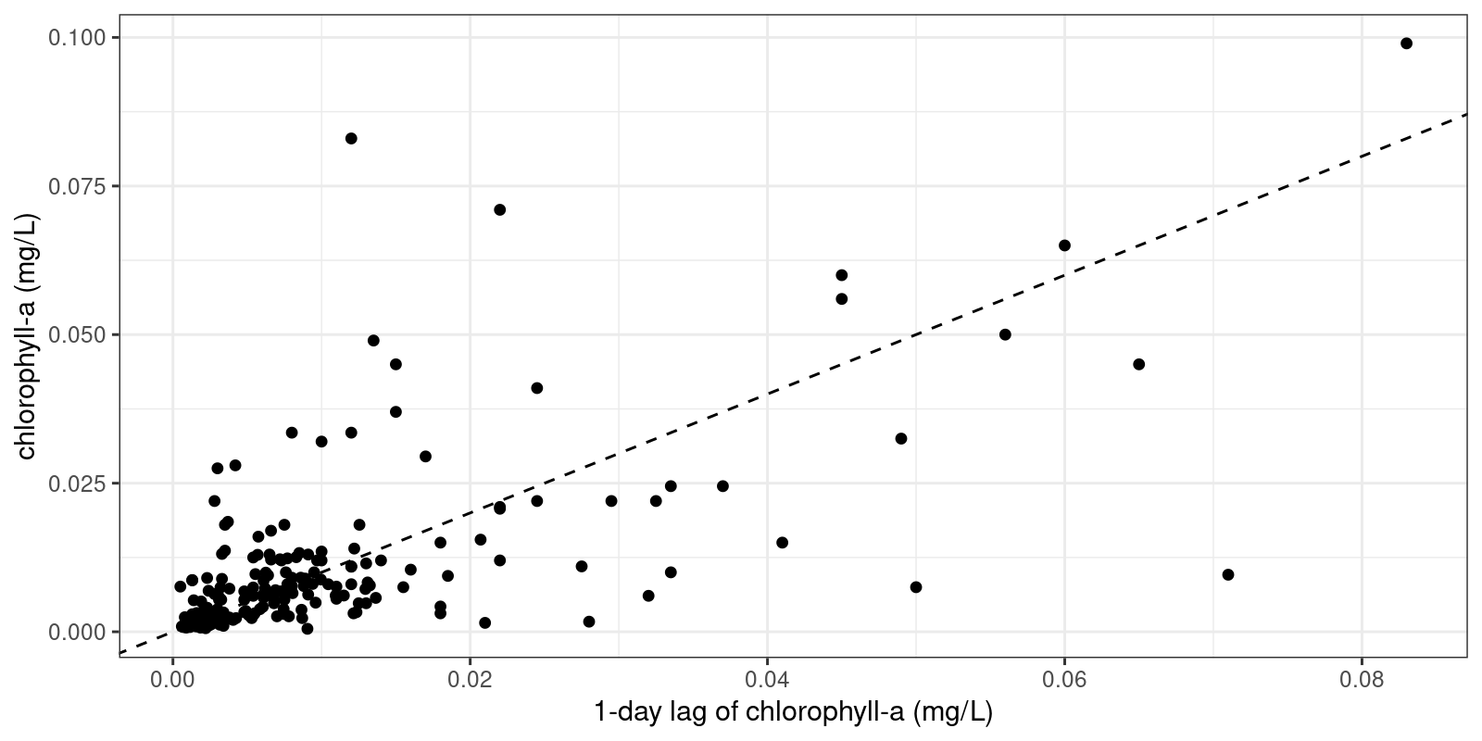
Bartlett Experimental Forest
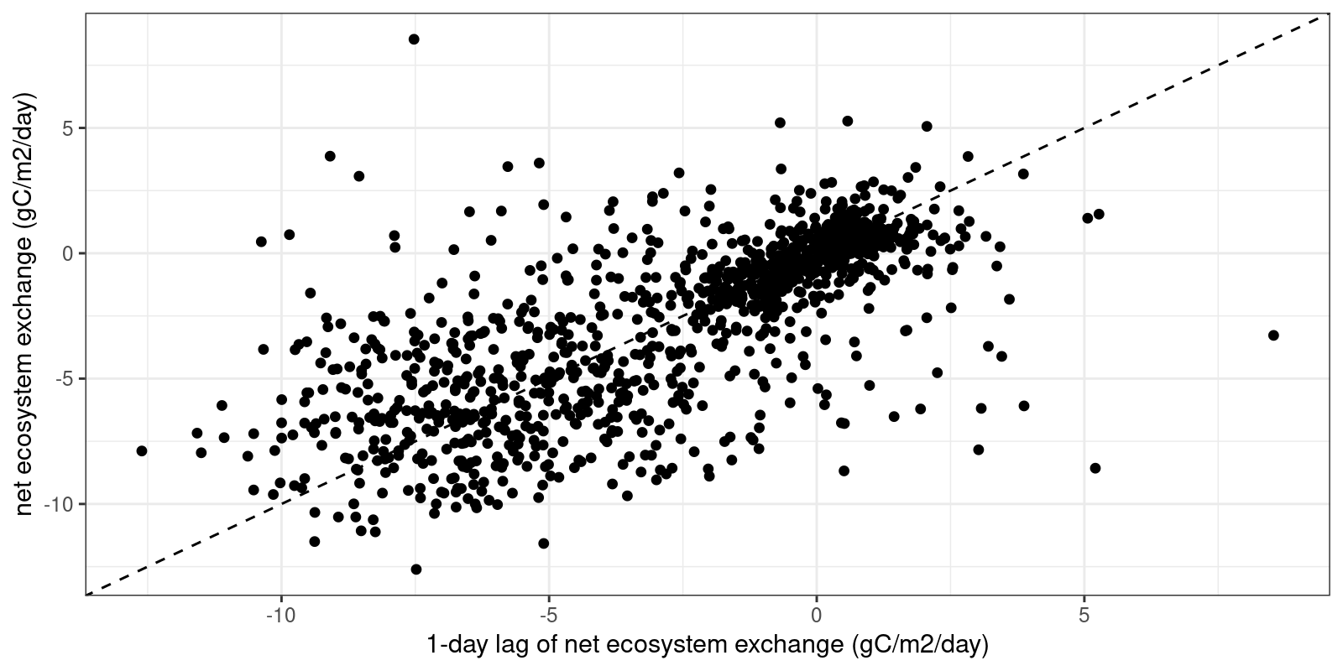
Figure 1. Target variable vs. one-day lag of environmental case study target variable

- Compare the R² value between the one-day lag and the current value of your target variable with the R² values you received when investigating relationships between environmental variables and the target variables in Objective 2, Q6. Which R² value is the highest, and what does this mean about the relative importance of the one-day lag vs. environmental variables in predicting your target variable?
Answer: For both case studies, the R² of the one-day lag of the target variable is higher than the R² for any environmental variable in Objective 2, indicating that a one-day lag is likely to be an extremely important component of an accurate predictive model, perhaps more so than other environmental variables.
- Observe the PACF (partial autocorrelation function) plot on the right. Based on this figure, how many lags of the target variable do you anticipate being included in the fitted ARIMA model? Explain your reasoning.
Answer: Student answers will vary; for both the Canning River and the Bartlett Experimental Forest, the PACF of chlorophyll-a and NEE, respectively, drops off steeply after one day, so a reasonable answer might be that they expect one lag to be included in the model.

Please download the plot associated with Q10 and copy-paste it into your report below.
Canning River
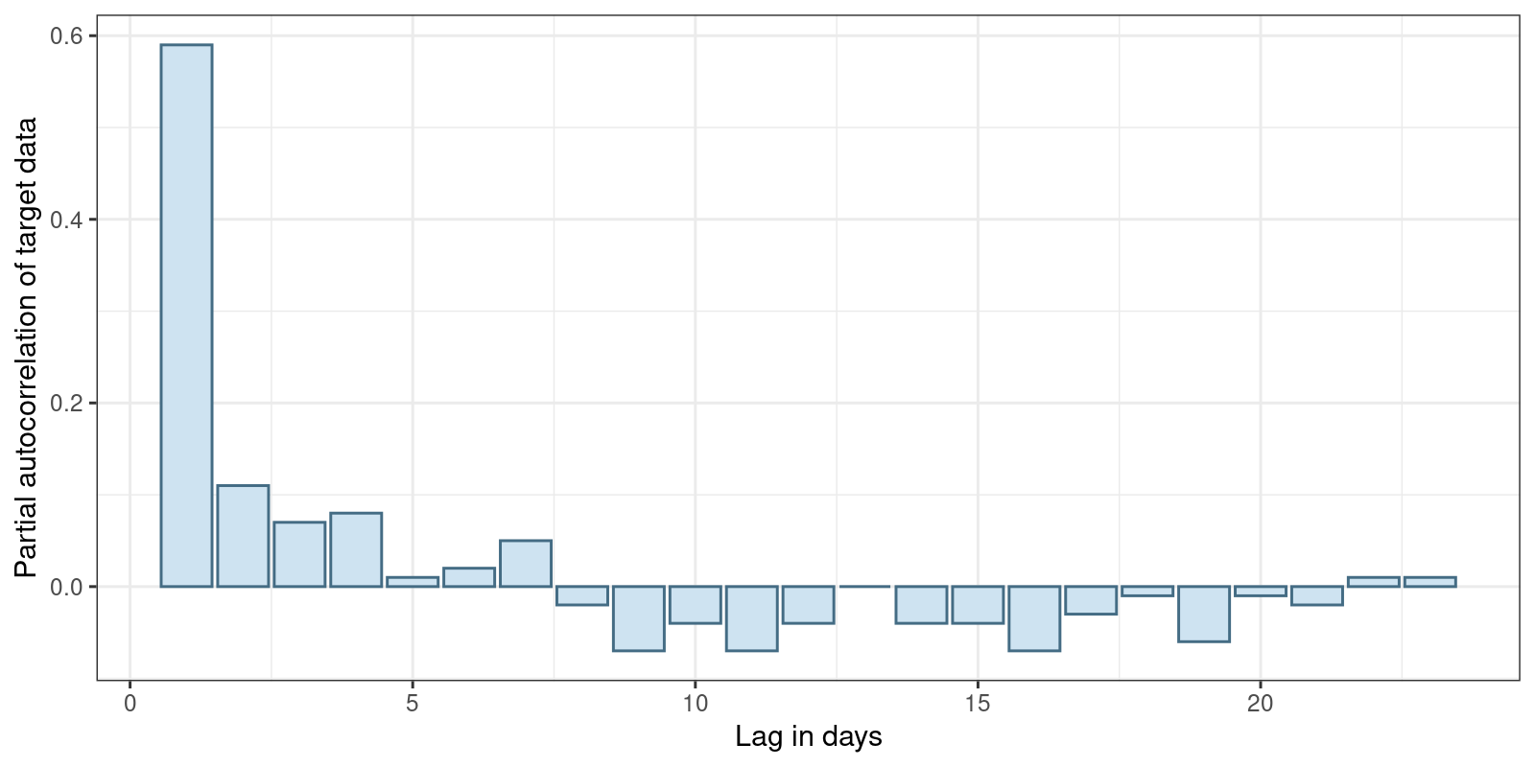

Bartlett Experimental Forest
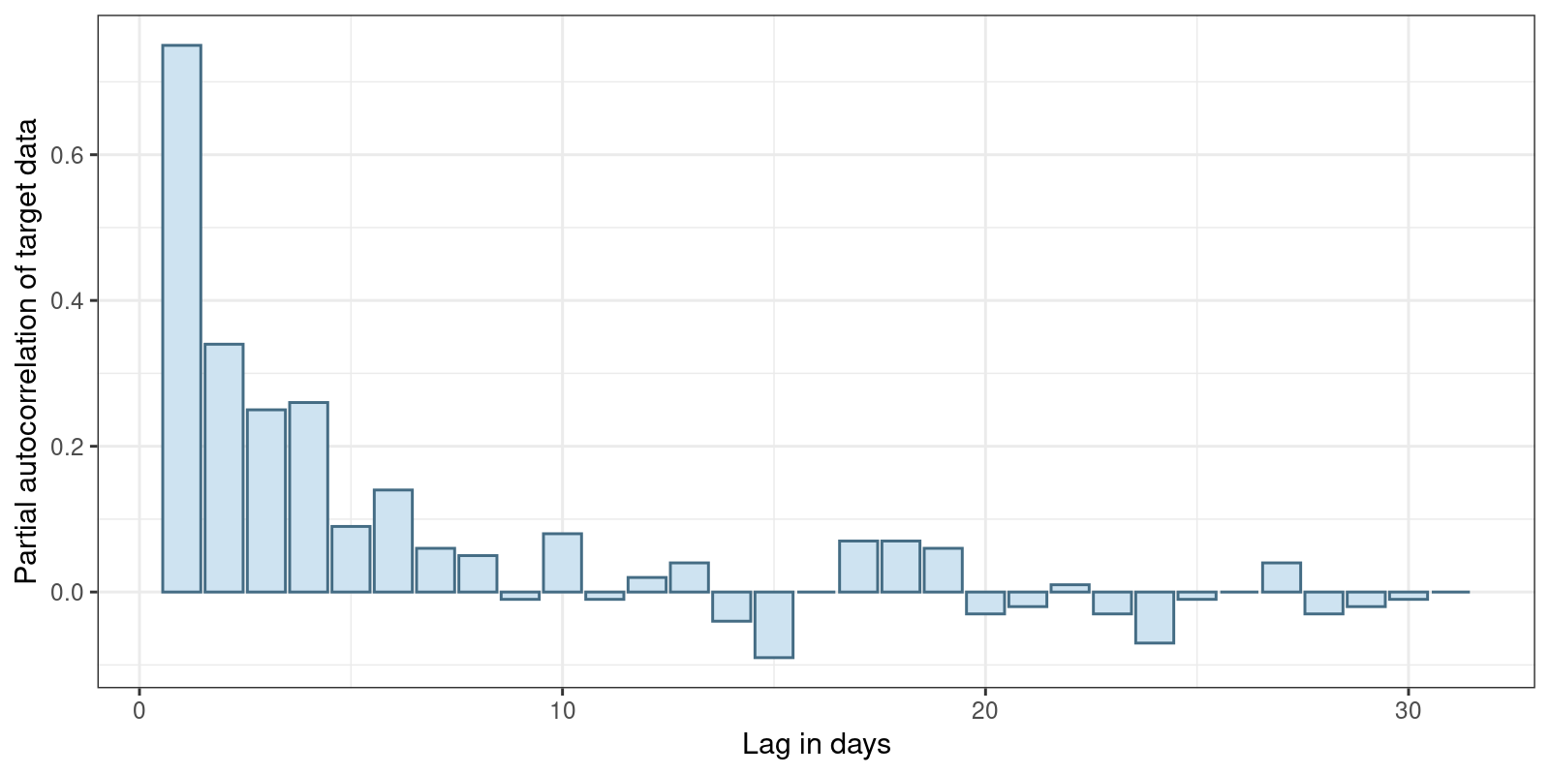
Figure 2. Partial autocorrelation of environmental case study target variable

- Observe the plot on the right. Based on visual inspection, does differencing substantially improve the stationarity of the target variable data? Explain your reasoning.
Answer: For both case studies, differencing likely does improve stationarity with respect to the mean (the mean becomes less variable over time with differencing) but not really with respect to the variance (in both cases, the variance still changes quite a bit over time even with differenced data, likely due to seasonality).
Please download the plot associated with Q11 and copy-paste it into your report below.
Canning River
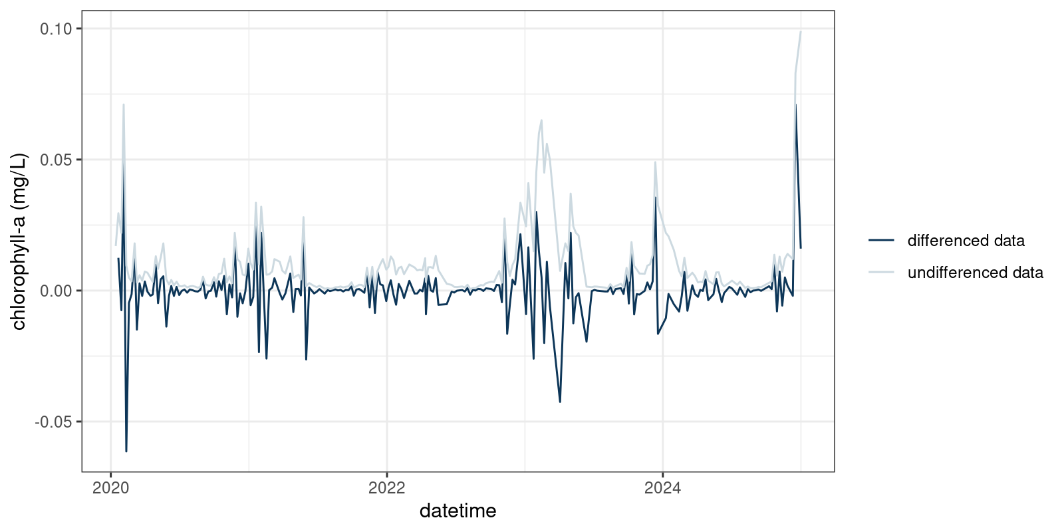
Bartlett Experimental Forest
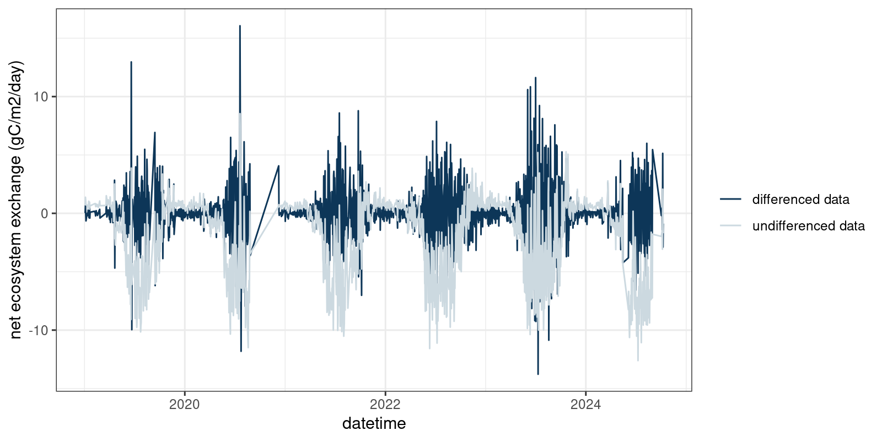
Figure 3. Differenced time series of environmental case study target variable

Objective 4: Fit model

Fit a ARIMA time series model to the data from your chosen environmental case study.

- List up to three exogenous regressors that you would like to include in your fitted ARIMA model. For each regressor, explain why you chose to include it in the model. If you choose not to include any regressors, explain your reasoning.
Answer:
Student answers will vary. It would be a reasonable choice not to include any exogenous regressors as the R² of the one-day lag is higher than that of any regressor. It would also be reasonable to include one or more regressors with relatively high values of R².
- Examine the (p, d, q) order of your ARIMA model printed above. Interpret the order of your ARIMA.
a. Record the order of your ARIMA model printed above.
Answer: Student answers will vary but should be in the form of (p, d, q).
b. How many lags are included in the model? How do you know?
Answer: Student answers will vary but they should provide the value for (p) in their fitted model as the number of lags.
c. Are the data differenced to fit the model? How do you know?
Answer: Student answers will vary but if the (d) in their model order is not 0, the data are differenced.
d. How many timesteps of previous errors are included in the model? How do you know?
Answer: Student answers will vary but they should provide the value for (q) in their fitted model as the number of timesteps.
- Which term is most important in your fitted model (i.e., has the greatest absolute value)?
Answer: Student answers will vary depending on the model structure they chose, but often it is one of the lag terms.
- If the standard error of a term is bigger than the absolute value of the estimate of a term, we cannot say for sure that the effect of that term is meaningfully different from 0. Are there any terms in your model that are not meaningfully different from 0? Which ones?
Answer: Student answers will vary depending on the model structure they chose.
- If you included exogenous regressors, assess their importance in the model. Based on the term estimates and standard errors, were these variables important in your final, fitted model? Explain your reasoning. If you did not include exogenous regressors, please state this.
Answer: Student answers will vary depending on the model structure they chose, but it is likely that the exogenous regressors were not very important compared to, e.g., the lag terms.

Objective 5: Assess model fit

Assess the fit of the ARIMA model using out-of-sample test data from your chosen environmental case study.

- Inspect the plot on the right. How well do you think the model predictions fit the observations in the test dataset? Explain your reasoning.
Answer: Student answers will vary depending on the model structure they chose; students may mention the degree of correspondence between the line representing the model predictions and the patterns in the data as a method of assessing how well the model predictions fit the observations.
Please download the plot associated with Q17 and copy-paste it into your report below.
Example plots are provided for both case studies for ARIMAs fit using no exogenous regressors.
Canning River
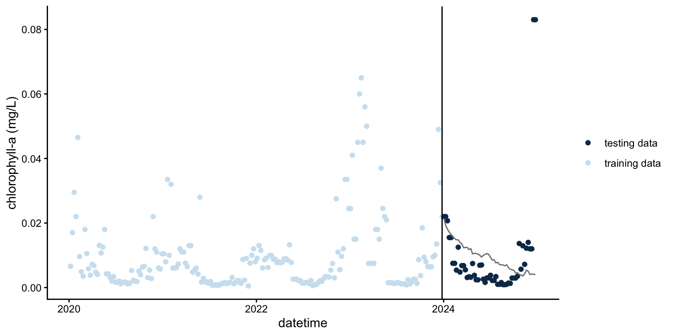
Bartlett Experimental Forest
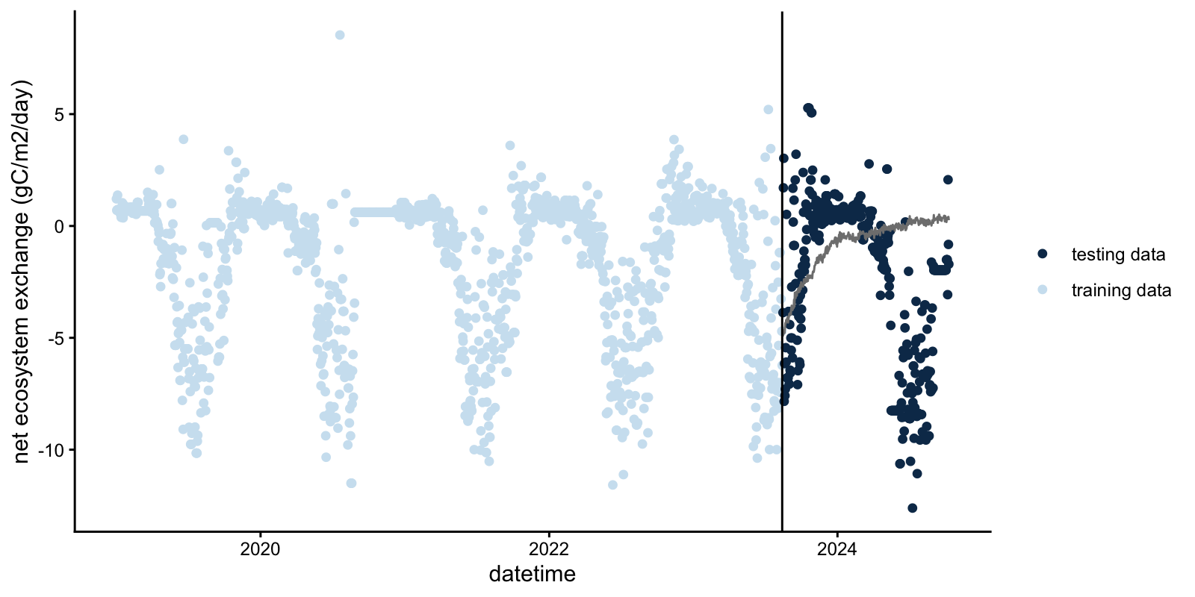
Figure 4. ARIMA predictions of out-of-sample observations of the environmental case study target variable
- Briefly describe in your own words how a 95% predictive interval can be estimated using the standard deviation of the model residuals.
Answer: If you assume a normal distribution for your predictions, the 95% prediction interval is the prediction plus/minus two times the standard deviation of the residuals.
- Record the standard deviation of the model residuals.
Answer: Student answers will vary depending on their model structure.
- Inspect the plot of model predictions with uncertainty. Now that you can see the uncertainty associated with model predictions, how well do you think the model predictions fit the observations in the test dataset? Explain your reasoning.
Answer: Student answers will vary.

Please download the plot associated with Q20 and copy-paste it into your report below.
Example plots for each case study for ARIMAs fit using no exogenous regressors are provided.
Canning River
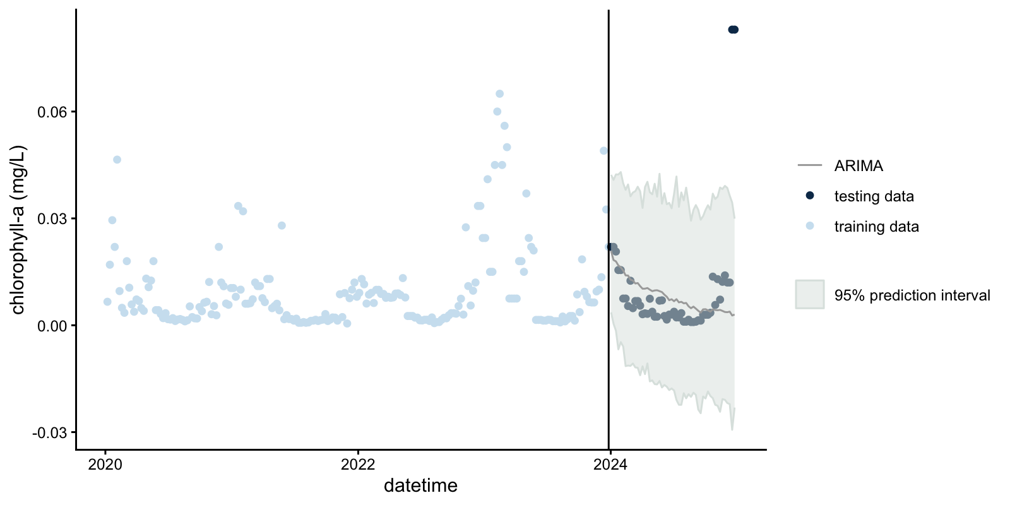

Bartlett Experimental Forest
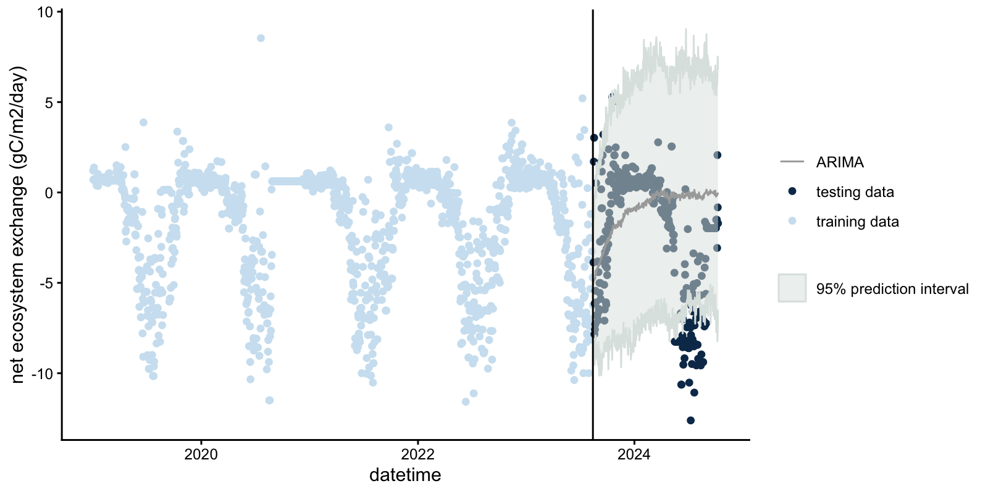
Figure 5. ARIMA predictions with uncertainty of out-of-sample observations of the environmental case study target variable
- Compare your answers to Q17 and Q20. Were there any differences in your interpretation of model fit when you visualized predictions with and without uncertainty? Why do you think this might be?
Answer: Student answers will vary. It is likely that they may change their opinion of the model fit when comparing answers between Q17 and Q20.
- Briefly define (a) RMSE and (b) ignorance score in your own words.
Answer:
RMSE is root mean square error and assesses, on average, how far your predictions are from observations; the lower the RMSE, the better the predictions
The ignorance score assesses predictions based on the probability that the predictions assigns to the actual outcome. The ignorance score can only be calculated for predictions with uncertainty.
- Click “Assess model” and record the value of the RMSE and ignorance score for your fitted ARIMA model.
Answer: Student answers will vary depending on their model structure.
- Compare the RMSE and ignorance score for your model to your partner’s model. Whose model scored better? Explain your reasoning.
Answer: Student answers will vary depending on their model structure.

Activity B: Upload your own data and fit a time series model

Objective 6: Upload standardized data

In this objective, you will learn about the importance of data standards for reproducible scientific analyses, as well as wrangle and upload a new environmental dataset of your choosing.

- Describe one example of a benefit of using data standards in ecology and environmental science, as well as one example of a risk if data standards are not followed.
Answer: Student answers will vary. Examples of benefits are that standardized metadata help future users understand how to use the data appropriately, and standardized datasets are machine-readable and therefore ready to be used in computer analyses. Examples of risks are that you or future users might have to do extra work to make the data machine readable, or accidentally misuse the data if they are not in a standardized format because of misunderstandings about the data structure due to lack of metadata.
- Is the standardized data format for this module a long or a wide format? Explain how you know.
Answer: A long format because there is a column for ‘variable’ instead of each variable having its own column.
- Fill out the following information:
  - Minimum number of timesteps required for dataset
Answer: 100
  - Maximum number of allowed unique values for ‘site_id’.
Answer: 1
  - Maximum number of allowed unique values for ‘variable’.
Answer: 10
  - Required format of ‘date’ column, using Y for year, M for month, and D for day.
Answer: YYYY-MM-DD

Objective 7: Fit an ARIMA model to your standardized dataset

Fit a ARIMA time series model to the data you uploaded in Objective 6.

- What is the target variable for your dataset?
Answer: Student answers will vary depending on their dataset.
- List the three exogenous regressors that you would like to include in your ARIMA model. For each regressor, explain why you chose to include it in the model. If you choose not to include any regressors, explain your reasoning.
Answer: Student answers will vary.
- Record the proportion of data you chose to use for model training.
Answer: Student answers will vary.
- Examine the (p, d, q) order of your ARIMA model printed above. Interpret the order of your ARIMA.
  - Record the order of your ARIMA model printed above.
Answer: Student answers will vary depending on their model structure but should be in the (p, d, q) format.
  - How many lags are included in the model? How do you know?
Answer: Student answers will vary but they should provide the value for (p) in their fitted model as the number of lags.
  - Are the data differenced to fit the model? How do you know?
Answer: Student answers will vary but if the (d) in their model order is not 0, the data are differenced.
  - How many timesteps of previous errors are included in the model? How do you know?
Answer: Student answers will vary but they should provide the value for (q) in their fitted model as the number of timesteps.
- Which term is most important in your fitted model (i.e., has the greatest absolute value)?
Answer: Student answers will vary depending on their dataset and model structure.

Objective 8: Assess model fit

Assess the fit of the ARIMA model from Objective 7 using out-of-sample test data from the dataset you uploaded in Objective 6.

- Inspect the plot above. How well do you think the model predictions with uncertainty fit the observations in the test dataset? Explain your reasoning.
Answer: Student answers will vary depending on their dataset and model structure.
Please download the plot associated with Q33 and copy-paste it into your report below.
Example plots for the two example datasets (Konza Prarie and Kent St. Weir) provided with the module for use in Activities B and C are provided below. These plots are for ARIMA models fit with no exogenous regressors.

Kent St. Weir – note negative predictions for chlorophyll-a! As negative values of chlorophyll-a are not possible, this may be a discussion point for students. How could we prevent the ARIMA model from giving us negative predictions for a variable that we know is never negative?
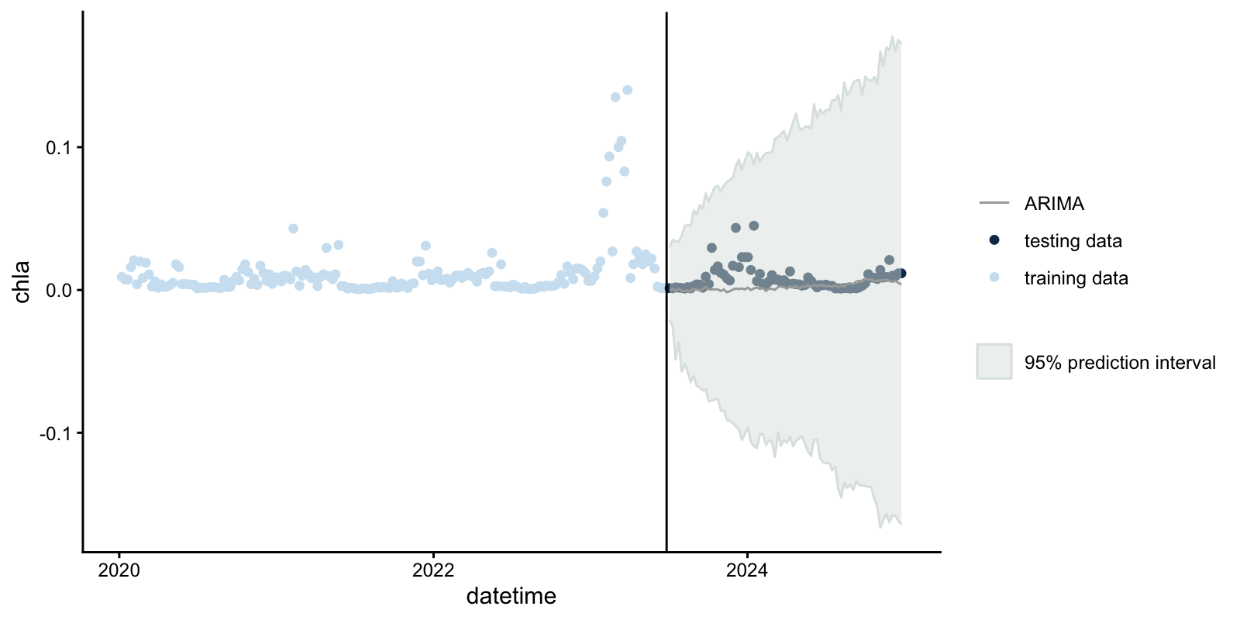

Konza Prarie
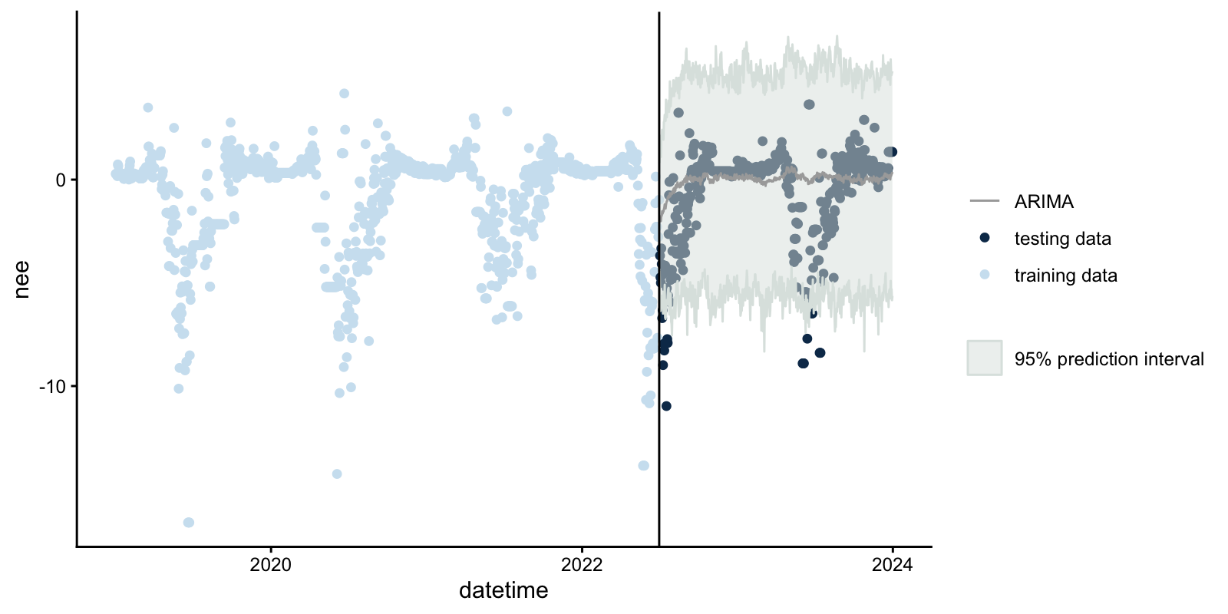
Figure 6. ARIMA predictions with uncertainty of out-of-sample observations of the standardized dataset target variable
- Record the RMSE and ignorance score for your model.
Answer: Student answers will vary depending on their dataset and model structure.

Activity C: Compare predictive performance across models

Objective 9: Fit additional models

Fit three additional models to the data you uploaded in Objective 6. You will fit an autoregressive neural network model, a persistence model, and a day-of-year model.

- Briefly describe, in your own words, each of the three additional models you will be fitting to your data.
  - autoregressive neural network model (NNETAR)
Answer: NNETAR models are designed to mimic the human brain. They have an input layer, an output layer, and at least one hidden layer of neurons. Data are either linearly or non-linearly transformed between layers, and autoregressive neural networks can use lagged values of the target variable as predictors in the model.
  - historical mean model
Answer: A historical mean model uses the mean of previous observations as the prediction for the next timestep.
  - day-of-year model (DOY)
Answer: A day-of-year model uses the Julian day of the year (1-365) to predict the target variable.
- Why are baseline or “null” models useful when conducting model comparisons?
Answer: If you compare a more complex model to a simple baseline or null model and the more complex model does not outperform the null model, you have learned that the additional complexity is not adding value to your model predictions.
- How many lags are used as inputs in your fitted NNETAR model, and how many neurons are in the hidden layer? Explain how you know.
Answer: Student answers will vary depending on their dataset and model structure. The model structure for the NNETAR model is provided as NNAR(p, k). The number of lags used as inputs is (p) and the number of neurons in the hidden layer is (k).
- Use the interactive plot legend to examine the fit of the mean model and the DOY model. Typically, the fit of the DOY model is a curvy line, while the mean model is a flat line. Use your understanding of the structure of these two models to explain why.
Answer: The mean model is a flat line because it is always using a single value (the mean of historical observations) as the predicted value for future observations. The DOY model is often a curvy line because many environmental variables vary in their magnitude throughout the year, and so the model will capture that annual variability and provide different predictions at different times of year.
Please download the plot associated with Q38 and copy-paste it into your report below.
Example plots for the two example datasets provided with the module (Konza Prarie and Kent St. Weir) for use in Activities B and C are provided below. These plots are for models fit with no exogenous regressors.
Kent St. Weir
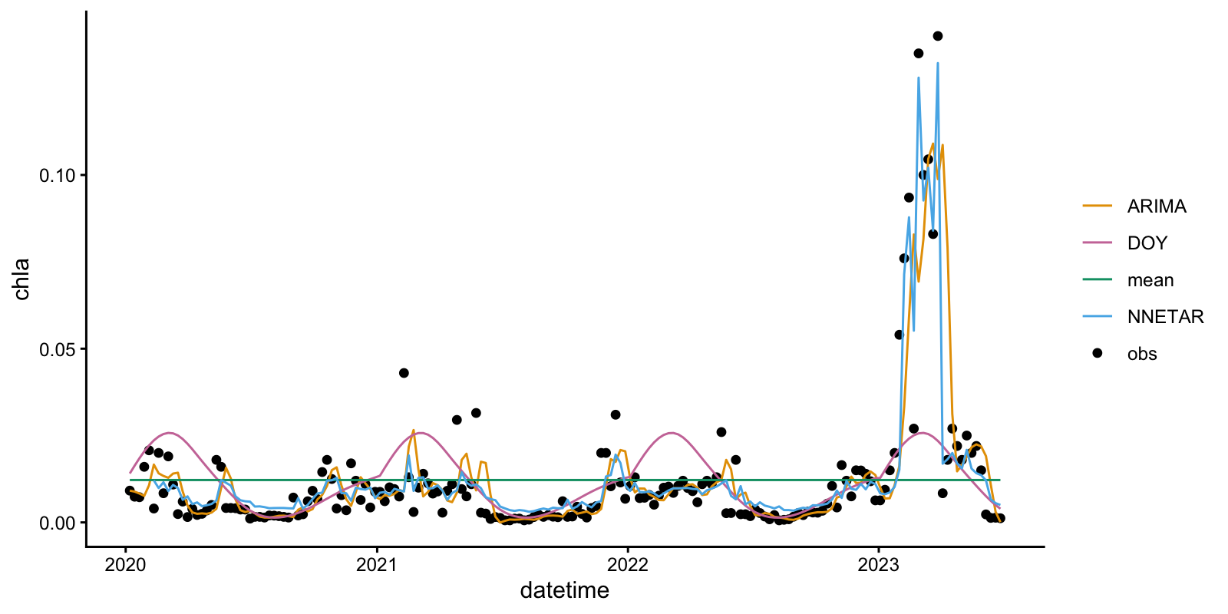
Konza Prarie
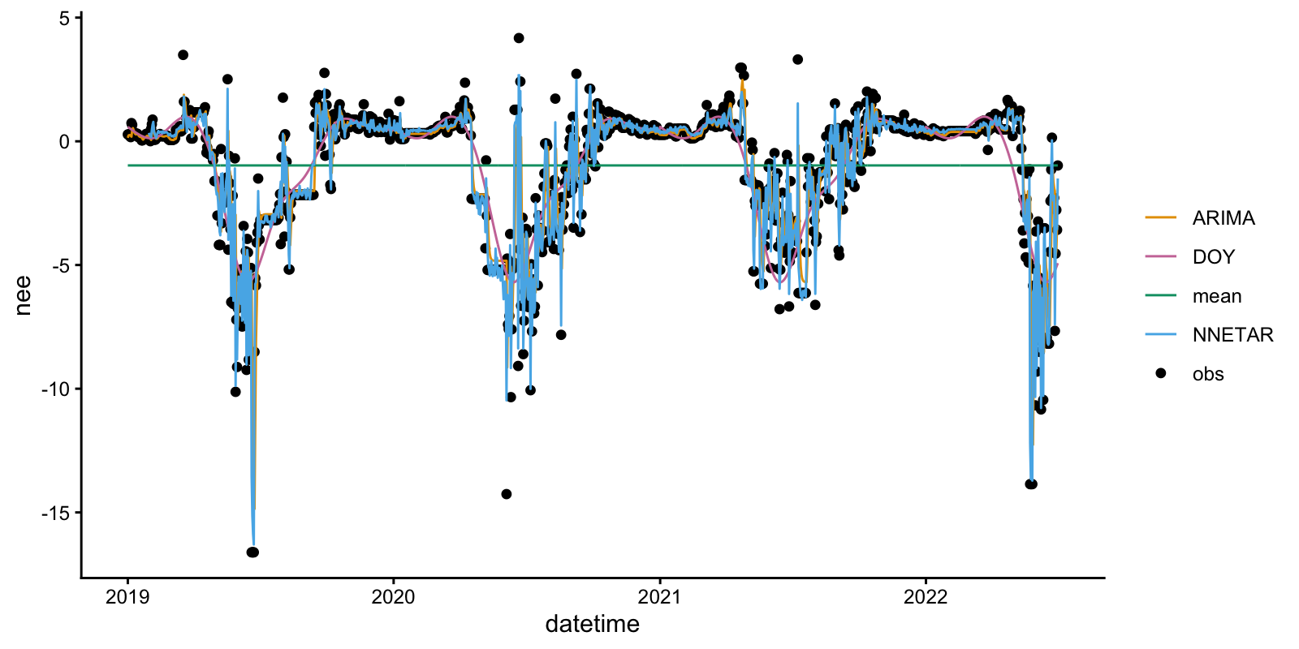
Figure 7. ARIMA, NNETAR, persistence, and DOY model fits for the standardized dataset target variable

Objective 10: Compare model performance

Compare predictive performance across models on the testing data from the dataset you uploaded in Objective 6.

- Which of the models has the smallest standard deviation of the residuals? Which has the largest?
Answer: Student answers will vary based on their dataset and model structure.
Please download the plot associated with Q39 and copy-paste it into your report below.
Example plots for the two example datasets provided with the module (Konza Prarie and Kent St. Weir) for use in Activities B and C are provided below. These plots are for models fit with no exogenous regressors.
Kent St. Weir
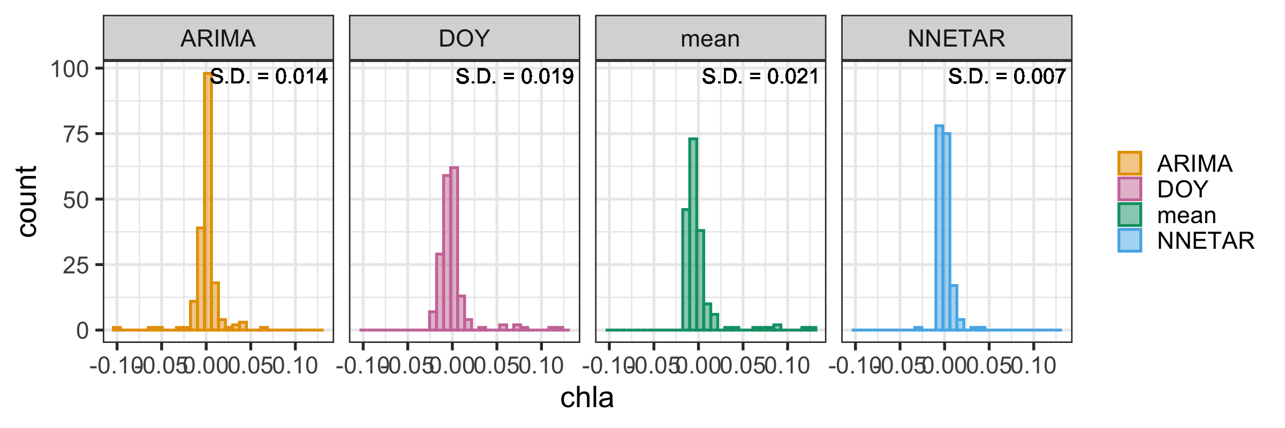
Konza Prarie
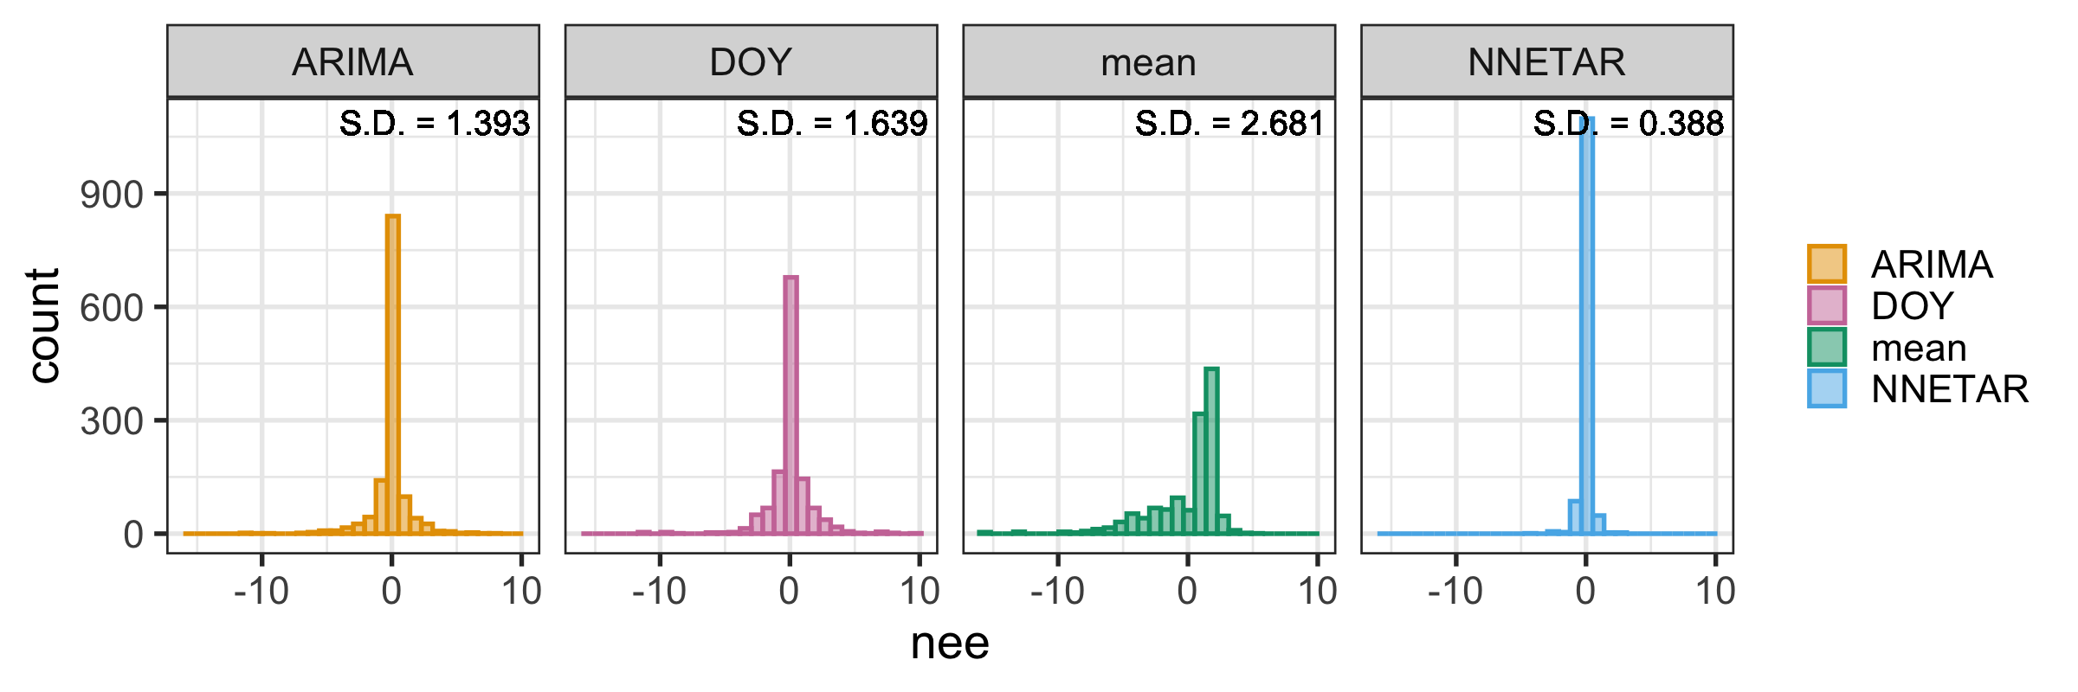
Figure 8. Distributions of the residuals of ARIMA, NNETAR, persistence, and DOY model fits for the standardized dataset target variable
- Interpret the values of the standard deviation of the residuals for the four models. Which model do you expect to have the largest predictve uncertainty interval when you generate predictions with uncertainty? Explain your reasoning.
Answer: Student answers will vary based on their dataset and model structure.
- Which of the models has the largest predictive uncertainty interval? Does this match what you predicted in Q40?
Answer: Student answers will vary based on their dataset and model structure.
Please download the plot associated with Q41 and copy-paste it into your report below.
Example plots for the two example datasets provided with the module (Konza Prarie and Kent St. Weir) for use in Activities B and C are provided below. These plots are for models fit with no exogenous regressors.

Kent St. Weir
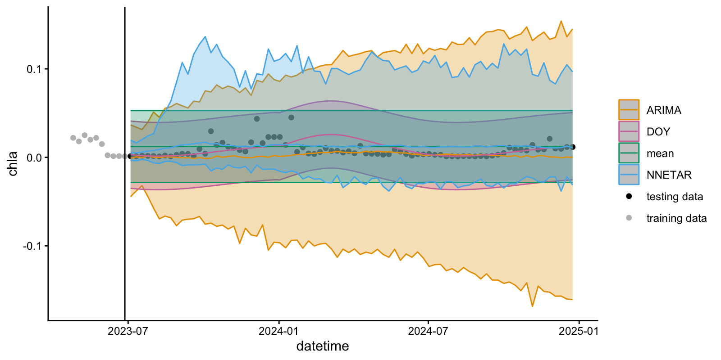

Konza Prarie
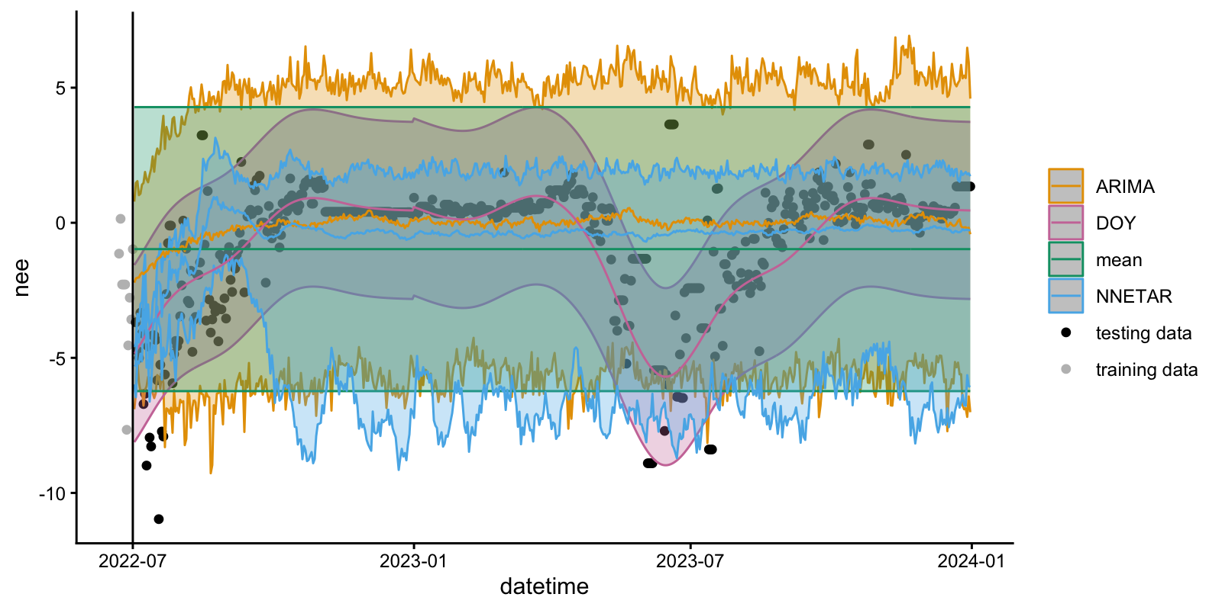
Figure 9. Predictions with uncertainty of ARIMA, NNETAR, persistence, and DOY models fit to the standardized dataset target variable
- Based on visual inspection of the plot of predictions with uncertainty, which model do you think has the highest predictive skill? Explain your reasoning.
Answer: Student answers will vary based on their dataset and model structure.
- Record the RMSE and ignorance scores of your four models.
Student answers will vary based on their dataset and model structure.
Table 4. RMSE and ignorance score of the ARIMA, NNETAR, persistence, and DOY models
Model | RMSE | ignorance
ARIMA
NNETAR
persistence
DOY

- Which of your models performs best according to RMSE?
Answer: Student answers will vary based on their dataset and model structure.
- Which of your models performs best according to the ignorance score?
Answer: Student answers will vary based on their dataset and model structure.
- Did the more complex models (ARIMA, NNETAR) perform better than the historical mean and/or DOY models? What does this result indicate about the importance of using more complex models (and exogenous regressors if you chose to include them) for predicting the target variable in your chosen dataset?
Answer: Student answers will vary based on their dataset and model structure.
This module was initially developed by: Lofton, M.E., Hipsey, M.R., Kurucz, K., and C.C. Carey. 07 August 2025. Macrosystems EDDIE: Time Series Modeling and Prediction of Environmental Data Module 11, Version 1. https://serc.carleton.edu/eddie/teaching_materials/modules/module11.html. Module development was supported by NSF grants EF 2318861, DEB 2213550, and OISE 2330211. This document last modified: 25 February 2026 by M.E. Lofton.
Module authorship contributions: MEL led the development of all module materials (R Shiny App and associated code, PowerPoint presentations, instructor manual, student handout). The module was conceptualized by MEL, CCC, and MRH. KK provided dataset assistance and all coauthors provided feedback on the module content and materials. Funding was provided by CCC..

