# Intel Deep Learning Training Tool

Intel DL Training Tool is a web based tool which helps you easily develop and train deep learning solutions using your own hardware. It is built on top of Caffe and Tensorflow frameworks.

It can run only on Linux and MacOS. Windows users will need to run a virtual Linux machine.

Its installer is available for Windows, Linux and MacOS at <https://software.intel.com/en-us/deep-learning-training-tool>. Windows and Mac installers have a GUI, while Linux installer is only a command line tool.

## Installation on Windows

Windows Deep Learning Training Tool runs on Linux and MacOS. If you have a Windows PC, you will need to run a virtual Linux machine on top of Virtualbox.

1. Copy Windows folder from USB sticks to your PC.
2. Install VirtualBox on your computer.
3. Start Virtualbox  
   Click File > Import Appliance

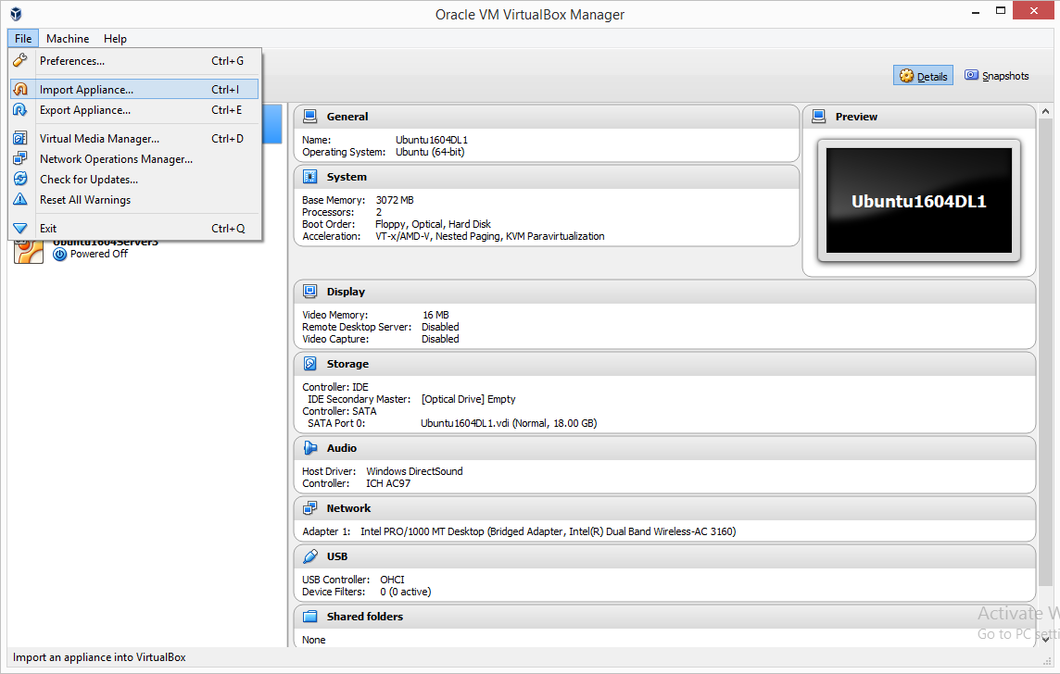

1. Select Ubuntu1604Server.ova file.  
   Adjust how many CPUs and how much memory you want to give to the virtual machine.  
   Click Import

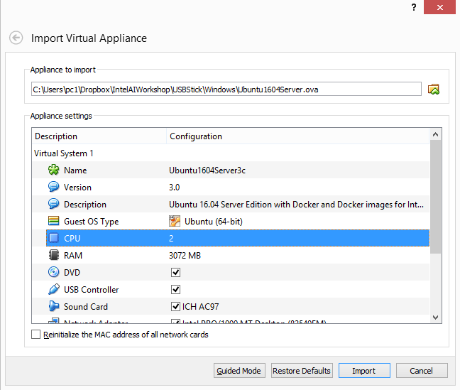

1. Start the virtual machine.
2. Login to the virtual machine. (username: demo, password: intel)
3. Run 'ifconfig' to learn its IP address. Note the IP address of the interface **enp0s3**.

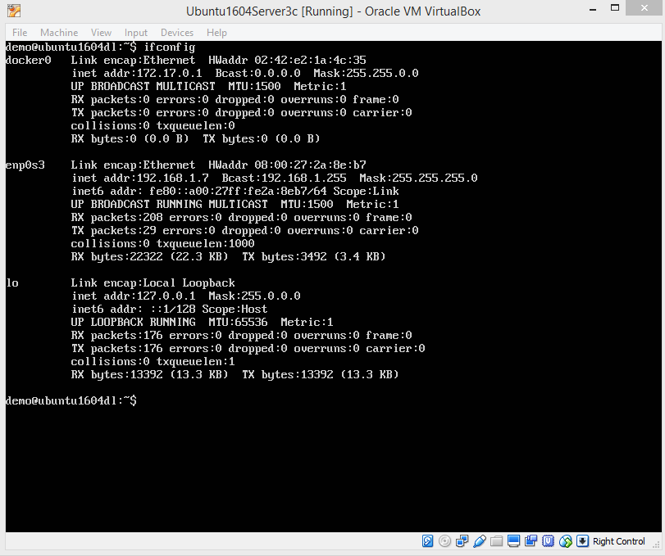

1. Start the installer.

Select “On my network Linux machine” option.

1. Enter IP address, user name (demo) and the password (intel).  
   Start installation.

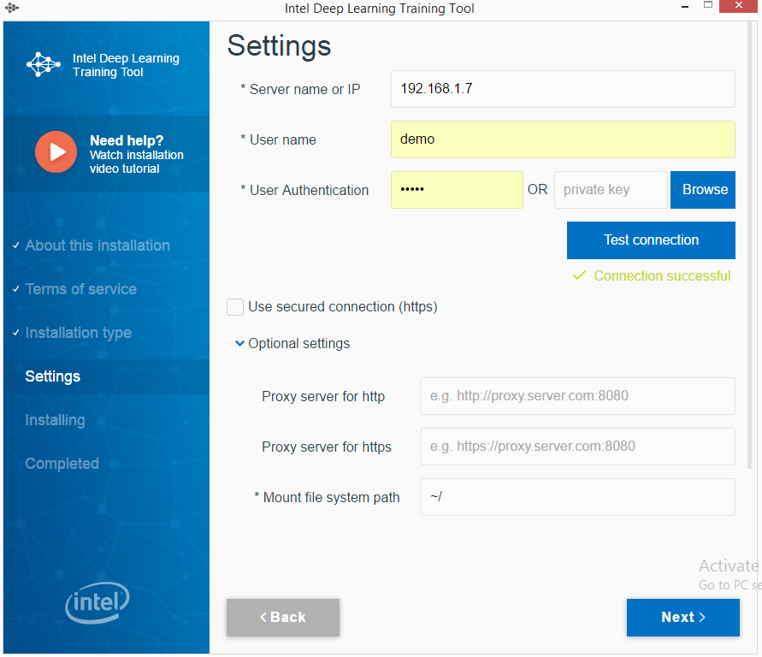

1. Note the address and the password.

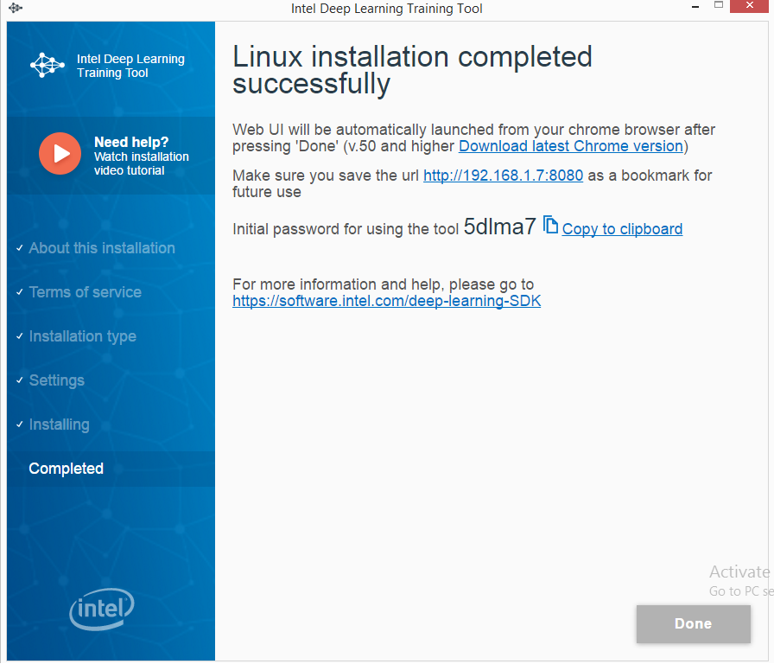

## Installation on Linux

Intel DL Training Tool is deployed as a set of Docker images. Normally, the installer installs Docker and pulls required images from the internet. However, it takes much time. To speed up the installation during this workshop, Docker and required images are distributed on USB sticks and preloaded following these steps.

1. Copy Linux folder from USB sticks to your PC.
2. Install Docker following the steps:

sudo apt-get update  
curl -fsSL https://download.docker.com/linux/ubuntu/gpg | sudo apt-key add -  
sudo add-apt-repository "deb [arch=amd64] https://download.docker.com/linux/ubuntu $(lsb_release -cs) stable"  
sudo apt-get update  
apt-cache policy docker-ce  
sudo apt-get install -y docker-ce  
sudo systemctl status docker

1. Extract docker_images.zip file.
2. Load Docker images following the steps:

sudo docker load -i docker-caffe.tar  
sudo docker load -i docker-tf.tar

sudo docker load -i docker-js.tar

sudo docker load -i docker-etcd.tar

sudo docker load -i docker-hyperkube.tar

sudo docker load -i docker-k8.tar

sudo docker load -i docker-kube.tar

sudo docker load -i docker-pause.tar

1. Run the installer:

./ install_training_tool.sh

## Installation on Mac

Intel DL Training Tool is deployed as a set of Docker images. Normally, the installer installs Docker and pulls required images from the internet. However, it takes much time. To speed up the installation during this workshop, Docker and required images are distributed on USB sticks and preloaded following these steps.

1. Copy Mac folder from USB sticks to your PC.
2. Install Docker by running Docker.dmg
3. Extract docker_images.zip file.
4. Load Docker images following the steps:

sudo docker load -i docker-caffe.tar  
sudo docker load -i docker-tf.tar

sudo docker load -i docker-js.tar

sudo docker load -i docker-etcd.tar

sudo docker load -i docker-hyperkube.tar

sudo docker load -i docker-k8.tar

sudo docker load -i docker-kube.tar

sudo docker load -i docker-pause.tar

1. Start the installer.