The Title Of Our Paper
Abstract
(摘要内容)
Keywords:

（目录）

1.Introduction

1.1 Problem Background
In the context of the rapidly expanding global tourism industry, ensuring economic benefits while protecting the environment and the well-being of local communities has become an urgent challenge.An important tourist destination, Juneau, Alaska, USA, is facing this problem.The number of cruise ship passengers received by Juneau each year has reached 1.6 million, far exceeding the carrying capacity of its permanent population of 30,000. On the busiest days, as many as seven large cruise ships visit simultaneously, with a total of more than 20,000 tourists on board, thereby exerting tremendous pressure on the city's infrastructure and exacerbating environmental issues, such as the accelerated retreat of the Mendenhall Glacier.
While the tourism industry has proven to be financially advantageous, generating approximately $375 million for Juno, its hidden costs, including pressure on infrastructure, increased carbon footprint, and impact on the quality of life of local residents, are gradually becoming apparent.To address these challenges, Juno City must develop and implement sustainable tourism management strategies to strike a balance between economic benefits and environmental protection.
1.2 Restatement of the Problem
The objective of this study is to establish a sustainable tourism industry model that will optimize the number of tourists and overall income, while implementing effective management measures. To this end, the following tasks must be completed:
First, the optimization objective is to reduce negative impacts on the environment and community while maintaining or increasing tourism revenue.
Second, the constraints to be considered include daily tourist limit, infrastructure carrying capacity, environmental protection needs (such as controlling glacier retreat rate), and the quality of life of local residents.
The expenditure plan is as follows: the additional income will be allocated to support environmental protection, infrastructure improvement, and community development plans, thereby promoting the sustainable tourism development of Juno through a model feedback mechanism.
The sensitivity analysis will evaluate the model's sensitivity to key variables such as tourist numbers, tax policies, and environmental protection measures to identify the most important factors and optimize decisions.
The objective of this study is to provide a feasible solution that balances economy and environment for Juno City, while also serving as a reference for other tourism destinations facing similar challenges.

1.3 Literature Review
In light of the global emphasis on sustainable development, tourism, as a significant economic catalyst, is confronted with the imperative of harmonizing economic advancement with environmental preservation.Pan et al. (2018) in their study observed that while sustainable tourism has achieved some progress in the transition to a green economy, it continues to grapple with numerous challenges. These challenges encompass the effective management of resources, the reduction of carbon emissions, and the harmonization of tourism demand and environmental protection.
In addressing the challenge of optimizing tourism demand, Sun et al. (2020) have proposed a novel concept: the management of carbon emissions from tourism through the optimization of the tourism demand mix. Their study underscored that the carbon footprint of tourism can be meaningfully reduced by strategically adjusting tourist origin and the nature of tourism activities. This concept offers novel approaches for tourism destinations to simultaneously maintain economic returns and achieve sustainable development goals.
The impact of climate change on tourism is also an important area of research. Scott et al. (2004) explored how climate change affects the distribution of tourism resources in North America, noting that climate change may lead to significant changes in tourism seasons and destinations. This is particularly salient for tourism destinations that depend on natural landscapes and outdoor activities.
Triwijoyo et al. (2024) proposed an optimization model for multi-criteria decision analysis for intelligent and sustainable sport tourism planning, emphasizing the integration of multiple factors in the decision-making process to achieve sustainable tourism development.
Hardy et al. (2002) provided an overview of the concept of sustainable tourism, stating that sustainable tourism involves not only environmental protection but also social and economic sustainability. They underscored the necessity to consider these factors holistically in tourism development to ensure long-term sustainability.The hidden costs of tourism have also garnered the attention of scholars.
Lusseau (2004) examined the long-term impacts of tourism activities through behavioral information, revealing the potential long-term damage of tourism to ecosystems. This underscores the importance of taking these hidden costs into account when formulating tourism policies.
Garrigos-Simon et al. (2018) explored the relationship between tourism and sustainability through bibliometric and visualization analyses, revealing research trends and hotspots in the field, which provides guidance for future research directions.Despite the significant amount of research on sustainable tourism, integrated management strategies for specific areas, such as Juneau, Alaska, are still lacking. This study aims to address this knowledge gap by employing existing theories and methodologies to develop a sustainable tourism development model tailored to the specific context of Juneau, with a focus on incorporating local realities.

1.4 Our Work
The objective of this study is to formulate a sustainable tourism model for the city of Juneau, Alaska. This model aims to optimize visitor numbers and revenues while mitigating the adverse environmental and community impacts of tourism. The following key steps are incorporated into our workflow:
1. The initial phase entailed the compilation of pertinent data concerning the City of Juneau, encompassing visitor statistics, tourism revenues, infrastructure loads, environmental metrics (e.g., glacier retreat rates), and the outcomes of resident satisfaction surveys.Subsequent to this, a preliminary analysis was conducted using statistical analysis tools. This analysis was undertaken to identify salient issues in the prevailing tourism operations and to ascertain the potential for optimization.
2. Based on extant literature and the results of the aforementioned data analysis, we constructed a multi-objective optimization model. The model's objective is to achieve a balance between economic gains and environmental protection, while also striving to enhance the quality of life experienced by residents.The model incorporates various constraints, including the maximum number of daily tourists permissible, the infrastructure's carrying capacity, the requirements for environmental protection (e.g., the control of glacier retreat rate), and the social satisfaction index.
3. We examined the impact of various policy scenarios on tourism. A suite of policy scenarios was meticulously designed, encompassing a range of measures including visitor number limits, tax policies (e.g., increasing hotel taxes and tourist fees), and infrastructure investment strategies.
Utilizing simulation techniques, the impacts of diverse policy combinations on tourism sustainability were evaluated, with particular attention directed towards changes in three dimensions: economic, environmental, and social.
4. Utilizing the model's feedback mechanism, we examined the potential utilization of additional revenues to support environmental protection, infrastructure enhancement, and community development programs.We conducted a sensitivity analysis to ascertain the model's sensitivity to key variables (e.g., number of tourists, tax and fee policies, and environmental protection measures) in order to optimize the decision-making strategy.
5. Subsequent to the construction and simulation of the model, we made further adjustments and optimizations to the model based on associated hidden costs to enhance its applicability to the sustainable tourism assessment of the city of Juneau.In light of the feedback, we made several adjustments and optimizations to the model to better align it with the actual situation in the city of Juneau.

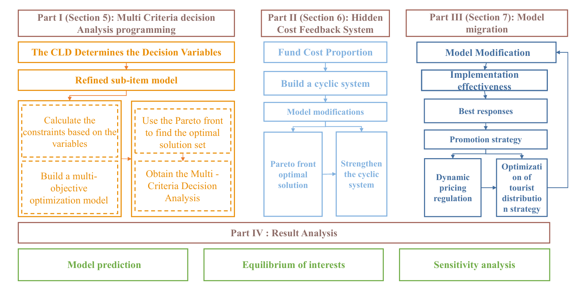
2. Assumptions
To simplify the analysis of variable relationships in sustainable tourism assessment, the following assumptions are made:
Assumption 1：Stable Cruise Ship Parameters
Passenger capacity, per capita consumption, and carbon emission coefficients of different cruise types remain stable.
Explanation: Operational strategy adjustments, market shifts, or tourism trends may alter these parameters.
Assumption 2:Fixed Tourist Spending Patterns
Per capita consumption patterns are assumed constant across cruise types.
Explanation: Economic development, price fluctuations, or destination-specific factors may invalidate this assumption, affecting revenue calculations.
Assumption 3:Constant Operational Costs
Crew expenses, taxes, infrastructure depreciation, and ecological restoration costs are fixed within the evaluation period.
Explanation: Real-world complexities (e.g., inflation, policy changes) may impact cost calculations.
Assumption 4:Linear Social Impact Relationships
Ship docking frequency is linearly correlated with resident satisfaction and housing costs.
Explanation: Simplified—real-world social dynamics involve multiple influencing factors.
Assumption 5:Full Policy Implementation
Government policies (e.g., carbon taxes) achieve their intended outcomes.
Explanation: Unpredictable social or regional variations may hinder policy execution.

3. (待填充)
4. Data
- Part I
5. 1 Economic Revenue Submodel
The cruise ship tourism industry serves as the primary catalyst for economic development in the Juneau region.
The tourism growth trend indicates a significant increase in cruise passenger numbers, with 1.7 million passengers recorded in 2023, marking a 28% growth compared to 2019 figures. Projections estimate an average annual growth rate of 8% in the coming years.
Large cruise ships (≥2,500 passengers) exhibit lower per capita spending ($150/person) but higher total revenue.
Medium-sized vessels (1,000–2,500 passengers) average $200/person
Small ships (<250 passengers) have elevated per capita costs ($500/person) but limited overall contribution.
Economic benefits:
$$R=\sum_{N=1}^{3}{（Cruise*visitor*{Visitor}_{cost}）+{Crew}_{cost}}-Operating cost$$

A large cruise ship can accommodate 4,000 passengers, and the cost of a cruise is calculated as follows: $150 × 4,000 passengers × 10 ships = $6 million per cruise.
A medium-sized cruise ship can accommodate 2,000 passengers, and the cost of a cruise is calculated as follows: $200 × 2,000 passengers × 20 ships = $8 million per cruise.
A small cruise ship can accommodate fewer passengers. 6 ships × 400 passengers × $500 = $1.2 million per cruise.
The total visitor expenditure is estimated to be approximately $15.2 million per season, which is the sum of the expenditures from the large and medium-sized cruise ships.
The annualized expenditure, over a period of six months, is approximately $304 million. This figure is comparable to the 2023 revenue of $320 million generated by cruise ships for the Juneau area.
5.2 Dynamic Adjustment Model of Social Resident SatisfactionDynamic Adjustment of Resident Satisfaction
Impact of ship call frequency:
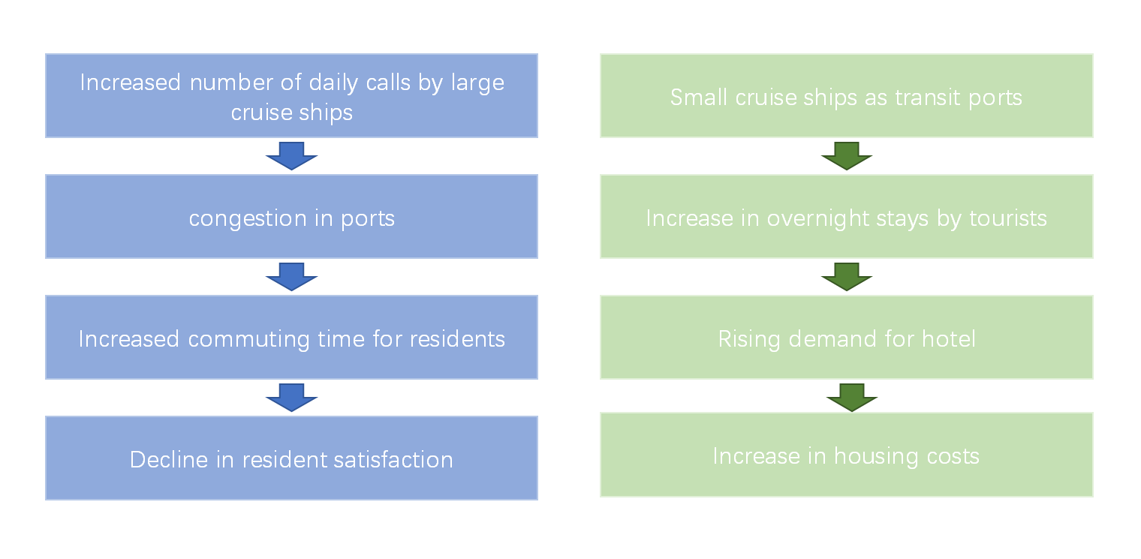
Specifically, it has been observed that for every 10% increase in tourist overnight stays, the housing cost index experiences an increase of 5%.
$$S=100-0.8*\frac{游客数}{容量}-10*住房成本指数+0.5*就业率-2*\frac{大型邮轮停靠数}{日}$$
Constraint Enhancement and Stability Conditions
Additional 10-point drop in resident satisfaction if number of large cruise ship calls >5/day (protest risk)

5.3 Refinement of the Environmental Model
Through the refinement of variables such as cruise ship type, passenger capacity, and call data, the model will achieve more precise quantification of economic, social, and environmental impacts.
- Carbon Emission Factors (based on Cruise Lines International Association data):
- Large cruise ships: 12 tons CO₂/hour
- Medium-sized ships: 8 tons CO₂/hour
- Small cruise ships: 3 tons CO₂/hour
Total Carbon Emissions Formula:

公式
\[
C = \sum (\text{停靠时长} \times \text{船只类型碳排放系数}) + 0.2 \times \text{游客数}
\]

Large cruise ship (10 ships × 12 hours × 12 tons) = 1,440 tons
Medium-sized cruise ships (20 ships × 10 hours × 8 tons) = 1,600 tons
Small cruise ships (6 ships × 24 hours × 3 tons) = 432 tons
Tourist contribution: 1.7 million people × 0.2 tons = 340 tons
Total Carbon Emission \( C ≈ 3,812 tons/season \) → Annualized 7,624 tons, which is a gap in comparison with the environmental threshold.
Dynamic Carbon Emission Formula
$$C_{total}=α*游轮数量+β*游客数+γ*冰川消退速率$$

System calibration based on historical data, set α=0.8 (cruise ship contribution),β=0.2 (tourist activity), γ=50 (glacier feedback)
Glacier recession feedback mechanism:
If the annual reduction rate of glacier area is>0.3${km}^{2}$ ,trigger emergency policy (e.g. 10% downward adjustment of tourist cap).
Air quality regulation:
When AQI<20, allow 10% increase in visitor volume
When AQI>30, reduce the number of cruise ship stops by 15%.

5.4 Multi-Objective Optimization Modeling
A causal loop diagram (CLD) maps feedback relationships among sustainable tourism factors in Juneau. Multi-criteria decision analysis (MCDA) optimizes trade-offs between stakeholder priorities. This study combines CLD and literature review to identify nine key factors (e.g., tourist volume, carbon emissions) and their interactions. MCDA generates solutions balancing economic, social, and environmental goals for sustainable planning.
5.4.1 Causal Loop Diagram Model
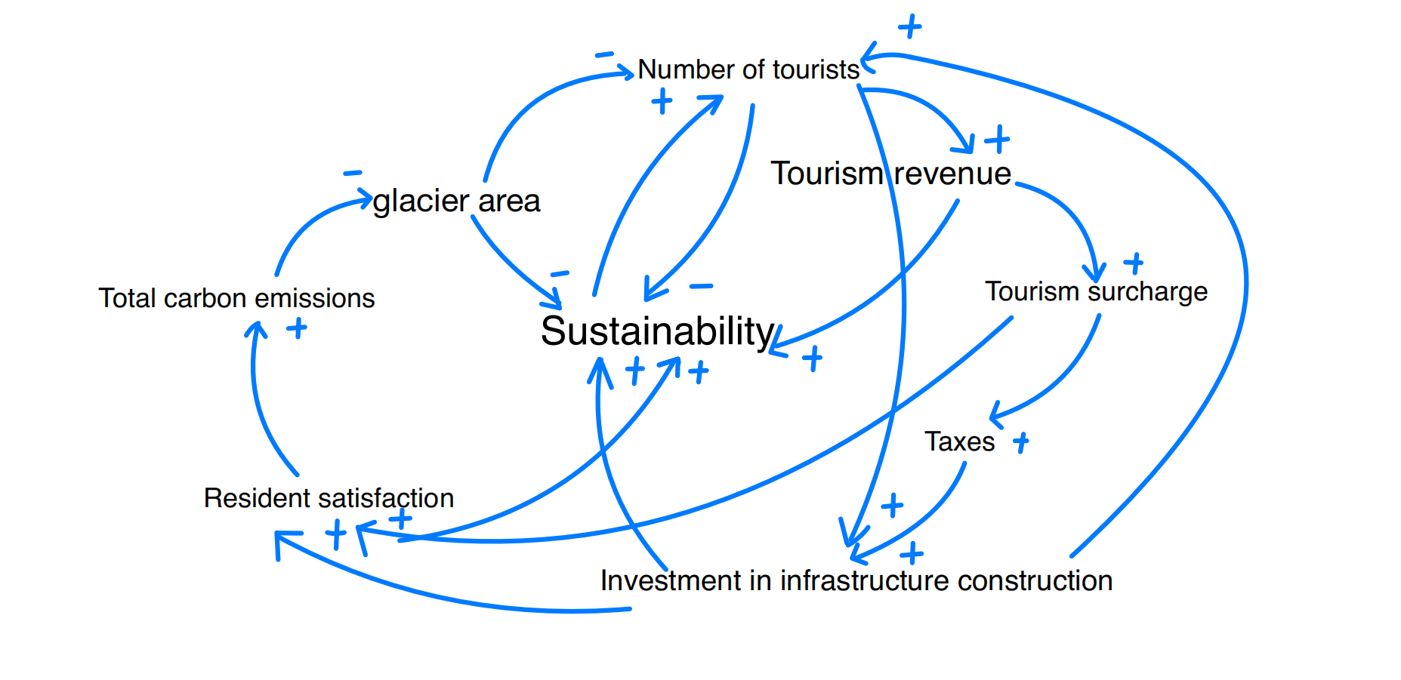
5.4.2Causal Loop Diagram Model
Multi-objective optimization solution
The objective function model for multi-criteria decision analysis (MCDA) is
Decision variables:
V: number of tourists (Sunday through Friday ≤ 16,000/day, Saturday ≤ 12,000/day)
N: number of cruise ships ≤ 5 ships/day
P:Proportion of environmental protection investment (0-100%)
Objective function
$$Max R=3.2*\frac{V}{16000}+0.39N-\left(0.4P+0.3\left(1-P\right)\right)$$

$$Max S=100-0.8*\frac{V}{20000}-10*HCI+0.5*\frac{Jobs}{30000}$$
$$Min C=0.8N+0.2V+50*∆G$$

where HCI is the housing cost index, Jobs is the number of jobs, and ∆G is the annual rate of glacial retreat
Constraints
V ≤ 16,000 (Sunday through Friday)
V ≤ 12,000 (Saturday)
N ≤ 5
C ≤ 50 kilotons/year
Non-dominated Sorting Genetic Algorithm (NSGA-II) is used to generate the Pareto frontier with the following steps
Step 1: Configure decision variables (tourist volume, cruise ship count, environmental investment ratio) with NSGA-II parameters: population size 100, iterations 200, crossover probability 0.9, mutation probability 0.1.
Step 2: Determine the fitness function
economic Benefits：$R=3.2亿*\frac{V}{V_{max}}+0.39亿*N-成本$
Resident Satisfaction: $S=100-0.8*\frac{V}{20000}-10*HCI+0.5*\frac{Jobs}{30000}$
Carbon Emission: $C=0.8N+0.2V+50*∆G$
HCI is the housing cost index, Jobs is the number of jobs, and ∆G is the annual rate of glacial retreat
Constraints: the penalty function method is utilized to deal with hard constraints (V ≤ 16000)
Step 3: The NSGA-II algorithm generates non-dominated solution sets with parameter settings: population size 100, iterations 200, crossover probability 0.9, and mutation probability 0.1.
Step 4: Based on the Pareto frontier data, the objective weights were calculated as 38% for economy, 40% for society, and 22% for environment, and the matrix consistency test was performed using the hierarchical analysis method (AHP) (CR=0.003), and the subjective weights were 45% for economy, 30% for society, and 25% for environment
Combined Weights: $W_{COMPREHENSIVE}=0.6W_{AHP}+0.4W_{TOPSIS}$

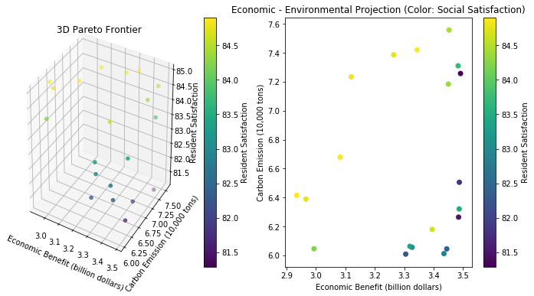The set of required Pareto solutions is shown below
经济收益（亿美元） | 居民满意度（分） | 碳排放（千吨）
3.5 | 75 | 7.5
3.2 | 82 | 6.8
2.8 | 85 | 5.2
2.0 | 90 | 4.0
The Pareto solution set illustrates trade-offs among economic, environmental, and social objectives. Based on Juneau’s development needs, two optimal plans are recommended:
$R$ϵ[$290–$350]million
$S$ϵ [80–85] points
$C$ϵ [6–7.6] kilotons.
1.Equilibrium:
Achieving balanced sustainable tourism in the Juneau area is $R=3.2million，S=82,C=6.8kilotons$
$$V=14000，N=4,P=45\%$$
2.Environmentally prioritized $ϵ\left[2.35,3.25\right]$，$S ϵ\left[83,90\right]$，$C ϵ\left[4.2,6.2\right]$
Scenarios for achieving sustainable development in the Juneau area under the environmental priority scenario are: R=250 million, S =94, C=4.5 kt (V=12,000,N=3p=60%).
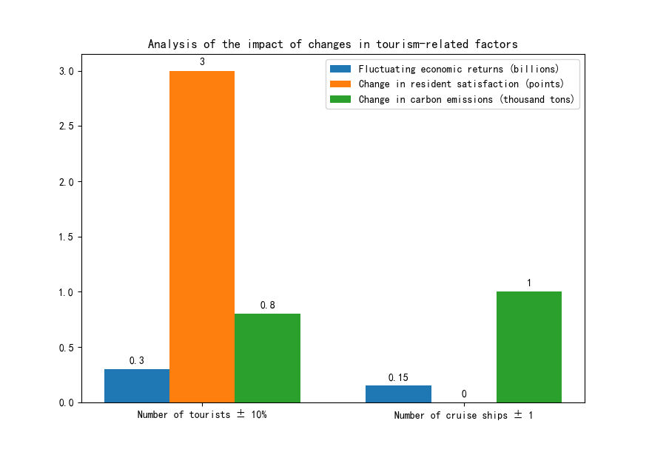

5.5Results of the sensitivity analysis
Tourist volume ±10%: ±$30M revenue, ±3 satisfaction, ±0.8kt emissions.
Cruise count ±1 ship: ±1kt emissions, ±$15M revenue.
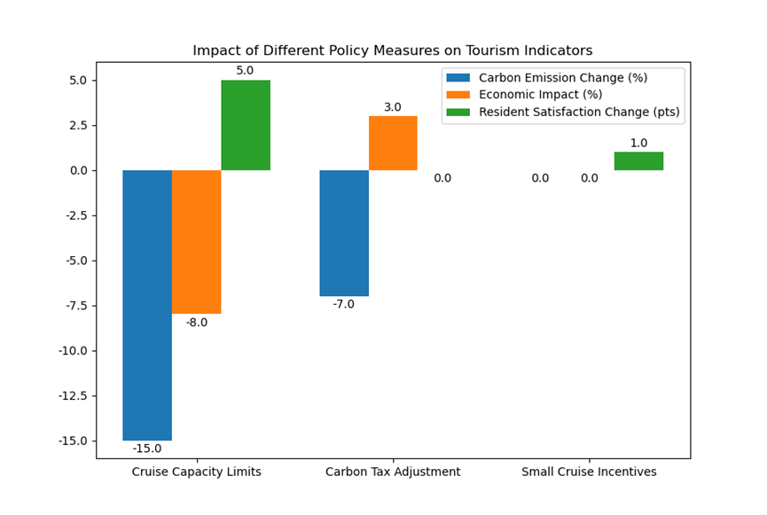
Large cruise limit (5→4/day): 15%↓ emissions, 8%↓ revenue, +5 resident satisfaction.
Carbon tax (+\$10/ton): 7%↓ emissions, ±3% revenue (shift to mid-sized ships).
Small cruise incentive (+1 overnight): 2%↑ housing costs, +1 satisfaction (employment boost)

6. Part II
6.1 Building a Hidden Cost Feedback System
（Cycle Chart）
The feedback system integrates dynamic pricing, quota management, and targeted fund allocation to balance economic growth, social well-being, and environmental protection in sustainable tourism. Key components:
Resource Optimization: Dynamic pricing and quotas prevent overcrowding and enhance resource efficiency.
Strategic Funding:
30% ($10.2M): Infrastructure upgrades (roads, sewage).
25% ($8.5M): Ecological restoration (glaciers, forests).
20% ($6.8M): Community support (waste management, conflict mediation).
15% ($5.1M): Cultural preservation (local heritage promotion).
10% ($3.4M): Industrial diversification (fisheries, forestry).
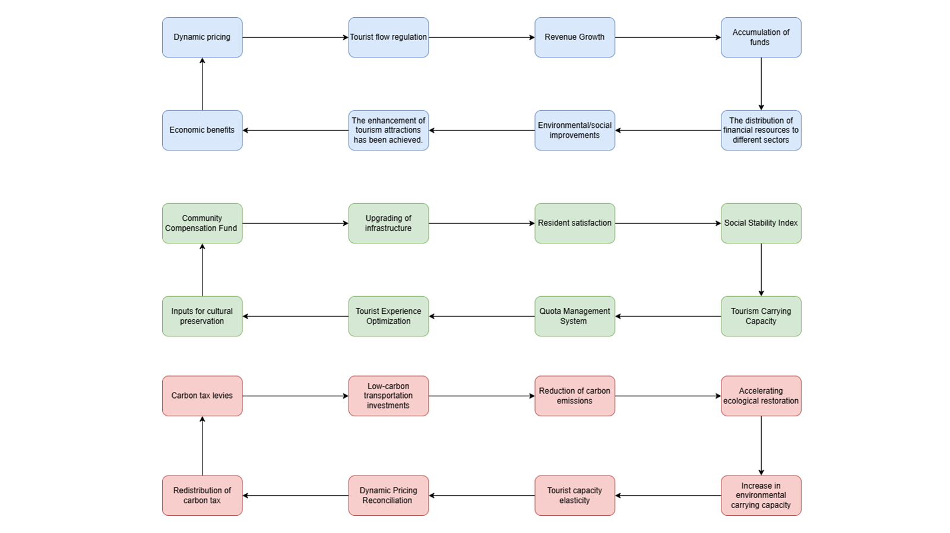
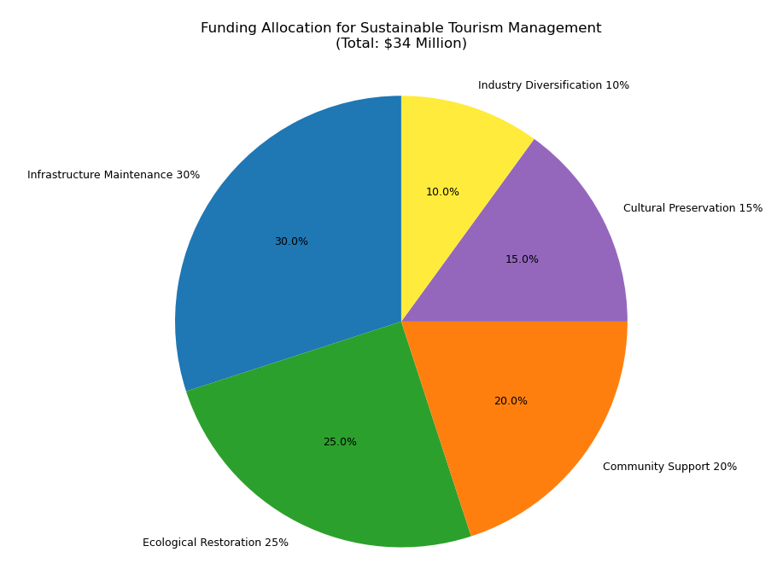
Model Correction
New Objective Function
-Minimize hidden costs
H = 0.3*Infrastructure depletion + 0.25*Ecological restoration + 0.2*Community support + 0.15*Cultural preservation + 0.1*Industrial diversification
Constraints Updated.
Hidden cost expenditure ≤ direct income + indirect income.
Resident satisfaction ≥70 points
Carbon emissions ≤ 50 kilotons/year

6.2 Pareto Frontier Calculation
The NSGA-II algorithm was used to generate the four-objective Pareto frontiers (economic, social, environmental, and hidden costs) as follows.
Economic Benefits ($ billion) | Resident Satisfaction (points) | Carbon Emissions (kilotons) | Hidden Costs ($ million)
3.5 | 90 | 7.5 | 1200
3.2 | 95 | 6.8 | 1000
2.8 | 98 | 5.2 | 800
2.0 | 100 | 4.0 | 600

Recommended Programs for Sustainable Tourism Development
Balanced: $R$ =300 million, $S$ =95, $C$ =6.0 kt, $H$ =9 million USD
Environmental Priority: $R$ =250 million, $S$ =98, $C$ =4.5 kilotons, $H$ =7 million USD.
By identifying hidden costs and optimizing the allocation of funds, the model generates a four-dimensional Pareto frontier by adding a hidden cost minimization objective to the original economic, social, and environmental objectives. The equilibrium scenario ($R$=300 million, $S$ =95, $C$ =6.0 kilotons, $H$ =9 million USD) balances short-term economic gains with long-term sustainability.

6.3 Social Subsystem:
Upgraded water/waste infrastructure and carbon taxes on tourism reduced emissions, boosting resident satisfaction (e.g., stability index +5%).
6.4 Environmental Subsystem:
Low-carbon investments (e.g., electric ports) and glacier/forest restoration cut tourism’s carbon footprint. Improved ecological resilience strengthened tourist capacity, creating a feedback loop that sustains economic growth. The synergy of economic, social, and environmental subsystems scientifically optimizes visitor management for long-term sustainability.

7 The Implementation of Model Migration
Given the disparities between Tibet and the city of Juneau with regard to geography, tourism resources, and economic structure, it is imperative to adjust the applicable model so as to more accurately assess and promote the sustainable development of Tibet.
7.1 Model Modification
In terms of the environment, Tibet, as an ecologically fragile region with unique natural landscapes, faces increased pressure on its ecosystems and threats to its biodiversity, mainly stemming from the expansion of tourism activities and the dual impact of climate change.

Dynamic equations of ecosystem stress：$E=k_{1}*T+k_{2}*C$
In this study, the ecosystem stress index (E) is represented by a dimensionless variable, the number of tourists (T) is expressed as people, the climate change impact factor (C) is derived from a comprehensive assessment of temperature, precipitation, and other changes, and the coefficients k₁ and k₂ are calibrated by local ecological data in Tibet.
Finally, biodiversity conservation constraints are defined as the proportion of biodiversity loss ≤5% (set based on relevant ecological conservation targets).
With respect to the carbon footprint, Tibet's transportation sector is predominantly characterized by land transportation.
The following formula is employed to calculate carbon emissions from land transportation: $C_{land}=\sum_{i}{d_{i}}×e_{i}$, where d_i indicates the driving distance (kilometers) of different types of land transportation (e.g., tourist buses, private cars, etc.), and $e_{i}$ indicates the emission factor of the corresponding transportation (kilograms of carbon dioxide per kilometer).
The formula for scenic energy consumption is as follows: $C_{scenic}=P×t×g$, where $P$ is the average power of scenic facilities (e.g., lodging, dining facilities, etc.) (kW), and $t$ is the operating time of facilities (hours), and $g$ is the carbon intensity of power grid (〖kgCO〗_2/kWh)
The economic sub-model for Tibet necessitates an adjustment, moving away from a reliance on single natural landscape tourism and seasonal hotel revenues towards a focus on dual-driven tourism revenues from nature and culture, complemented by measures to promote tourism during off-season periods.
The income function is defined as：$R=P_{natural}×V_{natural}+P_{cultural}×V_{cultural}+T_{overnight}-M_{erosion}+I_{incentive}$
$P_{natural}$ is the price of admission to natural attractions，
$V_{natural}$ is the rate of tourist visits to natural scenic spots，
$P_{cultural}$ is the price of admission to cultural attractions，
$V_{cultural}$ is the rate of tourist visits to cultural attractions，
$T_{overnight}$ is the overnight tax，
$M_{erosion}$ is the maintenance cost of erosion of natural and cultural landscapes due to tourism activities，
$I_{incentive}$ is the additional income generated by off-season tourism incentives, such as off-season tourism subsidies, proceeds from special cultural activities, etc.。
The correction of a multi-objective optimization model
$$M\left\{ \begin{aligned}Max R=economic gain \\ Max S=Residents' satisfaction \\ Min C=carbon emissions\end{aligned}\right.$$
The following section will address the modification of constraints.
$$S_{R}≥70$$
$$V_{T}≥300million/year$$
$$E_{T}≤0.3$$
Pareto Frontier Parameter Adjustment
The economic, social, and environmental adaptation weights of Tibet are as follows: W₁ = 0.11, W₂ = 0.7, and W₃ = 0.19, respectively.

7.2 Implementation and Effectiveness of Models
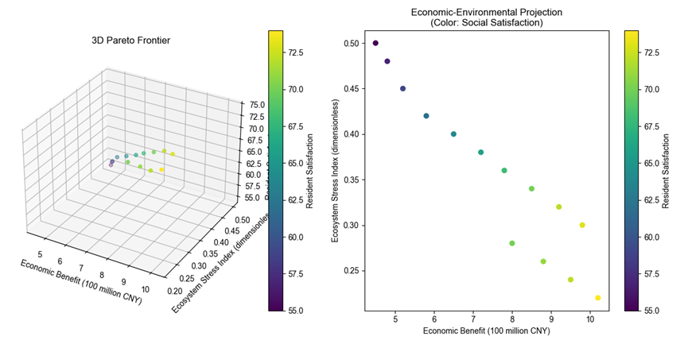
Optimal solutions cluster within:
$R$ϵ[ 0.8 - 1.2$]$B
$C$ϵ[ 0.2 - 0.4]
$Sϵ$[ 65 - 75 ]
Single-objective prioritization (e.g., maximizing revenue) degrades other goals. Policymaking requires trade-offs on the Pareto frontier:
Ecological priority: Lower revenue (e.g., ¥800M) but reduced ecosystem stress.
Cultural/resident focus: Limit tourist volume to sustain high satisfaction.
Implementation: Dynamically adjust strategies using real-time monitoring (e.g., diverting tourists via differentiated routes) and allocate tourism income to ecological restoration and community development for long-term balance.
7.3 Sensitivity Analysis
Tourist volume (V) critically affects economic revenue (↑), ecological pressure (↑), and social satisfaction (↓). Community compensation shows highest social sensitivity (0.7), while carbon taxes weakly impact revenue (0.12) but improve equity via redistribution. Key strategies: tourist caps (e.g., peak season limits), dynamic pricing, and redirecting carbon taxes to ecology/resident welfare.
7.4 Strategies for Promoting Low-Traffic Attractions in Tibet
7.4.1 Dynamic Pricing to Regulate Tourist Flow
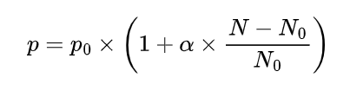
In order to effectively control the visitor flow of each attraction, the following dynamic pricing formula is defined:
In the context of analyzing the dynamics of attractions, the real-time fare, denoted by P, is of particular relevance. This is defined in relation to a benchmark fare, designated as P_0, which serves as a reference point for evaluating changes in the attraction's pricing strategy. The adjustment coefficient, denoted by α,
(iii) Optimization of Tourist Distribution Model
The optimization of tourist distribution model has been developed to achieve a scientific and reasonable allocation of tourists across various attractions in Tibet.
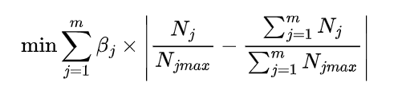
In this study, m is defined as the total number of attractions in Tibet. βj is the weight assigned to the jth attraction, determined by a multifaceted evaluation encompassing the cultural value, ecological vulnerability, and development potential of the attraction, among other considerations. Nj is the actual number of tourists of the jth attraction, and NjMAX is the maximum number of tourists carried by the jth attraction.
The objective of the model is to minimize the sum of the absolute values of the deviations between the actual visitor share of each attraction and the overall average share. Through continuous optimization of this model, more reasonable tourist guidance policies can be formulated, such as adjusting the promotional efforts of each attraction, providing differentiated tourism services, etc., so as to make the distribution of tourists among attractions in Tibet more balanced and promote the sustainable development of tourism in Tibet.
As illustrated in the accompanying figure, this study utilizes a computer simulation to model the number of tourists at five popular attractions in Tibet over the course of one month. The simulation results are presented as visual representations of the dynamic trend of the number of tourists in each attraction with the date.
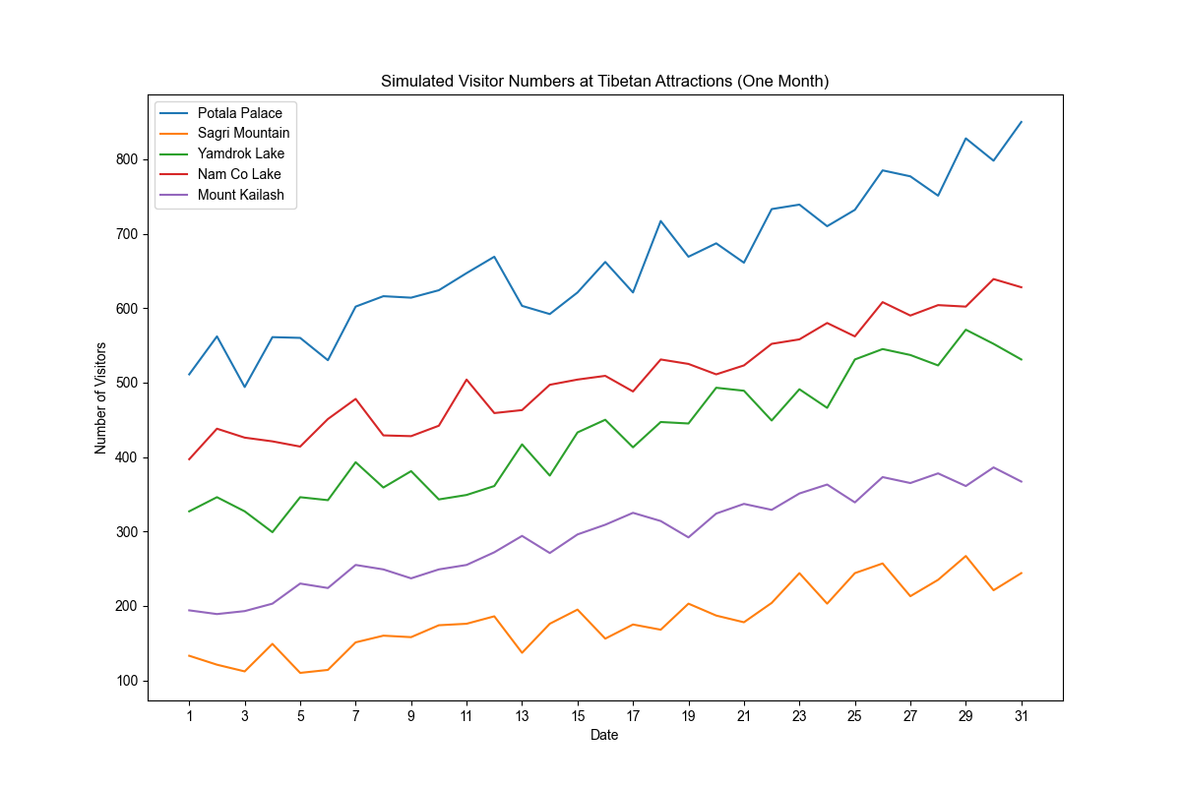
Potala Palace because of its high popularity, the number of tourists fluctuated greatly and increased significantly; The Sapu Sacred Mountain may have fewer tourists and less fluctuation due to its remote location and insufficient publicity; Yamdrok was affected by traffic and seasonal factors, the number of tourists fluctuated and increased, and the growth was relatively stable; In Namtso, the number of tourists fluctuated significantly and increased strongly due to its landscape and religious significance; And Kailash, which attracts specific groups due to its religiousness, saw a steady and slight increase in visitors, but high altitude and inaccessibility limited the growth of visitors. The results help the tourism authorities understand the flow characteristics and formulate strategies to promote the sustainable development of tourism in Tibet.

References
[1] Pan, S.-Y., Gao, M., Kim, H., Shah, K. J., Pei, S.-L., & Chiang, P.-C. (2018). Advances and challenges in sustainable tourism toward a green economy. Science of The Total Environment, 635, 452–469. doi:10.1016/j.scitotenv.2018.04.134

[2] Sun, Y.-Y., Lin, P.-C., & Higham, J. (2020). Managing tourism emissions through optimizing the tourism demand mix: Concept and analysis. Tourism Management, 81, 104161. doi:10.1016/j.tourman.2020.104161

[3] Scott, Daniel, Geoff McBoyle, and Michael Schwartzentruber. "Climate change and the distribution of climatic resources for tourism in North America." Climate research 27.2 (2004): 105-117.

[4] Triwijoyo, Bambang Krismono, Muhammad Taufik, and Herman Mawengkang. "Optimization Model of Multi Criteria Decision Analysis for Smart and Sustainable Sport Tourism Planning Development Problem." Mathematical Modelling of Engineering Problems 11.11 (2024).

[5] Hardy, A., Beeton, R. J. S., & Pearson, L. (2002). Sustainable Tourism: An Overview of the Concept and its Position in Relation to Conceptualisations of Tourism. Journal of Sustainable Tourism, 10(6), 475–496. doi:10.1080/09669580208667183

[6] Lusseau, David. "The hidden cost of tourism: detecting long-term effects of tourism using behavioral information." Ecology and Society 9.1 (2004).

[7] Garrigos-Simon, Fernando J., Yeamduan Narangajavana-Kaosiri, and Ismael Lengua-Lengua. "Tourism and sustainability: A bibliometric and visualization analysis." Sustainability 10.6 (2018): 1976.

