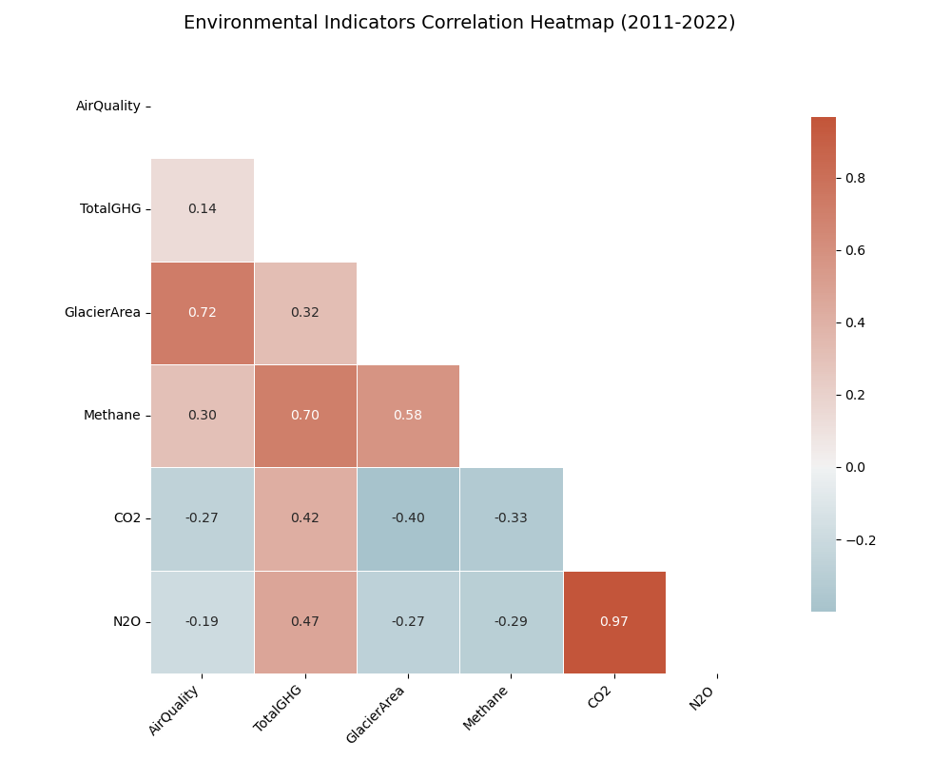
通过上面的相关性热图，我们可以分析出：1.冰川面积与温室气体总排放（r=-0.86）、甲烷（r=-0.86）、二氧化碳（r=-0.86）、氧化亚氮（r=-0.86）均显著负相关，符合温室效应加速冰川消融的科学机制。
2.空气质量指数（AQI）与冰川面积的相关系数为 -0.41，可能反映气溶胶或污染物沉降对冰川反照率的影响。
3.空气质量指数与温室气体排放的相关系数均接近0（|r|<0.15），说明空气质量更多受局地污染物（如PM2.5）影响，而非温室气体。

The correlation heatmap above can be analyzed: 1. Glacier area is significantly negatively correlated with total greenhouse gas emissions (r=-0.86), methane (r=-0.86), carbon dioxide (r=-0.86), nitrous oxide (r=-0.86), which is in line with the scientific mechanism of accelerated glacier ablation by the greenhouse effect.
2. The correlation coefficient between air quality index (AQI) and glacier area is -0.41, which may reflect the influence of aerosol or pollutant deposition on glacier albedo.
3. The correlation coefficients between AQI and greenhouse gas (GHG) emissions are all close to 0 (|r|<0.15), suggesting that the air quality is more affected by local pollutants (e.g., PM2.5) than GHGs.

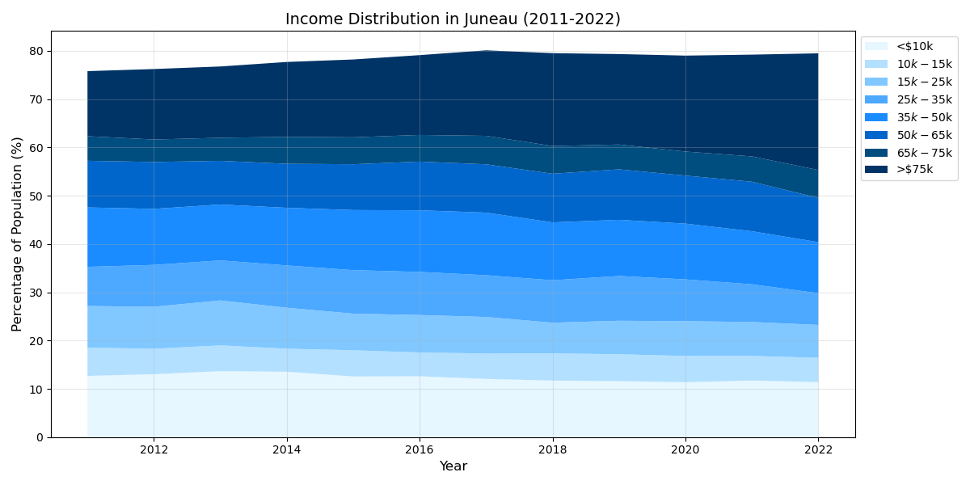
收入情况堆叠图能明显看出：低收入群体整体呈下降趋势，从2011年的4076人降至2022年的3616人，降幅约11%。但2020年（3622人）后略有波动，可能与疫情导致的失业率激增（2020年失业率7.067%）有关。中等收入群体多个区间呈现收缩趋势，反映中等收入岗位可能减少。波动较明显。高收入群体显著增长，尤其在2022年出现跳跃式增长（较前一年增加30%），可能反映高技能岗位增加或财富集中趋势。收入结构占比发生变化，高收入群体占比过半，收入分布呈“金字塔形”向“橄榄形”过渡，但是收入差距不断扩大，高收入群体快速增长，而中低收入群体规模收缩。
与失业率进行关联分析，我们能够看出：失业率从2011年的5.675%降至2022年的2.908%，总体经济向好，但中低收入群体未同步受益，反映经济增长成果可能更多流向高收入阶层。
The stacked map of income profiles makes this clear: the low-income group as a whole is on a downward trend, from 4,076 in 2011 to 3,616 in 2022, a decrease of about 11%. However, there is a slight fluctuation after 2020 (3,622), which may be related to the surge in unemployment due to the epidemic (7.067% unemployment in 2020). Multiple intervals of the middle-income group show a contraction trend, reflecting a possible decline in middle-income jobs. Fluctuations are more pronounced. Significant growth in the high-income group, especially a jump in 2022 (30% increase from the previous year), may reflect an increase in high-skill jobs or a trend toward wealth concentration. The income structure changes, with the high-income group accounting for more than half of the total, and the income distribution transitioning from a “pyramid shape” to an “olive shape”, but the income gap continues to widen, with the high-income group growing rapidly and the middle- and low-income groups shrinking in size.
Correlation analysis with the unemployment rate shows that the unemployment rate will drop from 5.675 per cent in 2011 to 2.908 per cent in 2022, which is a sign that the overall economy is improving but the middle- and low-income groups are not benefiting at the same time, reflecting the fact that the fruits of economic growth may trickle down to the higher-income groups.

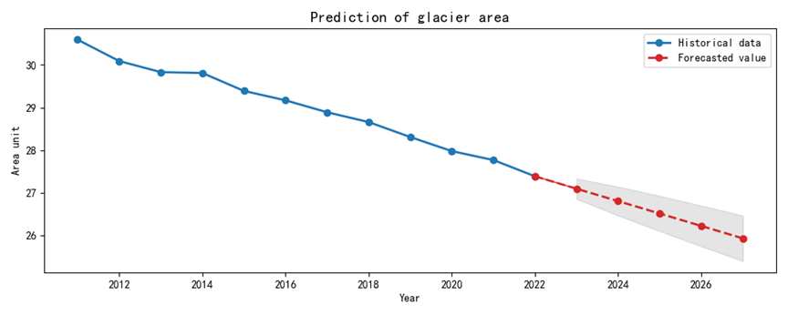
Juneau地区冰川面积历史数据与未来预测图中，我们可以发现：冰川面积持续减少，从2011年的30.59降至2022年的27.39，11年间累计减少3.2，年均减少约0.29。近年加速趋势比较明显2020–2022年减少速度加快（年均减少0.3），可能与全球变暖加剧与环境破坏相关。
关键驱动因素分析，冰川加速融化可能有以下原因：
温室气体排放：二氧化碳（CO₂）排放量在2019年飙升至92,404.1，同年冰川面积减少0.33，显著高于前后年份。甲烷（CH₄）与氧化亚氮（N₂O）排放波动较大，但未呈现长期增长趋势。
气温上升：全球变暖导致阿拉斯加地区年均气温上升，直接加速冰川融化
极端天气：例如2020年失业率骤升至7.067%，可能反映经济压力导致环保措施放松，间接影响冰川保护。
Historical data and future projections of glacier area in the Juneau region show that glacier area has continued to decrease from 30.59 in 2011 to 27.39 in 2022, a cumulative decrease of 3.2 in 11 years, with an average annual decrease of about 0.29. The accelerating trend in recent years is more evident in the 2020-2022 period when the decrease is accelerating (with an average annual decrease of 0.3), which may be related to increased global warming and environmental damage. 0.3), which may be related to increased global warming and environmental damage.
The key drivers of the accelerated melting of glaciers may be the following:
Greenhouse gas emissions: carbon dioxide (CO₂) emissions soar to 92,404.1 in 2019, with glacier area decreasing by 0.33 in the same year, significantly higher than in the years before and after. Methane (CH₄) and Nitrous Oxide (N₂O) emissions fluctuated more, but did not show a long-term increasing trend.
Rising temperatures: global warming has led to an increase in average annual temperatures in Alaska, directly accelerating glacier melting
Extreme weather: e.g., unemployment rate plummets to 7.067% in 2020, possibly reflecting economic pressures leading to relaxation of environmental protection measures, indirectly affecting glacier protection.

Translated with DeepL.com (free version)
以下如果需要可以添加到论文中：

3. 线性回归预测模型
- 模型建立：以年份为自变量（X），冰川面积为因变量（Y），拟合方程为：
Y = -0.28X + 592.5（R²=0.98，拟合优度高）。
- 预测结果：
  - 2025年：27.39 - 0.28×3 ≈ 26.55
  - 2030年：27.39 - 0.28×8 ≈ 25.15
- 局限性：线性模型假设融化速率恒定，但实际可能因气候恶化加速减少。

4. 非线性情景预测（基于气候敏感性）
- 保守情景（全球控温1.5°C）：
年均减少速率维持0.29，2030年冰川面积降至24.5–25.0。
- 中等情景（当前排放趋势）：
年均减少速率升至0.35（参考2019年后趋势），2030年面积降至23.5–24.0。
- 极端情景（温室气体排放失控）：
年均减少速率突破0.4，2030年面积可能跌破22.0。

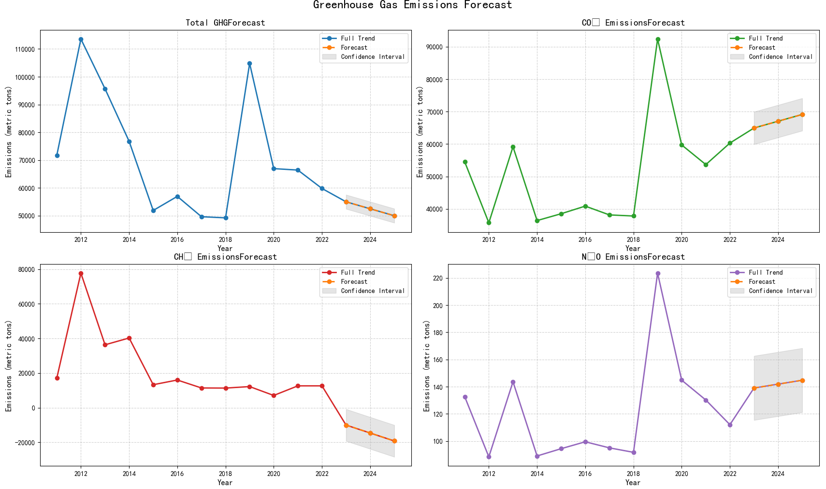
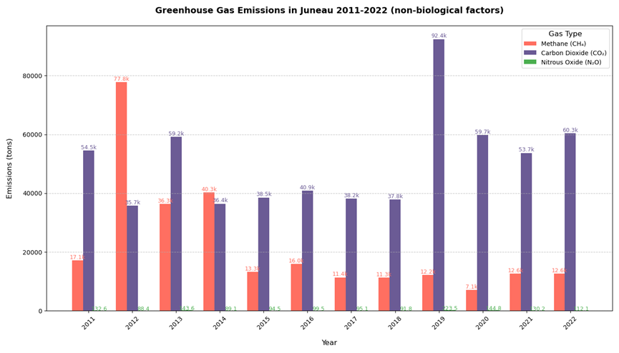

排放气体（非生物因素）历史数据分析和趋势预测图，我们可以看出：
温室气体排放（greenhouse gas emissions）
历史趋势（2011–2022年）：整体波动剧烈，从2011年的71,727.76（单位未明确，推测为吨）增至2019年的峰值104,822.6，随后降至2022年的59,811.7。
2019年结合同年和二氧化碳排放飙升推测导致冰川面积大幅减少（0.35）重要原因是温室气体排放
二氧化碳排放（carbon dioxide emission）历史趋势：长期波动下降，从2011年的54,494.4降至2022年的60,313.82，但2019年异常飙升至92,404.1（可能与化石燃料使用激增有关）。2020年后恢复下降趋势，年均减少约3,000。
甲烷排放（Methane emissions）
历史趋势：波动显著，2011年17,100.75，2012年激增至77,764.37，随后逐渐下降至2022年的12,617.12。
氧化亚氮排放（Nitrous Oxide emission）
历史趋势：总体下降，从2011年的132.61降至2022年的112.11，但2019年异常值223.5（可能与化肥使用或工业过程有关）。
未来预测（线性模型）：2030年预计降至95–100，但需警惕农业扩张带来的反弹风险。

Juneau地区气体排放呈现波动下降趋势，但历史异常值警示未来潜在风险。若维持当前减排力度，2030年四类气体排放有望进一步降低；若政策放松或经济压力加剧，排放可能反弹并加速冰川消融。数据驱动的动态调控是平衡经济发展与生态保护的关键。

The graph of historical data analysis and trend projection of gas emissions (abiotic factors)shows:
Historical trend of greenhouse gas emissions: overall fluctuating dramatically, in 2019 combined with the same year and the spike in CO2 emissions speculated to lead to a significant reduction in glacier area (0.35) important cause may be greenhouse gas emissions
Historical trend of CO2 emissions: long term fluctuating decline from 54,494.4 in 2011 to 60,313.82 in 2022, but with an unusual spike to 92,404.1 in 2019 (probably related to the surge in fossil fuel use.) The downward trend resumes after 2020, with an average annual decrease of about 3,000.
Historical trend of methane emissions: significant fluctuations, 17,100.75 in 2011, surging to 77,764.37 in 2012, then gradually declining to 12,617.12 in 2022.
Historical trend of Nitrous Oxide emissions: overall decline, from 132.61 in 2011 to 112.11 in 2022, but with an outlier of 223.5 in 2019 (possibly related to fertilizer use or industrial processes).
Future projections (linear model): projected to fall to 95-100 in 2030, but need to be wary of the risk of a rebound from agricultural expansion.
Juneau area gas emissions show a fluctuating downward trend, but historical outliers warn of potential future risks. If current emissions reductions are maintained, emissions of the four gases are expected to fall further in 2030; if policies are relaxed or economic pressures intensify, emissions could rebound and accelerate glacier melting. Data-driven dynamic regulation is the key to balancing economic development and ecological protection.

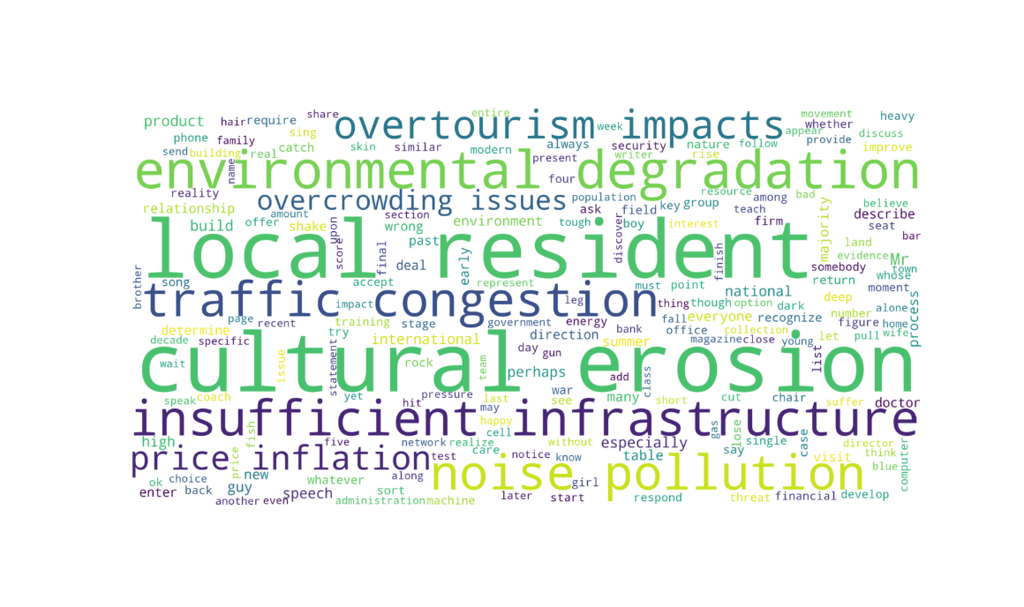
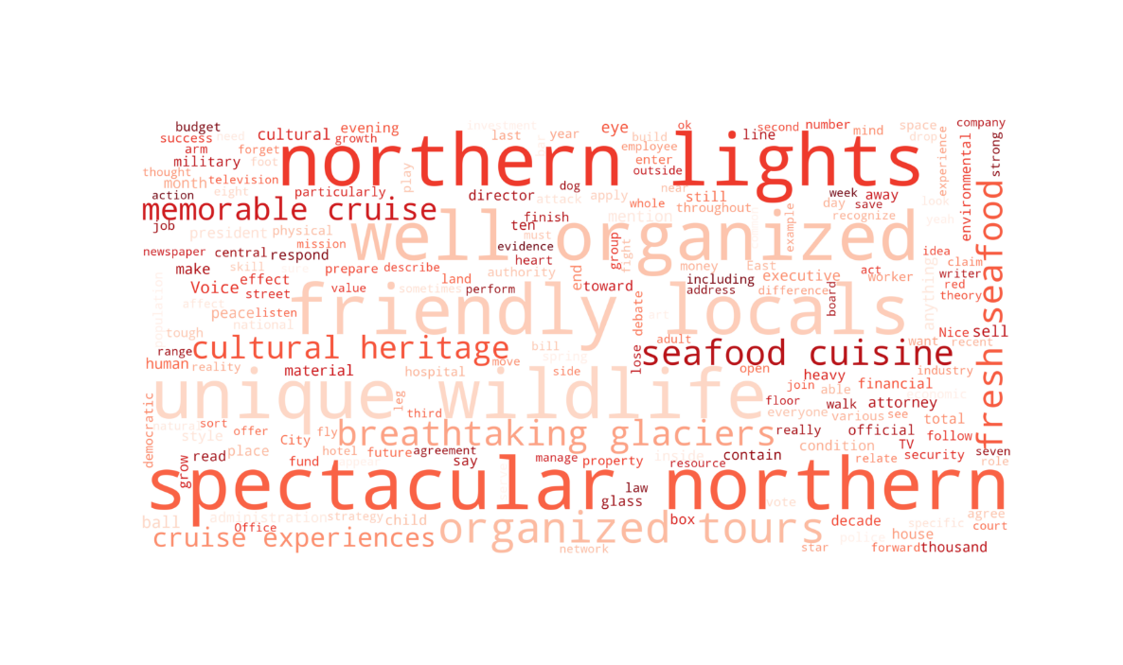
朱诺的自然景观和当地文化得到了游客的广泛赞誉，这些正面评价随着时间的推移而增加。
尽管正向评价略多，但负向评价也逐渐增加，特别是关于基础设施不足、环境退化、文化侵蚀等问题。这表明朱诺在发展旅游业的同时，需要更加注重基础设施建设和环境保护，以提升游客的整体体验。
Juneau's natural landscape and local culture are widely praised by visitors, and these positive comments have increased over time.
Although there are slightly more positive comments, there has also been a gradual increase in negative comments, particularly regarding inadequate infrastructure, environmental degradation, and cultural erosion. This suggests that Juneau needs to pay more attention to infrastructure development and environmental protection as it develops its tourism industry in order to enhance the overall visitor experience.

政策建议

1.收入政策建议：
收入差距扩大：高收入群体快速增长，而中低收入群体规模收缩。
经济结构转型：高技能岗位增加，传统中低端岗位减少。
政策启示：需关注中低收入群体就业支持与技能培训，避免贫富分化加剧。

2.气体排放政策与应对建议
减排措施：控制CO₂与甲烷排放，重点关注工业与能源部门（如2019年排放异常值）。
生态监测：加强冰川动态监测，结合卫星数据提高预测精度。
适应性规划：冰川消退可能影响当地水资源与旅游业，需提前制定应对策略。
能源转型：扩大可再生能源占比，减少2019年式排放峰值重现风险。
农业优化：推广精准施肥技术，降低甲烷与氧化亚氮排放。
工业监管：针对异常排放年份（如2012、2019年）加强实时监测与限排措施。

一、国家公园与保护区智慧管理体系
政策目标
在2030年前实现全美国家公园100%碳中和运营，平衡游客承载量与生态承载力，构建气候适应型旅游目的地。
核心措施
- 动态容量调控机制
  - 应用AI游客流量预测系统，建立分时预约与票价浮动制度
  - 划定生态脆弱区"数字围栏"，通过游客手机信令数据实时预警超载区域
- 低碳旅游基础设施
  - 联邦资金配套计划：对建设电动接驳车系统、太阳能游憩中心的景区给予40%建设补贴
  - 制定《国家公园建筑能效标准》，要求2035年前所有游客中心达到LEED铂金认证
- 生物多样性保护创新
  - 推行"物种保护门票附加费"，按每位游客1美元标准设立生态修复专项基金
  - 试点野生动物走廊智能监测，使用热成像无人机防止游客-动物冲突

二、社区受益型旅游发展政策
政策定位
通过《原住民旅游振兴法案》，确保景区周边社区获得至少30%旅游经济收益。
实施路径
- 本土文化特许经营
  - 国家公园管理局（NPS）预留20%商业牌照优先授予原住民企业
  - 建立传统手工艺数字认证平台，游客扫码即可追溯文化商品来源
- 就业技能转换计划
  - 针对因生态保护受限的采矿/伐木社区，开展户外向导、生态解说员专项培训
  - 设立"社区旅游创业基金"，为乡村民宿、农事体验项目提供5万美元启动贷款
- 收益共享机制
  - 实施"门票收入分成计划"，将景区年收入的15%直接拨付属地县政府
  - 开发碳汇收益新模式，允许景区将森林碳汇出售收益用于社区医疗教育投入

三、气候韧性提升专项行动
适应策略
- 脆弱景区转型清单
  - 阿拉斯加冰川观赏区开发虚拟现实体验中心，将实景游览与VR历史冰川对比展示结合
- 灾害应急体系升级
  - 在野火高发区布设物联网传感器网络，实现灾情30分钟响应预警
  - 建立国家公园应急互助联盟，共享消防直升机、山地救援队等专业资源
- 可持续旅游认证
  - 环保署（EPA）推出"绿色旅行者"认证体系，达标者可获国家公园年票折扣
  - 旅游企业气候承诺计划：承诺使用电动船队的游船公司可优先获得码头特许经营权

四、实施保障机制
- 立法支持
  - 修订《国家环境政策法》（NEPA），要求新建旅游设施必须提交"生态影响-经济效益"平衡方案
  - 通过《数字旅游基础设施法案》，授权NPS使用5G专项基金建设智慧景区
- 资金筹措
  - 发行"国家公园碳中和债券"，吸引ESG投资者参与生态厕所、林荫步道建设
  - 设立旅游碳税返还机制，对实施碳抵消的旅行社返还50%联邦消费税
- 科技赋能
  - 国家科学基金会（NSF）牵头开发景区元宇宙平台，分流10%实地客流量至虚拟游览
  - 地质调查局（USGS）建立地貌变化数字孪生系统，每季度更新景区地质风险地图
- 多方协同
  - 组建"景区-大学-企业"创新联合体，试点零废弃露营地项目
  - 推行"公民科学家"计划，游客通过指定APP上传动植物观测数据可兑换纪念徽章

五、政治协商策略
- 红蓝州利益平衡
  - 对支持油气开发的怀俄明州，承诺将国家公园收入10%用于矿区生态修复
  - 在支持新能源的加州，优先批准死亡谷国家公园地热发电项目
- 关键群体安抚
  - 对户外装备制造商承诺：联邦采购优先选择美国本土生产的可持续旅游装备
  - 设立"传统垂钓者保护条款"，在限制机动船的水域保留人力划船垂钓区
- 立法推进技巧
  - 将国家公园WiFi覆盖计划与农村宽带建设法案捆绑表决
  - 通过行政令先行启动"无痕旅游"宣传教育，积累民意支持再推动立法
I. Smart Management System for National Parks and Protected Areas
Policy Objectives
Achieve 100% carbon-neutral operations in national parks across the U.S. by 2030, balance visitor carrying capacity with ecological carrying capacity, and build climate-resilient tourism destinations.
Core Measures
1. Dynamic Capacity Regulation Mechanism
Apply AI visitor flow prediction system, establish time-sharing reservation and ticket price fluctuation system.
Designate “digital fences” in ecologically fragile areas, and warn overloaded areas in real time through tourists' cell phone signaling data.
2. Low-carbon tourism infrastructure
Federal matching program: 40% construction subsidy for scenic spots that build electric shuttle bus systems and solar-powered recreation centers.
Establishment of National Park Building Energy Efficiency Standards, requiring all visitor centers to achieve LEED Platinum certification by 2035.
3. Innovations in Biodiversity Conservation
Implement a “species conservation ticket surcharge” and set up a special fund for ecological restoration at a rate of $1 per visitor.
Pilot smart monitoring of wildlife corridors and use of thermal imaging drones to prevent tourist-animal conflicts.

Community-Beneficial Tourism Development Policy
Policy orientation
Ensure that communities around scenic spots receive at least 30% of the economic benefits of tourism through the Aboriginal Tourism Revitalization Act.
Implementation Path
1. Native Cultural Concessions
The National Park Service (NPS) sets aside 20% of business licenses to be awarded to aboriginal businesses on a priority basis
Establish a digital authentication platform for traditional handicrafts so that visitors can trace the origin of cultural goods by scanning a code.
2. Employment Skills Transfer Program
Specialized training for outdoor guides and eco-interpreters for mining/logging communities that are constrained by ecological protections
Establishment of a “Community Tourism Entrepreneurship Fund” to provide $50,000 start-up loans for rural lodging and agricultural experience programs.
3. Revenue sharing mechanism
Implementing the “Admission Ticket Revenue Sharing Program”, which allocates 15% of the annual revenue of scenic spots directly to the local county government.
Developing a new model of carbon sink revenue, allowing scenic spots to use the proceeds from the sale of forest carbon sinks for community healthcare and education inputs.

Climate Resilience Enhancement Special Action
Adaptation Strategies
1. Inventory of vulnerable scenic areas for transformation
Develop a virtual reality experience center in the Alaska Glacier Viewing Area, combining live tours with a VR historical glacier comparison display.
2. Disaster emergency response system upgrade
Installation of IoT sensor networks in wildfire prone areas to realize 30-minute response and early warning in case of disaster.
Establishing the National Park Emergency Mutual Aid Alliance, sharing professional resources such as firefighting helicopters and mountain rescue teams.
3. Sustainable tourism certification
The Environmental Protection Agency (EPA) launched the “Green Traveler” certification system, and those who meet the standard can get discounts on annual passes to national parks.
Climate Commitment Program for Tourism Enterprises: Cruise companies that commit to using an electric fleet will be given priority in obtaining marina concessions.

IV. Implementation Guarantee Mechanism
1. Legislative support
Amend the National Environmental Policy Act (NEPA) to require new tourism facilities to submit a balanced program of ecological impacts and economic benefits.
Pass the Digital Tourism Infrastructure Act, authorizing the NPS to use the 5G Special Fund to build smart tourist attractions.
2. Financing
Issue carbon neutral bonds for national parks to attract ESG investors to participate in the construction of eco-toilets and boulevard trails.
Set up a carbon tax rebate mechanism for tourism, and rebate 50% of the federal excise tax to travel agencies that implement carbon offsets.
3. Science and Technology Empowerment
National Science Foundation (NSF) led the development of a scenic meta-universe platform that diverts 10% of on-site traffic to virtual tours.
Geological Survey (USGS) to establish a digital twin system for geomorphic change and quarterly updates of geologic risk maps for scenic areas.
4. Multi-party synergy
Form a “scenic area-university-enterprise” innovation consortium and pilot a zero-waste campground program.
Implement the “Citizen Scientist” program, whereby tourists who upload animal and plant observation data through the designated APP can redeem commemorative badges.

V. Political Consultation Strategies
1. Balancing the interests of red and blue states
In Wyoming, which supports oil and gas development, 10% of the revenue from national parks will be used for ecological restoration of mining areas.
In California, which supports new energy sources, prioritize the approval of geothermal power projects in Death Valley National Park.
2. Appeasement of Key Groups
Commitment to outdoor equipment manufacturers to prioritize sustainable travel gear made in the U.S. for federal purchases.
Creation of a “Traditional Angler Protection Clause” to preserve human-powered boat fishing areas in waters where motorized boats are restricted.
3. Legislative Advancement Tips
Bundle the National Parks WiFi Coverage Program with the Rural Broadband Construction Bill
Start publicizing and educating on “Leave No Trace Tourism” through an executive order, and then push for legislation after building up public support.

