The Implementation of Model Migration
Given the disparities between Tibet and the city of Juneau with regard to geography, tourism resources, and economic structure, it is imperative to adjust the applicable model so as to more accurately assess and promote the sustainable development of Tibet.
Model Modification
In terms of the environment, Tibet, as an ecologically fragile region with unique natural landscapes, faces increased pressure on its ecosystems and threats to its biodiversity, mainly stemming from the expansion of tourism activities and the dual impact of climate change. For instance, the influx of tourists may exceed the ecological carrying capacity of certain natural scenic spots, while global warming has also impacted the plateau ecosystem. Consequently, it is imperative to develop a comprehensive ecosystem pressure model and a biodiversity conservation model to effectively adapt to the prevailing circumstances in Tibet.

Dynamic equations of ecosystem stress：$E=k_{1}*T+k_{2}*C$
In this study, the ecosystem stress index (E) is represented by a dimensionless variable, the number of tourists (T) is expressed as people, the climate change impact factor (C) is derived from a comprehensive assessment of temperature, precipitation, and other changes, and the coefficients k₁ and k₂ are calibrated by local ecological data in Tibet.
Finally, biodiversity conservation constraints are defined as the proportion of biodiversity loss ≤5% (set based on relevant ecological conservation targets).
With respect to the carbon footprint, Tibet's transportation sector is predominantly characterized by land transportation. During the peak tourist season, there is a substantial increase in the frequency of vehicle usage, accompanied by a notable rise in energy consumption at certain scenic locations to meet tourist demands. These factors collectively exert a considerable influence on the carbon footprint. In contrast to other regions, Tibet must also consider the reduced energy efficiency of high-altitude areas when developing its tourism sector. Consequently, the current carbon footprint model must be adapted to encompass not only cruise ship and water transportation emissions but also prioritize land transportation emissions and energy consumption in scenic areas.
The following formula is employed to calculate carbon emissions from land transportation: $C_{land}=\sum_{i}{d_{i}}×e_{i}$, where d_i indicates the driving distance (kilometers) of different types of land transportation (e.g., tourist buses, private cars, etc.), and $e_{i}$ indicates the emission factor of the corresponding transportation (kilograms of carbon dioxide per kilometer).
The formula for scenic energy consumption is as follows: $C_{scenic}=P×t×g$, where $P$ is the average power of scenic facilities (e.g., lodging, dining facilities, etc.) (kW), and $t$ is the operating time of facilities (hours), and $g$ is the carbon intensity of power grid (〖kgCO〗_2/kWh).It is important to note that, given the possibility of using clean energy in some areas of Tibet, the value of carbon intensity of the power grid must be combined with the actual energy structure of the locality to determine.
A comparison of the economies of Tibet and Juneau reveals notable disparities. Juneau's economy is predominantly reliant on glacier tourism and seasonal hotel revenues. In contrast, Tibet's tourism economy encompasses revenues from natural landscapes and cultural tourism, exhibiting seasonal influences with notable disparities between off- and peak-season tourism. Consequently, the economic sub-model for Tibet necessitates an adjustment, moving away from a reliance on single natural landscape tourism and seasonal hotel revenues towards a focus on dual-driven tourism revenues from nature and culture, complemented by measures to promote tourism during off-season periods.
The income function is defined as：$R=P_{natural}×V_{natural}+P_{cultural}×V_{cultural}+T_{overnight}-M_{erosion}+I_{incentive}$
$P_{natural}$ is the price of admission to natural attractions，
$V_{natural}$ is the rate of tourist visits to natural scenic spots，
$P_{cultural}$ is the price of admission to cultural attractions，
$V_{cultural}$ is the rate of tourist visits to cultural attractions，
$T_{overnight}$ is the overnight tax，
$M_{erosion}$ is the maintenance cost of erosion of natural and cultural landscapes due to tourism activities，
$I_{incentive}$ is the additional income generated by off-season tourism incentives, such as off-season tourism subsidies, proceeds from special cultural activities, etc.。
These adjustments are intended to ensure a more accurate reflection of the characteristics of Tibet's tourism economy. Furthermore, the implementation of off-season tourism promotion measures is expected to achieve several objectives. These objectives include balancing the distribution of tourists in both the off- and peak seasons, enhancing off-season tourism revenue, and promoting the sustainable development of Tibet's tourism economy.
The correction of a multi-objective optimization model
$$M\left\{ \begin{aligned}Max R=economic gain \\ Max S=Residents' satisfaction \\ Min C=carbon emissions\end{aligned}\right.$$
The following section will address the modification of constraints.
$$S_{R}≥70$$
$$V_{T}≥300million/year$$
$$E_{T}≤0.3$$
Pareto Frontier Parameter Adjustment
The economic, social, and environmental adaptation weights of Tibet are as follows: W₁ = 0.11, W₂ = 0.7, and W₃ = 0.19, respectively.

Implementation and Effectiveness of Models
Data source:
The Tibet Autonomous Region Tourism Development Department is the source of the following data. The department has obtained detailed tourism industry data, including the number of tourists in previous years, the composition of tourism revenue, and investment in tourism projects. This data was obtained through the department's official website, industry reports, and other channels. These data directly reflect the scale of development and trends of the tourism industry in Tibet and are essential for constructing tourism development models and analyzing the impact of tourist numbers on the economy, environment, and society.
The data underwent standardization as previously outlined.The multi-criteria decision-making model was employed to validate the data, with the following indexes utilized for evaluation: the root mean square error (RMSE) of ecosystem pressure prediction was set at less than 0.3 (dimensionless), and the prediction error of residents' satisfaction was constrained to less than 3 points.
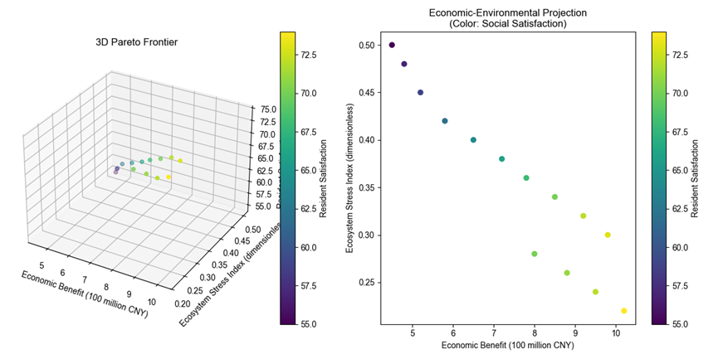
The optimal solution is centered on the range of economic benefits of 8 - 1.2 billion yuan, an ecosystem pressure index of 0.2 - 0.4 (dimensionless), and a resident satisfaction score of 65 - 75. To illustrate, when the economic benefit reaches 800 million yuan, it is imperative to maintain the ecosystem pressure index below 0.25, while the satisfaction score is to be sustained at approximately 68. This outcome underscores the necessity of a multifaceted approach, as the pursuit of a single objective, such as economic maximization, can lead to substantial degradation in other objectives. Consequently, effective policymaking necessitates the selection of a compromise between the Pareto frontier. In the event that ecological protection is prioritized, lower economic returns (e.g., 800 million yuan) and lower ecosystem pressure may be accepted. Conversely, if cultural heritage and residents' livelihoods are emphasized, the number of tourists must be appropriately limited to ensure a high level of residents' satisfaction. In practical implementation, the strategy should undergo dynamic adjustments with real-time monitoring data, such as the implementation of differentiated tourism routes to guide the dispersed flow of tourists and the earmarking of a portion of the tourism revenue for ecological restoration and community development. This approach is intended to achieve a long-term balance of sustainable tourism.
Sensitivity AnalysisA sensitivity analysis demonstrates that the number of tourists (V) exerts a substantial influence on economic revenue, ecological pressure, and social satisfaction. An increase in the number of tourists has been shown to directly promote economic income. However, this increase can also exacerbate ecosystem pressure and reduce resident satisfaction due to resource competition and other issues. The proportion of community compensation exhibited the highest sensitivity (0.7) to social satisfaction, indicating that economic compensation is a primary means of alleviating resident dissatisfaction. The carbon tax exhibited a comparatively less pronounced effect on economic gains (sensitivity 0.12), yet when combined with tax redistribution, it could indirectly enhance social equity. The findings underscore the imperative for a balanced approach, encompassing visitor volume control, dynamic pricing, and compensation mechanisms such as limiting visitor caps during peak seasons and allocating carbon tax revenues to resident welfare and ecological protection facilities.
It is evident that prioritizing social objectives constitutes the most rational foundation for orchestrating sustainable tourism development in Tibet. The rationale for this assertion is twofold. Firstly, the sub-goals of tourism innovation capacity and investment in public services can be achieved at optimal values in this case. Secondly, some other key sub-goals, such as tourism revenue and road mileage, can be achieved at near-optimal values.
The primary constraint of the study is that the proposed 10 sub-objectives for sustainable tourism development in Tibet do not comprehensively address a wide range of areas of sustainable tourism development due to the limitation of data availability. Furthermore, the weights of each sub-objective were not taken into consideration, which suggests that the objective function may be flawed to some extent. Future studies should consider a more comprehensive set of sub-objectives and undertake a thorough analysis of all sub-objectives, incorporating appropriate weighting.
Analysis of Siting Effects and Balancing Strategies
Effects of site selection on key measures
In the Tibetan plateau, ecological vulnerability and high-altitude climate issues have emerged as the primary constraints on development, superseding concerns over carbon emissions. The Tibetan plateau, with its unique alpine ecosystem, is characterized by an extremely fragile ecological environment that is highly resistant to recovery following damage. Concurrently, the high-altitude climatic conditions, characterized by low temperatures and a scarcity of oxygen, present challenges to the construction of tourism facilities and activities. In contrast to other regions that prioritize carbon emission control, Tibet's environmental priorities must shift from the control of carbon emissions to the protection of the ecosystem and the construction of tourism facilities adapted to the high-altitude climate. This adaptation is crucial for ensuring the sustainable development of the region.
The region's economic viability hinges on the development of niche cultural tourism and ecotourism, as opposed to the promotion of a singular natural landscape. Rather than relying on the development of a single natural landscape, the economic income of Tibet should be primarily derived from specialty cultural tourism and ecotourism. In contrast to the mass-sightseeing model prevalent in many tourist destinations, Tibet's cultural tourism encompasses a diverse array of activities, including Tibetan Buddhist cultural experiences and folklore festivals. Eco-tourism in Tibet involves activities such as highland wildlife viewing and eco-hiking. These tourism activities offer visitors a distinctive travel experience while also ensuring the preservation of the local ecological environment and generating more sustainable economic benefits for the region. Consequently, economic prioritization must transition from a single focus on the development of a natural landscape to the development of distinctive cultural and ecotourism products. This shift will further enhance competitiveness by upgrading the quality and content of tourism products.

Strategies for Promoting Low-Traffic Attractions in Tibet
(i) Dynamic Pricing to Regulate Tourist Flow
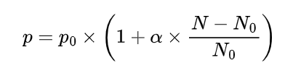
In order to effectively control the visitor flow of each attraction, the following dynamic pricing formula is defined:
In the context of analyzing the dynamics of attractions, the real-time fare, denoted by P, is of particular relevance. This is defined in relation to a benchmark fare, designated as P_0, which serves as a reference point for evaluating changes in the attraction's pricing strategy. The adjustment coefficient, denoted by α, is a variable that can be calibrated based on the particular characteristics of the attraction and the regulatory objective. This coefficient serves to calibrate the sensitivity of the fare to fluctuations in the number of visitors. P_1 denotes the current number of tourists in the attraction, while P_2 signifies the optimal number of tourists the attraction can accommodate.
For popular attractions, such as the Potala Palace, when the number of tourists exceeds the optimal capacity, the ticket price will be increased according to the above formula to regulate the influx of tourists. For attractions with a lower tourist flow, such as Sapu Shenshan, the ticket price will be decreased to attract more visitors and regulate the tourist flow.
(ii) Marketing resource allocation strategyA total of 35% of tourism revenue is allocated to the promotion of low-traffic attractions. The specific promotion channels are as follows:
Firstly, precision marketing is employed in digital media, leveraging big data analysis to ascertain potential tourists' interests, hobbies, travel habits, and other characteristics. This analysis enables the placement of targeted advertisements on major digital media platforms. For instance, for users with a proclivity for natural scenery photography, the company strategically showcases photos and videos of stunning natural landscapes in Tibet's low-traffic attractions, with the aim of capturing their attention.
Furthermore, the company has established a presence at prominent tourism exhibitions and activities. The company actively participates in various tourism exhibitions at home and abroad, setting up dedicated booths to showcase the distinctive appeal of these under-the-radar destinations. Concurrently, themed promotional activities are organized, enticing travelers and media reporters to experience and disseminate information about these attractions, thereby augmenting their popularity and influence.
(iii) Optimization of Tourist Distribution Model
The optimization of tourist distribution model has been developed to achieve a scientific and reasonable allocation of tourists across various attractions in Tibet.
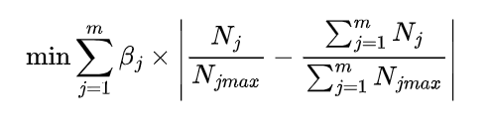
In this study, m is defined as the total number of attractions in Tibet. βj is the weight assigned to the jth attraction, determined by a multifaceted evaluation encompassing the cultural value, ecological vulnerability, and development potential of the attraction, among other considerations. Nj is the actual number of tourists of the jth attraction, and NjMAX is the maximum number of tourists carried by the jth attraction.
The objective of the model is to minimize the sum of the absolute values of the deviations between the actual visitor share of each attraction and the overall average share. Through continuous optimization of this model, more reasonable tourist guidance policies can be formulated, such as adjusting the promotional efforts of each attraction, providing differentiated tourism services, etc., so as to make the distribution of tourists among attractions in Tibet more balanced and promote the sustainable development of tourism in Tibet.
As illustrated in the accompanying figure, this study utilizes a computer simulation to model the number of tourists at five popular attractions in Tibet over the course of one month. The simulation results are presented as visual representations of the dynamic trend of the number of tourists in each attraction with the date.
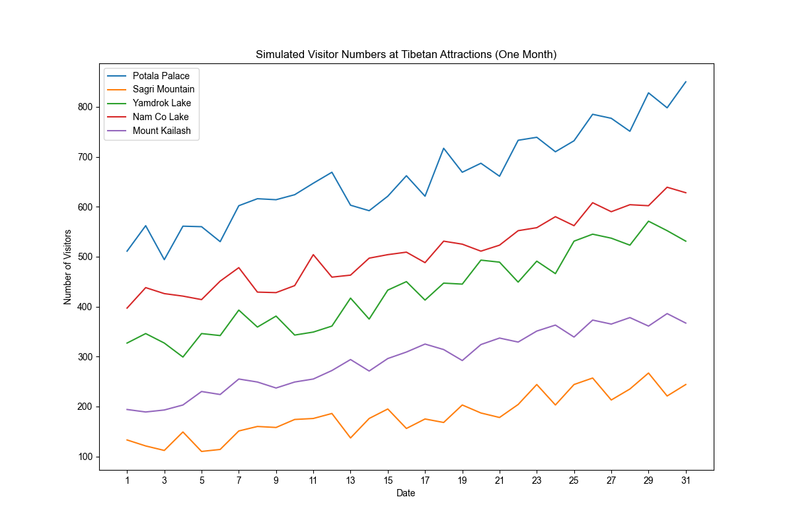
The number of visitors to the Potala Palace (blue dash line) exhibited significant fluctuations during the month, demonstrating a notable upward trend overall, with the number of visitors approaching 800 by the end of the month. This increase can be attributed to the Potala Palace's high visibility and its status as an iconic cultural heritage of Tibet. Additionally, the publicity and promotional efforts during the peak tourist season may have contributed to this increase.
In contrast, the number of visitors to Sapo Shenshan (orange line) remained relatively low, fluctuating within the range of 100 to 250 throughout the month. This attraction has yet to garner significant tourism, a phenomenon that may be attributed to its relatively remote location and inadequate publicity.
In contrast, the number of tourists at Yamdrok Yumtso (green line) exhibits seasonal fluctuations, with an overall upward trend, and the number of tourists at the end of the month ranges from 500 to 600. The region's appeal, attributed to its scenic lakes and mountains, has been a significant factor in attracting tourists. However, the observed fluctuations in the number of tourists may be attributable to various factors, including traffic congestion, seasonal variations, and the impact of tourism policies.
In contrast, Namucuo (the red line) exhibits more pronounced fluctuations in the number of tourists, displaying a marked upward trend, with approximately 650 tourists at the end of the month. Namucuo, a renowned holy lake in Tibet, draws visitors due to its natural beauty, religious and cultural significance.
Gang Rinpoche (purple line) exhibits a relatively stable number of visitors, with a slight increase, remaining between 350 and 400 at the end of the month. The religious sanctity of the site appeals to a specific group of tourists, but its high altitude and inaccessibility may have limited a significant increase in visitor numbers.
The simulation results offer insights to tourism management departments and practitioners, facilitating a deeper understanding of the evolving characteristics of tourist flows at various attractions. This understanding enables the formulation of targeted management strategies, such as optimizing the allocation of tourism resources, enhancing attraction publicity and promotion, and rationally arranging tourism service facilities. These strategies are designed to promote the sustainable development of the tourism industry in Tibet.

