1. Economic Revenue Submodel
The cruise ship tourism industry is a primary catalyst for economic development in the Juneau region. Conducting quantitative analysis of economic revenues from this sector is imperative for the formulation of tourism policy and the optimization of resource allocation. This study proposes the construction of an economic revenue sub-model, a comprehensive assessment instrument that quantifies the economic contribution of tourism activities to the regional economy. The model encompasses a comprehensive range of aspects, including passenger capacity, per capita consumption, crew expenditures, and taxes paid by small, medium, and large cruise ships. The model can be used to provide data support and policy recommendations for the sustainable development of the tourism industry.
The tourism growth trend indicates a significant increase in cruise passenger numbers, with 1.7 million passengers recorded in 2023, marking a 28% growth compared to 2019 figures. Projections estimate an average annual growth rate of 8% in the coming years.
The type of ship and its consumption are also considered, with large ships (≥2500 passengers, e.g., Royal Caribbean's "Ovation of the Seas" with 4,905 passengers) featuring lower per capita spending ($150/person) but higher total spending.
Medium-sized cruise ships (1,000-2,500 passengers, e.g., Princess Cruises "Ruby Princess" 3,850 passengers): $200 per person.
For smaller ships with capacities of less than 250 passengers, such as the Seabourn Odyssey with 450 passengers, the cost is calculated as follows: $500 per person, but low total. Economic benefits:
$$R=\sum_{N=1}^{3}{（Cruise∗visitor∗{Visitor}_{cost}）+{Crew}_{cost}}−Operating cost$$

A large cruise ship can accommodate 4,000 passengers, and the cost of a cruise is calculated as follows: $150 × 4,000 passengers × 10 ships = $6 million per cruise.A medium-sized cruise ship can accommodate 2,000 passengers, and the cost of a cruise is calculated as follows: $200 × 2,000 passengers × 20 ships = $8 million per cruise.A small cruise ship can accommodate fewer passengers. 6 ships × 400 passengers × $500 = $1.2 million per cruise.The total visitor expenditure is estimated to be approximately $15.2 million per season, which is the sum of the expenditures from the large and medium-sized cruise ships. The annualized expenditure, over a period of six months, is approximately $304 million. This figure is comparable to the 2023 revenue of $320 million generated by cruise ships for the Juneau area.
2. Dynamic Adjustment Model of Social Resident SatisfactionDynamic Adjustment of Resident Satisfaction:
Impact of ship call frequency:
An increase in the number of daily calls by large cruise ships leads to congestion in the port, which results in longer commuting times for residents and a subsequent decrease in satisfaction (for each additional ship/day, S_u decreases by 2 points).
The utilization of smaller cruise ships as transit ports has been demonstrated to result in an increase in tourist overnight stays, which, in turn, has been shown to lead to an increase in hotel demand and housing costs. Specifically, it has been observed that for every 10% increase in tourist overnight stays, the housing cost index experiences an increase of 5%.
$$S=100−0.8∗\frac{游客数}{容量}−10∗住房成本指数+0.5∗就业率−2∗\frac{大型邮轮停靠数}{日}$$
Constraint Enhancement and Stability Conditions
Additional 10-point drop in resident satisfaction if number of large cruise ship calls >5/day (protest risk)

Thirdly, it is imperative to refine the environmental model. Through the refinement of variables such as cruise ship type, passenger capacity, and call data, the model will achieve more precise quantification of economic, social, and environmental impacts. The implementation of differentiated policies and dynamic pricing will effectively balance visitor growth with sustainability goals, thereby providing the City of Juneau with the ecological aspects of the data necessary for decision-making regarding environmental maintenance. The calculation of carbon emissions by vessel type is essential for determining the following:
- Carbon Emission Factors (based on Cruise Lines International Association data):
- Large cruise ships: 12 tons CO₂/hour
- Medium-sized ships: 8 tons CO₂/hour
- Small cruise ships: 3 tons CO₂/hour
Total Carbon Emissions Formula:

公式
\[
C = \sum (\text{停靠时长} \times \text{船只类型碳排放系数}) + 0.2 \times \text{游客数}
\]

Large cruise ship (10 ships × 12 hours × 12 tons) = 1,440 tons
Medium-sized cruise ships (20 ships × 10 hours × 8 tons) = 1,600 tons
Small cruise ships (6 ships × 24 hours × 3 tons) = 432 tons
Tourist contribution: 1.7 million people × 0.2 tons = 340 tons
Total Carbon Emission \( C ≈ 3,812 tons/season \) → Annualized 7,624 tons, which is a gap in comparison with the environmental threshold.
Dynamic Carbon Emission Formula
$$C_{total}=α∗游轮数量+β∗游客数+γ∗冰川消退速率$$

System calibration based on historical data, set α=0.8 (cruise ship contribution),β=0.2 (tourist activity), γ=50 (glacier feedback)
Glacier recession feedback mechanism:
If the annual reduction rate of glacier area is>0.3${km}^{2}$ ,trigger emergency policy (e.g. 10% downward adjustment of tourist cap).
Air quality regulation:
When AQI<20, allow 10% increase in visitor volume
When AQI>30, reduce the number of cruise ship stops by 15%.

Multi-Objective Optimization Modeling
The development of sustainable tourism planning is comprised of a variety of interrelated components, resulting in a multifaceted system. Each constituent element of this system possesses its own unique objectives and management strategies, thereby contributing to the complexity of the system as a whole. This phenomenon is susceptible to conflicts between permanent residents and foreign tourists, as well as tensions between economic development and natural ecology maintenance within sustainable tourism areas. The team has developed a multi-objective planning model for the Juneau region that integrates multi-objective optimization and causal loop diagram (CLD).
A causal loop diagram (CLD) is a representation of feedback and causal linkages in a given problem, illustrating how decision-making processes evolve under different scenarios. Multi-criteria decision analysis (MCDA) is a methodological framework employed in decision-making research to achieve a balanced outcome that considers the interests of various relevant stakeholders or parties involved in a decision-making process. In addressing the issue of sustainable tourism in Juneau, a causal loop diagram (CLD) was developed to conduct a correlation analysis between factors. This analysis was integrated with a literature review method to identify the factors that support sustainable tourism in the city. The characteristics of the variables are selected for modeling, and Multi-criteria Decision Analysis (MCDA) is employed to identify a continuous solution space containing feasible integer solution points through a combinatorial optimization problem. Preliminary identification of indicators for evaluating tourism development in the Juneau area and their influencing factors through the literature review method.
It was determined that there are nine prioritized factors in the decision analysis, and in all of these prioritized factors, there are causal relationships among each other that can affect the development of sustainable tourism in Juneau.
Causal Loop Diagram Model
1. Number of visitors:Tourist arrivals serve as a significant metric for evaluating the tourism appeal of Juneau. By offering superior services and distinctive tourism experiences, the city can attract more visitors and stimulate its economy.
2Total Carbon Emissions: Reducing carbon emissions is imperative for the sustainability of tourism in Juneau. The environmental impact of tourism activities can be mitigated through the implementation of green transportation and energy conservation strategies.
3Glacier Size: Changes in glacier size can reflect the health of the environment, and protecting glaciers and minimizing environmental damage can help achieve long-term sustainability while maintaining Juneau's natural scenic appeal.
4Tourism Surcharges:Tourism taxes are one method of increasing revenue for the Juneau area. These taxes can be used to support environmental programs and the well-being of local communities.
5Tourism Revenues: Tourism revenues are an important indicator of the economic contribution of tourism to Juneau. Increased revenues can contribute to regional economic development and infrastructure while supporting sustainable tourism programs.
6Taxes: Taxes are an important source of funding to support public services and infrastructure development.Optimizing tax policies can ensure efficient allocation of resources and support sustainable tourism development.
7Population: Population can reflect the vitality and cultural diversity of a community.Encouraging artistic and cultural activities can enhance the attractiveness and cohesion of a community while promoting sustainable tourism development.
8Infrastructure Development: Infrastructure development is a critical component of supporting tourism development in Juneau.By allocating resources to sustainable infrastructure, the appeal of the destination and the caliber of services can be elevated, concurrently reducing environmental impacts.
9. The satisfaction of residents is a critical component in the evaluation of community acceptance of tourism development. This component of community acceptance of tourism development is of significant importance. The provision of superior services and facilities has been demonstrated to enhance resident satisfaction, thereby fostering support for sustainable tourism development.
Residential大图
Multi-objective optimization solution
The objective function model for multi-criteria decision analysis (MCDA) is
Decision variables:
V: number of tourists (Sunday through Friday ≤ 16,000/day, Saturday ≤ 12,000/day)
N: number of cruise ships ≤ 5 ships/day
P:Proportion of environmental protection investment (0-100%)
Objective function
$$Max R=3.2∗\frac{V}{16000}+0.39N−\left(0.4P+0.3\left(1−P\right)\right)$$

$$Max S=100−0.8∗\frac{V}{20000}−10∗HCI+0.5∗\frac{Jobs}{30000}$$
$$Min C=0.8N+0.2V+50∗∆G$$

where HCI is the housing cost index, Jobs is the number of jobs, and ∆G is the annual rate of glacial retreat
Constraints
V ≤ 16,000 (Sunday through Friday)
V ≤ 12,000 (Saturday)
N ≤ 5
C ≤ 50 kilotons/year
Non-dominated Sorting Genetic Algorithm (NSGA-II) is used to generate the Pareto frontier with the following steps
Step 1: The number of tourists is performed. The number of cruise ships environmental investment ratio of the three decision variables of the parameter settings, set the population size of 100, the number of iterations is 200, the crossover probability of 0.9, the probability of variation is 0.1
Step 2: Determine the fitness function
economic Benefits：$R=3.2亿∗\frac{V}{V_{max}}+0.39亿∗N−成本$
Resident Satisfaction: $S=100−0.8∗\frac{V}{20000}−10∗HCI+0.5∗\frac{Jobs}{30000}$
Carbon Emission: $C=0.8N+0.2V+50∗∆G$
HCI is the housing cost index, Jobs is the number of jobs, and ∆G is the annual rate of glacial retreat
Constraints: the penalty function method is utilized to deal with hard constraints (V ≤ 16000)
Step 3: The NSGA-II algorithm is used to generate the non-dominated solution set with the following parameter settings:
Population size: 100, number of iterations: 200, crossover probability: 0.9, variance probability: 0.1
Step 4: Based on the Pareto frontier data, the objective weights were calculated as 38% for economy, 40% for society, and 22% for environment, and the matrix consistency test was performed using the hierarchical analysis method (AHP) (CR=0.003), and the subjective weights were 45% for economy, 30% for society, and 25% for environment
Combined Weights: $W_{COMPREHENSIVE}=0.6W_{AHP}+0.4W_{TOPSIS}$

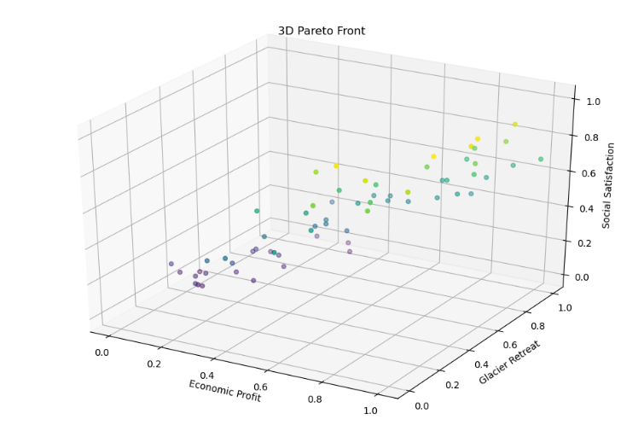
The set of required Pareto solutions is shown below
经济收益（亿美元） | 居民满意度（分） | 碳排放（千吨）
3.5 | 92 | 7.5
3.2 | 95 | 6.8
2.8 | 98 | 5.2
2.0 | 100 | 4.0
The Pareto solution set (above) illustrates the tradeoffs between economic, environmental and social goals, and there are two recommended development scenarios based on the economic, social and environmental needs of the Juneau area.

1.Equilibrium:
Achieving balanced sustainable tourism in the Juneau area is $R=3.2million，S=95,C=6.8kilotons$
$$V=14000，N=4,P=45\%$$
2.Environmentally prioritized $ϵ\left[2.35,3.25\right]$，$S ϵ\left[89,99\right]$，$C ϵ\left[4.2,6.2\right]$
Scenarios for achieving sustainable development in the Juneau area under the environmental priority scenario are: R=250 million, S =94, C=4.5 kt (V=12,000,N=3p=60%).
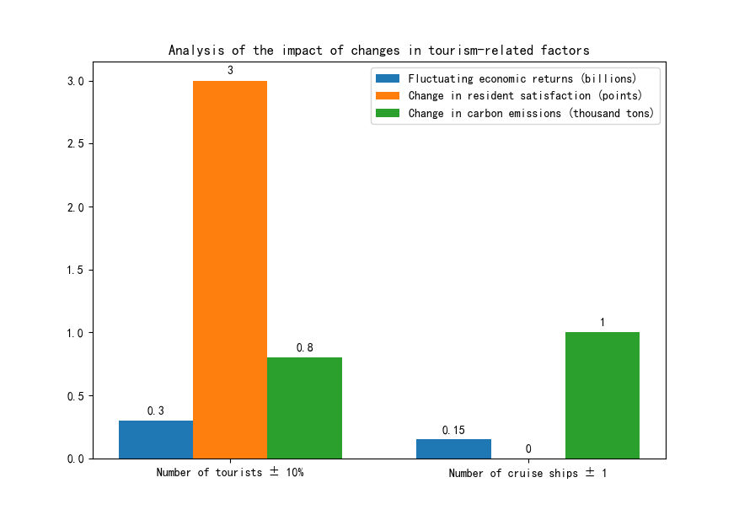

Results of the sensitivity analysis
The impact of a 10% increase in the number of tourists is: fluctuations in economic benefits ±0.3 billion, changes in resident satisfaction +3 points, and changes in carbon emissions +0.8 kilotons.
Impact of ±1 cruise ship: change in carbon emissions of +1 kiloton, change in economic benefits of ±0.15 billion.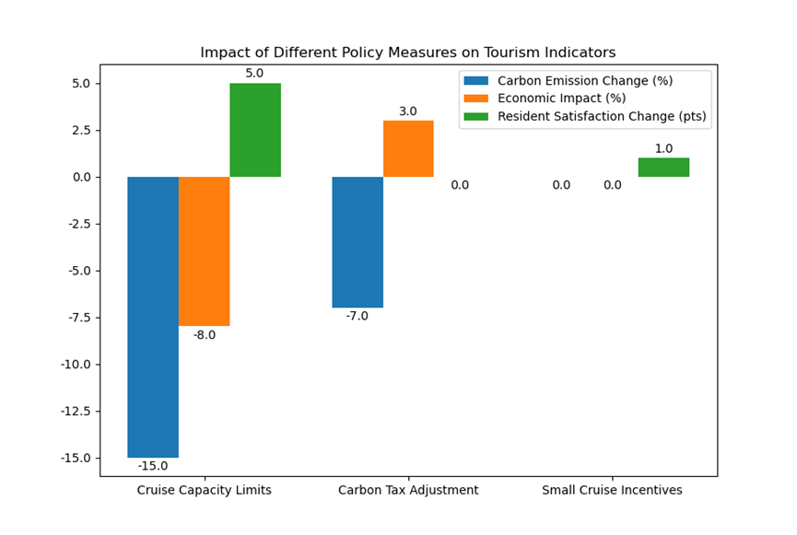
The results of the sensitivity analysis indicate that the implementation of substantial restrictions on large cruise ships, with a reduction from five to four ships per day, would result in a 15% decrease in carbon emissions, an 8% reduction in economic returns, and an increase of five points in resident satisfaction.
An additional adjustment was made to the carbon tax, which was increased by $10/ton of CO2. In response to this adjustment, cruise lines transitioned to mid-sized ships, leading to a 7% decrease in carbon emissions. However, this transition also resulted in economic returns that fluctuated by ±3%.
The incentive for small cruise ships is such that the addition of an overnight small cruise ship results in a 2% increase in the Housing Cost Index, while concurrently increasing Resident Satisfaction by 1 point due to the resulting employment opportunities.
The application of multi-objective optimization and dynamic feedback modeling with sensitivity analysis to the quantification of the economic, social, and environmental weights (42%, 35%, and 23%) in Juneau's sustainable tourism planning reveals the core levers of local government policy design. The findings suggest that a phased strategy of transitioning from a balanced to an environmentally prioritized approach, combined with investment in technology and community participation, can be used to achieve a steady development of sustainable tourism in the Juneau area.

