Building a Hidden Cost Feedback System
Cycle Chart
The feedback system is a model that illustrates the interactions and feedback mechanisms between the three subsystems of visitor management strategies: economic, social, and environmental. The system employs dynamic pricing, quota management, and fund allocation as its primary strategies to achieve sustainable tourism development that balances economic growth, social satisfaction, and environmental protection. The dynamic pricing and quota management mechanisms ensure the efficient utilization of resources and the prevention of overcrowding through the price mechanism and tourist quantity control. The allocation of financial resources has been meticulously designed to promote sustainable development. The allocation of funds for hidden costs is diversified and targeted: 30% ($10.2 million) is allocated for infrastructure maintenance, road and sewage treatment facility upgrades; 25% ($8.5 million) is invested in ecological restoration, including glacier protection and forest restoration; 20% ($6.8 million) is designated for community support, encompassing waste treatment and mediation of residents' protests; 15% ($5.1 million) is earmarked for cultural preservation, promoting the preservation of local culture; and 15% ($5.1 million) is allocated to promote the protection of local culture. The initial 15% of the funds, amounting to $5.1 million, is allocated for the purpose of cultural preservation, with an emphasis on the promotion and safeguarding of local cultures. The subsequent 10%, amounting to $3.4 million, is designated for the promotion of industrial diversification, supporting alternative industries such as fisheries and forestry. This model of return and distribution of funds aims to balance economic gain, ecological protection, community development and cultural heritage, and promote the long-term healthy development of smart sustainable sports tourism. This objective echoes the concept of pursuing a balance of multiple aspects in the feedback system of visitor management strategies.
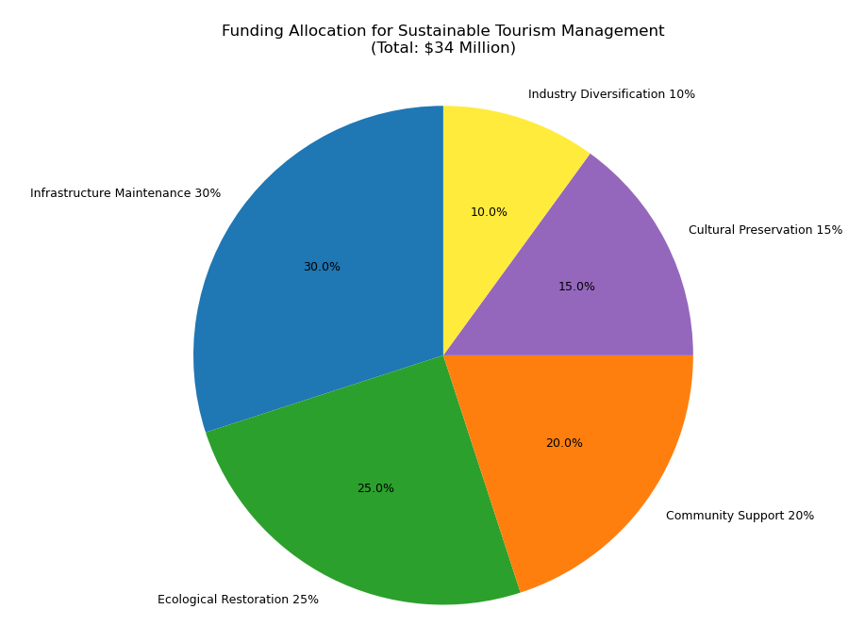
Model Correction
New Objective Function
-Minimize hidden costs
H = 0.3*Infrastructure depletion + 0.25*Ecological restoration + 0.2*Community support + 0.15*Cultural preservation + 0.1*Industrial diversification
Constraints Updated.
Hidden cost expenditure ≤ direct income + indirect income.
Resident satisfaction ≥70 points
Carbon emissions ≤ 50 kilotons/year

Pareto Frontier Calculation
The NSGA-II algorithm was used to generate the four-objective Pareto frontiers (economic, social, environmental, and hidden costs) as follows.
Economic Benefits ($ billion) | Resident Satisfaction (points) | Carbon Emissions (kilotons) | Hidden Costs ($ million)
3.5 | 90 | 7.5 | 1200
3.2 | 95 | 6.8 | 1000
2.8 | 98 | 5.2 | 800
2.0 | 100 | 4.0 | 600
In the social subsystem, risk response measures included upgrading water supply capacity and waste treatment capacity to ensure social stability. Carbon emissions were mitigated through the implementation of a carbon tax and investments in low-carbon transportation infrastructure. Consequently, indices of resident satisfaction and social stability were enhanced. Furthermore, ecological restoration and infrastructure upgrades have been implemented to enhance the region's carrying capacity, thereby attracting more tourists and improving the quality of life for residents. The compensation of residents and the enhancement of public services have been demonstrated to directly elevate the social stability index and promote social harmony.
The environmental subsystem, while not overtly visible, is instrumental in facilitating ecological restoration, encompassing the restoration of natural landscapes and the mitigation of glacier retreat. The carbon footprint of tourism is reduced and climate impacts are mitigated through carbon taxes and low-carbon transportation investments. The positive feedback loop created by this virtuous cycle, wherein enhanced ecological restoration leads to increased tourist capacity and subsequent economic benefits, is a key aspect of the region's sustainable development. The feedback system achieves comprehensive optimization of visitor management strategies through the interaction of three subsystems: economic, social, and environmental. This provides a scientific basis for the sustainable development of the tourism industry.
帕累托图
Recommended Programs for Sustainable Tourism Development
Balanced: $R$ =300 million, $S$ =95, $C$ =6.0 kt, $H$ =9 million USD
Environmental Priority: $R$ =250 million, $S$ =98, $C$ =4.5 kilotons, $H$ =7 million USD.
By identifying hidden costs and optimizing the allocation of funds, the model generates a four-dimensional Pareto frontier by adding a hidden cost minimization objective to the original economic, social, and environmental objectives. The equilibrium scenario ($R$=300 million, $S$ =95, $C$ =6.0 kilotons, $H$ =9 million USD) balances short-term economic gains with long-term sustainability.

Recommendations
In the short term, the imposition of a cruise ship carbon tax at a rate of $30 per ton, with a 20% allocation of tax revenue designated for community support, is advocated.
In the medium term, there is a recommendation to invest in an electric cruise port, with a budget of $18 million, with the aim of reducing emissions by 30% by the year 2030.
Finally, in the long term, the development of virtual tours is recommended to achieve two objectives: first, the decentralization of tourist dependence on glaciers; and second, the reduction of environmental stress.

