The Title Of Our Paper
Abstract
(摘要内容)
Keywords:

（目录）

1.Introduction

1.1 Problem Background
In the context of the rapidly expanding global tourism industry, ensuring economic benefits while protecting the environment and the well-being of local communities has become an urgent challenge.An important tourist destination, Juneau, Alaska, USA, is facing this problem.The number of cruise ship passengers received by Juneau each year has reached 1.6 million, far exceeding the carrying capacity of its permanent population of 30,000. On the busiest days, as many as seven large cruise ships visit simultaneously, with a total of more than 20,000 tourists on board, thereby exerting tremendous pressure on the city's infrastructure and exacerbating environmental issues, such as the accelerated retreat of the Mendenhall Glacier.
While the tourism industry has proven to be financially advantageous, generating approximately $375 million for Juno, its hidden costs, including pressure on infrastructure, increased carbon footprint, and impact on the quality of life of local residents, are gradually becoming apparent.To address these challenges, Juno City must develop and implement sustainable tourism management strategies to strike a balance between economic benefits and environmental protection.
1.2 Restatement of the Problem
The objective of this study is to establish a sustainable tourism industry model that will optimize the number of tourists and overall income, while implementing effective management measures. To this end, the following tasks must be completed:
First, the optimization objective is to reduce negative impacts on the environment and community while maintaining or increasing tourism revenue.
Second, the constraints to be considered include daily tourist limit, infrastructure carrying capacity, environmental protection needs (such as controlling glacier retreat rate), and the quality of life of local residents.
The expenditure plan is as follows: the additional income will be allocated to support environmental protection, infrastructure improvement, and community development plans, thereby promoting the sustainable tourism development of Juno through a model feedback mechanism.
The sensitivity analysis will evaluate the model's sensitivity to key variables such as tourist numbers, tax policies, and environmental protection measures to identify the most important factors and optimize decisions.
The objective of this study is to provide a feasible solution that balances economy and environment for Juno City, while also serving as a reference for other tourism destinations facing similar challenges.

1.3 Literature Review
In the context of a global focus on sustainable development, tourism is confronted with the challenge of balancing economic growth with environmental preservation. Pan et al. (2018) emphasised that, despite advancements towards a green economy, sustainable tourism continues to encounter challenges such as resource management, carbon emission reduction, and aligning tourism demand with environmental protection.
Sun et al. (2020) introduced the concept of managing tourism's carbon emissions by optimising the tourism demand mix, suggesting that strategic adjustments in tourist origins and activities can reduce the carbon footprint while maintaining economic benefits.
The impact of climate change on tourism is a significant consideration. In their seminal study, Scott et al. (2004) examined the effects of climate change on tourism resources in North America, noting potential shifts in seasons and destinations, which are of particular concern to areas reliant on natural landscapes.
Triwijoyo et al. (2024) developed an optimization model for sustainable sport tourism planning, integrating multiple decision-making factors for sustainable development.
Hardy et al. (2002) emphasised that sustainable tourism encompasses environmental, social, and economic sustainability, advocating for a holistic approach to ensure long-term viability.
Lusseau (2004) investigated the long-term ecological impacts of tourism, highlighting the need to consider these hidden costs in policy-making.
Garrigos-Simon et al. (2018) employed bibliometric and visualisation analyses to explore the nexus of tourism and sustainability, identifying research trends and providing a framework for future studies.
Despite extensive research, integrated management strategies for specific regions, such as Juneau, Alaska, remain underdeveloped. The present study aims to address this lacuna by developing a sustainable tourism model tailored to Juneau's unique context, focusing on local realities.

1.4 Our Work
The objective of the present study is to formulate a sustainable tourism model for Juneau, Alaska, with the aim of optimising both visitor numbers and revenues, whilst concomitantly minimising negative environmental and community impacts. The following key steps have been identified:
Data Compilation and Preliminary Analysis: A comprehensive data set was collated, encompassing visitor statistics, tourism revenues, infrastructure load, environmental metrics (e.g. glacier retreat rates), and resident satisfaction. The utilisation of statistical tools facilitates the identification of pivotal issues and the assessment of potential for enhancement in the present tourism operations.
The construction of a model was then undertaken. A multi-objective optimisation model was developed, seeking to balance economic benefits with environmental protection and resident quality of life. Constraints included daily tourist limits, infrastructure capacity, environmental protection needs, and social satisfaction.
The evaluation of policy scenarios: Various policy scenarios were designed, including visitor limits, tax policies, and infrastructure investments. Utilising simulations, the impacts of these policies on economic, environmental, and social sustainability were assessed.
Feedback and Sensitivity Analysis: The model's feedback mechanism was utilised to explore the potential for generating additional revenues for the purpose of environmental, infrastructural, and community enhancements. Sensitivity analysis identified the model's responsiveness to key variables, thus aiding in the optimization of decision-making.
Model Adjustment and Optimization: Following the simulation phase, the model was refined to account for hidden costs and to better fit Juneau's specific context, ensuring its relevance for sustainable tourism assessment.

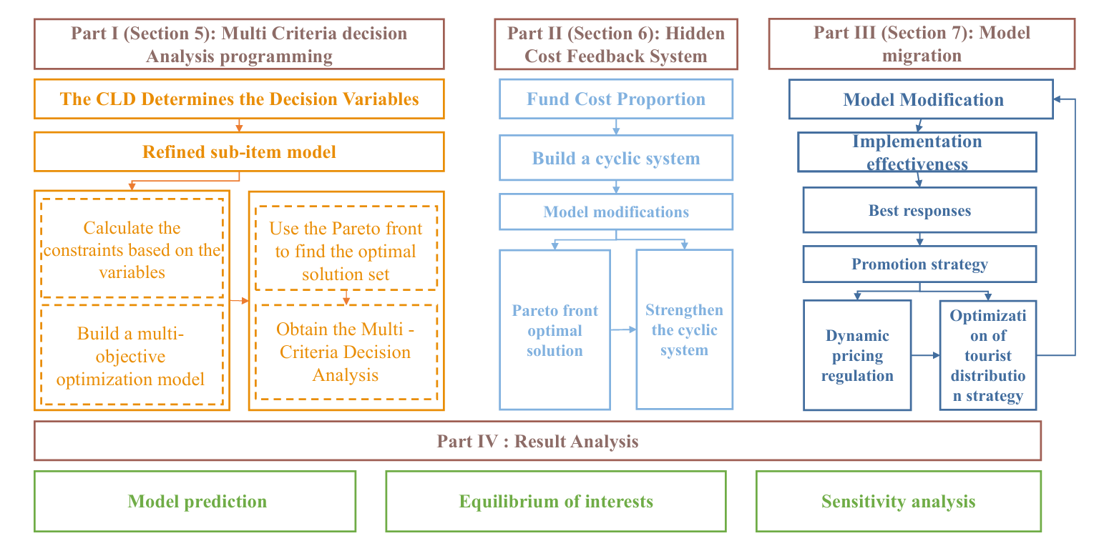
2. Assumptions
3. (待填充)
4. Data
- Part I
5. 1 Economic Revenue Submodel
The cruise ship tourism industry is a primary catalyst for economic development in the Juneau region. Conducting quantitative analysis of economic revenues from this sector is imperative for the formulation of tourism policy and the optimization of resource allocation. This study proposes the construction of an economic revenue sub-model, a comprehensive assessment instrument that quantifies the economic contribution of tourism activities to the regional economy. The model encompasses a comprehensive range of aspects, including passenger capacity, per capita consumption, crew expenditures, and taxes paid by small, medium, and large cruise ships. The model can be used to provide data support and policy recommendations for the sustainable development of the tourism industry.
The tourism growth trend indicates a significant increase in cruise passenger numbers, with 1.7 million passengers recorded in 2023, marking a 28% growth compared to 2019 figures. Projections estimate an average annual growth rate of 8% in the coming years.
The type of ship and its consumption are also considered, with large ships (≥2500 passengers, e.g., Royal Caribbean's "Ovation of the Seas" with 4,905 passengers) featuring lower per capita spending ($150/person) but higher total spending.
Medium-sized cruise ships (1,000-2,500 passengers, e.g., Princess Cruises "Ruby Princess" 3,850 passengers): $200 per person.
For smaller ships with capacities of less than 250 passengers, such as the Seabourn Odyssey with 450 passengers, the cost is calculated as follows: $500 per person, but low total. Economic benefits:
$$R=\sum_{N=1}^{3}{（Cruise*visitor*{Visitor}_{cost}）+{Crew}_{cost}}-Operating cost$$

A large cruise ship can accommodate 4,000 passengers, and the cost of a cruise is calculated as follows: $150 × 4,000 passengers × 10 ships = $6 million per cruise.A medium-sized cruise ship can accommodate 2,000 passengers, and the cost of a cruise is calculated as follows: $200 × 2,000 passengers × 20 ships = $8 million per cruise.A small cruise ship can accommodate fewer passengers. 6 ships × 400 passengers × $500 = $1.2 million per cruise.The total visitor expenditure is estimated to be approximately $15.2 million per season, which is the sum of the expenditures from the large and medium-sized cruise ships. The annualized expenditure, over a period of six months, is approximately $304 million. This figure is comparable to the 2023 revenue of $320 million generated by cruise ships for the Juneau area.
5.2 Dynamic Adjustment Model of Social Resident SatisfactionDynamic Adjustment of Resident Satisfaction
Impact of ship call frequency:
An increase in the number of daily calls by large cruise ships leads to congestion in the port, which results in longer commuting times for residents and a subsequent decrease in satisfaction (for each additional ship/day, S_u decreases by 2 points).
The utilization of smaller cruise ships as transit ports has been demonstrated to result in an increase in tourist overnight stays, which, in turn, has been shown to lead to an increase in hotel demand and housing costs. Specifically, it has been observed that for every 10% increase in tourist overnight stays, the housing cost index experiences an increase of 5%.
$$S=100-0.8*\frac{游客数}{容量}-10*住房成本指数+0.5*就业率-2*\frac{大型邮轮停靠数}{日}$$
Constraint Enhancement and Stability Conditions
Additional 10-point drop in resident satisfaction if number of large cruise ship calls >5/day (protest risk)

Thirdly, it is imperative to refine the environmental model. Through the refinement of variables such as cruise ship type, passenger capacity, and call data, the model will achieve more precise quantification of economic, social, and environmental impacts. The implementation of differentiated policies and dynamic pricing will effectively balance visitor growth with sustainability goals, thereby providing the City of Juneau with the ecological aspects of the data necessary for decision-making regarding environmental maintenance. The calculation of carbon emissions by vessel type is essential for determining the following:
- Carbon Emission Factors (based on Cruise Lines International Association data):
- Large cruise ships: 12 tons CO₂/hour
- Medium-sized ships: 8 tons CO₂/hour
- Small cruise ships: 3 tons CO₂/hour
Total Carbon Emissions Formula:

公式
\[
C = \sum (\text{停靠时长} \times \text{船只类型碳排放系数}) + 0.2 \times \text{游客数}
\]

Large cruise ship (10 ships × 12 hours × 12 tons) = 1,440 tons
Medium-sized cruise ships (20 ships × 10 hours × 8 tons) = 1,600 tons
Small cruise ships (6 ships × 24 hours × 3 tons) = 432 tons
Tourist contribution: 1.7 million people × 0.2 tons = 340 tons
Total Carbon Emission \( C ≈ 3,812 tons/season \) → Annualized 7,624 tons, which is a gap in comparison with the environmental threshold.
Dynamic Carbon Emission Formula
$$C_{total}=α*游轮数量+β*游客数+γ*冰川消退速率$$

System calibration based on historical data, set α=0.8 (cruise ship contribution),β=0.2 (tourist activity), γ=50 (glacier feedback)
Glacier recession feedback mechanism:
If the annual reduction rate of glacier area is>0.3${km}^{2}$ ,trigger emergency policy (e.g. 10% downward adjustment of tourist cap).
Air quality regulation:
When AQI<20, allow 10% increase in visitor volume
When AQI>30, reduce the number of cruise ship stops by 15%.

5.3 Multi-Objective Optimization Modeling
The development of sustainable tourism planning is comprised of a variety of interrelated components, resulting in a multifaceted system. Each constituent element of this system possesses its own unique objectives and management strategies, thereby contributing to the complexity of the system as a whole. This phenomenon is susceptible to conflicts between permanent residents and foreign tourists, as well as tensions between economic development and natural ecology maintenance within sustainable tourism areas. The team has developed a multi-objective planning model for the Juneau region that integrates multi-objective optimization and causal loop diagram (CLD).
A causal loop diagram (CLD) is a representation of feedback and causal linkages in a given problem, illustrating how decision-making processes evolve under different scenarios. Multi-criteria decision analysis (MCDA) is a methodological framework employed in decision-making research to achieve a balanced outcome that considers the interests of various relevant stakeholders or parties involved in a decision-making process. In addressing the issue of sustainable tourism in Juneau, a causal loop diagram (CLD) was developed to conduct a correlation analysis between factors. This analysis was integrated with a literature review method to identify the factors that support sustainable tourism in the city. The characteristics of the variables are selected for modeling, and Multi-criteria Decision Analysis (MCDA) is employed to identify a continuous solution space containing feasible integer solution points through a combinatorial optimization problem. Preliminary identification of indicators for evaluating tourism development in the Juneau area and their influencing factors through the literature review method.
It was determined that there are nine prioritized factors in the decision analysis, and in all of these prioritized factors, there are causal relationships among each other that can affect the development of sustainable tourism in Juneau.

5.4 Causal Loop Diagram Model
1. Number of visitors:Tourist arrivals serve as a significant metric for evaluating the tourism appeal of Juneau. By offering superior services and distinctive tourism experiences, the city can attract more visitors and stimulate its economy.
2.Total Carbon Emissions: Reducing carbon emissions is imperative for the sustainability of tourism in Juneau. The environmental impact of tourism activities can be mitigated through the implementation of green transportation and energy conservation strategies.
3.Glacier Size: Changes in glacier size can reflect the health of the environment, and protecting glaciers and minimizing environmental damage can help achieve long-term sustainability while maintaining Juneau's natural scenic appeal.
4.Tourism Surcharges:Tourism taxes are one method of increasing revenue for the Juneau area. These taxes can be used to support environmental programs and the well-being of local communities.
5.Tourism Revenues: Tourism revenues are an important indicator of the economic contribution of tourism to Juneau. Increased revenues can contribute to regional economic development and infrastructure while supporting sustainable tourism programs.
6.Taxes: Taxes are an important source of funding to support public services and infrastructure development.Optimizing tax policies can ensure efficient allocation of resources and support sustainable tourism development.
7.Population: Population can reflect the vitality and cultural diversity of a community.Encouraging artistic and cultural activities can enhance the attractiveness and cohesion of a community while promoting sustainable tourism development.
8.Infrastructure Development: Infrastructure development is a critical component of supporting tourism development in Juneau.By allocating resources to sustainable infrastructure, the appeal of the destination and the caliber of services can be elevated, concurrently reducing environmental impacts.
9.The satisfaction of residents is a critical component in the evaluation of community acceptance of tourism development. This component of community acceptance of tourism development is of significant importance. The provision of superior services and facilities has been demonstrated to enhance resident satisfaction, thereby fostering support for sustainable tourism development.
Residential大图
Multi-objective optimization solution
The objective function model for multi-criteria decision analysis (MCDA) is
Decision variables:
V: number of tourists (Sunday through Friday ≤ 16,000/day, Saturday ≤ 12,000/day)
N: number of cruise ships ≤ 5 ships/day
P:Proportion of environmental protection investment (0-100%)
Objective function
$$Max R=3.2*\frac{V}{16000}+0.39N-\left(0.4P+0.3\left(1-P\right)\right)$$

$$Max S=100-0.8*\frac{V}{20000}-10*HCI+0.5*\frac{Jobs}{30000}$$
$$Min C=0.8N+0.2V+50*∆G$$

where HCI is the housing cost index, Jobs is the number of jobs, and ∆G is the annual rate of glacial retreat
Constraints
V ≤ 16,000 (Sunday through Friday)
V ≤ 12,000 (Saturday)
N ≤ 5
C ≤ 50 kilotons/year
Non-dominated Sorting Genetic Algorithm (NSGA-II) is used to generate the Pareto frontier with the following steps
Step 1: The number of tourists is performed. The number of cruise ships environmental investment ratio of the three decision variables of the parameter settings, set the population size of 100, the number of iterations is 200, the crossover probability of 0.9, the probability of variation is 0.1
Step 2: Determine the fitness function
economic Benefits：$R=3.2亿*\frac{V}{V_{max}}+0.39亿*N-成本$
Resident Satisfaction: $S=100-0.8*\frac{V}{20000}-10*HCI+0.5*\frac{Jobs}{30000}$
Carbon Emission: $C=0.8N+0.2V+50*∆G$
HCI is the housing cost index, Jobs is the number of jobs, and ∆G is the annual rate of glacial retreat
Constraints: the penalty function method is utilized to deal with hard constraints (V ≤ 16000)
Step 3: The NSGA-II algorithm is used to generate the non-dominated solution set with the following parameter settings:
Population size: 100, number of iterations: 200, crossover probability: 0.9, variance probability: 0.1
Step 4: Based on the Pareto frontier data, the objective weights were calculated as 38% for economy, 40% for society, and 22% for environment, and the matrix consistency test was performed using the hierarchical analysis method (AHP) (CR=0.003), and the subjective weights were 45% for economy, 30% for society, and 25% for environment
Combined Weights: $W_{COMPREHENSIVE}=0.6W_{AHP}+0.4W_{TOPSIS}$

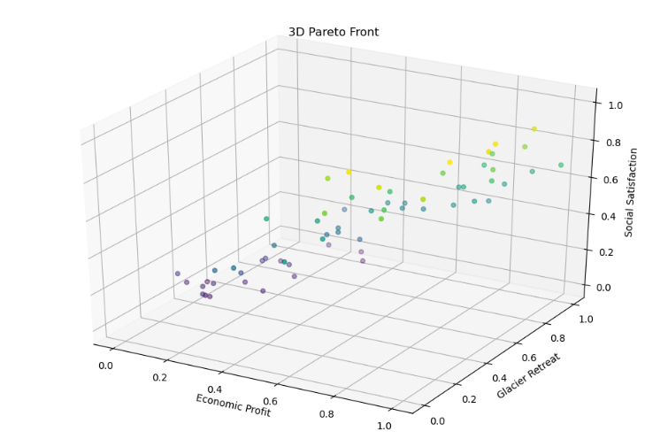
The set of required Pareto solutions is shown below
经济收益（亿美元） | 居民满意度（分） | 碳排放（千吨）
3.5 | 92 | 7.5
3.2 | 95 | 6.8
2.8 | 98 | 5.2
2.0 | 100 | 4.0
The Pareto solution set (above) illustrates the tradeoffs between economic, environmental and social goals, and there are two recommended development scenarios based on the economic, social and environmental needs of the Juneau area.

1.Equilibrium:
Achieving balanced sustainable tourism in the Juneau area is $R=3.2million，S=95,C=6.8kilotons$
$$V=14000，N=4,P=45\%$$
2.Environmentally prioritized $ϵ\left[2.35,3.25\right]$，$S ϵ\left[89,99\right]$，$C ϵ\left[4.2,6.2\right]$
Scenarios for achieving sustainable development in the Juneau area under the environmental priority scenario are: R=250 million, S =94, C=4.5 kt (V=12,000,N=3p=60%).
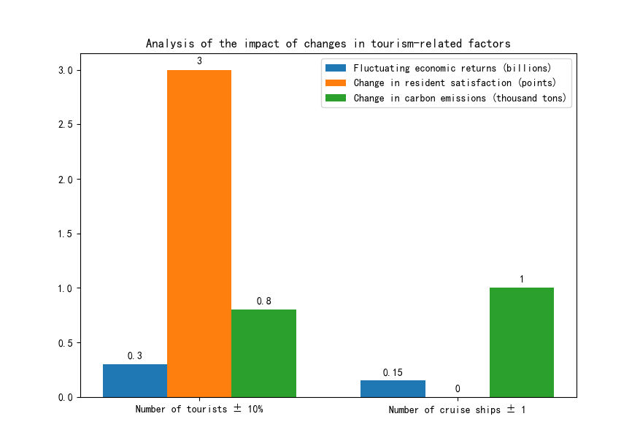

Results of the sensitivity analysis
The impact of a 10% increase in the number of tourists is: fluctuations in economic benefits ±0.3 billion, changes in resident satisfaction +3 points, and changes in carbon emissions +0.8 kilotons.
Impact of ±1 cruise ship: change in carbon emissions of +1 kiloton, change in economic benefits of ±0.15 billion.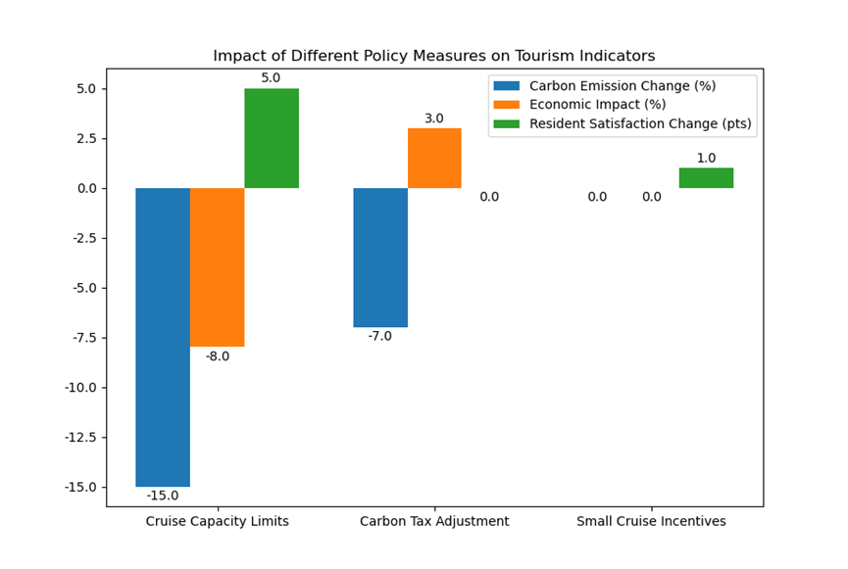
The results of the sensitivity analysis indicate that the implementation of substantial restrictions on large cruise ships, with a reduction from five to four ships per day, would result in a 15% decrease in carbon emissions, an 8% reduction in economic returns, and an increase of five points in resident satisfaction.
An additional adjustment was made to the carbon tax, which was increased by $10/ton of CO2. In response to this adjustment, cruise lines transitioned to mid-sized ships, leading to a 7% decrease in carbon emissions. However, this transition also resulted in economic returns that fluctuated by ±3%.
The incentive for small cruise ships is such that the addition of an overnight small cruise ship results in a 2% increase in the Housing Cost Index, while concurrently increasing Resident Satisfaction by 1 point due to the resulting employment opportunities.
The application of multi-objective optimization and dynamic feedback modeling with sensitivity analysis to the quantification of the economic, social, and environmental weights (42%, 35%, and 23%) in Juneau's sustainable tourism planning reveals the core levers of local government policy design. The findings suggest that a phased strategy of transitioning from a balanced to an environmentally prioritized approach, combined with investment in technology and community participation, can be used to achieve a steady development of sustainable tourism in the Juneau area.

6. Part II
6.1 Building a Hidden Cost Feedback System
（Cycle Chart）
The feedback system is a model that illustrates the interactions and feedback mechanisms between the three subsystems of visitor management strategies: economic, social, and environmental. The system employs dynamic pricing, quota management, and fund allocation as its primary strategies to achieve sustainable tourism development that balances economic growth, social satisfaction, and environmental protection. The dynamic pricing and quota management mechanisms ensure the efficient utilization of resources and the prevention of overcrowding through the price mechanism and tourist quantity control. The allocation of financial resources has been meticulously designed to promote sustainable development. The allocation of funds for hidden costs is diversified and targeted: 30% ($10.2 million) is allocated for infrastructure maintenance, road and sewage treatment facility upgrades; 25% ($8.5 million) is invested in ecological restoration, including glacier protection and forest restoration; 20% ($6.8 million) is designated for community support, encompassing waste treatment and mediation of residents' protests; 15% ($5.1 million) is earmarked for cultural preservation, promoting the preservation of local culture; and 15% ($5.1 million) is allocated to promote the protection of local culture. The initial 15% of the funds, amounting to $5.1 million, is allocated for the purpose of cultural preservation, with an emphasis on the promotion and safeguarding of local cultures. The subsequent 10%, amounting to $3.4 million, is designated for the promotion of industrial diversification, supporting alternative industries such as fisheries and forestry. This model of return and distribution of funds aims to balance economic gain, ecological protection, community development and cultural heritage, and promote the long-term healthy development of smart sustainable sports tourism. This objective echoes the concept of pursuing a balance of multiple aspects in the feedback system of visitor management strategies.
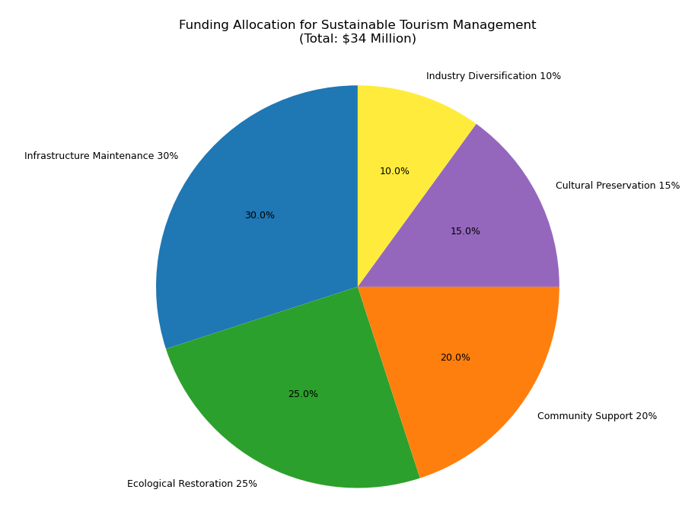
Model Correction
New Objective Function
-Minimize hidden costs
H = 0.3*Infrastructure depletion + 0.25*Ecological restoration + 0.2*Community support + 0.15*Cultural preservation + 0.1*Industrial diversification
Constraints Updated.
Hidden cost expenditure ≤ direct income + indirect income.
Resident satisfaction ≥70 points
Carbon emissions ≤ 50 kilotons/year

6.2 Pareto Frontier Calculation
The NSGA-II algorithm was used to generate the four-objective Pareto frontiers (economic, social, environmental, and hidden costs) as follows.
Economic Benefits ($ billion) | Resident Satisfaction (points) | Carbon Emissions (kilotons) | Hidden Costs ($ million)
3.5 | 90 | 7.5 | 1200
3.2 | 95 | 6.8 | 1000
2.8 | 98 | 5.2 | 800
2.0 | 100 | 4.0 | 600
In the social subsystem, risk response measures included upgrading water supply capacity and waste treatment capacity to ensure social stability. Carbon emissions were mitigated through the implementation of a carbon tax and investments in low-carbon transportation infrastructure. Consequently, indices of resident satisfaction and social stability were enhanced. Furthermore, ecological restoration and infrastructure upgrades have been implemented to enhance the region's carrying capacity, thereby attracting more tourists and improving the quality of life for residents. The compensation of residents and the enhancement of public services have been demonstrated to directly elevate the social stability index and promote social harmony.
The environmental subsystem, while not overtly visible, is instrumental in facilitating ecological restoration, encompassing the restoration of natural landscapes and the mitigation of glacier retreat. The carbon footprint of tourism is reduced and climate impacts are mitigated through carbon taxes and low-carbon transportation investments. The positive feedback loop created by this virtuous cycle, wherein enhanced ecological restoration leads to increased tourist capacity and subsequent economic benefits, is a key aspect of the region's sustainable development. The feedback system achieves comprehensive optimization of visitor management strategies through the interaction of three subsystems: economic, social, and environmental. This provides a scientific basis for the sustainable development of the tourism industry.
(帕累托图)

Recommended Programs for Sustainable Tourism Development
Balanced: $R$ =300 million, $S$ =95, $C$ =6.0 kt, $H$ =9 million USD
Environmental Priority: $R$ =250 million, $S$ =98, $C$ =4.5 kilotons, $H$ =7 million USD.
By identifying hidden costs and optimizing the allocation of funds, the model generates a four-dimensional Pareto frontier by adding a hidden cost minimization objective to the original economic, social, and environmental objectives. The equilibrium scenario ($R$=300 million, $S$ =95, $C$ =6.0 kilotons, $H$ =9 million USD) balances short-term economic gains with long-term sustainability.

6.3 Recommendations
In the short term, the imposition of a cruise ship carbon tax at a rate of $30 per ton, with a 20% allocation of tax revenue designated for community support, is advocated.
In the medium term, there is a recommendation to invest in an electric cruise port, with a budget of $18 million, with the aim of reducing emissions by 30% by the year 2030.
Finally, in the long term, the development of virtual tours is recommended to achieve two objectives: first, the decentralization of tourist dependence on glaciers; and second, the reduction of environmental stress.

7 The Implementation of Model Migration
Given the disparities between Tibet and the city of Juneau with regard to geography, tourism resources, and economic structure, it is imperative to adjust the applicable model so as to more accurately assess and promote the sustainable development of Tibet.
7.1 Model Modification
In terms of the environment, Tibet, as an ecologically fragile region with unique natural landscapes, faces increased pressure on its ecosystems and threats to its biodiversity, mainly stemming from the expansion of tourism activities and the dual impact of climate change. For instance, the influx of tourists may exceed the ecological carrying capacity of certain natural scenic spots, while global warming has also impacted the plateau ecosystem. Consequently, it is imperative to develop a comprehensive ecosystem pressure model and a biodiversity conservation model to effectively adapt to the prevailing circumstances in Tibet.

Dynamic equations of ecosystem stress：$E=k_{1}*T+k_{2}*C$
In this study, the ecosystem stress index (E) is represented by a dimensionless variable, the number of tourists (T) is expressed as people, the climate change impact factor (C) is derived from a comprehensive assessment of temperature, precipitation, and other changes, and the coefficients k₁ and k₂ are calibrated by local ecological data in Tibet.
Finally, biodiversity conservation constraints are defined as the proportion of biodiversity loss ≤5% (set based on relevant ecological conservation targets).
With respect to the carbon footprint, Tibet's transportation sector is predominantly characterized by land transportation. During the peak tourist season, there is a substantial increase in the frequency of vehicle usage, accompanied by a notable rise in energy consumption at certain scenic locations to meet tourist demands. These factors collectively exert a considerable influence on the carbon footprint. In contrast to other regions, Tibet must also consider the reduced energy efficiency of high-altitude areas when developing its tourism sector. Consequently, the current carbon footprint model must be adapted to encompass not only cruise ship and water transportation emissions but also prioritize land transportation emissions and energy consumption in scenic areas.
The following formula is employed to calculate carbon emissions from land transportation: $C_{land}=\sum_{i}{d_{i}}×e_{i}$, where d_i indicates the driving distance (kilometers) of different types of land transportation (e.g., tourist buses, private cars, etc.), and $e_{i}$ indicates the emission factor of the corresponding transportation (kilograms of carbon dioxide per kilometer).
The formula for scenic energy consumption is as follows: $C_{scenic}=P×t×g$, where $P$ is the average power of scenic facilities (e.g., lodging, dining facilities, etc.) (kW), and $t$ is the operating time of facilities (hours), and $g$ is the carbon intensity of power grid (〖kgCO〗_2/kWh).It is important to note that, given the possibility of using clean energy in some areas of Tibet, the value of carbon intensity of the power grid must be combined with the actual energy structure of the locality to determine.
A comparison of the economies of Tibet and Juneau reveals notable disparities. Juneau's economy is predominantly reliant on glacier tourism and seasonal hotel revenues. In contrast, Tibet's tourism economy encompasses revenues from natural landscapes and cultural tourism, exhibiting seasonal influences with notable disparities between off- and peak-season tourism. Consequently, the economic sub-model for Tibet necessitates an adjustment, moving away from a reliance on single natural landscape tourism and seasonal hotel revenues towards a focus on dual-driven tourism revenues from nature and culture, complemented by measures to promote tourism during off-season periods.
The income function is defined as：$R=P_{natural}×V_{natural}+P_{cultural}×V_{cultural}+T_{overnight}-M_{erosion}+I_{incentive}$
$P_{natural}$ is the price of admission to natural attractions，
$V_{natural}$ is the rate of tourist visits to natural scenic spots，
$P_{cultural}$ is the price of admission to cultural attractions，
$V_{cultural}$ is the rate of tourist visits to cultural attractions，
$T_{overnight}$ is the overnight tax，
$M_{erosion}$ is the maintenance cost of erosion of natural and cultural landscapes due to tourism activities，
$I_{incentive}$ is the additional income generated by off-season tourism incentives, such as off-season tourism subsidies, proceeds from special cultural activities, etc.。
These adjustments are intended to ensure a more accurate reflection of the characteristics of Tibet's tourism economy. Furthermore, the implementation of off-season tourism promotion measures is expected to achieve several objectives. These objectives include balancing the distribution of tourists in both the off- and peak seasons, enhancing off-season tourism revenue, and promoting the sustainable development of Tibet's tourism economy.
The correction of a multi-objective optimization model
$$M\left\{ \begin{aligned}Max R=economic gain \\ Max S=Residents' satisfaction \\ Min C=carbon emissions\end{aligned}\right.$$
The following section will address the modification of constraints.
$$S_{R}≥70$$
$$V_{T}≥300million/year$$
$$E_{T}≤0.3$$
Pareto Frontier Parameter Adjustment
The economic, social, and environmental adaptation weights of Tibet are as follows: W₁ = 0.11, W₂ = 0.7, and W₃ = 0.19, respectively.

7.2 Implementation and Effectiveness of Models
Data source:
The Tibet Autonomous Region Tourism Development Department is the source of the following data. The department has obtained detailed tourism industry data, including the number of tourists in previous years, the composition of tourism revenue, and investment in tourism projects. This data was obtained through the department's official website, industry reports, and other channels. These data directly reflect the scale of development and trends of the tourism industry in Tibet and are essential for constructing tourism development models and analyzing the impact of tourist numbers on the economy, environment, and society.
The data underwent standardization as previously outlined.The multi-criteria decision-making model was employed to validate the data, with the following indexes utilized for evaluation: the root mean square error (RMSE) of ecosystem pressure prediction was set at less than 0.3 (dimensionless), and the prediction error of residents' satisfaction was constrained to less than 3 points.
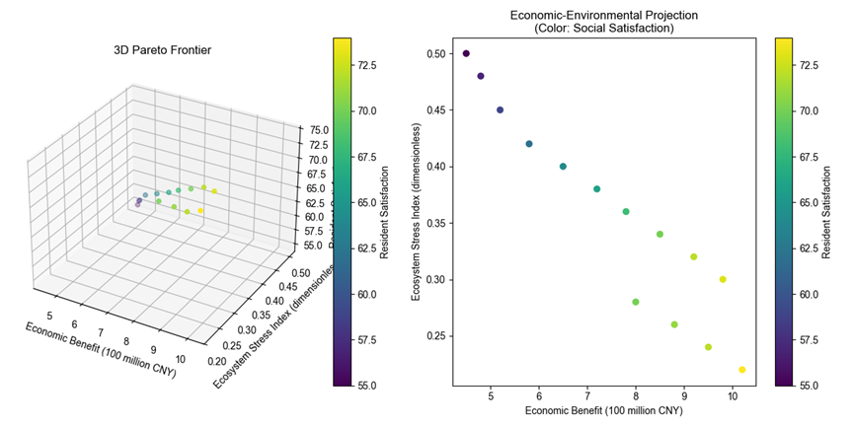
The optimal solution is centered on the range of economic benefits of 8 - 1.2 billion yuan, an ecosystem pressure index of 0.2 - 0.4 (dimensionless), and a resident satisfaction score of 65 - 75. To illustrate, when the economic benefit reaches 800 million yuan, it is imperative to maintain the ecosystem pressure index below 0.25, while the satisfaction score is to be sustained at approximately 68. This outcome underscores the necessity of a multifaceted approach, as the pursuit of a single objective, such as economic maximization, can lead to substantial degradation in other objectives. Consequently, effective policymaking necessitates the selection of a compromise between the Pareto frontier. In the event that ecological protection is prioritized, lower economic returns (e.g., 800 million yuan) and lower ecosystem pressure may be accepted. Conversely, if cultural heritage and residents' livelihoods are emphasized, the number of tourists must be appropriately limited to ensure a high level of residents' satisfaction. In practical implementation, the strategy should undergo dynamic adjustments with real-time monitoring data, such as the implementation of differentiated tourism routes to guide the dispersed flow of tourists and the earmarking of a portion of the tourism revenue for ecological restoration and community development. This approach is intended to achieve a long-term balance of sustainable tourism.
Sensitivity AnalysisA sensitivity analysis demonstrates that the number of tourists (V) exerts a substantial influence on economic revenue, ecological pressure, and social satisfaction. An increase in the number of tourists has been shown to directly promote economic income. However, this increase can also exacerbate ecosystem pressure and reduce resident satisfaction due to resource competition and other issues. The proportion of community compensation exhibited the highest sensitivity (0.7) to social satisfaction, indicating that economic compensation is a primary means of alleviating resident dissatisfaction. The carbon tax exhibited a comparatively less pronounced effect on economic gains (sensitivity 0.12), yet when combined with tax redistribution, it could indirectly enhance social equity. The findings underscore the imperative for a balanced approach, encompassing visitor volume control, dynamic pricing, and compensation mechanisms such as limiting visitor caps during peak seasons and allocating carbon tax revenues to resident welfare and ecological protection facilities.
It is evident that prioritizing social objectives constitutes the most rational foundation for orchestrating sustainable tourism development in Tibet. The rationale for this assertion is twofold. Firstly, the sub-goals of tourism innovation capacity and investment in public services can be achieved at optimal values in this case. Secondly, some other key sub-goals, such as tourism revenue and road mileage, can be achieved at near-optimal values.
The primary constraint of the study is that the proposed 10 sub-objectives for sustainable tourism development in Tibet do not comprehensively address a wide range of areas of sustainable tourism development due to the limitation of data availability. Furthermore, the weights of each sub-objective were not taken into consideration, which suggests that the objective function may be flawed to some extent. Future studies should consider a more comprehensive set of sub-objectives and undertake a thorough analysis of all sub-objectives, incorporating appropriate weighting.
Analysis of Siting Effects and Balancing Strategies
Effects of site selection on key measures
In the Tibetan plateau, ecological vulnerability and high-altitude climate issues have emerged as the primary constraints on development, superseding concerns over carbon emissions. The Tibetan plateau, with its unique alpine ecosystem, is characterized by an extremely fragile ecological environment that is highly resistant to recovery following damage. Concurrently, the high-altitude climatic conditions, characterized by low temperatures and a scarcity of oxygen, present challenges to the construction of tourism facilities and activities. In contrast to other regions that prioritize carbon emission control, Tibet's environmental priorities must shift from the control of carbon emissions to the protection of the ecosystem and the construction of tourism facilities adapted to the high-altitude climate. This adaptation is crucial for ensuring the sustainable development of the region.
The region's economic viability hinges on the development of niche cultural tourism and ecotourism, as opposed to the promotion of a singular natural landscape. Rather than relying on the development of a single natural landscape, the economic income of Tibet should be primarily derived from specialty cultural tourism and ecotourism. In contrast to the mass-sightseeing model prevalent in many tourist destinations, Tibet's cultural tourism encompasses a diverse array of activities, including Tibetan Buddhist cultural experiences and folklore festivals. Eco-tourism in Tibet involves activities such as highland wildlife viewing and eco-hiking. These tourism activities offer visitors a distinctive travel experience while also ensuring the preservation of the local ecological environment and generating more sustainable economic benefits for the region. Consequently, economic prioritization must transition from a single focus on the development of a natural landscape to the development of distinctive cultural and ecotourism products. This shift will further enhance competitiveness by upgrading the quality and content of tourism products.

Strategies for Promoting Low-Traffic Attractions in Tibet
(i) Dynamic Pricing to Regulate Tourist Flow
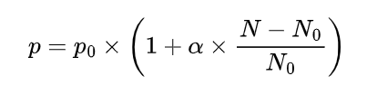
In order to effectively control the visitor flow of each attraction, the following dynamic pricing formula is defined:
In the context of analyzing the dynamics of attractions, the real-time fare, denoted by P, is of particular relevance. This is defined in relation to a benchmark fare, designated as P_0, which serves as a reference point for evaluating changes in the attraction's pricing strategy. The adjustment coefficient, denoted by α, is a variable that can be calibrated based on the particular characteristics of the attraction and the regulatory objective. This coefficient serves to calibrate the sensitivity of the fare to fluctuations in the number of visitors. P_1 denotes the current number of tourists in the attraction, while P_2 signifies the optimal number of tourists the attraction can accommodate.
For popular attractions, such as the Potala Palace, when the number of tourists exceeds the optimal capacity, the ticket price will be increased according to the above formula to regulate the influx of tourists. For attractions with a lower tourist flow, such as Sapu Shenshan, the ticket price will be decreased to attract more visitors and regulate the tourist flow.
(ii) Marketing resource allocation strategy
A total of 35% of tourism revenue is allocated to the promotion of low-traffic attractions. The specific promotion channels are as follows:
Firstly, precision marketing is employed in digital media, leveraging big data analysis to ascertain potential tourists' interests, hobbies, travel habits, and other characteristics. This analysis enables the placement of targeted advertisements on major digital media platforms. For instance, for users with a proclivity for natural scenery photography, the company strategically showcases photos and videos of stunning natural landscapes in Tibet's low-traffic attractions, with the aim of capturing their attention.
Furthermore, the company has established a presence at prominent tourism exhibitions and activities. The company actively participates in various tourism exhibitions at home and abroad, setting up dedicated booths to showcase the distinctive appeal of these under-the-radar destinations. Concurrently, themed promotional activities are organized, enticing travelers and media reporters to experience and disseminate information about these attractions, thereby augmenting their popularity and influence.
(iii) Optimization of Tourist Distribution Model
The optimization of tourist distribution model has been developed to achieve a scientific and reasonable allocation of tourists across various attractions in Tibet.
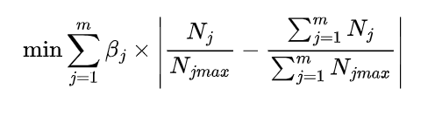
In this study, m is defined as the total number of attractions in Tibet. βj is the weight assigned to the jth attraction, determined by a multifaceted evaluation encompassing the cultural value, ecological vulnerability, and development potential of the attraction, among other considerations. Nj is the actual number of tourists of the jth attraction, and NjMAX is the maximum number of tourists carried by the jth attraction.
The objective of the model is to minimize the sum of the absolute values of the deviations between the actual visitor share of each attraction and the overall average share. Through continuous optimization of this model, more reasonable tourist guidance policies can be formulated, such as adjusting the promotional efforts of each attraction, providing differentiated tourism services, etc., so as to make the distribution of tourists among attractions in Tibet more balanced and promote the sustainable development of tourism in Tibet.
As illustrated in the accompanying figure, this study utilizes a computer simulation to model the number of tourists at five popular attractions in Tibet over the course of one month. The simulation results are presented as visual representations of the dynamic trend of the number of tourists in each attraction with the date.
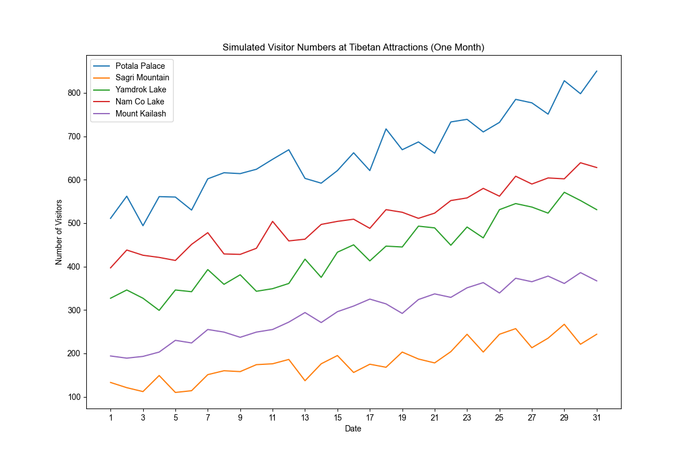
Potala Palace because of its high popularity, the number of tourists fluctuated greatly and increased significantly; The Sapu Sacred Mountain may have fewer tourists and less fluctuation due to its remote location and insufficient publicity; Yamdrok was affected by traffic and seasonal factors, the number of tourists fluctuated and increased, and the growth was relatively stable; In Namtso, the number of tourists fluctuated significantly and increased strongly due to its landscape and religious significance; And Kailash, which attracts specific groups due to its religiousness, saw a steady and slight increase in visitors, but high altitude and inaccessibility limited the growth of visitors. The results help the tourism authorities understand the flow characteristics and formulate strategies to promote the sustainable development of tourism in Tibet.

References
[1] Pan, S.-Y., Gao, M., Kim, H., Shah, K. J., Pei, S.-L., & Chiang, P.-C. (2018). Advances and challenges in sustainable tourism toward a green economy. Science of The Total Environment, 635, 452–469. doi:10.1016/j.scitotenv.2018.04.134

[2] Sun, Y.-Y., Lin, P.-C., & Higham, J. (2020). Managing tourism emissions through optimizing the tourism demand mix: Concept and analysis. Tourism Management, 81, 104161. doi:10.1016/j.tourman.2020.104161

[3] Scott, Daniel, Geoff McBoyle, and Michael Schwartzentruber. "Climate change and the distribution of climatic resources for tourism in North America." Climate research 27.2 (2004): 105-117.

[4] Triwijoyo, Bambang Krismono, Muhammad Taufik, and Herman Mawengkang. "Optimization Model of Multi Criteria Decision Analysis for Smart and Sustainable Sport Tourism Planning Development Problem." Mathematical Modelling of Engineering Problems 11.11 (2024).

[5] Hardy, A., Beeton, R. J. S., & Pearson, L. (2002). Sustainable Tourism: An Overview of the Concept and its Position in Relation to Conceptualisations of Tourism. Journal of Sustainable Tourism, 10(6), 475–496. doi:10.1080/09669580208667183

[6] Lusseau, David. "The hidden cost of tourism: detecting long-term effects of tourism using behavioral information." Ecology and Society 9.1 (2004).

[7] Garrigos-Simon, Fernando J., Yeamduan Narangajavana-Kaosiri, and Ismael Lengua-Lengua. "Tourism and sustainability: A bibliometric and visualization analysis." Sustainability 10.6 (2018): 1976.

