Projekt
Carina Heiling
0240008

Verfahren der forstlichen Standortskartierung
Wintersemester 2016/17

1. Die Berechnungen für die Jahresmitteltemperatur und den Jahresniederschlag für jede Rasterzelle ergeben Werte von 7-8 °C und 776-786mm für eine Seehöhe von 477m-745m scheint plausibel.
Eine Prüfung der Daten in SPSS zeigt das die Temperatur linear mit der Höhe abnimmt:
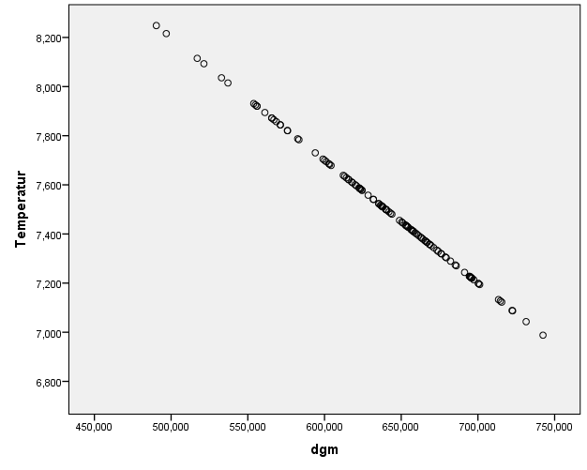

Correlations
 |  | Temperatur | dgm
Temperatur | Pearson Correlation | 1 | -1,000**
Temperatur | Sig. (2-tailed) |  | ,000
Temperatur | N | 116 | 116
dgm | Pearson Correlation | -1,000** | 1
dgm | Sig. (2-tailed) | ,000
dgm | N | 116 | 116
**. Correlation is significant at the 0.01 level (2-tailed).

Der Niederschlag nimmt mit der Höhe zu, bis zirka 620m und dann wieder ab:
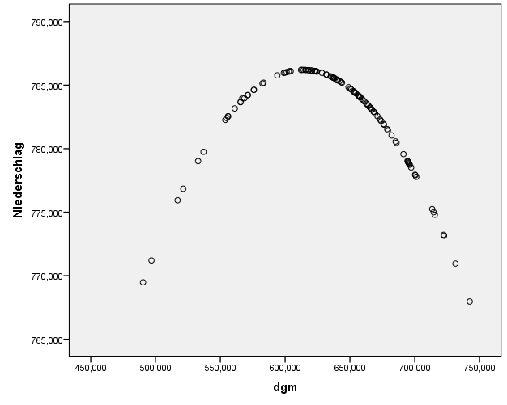

Correlations
 |  | Niederschlag | dgm
Niederschlag | Pearson Correlation | 1 | -,250**
Niederschlag | Sig. (2-tailed) |  | ,007
Niederschlag | N | 116 | 116
dgm | Pearson Correlation | -,250** | 1
dgm | Sig. (2-tailed) | ,007
dgm | N | 116 | 116
**. Correlation is significant at the 0.01 level (2-tailed).

2. Hangneigung, Krümmung, CTI und die Globalstrahlung zu den Sonnenwenden und der Tag/Nacht-Gleiche wurden berechnet und dem Datensatz hinzugefügt.

Hangneigung mit Höhenschichtlinien:
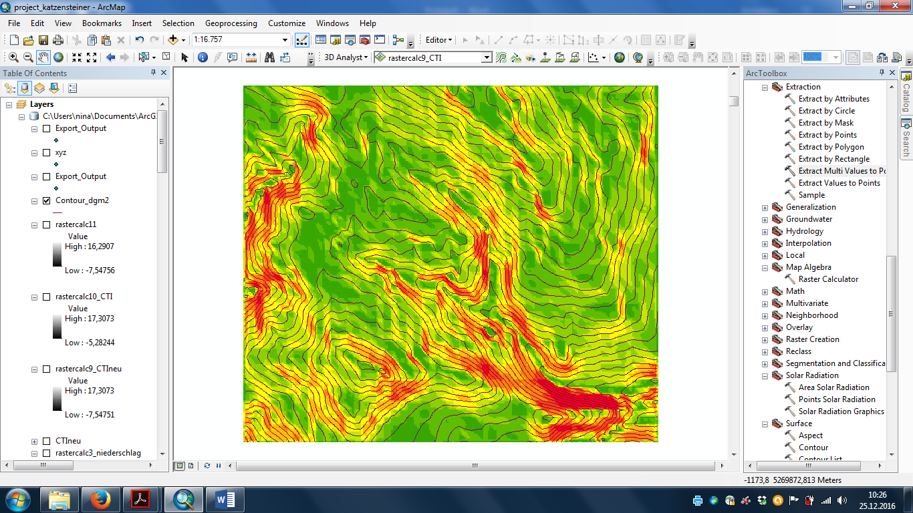

Krümmung (geglättet):
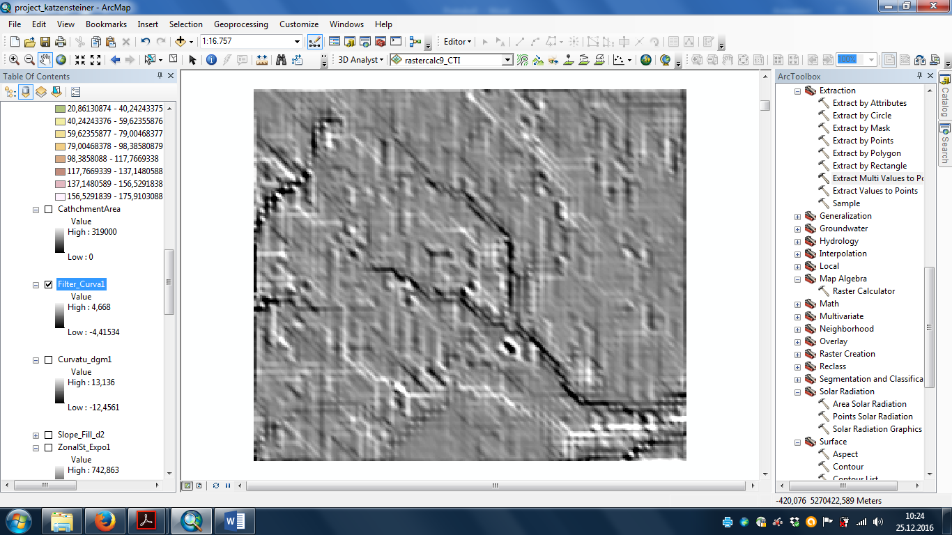

CTI:
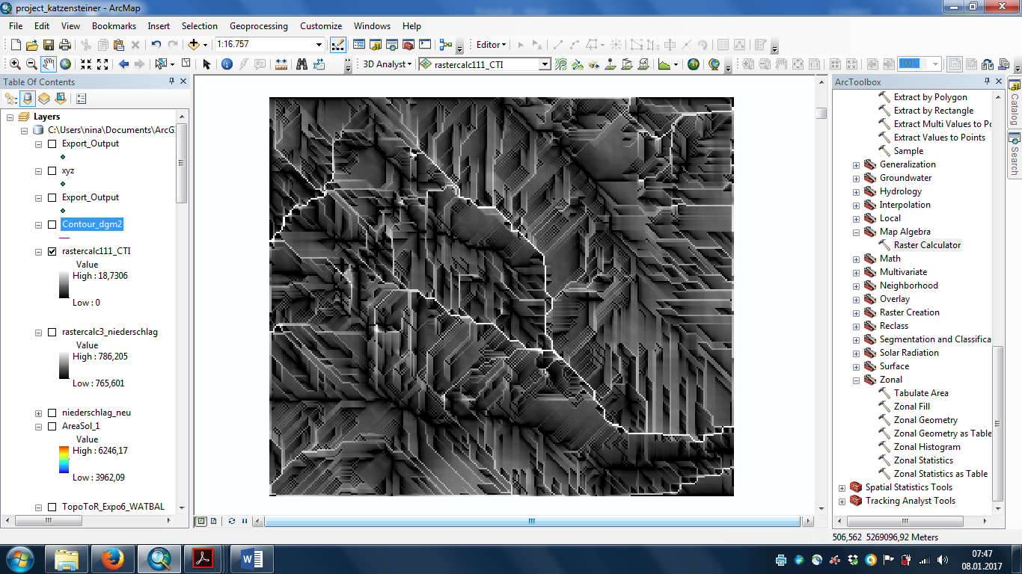

Globalstrahlung:
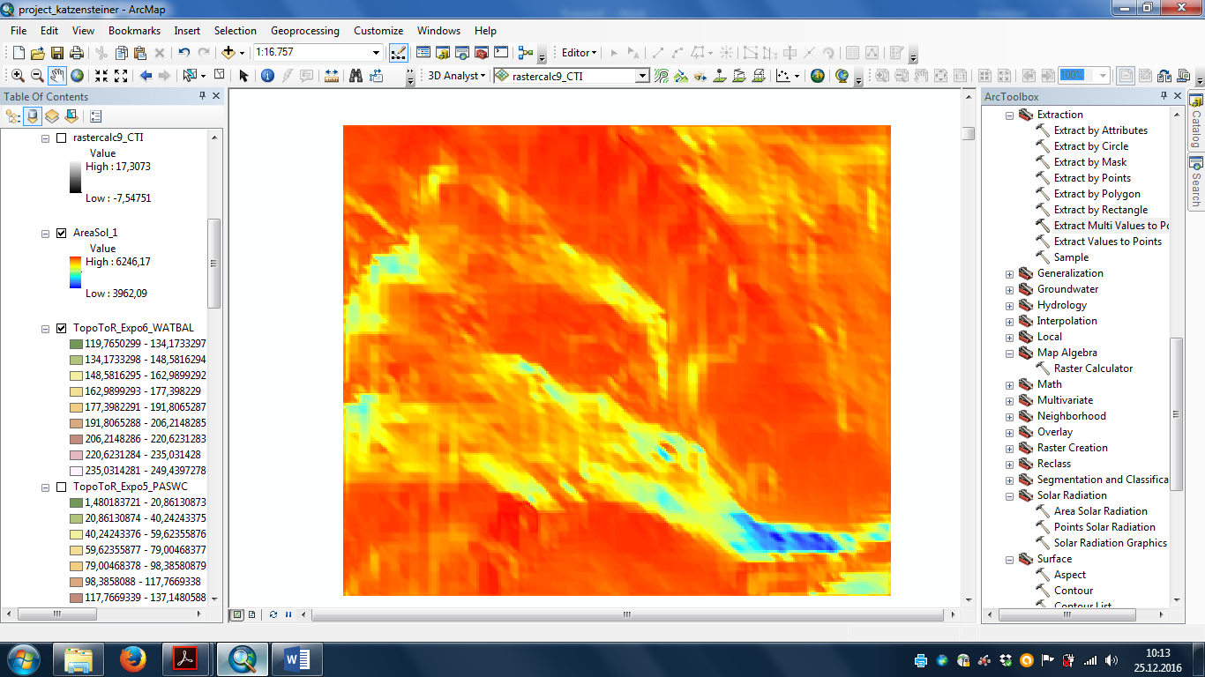

3. Die kartographische Darstellung der Wasserspeicherkapazitäten (PASWC):

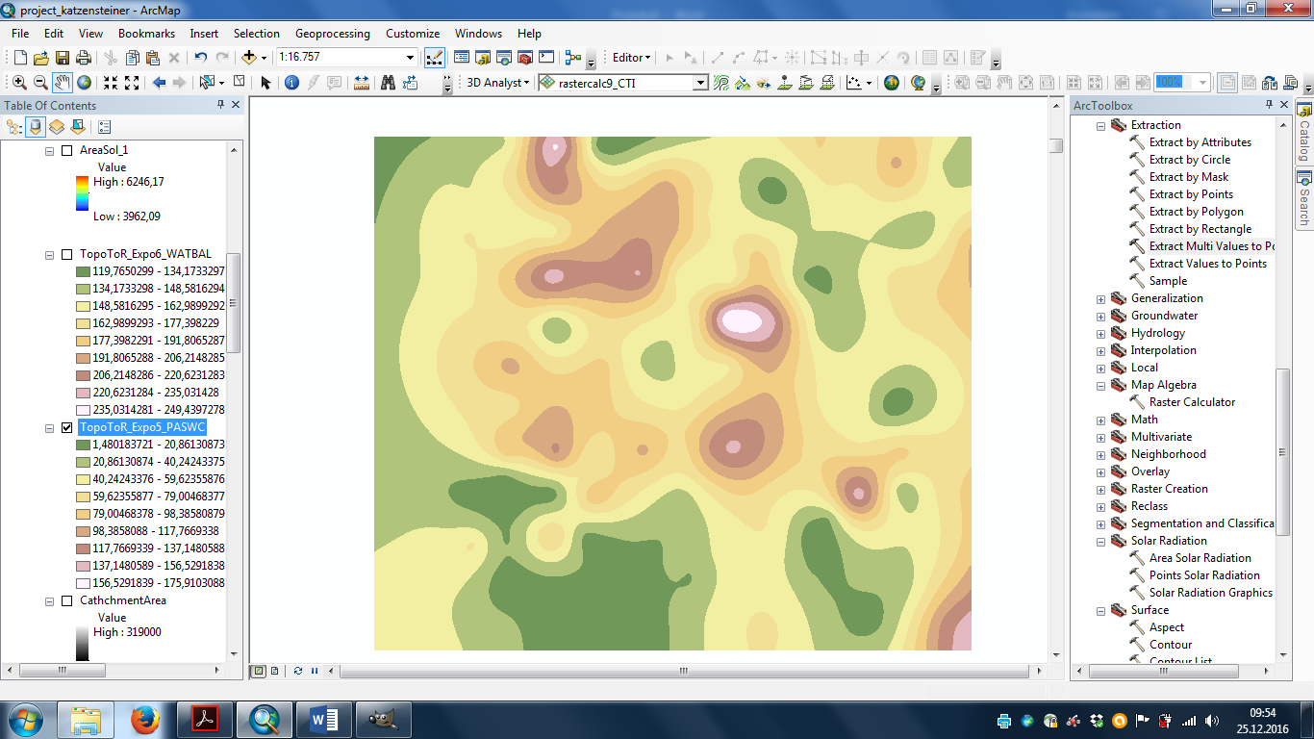

Die kartographische Darstellung der Wasserbilanzen (WATBAL):
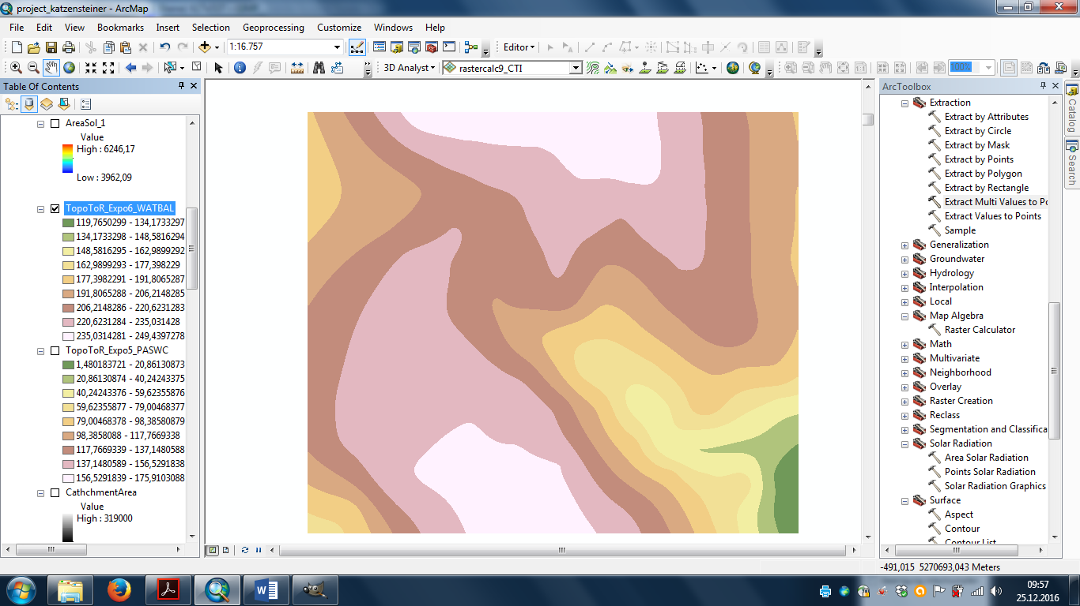

4. Die Punktdaten und die DGM-Ergebnisse wurden zusammengeführt und mit SPSS analysiert.

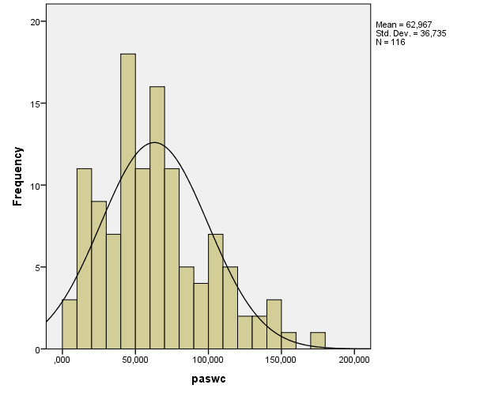
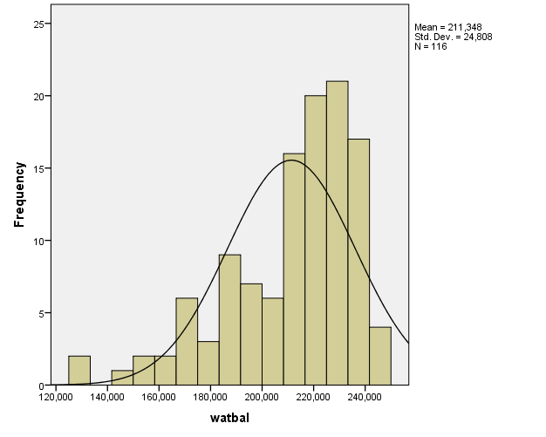

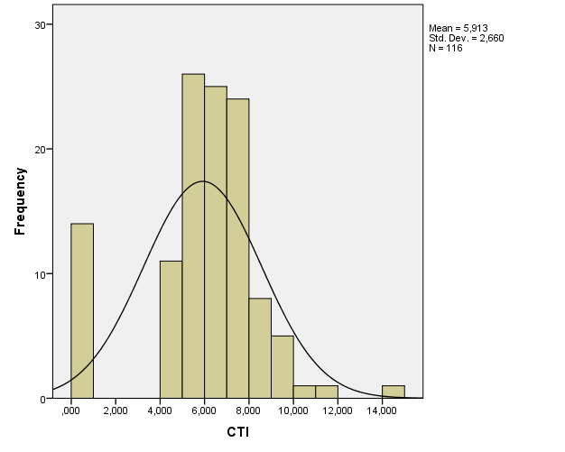
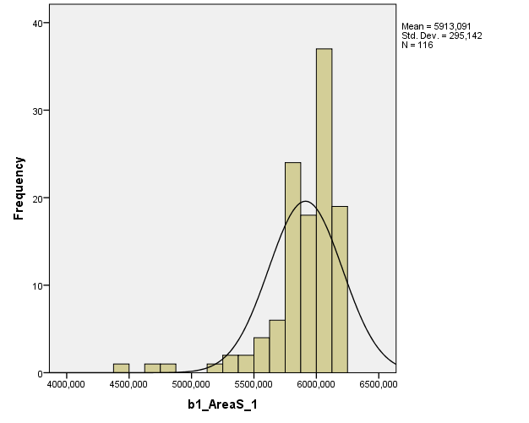

Descriptive Statistics
 | N | Minimum | Maximum | Mean | Std. Deviation
paswc | 116 | 8,640 | 177,200 | 62,96698 | 36,735090
watbal | 116 | 129,569 | 247,361 | 211,34806 | 24,807746
Temperatur | 116 | 6,988 | 8,248 | 7,51376 | ,257501
Niederschlag | 116 | 767,966 | 786,204 | 782,69990 | 3,972976
CTI | 116 | ,000 | 14,278 | 5,91335 | 2,659757
b1_AreaS_1 | 116 | 4416,360 | 6201,660 | 5913,09069 | 295,142421
dgm | 116 | 490,341 | 742,401 | 637,24871 | 51,500271
Valid N (listwise) | 116

K-means cluster analyse:

Quick Cluster

Notes
Output Created |  | 17-JAN-2017 12:33:53
Comments
Input | Data | C:\Users  ina\Desktop\Carina\forstl standortskartierung\GIS_project\Daten_GIS_neu.sav
Input | Active Dataset | DataSet1
Input | Filter | <none>
Input | Weight | <none>
Input | Split File | <none>
Input | N of Rows in Working Data File | 116
Missing Value Handling | Definition of Missing | User-defined missing values are treated as missing.
Missing Value Handling | Cases Used | Statistics are based on cases with no missing values for any clustering variable used.
Syntax |  | QUICK CLUSTER ZCTI Zb1_AreaS_1 Zdgm  /MISSING=LISTWISE  /CRITERIA=CLUSTER(4) MXITER(10) CONVERGE(0)  /METHOD=KMEANS(NOUPDATE)  /SAVE CLUSTER  /PRINT ANOVA.
Resources | Processor Time | 00:00:00,03
Resources | Elapsed Time | 00:00:00,06
Resources | Workspace Required | 896 bytes
Variables Created or Modified | QCL_3 | Cluster Number of Case

[DataSet1] C:\Users\nina\Desktop\Carina\forstl standortskartierung\GIS_project\Daten_GIS_neu.sav

Iteration Historyª
Iteration | Change in Cluster Centers
Iteration | 1 | 2 | 3 | 4
1 | 1,091 | 1,507 | 1,482 | 1,844
2 | ,368 | ,144 | ,107 | ,592
3 | ,322 | ,170 | ,083 | ,472
4 | ,218 | ,116 | ,064 | ,301
5 | ,000 | ,058 | ,030 | ,000
6 | ,000 | ,066 | ,039 | ,000
7 | ,000 | ,000 | ,000 | ,000
a. Convergence achieved due to no or small change in cluster centers. The maximum absolute coordinate change for any center is ,000. The current iteration is 7. The minimum distance between initial centers is 3,848.

Final Cluster Centers
 | Cluster
 | 1 | 2 | 3 | 4
Zscore(CTI) | -2,22327 | ,36468 | ,27934 | -,19674
Zscore(b1_AreaS_1) | ,34911 | ,05803 | ,20538 | -3,21713
Zscore(dgm) | ,55195 | -,91601 | ,59456 | -1,99623

ANOVA
 | Cluster |  | Error |  | F | Sig.
 | Mean Square | df | Mean Square | df | F | Sig.
Zscore(CTI) | 24,661 | 3 | ,366 | 112 | 67,338 | ,000
Zscore(b1_AreaS_1) | 22,139 | 3 | ,434 | 112 | 51,038 | ,000
Zscore(dgm) | 26,385 | 3 | ,320 | 112 | 82,440 | ,000
The F tests should be used only for descriptive purposes because the clusters have been chosen to maximize the differences among cases in different clusters. The observed significance levels are not corrected for this and thus cannot be interpreted as tests of the hypothesis that the cluster means are equal.

Number of Cases in each Cluster
Cluster | 1 | 13,000
Cluster | 2 | 35,000
Cluster | 3 | 62,000
Cluster | 4 | 6,000
Valid |  | 116,000
Missing |  | ,000

Hierachical cluster:

Cluster

Notes
Output Created |  | 17-JAN-2017 12:39:23
Comments
Input | Data | C:\Users  ina\Desktop\Carina\forstl standortskartierung\GIS_project\Daten_GIS_neu.sav
Input | Active Dataset | DataSet1
Input | Filter | <none>
Input | Weight | <none>
Input | Split File | <none>
Input | N of Rows in Working Data File | 116
Missing Value Handling | Definition of Missing | User-defined missing values are treated as missing.
Missing Value Handling | Cases Used | Statistics are based on cases with no missing values for any variable used.
Syntax |  | CLUSTER dgm b1_AreaS_1 CTI  /METHOD BAVERAGE  /MEASURE=EUCLID  /ID=D_R  /PRINT SCHEDULE  /PLOT DENDROGRAM VICICLE  /SAVE CLUSTER(4).
Resources | Processor Time | 00:00:00,58
Resources | Elapsed Time | 00:00:00,59
Variables Created or Modified | Cluster Membership |  | CLU4_1 | Average Linkage (Between Groups)

[DataSet1] C:\Users\nina\Desktop\Carina\forstl standortskartierung\GIS_project\Daten_GIS_neu.sav

Case Processing Summary^{a,b}
Cases
Valid |  | Missing |  | Total
N | Percent | N | Percent | N | Percent
116 | 100,0 | 0 | ,0 | 116 | 100,0
a. Euclidean Distance used
b. Average Linkage (Between Groups)

Average Linkage (Between Groups)

Agglomeration Schedule
Stage | Cluster Combined |  | Coefficients | Stage Cluster First Appears |  | Next Stage
Stage | Cluster 1 | Cluster 2 | Coefficients | Cluster 1 | Cluster 2 | Next Stage
1 | 57 | 69 | 2,114 | 0 | 0 | 7
2 | 89 | 103 | 4,417 | 0 | 0 | 97
3 | 7 | 41 | 4,812 | 0 | 0 | 46
4 | 25 | 54 | 5,681 | 0 | 0 | 7
5 | 13 | 22 | 6,443 | 0 | 0 | 14
6 | 56 | 68 | 6,694 | 0 | 0 | 16
7 | 25 | 57 | 6,824 | 4 | 1 | 47
8 | 29 | 83 | 7,454 | 0 | 0 | 60
9 | 44 | 47 | 7,534 | 0 | 0 | 38
10 | 27 | 106 | 8,056 | 0 | 0 | 21
11 | 14 | 40 | 9,018 | 0 | 0 | 31
12 | 26 | 45 | 9,549 | 0 | 0 | 33
13 | 30 | 72 | 9,769 | 0 | 0 | 23
14 | 13 | 95 | 9,993 | 5 | 0 | 42
15 | 31 | 61 | 10,360 | 0 | 0 | 44
16 | 56 | 58 | 10,488 | 6 | 0 | 47
17 | 8 | 16 | 10,536 | 0 | 0 | 65
18 | 78 | 79 | 10,843 | 0 | 0 | 35
19 | 19 | 104 | 10,996 | 0 | 0 | 53
20 | 76 | 77 | 11,114 | 0 | 0 | 73
21 | 15 | 27 | 11,662 | 0 | 10 | 46
22 | 18 | 23 | 11,724 | 0 | 0 | 34
23 | 30 | 71 | 11,992 | 13 | 0 | 53
24 | 39 | 109 | 12,172 | 0 | 0 | 31
25 | 90 | 94 | 12,757 | 0 | 0 | 45
26 | 51 | 108 | 12,864 | 0 | 0 | 59
27 | 12 | 73 | 12,981 | 0 | 0 | 43
28 | 21 | 49 | 13,220 | 0 | 0 | 63
29 | 24 | 60 | 13,292 | 0 | 0 | 36
30 | 38 | 114 | 13,895 | 0 | 0 | 42
31 | 14 | 39 | 14,536 | 11 | 24 | 59
32 | 62 | 66 | 14,806 | 0 | 0 | 48
33 | 26 | 46 | 15,954 | 12 | 0 | 39
34 | 10 | 18 | 16,692 | 0 | 22 | 61
35 | 65 | 78 | 16,820 | 0 | 18 | 37
36 | 24 | 52 | 17,334 | 29 | 0 | 54
37 | 65 | 115 | 17,608 | 35 | 0 | 64
38 | 34 | 44 | 17,887 | 0 | 9 | 61
39 | 6 | 26 | 17,905 | 0 | 33 | 58
40 | 1 | 53 | 18,987 | 0 | 0 | 74
41 | 50 | 96 | 19,635 | 0 | 0 | 71
42 | 13 | 38 | 20,287 | 14 | 30 | 83
43 | 12 | 82 | 20,391 | 27 | 0 | 57
44 | 31 | 70 | 20,493 | 15 | 0 | 68
45 | 90 | 92 | 21,598 | 25 | 0 | 88
46 | 7 | 15 | 22,038 | 3 | 21 | 62
47 | 25 | 56 | 22,236 | 7 | 16 | 66
48 | 62 | 80 | 22,281 | 32 | 0 | 85
49 | 35 | 43 | 22,839 | 0 | 0 | 77
50 | 37 | 55 | 22,998 | 0 | 0 | 79
51 | 32 | 59 | 23,002 | 0 | 0 | 81
52 | 81 | 116 | 23,480 | 0 | 0 | 91
53 | 19 | 30 | 24,877 | 19 | 23 | 70
54 | 24 | 36 | 25,070 | 36 | 0 | 68
55 | 20 | 33 | 26,000 | 0 | 0 | 84
56 | 74 | 86 | 26,957 | 0 | 0 | 75
57 | 11 | 12 | 27,293 | 0 | 43 | 84
58 | 5 | 6 | 27,432 | 0 | 39 | 66
59 | 14 | 51 | 27,957 | 31 | 26 | 78
60 | 29 | 84 | 28,264 | 8 | 0 | 89
61 | 10 | 34 | 28,968 | 34 | 38 | 80
62 | 7 | 28 | 30,721 | 46 | 0 | 78
63 | 21 | 67 | 32,496 | 28 | 0 | 82
64 | 65 | 93 | 32,600 | 37 | 0 | 79
65 | 8 | 98 | 34,353 | 17 | 0 | 92
66 | 5 | 25 | 34,743 | 58 | 47 | 71
67 | 42 | 97 | 35,516 | 0 | 0 | 90
68 | 24 | 31 | 35,692 | 54 | 44 | 74
69 | 9 | 107 | 35,814 | 0 | 0 | 92
70 | 19 | 101 | 36,283 | 53 | 0 | 86
71 | 5 | 50 | 36,767 | 66 | 41 | 83
72 | 17 | 105 | 36,878 | 0 | 0 | 80
73 | 76 | 91 | 37,431 | 20 | 0 | 93
74 | 1 | 24 | 39,893 | 40 | 68 | 93
75 | 4 | 74 | 40,232 | 0 | 56 | 95
76 | 64 | 85 | 40,313 | 0 | 0 | 98
77 | 35 | 63 | 40,358 | 49 | 0 | 82
78 | 7 | 14 | 40,585 | 62 | 59 | 103
79 | 37 | 65 | 41,104 | 50 | 64 | 88
80 | 10 | 17 | 42,518 | 61 | 72 | 86
81 | 3 | 32 | 43,173 | 0 | 51 | 91
82 | 21 | 35 | 43,597 | 63 | 77 | 90
83 | 5 | 13 | 44,602 | 71 | 42 | 85
84 | 11 | 20 | 47,109 | 57 | 55 | 89
85 | 5 | 62 | 49,481 | 83 | 48 | 94
86 | 10 | 19 | 50,241 | 80 | 70 | 104
87 | 48 | 75 | 53,975 | 0 | 0 | 98
88 | 37 | 90 | 60,755 | 79 | 45 | 94
89 | 11 | 29 | 60,874 | 84 | 60 | 95
90 | 21 | 42 | 63,987 | 82 | 67 | 99
91 | 3 | 81 | 66,354 | 81 | 52 | 100
92 | 8 | 9 | 67,490 | 65 | 69 | 102
93 | 1 | 76 | 67,649 | 74 | 73 | 99
94 | 5 | 37 | 69,043 | 85 | 88 | 102
95 | 4 | 11 | 69,325 | 75 | 89 | 104
96 | 102 | 113 | 70,551 | 0 | 0 | 109
97 | 2 | 89 | 72,435 | 0 | 2 | 100
98 | 48 | 64 | 77,230 | 87 | 76 | 101
99 | 1 | 21 | 79,764 | 93 | 90 | 105
100 | 2 | 3 | 88,522 | 97 | 91 | 106
101 | 48 | 87 | 93,671 | 98 | 0 | 111
102 | 5 | 8 | 95,783 | 94 | 92 | 103
103 | 5 | 7 | 97,034 | 102 | 78 | 108
104 | 4 | 10 | 102,350 | 95 | 86 | 106
105 | 1 | 99 | 126,244 | 99 | 0 | 108
106 | 2 | 4 | 134,303 | 100 | 104 | 112
107 | 110 | 111 | 145,723 | 0 | 0 | 113
108 | 1 | 5 | 152,632 | 105 | 103 | 112
109 | 88 | 102 | 189,953 | 0 | 96 | 110
110 | 88 | 100 | 196,847 | 109 | 0 | 111
111 | 48 | 88 | 240,991 | 101 | 110 | 114
112 | 1 | 2 | 269,865 | 108 | 106 | 114
113 | 110 | 112 | 302,614 | 107 | 0 | 115
114 | 1 | 48 | 567,735 | 112 | 111 | 115
115 | 1 | 110 | 1335,846 | 114 | 113 | 0

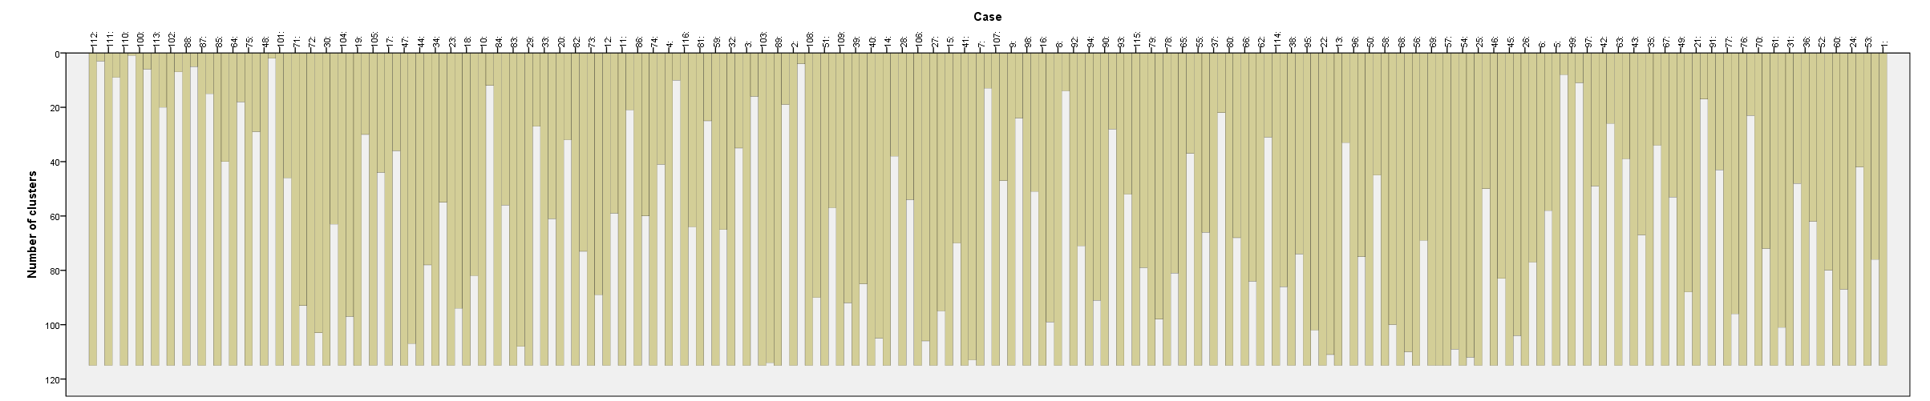

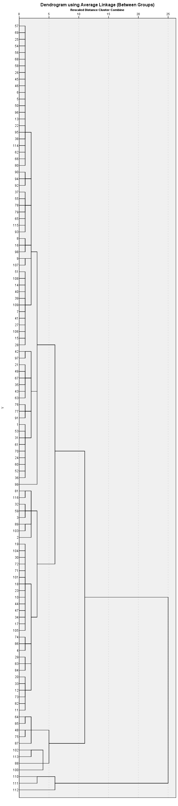

kaum Übereinstimmungen der Cluster-einteilung.

Discriminanzanalyse bezogen auf die 4 typen durch die hierachische clusteranalyse: ab dis_2
Sehr gute Übereinstimmung (100%)!

Discriminant

Notes
Output Created |  | 17-JAN-2017 12:51:31
Comments
Input | Data | C:\Users  ina\Desktop\Carina\forstl standortskartierung\GIS_project\Daten_GIS_neu.sav
Input | Active Dataset | DataSet1
Input | Filter | <none>
Input | Weight | <none>
Input | Split File | <none>
Input | N of Rows in Working Data File | 116
Missing Value Handling | Definition of Missing | User-defined missing values are treated as missing in the analysis phase.
Missing Value Handling | Cases Used | In the analysis phase, cases with no user- or system-missing values for any predictor variable are used. Cases with user-, system-missing, or out-of-range values for the grouping variable are always excluded.
Syntax |  | DISCRIMINANT  /GROUPS=cluster_h_4ges(1 4)  /VARIABLES=dgm CTI b1_AreaS_1  /ANALYSIS ALL  /SAVE=CLASS SCORES PROBS  /PRIORS SIZE  /STATISTICS=MEAN STDDEV UNIVF RAW TABLE  /CLASSIFY=NONMISSING POOLED.
Resources | Processor Time | 00:00:00,05
Resources | Elapsed Time | 00:00:00,05
Variables Created or Modified | Dis_2 | Predicted Group for Analysis 1
Variables Created or Modified | Dis1_3 | Discriminant Scores from Function 1 for Analysis 1
Variables Created or Modified | Dis2_3 | Discriminant Scores from Function 2 for Analysis 1
Variables Created or Modified | Dis3_3 | Discriminant Scores from Function 3 for Analysis 1
Variables Created or Modified | Dis1_4 | Probabilities of Membership in Group 1 for Analysis 1
Variables Created or Modified | Dis2_4 | Probabilities of Membership in Group 2 for Analysis 1
Variables Created or Modified | Dis3_4 | Probabilities of Membership in Group 3 for Analysis 1
Variables Created or Modified | Dis4_4 | Probabilities of Membership in Group 4 for Analysis 1
Number of unweighted cases written to the working file after classification |  | 116

[DataSet1] C:\Users\nina\Desktop\Carina\forstl standortskartierung\GIS_project\Daten_GIS_neu.sav

Analysis Case Processing Summary
Unweighted Cases |  | N | Percent
Valid |  | 116 | 100,0
Excluded | Missing or out-of-range group codes | 0 | ,0
Excluded | At least one missing discriminating variable | 0 | ,0
Excluded | Both missing or out-of-range group codes and at least one missing discriminating variable | 0 | ,0
Excluded | Total | 0 | ,0
Total |  | 116 | 100,0

Group Statistics
Average Linkage (Between Groups) |  | Mean | Std. Deviation | Valid N (listwise)
 |  | Mean | Std. Deviation | Unweighted | Weighted
1 | dgm | 642,92748 | 46,370364 | 104 | 104,000
1 | CTI | 5,96584 | 2,719127 | 104 | 104,000
1 | b1_AreaS_1 | 5992,16952 | 140,625084 | 104 | 104,000
2 | dgm | 607,00289 | 68,285646 | 9 | 9,000
2 | CTI | 5,76770 | 1,353994 | 9 | 9,000
2 | b1_AreaS_1 | 5431,24333 | 128,723962 | 9 | 9,000
3 | dgm | 535,98650 | 26,815610 | 2 | 2,000
3 | CTI | 6,79562 | ,575288 | 2 | 2,000
3 | b1_AreaS_1 | 4717,67000 | 99,489924 | 2 | 2,000
4 | dgm | 521,39300 | .ª | 1 | 1,000
4 | CTI | ,00000 | .ª | 1 | 1,000
4 | b1_AreaS_1 | 4416,36000 | .ª | 1 | 1,000
Total | dgm | 637,24871 | 51,500271 | 116 | 116,000
Total | CTI | 5,91335 | 2,659757 | 116 | 116,000
Total | b1_AreaS_1 | 5913,09069 | 295,142421 | 116 | 116,000
a. Insufficient data

Tests of Equality of Group Means
 | Wilks' Lambda | F | df1 | df2 | Sig.
dgm | ,851 | 6,549 | 3 | 112 | ,000
CTI | ,955 | 1,779 | 3 | 112 | ,155
b1_AreaS_1 | ,218 | 134,274 | 3 | 112 | ,000

Analysis 1

Summary of Canonical Discriminant Functions

Eigenvalues
Function | Eigenvalue | % of Variance | Cumulative % | Canonical Correlation
1 | 3,658ª | 98,9 | 98,9 | ,886
2 | ,038ª | 1,0 | 99,9 | ,192
3 | ,002ª | ,1 | 100,0 | ,048
a. First 3 canonical discriminant functions were used in the analysis.

Wilks' Lambda
Test of Function(s) | Wilks' Lambda | Chi-square | df | Sig.
1 through 3 | ,206 | 175,985 | 9 | ,000
2 through 3 | ,961 | 4,433 | 4 | ,351
3 | ,998 | ,260 | 1 | ,610

Standardized Canonical Discriminant Function Coefficients
 | Function
 | 1 | 2 | 3
dgm | ,089 | ,150 | 1,012
CTI | ,112 | 1,010 | ,017
b1_AreaS_1 | ,983 | -,087 | -,223

Structure Matrix
 | Function
 | 1 | 2 | 3
b1_AreaS_1 | ,992* | -,109 | -,072
CTI | ,053 | ,987* | -,151
dgm | ,218 | -,040 | ,975*
Pooled within-groups correlations between discriminating variables and standardized canonical discriminant functions
Variables ordered by absolute size of correlation within function.
*. Largest absolute correlation between each variable and any discriminant function

Canonical Discriminant Function Coefficients
 | Function
 | 1 | 2 | 3
dgm | ,002 | ,003 | ,021
CTI | ,042 | ,383 | ,006
b1_AreaS_1 | ,007 | -,001 | -,002
(Constant) | -43,101 | -,551 | -3,983
Unstandardized coefficients

Functions at Group Centroids
Average Linkage (Between Groups) | Function
Average Linkage (Between Groups) | 1 | 2 | 3
1 | ,570 | -,012 | -,007
2 | -3,458 | ,151 | ,133
3 | -8,574 | ,771 | -,213
4 | -11,013 | -1,691 | -,082
Unstandardized canonical discriminant functions evaluated at group means

Classification Statistics

Classification Processing Summary
Processed |  | 116
Excluded | Missing or out-of-range group codes | 0
Excluded | At least one missing discriminating variable | 0
Used in Output |  | 116

Prior Probabilities for Groups
Average Linkage (Between Groups) | Prior | Cases Used in Analysis
Average Linkage (Between Groups) | Prior | Unweighted | Weighted
1 | ,897 | 104 | 104,000
2 | ,078 | 9 | 9,000
3 | ,017 | 2 | 2,000
4 | ,009 | 1 | 1,000
Total | 1,000 | 116 | 116,000

Classification Resultsª
 |  | Average Linkage (Between Groups) | Predicted Group Membership |  |  |  | Total
 |  | Average Linkage (Between Groups) | 1 | 2 | 3 | 4 | Total
Original | Count | 1 | 104 | 0 | 0 | 0 | 104
Original | Count | 2 | 0 | 9 | 0 | 0 | 9
Original | Count | 3 | 0 | 0 | 2 | 0 | 2
Original | Count | 4 | 0 | 0 | 0 | 1 | 1
Original | % | 1 | 100,0 | ,0 | ,0 | ,0 | 100,0
Original | % | 2 | ,0 | 100,0 | ,0 | ,0 | 100,0
Original | % | 3 | ,0 | ,0 | 100,0 | ,0 | 100,0
Original | % | 4 | ,0 | ,0 | ,0 | 100,0 | 100,0
a. 100,0% of original grouped cases correctly classified.

Diskriminanzanalyse bezogen auf die 4 typen durch das k-means clustering: ab dis_3
Auch hier eine gute Übereinstimmung (96,6 %)!

Discriminant

Notes
Output Created |  | 17-JAN-2017 12:50:03
Comments
Input | Data | C:\Users  ina\Desktop\Carina\forstl standortskartierung\GIS_project\Daten_GIS_neu.sav
Input | Active Dataset | DataSet1
Input | Filter | <none>
Input | Weight | <none>
Input | Split File | <none>
Input | N of Rows in Working Data File | 116
Missing Value Handling | Definition of Missing | User-defined missing values are treated as missing in the analysis phase.
Missing Value Handling | Cases Used | In the analysis phase, cases with no user- or system-missing values for any predictor variable are used. Cases with user-, system-missing, or out-of-range values for the grouping variable are always excluded.
Syntax |  | DISCRIMINANT  /GROUPS=cluster_k_4ges(1 4)  /VARIABLES=dgm CTI b1_AreaS_1  /ANALYSIS ALL  /SAVE=CLASS SCORES PROBS  /PRIORS SIZE  /STATISTICS=MEAN STDDEV UNIVF RAW TABLE  /CLASSIFY=NONMISSING POOLED.
Resources | Processor Time | 00:00:00,05
Resources | Elapsed Time | 00:00:00,05
Variables Created or Modified | Dis_3 | Predicted Group for Analysis 1
Variables Created or Modified | Dis1_5 | Discriminant Scores from Function 1 for Analysis 1
Variables Created or Modified | Dis2_5 | Discriminant Scores from Function 2 for Analysis 1
Variables Created or Modified | Dis3_5 | Discriminant Scores from Function 3 for Analysis 1
Variables Created or Modified | Dis1_6 | Probabilities of Membership in Group 1 for Analysis 1
Variables Created or Modified | Dis2_6 | Probabilities of Membership in Group 2 for Analysis 1
Variables Created or Modified | Dis3_6 | Probabilities of Membership in Group 3 for Analysis 1
Variables Created or Modified | Dis4_6 | Probabilities of Membership in Group 4 for Analysis 1
Number of unweighted cases written to the working file after classification |  | 116

[DataSet1] C:\Users\nina\Desktop\Carina\forstl standortskartierung\GIS_project\Daten_GIS_neu.sav

Analysis Case Processing Summary
Unweighted Cases |  | N | Percent
Valid |  | 116 | 100,0
Excluded | Missing or out-of-range group codes | 0 | ,0
Excluded | At least one missing discriminating variable | 0 | ,0
Excluded | Both missing or out-of-range group codes and at least one missing discriminating variable | 0 | ,0
Excluded | Total | 0 | ,0
Total |  | 116 | 100,0

Group Statistics
Cluster Number of Case |  | Mean | Std. Deviation | Valid N (listwise)
 |  | Mean | Std. Deviation | Unweighted | Weighted
1 | dgm | 665,67446 | 37,826049 | 13 | 13,000
1 | CTI | ,00000 | ,000000 | 13 | 13,000
1 | b1_AreaS_1 | 6016,12846 | 126,090795 | 13 | 13,000
2 | dgm | 590,07374 | 31,264434 | 35 | 35,000
2 | CTI | 6,88330 | 1,754046 | 35 | 35,000
2 | b1_AreaS_1 | 5930,21657 | 174,766948 | 35 | 35,000
3 | dgm | 667,86848 | 25,705423 | 62 | 62,000
3 | CTI | 6,65633 | 1,534160 | 62 | 62,000
3 | b1_AreaS_1 | 5973,70645 | 189,479567 | 62 | 62,000
4 | dgm | 534,44250 | 29,534534 | 6 | 6,000
4 | CTI | 5,39006 | 2,897917 | 6 | 6,000
4 | b1_AreaS_1 | 4963,57833 | 403,160505 | 6 | 6,000
Total | dgm | 637,24871 | 51,500271 | 116 | 116,000
Total | CTI | 5,91335 | 2,659757 | 116 | 116,000
Total | b1_AreaS_1 | 5913,09069 | 295,142421 | 116 | 116,000

Tests of Equality of Group Means
 | Wilks' Lambda | F | df1 | df2 | Sig.
dgm | ,312 | 82,440 | 3 | 112 | ,000
CTI | ,357 | 67,338 | 3 | 112 | ,000
b1_AreaS_1 | ,422 | 51,038 | 3 | 112 | ,000

Analysis 1

Summary of Canonical Discriminant Functions

Eigenvalues
Function | Eigenvalue | % of Variance | Cumulative % | Canonical Correlation
1 | 3,456ª | 61,6 | 61,6 | ,881
2 | 1,575ª | 28,1 | 89,7 | ,782
3 | ,580ª | 10,3 | 100,0 | ,606
a. First 3 canonical discriminant functions were used in the analysis.

Wilks' Lambda
Test of Function(s) | Wilks' Lambda | Chi-square | df | Sig.
1 through 3 | ,055 | 323,087 | 9 | ,000
2 through 3 | ,246 | 156,472 | 4 | ,000
3 | ,633 | 51,015 | 1 | ,000

Standardized Canonical Discriminant Function Coefficients
 | Function
 | 1 | 2 | 3
dgm | ,740 | ,332 | -,585
CTI | -,502 | ,889 | -,081
b1_AreaS_1 | ,596 | ,155 | ,819

Structure Matrix
 | Function
 | 1 | 2 | 3
dgm | ,723* | ,355 | -,593
CTI | -,354 | ,932* | ,081
b1_AreaS_1 | ,482 | ,345 | ,805*
Pooled within-groups correlations between discriminating variables and standardized canonical discriminant functions
Variables ordered by absolute size of correlation within function.
*. Largest absolute correlation between each variable and any discriminant function

Canonical Discriminant Function Coefficients
 | Function
 | 1 | 2 | 3
dgm | ,025 | ,011 | -,020
CTI | -,312 | ,553 | -,050
b1_AreaS_1 | ,003 | ,001 | ,004
(Constant) | -32,466 | -15,239 | -11,807
Unstandardized coefficients

Functions at Group Centroids
Cluster Number of Case | Function
Cluster Number of Case | 1 | 2 | 3
1 | 2,884 | -2,862 | ,159
2 | -1,449 | ,012 | ,972
3 | ,732 | ,808 | -,397
4 | -5,359 | -2,217 | -1,908
Unstandardized canonical discriminant functions evaluated at group means

Classification Statistics

Classification Processing Summary
Processed |  | 116
Excluded | Missing or out-of-range group codes | 0
Excluded | At least one missing discriminating variable | 0
Used in Output |  | 116

Prior Probabilities for Groups
Cluster Number of Case | Prior | Cases Used in Analysis
Cluster Number of Case | Prior | Unweighted | Weighted
1 | ,112 | 13 | 13,000
2 | ,302 | 35 | 35,000
3 | ,534 | 62 | 62,000
4 | ,052 | 6 | 6,000
Total | 1,000 | 116 | 116,000

Classification Resultsª
 |  | Cluster Number of Case | Predicted Group Membership |  |  |  | Total
 |  | Cluster Number of Case | 1 | 2 | 3 | 4 | Total
Original | Count | 1 | 13 | 0 | 0 | 0 | 13
Original | Count | 2 | 0 | 31 | 4 | 0 | 35
Original | Count | 3 | 0 | 0 | 62 | 0 | 62
Original | Count | 4 | 0 | 0 | 0 | 6 | 6
Original | % | 1 | 100,0 | ,0 | ,0 | ,0 | 100,0
Original | % | 2 | ,0 | 88,6 | 11,4 | ,0 | 100,0
Original | % | 3 | ,0 | ,0 | 100,0 | ,0 | 100,0
Original | % | 4 | ,0 | ,0 | ,0 | 100,0 | 100,0
a. 96,6% of original grouped cases correctly classified.

Logistic regression: dummy_k_1 -> PRE_4, PGR_4

Logistic Regression

Notes
Output Created |  | 17-JAN-2017 13:05:16
Comments
Input | Data | C:\Users  ina\Desktop\Carina\forstl standortskartierung\GIS_project\Daten_GIS_neu.sav
Input | Active Dataset | DataSet1
Input | Filter | <none>
Input | Weight | <none>
Input | Split File | <none>
Input | N of Rows in Working Data File | 116
Missing Value Handling | Definition of Missing | User-defined missing values are treated as missing
Syntax |  | LOGISTIC REGRESSION VARIABLES Dummy_k_1  /METHOD=ENTER CTI Slope_Fill Filter_Cur  /SAVE=PRED PGROUP  /CRITERIA=PIN(0.05) POUT(0.10) ITERATE(20) CUT(0.5).
Resources | Processor Time | 00:00:00,05
Resources | Elapsed Time | 00:00:00,09
Variables Created or Modified | PRE_4 | Predicted probability
Variables Created or Modified | PGR_4 | Predicted group

[DataSet1] C:\Users\nina\Desktop\Carina\forstl standortskartierung\GIS_project\Daten_GIS_neu.sav

Case Processing Summary
Unweighted Casesª |  | N | Percent
Selected Cases | Included in Analysis | 116 | 100,0
Selected Cases | Missing Cases | 0 | ,0
Selected Cases | Total | 116 | 100,0
Unselected Cases |  | 0 | ,0
Total |  | 116 | 100,0
a. If weight is in effect, see classification table for the total number of cases.

Dependent Variable Encoding
Original Value | Internal Value
,00 | 0
1,00 | 1

Block 0: Beginning Block

Classification Table^{a,b}
 | Observed |  | Predicted
 |  |  | Dummy_k_1 |  | Percentage Correct
 |  |  | ,00 | 1,00 | Percentage Correct
Step 0 | Dummy_k_1 | ,00 | 103 | 0 | 100,0
Step 0 | Dummy_k_1 | 1,00 | 13 | 0 | ,0
Step 0 | Overall Percentage |  |  |  | 88,8
a. Constant is included in the model.
b. The cut value is ,500

Variables in the Equation
 |  | B | S.E. | Wald | df | Sig. | Exp(B)
Step 0 | Constant | -2,070 | ,294 | 49,451 | 1 | ,000 | ,126

Variables not in the Equation
 |  |  | Score | df | Sig.
Step 0 | Variables | CTI | 72,997 | 1 | ,000
Step 0 | Variables | Slope_Fill | 8,272 | 1 | ,004
Step 0 | Variables | Filter_Cur | 10,899 | 1 | ,001
Step 0 | Overall Statistics |  | 86,119 | 3 | ,000

Block 1: Method = Enter

Omnibus Tests of Model Coefficients
 |  | Chi-square | df | Sig.
Step 1 | Step | 81,390 | 3 | ,000
Step 1 | Block | 81,390 | 3 | ,000
Step 1 | Model | 81,390 | 3 | ,000

Model Summary
Step | -2 Log likelihood | Cox & Snell R Square | Nagelkerke R Square
1 | ,000ª | ,504 | 1,000
a. Estimation terminated at iteration number 20 because maximum iterations has been reached. Final solution cannot be found.

Classification Tableª
 | Observed |  | Predicted
 |  |  | Dummy_k_1 |  | Percentage Correct
 |  |  | ,00 | 1,00 | Percentage Correct
Step 1 | Dummy_k_1 | ,00 | 103 | 0 | 100,0
Step 1 | Dummy_k_1 | 1,00 | 0 | 13 | 100,0
Step 1 | Overall Percentage |  |  |  | 100,0
a. The cut value is ,500

Variables in the Equation
 |  | B | S.E. | Wald | df | Sig. | Exp(B)
Step 1ª | CTI | -7,951 | 1179,237 | ,000 | 1 | ,995 | ,000
Step 1ª | Slope_Fill | -1,558 | 311,918 | ,000 | 1 | ,996 | ,210
Step 1ª | Filter_Cur | 1,282 | 5376,728 | ,000 | 1 | 1,000 | 3,603
Step 1ª | Constant | 33,964 | 6673,935 | ,000 | 1 | ,996 | 562636349154101,500
a. Variable(s) entered on step 1: CTI, Slope_Fill, Filter_Cur.

Logistic regression: dummy_k_2 -> PRE_5, PGR_5

Logistic Regression

Notes
Output Created |  | 30-JAN-2017 08:45:03
Comments
Input | Data | C:\Users  ina\Desktop\Carina\forstl standortskartierung\GIS_project\Daten_GIS_neu.sav
Input | Active Dataset | DataSet1
Input | Filter | <none>
Input | Weight | <none>
Input | Split File | <none>
Input | N of Rows in Working Data File | 116
Missing Value Handling | Definition of Missing | User-defined missing values are treated as missing
Syntax |  | LOGISTIC REGRESSION VARIABLES Dummy_k_2  /METHOD=ENTER CTI Slope_Fill Filter_Cur  /SAVE=PRED PGROUP  /CRITERIA=PIN(0.05) POUT(0.10) ITERATE(20) CUT(0.5).
Resources | Processor Time | 00:00:00,02
Resources | Elapsed Time | 00:00:00,09
Variables Created or Modified | PRE_5 | Predicted probability
Variables Created or Modified | PGR_5 | Predicted group

[DataSet1] C:\Users\nina\Desktop\Carina\forstl standortskartierung\GIS_project\Daten_GIS_neu.sav

Case Processing Summary
Unweighted Casesª |  | N | Percent
Selected Cases | Included in Analysis | 116 | 100,0
Selected Cases | Missing Cases | 0 | ,0
Selected Cases | Total | 116 | 100,0
Unselected Cases |  | 0 | ,0
Total |  | 116 | 100,0
a. If weight is in effect, see classification table for the total number of cases.

Dependent Variable Encoding
Original Value | Internal Value
,00 | 0
1,00 | 1

Block 0: Beginning Block

Classification Table^{a,b}
 | Observed |  | Predicted
 |  |  | Dummy_k_2 |  | Percentage Correct
 |  |  | ,00 | 1,00 | Percentage Correct
Step 0 | Dummy_k_2 | ,00 | 81 | 0 | 100,0
Step 0 | Dummy_k_2 | 1,00 | 35 | 0 | ,0
Step 0 | Overall Percentage |  |  |  | 69,8
a. Constant is included in the model.
b. The cut value is ,500

Variables in the Equation
 |  | B | S.E. | Wald | df | Sig. | Exp(B)
Step 0 | Constant | -,839 | ,202 | 17,208 | 1 | ,000 | ,432

Variables not in the Equation
 |  |  | Score | df | Sig.
Step 0 | Variables | CTI | 6,724 | 1 | ,010
Step 0 | Variables | Slope_Fill | ,154 | 1 | ,695
Step 0 | Variables | Filter_Cur | ,166 | 1 | ,683
Step 0 | Overall Statistics |  | 8,068 | 3 | ,045

Block 1: Method = Enter

Omnibus Tests of Model Coefficients
 |  | Chi-square | df | Sig.
Step 1 | Step | 9,723 | 3 | ,021
Step 1 | Block | 9,723 | 3 | ,021
Step 1 | Model | 9,723 | 3 | ,021

Model Summary
Step | -2 Log likelihood | Cox & Snell R Square | Nagelkerke R Square
1 | 132,335ª | ,080 | ,114
a. Estimation terminated at iteration number 5 because parameter estimates changed by less than ,001.

Classification Tableª
 | Observed |  | Predicted
 |  |  | Dummy_k_2 |  | Percentage Correct
 |  |  | ,00 | 1,00 | Percentage Correct
Step 1 | Dummy_k_2 | ,00 | 78 | 3 | 96,3
Step 1 | Dummy_k_2 | 1,00 | 32 | 3 | 8,6
Step 1 | Overall Percentage |  |  |  | 69,8
a. The cut value is ,500

Variables in the Equation
 |  | B | S.E. | Wald | df | Sig. | Exp(B)
Step 1ª | CTI | ,338 | ,128 | 6,963 | 1 | ,008 | 1,403
Step 1ª | Slope_Fill | ,036 | ,038 | ,892 | 1 | ,345 | 1,037
Step 1ª | Filter_Cur | ,479 | ,401 | 1,426 | 1 | ,232 | 1,614
Step 1ª | Constant | -3,373 | 1,088 | 9,602 | 1 | ,002 | ,034
a. Variable(s) entered on step 1: CTI, Slope_Fill, Filter_Cur.

Logistic regression: dummy_k_3 -> PRE_5, PGR_5

Logistic Regression

Notes
Output Created |  | 30-JAN-2017 08:56:27
Comments
Input | Data | C:\Users  ina\Desktop\Carina\forstl standortskartierung\GIS_project\Daten_GIS_neu.sav
Input | Active Dataset | DataSet1
Input | Filter | <none>
Input | Weight | <none>
Input | Split File | <none>
Input | N of Rows in Working Data File | 116
Missing Value Handling | Definition of Missing | User-defined missing values are treated as missing
Syntax |  | LOGISTIC REGRESSION VARIABLES Dummy_k_3  /METHOD=ENTER CTI Slope_Fill Filter_Cur  /SAVE=PRED PGROUP  /CRITERIA=PIN(0.05) POUT(0.10) ITERATE(20) CUT(0.5).
Resources | Processor Time | 00:00:00,03
Resources | Elapsed Time | 00:00:00,05
Variables Created or Modified | PRE_6 | Predicted probability
Variables Created or Modified | PGR_6 | Predicted group

[DataSet1] C:\Users\nina\Desktop\Carina\forstl standortskartierung\GIS_project\Daten_GIS_neu.sav

Case Processing Summary
Unweighted Casesª |  | N | Percent
Selected Cases | Included in Analysis | 116 | 100,0
Selected Cases | Missing Cases | 0 | ,0
Selected Cases | Total | 116 | 100,0
Unselected Cases |  | 0 | ,0
Total |  | 116 | 100,0
a. If weight is in effect, see classification table for the total number of cases.

Dependent Variable Encoding
Original Value | Internal Value
,00 | 0
1,00 | 1

Block 0: Beginning Block

Classification Table^{a,b}
 | Observed |  | Predicted
 |  |  | Dummy_k_3 |  | Percentage Correct
 |  |  | ,00 | 1,00 | Percentage Correct
Step 0 | Dummy_k_3 | ,00 | 0 | 54 | ,0
Step 0 | Dummy_k_3 | 1,00 | 0 | 62 | 100,0
Step 0 | Overall Percentage |  |  |  | 53,4
a. Constant is included in the model.
b. The cut value is ,500

Variables in the Equation
 |  | B | S.E. | Wald | df | Sig. | Exp(B)
Step 0 | Constant | ,138 | ,186 | ,551 | 1 | ,458 | 1,148

Variables not in the Equation
 |  |  | Score | df | Sig.
Step 0 | Variables | CTI | 10,483 | 1 | ,001
Step 0 | Variables | Slope_Fill | ,701 | 1 | ,403
Step 0 | Variables | Filter_Cur | ,619 | 1 | ,431
Step 0 | Overall Statistics |  | 11,692 | 3 | ,009

Block 1: Method = Enter

Omnibus Tests of Model Coefficients
 |  | Chi-square | df | Sig.
Step 1 | Step | 12,370 | 3 | ,006
Step 1 | Block | 12,370 | 3 | ,006
Step 1 | Model | 12,370 | 3 | ,006

Model Summary
Step | -2 Log likelihood | Cox & Snell R Square | Nagelkerke R Square
1 | 147,888ª | ,101 | ,135
a. Estimation terminated at iteration number 4 because parameter estimates changed by less than ,001.

Classification Tableª
 | Observed |  | Predicted
 |  |  | Dummy_k_3 |  | Percentage Correct
 |  |  | ,00 | 1,00 | Percentage Correct
Step 1 | Dummy_k_3 | ,00 | 24 | 30 | 44,4
Step 1 | Dummy_k_3 | 1,00 | 11 | 51 | 82,3
Step 1 | Overall Percentage |  |  |  | 64,7
a. The cut value is ,500

Variables in the Equation
 |  | B | S.E. | Wald | df | Sig. | Exp(B)
Step 1ª | CTI | ,294 | ,097 | 9,194 | 1 | ,002 | 1,341
Step 1ª | Slope_Fill | -,021 | ,035 | ,366 | 1 | ,545 | ,979
Step 1ª | Filter_Cur | ,302 | ,339 | ,795 | 1 | ,373 | 1,352
Step 1ª | Constant | -1,354 | ,759 | 3,187 | 1 | ,074 | ,258
a. Variable(s) entered on step 1: CTI, Slope_Fill, Filter_Cur.

Logistic regression: dummy_k_4 -> PRE_6, PGR_6 (TEST!)

Logistic Regression

Notes
Output Created |  | 30-JAN-2017 08:58:50
Comments
Input | Data | C:\Users  ina\Desktop\Carina\forstl standortskartierung\GIS_project\Daten_GIS_neu.sav
Input | Active Dataset | DataSet1
Input | Filter | <none>
Input | Weight | <none>
Input | Split File | <none>
Input | N of Rows in Working Data File | 116
Missing Value Handling | Definition of Missing | User-defined missing values are treated as missing
Syntax |  | LOGISTIC REGRESSION VARIABLES Dummy_4  /METHOD=ENTER CTI Slope_Fill Filter_Cur  /SAVE=PRED PGROUP  /CRITERIA=PIN(0.05) POUT(0.10) ITERATE(20) CUT(0.5).
Resources | Processor Time | 00:00:00,02
Resources | Elapsed Time | 00:00:00,05
Variables Created or Modified | PRE_7 | Predicted probability
Variables Created or Modified | PGR_7 | Predicted group

[DataSet1] C:\Users\nina\Desktop\Carina\forstl standortskartierung\GIS_project\Daten_GIS_neu.sav

Case Processing Summary
Unweighted Casesª |  | N | Percent
Selected Cases | Included in Analysis | 116 | 100,0
Selected Cases | Missing Cases | 0 | ,0
Selected Cases | Total | 116 | 100,0
Unselected Cases |  | 0 | ,0
Total |  | 116 | 100,0
a. If weight is in effect, see classification table for the total number of cases.

Dependent Variable Encoding
Original Value | Internal Value
,00 | 0
1,00 | 1

Block 0: Beginning Block

Classification Table^{a,b}
 | Observed |  | Predicted
 |  |  | Dummy_4 |  | Percentage Correct
 |  |  | ,00 | 1,00 | Percentage Correct
Step 0 | Dummy_4 | ,00 | 110 | 0 | 100,0
Step 0 | Dummy_4 | 1,00 | 6 | 0 | ,0
Step 0 | Overall Percentage |  |  |  | 94,8
a. Constant is included in the model.
b. The cut value is ,500

Variables in the Equation
 |  | B | S.E. | Wald | df | Sig. | Exp(B)
Step 0 | Constant | -2,909 | ,419 | 48,138 | 1 | ,000 | ,055

Variables not in the Equation
 |  |  | Score | df | Sig.
Step 0 | Variables | CTI | ,247 | 1 | ,619
Step 0 | Variables | Slope_Fill | 26,715 | 1 | ,000
Step 0 | Variables | Filter_Cur | 4,345 | 1 | ,037
Step 0 | Overall Statistics |  | 32,968 | 3 | ,000

Block 1: Method = Enter

Omnibus Tests of Model Coefficients
 |  | Chi-square | df | Sig.
Step 1 | Step | 27,399 | 3 | ,000
Step 1 | Block | 27,399 | 3 | ,000
Step 1 | Model | 27,399 | 3 | ,000

Model Summary
Step | -2 Log likelihood | Cox & Snell R Square | Nagelkerke R Square
1 | 19,827ª | ,210 | ,629
a. Estimation terminated at iteration number 8 because parameter estimates changed by less than ,001.

Classification Tableª
 | Observed |  | Predicted
 |  |  | Dummy_4 |  | Percentage Correct
 |  |  | ,00 | 1,00 | Percentage Correct
Step 1 | Dummy_4 | ,00 | 108 | 2 | 98,2
Step 1 | Dummy_4 | 1,00 | 3 | 3 | 50,0
Step 1 | Overall Percentage |  |  |  | 95,7
a. The cut value is ,500

Variables in the Equation
 |  | B | S.E. | Wald | df | Sig. | Exp(B)
Step 1ª | CTI | -,231 | ,453 | ,261 | 1 | ,610 | ,794
Step 1ª | Slope_Fill | ,379 | ,123 | 9,525 | 1 | ,002 | 1,461
Step 1ª | Filter_Cur | -1,554 | ,699 | 4,947 | 1 | ,026 | ,211
Step 1ª | Constant | -8,332 | 3,596 | 5,368 | 1 | ,021 | ,000
a. Variable(s) entered on step 1: CTI, Slope_Fill, Filter_Cur.

7. Bei dem Versuch die Funktionen aus der logistischen Regression für jede Dummyvariable darzustellen und mit dem Werkzeug „Highest“ (aus „local“) zu verknüpfen, ist das enstandene Bild leider wenig aussagekräftig:
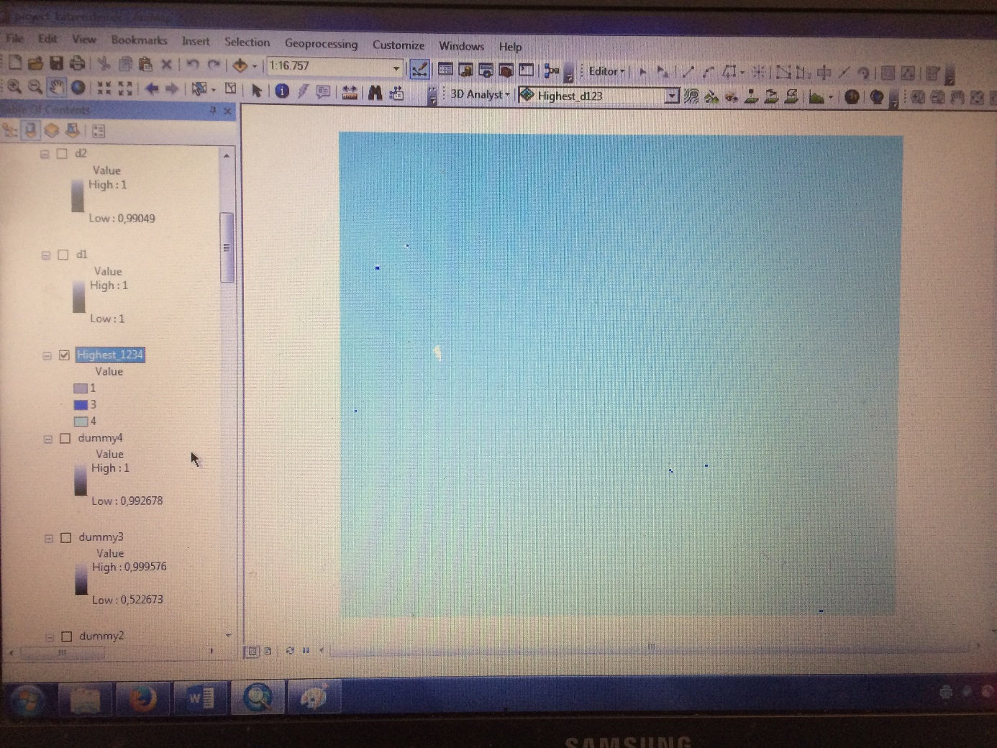

Grid Variogramm mit Surfer:
x-coord., y-coord., CTI (=rasterca_4)

map surface:

2. Versuch doch noch eine Karte zu machen:

k-means cluster nur mit „slope“ und „curvatur“:

Quick Cluster

Notes
Output Created |  | 02-MAR-2017 09:17:10
Comments
Input | Data | C:\Users  ina\Desktop\Carina\forstl standortskartierung\GIS_project\Daten_GIS_neu.sav
Input | Active Dataset | DataSet1
Input | Filter | <none>
Input | Weight | <none>
Input | Split File | <none>
Input | N of Rows in Working Data File | 116
Missing Value Handling | Definition of Missing | User-defined missing values are treated as missing.
Missing Value Handling | Cases Used | Statistics are based on cases with no missing values for any clustering variable used.
Syntax |  | QUICK CLUSTER Filter_Cur Slope_Fill  /MISSING=LISTWISE  /CRITERIA=CLUSTER(4) MXITER(10) CONVERGE(0)  /METHOD=KMEANS(NOUPDATE)  /SAVE CLUSTER  /PRINT INITIAL.
Resources | Processor Time | 00:00:00,05
Resources | Elapsed Time | 00:00:00,20
Resources | Workspace Required | 616 bytes
Variables Created or Modified | QCL_3 | Cluster Number of Case

[DataSet1] C:\Users\nina\Desktop\Carina\forstl standortskartierung\GIS_project\Daten_GIS_neu.sav

Initial Cluster Centers
 | Cluster
 | 1 | 2 | 3 | 4
Filter_Cur | ,734 | 1,138 | -,046 | 1,648
Slope_Fill | 33,542 | 20,403 | 1,020 | 7,950

Iteration Historyª
Iteration | Change in Cluster Centers
Iteration | 1 | 2 | 3 | 4
1 | 1,686 | 3,045 | 2,030 | 2,114
2 | 1,947 | ,670 | 1,254 | ,331
3 | 1,525 | ,299 | ,626 | ,445
4 | ,000 | ,000 | ,074 | ,065
5 | ,000 | ,000 | ,000 | ,000
a. Convergence achieved due to no or small change in cluster centers. The maximum absolute coordinate change for any center is ,000. The current iteration is 5. The minimum distance between initial centers is 7,134.

Final Cluster Centers
 | Cluster
 | 1 | 2 | 3 | 4
Filter_Cur | ,027 | -,109 | -,074 | ,096
Slope_Fill | 28,456 | 16,678 | 4,991 | 10,202

Number of Cases in each Cluster
Cluster | 1 | 4,000
Cluster | 2 | 35,000
Cluster | 3 | 30,000
Cluster | 4 | 47,000
Valid |  | 116,000
Missing |  | ,000

Discriminant

Notes
Output Created |  | 02-MAR-2017 09:20:20
Comments
Input | Data | C:\Users  ina\Desktop\Carina\forstl standortskartierung\GIS_project\Daten_GIS_neu.sav
Input | Active Dataset | DataSet1
Input | Filter | <none>
Input | Weight | <none>
Input | Split File | <none>
Input | N of Rows in Working Data File | 116
Missing Value Handling | Definition of Missing | User-defined missing values are treated as missing in the analysis phase.
Missing Value Handling | Cases Used | In the analysis phase, cases with no user- or system-missing values for any predictor variable are used. Cases with user-, system-missing, or out-of-range values for the grouping variable are always excluded.
Syntax |  | DISCRIMINANT  /GROUPS=QCL_3(1 4)  /VARIABLES=Filter_Cur Slope_Fill  /ANALYSIS ALL  /PRIORS SIZE  /STATISTICS=MEAN STDDEV UNIVF RAW TABLE  /CLASSIFY=NONMISSING POOLED.
Resources | Processor Time | 00:00:00,05
Resources | Elapsed Time | 00:00:00,11

[DataSet1] C:\Users\nina\Desktop\Carina\forstl standortskartierung\GIS_project\Daten_GIS_neu.sav

Analysis Case Processing Summary
Unweighted Cases |  | N | Percent
Valid |  | 116 | 100,0
Excluded | Missing or out-of-range group codes | 0 | ,0
Excluded | At least one missing discriminating variable | 0 | ,0
Excluded | Both missing or out-of-range group codes and at least one missing discriminating variable | 0 | ,0
Excluded | Total | 0 | ,0
Total |  | 116 | 100,0

Group Statistics
Cluster Number of Case |  | Mean | Std. Deviation | Valid N (listwise)
 |  | Mean | Std. Deviation | Unweighted | Weighted
1 | Filter_Cur | ,02730 | ,491574 | 4 | 4,000
1 | Slope_Fill | 28,45613 | 4,305780 | 4 | 4,000
2 | Filter_Cur | -,10883 | ,788319 | 35 | 35,000
2 | Slope_Fill | 16,67788 | 2,557280 | 35 | 35,000
3 | Filter_Cur | -,07438 | ,847254 | 30 | 30,000
3 | Slope_Fill | 4,99083 | 1,740272 | 30 | 30,000
4 | Filter_Cur | ,09631 | ,481589 | 47 | 47,000
4 | Slope_Fill | 10,20208 | 1,640908 | 47 | 47,000
Total | Filter_Cur | -,01211 | ,687419 | 116 | 116,000
Total | Slope_Fill | 11,43770 | 5,844259 | 116 | 116,000

Tests of Equality of Group Means
 | Wilks' Lambda | F | df1 | df2 | Sig.
Filter_Cur | ,982 | ,702 | 3 | 112 | ,553
Slope_Fill | ,125 | 262,144 | 3 | 112 | ,000

Discriminantanalyse:

Summary of Canonical Discriminant Functions

Eigenvalues
Function | Eigenvalue | % of Variance | Cumulative % | Canonical Correlation
1 | 7,056ª | 99,7 | 99,7 | ,936
2 | ,018ª | ,3 | 100,0 | ,134
a. First 2 canonical discriminant functions were used in the analysis.

Wilks' Lambda
Test of Function(s) | Wilks' Lambda | Chi-square | df | Sig.
1 through 2 | ,122 | 235,709 | 6 | ,000
2 | ,982 | 2,031 | 2 | ,362

Standardized Canonical Discriminant Function Coefficients
 | Function
 | 1 | 2
Filter_Cur | -,070 | ,999
Slope_Fill | 1,002 | ,008

Structure Matrix
 | Function
 | 1 | 2
Slope_Fill | ,998* | ,070
Filter_Cur | -,008 | 1,000*
Pooled within-groups correlations between discriminating variables and standardized canonical discriminant functions
Variables ordered by absolute size of correlation within function.
*. Largest absolute correlation between each variable and any discriminant function

Canonical Discriminant Function Coefficients
 | Function
 | 1 | 2
Filter_Cur | -,101 | 1,448
Slope_Fill | ,479 | ,004
(Constant) | -5,482 | -,028
Unstandardized coefficients

Functions at Group Centroids
Cluster Number of Case | Function
Cluster Number of Case | 1 | 2
1 | 8,150 | ,125
2 | 2,521 | -,119
3 | -3,083 | -,116
4 | -,603 | ,152
Unstandardized canonical discriminant functions evaluated at group means

Classification Statistics

Classification Processing Summary
Processed |  | 116
Excluded | Missing or out-of-range group codes | 0
Excluded | At least one missing discriminating variable | 0
Used in Output |  | 116

Prior Probabilities for Groups
Cluster Number of Case | Prior | Cases Used in Analysis
Cluster Number of Case | Prior | Unweighted | Weighted
1 | ,034 | 4 | 4,000
2 | ,302 | 35 | 35,000
3 | ,259 | 30 | 30,000
4 | ,405 | 47 | 47,000
Total | 1,000 | 116 | 116,000

Classification Resultsª
 |  | Cluster Number of Case | Predicted Group Membership |  |  |  | Total
 |  | Cluster Number of Case | 1 | 2 | 3 | 4 | Total
Original | Count | 1 | 4 | 0 | 0 | 0 | 4
Original | Count | 2 | 0 | 32 | 0 | 3 | 35
Original | Count | 3 | 0 | 0 | 30 | 0 | 30
Original | Count | 4 | 0 | 0 | 0 | 47 | 47
Original | % | 1 | 100,0 | ,0 | ,0 | ,0 | 100,0
Original | % | 2 | ,0 | 91,4 | ,0 | 8,6 | 100,0
Original | % | 3 | ,0 | ,0 | 100,0 | ,0 | 100,0
Original | % | 4 | ,0 | ,0 | ,0 | 100,0 | 100,0
a. 97,4% of original grouped cases correctly classified.

Logistic Regression

Notes
Output Created |  | 02-MAR-2017 09:33:09
Comments
Input | Data | C:\Users  ina\Desktop\Carina\forstl standortskartierung\GIS_project\Daten_GIS_neu.sav
Input | Active Dataset | DataSet1
Input | Filter | <none>
Input | Weight | <none>
Input | Split File | <none>
Input | N of Rows in Working Data File | 116
Missing Value Handling | Definition of Missing | User-defined missing values are treated as missing
Syntax |  | LOGISTIC REGRESSION VARIABLES Dummy1_neu  /METHOD=ENTER Filter_Cur Slope_Fill  /SAVE=PRED PGROUP  /CRITERIA=PIN(0.05) POUT(0.10) ITERATE(20) CUT(0.5).
Resources | Processor Time | 00:00:00,06
Resources | Elapsed Time | 00:00:00,14
Variables Created or Modified | PRE_8 | Predicted probability
Variables Created or Modified | PGR_8 | Predicted group

[DataSet1] C:\Users\nina\Desktop\Carina\forstl standortskartierung\GIS_project\Daten_GIS_neu.sav

Case Processing Summary
Unweighted Casesª |  | N | Percent
Selected Cases | Included in Analysis | 116 | 100,0
Selected Cases | Missing Cases | 0 | ,0
Selected Cases | Total | 116 | 100,0
Unselected Cases |  | 0 | ,0
Total |  | 116 | 100,0
a. If weight is in effect, see classification table for the total number of cases.

Dependent Variable Encoding
Original Value | Internal Value
,00 | 0
1,00 | 1

Block 0: Beginning Block

Classification Table^{a,b}
 | Observed |  | Predicted
 |  |  | Dummy1_neu |  | Percentage Correct
 |  |  | ,00 | 1,00 | Percentage Correct
Step 0 | Dummy1_neu | ,00 | 112 | 0 | 100,0
Step 0 | Dummy1_neu | 1,00 | 4 | 0 | ,0
Step 0 | Overall Percentage |  |  |  | 96,6
a. Constant is included in the model.
b. The cut value is ,500

Variables in the Equation
 |  | B | S.E. | Wald | df | Sig. | Exp(B)
Step 0 | Constant | -3,332 | ,509 | 42,883 | 1 | ,000 | ,036

Variables not in the Equation
 |  |  | Score | df | Sig.
Step 0 | Variables | Filter_Cur | ,014 | 1 | ,907
Step 0 | Variables | Slope_Fill | 35,436 | 1 | ,000
Step 0 | Overall Statistics |  | 35,448 | 2 | ,000

Block 1: Method = Enter

Omnibus Tests of Model Coefficients
 |  | Chi-square | df | Sig.
Step 1 | Step | 34,799 | 2 | ,000
Step 1 | Block | 34,799 | 2 | ,000
Step 1 | Model | 34,799 | 2 | ,000

Model Summary
Step | -2 Log likelihood | Cox & Snell R Square | Nagelkerke R Square
1 | ,000ª | ,259 | 1,000
a. Estimation terminated at iteration number 20 because maximum iterations has been reached. Final solution cannot be found.

Classification Tableª
 | Observed |  | Predicted
 |  |  | Dummy1_neu |  | Percentage Correct
 |  |  | ,00 | 1,00 | Percentage Correct
Step 1 | Dummy1_neu | ,00 | 112 | 0 | 100,0
Step 1 | Dummy1_neu | 1,00 | 0 | 4 | 100,0
Step 1 | Overall Percentage |  |  |  | 100,0
a. The cut value is ,500

Variables in the Equation
 |  | B | S.E. | Wald | df | Sig. | Exp(B)
Step 1ª | Filter_Cur | ,988 | 543,648 | ,000 | 1 | ,999 | 2,687
Step 1ª | Slope_Fill | 18,894 | 630,972 | ,001 | 1 | ,976 | 160589361,367
Step 1ª | Constant | -438,200 | 14564,922 | ,001 | 1 | ,976 | ,000
a. Variable(s) entered on step 1: Filter_Cur, Slope_Fill.

Logistic Regression

Notes
Output Created |  | 02-MAR-2017 09:34:19
Comments
Input | Data | C:\Users  ina\Desktop\Carina\forstl standortskartierung\GIS_project\Daten_GIS_neu.sav
Input | Active Dataset | DataSet1
Input | Filter | <none>
Input | Weight | <none>
Input | Split File | <none>
Input | N of Rows in Working Data File | 116
Missing Value Handling | Definition of Missing | User-defined missing values are treated as missing
Syntax |  | LOGISTIC REGRESSION VARIABLES Dummy2_neu  /METHOD=ENTER Filter_Cur Slope_Fill  /SAVE=PRED PGROUP  /CRITERIA=PIN(0.05) POUT(0.10) ITERATE(20) CUT(0.5).
Resources | Processor Time | 00:00:00,03
Resources | Elapsed Time | 00:00:00,03
Variables Created or Modified | PRE_9 | Predicted probability
Variables Created or Modified | PGR_9 | Predicted group

[DataSet1] C:\Users\nina\Desktop\Carina\forstl standortskartierung\GIS_project\Daten_GIS_neu.sav

Case Processing Summary
Unweighted Casesª |  | N | Percent
Selected Cases | Included in Analysis | 116 | 100,0
Selected Cases | Missing Cases | 0 | ,0
Selected Cases | Total | 116 | 100,0
Unselected Cases |  | 0 | ,0
Total |  | 116 | 100,0
a. If weight is in effect, see classification table for the total number of cases.

Dependent Variable Encoding
Original Value | Internal Value
,00 | 0
1,00 | 1

Block 0: Beginning Block

Classification Table^{a,b}
 | Observed |  | Predicted
 |  |  | Dummy2_neu |  | Percentage Correct
 |  |  | ,00 | 1,00 | Percentage Correct
Step 0 | Dummy2_neu | ,00 | 81 | 0 | 100,0
Step 0 | Dummy2_neu | 1,00 | 35 | 0 | ,0
Step 0 | Overall Percentage |  |  |  | 69,8
a. Constant is included in the model.
b. The cut value is ,500

Variables in the Equation
 |  | B | S.E. | Wald | df | Sig. | Exp(B)
Step 0 | Constant | -,839 | ,202 | 17,208 | 1 | ,000 | ,432

Variables not in the Equation
 |  |  | Score | df | Sig.
Step 0 | Variables | Filter_Cur | 1,001 | 1 | ,317
Step 0 | Variables | Slope_Fill | 40,648 | 1 | ,000
Step 0 | Overall Statistics |  | 41,665 | 2 | ,000

Block 1: Method = Enter

Omnibus Tests of Model Coefficients
 |  | Chi-square | df | Sig.
Step 1 | Step | 48,714 | 2 | ,000
Step 1 | Block | 48,714 | 2 | ,000
Step 1 | Model | 48,714 | 2 | ,000

Model Summary
Step | -2 Log likelihood | Cox & Snell R Square | Nagelkerke R Square
1 | 93,344ª | ,343 | ,486
a. Estimation terminated at iteration number 6 because parameter estimates changed by less than ,001.

Classification Tableª
 | Observed |  | Predicted
 |  |  | Dummy2_neu |  | Percentage Correct
 |  |  | ,00 | 1,00 | Percentage Correct
Step 1 | Dummy2_neu | ,00 | 77 | 4 | 95,1
Step 1 | Dummy2_neu | 1,00 | 8 | 27 | 77,1
Step 1 | Overall Percentage |  |  |  | 89,7
a. The cut value is ,500

Variables in the Equation
 |  | B | S.E. | Wald | df | Sig. | Exp(B)
Step 1ª | Filter_Cur | -,405 | ,398 | 1,038 | 1 | ,308 | ,667
Step 1ª | Slope_Fill | ,339 | ,068 | 25,021 | 1 | ,000 | 1,403
Step 1ª | Constant | -5,089 | ,921 | 30,495 | 1 | ,000 | ,006
a. Variable(s) entered on step 1: Filter_Cur, Slope_Fill.

Logistic Regression

Notes
Output Created |  | 02-MAR-2017 09:34:54
Comments
Input | Data | C:\Users  ina\Desktop\Carina\forstl standortskartierung\GIS_project\Daten_GIS_neu.sav
Input | Active Dataset | DataSet1
Input | Filter | <none>
Input | Weight | <none>
Input | Split File | <none>
Input | N of Rows in Working Data File | 116
Missing Value Handling | Definition of Missing | User-defined missing values are treated as missing
Syntax |  | LOGISTIC REGRESSION VARIABLES Dummy3_neu  /METHOD=ENTER Filter_Cur Slope_Fill  /SAVE=PRED PGROUP  /CRITERIA=PIN(0.05) POUT(0.10) ITERATE(20) CUT(0.5).
Resources | Processor Time | 00:00:00,02
Resources | Elapsed Time | 00:00:00,03
Variables Created or Modified | PRE_10 | Predicted probability
Variables Created or Modified | PGR_10 | Predicted group

[DataSet1] C:\Users\nina\Desktop\Carina\forstl standortskartierung\GIS_project\Daten_GIS_neu.sav

Case Processing Summary
Unweighted Casesª |  | N | Percent
Selected Cases | Included in Analysis | 116 | 100,0
Selected Cases | Missing Cases | 0 | ,0
Selected Cases | Total | 116 | 100,0
Unselected Cases |  | 0 | ,0
Total |  | 116 | 100,0
a. If weight is in effect, see classification table for the total number of cases.

Dependent Variable Encoding
Original Value | Internal Value
,00 | 0
1,00 | 1

Block 0: Beginning Block

Classification Table^{a,b}
 | Observed |  | Predicted
 |  |  | Dummy3_neu |  | Percentage Correct
 |  |  | ,00 | 1,00 | Percentage Correct
Step 0 | Dummy3_neu | ,00 | 86 | 0 | 100,0
Step 0 | Dummy3_neu | 1,00 | 30 | 0 | ,0
Step 0 | Overall Percentage |  |  |  | 74,1
a. Constant is included in the model.
b. The cut value is ,500

Variables in the Equation
 |  | B | S.E. | Wald | df | Sig. | Exp(B)
Step 0 | Constant | -1,053 | ,212 | 24,668 | 1 | ,000 | ,349

Variables not in the Equation
 |  |  | Score | df | Sig.
Step 0 | Variables | Filter_Cur | ,335 | 1 | ,563
Step 0 | Variables | Slope_Fill | 49,668 | 1 | ,000
Step 0 | Overall Statistics |  | 49,993 | 2 | ,000

Block 1: Method = Enter

Omnibus Tests of Model Coefficients
 |  | Chi-square | df | Sig.
Step 1 | Step | 132,613 | 2 | ,000
Step 1 | Block | 132,613 | 2 | ,000
Step 1 | Model | 132,613 | 2 | ,000

Model Summary
Step | -2 Log likelihood | Cox & Snell R Square | Nagelkerke R Square
1 | ,000ª | ,681 | 1,000
a. Estimation terminated at iteration number 20 because maximum iterations has been reached. Final solution cannot be found.

Classification Tableª
 | Observed |  | Predicted
 |  |  | Dummy3_neu |  | Percentage Correct
 |  |  | ,00 | 1,00 | Percentage Correct
Step 1 | Dummy3_neu | ,00 | 86 | 0 | 100,0
Step 1 | Dummy3_neu | 1,00 | 0 | 30 | 100,0
Step 1 | Overall Percentage |  |  |  | 100,0
a. The cut value is ,500

Variables in the Equation
 |  | B | S.E. | Wald | df | Sig. | Exp(B)
Step 1ª | Filter_Cur | 7,953 | 1563,497 | ,000 | 1 | ,996 | 2845,450
Step 1ª | Slope_Fill | -46,194 | 1262,195 | ,001 | 1 | ,971 | ,000
Step 1ª | Constant | 338,640 | 9295,997 | ,001 | 1 | ,971 | 1,173E+147
a. Variable(s) entered on step 1: Filter_Cur, Slope_Fill.

Logistic Regression

Notes
Output Created |  | 02-MAR-2017 09:35:50
Comments
Input | Data | C:\Users  ina\Desktop\Carina\forstl standortskartierung\GIS_project\Daten_GIS_neu.sav
Input | Active Dataset | DataSet1
Input | Filter | <none>
Input | Weight | <none>
Input | Split File | <none>
Input | N of Rows in Working Data File | 116
Missing Value Handling | Definition of Missing | User-defined missing values are treated as missing
Syntax |  | LOGISTIC REGRESSION VARIABLES Dummy4_neu  /METHOD=ENTER Filter_Cur Slope_Fill  /SAVE=PRED PGROUP  /CRITERIA=PIN(0.05) POUT(0.10) ITERATE(20) CUT(0.5).
Resources | Processor Time | 00:00:00,02
Resources | Elapsed Time | 00:00:00,02
Variables Created or Modified | PRE_11 | Predicted probability
Variables Created or Modified | PGR_11 | Predicted group

[DataSet1] C:\Users\nina\Desktop\Carina\forstl standortskartierung\GIS_project\Daten_GIS_neu.sav

Case Processing Summary
Unweighted Casesª |  | N | Percent
Selected Cases | Included in Analysis | 116 | 100,0
Selected Cases | Missing Cases | 0 | ,0
Selected Cases | Total | 116 | 100,0
Unselected Cases |  | 0 | ,0
Total |  | 116 | 100,0
a. If weight is in effect, see classification table for the total number of cases.

Dependent Variable Encoding
Original Value | Internal Value
,00 | 0
1,00 | 1

Block 0: Beginning Block

Classification Table^{a,b}
 | Observed |  | Predicted
 |  |  | Dummy4_neu |  | Percentage Correct
 |  |  | ,00 | 1,00 | Percentage Correct
Step 0 | Dummy4_neu | ,00 | 69 | 0 | 100,0
Step 0 | Dummy4_neu | 1,00 | 47 | 0 | ,0
Step 0 | Overall Percentage |  |  |  | 59,5
a. Constant is included in the model.
b. The cut value is ,500

Variables in the Equation
 |  | B | S.E. | Wald | df | Sig. | Exp(B)
Step 0 | Constant | -,384 | ,189 | 4,122 | 1 | ,042 | ,681

Variables not in the Equation
 |  |  | Score | df | Sig.
Step 0 | Variables | Filter_Cur | 1,983 | 1 | ,159
Step 0 | Variables | Slope_Fill | 3,563 | 1 | ,059
Step 0 | Overall Statistics |  | 5,552 | 2 | ,062

Block 1: Method = Enter

Omnibus Tests of Model Coefficients
 |  | Chi-square | df | Sig.
Step 1 | Step | 5,867 | 2 | ,053
Step 1 | Block | 5,867 | 2 | ,053
Step 1 | Model | 5,867 | 2 | ,053

Model Summary
Step | -2 Log likelihood | Cox & Snell R Square | Nagelkerke R Square
1 | 150,746ª | ,049 | ,067
a. Estimation terminated at iteration number 4 because parameter estimates changed by less than ,001.

Classification Tableª
 | Observed |  | Predicted
 |  |  | Dummy4_neu |  | Percentage Correct
 |  |  | ,00 | 1,00 | Percentage Correct
Step 1 | Dummy4_neu | ,00 | 54 | 15 | 78,3
Step 1 | Dummy4_neu | 1,00 | 43 | 4 | 8,5
Step 1 | Overall Percentage |  |  |  | 50,0
a. The cut value is ,500

Variables in the Equation
 |  | B | S.E. | Wald | df | Sig. | Exp(B)
Step 1ª | Filter_Cur | ,443 | ,320 | 1,912 | 1 | ,167 | 1,557
Step 1ª | Slope_Fill | -,067 | ,036 | 3,462 | 1 | ,063 | ,935
Step 1ª | Constant | ,359 | ,438 | ,674 | 1 | ,412 | 1,433
a. Variable(s) entered on step 1: Filter_Cur, Slope_Fill.

2. versuch: Nur mit slope:

Cluster

Notes
Output Created |  |  | 03-MAR-2017 07:14:09
Comments
Input | Data |  | C:\Users  ina\Desktop\Carina\forstl standortskartierung\GIS_project\Daten_GIS_neu.sav
Input | Active Dataset |  | DataSet1
Input | Filter |  | <none>
Input | Weight |  | <none>
Input | Split File |  | <none>
Input | N of Rows in Working Data File |  | 116
Missing Value Handling | Definition of Missing |  | User-defined missing values are treated as missing.
Missing Value Handling | Cases Used |  | Statistics are based on cases with no missing values for any variable used.
Syntax |  |  | CLUSTER Slope_Fill  /METHOD BAVERAGE  /MEASURE=SEUCLID  /PRINT SCHEDULE  /PLOT DENDROGRAM VICICLE  /SAVE CLUSTER(4).
Resources | Processor Time |  | 00:00:02,15
Resources | Elapsed Time |  | 00:00:02,26
Variables Created or Modified | Cluster Membership | CLU4_2 | Average Linkage (Between Groups)

[DataSet1] C:\Users\nina\Desktop\Carina\forstl standortskartierung\GIS_project\Daten_GIS_neu.sav

Case Processing Summary^{a,b}
Cases
Valid |  | Missing |  | Total
N | Percent | N | Percent | N | Percent
116 | 100,0 | 0 | ,0 | 116 | 100,0
a. Squared Euclidean Distance used
b. Average Linkage (Between Groups)

Average Linkage (Between Groups)

Agglomeration Schedule
Stage | Cluster Combined |  | Coefficients | Stage Cluster First Appears |  | Next Stage
Stage | Cluster 1 | Cluster 2 | Coefficients | Cluster 1 | Cluster 2 | Next Stage
1 | 47 | 70 | ,000 | 0 | 0 | 24
2 | 57 | 74 | ,000 | 0 | 0 | 54
3 | 44 | 66 | ,000 | 0 | 0 | 22
4 | 21 | 23 | ,000 | 0 | 0 | 19
5 | 68 | 96 | ,000 | 0 | 0 | 54
6 | 26 | 38 | ,000 | 0 | 0 | 64
7 | 37 | 41 | ,000 | 0 | 0 | 14
8 | 65 | 108 | ,000 | 0 | 0 | 55
9 | 56 | 98 | ,000 | 0 | 0 | 24
10 | 34 | 48 | ,001 | 0 | 0 | 42
11 | 18 | 53 | ,001 | 0 | 0 | 27
12 | 39 | 40 | ,001 | 0 | 0 | 49
13 | 67 | 86 | ,001 | 0 | 0 | 43
14 | 37 | 52 | ,001 | 7 | 0 | 27
15 | 28 | 69 | ,001 | 0 | 0 | 32
16 | 30 | 58 | ,001 | 0 | 0 | 35
17 | 12 | 29 | ,001 | 0 | 0 | 38
18 | 33 | 78 | ,003 | 0 | 0 | 48
19 | 21 | 104 | ,003 | 4 | 0 | 31
20 | 71 | 115 | ,003 | 0 | 0 | 58
21 | 2 | 43 | ,004 | 0 | 0 | 44
22 | 3 | 44 | ,004 | 0 | 3 | 44
23 | 27 | 50 | ,004 | 0 | 0 | 48
24 | 47 | 56 | ,004 | 1 | 9 | 46
25 | 13 | 63 | ,004 | 0 | 0 | 45
26 | 22 | 95 | ,005 | 0 | 0 | 47
27 | 18 | 37 | ,006 | 11 | 14 | 83
28 | 6 | 77 | ,006 | 0 | 0 | 74
29 | 10 | 17 | ,007 | 0 | 0 | 53
30 | 79 | 83 | ,008 | 0 | 0 | 59
31 | 21 | 64 | ,008 | 19 | 0 | 52
32 | 28 | 72 | ,009 | 15 | 0 | 51
33 | 45 | 59 | ,010 | 0 | 0 | 70
34 | 16 | 24 | ,010 | 0 | 0 | 98
35 | 30 | 92 | ,011 | 16 | 0 | 56
36 | 89 | 100 | ,011 | 0 | 0 | 101
37 | 4 | 61 | ,011 | 0 | 0 | 77
38 | 12 | 82 | ,012 | 17 | 0 | 68
39 | 55 | 109 | ,012 | 0 | 0 | 65
40 | 51 | 75 | ,013 | 0 | 0 | 64
41 | 15 | 31 | ,014 | 0 | 0 | 59
42 | 34 | 60 | ,017 | 10 | 0 | 55
43 | 67 | 106 | ,019 | 13 | 0 | 72
44 | 2 | 3 | ,019 | 21 | 22 | 70
45 | 13 | 32 | ,021 | 25 | 0 | 80
46 | 47 | 99 | ,021 | 24 | 0 | 61
47 | 22 | 73 | ,022 | 26 | 0 | 67
48 | 27 | 33 | ,023 | 23 | 18 | 66
49 | 39 | 94 | ,024 | 12 | 0 | 77
50 | 1 | 87 | ,025 | 0 | 0 | 82
51 | 28 | 62 | ,026 | 32 | 0 | 74
52 | 21 | 113 | ,027 | 31 | 0 | 73
53 | 10 | 14 | ,027 | 29 | 0 | 68
54 | 57 | 68 | ,031 | 2 | 5 | 76
55 | 34 | 65 | ,035 | 42 | 8 | 82
56 | 30 | 84 | ,037 | 35 | 0 | 76
57 | 46 | 80 | ,041 | 0 | 0 | 87
58 | 25 | 71 | ,042 | 0 | 20 | 71
59 | 15 | 79 | ,046 | 41 | 30 | 75
60 | 97 | 114 | ,047 | 0 | 0 | 91
61 | 20 | 47 | ,051 | 0 | 46 | 95
62 | 42 | 105 | ,051 | 0 | 0 | 84
63 | 9 | 36 | ,053 | 0 | 0 | 85
64 | 26 | 51 | ,056 | 6 | 40 | 79
65 | 11 | 55 | ,059 | 0 | 39 | 92
66 | 27 | 101 | ,063 | 48 | 0 | 88
67 | 7 | 22 | ,066 | 0 | 47 | 83
68 | 10 | 12 | ,069 | 53 | 38 | 92
69 | 49 | 76 | ,075 | 0 | 0 | 86
70 | 2 | 45 | ,076 | 44 | 33 | 89
71 | 19 | 25 | ,088 | 0 | 58 | 89
72 | 67 | 90 | ,090 | 43 | 0 | 84
73 | 21 | 88 | ,105 | 52 | 0 | 81
74 | 6 | 28 | ,108 | 28 | 51 | 87
75 | 15 | 81 | ,115 | 59 | 0 | 93
76 | 30 | 57 | ,115 | 56 | 54 | 93
77 | 4 | 39 | ,122 | 37 | 49 | 88
78 | 102 | 103 | ,123 | 0 | 0 | 96
79 | 26 | 85 | ,141 | 64 | 0 | 102
80 | 13 | 54 | ,142 | 45 | 0 | 85
81 | 21 | 93 | ,160 | 73 | 0 | 97
82 | 1 | 34 | ,177 | 50 | 55 | 97
83 | 7 | 18 | ,229 | 67 | 27 | 100
84 | 42 | 67 | ,233 | 62 | 72 | 103
85 | 9 | 13 | ,272 | 63 | 80 | 94
86 | 49 | 116 | ,286 | 69 | 0 | 96
87 | 6 | 46 | ,310 | 74 | 57 | 99
88 | 4 | 27 | ,342 | 77 | 66 | 95
89 | 2 | 19 | ,374 | 70 | 71 | 99
90 | 35 | 91 | ,384 | 0 | 0 | 98
91 | 8 | 97 | ,387 | 0 | 60 | 102
92 | 10 | 11 | ,633 | 68 | 65 | 100
93 | 15 | 30 | ,697 | 75 | 76 | 104
94 | 5 | 9 | ,853 | 0 | 85 | 105
95 | 4 | 20 | ,936 | 88 | 61 | 104
96 | 49 | 102 | ,937 | 86 | 78 | 107
97 | 1 | 21 | ,972 | 82 | 81 | 103
98 | 16 | 35 | 1,086 | 34 | 90 | 110
99 | 2 | 6 | 1,103 | 89 | 87 | 105
100 | 7 | 10 | 1,648 | 83 | 92 | 108
101 | 89 | 107 | 1,964 | 36 | 0 | 107
102 | 8 | 26 | 2,032 | 91 | 79 | 106
103 | 1 | 42 | 2,459 | 97 | 84 | 106
104 | 4 | 15 | 3,224 | 95 | 93 | 108
105 | 2 | 5 | 5,456 | 99 | 94 | 110
106 | 1 | 8 | 6,956 | 103 | 102 | 113
107 | 49 | 89 | 7,162 | 96 | 101 | 111
108 | 4 | 7 | 9,393 | 104 | 100 | 112
109 | 110 | 112 | 10,547 | 0 | 0 | 115
110 | 2 | 16 | 17,146 | 105 | 98 | 112
111 | 49 | 111 | 24,023 | 107 | 0 | 113
112 | 2 | 4 | 32,720 | 110 | 108 | 114
113 | 1 | 49 | 45,401 | 106 | 111 | 114
114 | 1 | 2 | 99,021 | 113 | 112 | 115
115 | 1 | 110 | 463,872 | 114 | 109 | 0

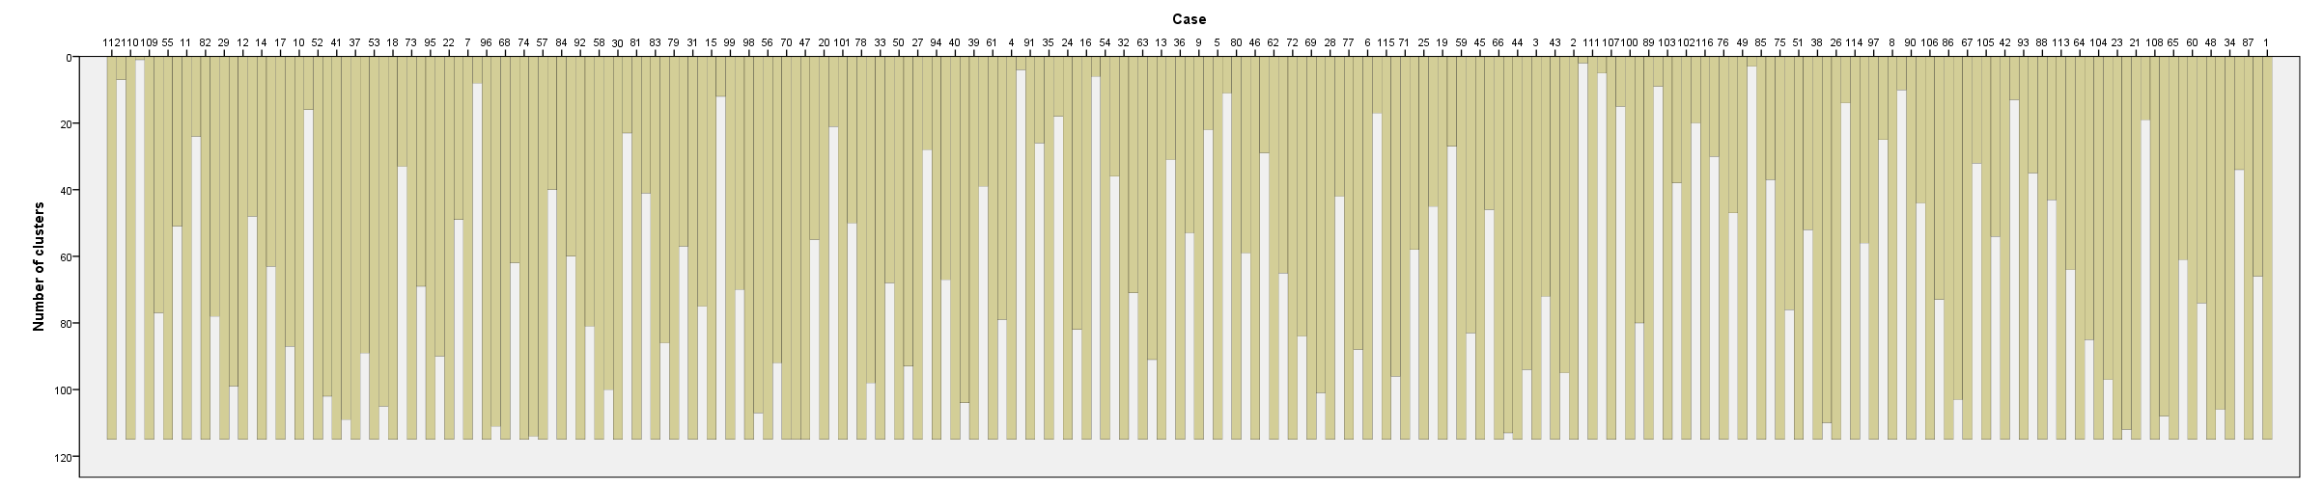

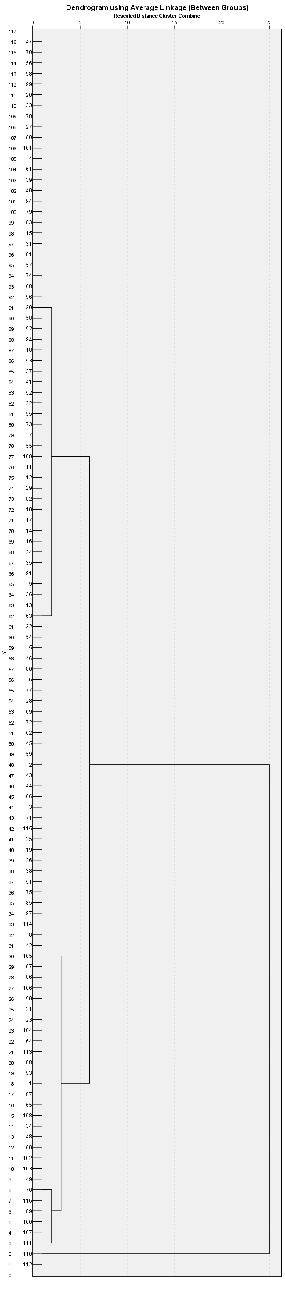

Discriminant

Notes
Output Created |  | 03-MAR-2017 07:16:55
Comments
Input | Data | C:\Users  ina\Desktop\Carina\forstl standortskartierung\GIS_project\Daten_GIS_neu.sav
Input | Active Dataset | DataSet1
Input | Filter | <none>
Input | Weight | <none>
Input | Split File | <none>
Input | N of Rows in Working Data File | 116
Missing Value Handling | Definition of Missing | User-defined missing values are treated as missing in the analysis phase.
Missing Value Handling | Cases Used | In the analysis phase, cases with no user- or system-missing values for any predictor variable are used. Cases with user-, system-missing, or out-of-range values for the grouping variable are always excluded.
Syntax |  | DISCRIMINANT  /GROUPS=CLU4_2(1 4)  /VARIABLES=Slope_Fill  /ANALYSIS ALL  /SAVE=CLASS  /PRIORS EQUAL  /CLASSIFY=NONMISSING POOLED.
Resources | Processor Time | 00:00:00,05
Resources | Elapsed Time | 00:00:00,06
Variables Created or Modified | Dis_4 | Predicted Group for Analysis 1
Number of unweighted cases written to the working file after classification |  | 116

[DataSet1] C:\Users\nina\Desktop\Carina\forstl standortskartierung\GIS_project\Daten_GIS_neu.sav

Analysis Case Processing Summary
Unweighted Cases |  | N | Percent
Valid |  | 116 | 100,0
Excluded | Missing or out-of-range group codes | 0 | ,0
Excluded | At least one missing discriminating variable | 0 | ,0
Excluded | Both missing or out-of-range group codes and at least one missing discriminating variable | 0 | ,0
Excluded | Total | 0 | ,0
Total |  | 116 | 100,0

Group Statistics
Average Linkage (Between Groups) |  | Valid N (listwise)
 |  | Unweighted | Weighted
1 | Slope_Fill | 28 | 28,000
2 | Slope_Fill | 77 | 77,000
3 | Slope_Fill | 9 | 9,000
4 | Slope_Fill | 2 | 2,000
Total | Slope_Fill | 116 | 116,000

Analysis 1

Summary of Canonical Discriminant Functions

Eigenvalues
Function | Eigenvalue | % of Variance | Cumulative % | Canonical Correlation
1 | 3,917ª | 100,0 | 100,0 | ,893
a. First 1 canonical discriminant functions were used in the analysis.

Wilks' Lambda
Test of Function(s) | Wilks' Lambda | Chi-square | df | Sig.
1 | ,203 | 179,173 | 3 | ,000

Standardized Canonical Discriminant Function Coefficients
 | Function
 | 1
Slope_Fill | 1,000

Structure Matrix
 | Function
 | 1
Slope_Fill | 1,000
Pooled within-groups correlations between discriminating variables and standardized canonical discriminant functions
Variables ordered by absolute size of correlation within function.

Functions at Group Centroids
Average Linkage (Between Groups) | Function
Average Linkage (Between Groups) | 1
1 | 1,556
2 | -1,223
3 | 3,918
4 | 7,669
Unstandardized canonical discriminant functions evaluated at group means

Classification Statistics

Classification Processing Summary
Processed |  | 116
Excluded | Missing or out-of-range group codes | 0
Excluded | At least one missing discriminating variable | 0
Used in Output |  | 116

Prior Probabilities for Groups
Average Linkage (Between Groups) | Prior | Cases Used in Analysis
Average Linkage (Between Groups) | Prior | Unweighted | Weighted
1 | ,250 | 28 | 28,000
2 | ,250 | 77 | 77,000
3 | ,250 | 9 | 9,000
4 | ,250 | 2 | 2,000
Total | 1,000 | 116 | 116,000

Logistic Regression

Notes
Output Created |  | 03-MAR-2017 07:21:23
Comments
Input | Data | C:\Users  ina\Desktop\Carina\forstl standortskartierung\GIS_project\Daten_GIS_neu.sav
Input | Active Dataset | DataSet1
Input | Filter | <none>
Input | Weight | <none>
Input | Split File | <none>
Input | N of Rows in Working Data File | 116
Missing Value Handling | Definition of Missing | User-defined missing values are treated as missing
Syntax |  | LOGISTIC REGRESSION VARIABLES D1  /METHOD=ENTER Slope_Fill  /SAVE=PRED PGROUP  /CRITERIA=PIN(0.05) POUT(0.10) ITERATE(20) CUT(0.5).
Resources | Processor Time | 00:00:00,05
Resources | Elapsed Time | 00:00:00,11
Variables Created or Modified | PRE_12 | Predicted probability
Variables Created or Modified | PGR_12 | Predicted group

[DataSet1] C:\Users\nina\Desktop\Carina\forstl standortskartierung\GIS_project\Daten_GIS_neu.sav

Case Processing Summary
Unweighted Casesª |  | N | Percent
Selected Cases | Included in Analysis | 116 | 100,0
Selected Cases | Missing Cases | 0 | ,0
Selected Cases | Total | 116 | 100,0
Unselected Cases |  | 0 | ,0
Total |  | 116 | 100,0
a. If weight is in effect, see classification table for the total number of cases.

Dependent Variable Encoding
Original Value | Internal Value
,00 | 0
1,00 | 1

Block 0: Beginning Block

Classification Table^{a,b}
 | Observed |  | Predicted
 |  |  | D1 |  | Percentage Correct
 |  |  | ,00 | 1,00 | Percentage Correct
Step 0 | D1 | ,00 | 79 | 0 | 100,0
Step 0 | D1 | 1,00 | 37 | 0 | ,0
Step 0 | Overall Percentage |  |  |  | 68,1
a. Constant is included in the model.
b. The cut value is ,500

Variables in the Equation
 |  | B | S.E. | Wald | df | Sig. | Exp(B)
Step 0 | Constant | -,759 | ,199 | 14,498 | 1 | ,000 | ,468

Variables not in the Equation
 |  |  | Score | df | Sig.
Step 0 | Variables | Slope_Fill | 18,710 | 1 | ,000
Step 0 | Overall Statistics |  | 18,710 | 1 | ,000

Block 1: Method = Enter

Omnibus Tests of Model Coefficients
 |  | Chi-square | df | Sig.
Step 1 | Step | 19,385 | 1 | ,000
Step 1 | Block | 19,385 | 1 | ,000
Step 1 | Model | 19,385 | 1 | ,000

Model Summary
Step | -2 Log likelihood | Cox & Snell R Square | Nagelkerke R Square
1 | 125,867ª | ,154 | ,216
a. Estimation terminated at iteration number 4 because parameter estimates changed by less than ,001.

Classification Tableª
 | Observed |  | Predicted
 |  |  | D1 |  | Percentage Correct
 |  |  | ,00 | 1,00 | Percentage Correct
Step 1 | D1 | ,00 | 68 | 11 | 86,1
Step 1 | D1 | 1,00 | 30 | 7 | 18,9
Step 1 | Overall Percentage |  |  |  | 64,7
a. The cut value is ,500

Variables in the Equation
 |  | B | S.E. | Wald | df | Sig. | Exp(B)
Step 1ª | Slope_Fill | ,167 | ,044 | 14,817 | 1 | ,000 | 1,182
Step 1ª | Constant | -2,781 | ,583 | 22,779 | 1 | ,000 | ,062
a. Variable(s) entered on step 1: Slope_Fill.

Logistic Regression

Notes
Output Created |  | 03-MAR-2017 07:21:51
Comments
Input | Data | C:\Users  ina\Desktop\Carina\forstl standortskartierung\GIS_project\Daten_GIS_neu.sav
Input | Active Dataset | DataSet1
Input | Filter | <none>
Input | Weight | <none>
Input | Split File | <none>
Input | N of Rows in Working Data File | 116
Missing Value Handling | Definition of Missing | User-defined missing values are treated as missing
Syntax |  | LOGISTIC REGRESSION VARIABLES D2  /METHOD=ENTER Slope_Fill  /SAVE=PRED PGROUP  /CRITERIA=PIN(0.05) POUT(0.10) ITERATE(20) CUT(0.5).
Resources | Processor Time | 00:00:00,05
Resources | Elapsed Time | 00:00:00,08
Variables Created or Modified | PRE_13 | Predicted probability
Variables Created or Modified | PGR_13 | Predicted group

[DataSet1] C:\Users\nina\Desktop\Carina\forstl standortskartierung\GIS_project\Daten_GIS_neu.sav

Case Processing Summary
Unweighted Casesª |  | N | Percent
Selected Cases | Included in Analysis | 116 | 100,0
Selected Cases | Missing Cases | 0 | ,0
Selected Cases | Total | 116 | 100,0
Unselected Cases |  | 0 | ,0
Total |  | 116 | 100,0
a. If weight is in effect, see classification table for the total number of cases.

Dependent Variable Encoding
Original Value | Internal Value
,00 | 0
1,00 | 1

Block 0: Beginning Block

Classification Table^{a,b}
 | Observed |  | Predicted
 |  |  | D2 |  | Percentage Correct
 |  |  | ,00 | 1,00 | Percentage Correct
Step 0 | D2 | ,00 | 0 | 48 | ,0
Step 0 | D2 | 1,00 | 0 | 68 | 100,0
Step 0 | Overall Percentage |  |  |  | 58,6
a. Constant is included in the model.
b. The cut value is ,500

Variables in the Equation
 |  | B | S.E. | Wald | df | Sig. | Exp(B)
Step 0 | Constant | ,348 | ,189 | 3,414 | 1 | ,065 | 1,417

Variables not in the Equation
 |  |  | Score | df | Sig.
Step 0 | Variables | Slope_Fill | 71,759 | 1 | ,000
Step 0 | Overall Statistics |  | 71,759 | 1 | ,000

Block 1: Method = Enter

Omnibus Tests of Model Coefficients
 |  | Chi-square | df | Sig.
Step 1 | Step | 157,345 | 1 | ,000
Step 1 | Block | 157,345 | 1 | ,000
Step 1 | Model | 157,345 | 1 | ,000

Model Summary
Step | -2 Log likelihood | Cox & Snell R Square | Nagelkerke R Square
1 | ,000ª | ,742 | 1,000
a. Estimation terminated at iteration number 20 because maximum iterations has been reached. Final solution cannot be found.

Classification Tableª
 | Observed |  | Predicted
 |  |  | D2 |  | Percentage Correct
 |  |  | ,00 | 1,00 | Percentage Correct
Step 1 | D2 | ,00 | 48 | 0 | 100,0
Step 1 | D2 | 1,00 | 0 | 68 | 100,0
Step 1 | Overall Percentage |  |  |  | 100,0
a. The cut value is ,500

Variables in the Equation
 |  | B | S.E. | Wald | df | Sig. | Exp(B)
Step 1ª | Slope_Fill | -75,767 | 1681,807 | ,002 | 1 | ,964 | ,000
Step 1ª | Constant | 902,064 | 20023,331 | ,002 | 1 | ,964 | .
a. Variable(s) entered on step 1: Slope_Fill.

Logistic Regression

Notes
Output Created |  | 03-MAR-2017 07:22:15
Comments
Input | Data | C:\Users  ina\Desktop\Carina\forstl standortskartierung\GIS_project\Daten_GIS_neu.sav
Input | Active Dataset | DataSet1
Input | Filter | <none>
Input | Weight | <none>
Input | Split File | <none>
Input | N of Rows in Working Data File | 116
Missing Value Handling | Definition of Missing | User-defined missing values are treated as missing
Syntax |  | LOGISTIC REGRESSION VARIABLES D3  /METHOD=ENTER Slope_Fill  /SAVE=PRED PGROUP  /CRITERIA=PIN(0.05) POUT(0.10) ITERATE(20) CUT(0.5).
Resources | Processor Time | 00:00:00,05
Resources | Elapsed Time | 00:00:00,06
Variables Created or Modified | PRE_14 | Predicted probability
Variables Created or Modified | PGR_14 | Predicted group

[DataSet1] C:\Users\nina\Desktop\Carina\forstl standortskartierung\GIS_project\Daten_GIS_neu.sav

Case Processing Summary
Unweighted Casesª |  | N | Percent
Selected Cases | Included in Analysis | 116 | 100,0
Selected Cases | Missing Cases | 0 | ,0
Selected Cases | Total | 116 | 100,0
Unselected Cases |  | 0 | ,0
Total |  | 116 | 100,0
a. If weight is in effect, see classification table for the total number of cases.

Dependent Variable Encoding
Original Value | Internal Value
,00 | 0
1,00 | 1

Block 0: Beginning Block

Classification Table^{a,b}
 | Observed |  | Predicted
 |  |  | D3 |  | Percentage Correct
 |  |  | ,00 | 1,00 | Percentage Correct
Step 0 | D3 | ,00 | 107 | 0 | 100,0
Step 0 | D3 | 1,00 | 9 | 0 | ,0
Step 0 | Overall Percentage |  |  |  | 92,2
a. Constant is included in the model.
b. The cut value is ,500

Variables in the Equation
 |  | B | S.E. | Wald | df | Sig. | Exp(B)
Step 0 | Constant | -2,476 | ,347 | 50,878 | 1 | ,000 | ,084

Variables not in the Equation
 |  |  | Score | df | Sig.
Step 0 | Variables | Slope_Fill | 31,544 | 1 | ,000
Step 0 | Overall Statistics |  | 31,544 | 1 | ,000

Block 1: Method = Enter

Omnibus Tests of Model Coefficients
 |  | Chi-square | df | Sig.
Step 1 | Step | 27,574 | 1 | ,000
Step 1 | Block | 27,574 | 1 | ,000
Step 1 | Model | 27,574 | 1 | ,000

Model Summary
Step | -2 Log likelihood | Cox & Snell R Square | Nagelkerke R Square
1 | 35,724ª | ,212 | ,503
a. Estimation terminated at iteration number 7 because parameter estimates changed by less than ,001.

Classification Tableª
 | Observed |  | Predicted
 |  |  | D3 |  | Percentage Correct
 |  |  | ,00 | 1,00 | Percentage Correct
Step 1 | D3 | ,00 | 105 | 2 | 98,1
Step 1 | D3 | 1,00 | 7 | 2 | 22,2
Step 1 | Overall Percentage |  |  |  | 92,2
a. The cut value is ,500

Variables in the Equation
 |  | B | S.E. | Wald | df | Sig. | Exp(B)
Step 1ª | Slope_Fill | ,352 | ,097 | 13,184 | 1 | ,000 | 1,422
Step 1ª | Constant | -7,968 | 1,790 | 19,813 | 1 | ,000 | ,000
a. Variable(s) entered on step 1: Slope_Fill.

Logistic Regression

Notes
Output Created |  | 03-MAR-2017 07:22:39
Comments
Input | Data | C:\Users  ina\Desktop\Carina\forstl standortskartierung\GIS_project\Daten_GIS_neu.sav
Input | Active Dataset | DataSet1
Input | Filter | <none>
Input | Weight | <none>
Input | Split File | <none>
Input | N of Rows in Working Data File | 116
Missing Value Handling | Definition of Missing | User-defined missing values are treated as missing
Syntax |  | LOGISTIC REGRESSION VARIABLES D4  /METHOD=ENTER Slope_Fill  /SAVE=PRED PGROUP  /CRITERIA=PIN(0.05) POUT(0.10) ITERATE(20) CUT(0.5).
Resources | Processor Time | 00:00:00,02
Resources | Elapsed Time | 00:00:00,03
Variables Created or Modified | PRE_15 | Predicted probability
Variables Created or Modified | PGR_15 | Predicted group

[DataSet1] C:\Users\nina\Desktop\Carina\forstl standortskartierung\GIS_project\Daten_GIS_neu.sav

Case Processing Summary
Unweighted Casesª |  | N | Percent
Selected Cases | Included in Analysis | 116 | 100,0
Selected Cases | Missing Cases | 0 | ,0
Selected Cases | Total | 116 | 100,0
Unselected Cases |  | 0 | ,0
Total |  | 116 | 100,0
a. If weight is in effect, see classification table for the total number of cases.

Dependent Variable Encoding
Original Value | Internal Value
,00 | 0
1,00 | 1

Block 0: Beginning Block

Classification Table^{a,b}
 | Observed |  | Predicted
 |  |  | D4 |  | Percentage Correct
 |  |  | ,00 | 1,00 | Percentage Correct
Step 0 | D4 | ,00 | 114 | 0 | 100,0
Step 0 | D4 | 1,00 | 2 | 0 | ,0
Step 0 | Overall Percentage |  |  |  | 98,3
a. Constant is included in the model.
b. The cut value is ,500

Variables in the Equation
 |  | B | S.E. | Wald | df | Sig. | Exp(B)
Step 0 | Constant | -4,043 | ,713 | 32,129 | 1 | ,000 | ,018

Variables not in the Equation
 |  |  | Score | df | Sig.
Step 0 | Variables | Slope_Fill | 25,211 | 1 | ,000
Step 0 | Overall Statistics |  | 25,211 | 1 | ,000

Block 1: Method = Enter

Omnibus Tests of Model Coefficients
 |  | Chi-square | df | Sig.
Step 1 | Step | 20,207 | 1 | ,000
Step 1 | Block | 20,207 | 1 | ,000
Step 1 | Model | 20,207 | 1 | ,000

Model Summary
Step | -2 Log likelihood | Cox & Snell R Square | Nagelkerke R Square
1 | ,000ª | ,160 | 1,000
a. Estimation terminated at iteration number 20 because maximum iterations has been reached. Final solution cannot be found.

Classification Tableª
 | Observed |  | Predicted
 |  |  | D4 |  | Percentage Correct
 |  |  | ,00 | 1,00 | Percentage Correct
Step 1 | D4 | ,00 | 114 | 0 | 100,0
Step 1 | D4 | 1,00 | 0 | 2 | 100,0
Step 1 | Overall Percentage |  |  |  | 100,0
a. The cut value is ,500

Variables in the Equation
 |  | B | S.E. | Wald | df | Sig. | Exp(B)
Step 1ª | Slope_Fill | 6,647 | 369,524 | ,000 | 1 | ,986 | 770,719
Step 1ª | Constant | -187,194 | 10292,062 | ,000 | 1 | ,985 | ,000
a. Variable(s) entered on step 1: Slope_Fill.

1 / (1 + Exp(-("Filter_Curva1"*0.988+"Slope_Fill_d2"*18,894-438,2)))

