Name:prasanna

Id:17334002

Creating emp table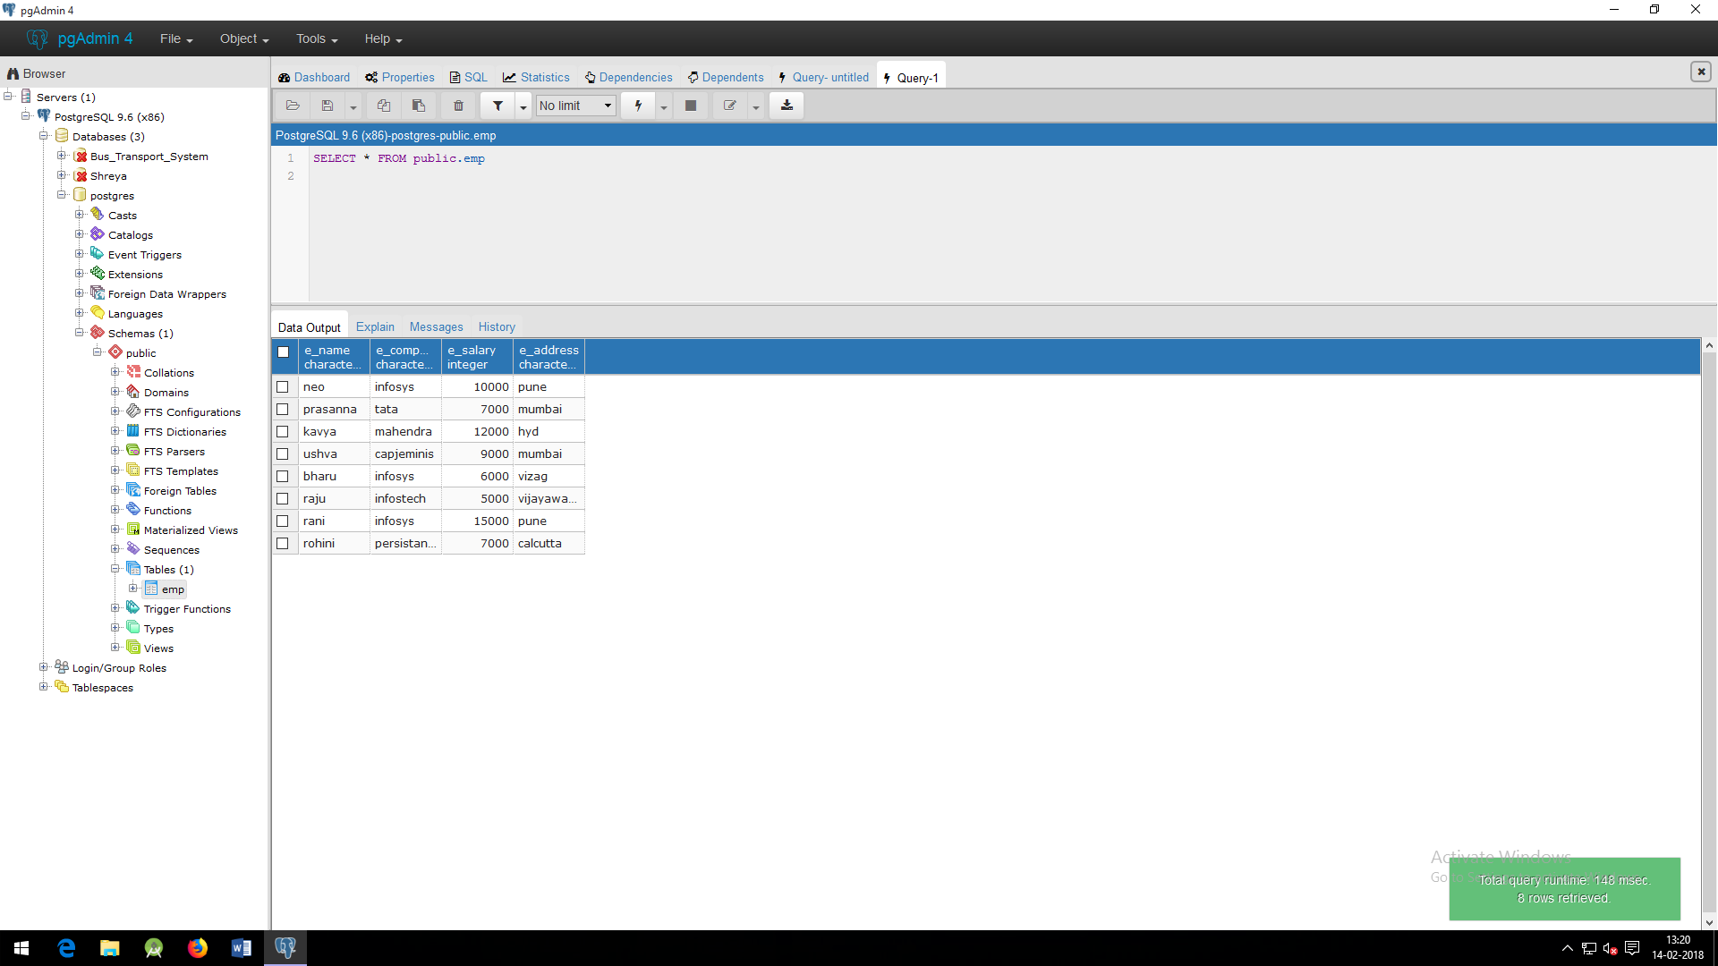

Name:prasanna

Id:17334002

DEMONASTRATION OF UPDATE COMMAND

1)ALL EMPLOYES OF INFOSYS HAVING SALARY GREATER THAN 8000 THOSE ARE SHIFTED TO CAPJEMINIS .THE LEAVING CITY OF THESE EMPLOYES IS MUMBAI

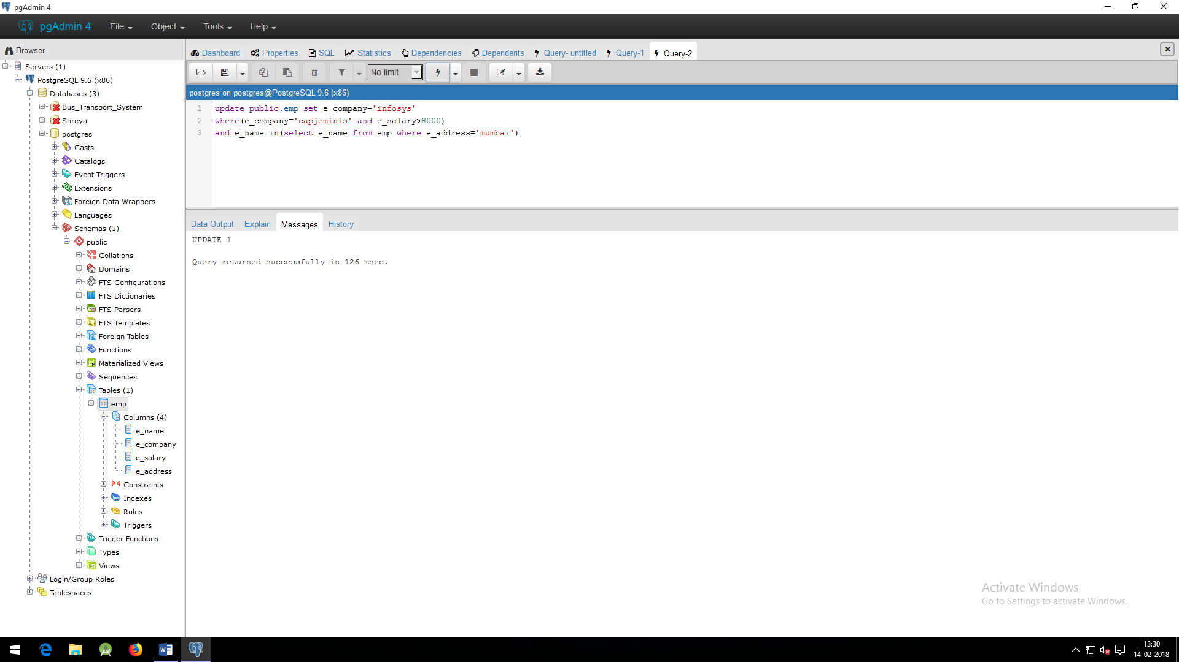

AFTER UPDATING

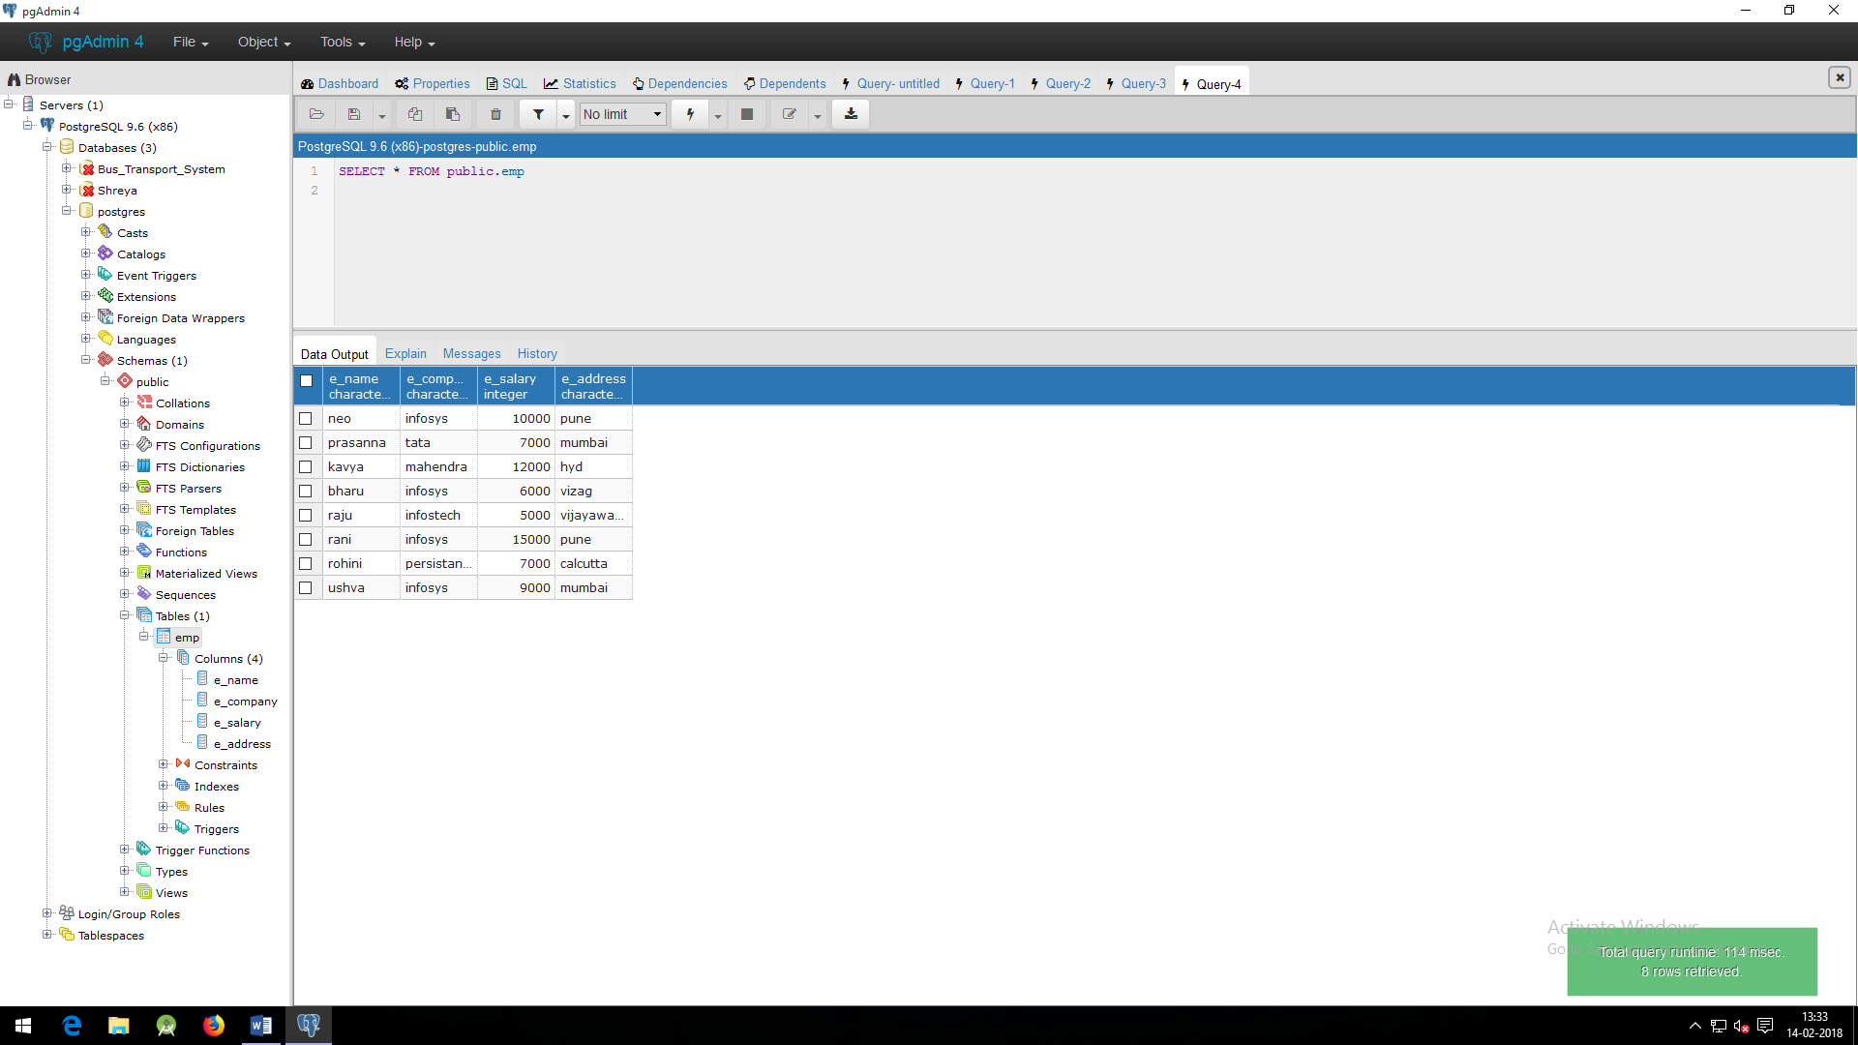

Name:prasanna

Id:17334002

3)INCREASING THE SALARY OF THE EMP WHOSE NAME IS’NEO’

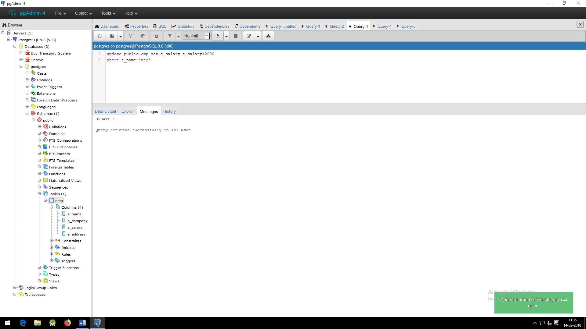

AFTER UPDATING E_SALARY OF NEO

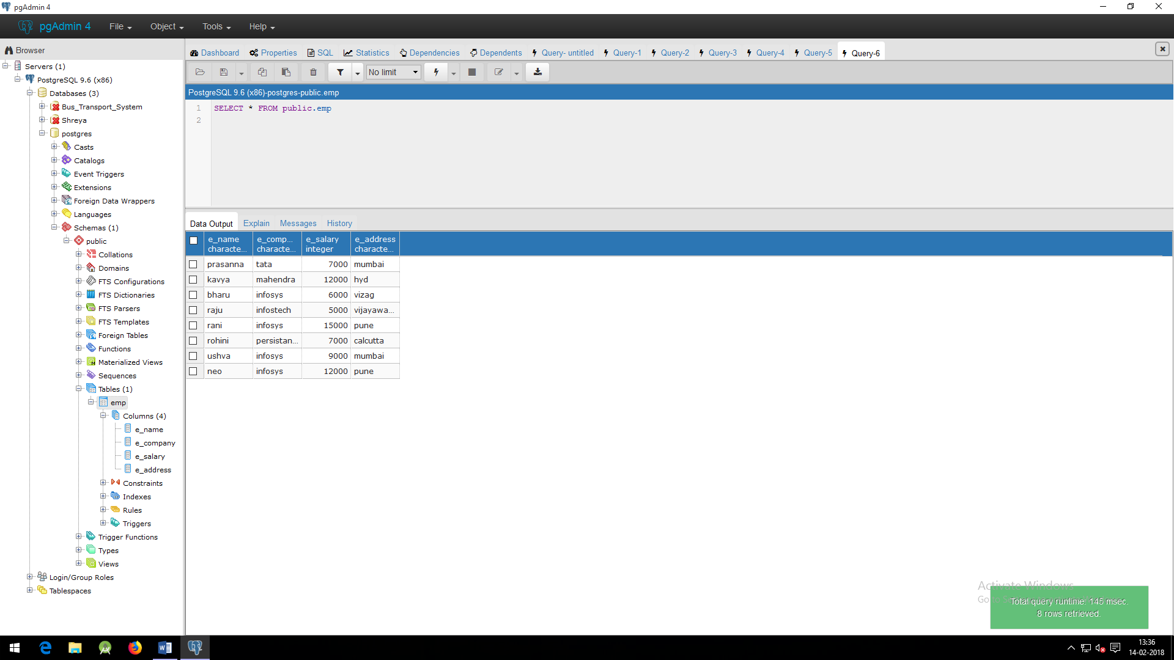

Name:prasanna

Id:17334002

The name of emp having comp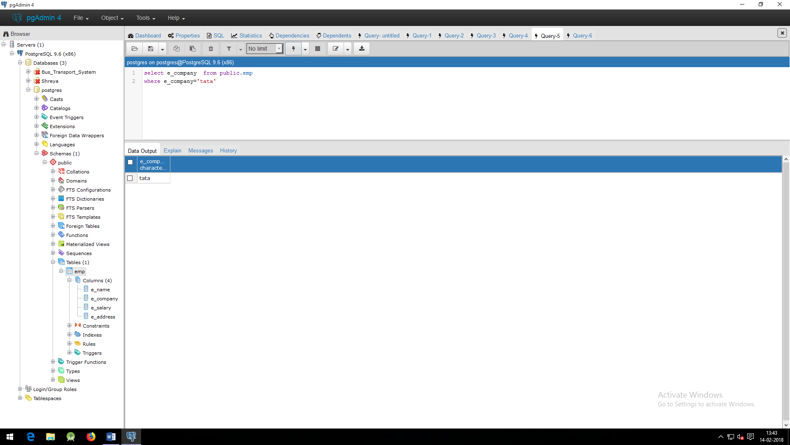

3)the name of emp having company tata and salary GREATER THAN 10000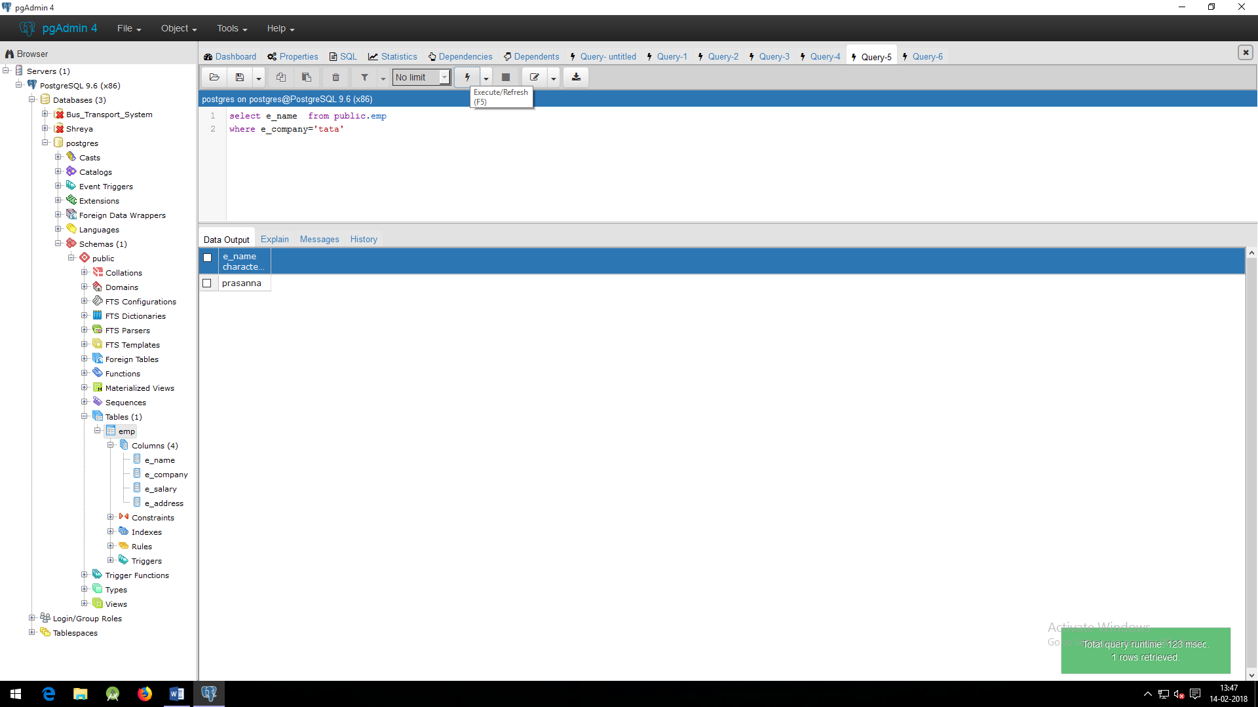

4)LIST THE NAME OF EMP WHO ARE NOT EMP IN COMPANY TATA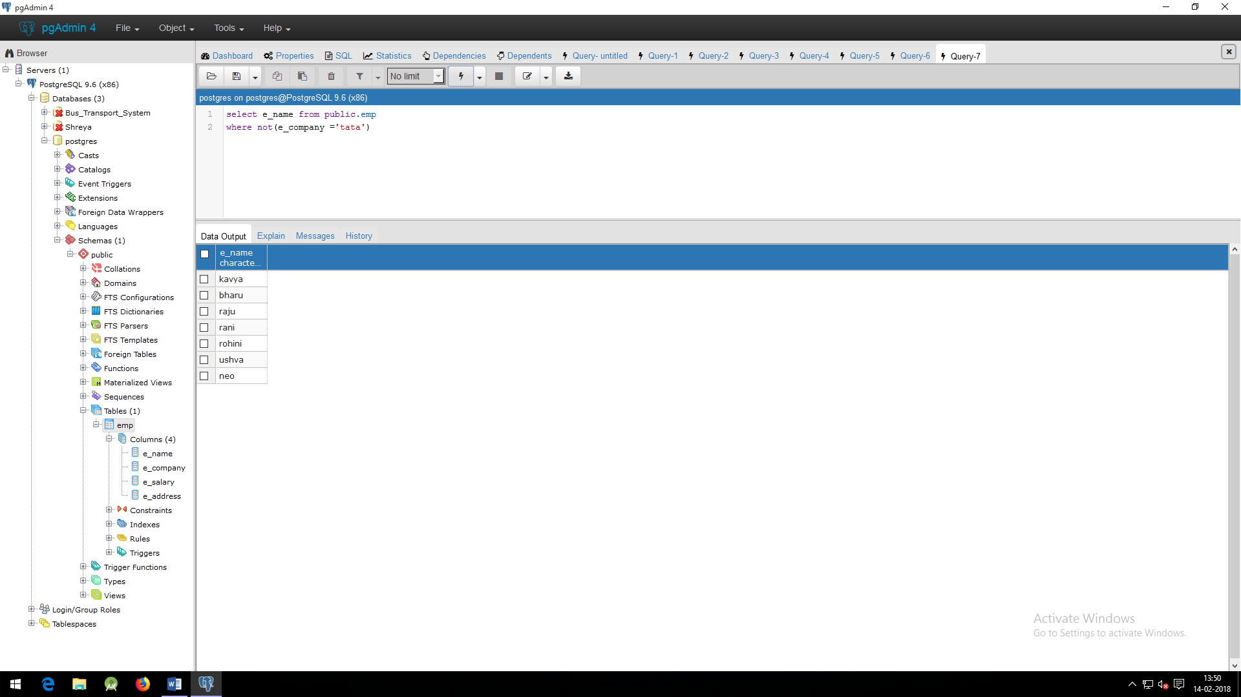

5)the detais of batches having specified batch_name

