**PROJECT**

**Chat Application**

**GROUP: 1**

**Nguyễn Lê Tài Đức**

**Lê Bá Thịnh**

**Tô Cao Kim Ngân**

**Trần Minh Nhựt**

1. **Architecture Diagram**

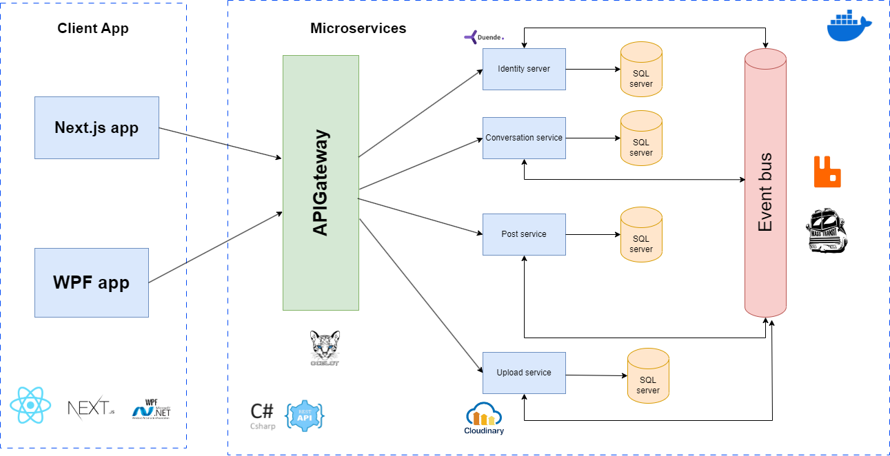

1. **Subsystem Diagram**
   1. **High Level**

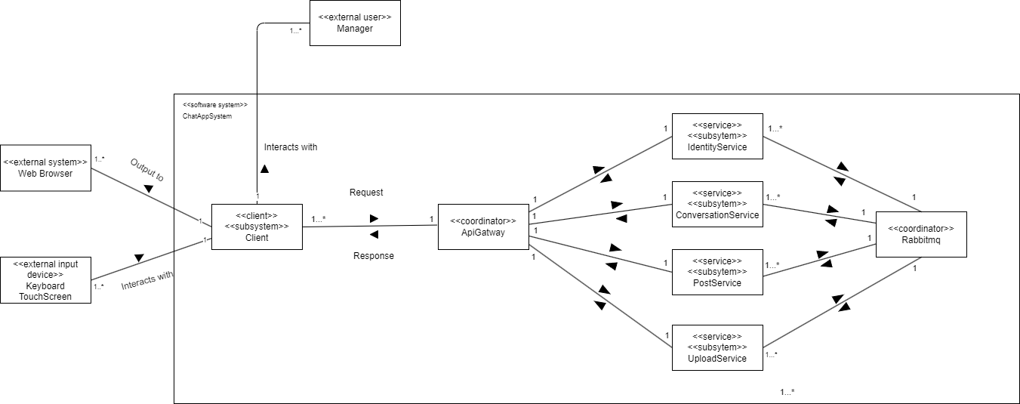

* 1. **Identity**

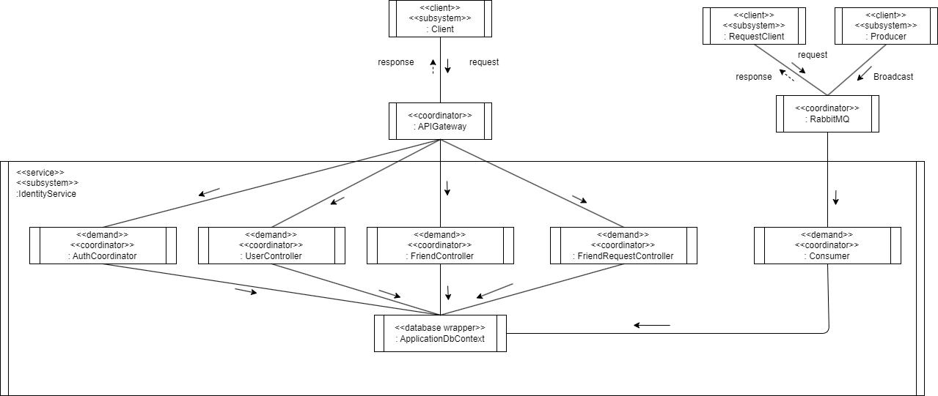

* 1. **Conversation**

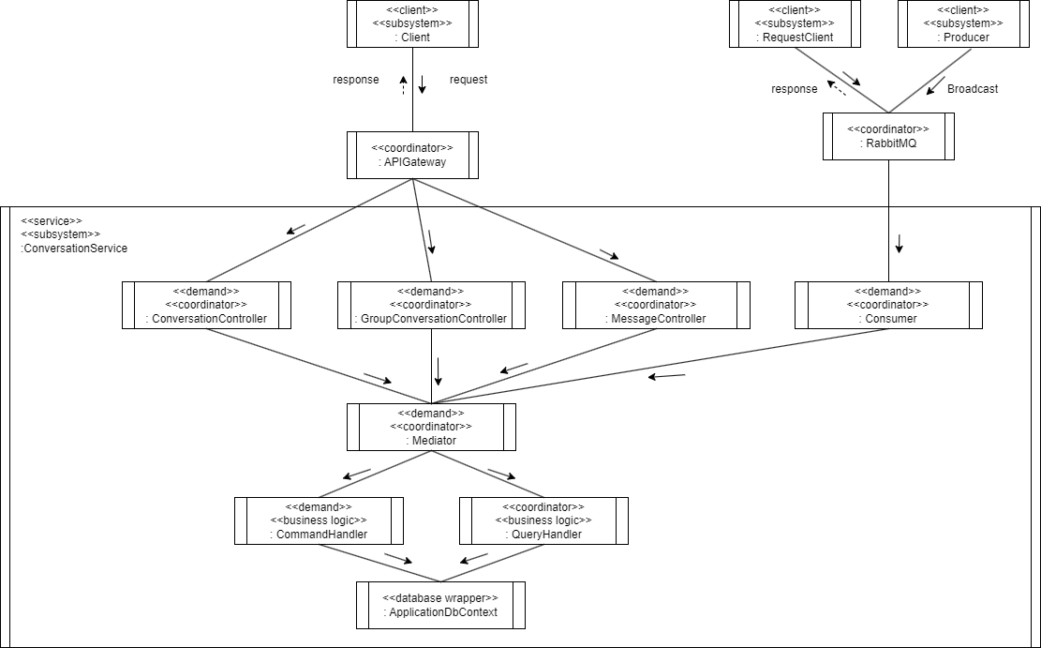

* 1. **Upload**

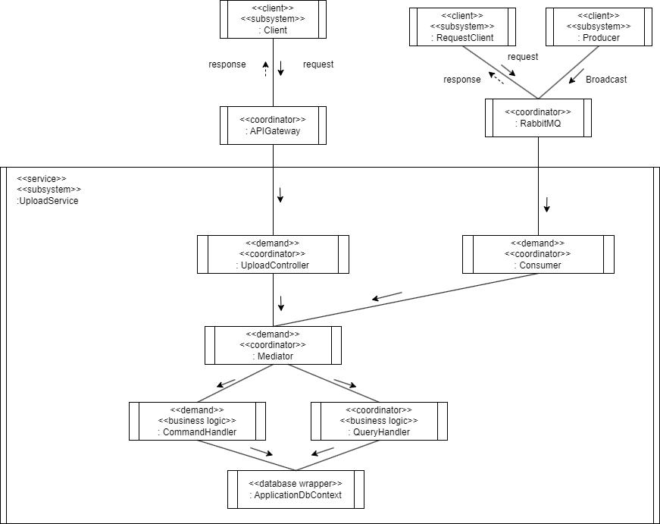

* 1. **Post**

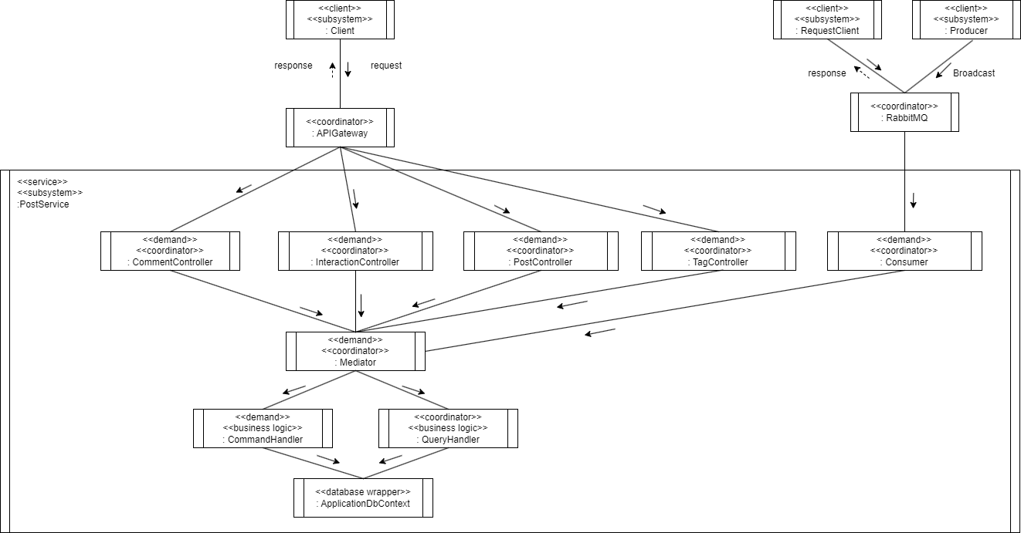

1. **Class Diagram**
   1. **Identity**
      1. **Accept Friend Request**

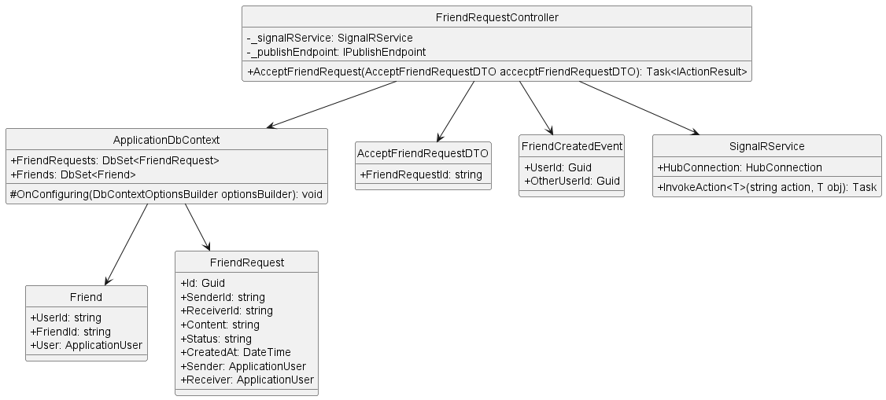

* + 1. **Block User**

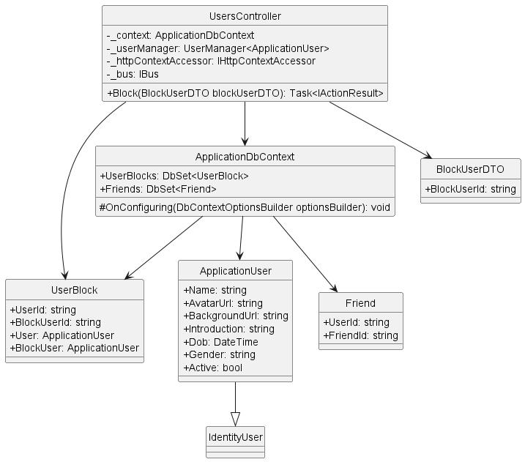

* + 1. **Delete Friend**

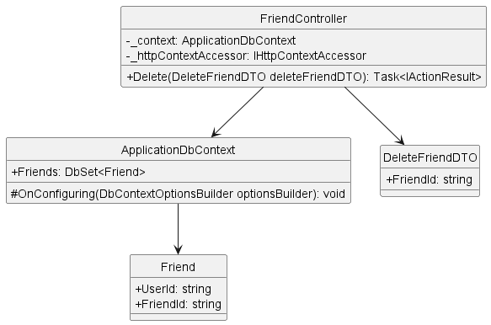

* + 1. **Delete Friend Request**

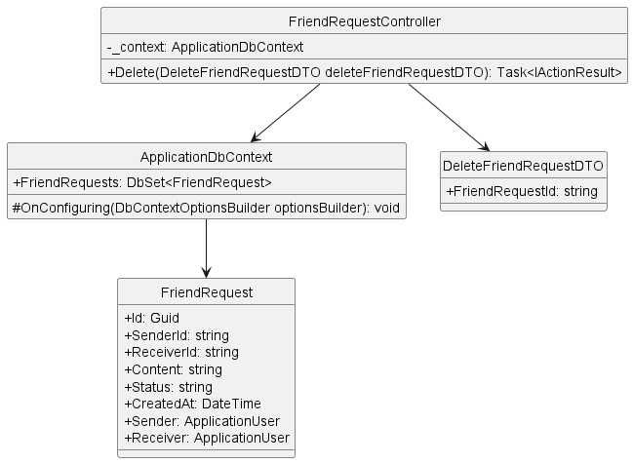

* + 1. **Get Friend List By User Id**

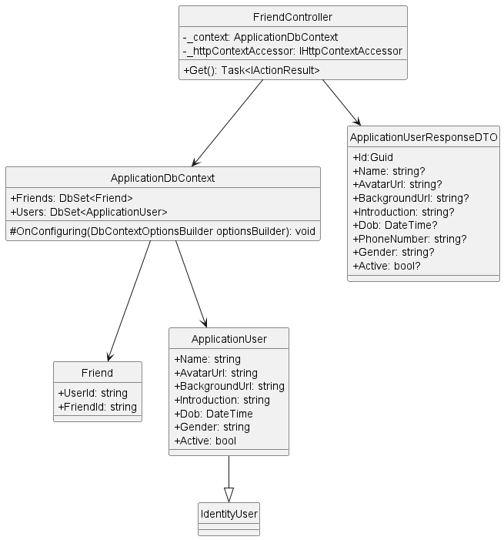

* + 1. **Get Friend Request List**

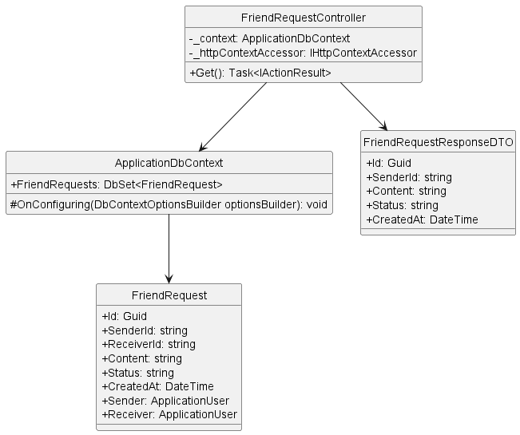

* + 1. **Get User By Id**

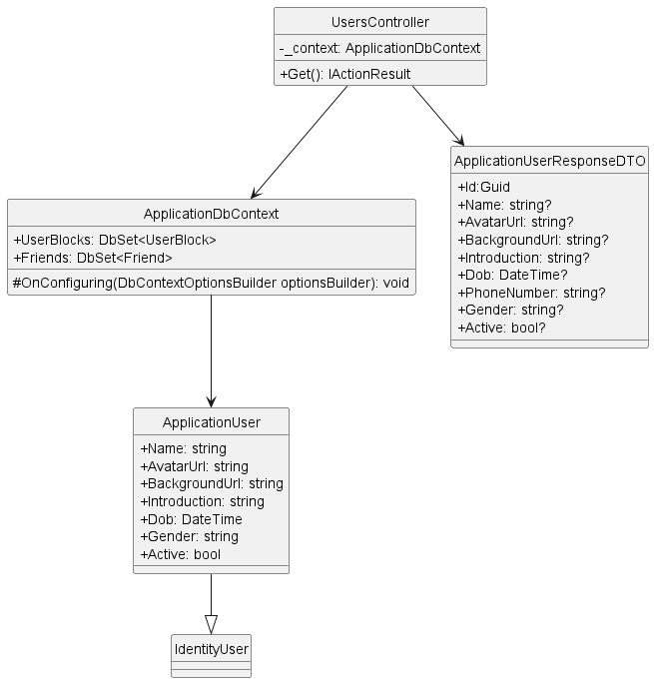

* + 1. **Login**

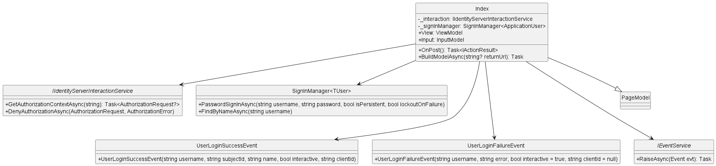

* + 1. **Register**

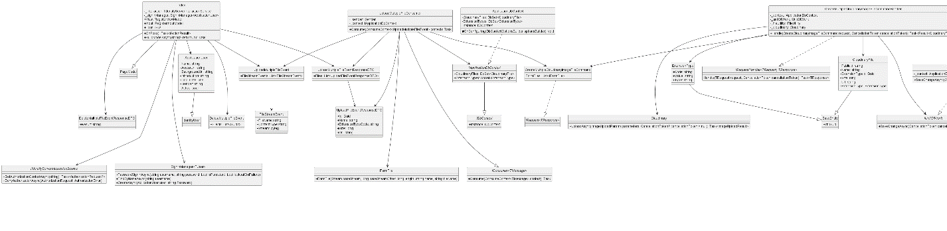

* + 1. **Search User**

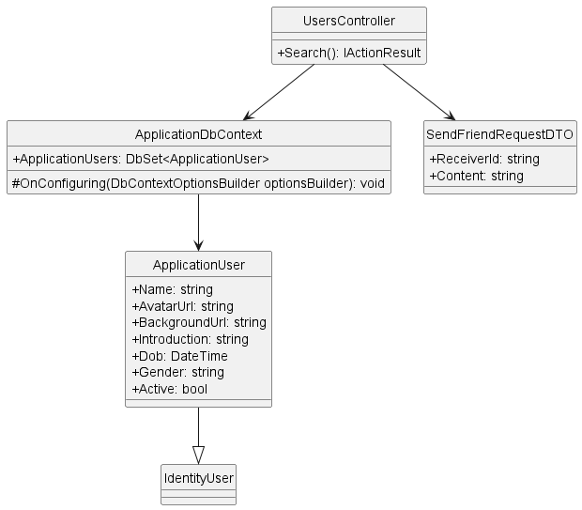

* + 1. **Send Friend Request**

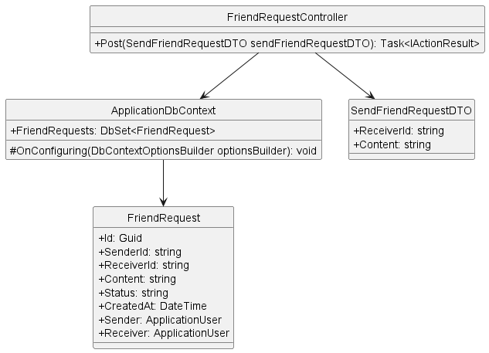

* + 1. **Unblock User**

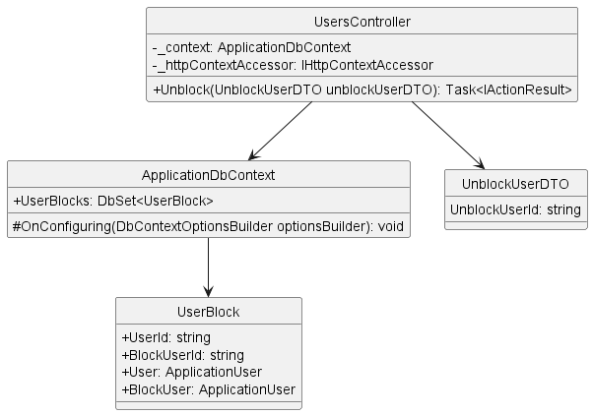

* + 1. **Update User**

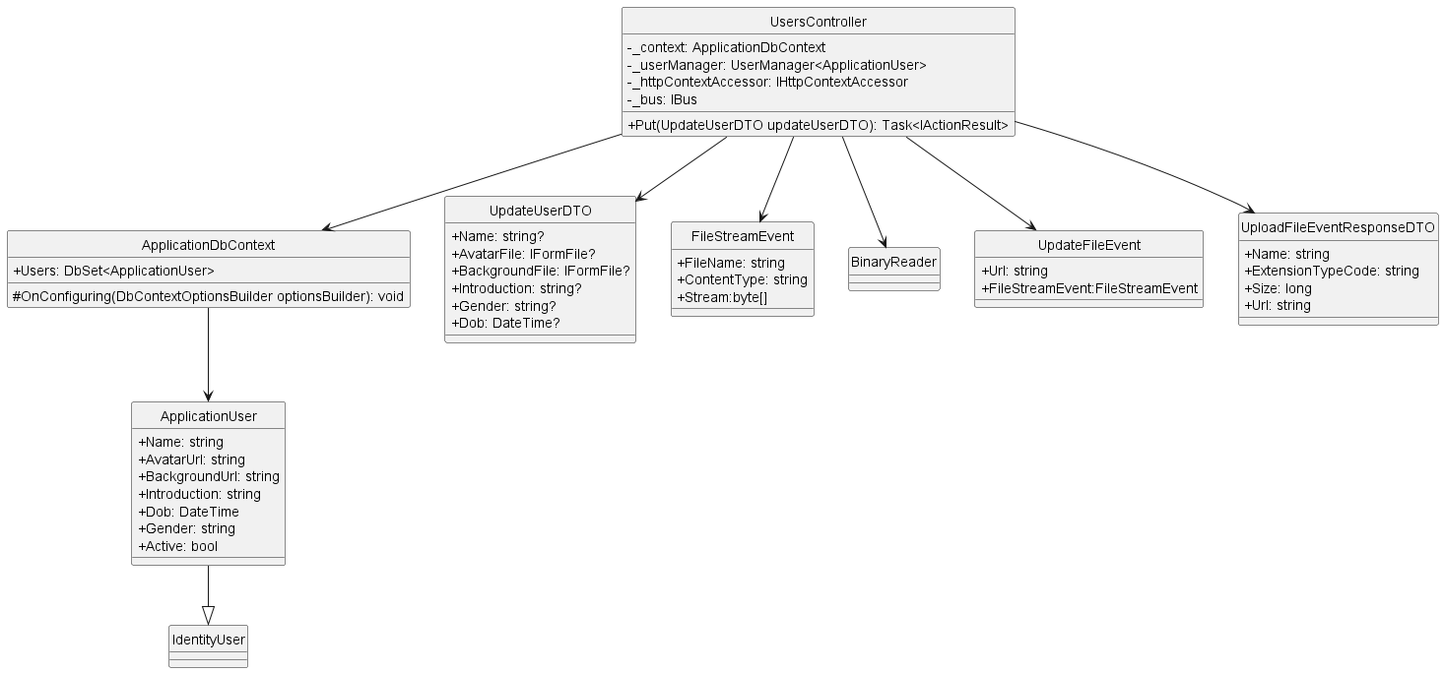

1. **Database diagram**
   1. **File Db**

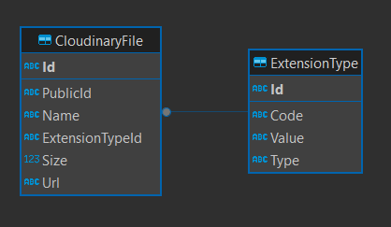

* 1. **IdentityDB**

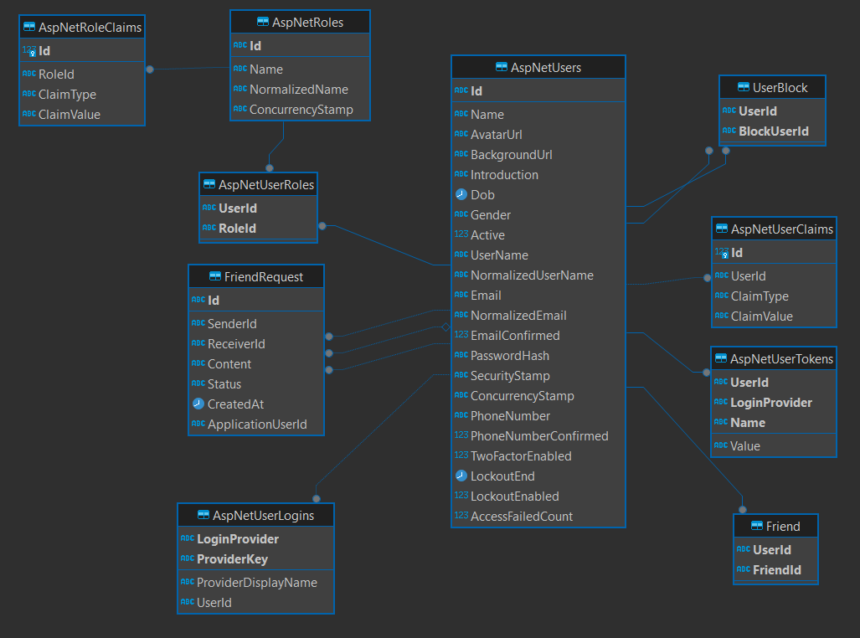

* 1. **MessageDB**

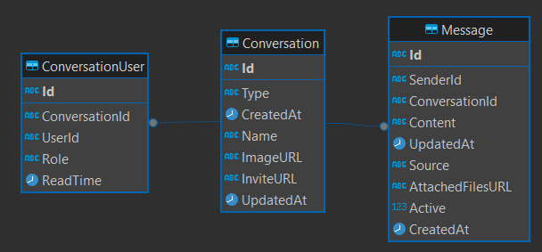

* 1. **PostDB**

