Accesories

Cars

All

Categories

 Profile

Home About Us Contact Us Location

A

Electronics

Art

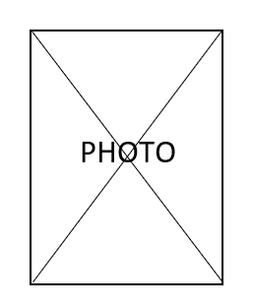

Products

Product Name  
Informations  
Current Price: 12.500$

End At: 2024-06-22 01:00:00

Product Name  
Informations  
Current Price: 7500$

End At: 2024-09-16 12:30:00

Product Name  
Informations  
Current Price: 1000$

End At: 2024-07-10 19:50:00

!!!!!!!!!!!!!!  
Scroll Down   
For More Products

Enter Auction

Enter Auction

Enter Auction

­­­­­

PHOTO

Back

Raise Price

Product Name

Informations

Type : Category

Current Price : 1000$

End Time : 2024-07-10 19:50:00

Total : 1500$