Agent Harness and Investor Architecture
  - System design and decision integrity
The architecture separates durable investment intelligence from the execution machinery that produces it. Domain control determines what a research task may see and do. Canonical state preserves evidence, judgments and outcomes. A replaceable AI harness performs bounded reasoning and tool use within those controls.
This report describes the complete system design: evidence and context, adaptive AI research, harness boundaries, persistent investors, ensemble analysis, decision attribution and evaluated learning. The organizing principle is that investment history and decision authority remain independent of a particular model or runtime.

The model and the harness have different roles
The model produces interpretations, hypotheses and proposed actions from the information presented to it. The harness manages the iterative interaction around the model, including tool requests, temporary context, optional workers and diagnostic traces. Neither owns the durable investment record or determines whether a research conclusion is accepted.

The workflow owns consequential transitions
A workflow sequences evidence preparation, research, validation, review and decision acceptance. A harness can explore within the research stage; domain control determines the conditions for entering and leaving each consequential stage. A completed model turn is a provisional output that remains subject to the research contract.

Persistent identity belongs to an investor
An investor archetype describes an investment mandate. An instance combines that mandate with a particular reasoning configuration and private attributable experience. Specialist workers are task-scoped roles rather than permanent investors. Keeping these lifecycles separate permits reusable analytical expertise without multiplying durable identities unnecessarily.

Evaluation supplies the empirical test
The system preserves exact information sets, version attribution and independent judgments so that research quality, forecast calibration and ensemble contribution can be examined separately. Predictive advantage and effective learning remain empirical questions assessed through controlled comparisons and prospective evidence.

Ownership and information flow
Three logical planes define responsibilities and trust boundaries. They can coexist within one application; their separation is an ownership decision rather than a requirement for a particular deployment or storage technology.
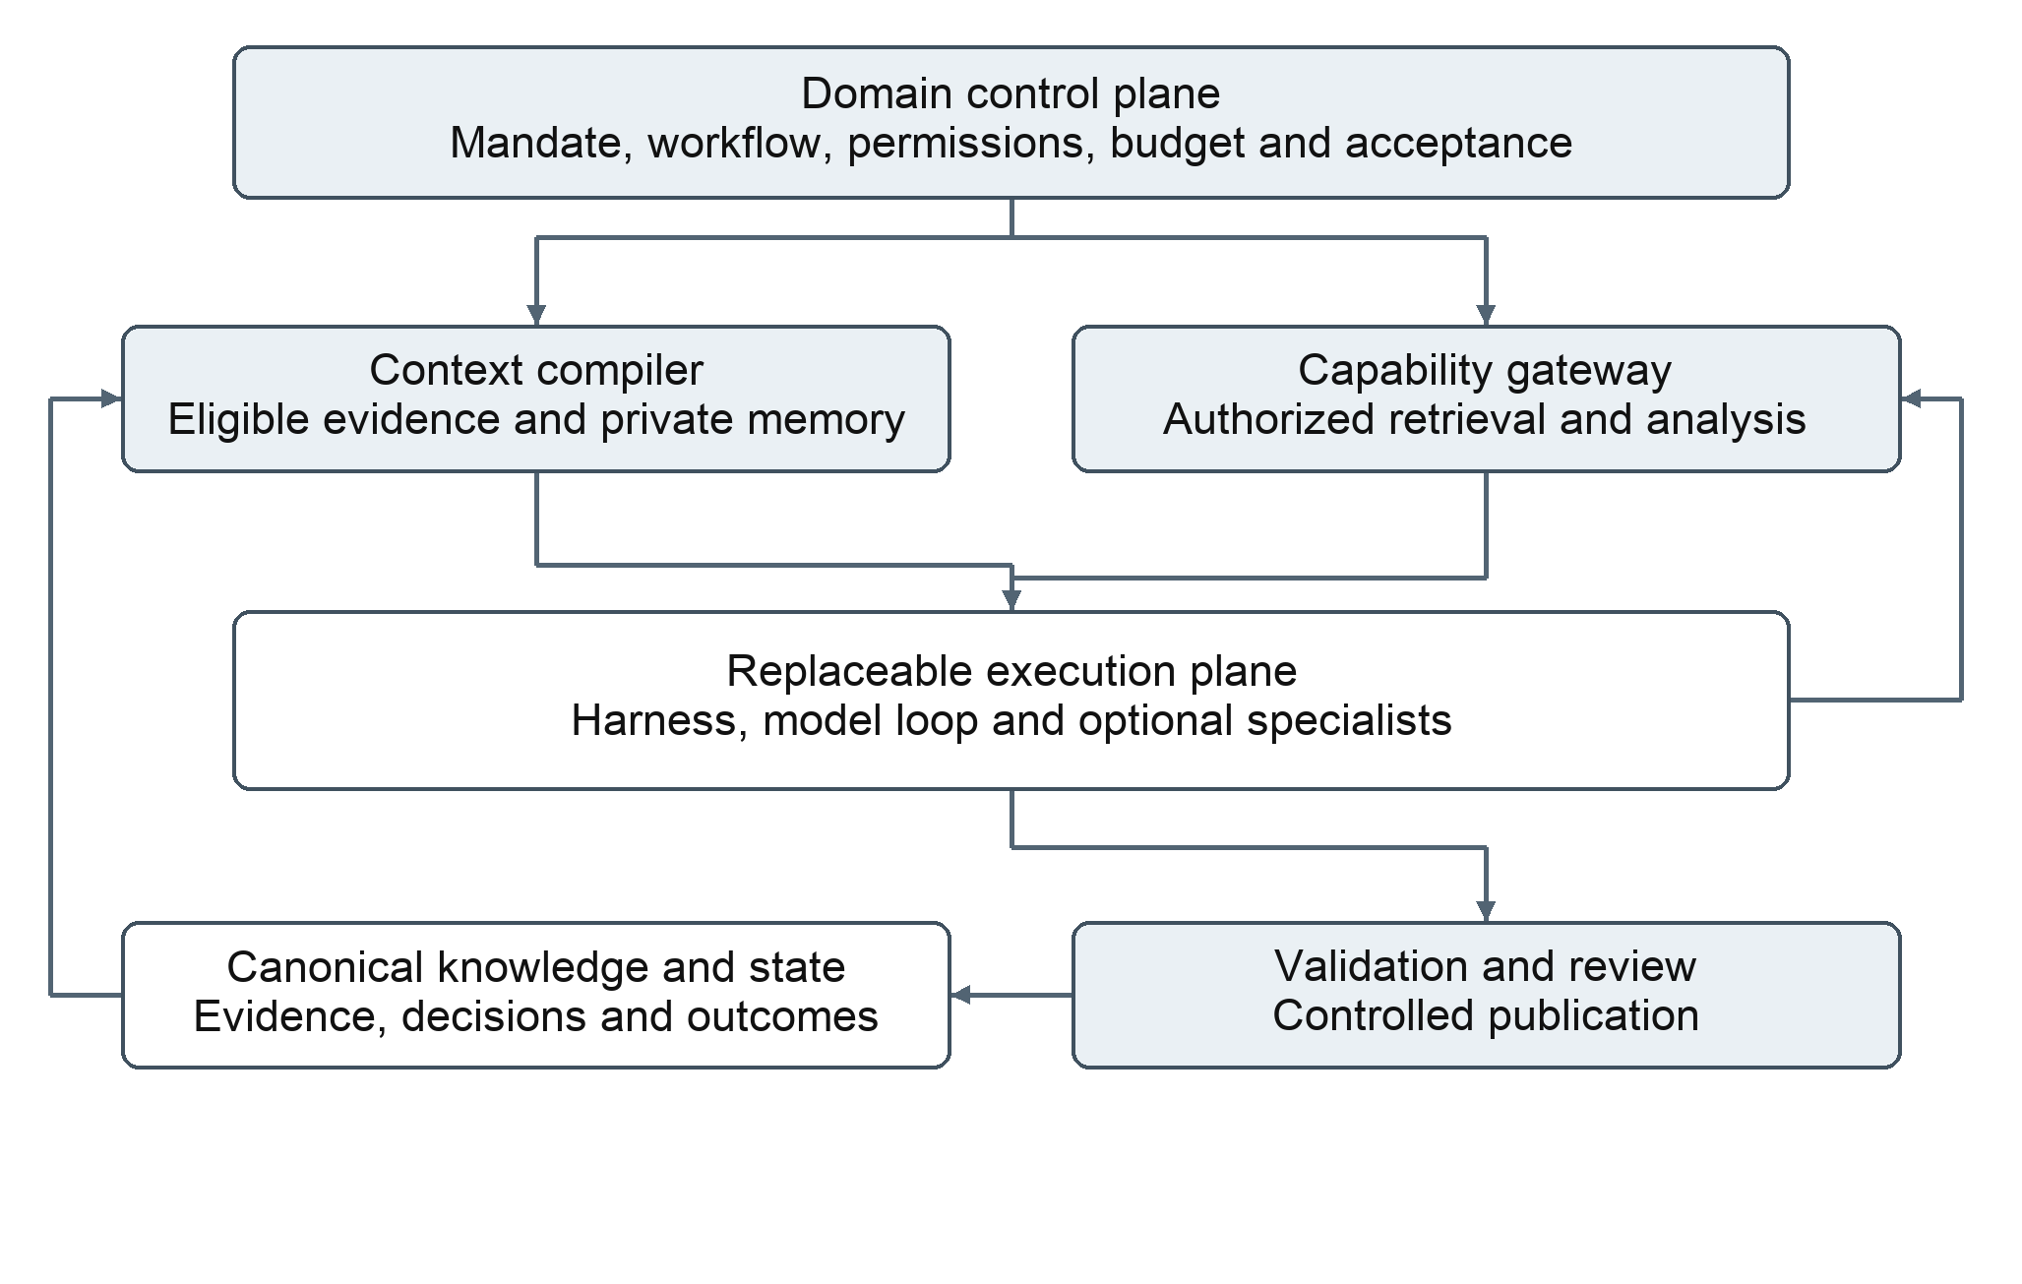
Figure 1 Domain control governs execution while canonical knowledge and state preserve investment continuity
The control plane owns mandates, workflow state, role and investor identity, grants, shared budgets, review policy and decision acceptance. The knowledge plane owns versioned sources, claims, thesis revisions, decisions, outcomes and approved procedures. The execution plane owns model interactions and temporary session state.
The context compiler and capability gateway mediate information and actions. Accepted outputs reach canonical state through controlled publication. Native traces remain linked diagnostic artifacts; they do not become a second system of record.

Evidence provenance and compiled context

Research records form a connected lineage
Original sources retain stable identity, content version, provenance, rights and passage locators. Observations refer to those sources; calculations refer to their inputs, units and definitions. Claims distinguish source statements, computed values, assumptions and investment inference. A thesis connects claims to scenarios, catalysts, valuation, risks and falsification conditions.
Corrections create new vintages and identify dependent claims for review. The original source and the thesis based on it remain inspectable. Content hashes support consistency checks and lineage; access controls and protected audit retention establish the separate boundary for authorized changes.

Temporal eligibility precedes relevance
Event time, public availability, system capture and decision time are distinct. Historical information replay asks what was publicly available at a cutoff. Operational replay asks what this system had actually captured and admitted. A source may satisfy one mode and fail the other. Outcome labels and lessons created later cannot enter an earlier operational information set.

The compiler creates an attributable projection
For an admitted task, the compiler resolves the mandate, cutoff, permitted sources, investor namespace and relevant portfolio state. It filters eligibility before ranking evidence, selects a bounded initial context, and records retrievable references, omissions and coverage gaps. The projection is a derived artifact; it does not alter the original records.
References allow an agent to request specific evidence rather than repeatedly carrying entire documents or histories. Hydrated content still consumes context capacity and may be transferred to a model provider. Each exposed fragment and its version remain attributable to the run, including detail returned during tool use.

Independence is enforced through access
A peer opinion, private investor lesson or future outcome is excluded by the compiler and by retrieval services when the task forbids it. Instructions alone do not enforce isolation. Additional research must meet the same cutoff and access policy; a changed information set creates an explicit version rather than silently extending the original comparison.
Context adequacy is evaluated through evidence coverage and reviewed research cases. A smaller context is useful only when it preserves the material needed to reason correctly. Missing required evidence is an explicit condition for further work, qualification or abstention.

Adaptive AI research
The research lead uses an admitted information set to form hypotheses, identify decisive uncertainties and request evidence or analytical assistance. Financial arithmetic remains deterministic. Interpretation and hypothesis revision remain attributable to the AI research process.
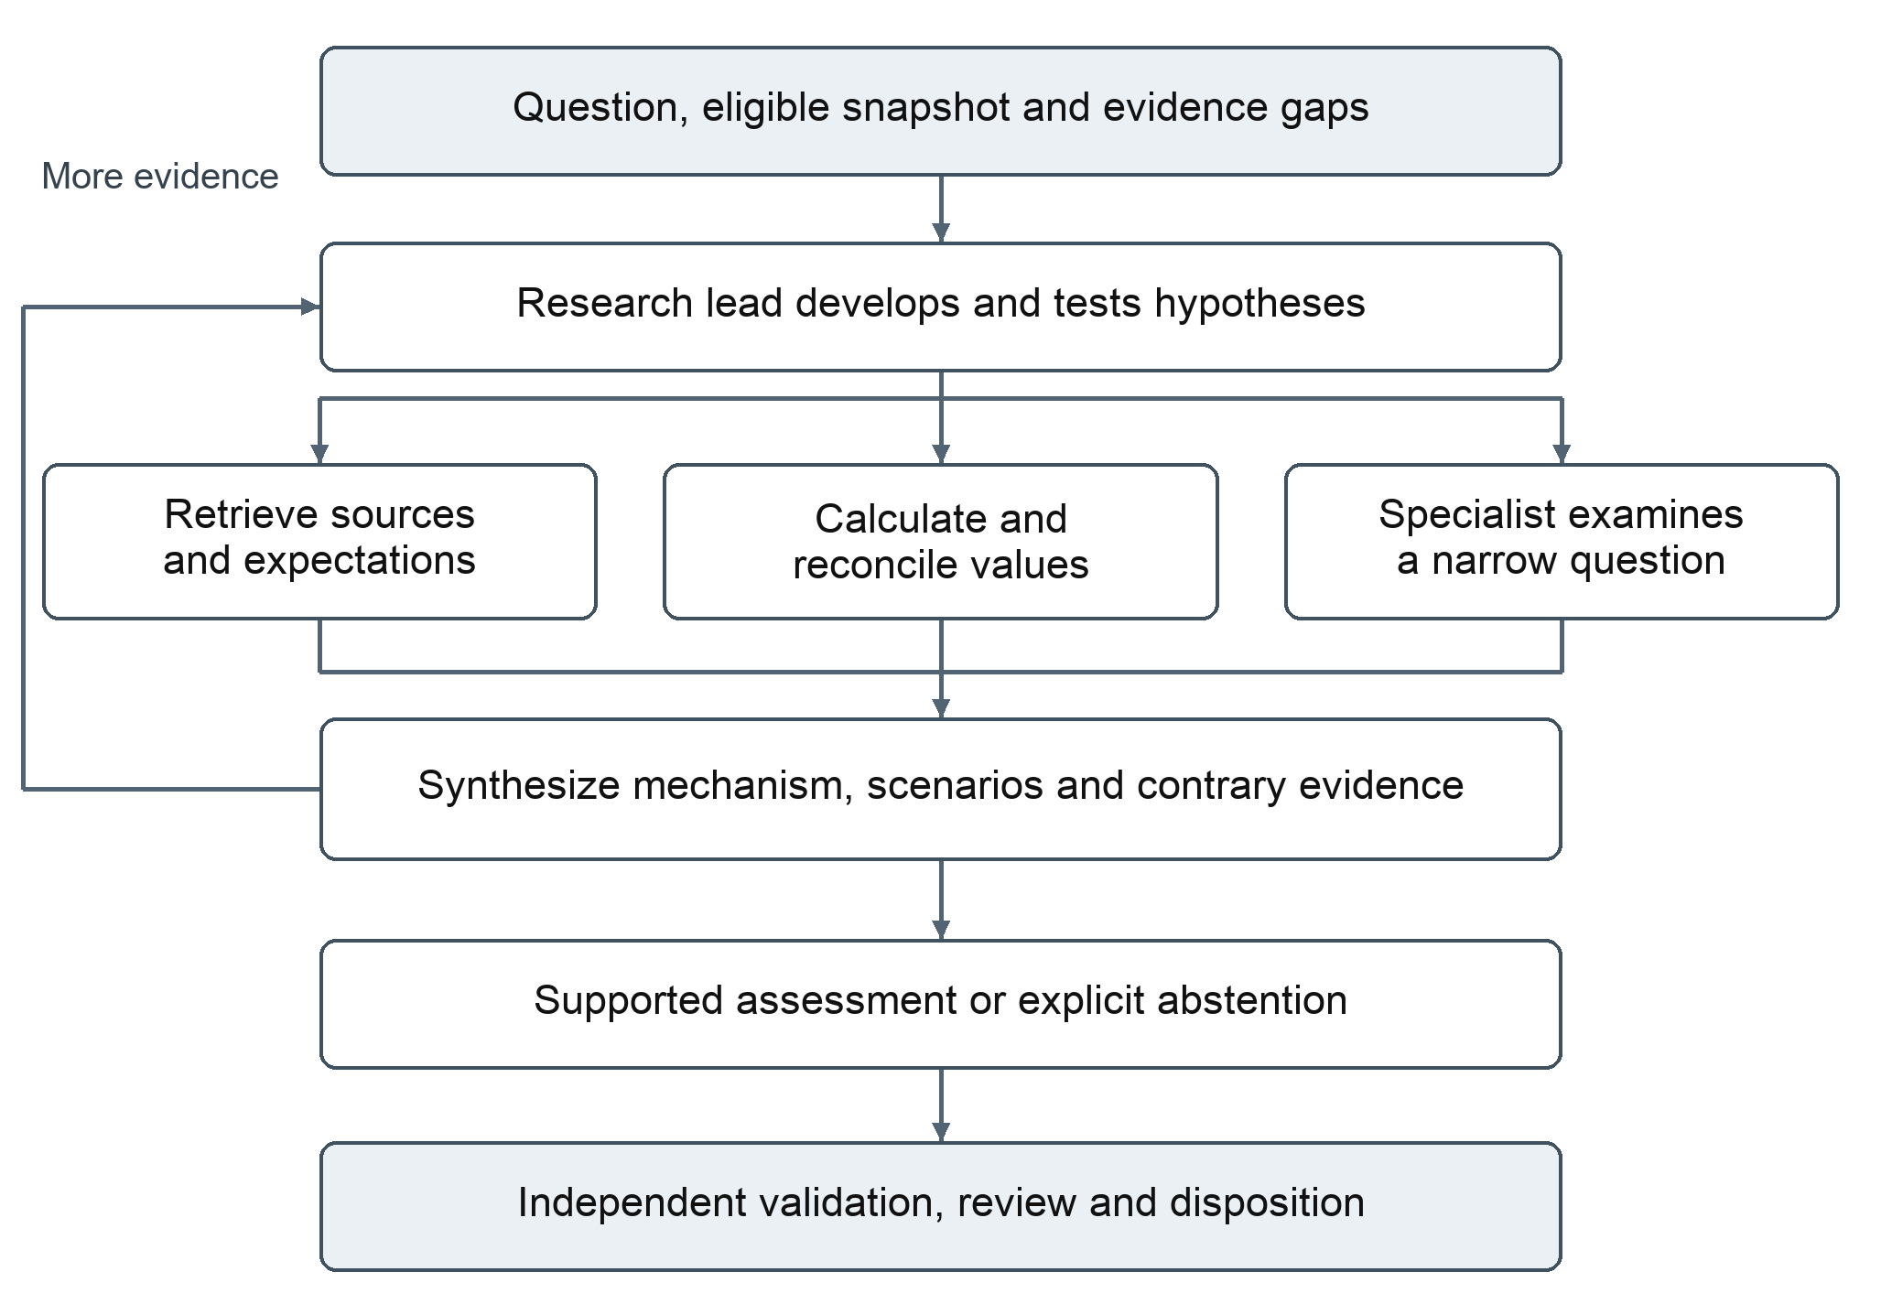
Figure 2 The lead alternates research and synthesis before submitting a supported assessment or abstention for review
Workers answer a narrow question under a subset of the parent permissions and the same total budget. Their findings carry evidence references and limitations. The lead integrates them with contrary evidence and retains responsibility for the resulting argument.
The output states the mechanism, comparison with verified expectations, scenarios, confidence and falsifiers. Independent review tests entailment and decision usefulness alongside deterministic checks. Revisions retain earlier findings, while unresolved contradictions and insufficient support remain visible.

The harness execution boundary
A small execution boundary carries the task, context manifest, permitted capabilities, shared budget and output contract into a compatible harness. It returns provisional structured results and consequential events without requiring all runtimes to share the same internal session mechanics.
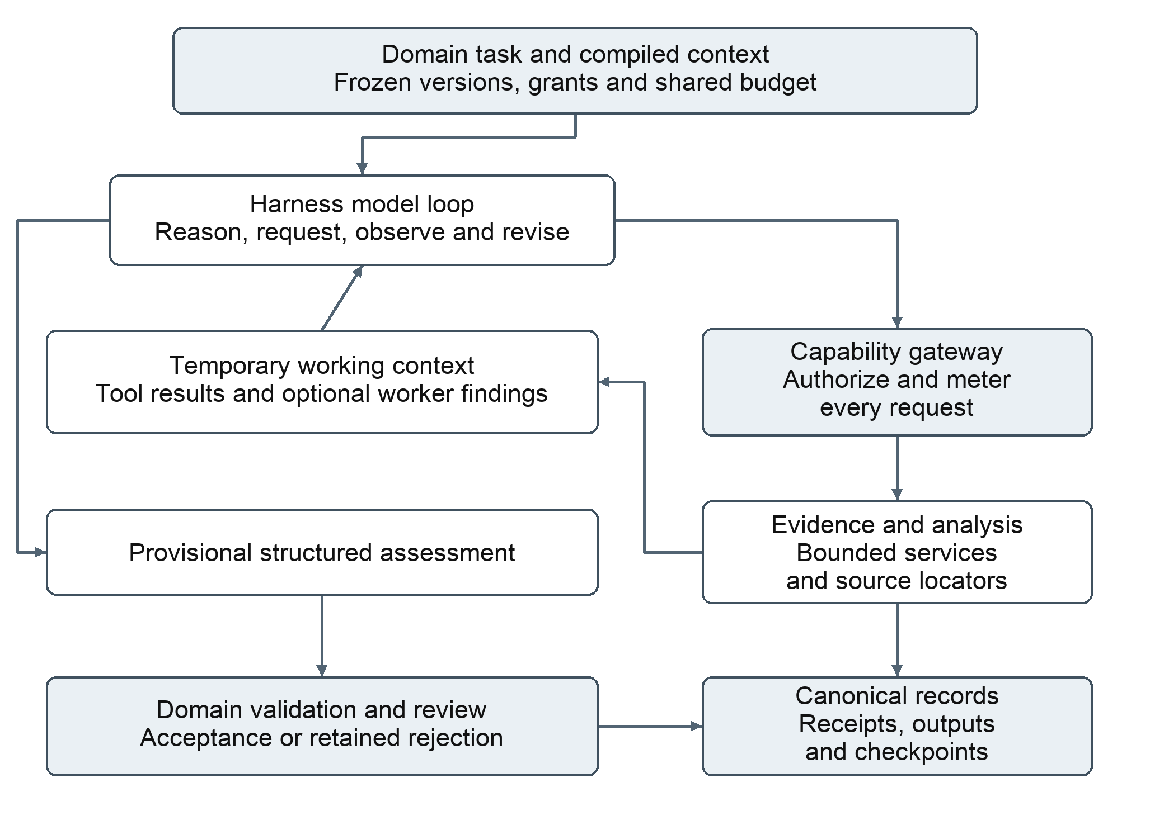
Figure 3 Harness reasoning and tool use operate within domain permissions and return candidates for controlled acceptance
The gateway checks the actor, scope, temporal eligibility, arguments and resources before each tool operation. Explicit denials and service failures return as such. Source text, model output and worker messages cannot modify grants. Credentials and canonical write authority remain outside model-readable working context.
Runtime capability declarations govern task eligibility, including structured output, tool use, cancellation and usage accounting. Model choice is a task policy. A supported connection does not establish that a model can perform the required reasoning or tool behavior reliably.

Durable workflow and resource control

Canonical stages provide continuity
The platform persists task admission, stage state, attempt intent, operation identity, receipts and verified output references. After interruption, it reuses completed artifacts and reconstructs the next authorized stage. A new harness session receives the task-specific projection and open questions needed to continue.
Timeout and cancellation do not prove that an external operation failed. An uncertain result remains unresolved until reconciled. Stable operation identities prevent repeat work from silently becoming duplicate effects, and late worker results must satisfy current publication authority before acceptance.

One budget covers the complete research task
Lead work, workers, retries, repair attempts and internal model calls draw from shared ceilings for calls, tokens, spending, tool reads and active execution. Capacity is reserved before dispatch and reconciled with observed usage. Unknown usage remains explicit and is treated conservatively.
Human review is a durable workflow pause. Waiting for a decision does not require a live model session or grant a fresh research allowance. A resumed task preserves its original mandate and remaining permissions unless domain control authorizes an explicit change.

Records distinguish research from runtime diagnostics
Canonical events capture information exposure, analytical outputs, review dispositions, budget effects and accepted transitions. Native traces aid diagnosis and may include sensitive source content. Trace collection and transfer follow the same access and data policies as the evidence they contain.

Version attribution makes comparisons interpretable
Each consequential decision links to its archetype and investor identity, model and harness policy, context compiler, procedures, tool definitions, risk policy and exact input versions. Where a provider does not expose an immutable model version, the recorded identity includes the available metadata and that limitation.
A change of model or harness creates an explicit version transition. Evaluation compares research quality, tool reliability, resource use and relevant outcomes under controlled information sets. The canonical record carries continuity; the new runtime does not need to import proprietary conversation internals.

Investor identity and memory
An archetype defines objective, universe, horizon, analytical process and constraints. An instance binds an archetype version to a model, harness and context policy and maintains an attributable history. The mandate remains stable while evaluated statistical beliefs and approved lessons evolve.
Memory layer | Contents | Use in research
Identity | Mandate, horizon, process and constraints. | Establishes the decision objective and permitted approach.
Episodes | Source-linked research cases, decisions and post-mortems. | Supplies eligible examples with their original information sets.
Statistics | Computed calibration, payoff patterns, costs and performance. | Provides relevant empirical summaries with sample size and uncertainty.
Approved lessons | Versioned lessons and procedure changes with evaluation evidence. | Changes subsequent behavior within an explicit scope.

Shared facts and private experience have different scopes
Corrected sources, verified calculation fixes and general analytical procedures can be shared. Investor preferences, private decision episodes and empirically learned heuristics remain private by default. An ensemble can alter its weighting of an investor without copying that investor's behavior into every peer.

Controlled comparisons separate sources of diversity
Replica comparisons hold the mandate, information set and starting portfolio constant while varying model, harness or context policy. Persistent-individual comparisons retain separate histories so that the effects of accumulated experience can be studied. These modes carry different cohort definitions and are evaluated accordingly.
Several simultaneous changes make attribution difficult. Comparisons therefore identify the dimension being varied, preserve policy versions and report uncertainty. Different names, personas or providers alone do not establish independent reasoning or useful diversification.

Memory remains selective and time aware
The full history stays in canonical storage. The compiler retrieves relevant episodes, applicable lessons and statistical summaries for a particular task, subject to cutoff and privacy. Small samples, overlapping events and changing regimes qualify the interpretation of every empirical lesson.

Ensemble analysis and debate
Investors receive a common eligible snapshot and their own permitted history. The platform freezes independent judgments before exposing peer conclusions. Debate focuses on material disagreements, with initial and final views retained for separate evaluation.
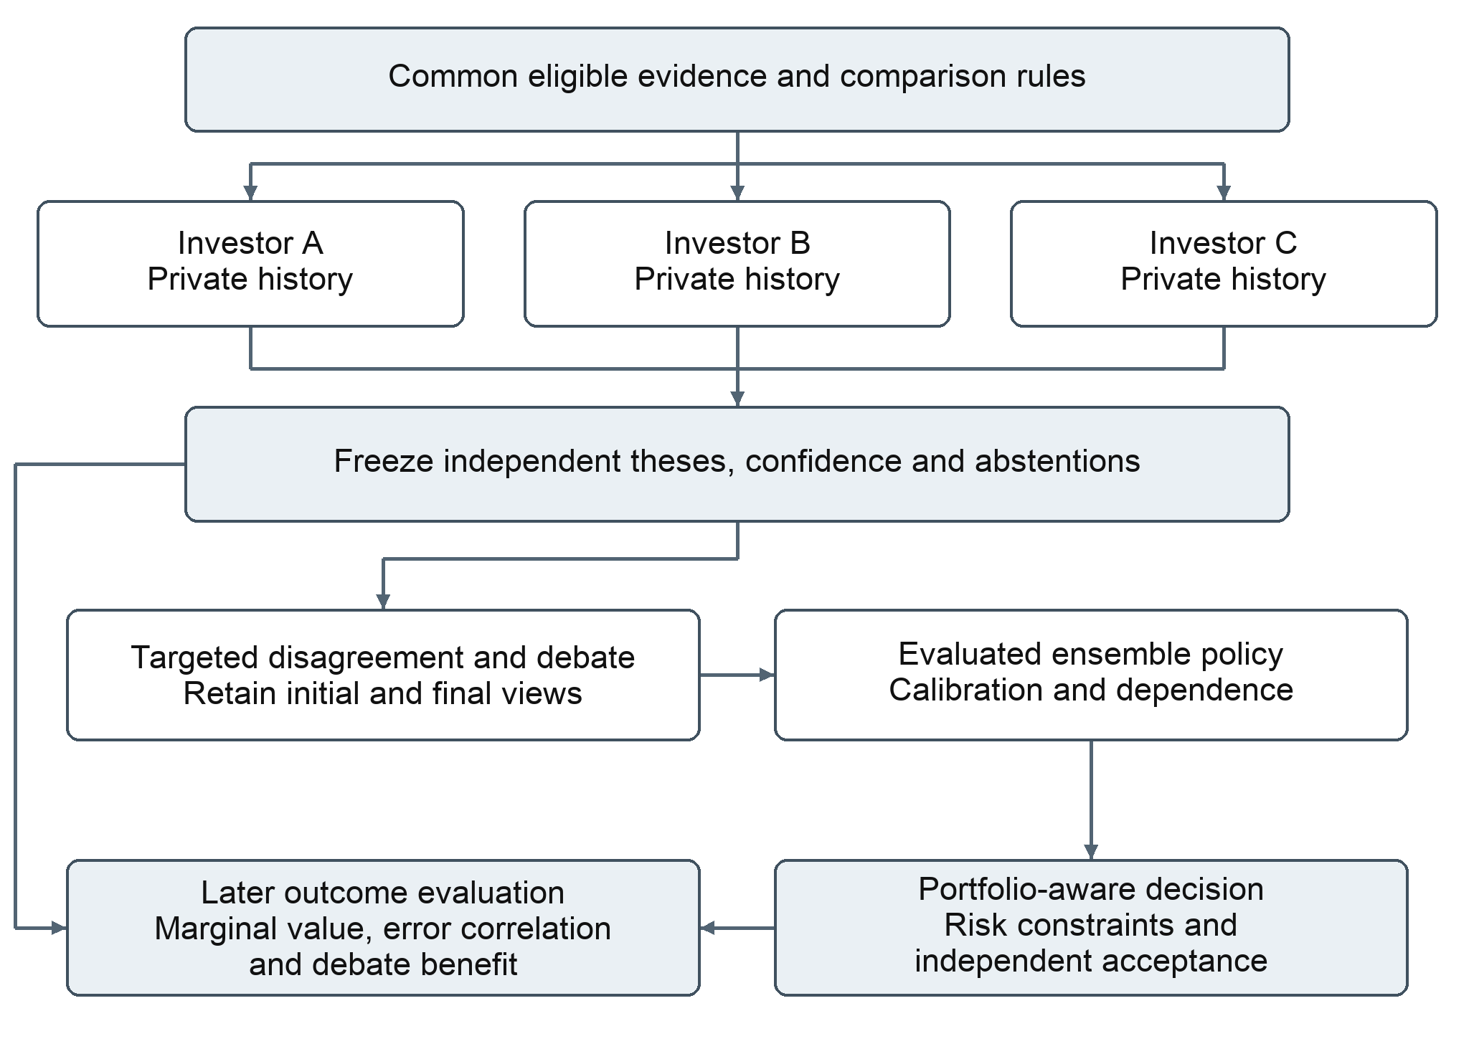
Figure 4 Independent commitment precedes debate and aggregation while later outcomes measure marginal contribution
The ensemble policy considers calibrated confidence, conditional performance, evidence quality and dependence between errors. Estimates use explicit uncertainty and constrained adjustments rather than rewarding recent winners automatically. Portfolio risk and independent acceptance govern the resulting recommendation.
Evaluation compares the ensemble with lead-only and individual-investor baselines. It measures marginal information, error correlation, coverage, debate benefit and total research cost. Weighting changes enter subsequent decisions only after controlled evaluation; private lessons remain scoped to the relevant investor.

Decision attribution and evaluation

Decision execution and outcome remain separate
The decision record freezes the original belief, action, horizon, confidence, scenarios, reference information and thesis lineage. Execution records describe paper orders, fills, costs and deviations from the recommendation. Position snapshots establish holdings, cash and exposures at a known time. Outcome records link observed results to the decision and the relevant benchmark or target.
These separations distinguish thesis realization, forecast accuracy and portfolio effects. A correct mechanism can coexist with a loss caused by timing or sizing; a profitable position can coexist with an unsupported thesis. Post-mortems append interpretations without rewriting the original argument.

Portfolio constraints apply outside the narrative
Recommendations account for concentration, correlated exposures, liquidity, opportunity cost and transaction costs. External policy checks enforce portfolio constraints even when the agent argues for a different action. The research system generates and evaluates recommendations and paper portfolios; live brokerage execution is outside its scope.

Evaluation operates at distinct levels
Level | What it establishes
Deterministic validation | Resolvable references, arithmetic, units, timing, output structure, permissions and reconciled records.
Semantic review | Whether sources support claims, assumptions are defensible, contradictions are addressed and the argument is decision-useful.
Forecast evaluation | Accuracy and calibration at a declared horizon, with abstentions, original confidence and target definitions retained.
Portfolio evaluation | Cost-aware relative performance, exposure, drawdown and attribution to selection, timing, sizing and execution.
Ensemble evaluation | Marginal contribution, dependence, benefit of debate and quality relative to resource and review cost.

Counterfactual actions are diagnostic comparisons under declared assumptions. They do not establish that an ex-post optimal action was knowable. Historical replay also cannot remove future knowledge embedded in model training; prospective cohorts supply a separate test. Paper results retain their liquidity, cost and market assumptions.

Controlled learning and policy evolution
The learning loop combines deterministic analysis with model interpretation. Statistics describe attributable experience; a model proposes a lesson or policy change. Evidence and a predeclared evaluation determine whether that candidate affects subsequent research.
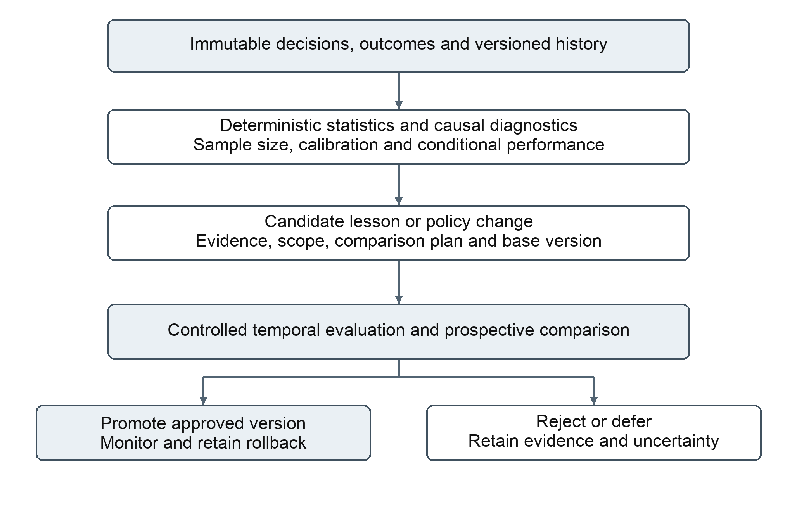
Figure 5 Lessons become approved versions only after controlled evaluation and remain reversible
Candidates identify the affected investor or shared procedure, base version, supporting cases, uncertainty, expected benefit and comparison plan. Evaluation considers independent observations, temporal holdouts, regime sensitivity, multiple trials and costs. Promotion preserves lineage and a rollback path; rejection and deferral retain the evidence.
Approved lessons cannot expand permissions or revise past judgments. Ensemble policies evolve without erasing investor individuality. The final architecture connects reusable research, independent perspectives and measured experience through one durable record, while empirical results determine which changes deserve continued use.

