Investment Research Agent System Business Report
  - Product rationale and research value
The Investment Research Agent System is designed to make AI-assisted investment research inspectable, cumulative and measurable. It connects original evidence to analytical claims, contemporaneous decisions and subsequent outcomes, while preserving the information and reasoning behind each judgment.
The product serves analysts, portfolio decision makers and research teams who need to scrutinize an argument, compare independent views and learn from experience. Its central design separates durable investment knowledge from the model or agent harness performing the research. The research record remains useful as execution technology changes.

The problem the system addresses
A research conclusion depends on several different questions: what happened, what was expected, why the difference matters, how it affects value, and what could invalidate the view. Those questions span filings, transcripts, market observations, financial calculations and prior decisions. When these inputs remain disconnected, a fluent answer can obscure a weak assumption, an outdated source or an unresolved contradiction.
The system organizes each investigation as a connected case. A reader can trace a material claim to its evidence, inspect the calculation supporting it, identify the opposing case and understand the conditions under which the thesis should change. Missing evidence and abstentions remain part of the record.

Where durable value accumulates
The accumulated asset is a versioned body of research: source history, analytical procedures, accepted and rejected judgments, reviewer findings, investor-specific experience and evaluated lessons. Repeated use provides material for testing which methods and perspectives contribute useful information. The value proposition depends on better research and decision processes, measured against simpler alternatives and the effort required to review them.
Predictive advantage, ensemble benefit and learning effectiveness are hypotheses evaluated through controlled comparisons and prospective outcomes. A coherent architecture makes these questions testable; it does not establish their answers.

The complete research lifecycle
Each case begins with a defined question, investment horizon and information cutoff. The system assembles eligible sources and expectations, performs source-linked calculations, and gives the research lead a bounded information set. The lead tests hypotheses and requests targeted assistance where needed.
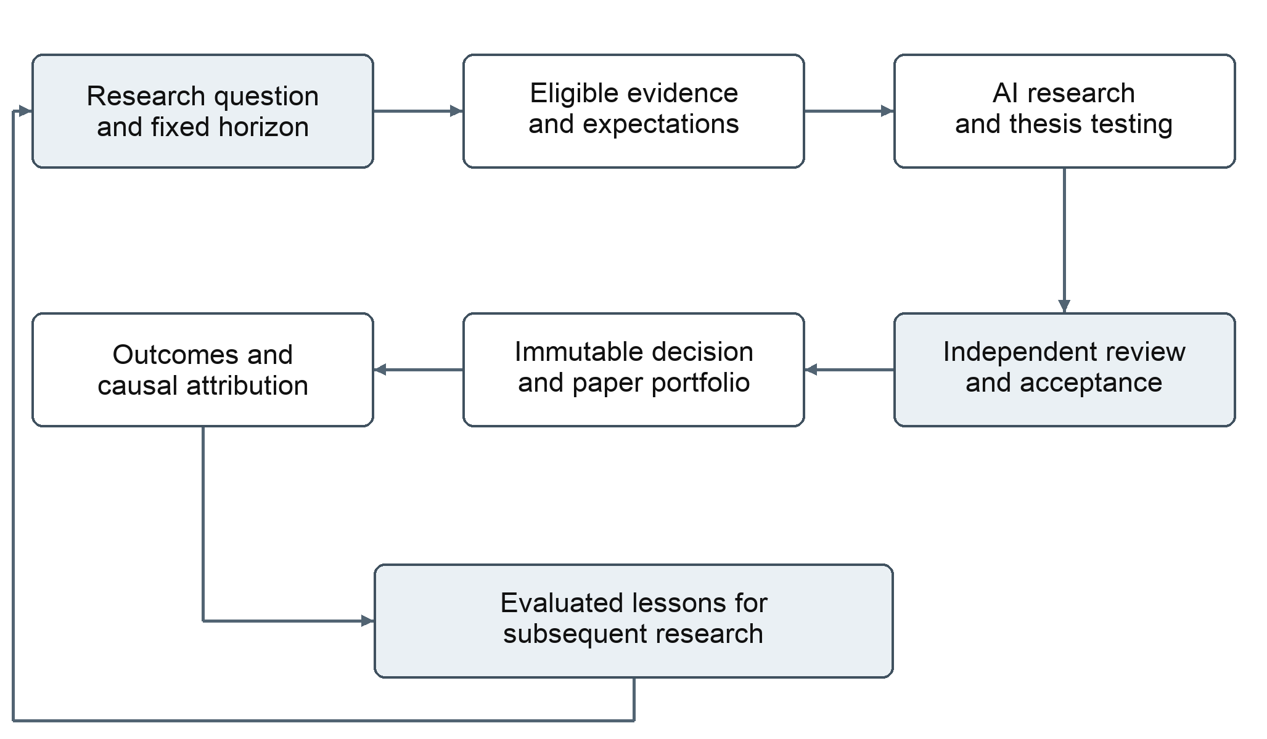
Figure 1 The research lifecycle preserves evidence and decisions while feeding evaluated lessons into subsequent work
The resulting assessment states the economic mechanism, scenarios, confidence, contrary evidence and falsification conditions. Independent review examines both traceability and whether the evidence actually supports the reasoning. Acceptance freezes the decision and its lineage; revision, rejection and abstention are retained alongside accepted work.
Paper-portfolio evaluation connects decisions to holdings, costs and later outcomes. Outcomes append to the original record. They do not replace the contemporaneous argument, which remains the basis for judging what was reasonable given the information available.

Architecture as a product decision
The platform owns the research mandate, workflow, permissions, resource budget and decision acceptance. It also owns the canonical evidence and decision history. A replaceable harness supplies model interaction, iterative tool use and temporary working context within an admitted task.

Information selection is governed centrally
The context compiler selects evidence and investor memory according to the task, cutoff and access rules. It provides the material required for reasoning, references to further eligible detail, and explicit coverage gaps. This supports consistent historical comparisons and prevents one investor from seeing another investor's opinion before independent judgment.

Capabilities have explicit boundaries
The capability gateway exposes bounded evidence retrieval and analytical services. It checks authorization and resources for each request. Deterministic services handle financial arithmetic and reconciliation, while the AI performs hypothesis formation, interpretation and synthesis. Review and publication authority remain with the domain workflow.

Delegation must add research value
A single research lead is the default unit of analysis. Specialists address a concrete accounting issue, disputed source interpretation or other narrow uncertainty. Their outputs remain attributable and their resources count against the shared research budget. Their contribution is assessed through research quality, evidence coverage, cost and reviewer effort.

Continuity survives a change of execution engine
Evidence, accepted artifacts, open questions and workflow stages persist outside native agent sessions. A case can continue in a new session from verified records. This protects institutional research continuity and permits comparison of models and harnesses without making their temporary conversation formats the investment system of record.
These boundaries also clarify accountability. A model can propose a conclusion or request additional research; the platform controls eligible information, admissible actions and acceptance. Greater autonomy inside a task does not confer broader decision authority.

Persistent investors and independent perspectives
An investor archetype defines philosophy, objective, horizon and constraints. An investor instance binds that mandate to a model, harness and context policy, together with an attributable private history. The same philosophy can therefore be expressed by several independently evaluated investors.

Experience has a defined structure
Investor memory separates stable identity, source-linked research episodes, deterministically computed statistics and approved lessons. The system retrieves relevant experience with its sample size, uncertainty and applicability. Shared factual corrections can benefit every investor, while investor-specific preferences and empirical lessons remain private by default.

Ensembles preserve independence before debate
Investors first form judgments against a common eligible evidence snapshot without access to peer opinions. Initial theses, confidence and abstentions are frozen before material disagreements are exposed. Targeted debate permits additional research and revised judgments, with both the initial and final views retained.
The ensemble evaluates calibration, conditional performance and dependence between opinions. Adding an investor must improve information quality or portfolio contribution relative to its cost. Distinct styles and models provide experimental dimensions; their independence and usefulness must be measured.

Learning is evaluated before it changes behavior
Outcome analysis produces candidate lessons, changes to research procedures and proposed ensemble policies. Each candidate has supporting evidence, a defined scope and an evaluation plan. Promotion creates an attributable version for subsequent decisions, with monitoring and a rollback path. Recent profits or a persuasive post-mortem cannot alone establish a durable lesson.

Portfolio context changes the decision
A positive security view is considered alongside existing holdings, correlated exposures, liquidity, cash, opportunity cost and transaction costs. The system distinguishes thesis quality, forecast accuracy and sizing or execution effects. Paper-portfolio evaluation makes these relationships inspectable; live brokerage execution is outside the research system's scope.

How the product earns confidence
Success is measured across distinct dimensions so that a reliable workflow, a persuasive assessment and a profitable paper position are not treated as interchangeable evidence. Comparisons retain failures, abstentions and the full cost of unsuccessful work.
Dimension | Evidence of value
Research quality | Supported material claims, contrary-evidence coverage, correction frequency and usefulness of stated falsifiers.
Analyst usefulness | Time to complete and review a case, reviewer effort, accepted-case coverage and ease of inspecting the reasoning.
Operational reliability | Recoverable research history, reproducible inputs, verified artifacts and controlled handling of uncertain operations.
Research economics | Total model and tool use, latency, resource cost and marginal benefit of specialist work.
Forecast quality | Calibration and predeclared forecast accuracy at defined horizons, including abstentions and prospective observations.
Ensemble contribution | Error dependence, marginal information value, benefit of debate and improvement against individual or lead-only baselines.
Portfolio contribution | Benchmark-relative outcomes, exposure, drawdown, liquidity and cost assumptions, with separate thesis and execution attribution.
Learning effectiveness | Performance after an approved change, stability across conditions, rejected candidates and reversions.

What an interested reader should be able to inspect
A complete case connects the question and cutoff to source versions, calculations, initial hypotheses, contrary evidence, reviewer dispositions and the accepted decision. Later evaluation links outcomes to the original thesis and its exact policy versions. This record supports both individual case review and comparison across investors.
Prospective evidence matters because historical reconstruction cannot eliminate knowledge already embedded in a model. Portfolio simulations likewise depend on their market, liquidity and transaction-cost assumptions. These limits accompany the relevant results, allowing research utility and investment performance to be judged on their own evidence.

