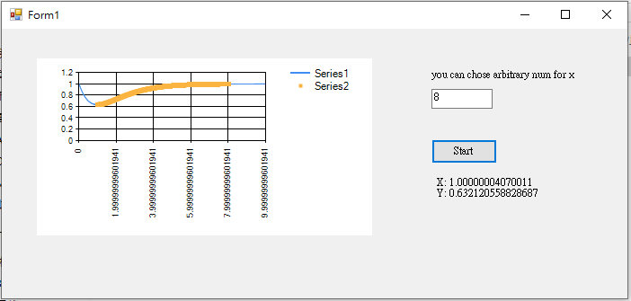

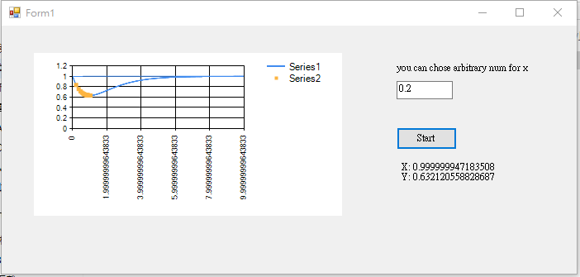

The key rule is that:

If the slope of current point is positive, then find x in the direction of left.

If the slope of current point is negative, then find x in the direction of right.

If the slope equals to 0 or iteration times becomes 30000, then stop the iteration and return the position of current point.

I design a Form which let user can input a arbitrary real number in textbox and then click the button, system will find the local minimum point automatically.