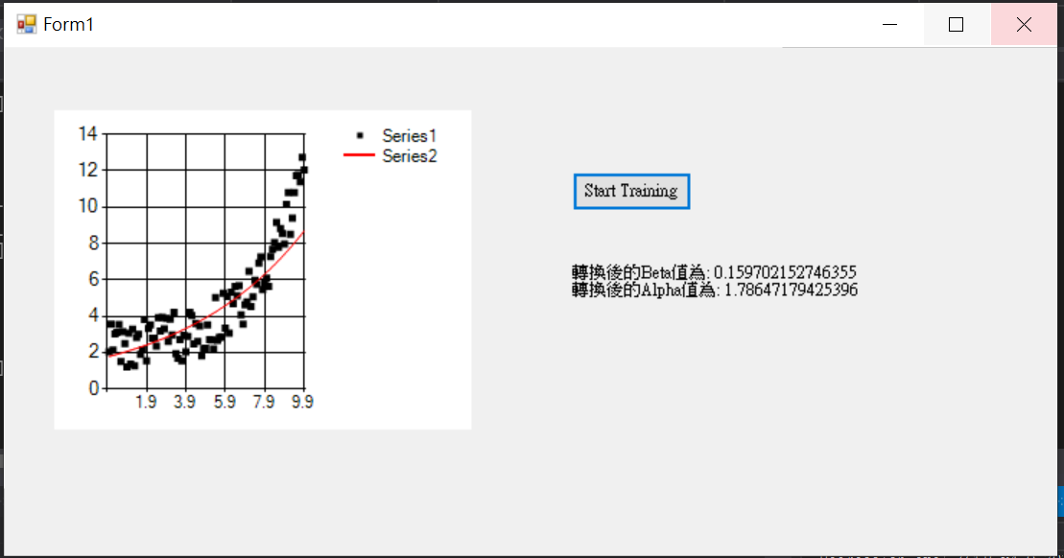

First of all, nonlinear regression model $y=αⅇ^{βx}$ need to ne transform to linear regression model, so I create a new column y’(log y) in the original file. The function after adjust would be: $\ln{y= βx+ln}α$. Then, use the way which used to find parameter of linear regression model to solve it.