**Property Tycoon**

**Team Number**: 5

**Team Member**:

Abdullayev, Elchin

Meftouh, Ishak

Yeung, Yue Hin Gerry

Li, Jiaying

Yan, Guohao

Github: <https://github.com/CarlAcount/Game>

**Planning**

GANTT Chart

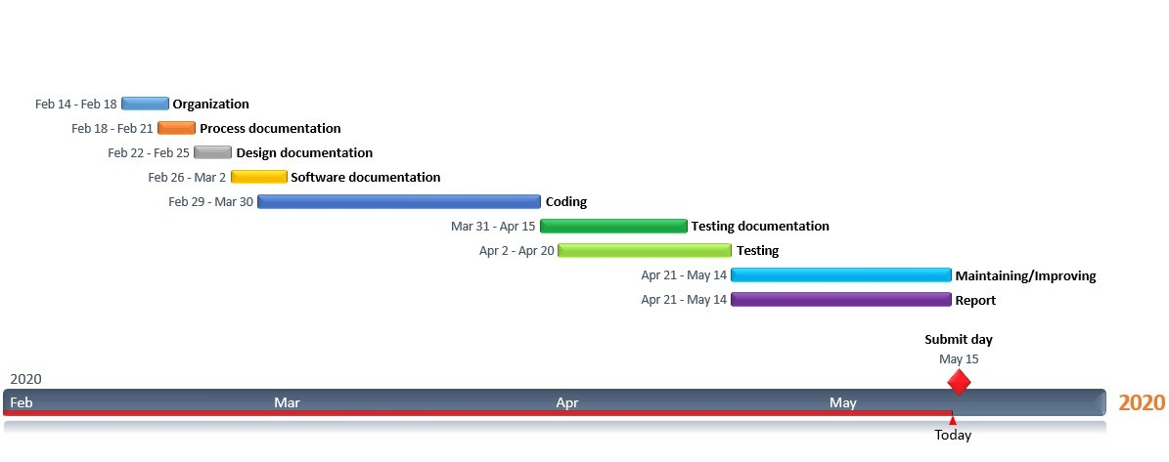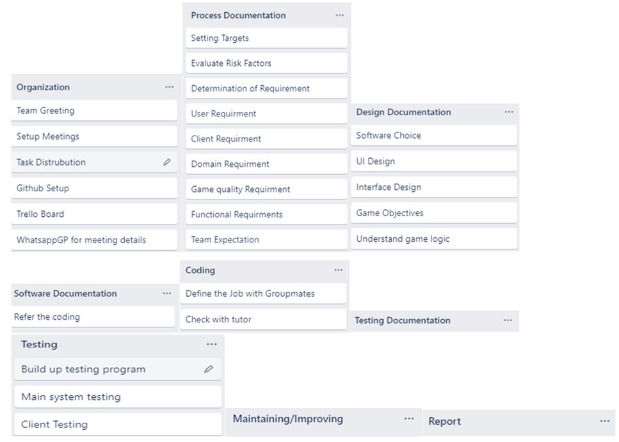

PERT Chart

<https://github.com/CarlAcount/Game/blob/master/doc/Planning/318dfb76-40fc-4012-b7cf-6430f17a7487.jpg>

**User Guide**

Run Main.java in the Game project

Click Add Players button

Input the number of player and click OK

Enter the player's name in turn. For example, Player1 and Player2

The player's name has been saved, and then you need to click the Play button

After clicking the Play button, the program will prompt the user to enter the game time. The game will end after one of the players wins the game or the game time is exhausted.

Now that the game is set up, the user can see the player amount and player list on the game interface. The green box in the upper left corner displays descriptive information when the player draws a lucky card. The yellow box in the lower right corner displays the description information of the opportunity card in the box when the player draws the opportunity card. The box in the lower left corner will display street information in the box when the mouse is moved to the street.

Now, click Role Dice button, the game will assign the order in which the players roll the dice according to the order in which they enter. The result of the dice is displayed in the box on the left of the player list. When the player walks across the street, the street will change to green.

Property on the map can be auctioned off and the person with the high price gets the property. Click Auction button

The information about the end of the auction will be displayed below the button,

Map property can be purchased. The purchase success will be displayed at the bottom of the box.

Property on the map can be rented. The results of the rental will be displayed at the bottom of the button box.

In the end, time did not run out but since there were players who won the game, the game ended. End of game is shown as the button on the program does not work.

**Report**

GUI Development

Unity3D for GUI

In order to enhance the enjoyment and playability of the game. We want to create a better looking and more practical GUI through unity3D and javaFx. We aim to create better board and better functions to achieve this.

Feedback

For the continuous improvement and progress of the game, we would create a website and put the website link on the software. This website is used to receive user comments and feedback.

To do this, the webpage would have a webpage display board. Users can upload images, provide messages and even some codes. Through these we will continue to improve the program.

Online multiplayer

We would like this game can be played online by multiple people. So that users can play on windows platform over WAN. This will make it easier for users to play.

To do this, we would run the game through the game platform steam to achieve Online multiplayer.

Peer Marking

Abdullayev, Elchin : 18

Meftouh, Ishak : 18

Yeung, Yue Hin Gerry : 18

Li, Jiaying : 23

Yan, Guohao : 23